Effect of planting date on seasonal timing of pest complexes and insecticide efficacy
Lasair ní Chochlain and Kelly Hamby
Department of Entomology, University of Maryland, College Park, MD
lasair@umd.edu, kahamby@umd.edu
2024 Final Grant Report for the Maryland Soybean Board

Final report
Project goals:
We aim to better understand timing of pest pressure in full season soybean to provide best management advice to Maryland growers.
Project objectives:
In order to achieve this goal we shall:
1) Assess the effects of two planting dates on the timing, abundance, and economic impacts of slugs, insects, and pathogens;
2) Determine the control efficacy and economic benefits of adding a pyrethroid insecticide to the postemergence herbicide application across two soybean planting dates;
3) Ascertain whether there are any increased pest risks later in the growing season that are triggered by the insecticide-herbicide tank mix approach.
Deliverables and key performance indicators
Experimental design:
We planted P38A54E full season, non irrigated soybeans at 15” row spacing for a population of 120-140,000 live seeds per acre using a planter or a drill, with 6-8 rows skipped to provide 30” rows to install traps. Plots were 45 ft wide by 60-79 ft long. We planted the earlier planting treatment (May) as soon as possible and the later planting treatment (June) 1 month later. We measured timing, abundance, and economic impact of slugs, arthropods, and early-season pathogens across two planting dates (as early as possible and one month later) and two farms [CMREC (Beltsville, MD) and WyeREC (Queenstown, MD)] for two years. The experimental design was replicated in two fields at each farm with three replicates of each treatment combination (date*pesticide) per field. The planting and harvest dates are summarized in Table 1.

Table 1. Dates of soybean planting, post-emergence treatment, and harvest at CMREC (Beltsville = BV) and WyeREC (Queenstown = QT) for both study years (2022 and 2023).
Treatment, Year, Farm | Planting | Post-emergence | Harvest
May 2022, BV, QT | May 2, Apr 29 | Jun 28, 30 | Oct 20, 19
June 2022, BV, QT | Jun 7, 1 | Jul 21, 22 | Oct 20, 19
May 2023, BV, QT | May 12, Apr 27 | Jul 4, 10 | Oct 19, 4
June 2023, BV, QT | Jun 12, May 31 | Jul 20, 25 | Oct 19, 4

Deliverables and key performance indicators for Objective 1:
We assessed how pest pressure varies by planting date using slug traps and sweep net monitoring. We analyzed 2 years of slug pressure data (11 weeks from May-July) across 2 farms and 4 fields which enables us to better understand slug pressure and variation. To determine if this pest pressure is economic based on established thresholds, we analyzed 2 years of leaf defoliation data from both in situ and lab measurements across 2 farms and 4 fields. We sampled the June plots across 3 dates in 2022 and the May plots across 4 (Jun-Aug). In 2023, we increased to 4 sampling dates in the June plots and 5 in the May plots (May-July). In total we recorded the defoliation of 2520 individual leaves in 2022 and 3240 leaves in 2023. In 2023 we increased our effort and recorded total leaf size as well as growth stage throughout the entire measurement period, which allowed for greater resolution of both percent defoliation and relevant thresholds. From the early vegetative stages until canopy closure, we conducted 3 visual assessments of 6ft of row (both sides). We counted total stand; damage incidence, or the number of plants with pest damage (slugs, arthropods); and the number of plants with yellowing, wilting, necrosis, or any other obvious disease symptoms. Disease symptoms were photographed and leaf samples taken for analysis by a UMD plant pathologist. When representative pathogen damaged plants were either located outside plot area or were not going to survive until harvest, they were dug up with the roots for better identification. Finally, we bagged and froze sweep net captures 4-5 times per season for 252-324 samples per site per year and identified all arthropods. We also evaluated pod damage, details below.
Deliverables and key performance indicators for Objective 2:
We followed standard nutrient and chemical management practices for mid-Atlantic no till production, with burn down, pre-emergence, and post-emergence herbicide treatments. When we applied the post-emergence herbicide, we mixed in the highest labeled rate of Warrior II (1.92 fl oz/acre) for the insecticide+herbicide treated plots. This is the rate recommended for grasshoppers, stink bugs and spider mites, which were identified by MSB in 2021 as key pests. The timing of this application is indicated by the tractor icon and arrow in Figure 1. To evaluate the pest control benefits of the post-emergence Warrior II application, we focused our most intensive sampling efforts (sweep netting, defoliation assessments and visual counts of damaged plants) within 7 days before spraying and about 2 weeks after spraying. To determine the economic benefit of an insecticide applied at this timing, we utilized the aforementioned sweep netting and defoliation assessments in addition to pod damage and yield, comparing between the insecticide and herbicide-only subplots. To measure pod damage, we destructively sampled 6 representative soybean plants per plot (a total of 288 plants per year) and counted the number of total and damaged pods. We evaluated 26,812 pods in total across two years.
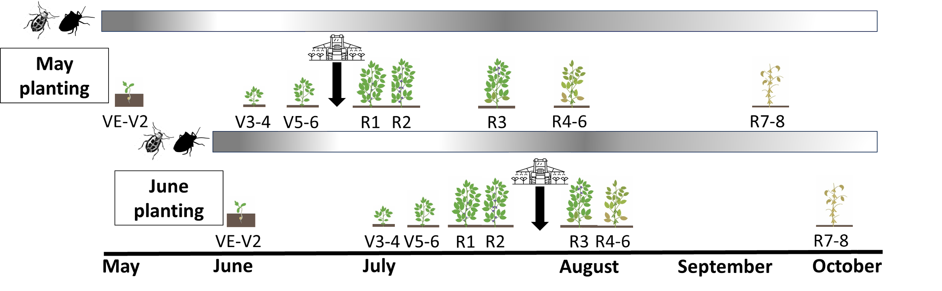Figure 1. icon bar signifies pest damage risk (based on growth stage), with darker shade indicating higher risk with time of year indicated along the bottom. Growth stages are approximate and depend on temperature and rainfall. Generally, for VE-V2 plants, yield loss is only observed if stand is reduced (1). V3-V6 plants can withstand up to 100% defoliation with no yield loss, but potential for yield loss increases with plant stress and growth stage (2). For R1-R2 plants, lower amounts of defoliation can contribute to yield loss and that likelihood increases with low plant densities and water stress (3). In R3-R5, plants are at a maximum risk for yield loss (4). In R6-R7, plants are vulnerable to pod injury, and some yield loss is still possible but less likely (4).

Deliverables and key performance indicators for Objective 3:
In order to assess any alteration in natural enemy suppression that may result in secondary pest outbreaks, we sampled post-spray in both years. To determine if there were pest outbreaks triggered by the insecticide treatment, we utilized our sweep net data.

Final results
1) Assess the effects of two planting dates on the timing, abundance, and economic impacts of slugs, insects, and pathogens;
Overall, both planting dates resulted in similar soybean yield for the majority of site years (three out of 4). Pest pressure was higher in 2022, as indicated by higher slug abundance as well as stink bugs reaching threshold populations, and in 2022 the earlier planting averaged higher leaf defoliation compared to the later planting. Disease prevalence was low in visual assessments both years.
Slugs: Slug pressure was measured using shingle traps combined with cups of soapy water to increase humidity. In 2022, the earlier planting experienced on average higher pressure across both farms, and Beltsville had higher slug densities than WyeREC (Figure 1). We expected slugs to peak earlier in the season when conditions are wet and cold; however, peak slug activity/density occurred around June 1 at WyeREC and around June 20 at Beltsville, meaning that slug pressure may have overlapped with VE-2 plants in the June planted plots and V3+ plants in the May planting. Slug traps may also be more attractive at this time of year when conditions tend to be drier. Younger plants are generally more vulnerable to slug damage and yield loss, so it is possible that despite the higher abundances early plantings did not experience as much damage. Slug abundances in 2023 were much lower at both farms (Figure 2), with densities highest throughout June at WyeREC and in late June/early July at Beltsville but never exceeding 3 slugs/trap on average. Based on this trap data, slug pressure may have overlapped with early vegetative plants in June planted plots and later vegetative plants in May planted plots.

Defoliation: There are economic thresholds for leaf defoliation which range between 10-30% based on growth stage. We did not see an economic level of defoliation in either 2022 or 2023. Leaf defoliation was less than 15% in 2022 every time we sampled and in 2023 was only above 15% in the vegetative stages where the threshold is generally 30% (Figures 3-4). In 2022, we measured consistent defoliation throughout the season, which came closest to thresholds earlier and later in the season. When approximately VE-V1 plants are compared across planting dates, we measured almost twice as much area defoliated in earlier planting plots vs later planting plots. (Figure 3). This effect persisted in 2023, where the percent defoliation that we measured on VE-V1 May plots was almost double the percent measured in VE-V1 June plots, suggesting that earlier planting may increase pest damage on VE-V1 plants (Figure 4)

Sweep nets: Insect pest counts in sweep net samples were compared to regional economic thresholds. Specifically, we evaluated stink bugs, caterpillars, bean leaf beetle, kudzu bug, and potato leafhopper, which have existing thresholds. We did not observe any other pests in high abundance. Stink bugs were the only insect above threshold in 2022, and were over threshold (>3 stink bugs per 10 sweeps) in five samples across our mid-August and mid-September sampling dates. By September, plants are R6+ and largely immune to yield loss, so we last sampled in late August in 2023 and no thresholds were met at any point in the season.

Pod damage: Pod damage was below action threshold (5%) in both years, so no insecticide would be warranted. Earlier planting in May did decrease the proportion of damaged pods. (Figure 5)

Yield: Planting date did not increase yield overall (Figure 6). However, planting earlier increased yield in 2023 (Figure 7). In 2023, yield ranged from 30 bu/ac to 94 bu/ac, exhibiting more variation than in 2022, which suggests that pest pressure and environmental conditions were more variable in 2023 compared to 2022.

2) Determine the control efficacy and economic benefits of adding a pyrethroid insecticide to the postemergence herbicide application across two soybean planting dates;
We expected that the post emergence pyrethroid application would not provide an economic benefit as the timing did not overlap with economic pest damage. Pest abundances were low in sweep nets and defoliation was below threshold. The pyrethroid did effectively control pest pressure in the May planting, as measured by a decrease in leaf defoliation, however this effect did not persist through R5/R6 when we surveyed pod damage and did not result in a yield benefit.
Defoliation: The insecticide treatment effectively reduced pest damage (as measured by the area defoliated on leaves) collected approximately two weeks post-spray over both years of replication, but only in the May planting (t(90) = -0.565, p = 0.0056). In the June planting the insecticide treatment had no effect on measured pest damage (t(90) = -0.169, p = 0.83) (Figure 3-4).

Sweep nets: Caterpillars, bean leaf beetle, kudzu bug, and potato leafhopper, and stink bugs were not above standard thresholds either before or after the post-emergence treatment which was applied in June/July. Other pest abundances were low.

Pod damage: Pod damage was sampled about 2 months after the post emergence spray. Insecticide treatment did not impact pod damage across both plantings, which we expected based on the timing (Figure 5).

Yield: Mixing Warrior II with the post-emergence herbicide treatment had no effect on yield across both planting dates and years, unsurprisingly because there were no yield limiting pests present at the time of application (Figure 6).

3) Ascertain whether there are any increased pest risks later in the growing season that are triggered by the insecticide-herbicide tank mix approach.
Sweep nets: There was no evidence of a secondary pest outbreak in our sweep net samples from 2022 or 2023. Neither aphids nor spider mites met established thresholds in either the insecticide or non-insecticide treated plots.
Pod damage: Insecticide treatment did not increase pod damage across both plantings (Figure 5), indicating that economic pest pressure did not increase as a result of this treatment.
Yield: Insecticide treatment did not decrease yield (Figure 5), indicating that economic pest pressure did not increase as a result of this treatment.

Figures

Slugs
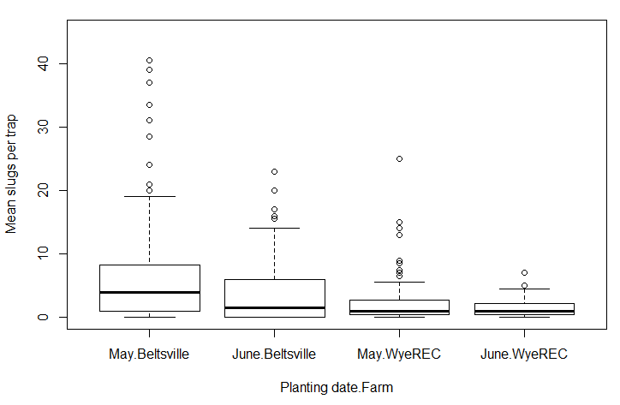
b
a
a
b
Figure 1. 2022 slug pressure summarized in a box plot across both plantings (May, June), and farms (Beltsville, WyeREC). 2 traps were deployed per subplot. Planting: F_{1,404} = 4.60, p = 0.0326; Pesticide: F_{1,385} = 0.049, p = 0.825
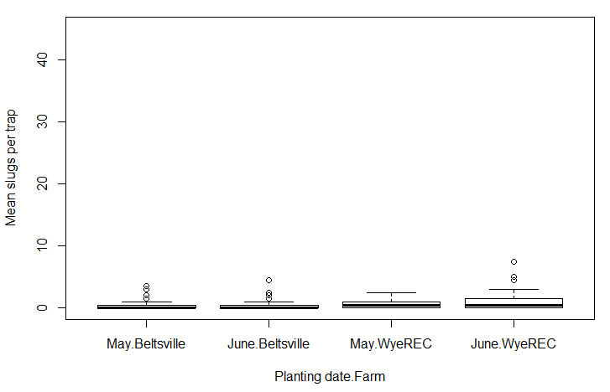
a
a
a
a
Figure 2. 2023 slug pressure summarized in a box plot across both plantings (May, June), and farms (Beltsville, WyeREC). 2 traps were deployed per subplot. Planting: F_{1,390} = 3.40, p = 0.0658; Pesticide: F_{1,399} = 1.45, p = 0.229

Defoliation
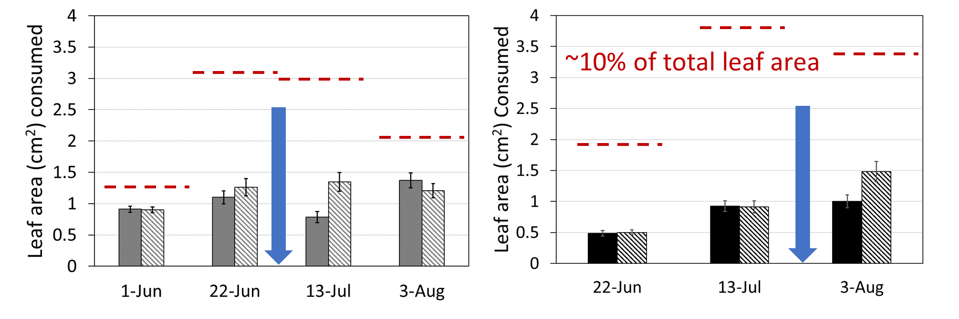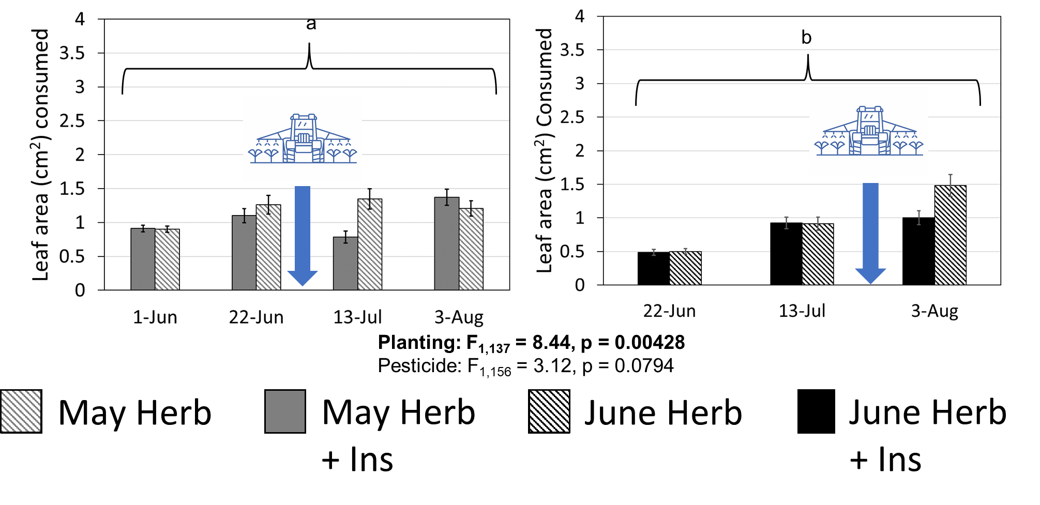
Figure 3. Leaf defoliation measurements for 2022. Y axis is cm leaf consumed and X axis is planting date. The blue arrow denotes the timing of the pesticide application. The “a” and “b” brackets represent statistical differences as a result of planting over the course of the season. The figure legend depicts the 2x2 experimental design; May = grey, June = black, herbicide alone = striped, herbicide + insecticide = solid. The red dashed line represents approximately 10% of the total leaf area based on average leaf size (the most conservative threshold, applied during the R1-R2 stages).
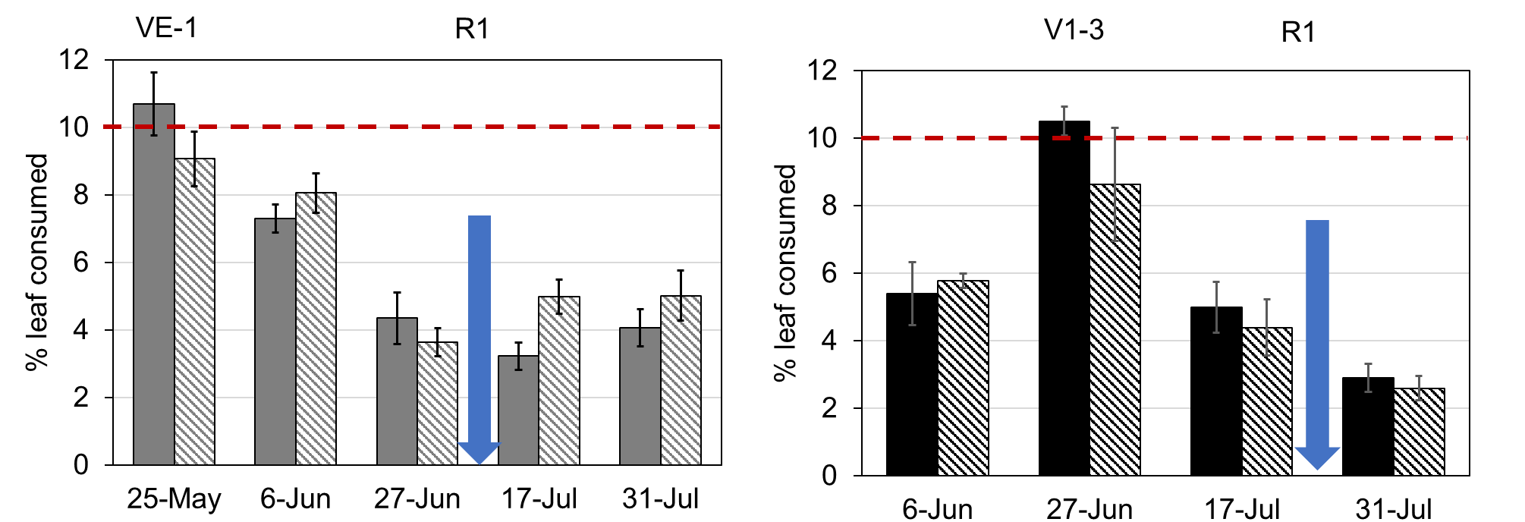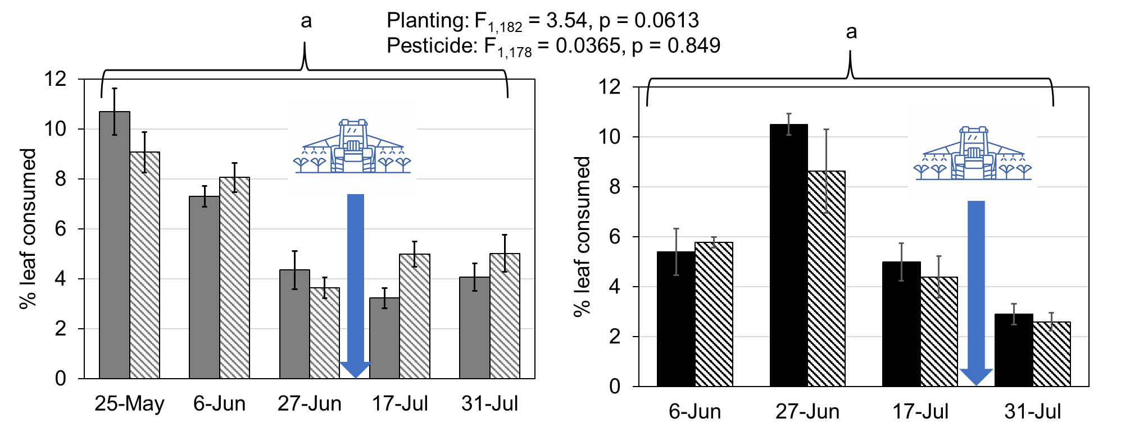
Figure 4. Leaf defoliation measurements for 2023. Y axis is % leaf consumed and lower X axis is planting date. Upper x axis (VE, V1, V2, V3…R1) depicts growth stage at times when defoliation was above 10% as well as the application of the post-emergence pesticide. The blue arrow and the tractor denotes the timing of this application. As above, May = grey, June = black, herbicide alone = striped, herbicide + insecticide = solid. The “a” brackets represent no statistical differences as a result of planting or pesticide over the course of the season. The red dashed line represents 10% of the total leaf area.

Pod damage
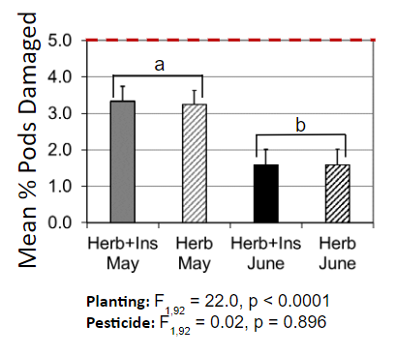
Figure 5. Pod damage was compared over both 2022 and 2023 using R in a linear mixed model with farm and year as random effects. Y axis is % of damaged pods, X axis is treatments. 2022 and 2023 data combined (n = 24) as planting date decreased the mean % of pods damaged in all except 1 site year (Wye 2022). The “a” and “b” brackets represent statistical differences as a result of planting date across both sites and years.

Yield corrected to 13% moisture
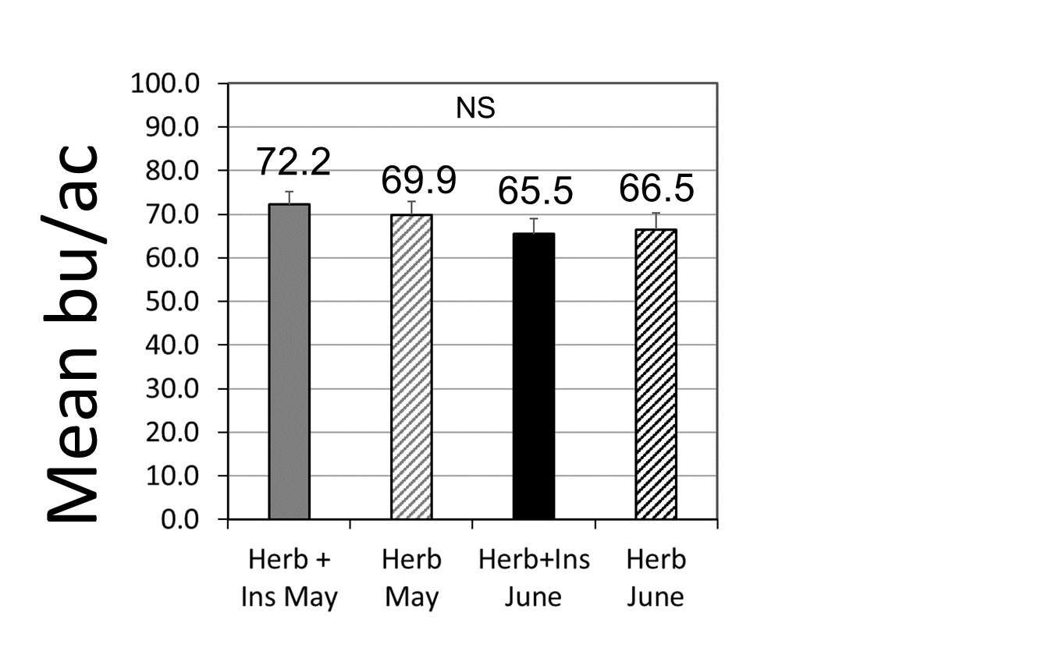
Figure 6. Yields were compared over both 2022 and 2023 using R in a linear mixed model with farm and year as random effects. There were no significant effects as a result of treatment. (Planting: F_{1,92} = 0.0434, p = 0.836; Pesticide: F_{1,92} = 2.343, p = 0.129)
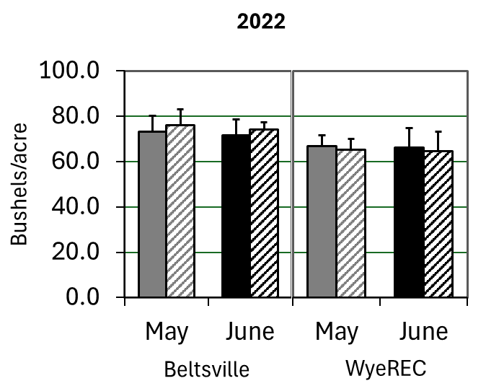

a
a
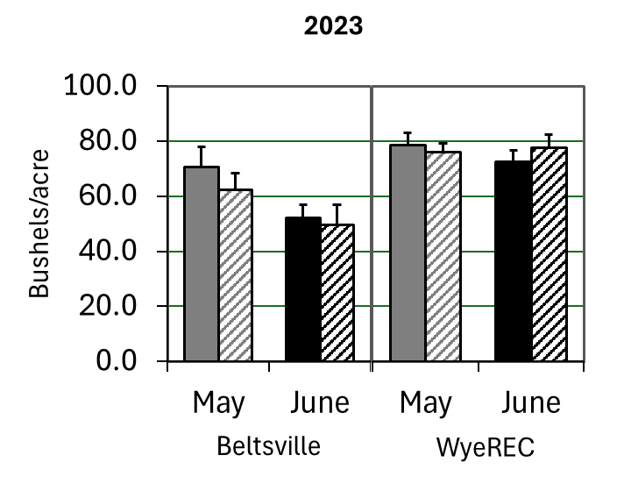

a
a
b
Figure 7. Yield was separated by year and compared in two linear mixed models (using R) with farm as a random effect. (2022: Planting: F_{1,44} = 0.0737, p = 0.787; Pesticide: F_{1,44} = 0.0142, p = 0.906; 2023: Planting: F_{1,44} = 5.12, p = 0.0286; Pesticide: F_{1,44} = 0.245, p = 0.623) Y axis is bushels/acre corrected to 13% moisture. X axis is farm and planting date. Key: herbicide only - striped, herbicide and insecticide - solid.

Findings

Objective 1: Despite longer growing time, there was no overall difference in yield at harvest, suggesting that pest pressure (and damage to soybean) may be higher in May compared to June plantings. Supporting this, 2022 slug activity-abundance and leaf area defoliated were higher in the May planting, although this effect did not persist in 2023. 2023 generally had lower pest pressure than 2022, with an order of magnitude fewer slugs and no common pests above threshold. We hypothesize that this decreased pest pressure may explain why planting earlier increased yield in 2023 (but not 2022). In summary, soybean planted in late April/early May could experience slightly higher pest pressure compared to June plantings, but generally not enough to warrant treatment. In the 2 years of this study, disease pressure was low at both sites, and planting earlier did not increase pathogen incidence. This research has increased our understanding of how planting date impacts pest pressure in mid-Atlantic, no-till, full season soybean, but more work is needed to account for temporal and spatial variation in climate and allow for region- and year-specific recommendations.
Objective 2: We did not detect a yield benefit from using insecticides at the postemergence herbicide timing. In the years studied, yield limiting pests were not present at threshold abundances, making any reduction in pest damage have little impact on yield. In such situations, reducing chemical applications can reduce input costs and increase profits. An integrated pest management approach with regular scouting and dynamic response to pest pressure can help avoid losses due to unexpected pests and reduce unnecessary chemical inputs.
Objective 3: There was no evidence for secondary pest outbreaks; however, insecticides may still reduce natural enemy abundances and potential for biological control suppression of pests.

Benefit to soybean farmers and other researchers
Objective 1: We have a better understanding of the timing, abundance, and economic impacts of pests in mid-Atlantic, no till, full season soybean. During the 2 years of this study economic levels of pest pressure did not overlap with the most vulnerable growth stages for either planting date. The benefits and drawbacks of earlier planting dates may depend on overall pest pressure that year and the degree to which the longer growing time can (or cannot) compensate for pest pressure over that longer period. We have therefore identified a knowledge gap in exactly how spatial and temporal variation in climate and pest pressure impact yield outcomes. Suggested directions for future research include tracking how ongoing climate change and increased variability during the soybean growing season impact pest pressure and soybean performance.
Later planting of mid-Atlantic, no till, full season soybean appears to experience greater slug activity-abundance in seedling soybean (VE-V2). However, slug trap data did not align with our expectation of slug biology. Measured abundances were higher in June, when conditions are warmer and drier, than in May. We hypothesize that slugs may be congregating in slug traps when conditions are less ideal, and not when conditions are more ideal, making these traps an inaccurate way of measuring economic slug activity-abundance. More work is needed to develop useful slug monitoring, thresholds, and treatments, as well as understand how planting date impacts pathogen incidence.
Objective 2: We found that tank-mixing a pyrethroid only decreased defoliation in the May planting, and did not confer an economic benefit in either planting date treatment. This information will allow growers to maximize their profits by skipping unnecessary input costs. Further research is needed to understand why the pyrethroid was less effective in the June planting.
Objective 3: We did not observe any increased pest risks later in the season as a result of the tank-mix approach. However, investigation into potential non-target effects should continue, as pest pressure and the potential for secondary outbreaks is likely to increase with climate change.

Presentations
Preliminary 2022 results for defoliation, yield, and pod damage were presented at the 2023 Commodity Classic on 7/27/23, and a more summarized and final version of this data was presented in poster form at the 2023 Entomological Society of America National Meeting on 11/6/23 in National Harbor, Maryland. Findings from this study were included in extension presentations on slug and insect best management practices at 12 meetings reaching 916 audience members.
References
(1) Hammond 2000 Crop Prot 19(2): 113–120.
(2) Hintz et al 1991 J Prod Agric 4(4): 585–589.
(3) Thrash et al 2021 J Econ Entomol 114(2): 702–709.
(4) Fehr et al 1977 Crop Sci 17(6).
(5) Hunt, T., & Jarvi, K. (2007). Evaluating Soybean Defoliation and Treatment Need. CropWatch. UNL.
(6) Getman-Pickering et al (2020). Methods Ecol Evol, 11(2), 215–221

