FY23 Research Summary May 31, 2024

Title: Integrated Management of Herbicide-Resistant Giant and Common Ragweeds in Minnesota
Lead-PI: Dr. Debalin Sarangi

Project objectives:
The objective of this research is to evaluate the effect of integrated weed management tactics on herbicide-resistant giant ragweed and common ragweed control, soybean growth, and yield.

Research updates:
The field experiment was conducted at the Rosemount Research and Outreach Center near Rosemount, MN in 2023. The experiment will be repeated in 2024 in the same field as a part of the FY24 project. The first year’s trial data were summarized. The integrated management of common ragweed project is ongoing in Crookston, MN. A graduate student was recruited, and he was partially funded through this project.

The research results from the Rosemount trial in 2023 showed that cover crop terminated using Roundup PowerMax at 7 days after planting (DAP) resulted in > 80% control of giant ragweed at 21 DAP and that was similar to the control obtained with no-tillage burndown treatment using Enlist One + Roundup PowerMax3. The preemergence application of Verdict at 5 fl oz/A improved giant ragweed control by 21% compared to no preemergence herbicide application. Cover crop terminated at 7 DAP (“planting green” treatment) combined with preemergence followed by postemergence herbicide application resulted in the greatest soybean yield (47 bu/A) which was similar to the postemergence-only and preemergence followed by postemergence herbicide treatments in cover crop treatments (terminated at planting or 7 DAP), conventional tillage, and no-tillage burndown treatments. Reduced-tillage treatment combined with preemergence followed by postemergence herbicide application also had a similar yield as the aforementioned treatments.

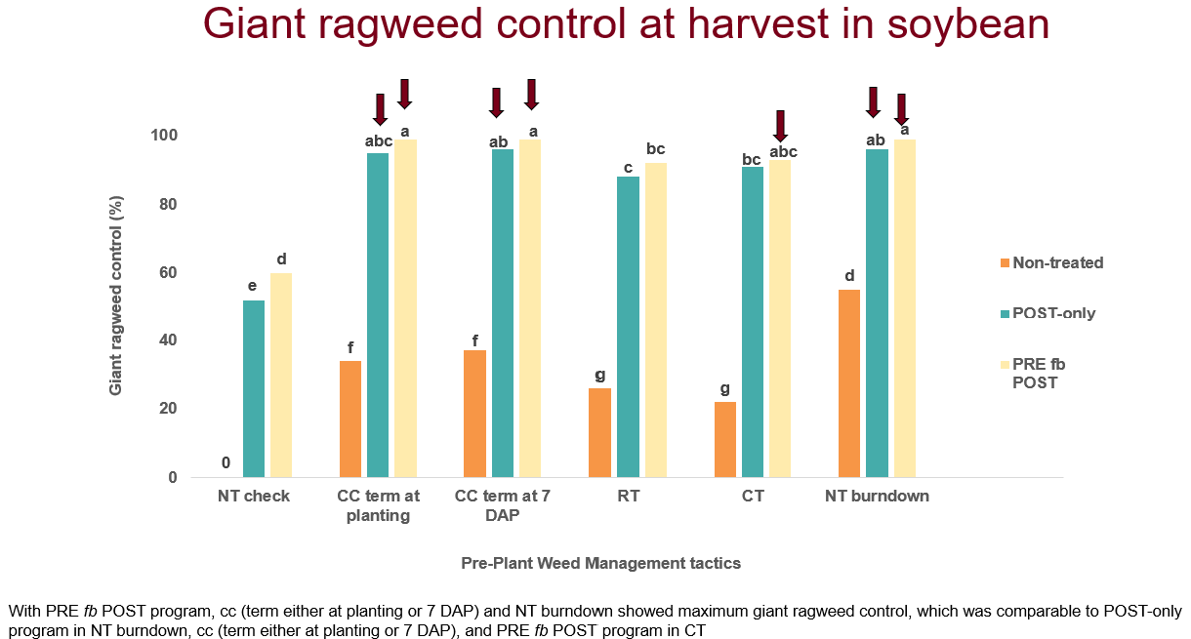

Figure 1: Giant ragweed control at soybean harvest in Rosemount, MN in 2023.
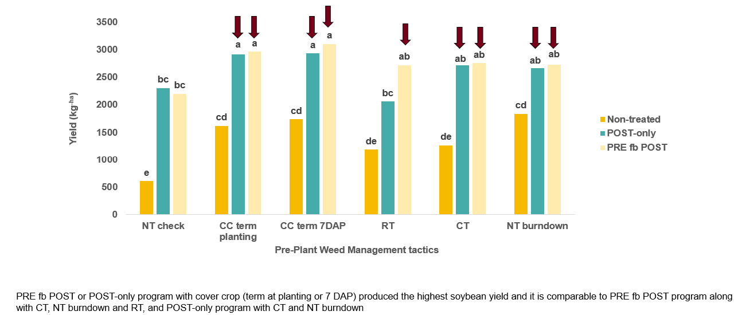

Figure 2: Soybean yield as impacted by the treatments in Rosemount, MN, in 2023.

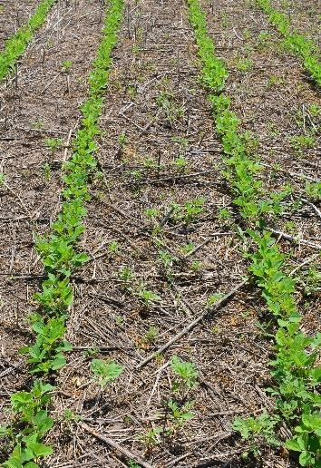
d
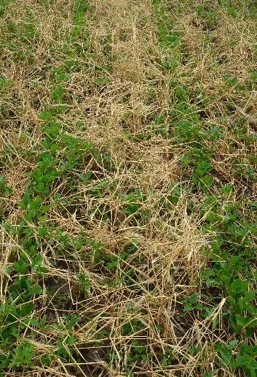
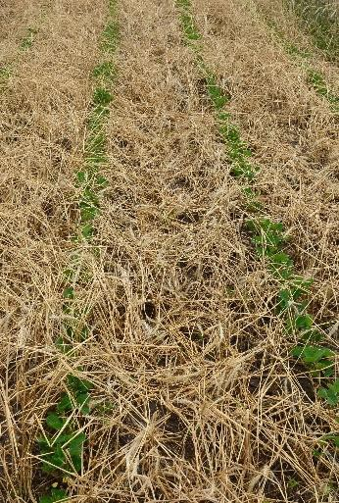
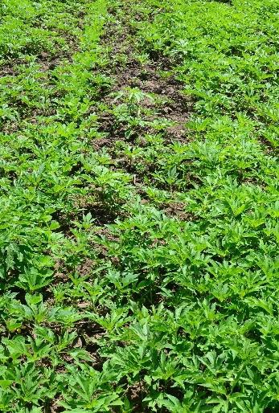
Figure 3: Comparison of main plot treatments (pre-plant tactics) in Rosemount, MN, in 2023: a. cover crop terminated at planting, b. cover crop terminated at 21 days after planting, c. conventional tillage, d. no-till burndown herbicide application.
a
b
c
Performance Metrices:
1. Results obtained from this research improve the yield and quality of soybean grown in Minnesota.
- Many treatment combinations improved giant ragweed control and soybean yield.

2. Stakeholders are educated about herbicide resistance, weed biology, integrated management, and cover crop management.
- The research results were presented at the North Central Weed Science Society’s Annual Meeting in Minneapolis in 2023, the Weed Science Society of America’s Annual Meeting in San Antonio, TX, and UMN Extension’s Research Updates in 2024. The project was also demonstrated at the Corn and Soybean Weed Management Field Day in Rosemount, MN, in 2023.

3. Results are presented at Extension events attended by soybean growers.
- The project was demonstrated at the Corn and Soybean Weed Management Field Day in Rosemount, MN, in 2023.

4. One graduate student is mentored.
- Yes.

5. Peer-reviewed and Extension articles are published containing these results.
- Not yet, but they will be published after finishing two years’ of data collection in Rosemount, MN, and in Crookston, MN.

