Minnesota Soybean Research and Promotion Council

Annual Research Final Report

Project Title: 2023 Western Minnesota Soybean IPM Survey

Principal Investigator(s): Angie Peltier & Anthony Hanson, Univ. of Minnesota Extension

Project Period: May 1, 2023-April 30, 2024
Research Question/Objectives:
1) Conduct field surveys to report soybean crop stage and pest conditions in NW and WC MN.
    - Partner with the NDSU IPM program in conducting and reporting field and pest conditions across a region that includes NW and WC MN and eastern ND.
    - Deliver timely crop updates based on field observations with an emphasis on soybean aphid, two-spotted spider mite and other crop pest conditions as they develop.
Materials, Methods & Results: The IPM scouts with Crookston and Moorhead as their ‘home base’ began the season scouting small grains fields with funding from the Minnesota Wheat Research & Promotion Council, switching over to soybeans mid-season. At each field, the scout collected data both inside and outside fields following a detailed protocol. Briefly, outside each soybean field, grass areas that bordered fields were swept for number of grasshopper nymphs (Figure 1) and adults (Figure 2) of all grasshopper species. Soybeans were inspected for growth stage (Figure 3), soybean aphid incidence (Figure 4) or the number of plants infested, soybean aphid severity (Figure 5) or the number of aphids per infested plant, presence of aphids colonized by parasitic wasps (Figure 6), number of bean leaf beetles (Figure 7) and the severity of chewing injury they caused (Figure 8), two spotted spider mite (TSSM) presence on the field edge (Figure 9) and inside the field (Figure 10), soybean gall midge presence (Figure 11) and soybean tentiform leafminer presence (Figure 12). Please find Figures 1 through 12 and a brief discussion of findings below.
Grasshoppers. Grasshopper nymphs (green triangles) were found outside of many fields in northwest (NW) Minnesota from the commencement of the soybean leg of the survey (Figure 1), but there were more ‘no nymph’ locations (black dot) outside of west-central (WC) fields. As the survey progressed, grasshopper nymphs were found outside of fewer and fewer fields. It is likely that the survey was simply documenting the progression of grasshopper nymphs through developmental milestones until they were adults. As wheat crops are typically seeded and therefore emerge much earlier than soybeans, while there was likely some early-season feeding injury on soybean, the bulk of early-season grasshopper pressure was in small grains.
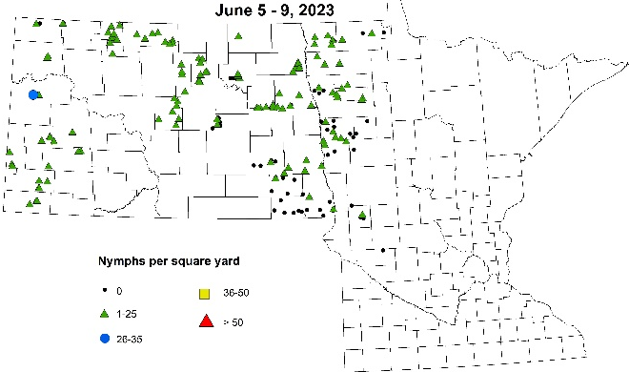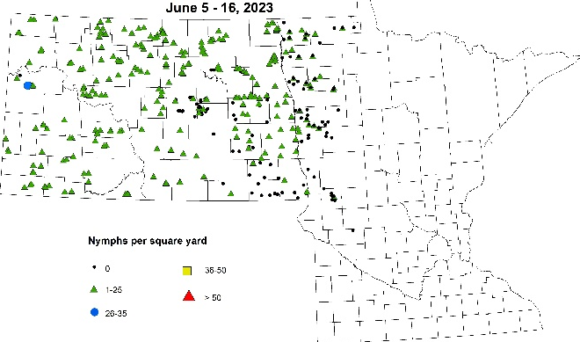 Figure 1. Grasshopper (all species) nymph per square yard caught on the edge of scouted soybean fields over two-week periods from June 5 through 16, 2023; continued on next page. Map: NDSU IPM.

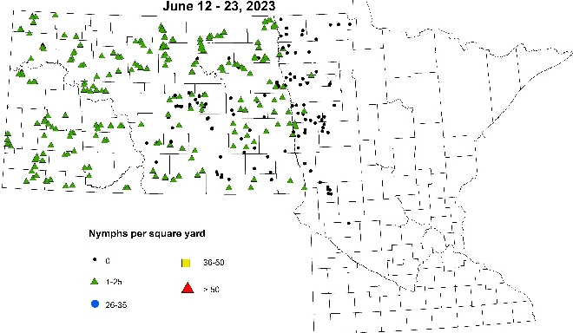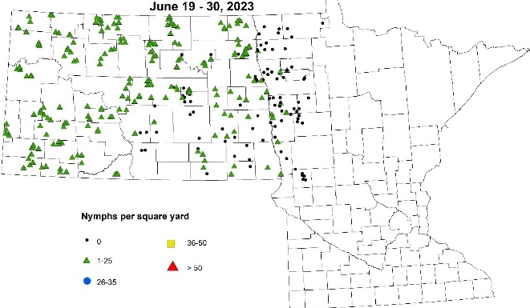
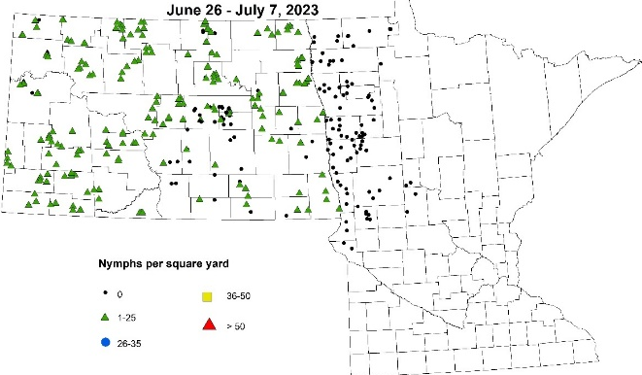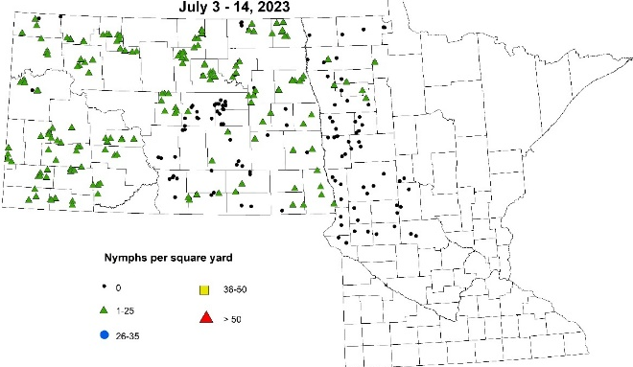
Figure 1. Continued from previous page. Grasshopper (multiple species) nymphs caught on the edge of scouted soybean fields over two-week periods from June 12 through July 14, 2023. Map: NDSU IPM.

If grasshoppers were observed outside of surveyed fields were more likely to be adults than nymphs by mid-July (Figure 2). As small grains fields began to mature, grasshopper adults were likely to move to adjacent soybean fields. Field edges in NW MN had more adult grasshoppers (green triangles) than those in WC-MN in which there were many more ‘no grasshopper’ (black dot) locations. Threshold-level grasshopper populations were observed in some soybean fields in the region and this author provided information about scouting grasshoppers, treatment thresholds and grasshopper insecticide options to producers.

For more information about grasshopper management, visit:
https://extension.umn.edu/corn-pest-management/grasshopper-management-minnesota-crops.

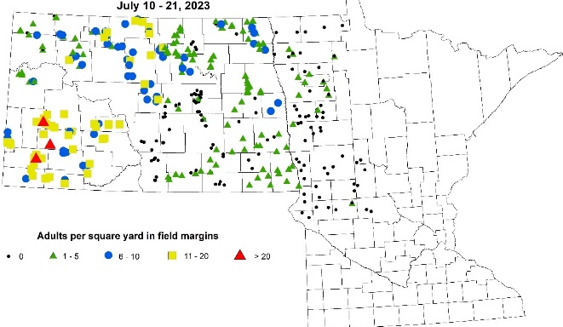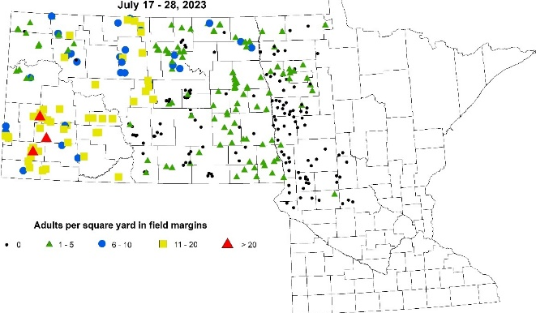

Figure 2. Grasshopper (multiple spp.) adults caught on the edge of scouted soybean fields over two-week periods from July 10 to 28, 2023. Continued on next page. Map: NDSU IPM.
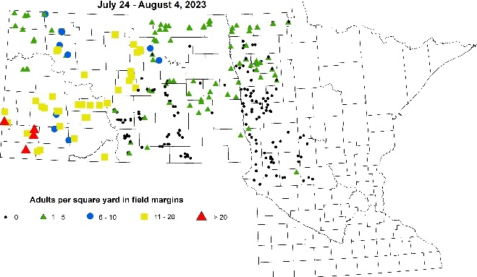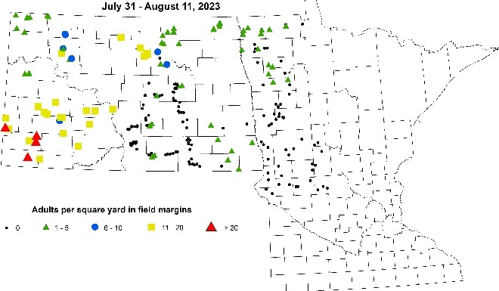 Figure 2. Continued from previous page. Grasshopper (multiple spp.) adults caught on the edge of scouted soybean fields over two-week periods from July 24 to August 11, 2023. Map: NDSU IPM.
Soybean growth stages. Unlike in surveys in previous years, when soybean growth stages were further along in WC than in NW MN early-on, fields with soybeans at the later vegetative growth stages and earlier reproductive growth stages were scattered across NW and WC MN (Figure 3). It was only as we approached the middle of July that the shorter-seasoned soybean varieties in NW MN began to outpace longer-season varieties in WC MN. By the last week of the survey, most of the NW and WC region’s scouted fields were of similar maturity, ranging from full pod (R4) to beginning seed (R5).
For more information about growth staging soybeans, visit: https://extension.umn.edu/growing-soybean/soybean-growth-stages.

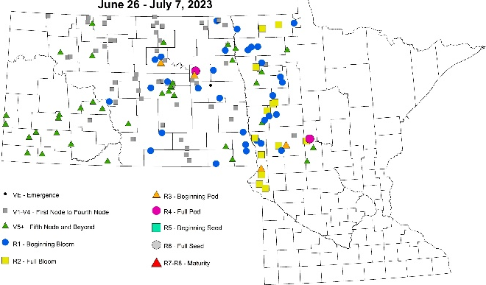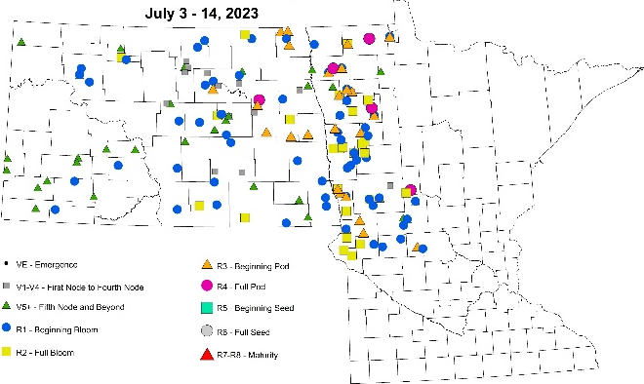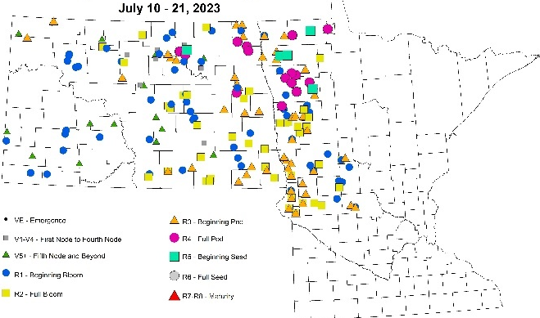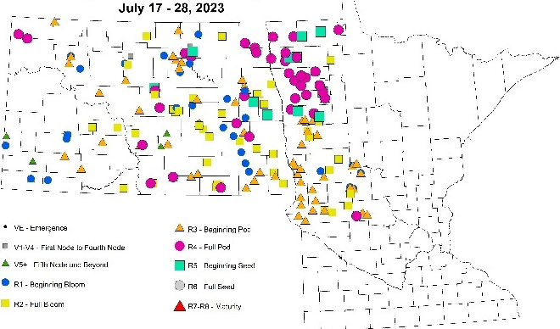
Figure 3. Soybean growth stages over two-week periods from June 26 through August 11, 2023. Continued on next page. Map: NDSU IPM.
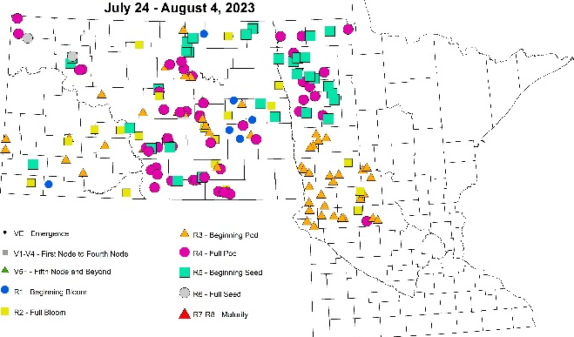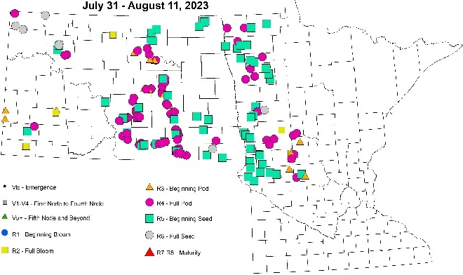Figure 3. Continued from previous page. Soybean growth stages over two-week periods from June 26 through August 11, 2023; Map: NDSU IPM.

Soybean aphid. Soybean aphid (SBA) incidence, or the percentage of plants infested with SBA was detected earlier than in recent years, reaching between 80 and 100% by the middle of July in several fields in Mahnomen, Clay, Otter Tail and Todd Counties (Figure 4). Eighty- 100% SBA incidence was observed in fields as far north at Polk County south to Stearns and Grant Counties by the end of the scouting period.
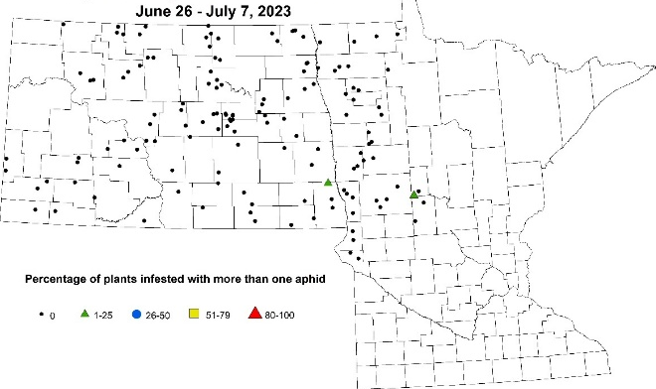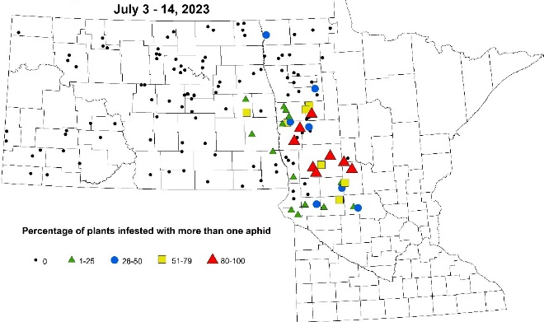
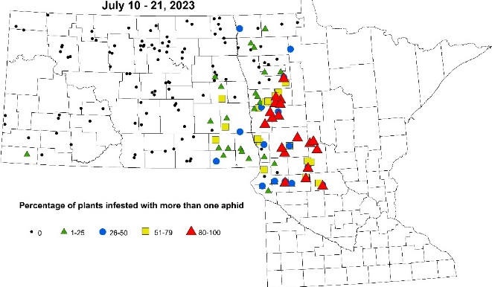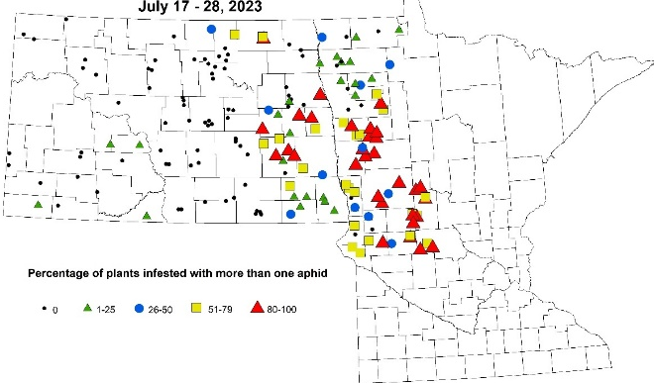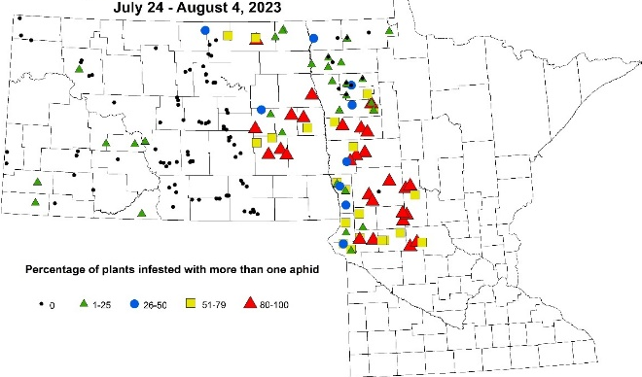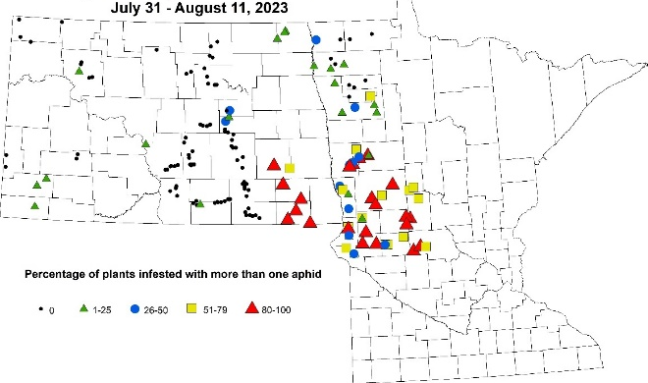Figure 4. Soybean aphid incidence (percentage of plants infested with more than one SBA) over two-week periods from July 10 to August 11, 2023. Map: NDSU IPM.

SBA, or the average number of SBAs per plant began to ramp up by mid-July, with one field in Mahnomen County reaching two elements of the three-part treatment threshold (250 SBA per plant, on more than 80% of plants) (Figure 5). Some of the fields were visited over several weeks, with population densities only increasing and no evidence that an insecticide treatment had been made. Over the weeks, 16 field visits found more than 250 SBA per plant. In 2019, 2021 and 2022 (the last 3 years of this survey), ZERO fields reached a density of 250 SBA/plant. That 2023 proved a ‘good SBA year’, there were likely more adult SBA traveling to their overwintering host (buckthorn) to mate and lay eggs to find 2024 soybean fields.

For more information about soybean aphid scouting, treatment threshold and insecticide options, visit:
https://extension.umn.edu/soybean-pest-management/soybean-aphid.

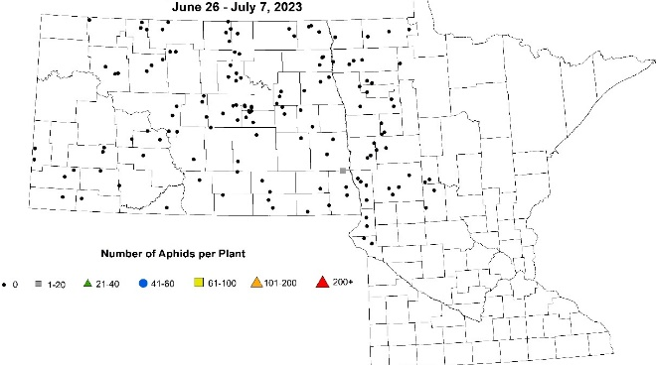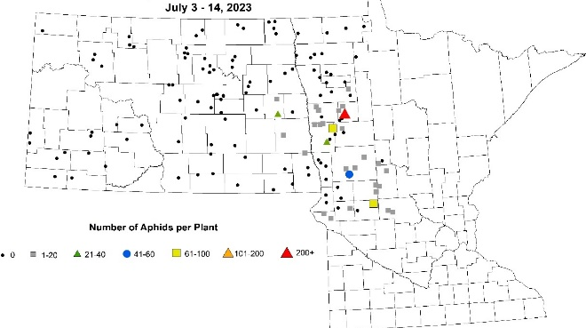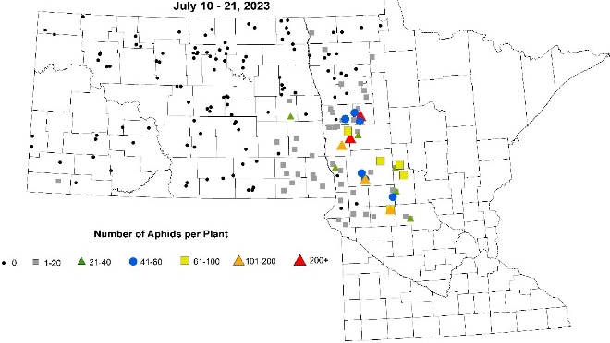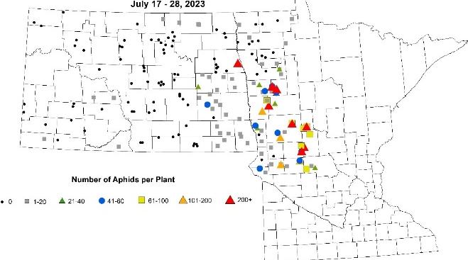
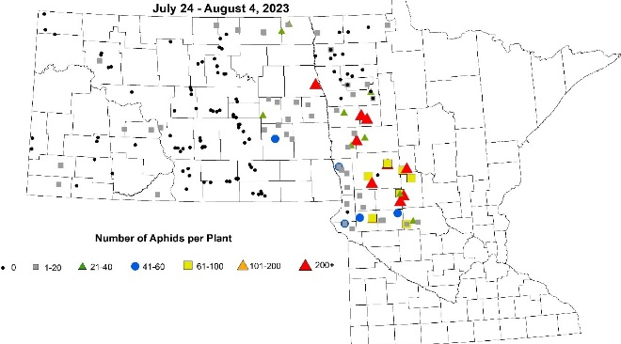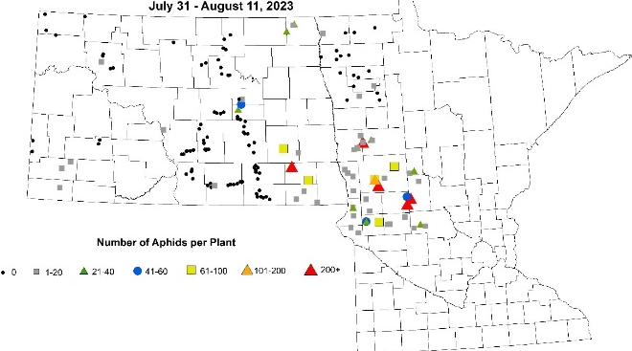Figure 5. Soybean aphid (Aphis glycines) severity (number of aphids per plant) over two-week periods from June 26 to August 11, 2023; Map: NDSU IPM.

Wasps parasitic to SBA. Several natural enemies of soybean aphids (SBA) are commonly observed in Minnesota, including Asian lady beetles/larvae, lacewings, pirate bugs and parasitic wasps. They can feed on SBA adults and nymphs and help to keep their population densities in check. Many of the insecticide active ingredients are effective against both SBA and these natural enemies. Careful scouting for both SBA and these natural enemies can ensure that one does not spray SBA before treatment thresholds have been reached, unintentionally eliminating these natural enemies. Several conversations with farmers and crop advisors alike revealed that many had never seen a year in which evidence of parasitic wasp predation on SBA (SBA ‘mummies’) was so slow to develop. Results of this survey concurred, with mummies only observed beginning in the middle of July, and 76-100% of plants with mummies only observed in the second half of July in fields that had long been infested with SBA (Figure 6). For more info on natural enemies of SBA, visit: https://extension.umn.edu/soybean-pest-management/scouting-soybean-aphid#predators-and-parasites-of-soybean-aphid-1354514.

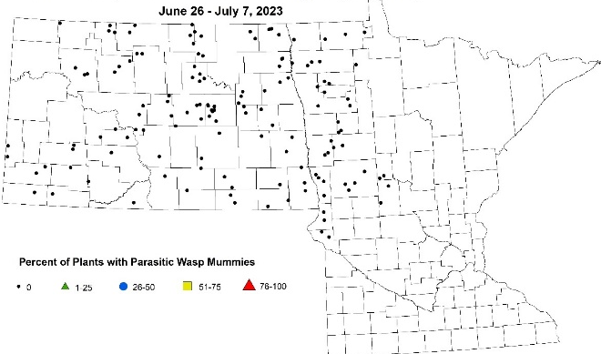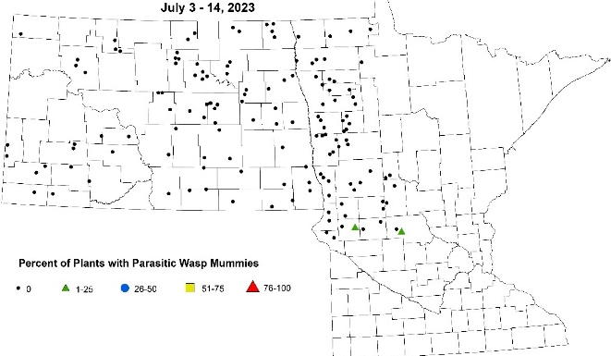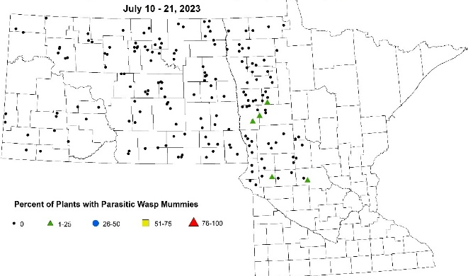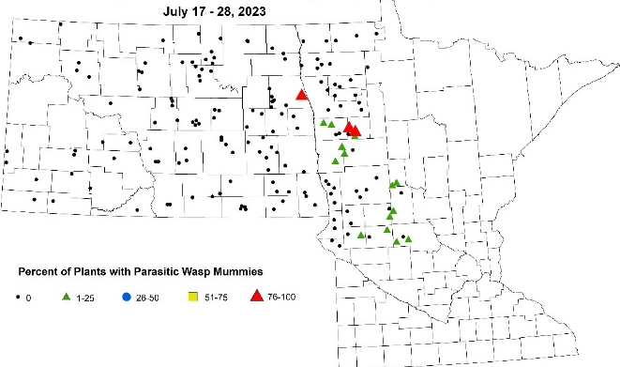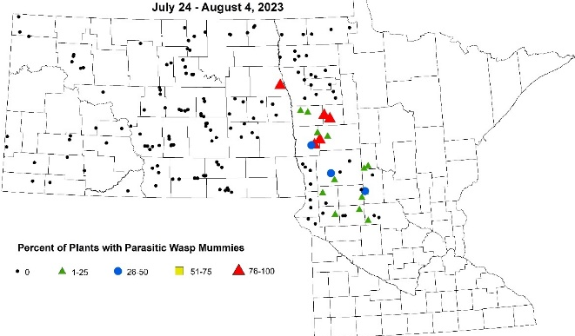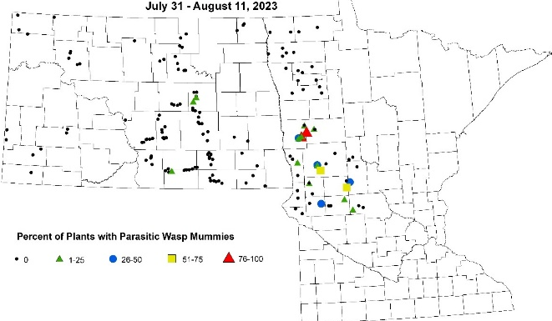
Figure 6. Percentage of plants with soybean aphids (Aphis glycines) that were colonized by parasitic wasps over two-week periods from June 26 through August 11, 2023; Maps: NDSU IPM.
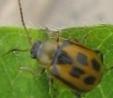
Bean leaf beetle. Scouts used a sweep net to estimate bean leaf beetle (BLB) population densities and examined soybean leaves to estimate feeding injury. Fewer than 11 BLB were sound in one field before mid-July (Figure 7). In general, BLB numbers were less than 51 in all but one location in MN.
However, UMN treatment thresholds are not based on BLB population density, but rather feeding injury plus continued presence of the beetles. Feeding injury as high as 20-29% defoliation was observed in a handful of fields, primarily in WC MN as early as mid-July and 30% or greater by the first week of August (Figure 8).
Treatment thresholds are reached before flowering when beetles are present and defoliation is 50% or greater; between flowering (R1) and pod fill (R6) with 20% defoliation, and one should treat aggressively if pod clipping is 10% or greater.

For more information about bean leaf beetle, visit: https://extension.umn.edu/soybean-pest-management/bean-leaf-beetles.
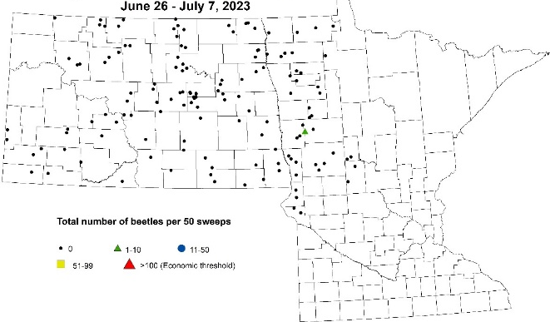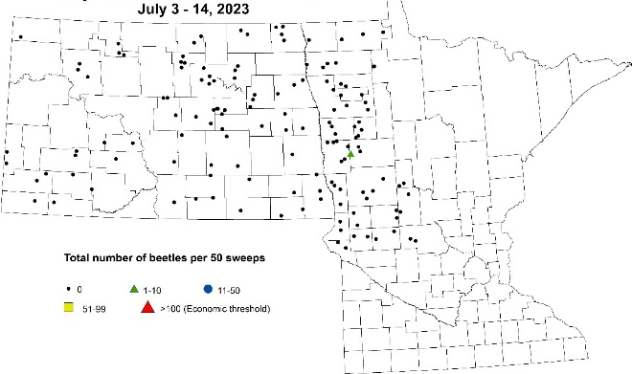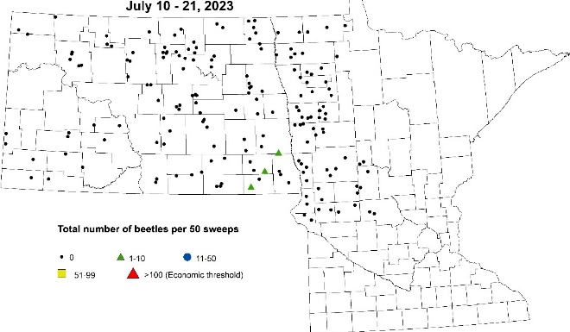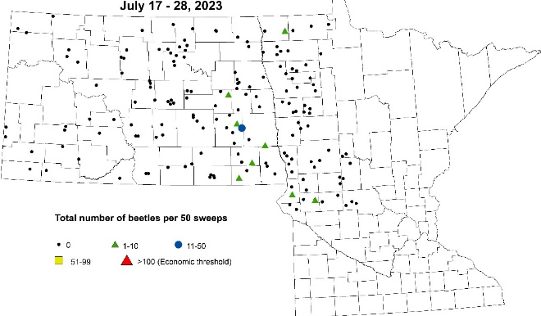
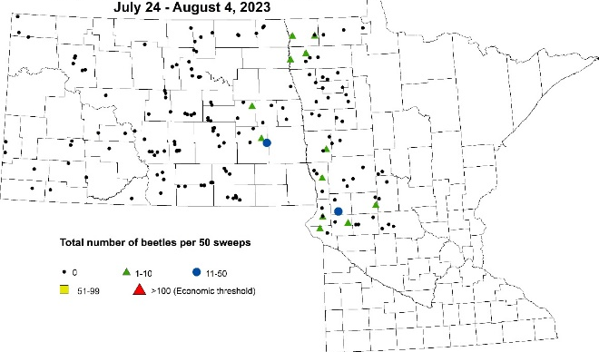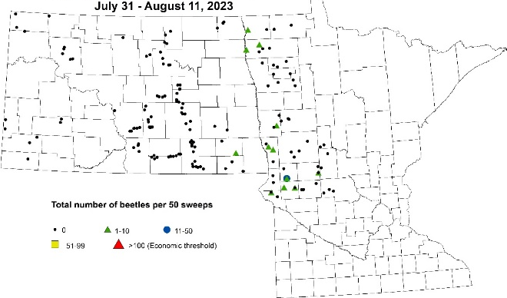 Figure 7. Number of bean leaf beetles (Cerotoma trifurcate) per 50 sweeps over two-week periods from June 26 to July 14, 2023; Map: NDSU IPM.

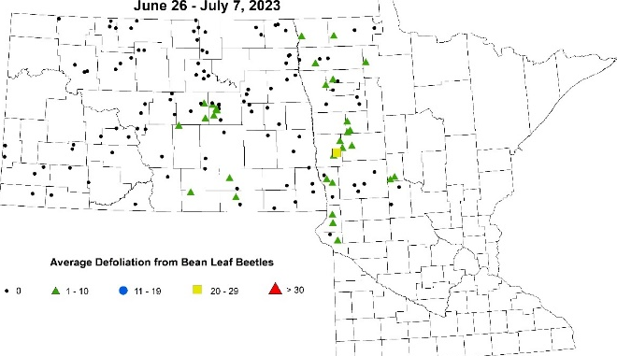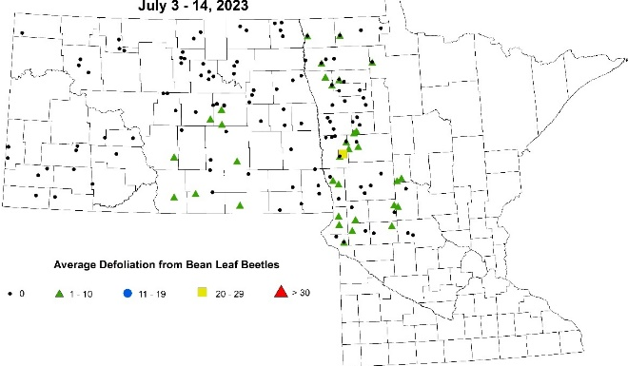
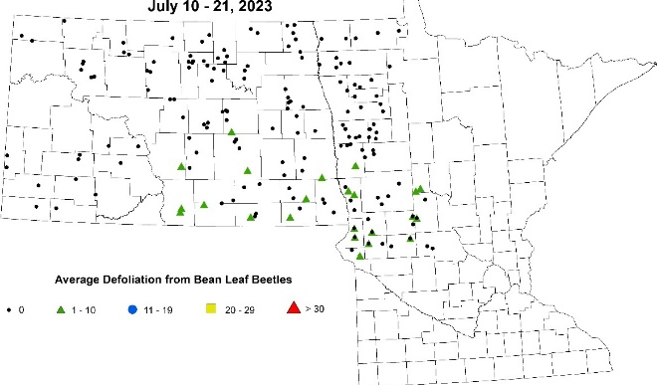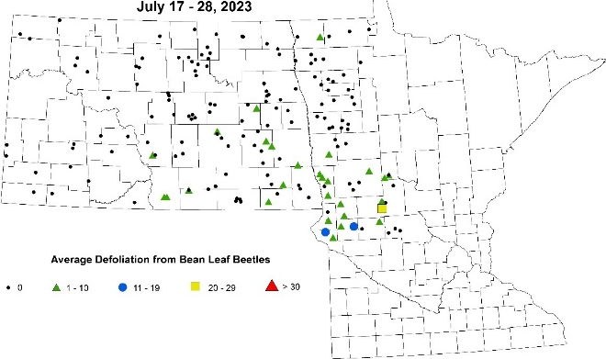 Figure 8. Average bean leaf beetle (Cerotoma trifurcate) defoliation injury over two-week periods from June 26 to August 11, 2023; continued on next page. Map: NDSU IPM.

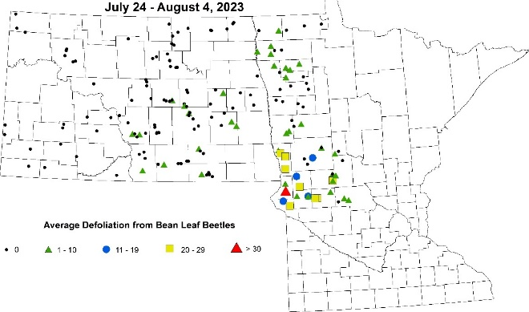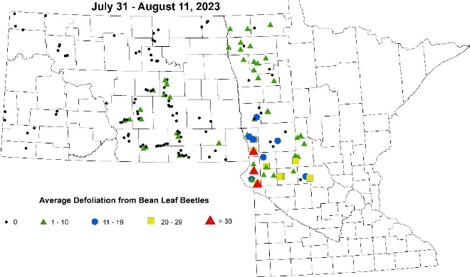 Figure 8. Continued from previous page. average bean leaf beetle (Cerotoma trifurcate) defoliation injury over two-week periods from July 10 to August 11, 2023; Map: NDSU IPM.

Two-spotted spider mites. Scouts evaluated the presence (red triangles) or absence (black dot) of two-spotted spider mites (TSSM) on field edges (Figure 9) and inside fields (Figure 10). TSSM can first often be observed feeding on perennial plants outside of fields where they survive the winter. were present on the outside of scouted fields by mid-July in Clay and Todd County fields, with these infestations becoming more common in the WC counties as the scouting season progressed (Fig. 9).
As the quality of the perennial plants outside the field declines due to water stress, TSSM can begin to move into the field, using webbing to ‘balloon’ into the soybean field starting from field edges and progressing further into the field over time. Comparing the maps in Figures 9 and 10 from each time period, this progression is evident. Eventually, TSSM made their way into many of the soybean fields in Clay and Becker Counties and WC MN (Fig. 10).
Stippling is feeding injury caused by TSSM that results when mites suck all of the contents (including green chlorophyll) out of individual cells. The treatment threshold (heavy stippling on lower leaves with some stippling progressing into the middle canopy with scattered colonies in the upper canopy; yellowing of lower leaves common and some lower leaf loss) was reached in 22 scouted fields in 2023.

For more information about TSSM, visit:
https://extension.umn.edu/soybean-pest-management/managing-spider-mite-soybean.

For more information about managing the crop when both TSSM and soybean aphid are present, visit:
https://blog-crop-news.extension.umn.edu/2023/07/management-of-soybean-aphids-and.html.

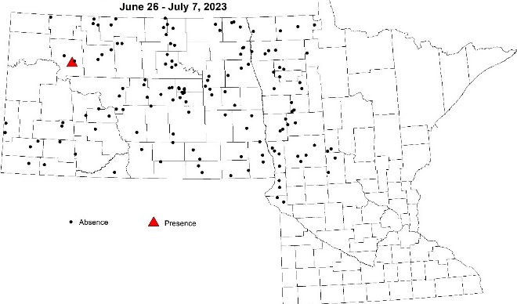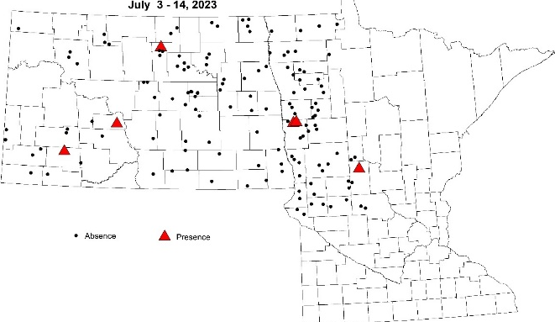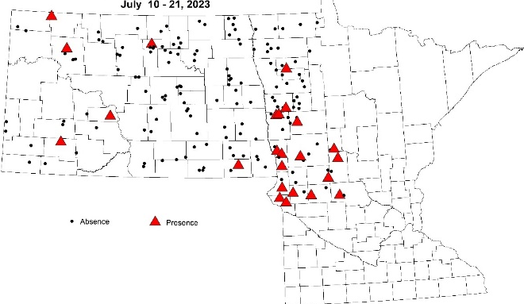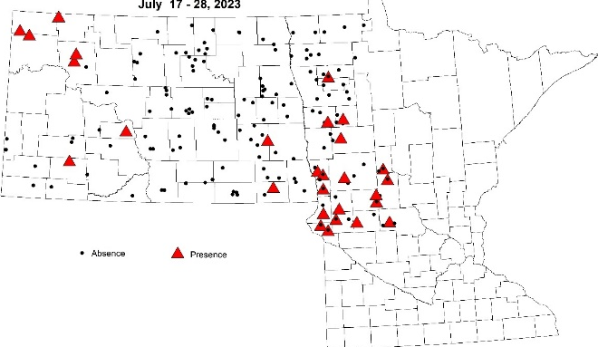

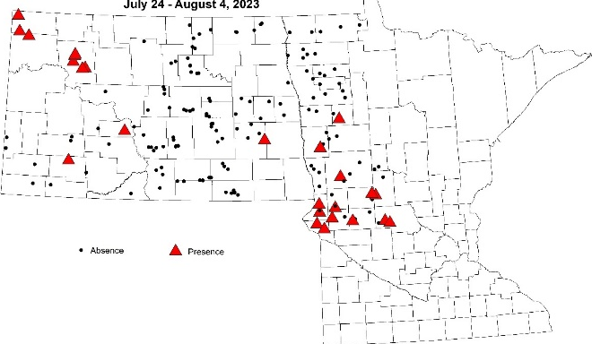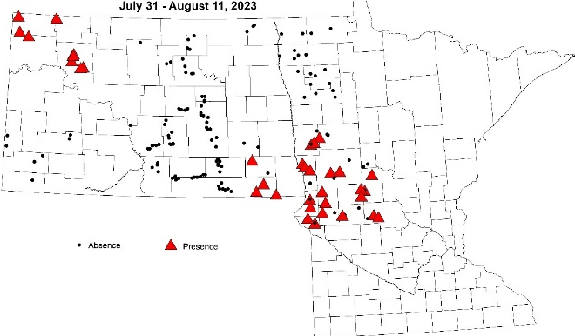 Figure 9. Presence of two-spotted spider mites (Tetranychus urticae) on edge of field (red triangle) over two-week periods from June 26 to August 11, 2023; Map: NDSU IPM.

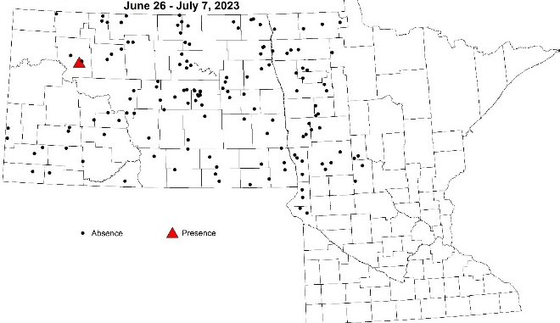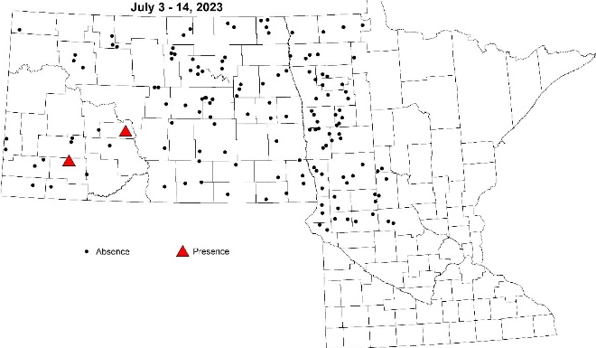

Figure 10. Presence of two-spotted spider mites (Tetranychus urticae) inside field (red triangle) over two-week periods from June 26 to August 11, 2023; continued on next page. Map: NDSU IPM.
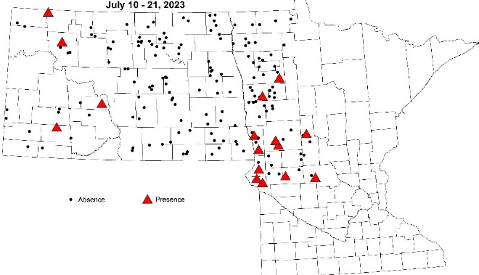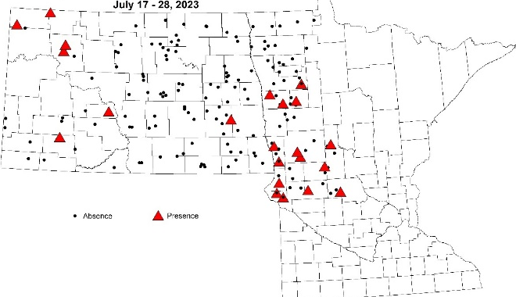
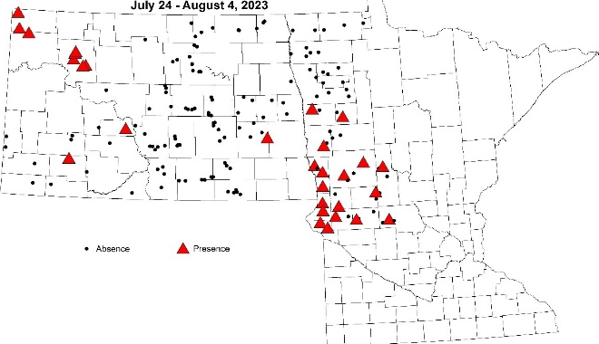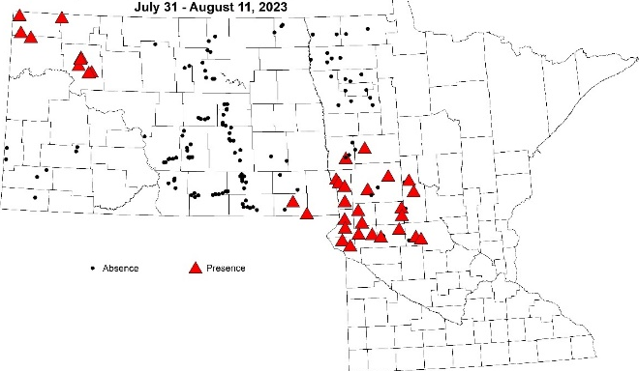
Figure 10. Continued from previous page. Presence of two-spotted spider mites (Tetranychus urticae) inside field (red triangle) over two-week periods from June 26 to August 11, 2023; Map: NDSU IPM.
Soybean gall midge. Scouts checked soybeans along the edge of fields for presence (red triangles) or absence (black dots) of soybean gall midge (SGM), a pest found for the first time in southwest Minnesota, in Rock County in 2018. As adults, SGM is a tiny fly incapable of flying long distances and so infestations of vegetative plants by SGM larvae are typically located on the field edge closest to an infested soybean field the previous year. While the surveyed fields extended south to include Big Stone (infested in 2019), Stevens and Pope (infested in 2021) and Stearns County, it is not known why no infested fields were observed in 2023 (Figure 11).
For more information about soybean gall midge, visit:
https://extension.umn.edu/soybean-pest-management/soybean-gall-midge-minnesota-soybean.

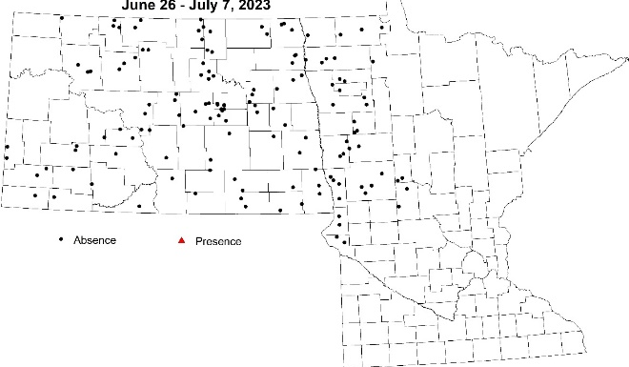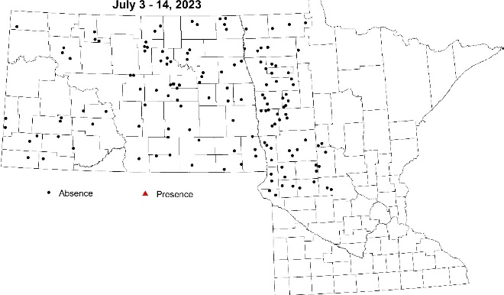

Figure 11. Soybean gall midge (Resseliella maxima) presence (red triangle) and absence (black dots) in scouted soybean fields from June 26-August 11, 2023; continued on next page. Map: NDSU IPM.
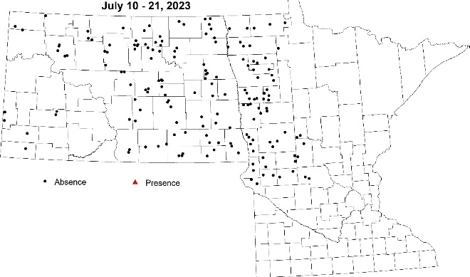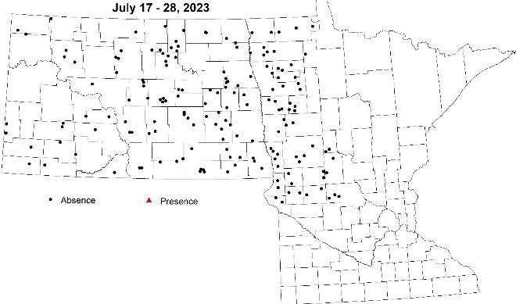
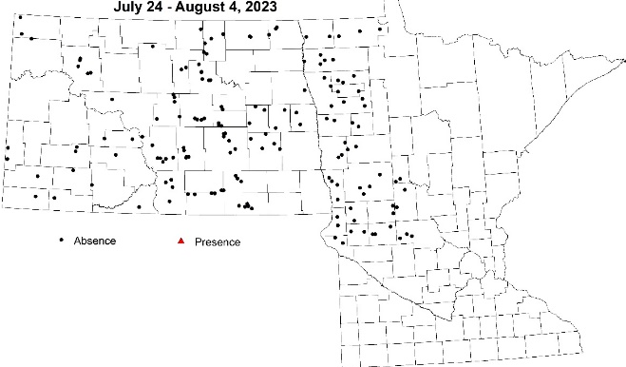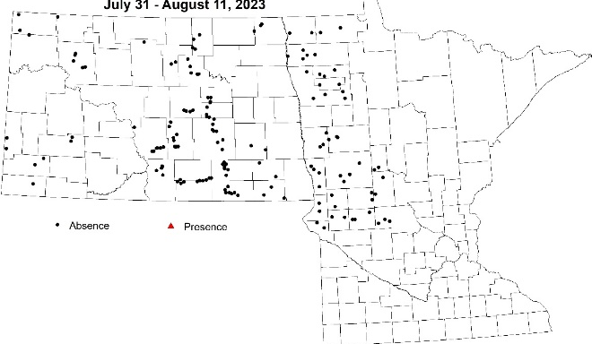
Figure 11. Continued from previous page. Soybean gall midge (Resseliella maxima) presence (red triangle) and absence (black dots) in scouted soybean fields from June 26-August 11, 2023. Map: NDSU IPM.

Soybean tentiform leafminer. While native to North America and a pest of two legumes, American hogpeanut and slickseed fuzzybean, soybean tentiform leafminer (STL) was found for the first time in the US, feeding on soybean leaves in southeast Minnesota. Photo: STL mines 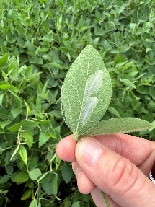
Mined leaf tissue can reduce the leaf’s photosynthetic area and if enough leaf area is affected (similar to injury caused by defoliating insects), yield loss will occur.
Scouts looked for mines on the underside of soybean leaves of plants on the edge of fields. If the field had a wooded area adjacent to it, the soybeans closest to the wooded area were examined first. Only one surveyed field, in Douglas County, was infested with STL (Figure 12). A scouting tour that occurred on August 24 in NW MN revealed two additional fields infested with STL, one in eastern and one in western Marshall County. STL was also found in four fields in two counties in North Dakota, the first finds in this state. These authors suspect that the ‘footprint’ of STL is likely much larger in MN.

For more information about soybean tentiform leafminer, visit:
https://extension.umn.edu/soybean-pest-management/soybean-tentiform-leafminer-minnesota-soybean.

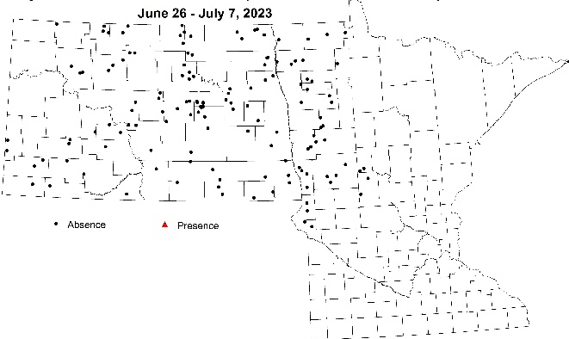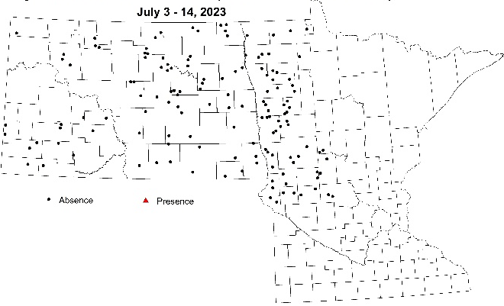
Figure 12. Soybean tentiform leafminer (Macrosaccus morrisella) presence (red triangle) and absence (black dots) in scouted soybean fields from June 26-August 11, 2023; continued on next page. Map: NDSU IPM.

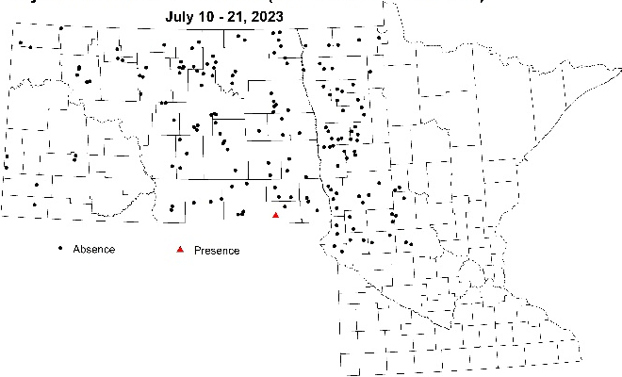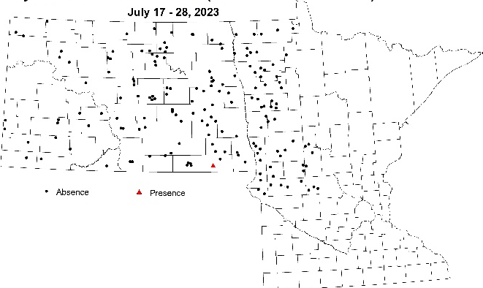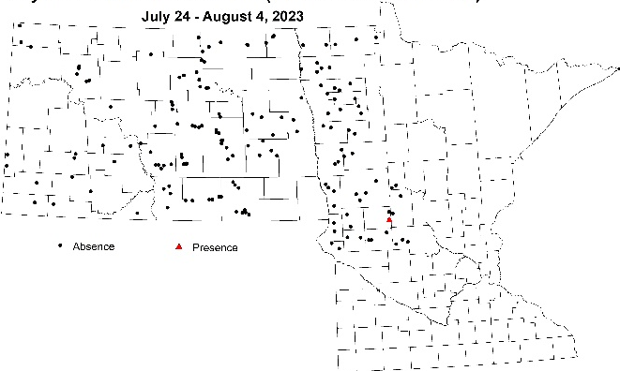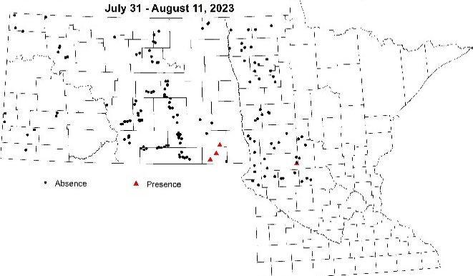

Figure 12. Continued from previous page. Soybean tentiform leafminer (Macrosaccus morrisella) presence (red triangle) and absence (black dots) in scouted soybean fields from June 26-August 11, 2023; Map: NDSU IPM.

Application/Use: The MSRPC-sponsored western IPM survey is essential to feed valuable pest incidence and severity information to UMN Extension specialists and regional educators (such as these authors) alike. This information is then used to provide timely research-based information regarding pest ID, scouting strategy, treatment thresholds and management through existing means dissemination. Local and regional radio interviews, digital and email newsletter articles shared on social media, press releases distributed state-wide and webinars were all used during the 2023 growing season to share information gathered through this survey.

Economic Benefit to a Typical 500 Acre Soybean Enterprise: The dry conditions that prevailed throughout much of western MN throughout 2023 meant that in addition to the resurgence of soybean aphid, two-spotted spider mites could also be present in soybean fields. The additional presence of defoliating insects (grasshopper nymphs and adults and green cloverworm) and insecticide-resistant pest populations can complicate decisions regarding treatment thresholds and which pesticide active ingredients to use.
Example 1: When defoliation in the lower, middle and upper canopy by green cloverworm or grasshoppers reached 30% before flowering or 20% during reproductive growth stages, knowing that there is also a soybean aphid infestation nearing the treatment threshold is essential information. As there does not seem to be a fitness cost to maintaining resistance to pyrethroid insecticides in soybean aphid, soybean aphids encountered in Minnesota is likely to resistant to pyrethroid insecticides. While pyrethroid a.i.’s (such as bifenthrin) might have been a farmer’s preferred class of insectides to use to manage green cloverworms, another insecticide application with an a.i. from another insecticide class may be needed in the very near term (chemical, your time and application costs) as soybean aphid would not have been managed. This could be a costly error indeed.
Example 2: When soybean aphid is nearing the treatment threshold, a farmer is aware that there is very likely to be resistance to pyrethroids in the aphid population. So armed with this knowledge, the farmer decides to use a mixture of active ingredients, including bifenthrin (lambda-cyhalothrin) and thiamethoxam (a neonicotinoid) (ex. Endigo ZC), thinking that while the lambda-cyhalothrin a.i. won’t work on the aphids, the neonic a.i. will. Unfortunately, this would have been a mistake for a couple of reasons: 1) there was also a spider mite infestation in the field and lambda-cyhalothrin tends to flare spider mite infestations and 2) from a resistance management standpoint, a lower rate of a single effective (against soybean aphid) active ingredient puts tremendous selection pressure on the soybean aphid population to select out those individuals capable of surviving now two different classes of insecticides.
In addition to sharing information about how having multiple pests colonize a single soybean crop through the means detailed on the previous page, these authors answered numerous questions of individual soybean producer and crop advisor about thresholds and treatment options.

Related Research: The 2023 soybean IPM scouts began the summer scouting wheat fields in western MN in a complementary survey. Look elsewhere in this booklet for a summary of the Minnesota Wheat Research & Promotion Council-sponsored Small Grains IPM survey.

Recommended Future Research: Next year, with funding from the Minnesota Invasive Terrestrial Plants and Pests Center, a STL-specific scouting tour will help to more granularly determine the range of this new and potentially yield-limiting pest.

Thank you: The authors would like to thank the 2023 IPM scouts, Amelia Lansdverk and Katie Olson for their hard work on behalf of western MN soybean producers. The NDSU IPM Crop Survey is supported by the Crop Protection and Pest Management Program - Extension Implementation Program, award number 2021-70006-35330 from the USDA National Institute of Food and Agriculture and is coordinated by Dr. Janet Knodel and Patrick Beauzay of NDSU Extension Entomology.

Outreach:
Prairie Grains Conference – Soybean Research Reporting session. Grand Forks, ND, Dec. 14, 2023. (~60 attendees)

Summaries of this study were included in the On-farm Research Trials Booklet distributed at winter meetings including the On-farm Research Summit that precedes the Prairie Grains Conferences and all of the Small Grains Update Meetings held in January 2024. Typically, approximately 810 are printed and distributed.

Marshall County Soybean & Corn Growers Association Annual Mtng., Warren, MN, Dec. 5, 2023 (~20 attendees).

Fact sheet on ID and Management of Foliage Feeding Caterpillars was distributed at commercial and private pesticide recertification workshops, Small Grains Updates, and other meetings.
    - McIntosh, MN, private PAT workshop, Jan. 16, 2024, 33 attendees
    - Ada, MN, private PAT workshop, Jan. 17, 2024, 36 attendees
    - Comstock, MN, private PAT workshop, Jan. 19, 2024, ~25 attendees
    - Crookston, MN, commercial/non-commercial PAT workshop, Jan. 30, 2024, 22 attendees
    - Roseau, MN, private PAT workshop, Feb 1, 2024, 28 attendees
    - Crookston, MN, private PAT workshop, Feb. 2, 2024, 27 attendees
    - Thief River Falls, MN, private PAT workshop, Feb.16, 2024, 40 attendees

Small Grains Update Meetings – (~300 attendees)
- Dilworth, MN, Jan. 9, 2024
- Ada, MN, Jan. 10, 2024
- Crookston, MN, Jan. 10, 2024
- Hallock, MN, Jan. 10, 2024
- Roseau, MN, Jan. 10, 2024
- St. Hilaire, MN, Jan. 11, 2024

