Title: Improving our ability to detect, predict, and manage soybean sudden death syndrome in Kansas

Rodrigo B. Onofre (PI), Department of Plant Pathology Department, 785-477-0171, onofre@ksu.edu
Christopher Little (Co-PI), Plant Pathology Department, 785-532-6176, crlittle@ksu.edu
Erick De Wolf (Co-PI), Plant Pathology Department, 785-532-3968, dewolf1@ksu.edu
James Stack (Co-PI), Plant Pathology Department, 785-532-1388, jstack@ksu.edu

OBJECTIVES
Objective 1: Evaluate the influence of agronomic practices on soybean sudden death syndrome (SDS) through on-farm trials evaluating row spacing, plant population, and variety selection.

In year one of this project, field trials were established in Rossville and Topeka in Kansas and one location in Iowa.

Madison Kessler, the MS student working on this project, presented preliminary results at the 2024 American Phytopathological Society North Central Meeting. Madison’s poster won first place in the competition. The meeting was held in Manhattan, KS from 10-12 June 2024. Please see attached file “Objective 1_Onofre” for preliminary results.

Objective 2: Develop a sudden death syndrome prediction tool for predicting disease prior planting.

Madison Kessler presented preliminary results at the 13th International Epidemiology Workshop. The meeting took place in Foz do Iguaçu, Brazil from 9-12 April 2024. Please see attached file “Objective 2_Onofre” for preliminary results.

Objective 3: Evaluate genetic diversity of Fusarium spp. from soybeans causing SDS in Kansas.

Madison Kessler together with Luiza Adami presented preliminary results at the 2024 American Phytopathological Society North Central Meeting. The meeting was held in Manhattan, KS from 10-12 June 2024. Please see attached file “Objective 3_Onofre” for preliminary results.

During the 2022 season, symptomatic plants were sampled from 13 fields across five counties in Kansas (Fig. 1) resulting in 128 Fusarium spp. being isolated. Genetic analysis using PCR and sequencing of the translation elongation factor-1α (EF-1α) gene was conducted for all isolates. Additionally, isolates identified as part of the FSSC clade 2 were further sequenced for the nuclear rDNA intergenic spacer (IGS) region. Phylogenetic trees were constructed using the Maximum Likelihood method with bootstrap support from1000 replicates. Of the 128 isolates, 113 isolates were confirmed F. virguliforme. Of the remaining isolates six were identified as FSSC clade 5, one as FSS Cclade 3, two as FFSC, two as FOSC, and four as undescribed Fusarium spp. These data suggest that in the fields sampled, F. virguliforme is likely the dominant species causing SDS in Kansas.

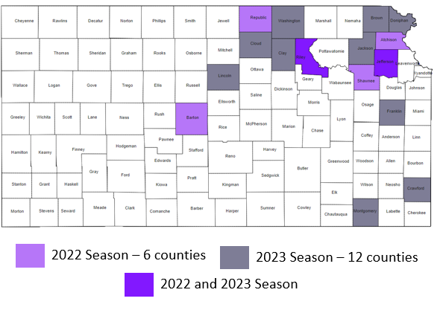
Figure 1. Kansas counties where soybean sudden death syndrome symptomatic plants were collected during the 2022 and 2023 seasons.

Objective 4: Validate a rapid diagnostic tool for SDS based on loop-mediated isothermal amplification (LAMP).

The specificity tests were performed using 22 isolates kindly sent by Dr. Martin Chilvers (Michigan State University). Those isolates include all four species that cause Sudden Death Syndrome (SDS), plus other species that could be found in a soybean field and other Fusarium Species Complex representatives. Each sample in each replicate was performed in duplicate. We noticed that the p6 set of primer is amplifying all SDS pathogens species, however, the Fusarium phaseoli, F. cuneirostrum, and F. azukicola are also amplifying. This means that the primers is not specific for F. virguliforme and for SDS pathogens. New primers are currently being re-designed and will be included in upcoming tests.

Objective 5: Generate and promote data-driven best management practices based on results of objectives 1, 2 and 3.

Through a dynamic extension programming, objectives 1, 2, and 3 were shared during multiple occasions with Kansas Soybean Producers which included on-farm field days and winter meetings, radio and local TV interviews, YouTube, social media, and the K-State Agronomy eUpdate.

