Enhancing Profitability of Soybean Production and Soil Health through Livestock Integration
Joshua Wianecki¹, Miranda Meehan¹, Lindsay Chamberlain Malone², Zachary Carlson¹, Kevin Sedivec^{2,3}, Colin Tobin⁴, Michael Ostlie⁴
¹Department of Animal Sciences, North Dakota State University, Fargo ND. ²School of Natural Resource Sciences, North Dakota State University, Fargo ND. ³Central Grasslands Research Extension Center, Streeter ND. ⁴Carrington Research Extension Center, Carrington ND.

Background
With cover crop utilization continuing to expand throughout North Dakota, increasing 107% from 2017 to 2022, now totaling 838,252 acres under cover crop management, producers may be interested in strategies that generate revenue while maintaining the soil health benefits of cover cropping (USDA NASS, 2024). Cover crops have been shown to increase soil health through erosion resistance, increased organic matter, and increased water infiltration, as well as reduced nutrient loss and reduced weed pressure (Moore et al., 2014; Basche et al., 2016; Chen et al., 2022). In row crop systems within the Northern Great Plains, cover crops are often planted for these soil health benefits, with herbage produced in the fall and spring potentially being unutilized as forage for livestock.
Integrating livestock into cover crop systems through grazing utilizes forage, extending the grazing season and reducing feed costs, while maintaining soil health benefits of cover crop practices (Franzluebbers and Stuedemann, 2007; Blanco-Canqui et al., 2020). Forage produced by cover crops is often high in nutritional quality at a time when perennial grazing systems are either low in quality or not ready for grazing. Grazing cover crops during these periods can reduce grazing pressure on perennial grazing systems. Grazing cover crops has demonstrated enhanced soil biological activity and nutrient cycling as well as increased soil aggregate stability (Liebig et al., 2012; Assmann et al., 2014; Simon et al., 2021). Total effects of livestock integration is greatly dependent on both grazing and cropping management. Archer et al. (2020) found integrating grazing into wheat – pea – corn rotations had no effect cash crop yield while wheat – pea rotations saw statistically significant reductions in yield following grazing. Morris et al. (1998) demonstrated both grazing season and tillage practices significantly affect bulk density, with spring grazing treatments experiencing significantly higher bulk density compared to summer grazed treatments.
While crop and livestock management has been shown to affect integrated crop livestock system effects on soils, literature describing the effects of grazing cover crops directly prior to row crop production is minimal. Shortened growing seasons and variability of climate within the Northern Great Plains create potential challenges with livestock integration that may not occur within other regions of the United States. The objective of this study is to investigate the impacts of livestock integration within soybean production systems on soil health, crop productivity, and animal performance.
Materials and Methods
Two locations at the Central Grasslands Research Extension Center (CGREC) and Carrington Research Extension Center (CREC) were selected for this 2-year study. Each field was divided into nine paddocks and randomly assigned one of four treatments: dual season (fall and spring) grazing (DG), spring grazing (SG), no grazing (NG) or no winter rye cover crop (NR). The NG plots were split to include a NR subplot.
Winter rye was seeded via no-till drill following the harvest of the previous small grain crop on 9/08/2022 at both location; following soybean harvest on 10/20/2024 at CGREC and 11/16/2024 at CREC. Forage production was evaluated prior to and post-grazing by clipping all live rye within six 0.25m² quadrats randomly placed within each paddock. Absolute ground cover was assessed during clipping by determining the percentage of bare ground, live rye, residue, and weed species within each quadrat. Forage biomass was estimated to determine grazing period duration. Post-graze biomass clippings were also used to assess forage utilization of the grazing treatments. Forage samples were dried, ground, and sent to the NDSU Nutrition Lab for quality analysis of crude protein (CP), neutral detergent fiber (NDF), acid detergent fiber (ADF), and in vitro dry matter digestibility (IVDMD).
Grazing period duration was determined through estimated forage production as well as daily visual pasture inspection. Stocking rates were adjusted for the available forage at each location. In fall of 2022, each DG plot was grazed by four cows averaging approximately 990 lbs grazed at CGREC and five cows averaging approximately 1200 lbs at CREC. In spring of 2023 each DG and SG plot was grazed nine yearling heifers averaging 690 lbs at CGREC and six yearling heifers averaging 1040 lbs at CREC. Due to inadequate winter rye biomass, grazing was deferred at both locations in fall of 2023. In spring of 2024, each DG and SG treatment was grazed by seven heifers averaging approximately 745 lbs at CGREC. Grazing was deferred at CREC in 2024 due to challenges applying grazing treatments. A control group of cattle were retained in confinement and fed a diet formulated to maintain approximately 1.5lb day⁻¹ rate of gain during each grazing period excluding fall 2022. Livestock performance was evaluated through average daily gain (ADG) and body condition score (BCS) pre- and post-grazing. Cattle were weighed following a five-day restricted feed period across two consecutive days, and weights were averaged. Body condition score was recorded by two independent assessors and averaged.
Soil samples were collected post-grazing. Soil chemical analysis included total nitrogen (TN), nitrate (NO₃⁻), phosphorous (P), potassium (K), soil organic matter (OM), total carbon (TC) and total organic carbon (TOC). All soil chemical properties were collected at depths of 0-15 cm and 15-30 cm with a 1.9 cm x 38 cm probe. Eight cores were collected per plot, composited, and sent to AgVise Laboratories for analysis. Soil physical analysis included bulk density and aggregate stability. Bulk density samples were collected with a 5cm slide hammer corer at depths of 0-3 cm and 5-8 cm. Bulk density samples were dried and weighed for each core depth. Aggregate stability was collected by soil slice at 15 cm and sent to AgVise Laboratories for analysis via sand-corrected wet slaking. Soil biological properties were evaluated by soil microbial biomass carbon (SMBC) and fungi hyphal count using visual gridline intercept method. Cores were collected at a depth of 15 cm with a 1.9 cm x 38 cm probe and composited. Samples were frozen at -20°C until analyzed.
Following grazing, the winter rye was chemically terminated with glyphosate. Cash crops were no-till seeded following winter rye termination. Soybeans were seeded on 6/07/2023 at CGREC and 6/09/204 at CREC, and silage corn was seeded on 5/23/2024 at CGREC. Soybean production was evaluated through stand counts and yield data. Soybean stand counts were performed in mid-July 2023. Live soybeans were counted within a 1.5m section of a randomly selected row. Average growth stage was noted within each stand. Soybean growth stages were determined by the number of trifoliate leaves on each plant. Soybeans were harvested by plot harvester with calibrated yield monitor. Three 100 feet by 4 row sections were randomly selected within each plot and harvested.
As cattle were withheld from grazing at CREC in spring 2024 due to challenges apply cattle to grazing treatments. Due to lack of grazing in 2024 at CREC, this report has excluded data from CREC.
All statistical differences were determined by analysis of variance (ANOVA) within R v4.3.2 using the aov() function. Comparison of means utilized Tukey’s HSD using the emmeans() package (Lenth, 2024). Significance was determined at P ≤ 0.05.
Results
The inclusion of winter rye decreased the number of trifoliate leaves at time of soybean staging with NR having a greater (P ≤ 0.05) number of trifoliate leaves. There were no significant differences in maturity between SG, DG, or NG. While soybean maturity was affected, no effect (P > 0.05) was observed on soybean yield with 14.0 bushels ac⁻¹ in SG, 16.5 bushels ac⁻¹ in DG, 14.0 bushels ac⁻¹ in NG and bushels ac⁻¹ in NR.
Pre-grazing estimated forage biomass production (Table 2) in spring 2024 were not significantly different (p > 0.05) with 136 lbs ac⁻¹ in SG, 104 lbs ac⁻¹ in DG, and 103 lbs ac⁻¹ in NG. Post-grazing estimated remaining standing forage biomass (Table 3) did not statistically differ between grazing treatments but was expectedly lower (P ≤ 0.05) than NG with 198 lbs ac⁻¹ in SG, 119 lbs ac⁻¹ in DG, and 339 lbs ac⁻¹ in DG.
Table 1. Pre-grazing estimated forage biomass and absolute ground cover at Central Grasslands Research Extension Center - Spring 2024
Treatment | Forage Biomass  kg/ha |  | Percent  Live Rye Cover |  |  | Percent  Bare ground |  |  | Percent  Residue Cover |  |  | Percent  Weed Cover
DG | 104 |  | 23ª |  |  | 41ª |  |  | 16ª |  |  | 41^{a,b}
SG | 136 |  | 22ª |  |  | 47ª |  |  | 24^{a,b} |  |  | 21ª
NG | 103 |  | 22ª |  |  | 38ª |  |  | 42^{b} |  |  | 13ª
NR | -- |  | 0^{b} |  |  | 13^{b} |  |  | 43^{b} |  |  | 54^{b}
^{a,b,c}Means not connected by same letters are significantly different (P ≤ 0.05)

Table 2. Post-grazing estimated forage biomass and absolute ground cover at Central Grasslands Research Extension Center - Spring 2024
Treatment | Forage Biomass  kg/ha |  |  | Percent  Live Rye Cover |  |  | Percent  Bare ground |  |  | Percent  Residue Cover |  |  | Percent  Weed Cover
DG |  | 133ª |  |  | 11ª |  |  | 45^{a,b} |  |  | 17ª |  |  | 38ª
SG |  | 222ª |  |  | 19^{b} |  |  | 64ª |  |  | 15ª |  |  | 13^{b}
NG |  | 379^{b} |  |  | 27^{c} |  |  | 29^{b,c} |  |  | 46^{b} |  |  | 11^{b}
NR |  | -- |  |  | 0^{d} |  |  | 22^{c} |  |  | 26ª |  |  | 63^{c}
^{a,b,c}Means not connected by same letters are significantly different (P ≤ 0.05)

Pre-grazing rye cover (Table 2) did not differ (p > 0.05) between SG, DG, or NG. Pre-grazing residue in DG was significantly (P ≤ 0.05) lower than NG and NR. Weed cover pre-grazing was greater (P ≤ 0.05) in NR and DG than SG or NG. Bare ground cover was lowest within NR due to high weed establishment; while SG, DG, and NG did not differ in percent bare ground. Rye cover post-grazing (Table 3) was significantly (P ≤ 0.05) different between all treatments. Post-grazing residue cover was highest (p ≤ 0.05) in NG compared to all other treatments. Weed cover post-grazing was greatest (P ≤ 0.05) in NR, and significantly greater in DG than SG or NG. Bare ground cover was lowest within NR, however, did not differ with NG. Both SG and DG had significantly higher percent bare ground than NR, while only SG differed from NG.
Animal performance on pasture (Figure 1) did not differ (P > 0.05) within grazing treatments with loss of gain of -5.05 lbs day⁻¹ in DG and -5.54 lbs day⁻¹ in SG in the spring of 2024. Cattle within dry lot control pens experienced 0.92 lbs day⁻¹ gain during the grazing period. While animals displayed loss of gain during grazing, the short grazing period did not allow for acclimation of the diet which may have reduced short-term performance.
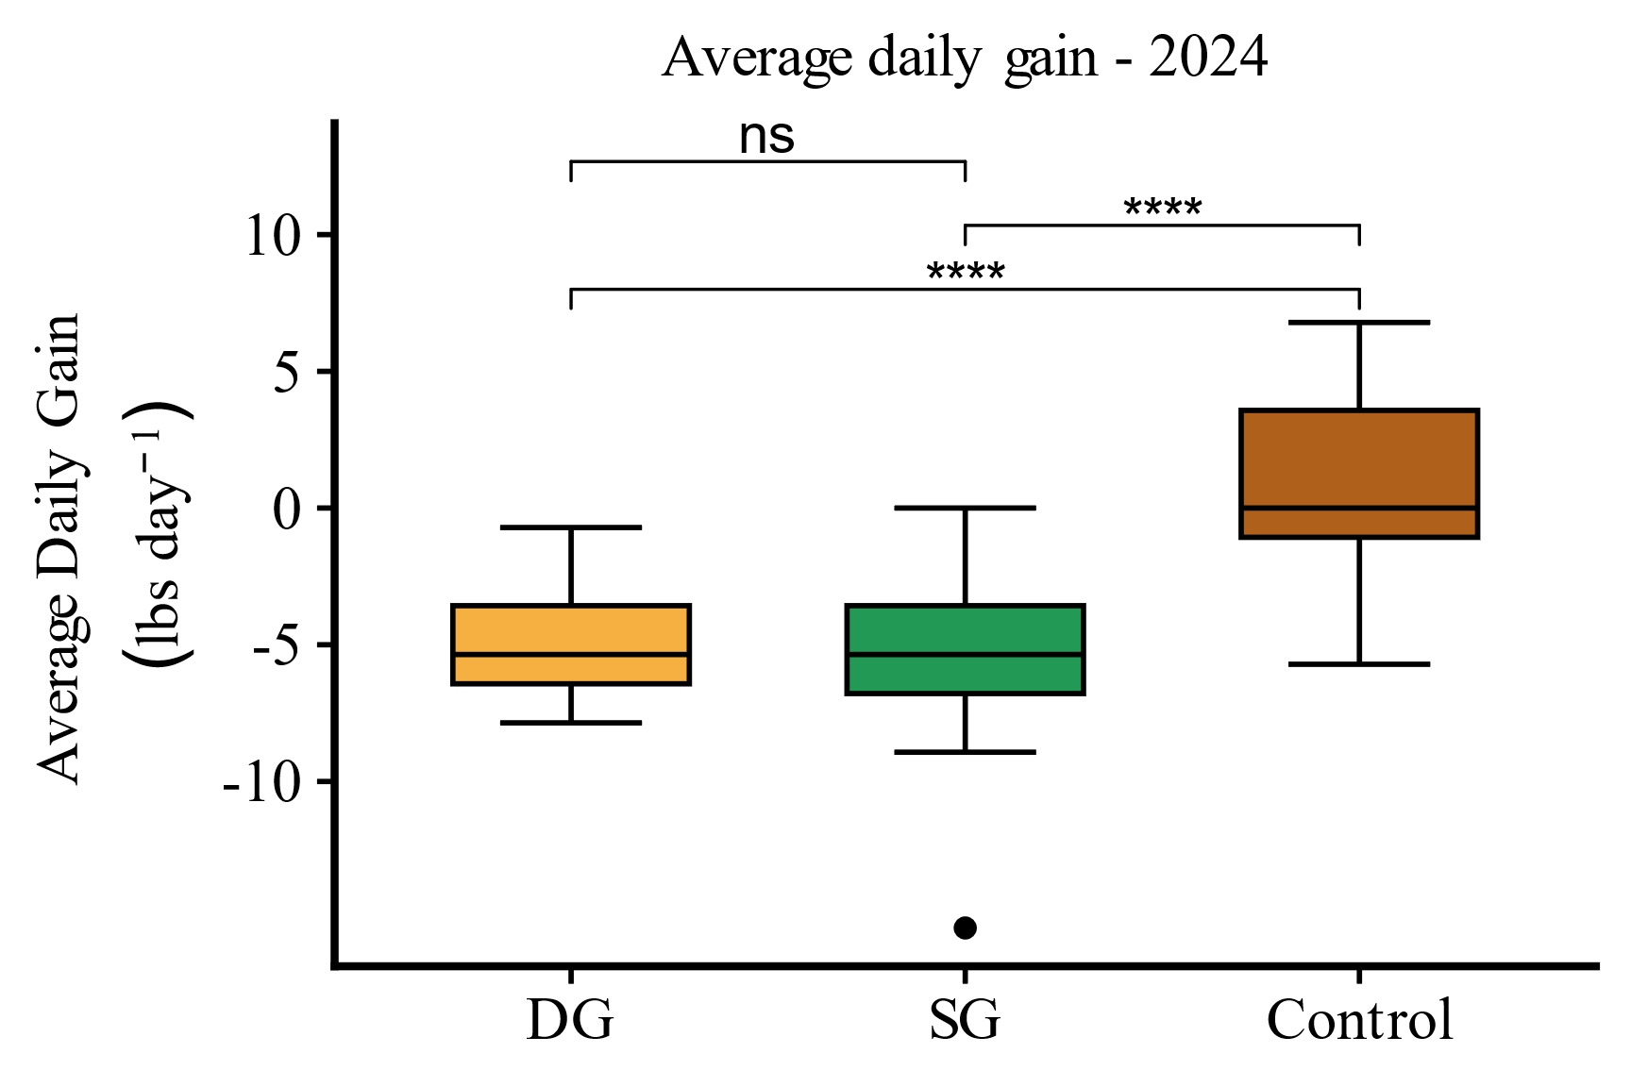
Figure 1. Average daily gain at Central Grasslands Research Extension Center during the spring 2024 grazing season. (ns = P > 0.05, **** = P < 0.0001)
Soil chemical properties (Table 4) including NO₃⁻, TN, K, OM, TC, and TOC did not differ at 0-15 cm or 15-30 cm depths following two years of grazing. Soil P was significantly (P ≤ 0.05) lower in NR than DG at 15-30 cm depth. Soil Olsen-P was 5 ppm in DG, 3.67 ppm in SG, 2.67 in NG, and 2 ppm in NR. Total wet stable aggregation (Figure 3) did not differ in either year, however, the macro aggregate fraction (250-2000 µm) was significantly higher in NG than NR in 2023. Near surface bulk density at 0-3 cm and 5-8 cm (Figure 4) only significantly differed (P ≤ 0.05) in SG and NR at 0-3 cm, however, no treatments experienced bulk density at levels that would negatively impact root development. Soil hyphae counts did not differ in 2023 (P > 0.05). Biological properties for 2024 are pending.
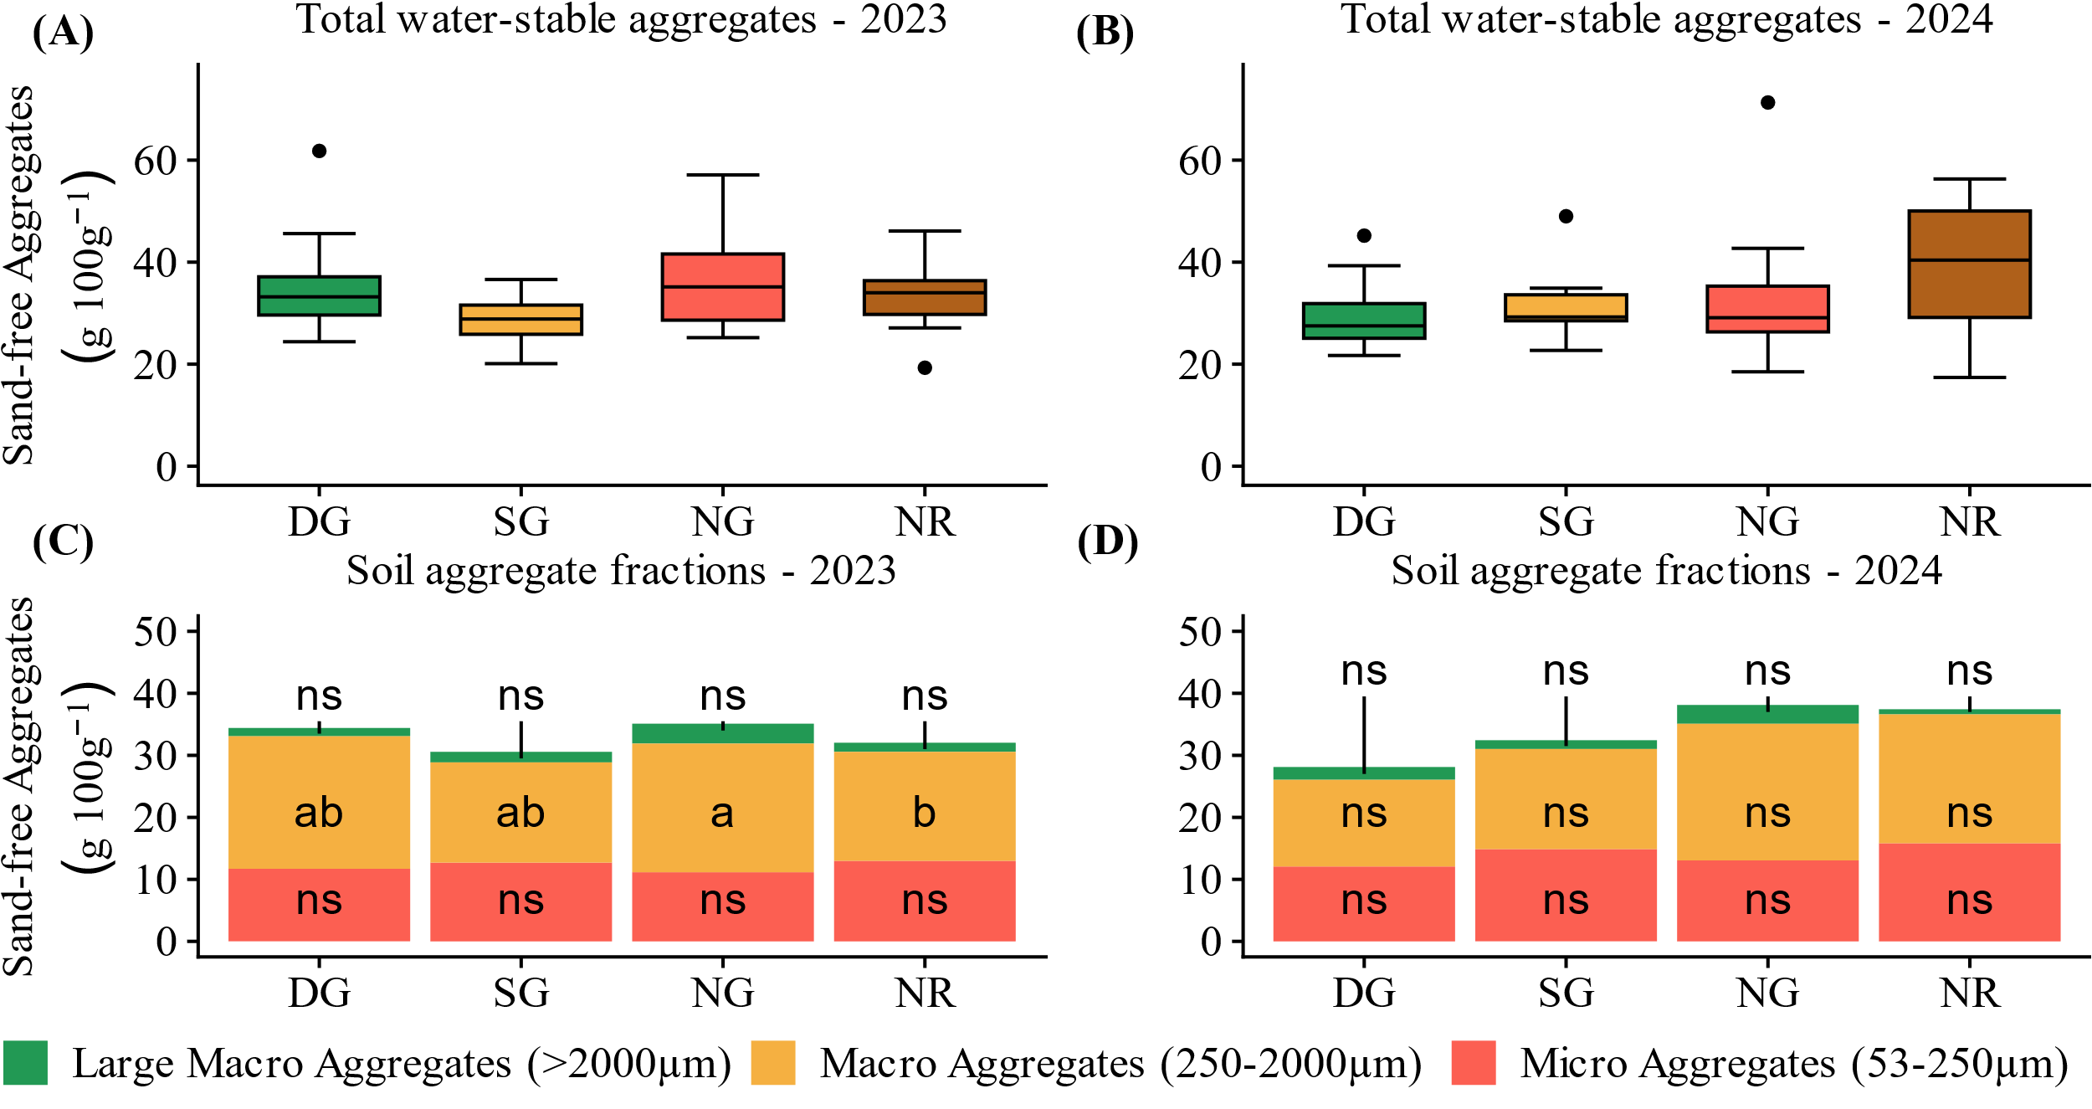
Figure 2. Total wet-stable soil aggregates and aggregate fractions at Central Grasslands Research Extension Center following grazing. (A) = Total water-stable aggregates 2003, (B) = Total water-stable aggregates 2024, (C) = Water-stable aggregate fractions 2023, (D) = Water-stable aggregate fractions 2024. Means not connected by same letter are significantly different (P ≤ 0.05)
Table 3. Soil chemical analyses at Central Grasslands Research Extension Center - Spring 2024
Treatment | Depth  (cm) | OM  (%) | pH | TN  (%) | NO₃⁻  (ppm) | P-Olsen  (ppm) | K  (ppm) | TC  (%) | TOC  (%)
DG | 0-15 | 4.23 | 6.87 | 0.23 | 7.00 | 12.67 | 129.33 | 2.30 | 2.27
DG | 15-30 | 3.37 | 7.20 | 0.16 | 3.83 | 5.00ª | 106.33 | 1.70 | 1.70
SG | 0-15 | 3.60 | 7.03 | 0.19 | 6.33 | 11.00 | 104.33 | 1.87 | 1.83
SG | 15-30 | 2.07 | 7.33 | 0.11 | 2.83 | 3.67^{ab} | 80.33 | 1.10 | 1.03
NG | 0-15 | 3.93 | 7.27 | 0.21 | 6.33 | 7.00 | 121.67 | 2.07 | 2.07
NG | 15-30 | 2.67 | 7.57 | 0.14 | 3.67 | 2.67^{ab} | 105.67 | 1.43 | 1.37
NR | 0-15 | 4.07 | 6.80 | 0.21 | 4.83 | 6.67 | 120.33 | 2.17 | 2.10
NR | 15-30 | 2.37 | 7.20 | 0.12 | 2.67 | 2^{b} | 97.67 | 1.27 | 1.20
^{a,b}Means not connected by same letter are significantly different within depth (P ≤ 0.05)
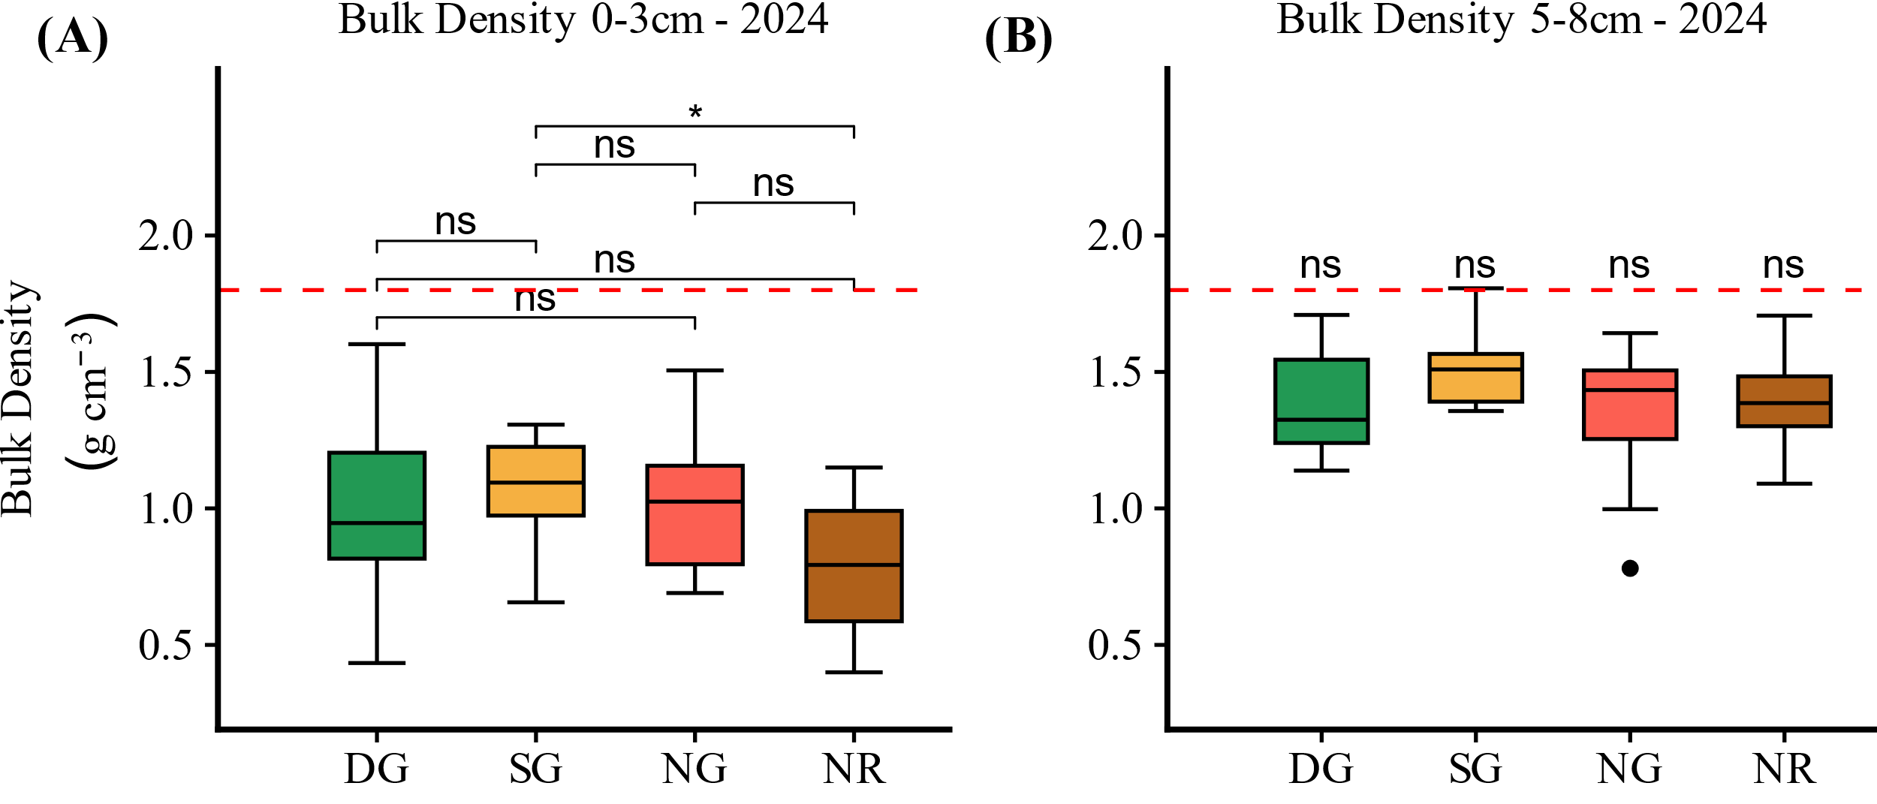
Figure 3. Soil bulk density at 0-3cm and 5-8cm depths at Central Grasslands Research Extension Center, spring 2024. Red line signifies bulk density of 1.8 g cm⁻³ threshold for inhibition of root development in sandy loam soils. (A) = 0-3 cm depth, (B) = 5-8 cm depth. (ns = P > 0.05, * = P ≤ 0.05)

Discussion
Delayed soybean harvest and subsequent winter rye seeding resulted in insufficient forage biomass for grazing in fall of 2023. Similarly, spring 2024 forage biomass was lower than anticipated and paired with cool temperatures and higher than average precipitation slowed winter rye growth, shortening the spring grazing period. While climatic factors have proven to make extended integrated livestock grazing challenging, cover crops provided up to 1.9 aum ha⁻¹ extending the grazing season and reducing early season pressure on developing grazing systems. While livestock experienced loss of gain in 2024, this can be attributed to the short grazing season, which did not allow animals to acclimate to change of diet. Livestock in 2023 grazed longer, resulting in greater rate of gain of 0.61lbs day⁻¹ due to the longer grazing period allowing acclimation to the diet.
Livestock integration did not result in negative effects to the soil health benefits of the cover crop. Notably, ground cover was not significantly affected by grazing. Near surface bulk density only significantly differed between SG and NR, potentially due to variability within soils across the field rather than livestock traffic. While statistically significant, SG bulk density was still below 1.8 g cm⁻³ which may impede root development of soybeans (Place et al., 2008). Soil aggregate stability was also unaffected by both grazing and cover crop practices. Literature demonstrates that both cover cropping and grazing can increase soil aggregate stability, but soil physical properties are slow to change and may require more time under these practices to experience changes (Simon et al., 2021; Bansal et al., 2022).
Soybean plants were significantly larger in NR than all other treatments at time of staging, likely due to low precipitation following cover crop termination limiting soil moisture and delaying germination. Grazing treatments were statistically larger than NG, which may have also been a function of available moisture, as grazed rye maintained lower biomass through the grazing period, reducing water uptake. Despite differences in plant size at staging, soybean yield did not differ across treatments. Rye residues within cover crop treatments may have aided in retaining soil moisture as well as provided nutrients throughout the growing season, creating comparable yields.
Benefits to Industry
Integrating livestock into row crop production had no negative effects on soybean yield or the soil health benefits of a cover crop. Previous literature has demonstrated integrated crop livestock systems have the capability to further enhance soil health and productivity over time, which may be captured under a long-term assessment of these practices. Additionally, cover crop biomass was utilized as a forage source for livestock, extending the grazing season and reducing feed costs. Early spring grazing of cover crops allows other pasture systems to develop, increasing flexibility and resiliency of livestock grazing. Integrated crop livestock systems offer producers management strategies that can enhance soil health while offsetting the investment of cover cropping through forage and livestock production.
Literature Cited
Archer, D.W., M.A. Liebig, and S.L. Kronberg. 2020. Dryland crop production and economic returns for crop residue harvest or grazing. Agron. J. 112(3): 1881–1894. doi: 10.1002/agj2.20100.
Assmann, T.S., M.A. de Bortolli, A.L. Assmann, A.B. Soares, C.S.R. Pitta, et al. 2014. Does cattle grazing of dual-purpose wheat accelerate the rate of stubble decomposition and nutrients released? Agric. Ecosyst. Environ. 190: 37–42. doi: 10.1016/j.agee.2014.01.011.
Bansal, S., P. Chakraborty, and S. Kumar. 2022. Crop–livestock integration enhanced soil aggregate-associated carbon and nitrogen, and phospholipid fatty acid. Sci. Rep. 12(1): 2781. doi: 10.1038/s41598-022-06560-6.
Basche, A.D., T.C. Kaspar, S.V. Archontoulis, D.B. Jaynes, T.J. Sauer, et al. 2016. Soil water improvements with the long-term use of a winter rye cover crop. Agric. Water Manag. 172: 40–50. doi: 10.1016/j.agwat.2016.04.006.
Blanco-Canqui, H., M.E. Drewnoski, J.C. MacDonald, D.D. Redfearn, J. Parsons, et al. 2020. Does cover crop grazing damage soils and reduce crop yields? Agrosystems Geosci. Environ. 3(1): e20102. doi: 10.1002/agg2.20102.
Chen, L., R.M. Rejesus, S. Aglasan, S.C. Hagen, and W. Salas. 2022. The impact of cover crops on soil erosion in the US Midwest. J. Environ. Manage. 324: 116168. doi: 10.1016/j.jenvman.2022.116168.
Franzluebbers, A.J., and J.A. Stuedemann. 2007. Crop and cattle responses to tillage systems for integrated crop–livestock production in the Southern Piedmont, USA. Renew. Agric. Food Syst. 22(3): 168–180. doi: 10.1017/S1742170507001706.
Liebig, M.A., D.L. Tanaka, S.L. Kronberg, E.J. Scholljegerdes, and J.F. Karn. 2012. Integrated crops and livestock in central North Dakota, USA: Agroecosystem management to buffer soil change. Renew. Agric. Food Syst. 27(2): 115–124. doi: 10.1017/S1742170511000172.
Moore, E. b., M. h. Wiedenhoeft, T. c. Kaspar, and C. a. Cambardella. 2014. Rye Cover Crop Effects on Soil Quality in No-Till Corn Silage–Soybean Cropping Systems. Soil Sci. Soc. Am. J. 78(3): 968–976. doi: 10.2136/sssaj2013.09.0401.
Morris, J.L., V.G. Allen, D.H. Vaughan, J.M. Luna, and M.A. Cochran. 1998. Establishment of Corn in Rotation with Alfalfa and Rye: Influence of Grazing, Tillage, and Herbicides. Agron. J. 90(6): 837–844. doi: 10.2134/agronj1998.00021962009000060020x.
Place, G., D. Bowman, M. Burton, and T. Rufty. 2008. Root penetration through a high bulk density soil layer: differential response of a crop and weed species. Plant Soil 307(1): 179–190. doi: 10.1007/s11104-008-9594-4.
Simon, L.M., A.K. Obour, J.D. Holman, S.K. Johnson, and K.L. Roozeboom. 2021. Forage productivity and soil properties in dual-purpose cover crop systems. Agron. J. 113(6): 5569–5583. doi: 10.1002/agj2.20877.
USDA-NASS 2024. 2022 Census of Agriculture – North Dakota data. p. 612. USDA-National Agriculture Statistics Service. Washington, D.C

