Project Title- Integrated agricultural systems to promote soil health and environmental resilience
This report summarizes the third year of research at the LAiYERS (Land mAnagement for improved Yield, Environmental Resilience, and Sustainability) plots, evaluating the impact of poultry manure and cover crop impacts on water quality, soil health, and crop yield. The 0.1 hectare (1/4 acre) plots were established in 2021 (Fig. 1), with subsurface tiles and drainage sampling wells installed in spring, and soybeans planted (June 30, 2021) after installation was complete. The first treatments were initiated in the fall of 2021 with cover crops planted to the designated plots (Systems 1, 3, 4, 6, 8) and the early winter and balanced poultry manure treatments applied (Systems 4, 5, 8, 9). The spring fertilizer and poultry manure treatments were applied in 2022 for the corn year of the rotation. The first manure treatments for the 2024 corn year were applied on November 15th, 2023 (early winter manure), and additional treatments will be applied in the spring of 2024.
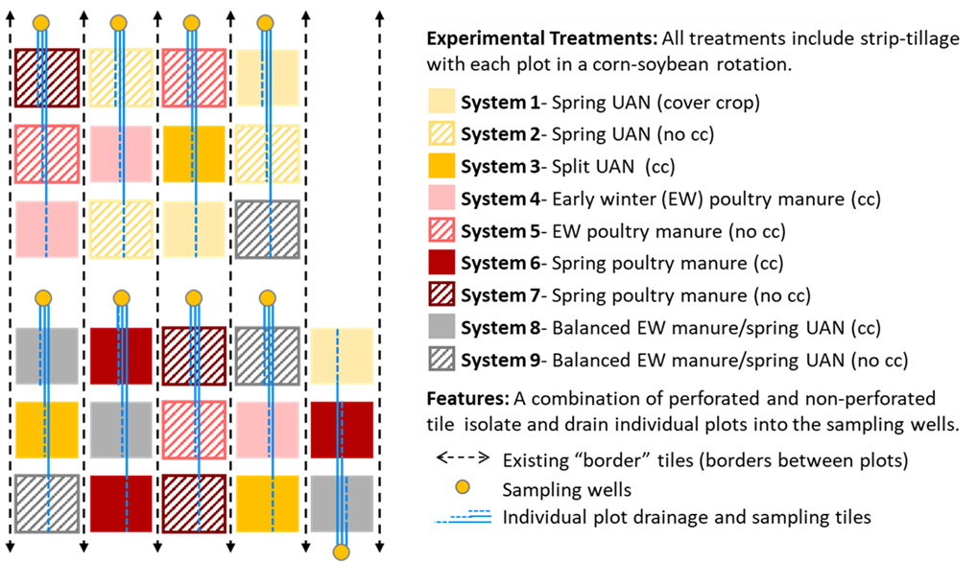

Figure 1. LAiYERS site experimental design. Each system- treatment is assigned to the 27 quarter-acre plots in triplicate. The N-management treatment is applied in the early winter or spring for the upcoming corn year.

Each of the nine system treatments are replicated in triplicate. The spring UAN treatments, with
and without cover crops, serve as the experimental control. An additional UAN treatment includes a split UAN application with spring side dress to address concerns with yield loss due to potential
low nitrogen availability following cover crops. Phosphorus and potassium are applied to the UAN treatment plots (Systems 1-3) for each corn year. The manure application treatments allow for a
side by side comparison of early winter and spring manure application with and without cover
crops. We also include a balanced manure treatment with manure applied every 5 years (early
winter application after soybeans in years 1 and 3). The plot and sampling well installation was
completed in June 2021.
An overview timeline (fig. 2) highlights field activities, including planting, harvest, and cover crop termination dates from 2021 through soybean harvest in 2023. Manure and UAN were applied for the 2022 corn growing season (early winter 2021 and spring 2022), with no manure or UAN treatments applied for the 2023 soybean year. Soybeans plants were monitored throughout the 2023 growing season, with tissue samples collected at approximately the V5 growth stage on July 19th (no cover crop plots) and July 27th (cover crop plots). Additional field work in 2023 included the early winter manure application for the 2024 corn year on November 15th, strip tilling at all plots on Nov. 19th, and P&K applied to the UAN plots (Systems 1-3) on Nov. 19th.
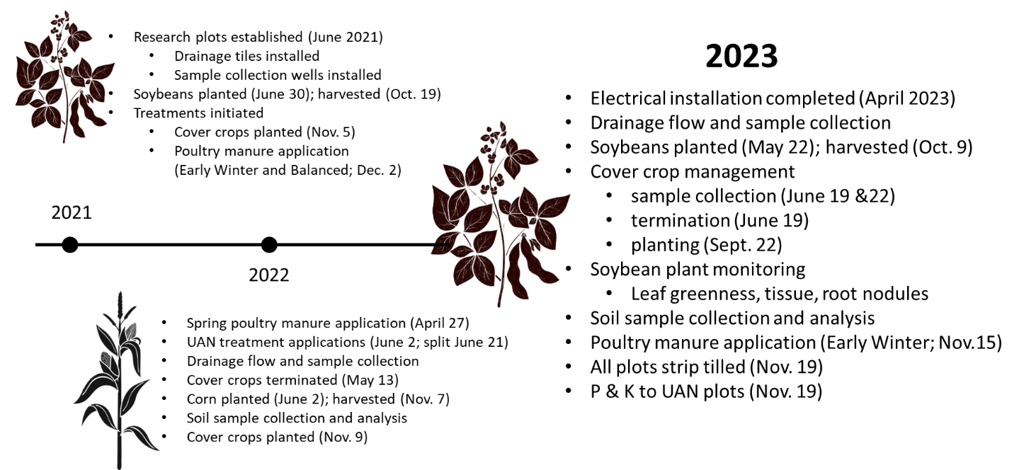
Figure 2. LAiYERS project timeline. The crop rotation includes soybeans in odd numbered years, corn in even numbered years, and cereal rye as a cover crop at designated plots in all years. Fall strip tillage will be used each year to increase spring field drying and accessibility and partially incorporate manure during application years.

Differences in subsurface drainage NOx-N between treatments were measured in 2023.
There were a few incorrectly planted (or not planted) cover crop plots in 2021/22 and 2022/23 as the AEA farm management team became familiar with the research site. For the purpose of this report we have included the actual applied treatments in the water quality data analysis discussion to improve the robustness of data observed. For example, plot 11 is assigned as a system 1 (UAN with cover crop), but planting of cereal rye was missed in the fall of 2021 and 2022. Therefore, the plot was treated in 2021/22 and 2022/23 as a system 2 plot (UAN with no cover crop) for this report instead of the plot’s assigned system 1. We accompanied the farm staff in the field for cover crop planting in the fall of 2023, and all plots were planted as assigned.
The drainage season average subsurface drainage water NOx-N (nitrate-N + nitrite-N) concentrations were similar for all treatments in 2022. Differences in drainage water NOx-N concentrations were observed by treatment in 2023. The lowest measured concentrations were with the spring poultry manure treated plots, followed by the early winter and balanced manure plots. The highest concentrations were measured at the UAN plots, although these differences may not be statistically significant. All plots last received manure or fertilizer treatment for the 2022 corn year (early winter 2021 or spring 2022). There was no manure or UAN applied for the 2023 soybean year. Additional years of drainage sampling and analysis are needed to identify trends in NOx-N concentrations with treatment.
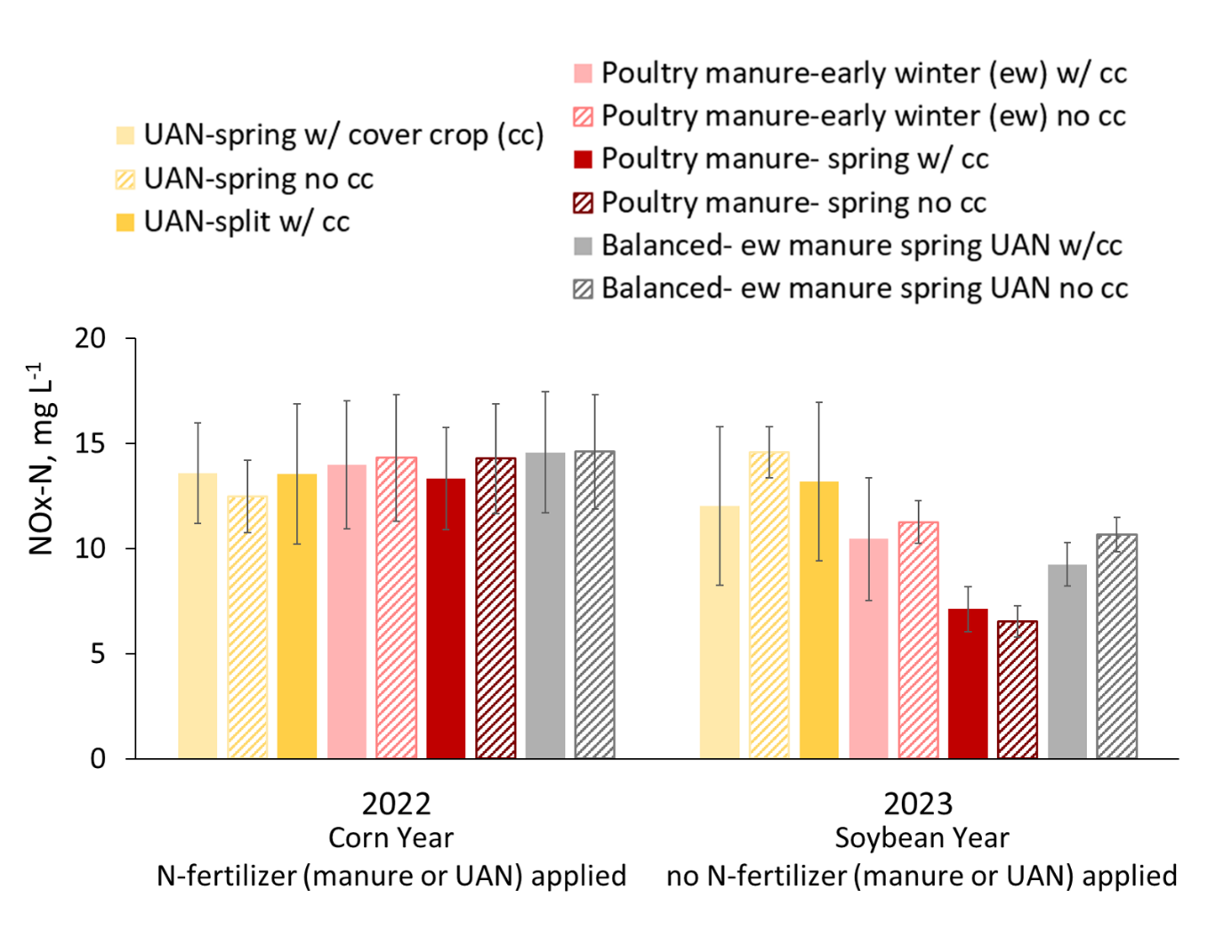
Figure 3. Average tile drainage water NOx-N concentrations by treatment with standard deviation error bars. The solid bars are the cover crop treated plots, and the thatched are the no cover crop plots.
Cover crops suppressed weeds but negatively impacted soybean yields.
Cereal rye was drilled in 18 cm rows on Nov. 3rd, 2022. In 2023, soybeans were “planted green” into the standing cover crop on May 22nd. Field work was delayed, and the cover crop was terminated approximately 4-weeks after planting on June 19th. Cover crop above ground plant samples were collected and analyzed for biomass and nutrient contents. At each plot, duplicate samples were collected from 0.8 m² quadrats. The quadrats were gently tossed into the cover crop to randomize sample collection, a photo was taken to document the cover crop canopy coverage, and all of the rye within the quadrat was cut at the ground and gathered in a plastic container to be weighed. After recording the weight, approximately 500 g of plant material was subsampled following AgSource recommended procedures and placed in a paper bag to submit for analysis. The cover crop analysis results showed high C:N ratios, indicating potential N depletion or tie up in the plots. The early cover crop biomass and tissue analysis data does not indicate a treatment effect, with relatively similar results for all plots. A longer term data set is needed to evaluate the impact of treatment on cover crop growth. The average biomass (dry) was 4.25 tons/acre, with a range of 3.14-5.46 tons/acre collected dry biomass. The average C:N ratio for all treatments was 62:1, with a range of 45:1 – 75:1.
Lori Kriz, a participant in the RET program (Research Experience for Teachers) monitored soybean plants during the summer. She documented plant greenness, canopy coverage, weed growth, and soybean root nodules at various growth stages. Her results were presented at poster session at the end of the program.
Crop (soybeans and cover crop) and weed canopy coverage were measured with the Canopeo app, a photo processing app that estimates the percentage of plant canopy in the field. Figure 4 gives an example of the Canopeo app canopy coverage results. Living vegetation is processed to white/blank space and the open soil surface is processed to black. The percentage of area covered in white is the canopy coverage. Total canopy was photographed, then all vegetation (weeds or rye) were removed to document the soybean canopy. Weeds were almost completely suppressed in the rye plots, and did not contribute to the total canopy in those plots.
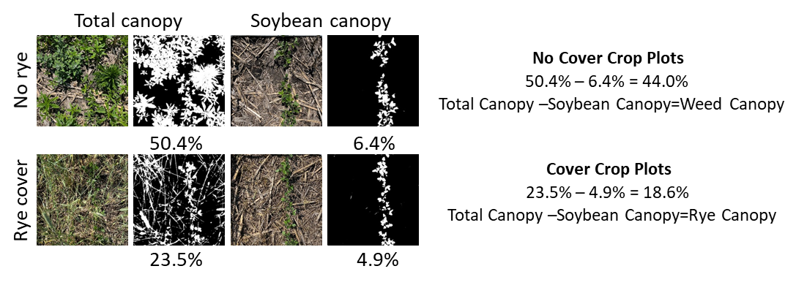

Figure 4. Near complete weed suppression was observed in the cover crop plots. The color images show photographs trimmed to the edges of a 0.8m² quadrat used during rye above ground biomass sample collection on June 27, 2023.
The no cover crop plots had heavy weed coverage at the time of sampling, with the majority of the weeds identified as water hemp. The cover crop was effective at weed control, with relatively few weed seedlings identified in the cover crop plots.
While there was virtually complete weed control in the cover crop plots when evaluated during the above ground biomass sampling, there was also an impact on soybean plant growth. Soybean plants were monitored throughout the growing season, with observations recorded and samples collected at various growth stages. The height and density of the cover crops shaded the growing soybeans, with notably delayed growth stages of soybeans in the cover cropped plots compared to the no cover crop plots.
Differences in soybean nodulation were observed in cover crop vs no cover crop plots at V5 growth stage (figure 5). Soybean plants were carefully dug from each plot to collect intact root systems at the V2 and V5 stages to evaluate root nodule size and quantity (fig. 6). The tops of the plants were removed at about 2” above ground to reduce the size of sample stored in a cooler with ice in the field. The samples were transported to the Water Quality Research Lab (WQRL) and stored at 4°C until they could be processed. The root portion of the plants were gently rinsed, and the root nodules were carefully removed from the roots and dissected to observe the color of the nodules. Pink nodules indicate active nitrogen fixation. There was very little difference observed in the number of nodules counted at the V2 stage between the cover crop and no cover crop plots. At the V5 stage, more nodules were counted from the cover crop plots compared to the cover crop plots.
Percent of nodules that were pink
No CC-84% at V2 and V5
CC- 91% (V2) and 81% (V5)
Figure 5. Comparison of pink nodules (an indication of active nitrogen fixation) in soybean plants at V2 and V5 growth stages in cover crop vs no cover crop plots.
During the growing season, above ground soybean plant (leaf) samples were collected at approximately V5 growth stage on July 21 (no cover crop plots) and July 28 (cover crop plots). Leaf samples were collected following AgSource’s recommended sampling procedure for soybean tissue (leaf) analysis. The first fully developed trifoliate leaf from the top of each plant was collected, sampling 20 plants at each plot. Samples were transported immediately to AgSource for tissue analysis (N, P, and micronutrients). Soybean yields and select tissue analysis results are highlighted in table 1. The soybean tissue analysis indicated optimum availability of key nutrients, so nutrient tie up was not the driver of lower yields.
Table 1. Average 2023 soybean yields and select tissue analysis results with standard deviation. Soybean plants were at approximately V5 growth stage when tissue samples were collected. Due to high variability within treatments, yield differences may not be significant.
The soybean yields were highly variable between plots, but there was a measured decrease in average yields overall with cover crops when comparing the cover crop vs no cover crop yields for each N-source/timing treatment component. The late termination of the cover crops visibly impacted the soybean plant growth during early emergence and into the flowering stages. The robust cover crop was shading the soybean plants and competing for available moisture. While there was a measurable decrease in weed coverage with cover crops, a better balance in termination timing to achieve optimal yields is necessary.
Progress Toward Project Metrics
KPI #1: Data on yield, soil and water quality. Measured annually by collection of environmental datasets.
Environmental sample collection was completed throughout the 2023 season. Soybean plant samples, including leaf greenness and root nodules, were collected at various growth stages (V2, V5, R1) and cover crop samples were collected for biomass and tissue analysis at termination. These results were presented at the RET (Research Experience for Teachers) Showcase on July 25th. Soil samples were collected with the soybean roots to a depth of 5-7” for nutrient analysis. Subsurface tile drainage water samples will be collected throughout the 2023 drainage season.
KPI #2: Improved understanding of manure integrated cropping systems and their impact on soybean yield and soil and water quality.
We have completed the third year of research and data collection at the LAiYERS plots. The transition year (2021) involved intensive soil sample collection to document the background/starting conditions of the plots. The drainage data includes a year with fertilizer application (corn year; 2022) and no fertilizer application (soybean year; 2023), with distinct differences by treatment in 2023. Soybean plants were monitored at various growth stages throughout the season, and results suggest that late termination of cover crops negatively impacted soybean plant growth and yields. Soybean tissue analysis did not indicate nutrient deficiency, suggesting competition with cover crops for moisture and sunlight negatively impacted yields.
We were able to expand our outreach with the project to include a visiting elementary school teacher who was participating in the Research Experience for Teachers (RET) program at Iowa State University. With assistance, she evaluated and presented a poster highlighting the early results comparing the impact of cover crops on weed canopy, soybean plant greenness, and soybean root nodules.
Final Project Results (layman's terms for all audiences)
Iowa State University has partnered with Iowa Soybean and Iowa Egg Council to explore
integrated agricultural systems to promote soil health and environmental resilience. Additional projects have been funded by the Egg Industry Center and Soil Tech to explore and document the dynamics involved in nutrient mineralization and the potential greenhouse gas potential. This is a unique, long-term study that included the establishment of new field plots in 2021, that are now established and producing useful data.

The field site includes 27 plots with the following treatments:
1. Cover crop with spring UAN
2. No cover crop with spring UAN
3. Cover crop with split UAN with 75 lbs N/acre spring applied and 75 lbs N/acre as sidedress
4. Cover crop with early winter manure
5. No cover crop with early winter manure
6. Cover crop with spring manure
7. No cover crop with spring manure
8. Cover crop with balanced early winter manure and spring UAN
9. No cover crop with balanced early winter manure and spring UAN

All plots are managed using strip till. The first manure and UAN treatments were applied for the 2022 corn year, with the first year of treatment effects monitored in 2022. Cover crop termination timing was managed in 2023 to look at the impact of cover crops on weed suppression. While there was a measurable decrease in weed coverage with cover crops, a better balance in termination timing to achieve optimal soybean plant growth and yields is necessary. Soybean plant growth was noticeably delayed in the cover crop plots, and the average soybean yields were also lower with cover crops. Moving forward, this study will provide practical guidance to farmers interested in maximizing yield, resiliency to varying climatic conditions, and protecting downstream water quality.

Additional Funded Projects
Quantifying soil nitrogen dynamics in manured fields. Iowa Nutrient Research Center. S. Archontoulis, M. McDaniel, P. Kyveryga, S. Nelson. $171,200. 2021 - 2023
Manure management for sustainable egg production and environmental resilience. Iowa Egg Industry Center. S. McMillan, M. Soupir, D. Andersen, S. Hall. $84,990. 7/1/23 – 6/30/25.
Sensor integration to demonstrate benefits of regenerative agriculture on soil health. Soil Tech. S. McMillan, D. Andersen, M. Soupir, C. Gomes, N. Hoover. $50,000. 1/1/24 – 12/31/24.
Poultry manure management to promote soil health and environmental resilience. Iowa Egg Council. M. Soupir, D Anderson, N. Hoover. $69,540. 1/1/24-12/31/24.
Presentations
Manure Applicator Certification Program- Spring vs. Fall applied poultry manure video segment (recorded Sept.7th for 2024 training season)
Tours
IEC field day/site visit- November 15, 2023
Video for virtual tour- https://vimeo.com/891501928/772f6544c3?share=copy
Posters
Lori Kriz (RET participant), N. Hoover, M. Soupir. Assessing the Impact of Cover Crops on Soybean Plant Nodules, Weed Canopy, and Greenness. Poster presented at the conclusion of the RET program on 7/25/23.
Hoover, N.L., M. Soupir, D. Anderson, S.W. Potter, R.S. Kanwar. 2022. Land Management for Improved Yields, Environmental Resilience, and Sustainability. Poster presentation at the ASABE International Drainage Symposium, Des Moines, IA. 8/30/22 to 9/2/22.

