Kansas Soybean Commission Final Report

Principal Investigators: Greg Aldrich, Grain Science and Industry, Kansas state university, aldrich4@ksu.edu
Donghai Wang, Biological and Agricultural Engineering, Kansas state university, dwang@ksu.edu
Amount of Funding: $121,167
Title: Increase Soybean Nutritional Values and Consumer Acceptability for use in Pet Foods through Fermentation Technology
Project Duration: July 1, 2022 to June 30, 2023
Report Period: July 1, 2022 to June 30, 2023

I. Objectives
The goal of this proposed research is to change the narrative regarding soybean inclusion in pet foods by enhancing the nutritional value and resolving flatulence issues associated with oligosaccharides, eliminating trypsin inhibitors, while increasing bioactive molecules such as isoflavones, and saponins through fermentation technology. The specific objectives are:
- To convert oligosaccharides and modify proteins in soybean meal through fermentation to improve its nutritional values for dog food.
- To study the effect of fermentation on trypsin removal and soybean nutritional values.
- To study the potential of fermented soy meal as a major ingredient for dog food application.

Objective 1. Convert oligosaccharides and modify proteins in soybean meal through fermentation to improve its nutritional values for dog food

Materials and methods

Preparation of Aspergillus oryzae spore suspension: Freeze dried Aspergillus Oryzae (lyophilized, ATCC 42149) was obtained from the American Type Culture Collection (Manassas, Virginia, USA) and recovered on a Czapek-Dox agar plate and harvested with 50% glycerol solutions (Figure 1). A hemacytometer chamber was used for spore counting. Solutions with estimated spore concentrations were stored at 4 ℃ until used for fermentation.

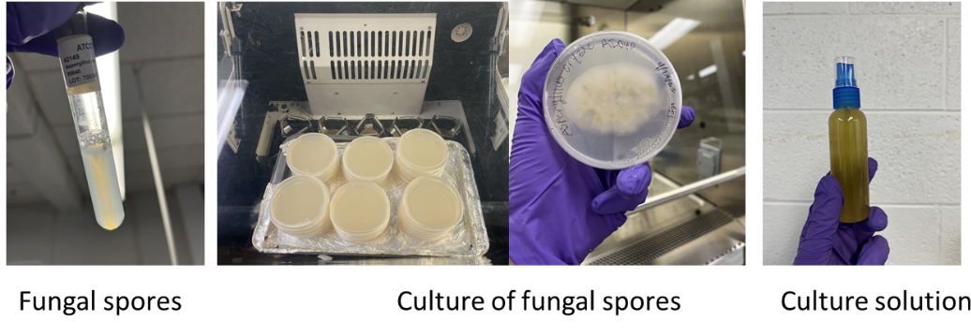
Figure 1. Seeds culture and spore suspension of A. oryzae.

Fermentation and sample collection: Commercial soybean meal (SBM) was purchased from local distributor (MKC, Manhattan, KS). Distilled water was added to soybean meal to reach a 50% initial moisture content before retorting for 2 hours under 121.1 ℃. Retorted soybean meal was evenly divided into 3 groups and inoculated with Aspergillus oryzae spore suspensions at dosage of 1×10⁴ (dose 1), 5×10⁵ (dose 2) and 1×10⁶ (dose 3) spore/g SBM on dry matter basis. Fermentation was carried out in a ventilation chamber under 37℃，80±5% R.H. and light cycle of a 2-hour darkness/day (Figure 2). Substrate was sprayed on surface with distilled water and then flipped with ethanol cleaned spatulas every 12 hours. Samples were collected from each group at 0, 12, 24, 36 and 48 hours of fermentation and immediately dried in oven at 60 ℃ for around 36 hours and stored at room temperature for further analysis. The above fermentation process was repeated 3 times with each time on different days and trays of each treatment were placed in different locations (left, middle and right) in the chamber.
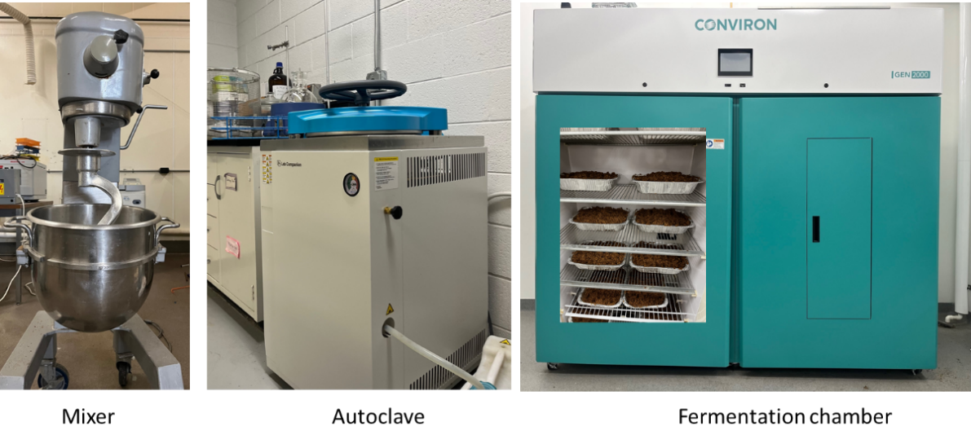
Figure 2. Mixer, autoclave and fermentation chamber used for soybean meal solid-state fermentation.

Composition analysis: Dry matter (DM), organic matter (OM), and ash were determined according to AOAC methods. Crude protein (CP) was determined by Dumas combustion method using a nitrogen analyzer. The conversion factor from nitrogen to crude protein was 6.25. Crude fat was determined by acid hydrolysis followed by hexane extraction using semi-automated equipment. Gross energy was measured as total heat of sample combustion by calorimetry. The soluble dietary fiber (SDF), insoluble dietary fiber (IDF), and total dietary fiber (TDF) content of diet samples were measured by an ANKOM Dietary Fiber Analyzer.

In-vitro protein digestibility: The in-vitro pepsin-pancreatin protein digestibility method was determined in duplicates. For each duplicate, 1 gram of sample was weighed into 50 mL centrifuge tubes, followed by addition of 15 mL of 0.1N HCL-pepsin solution to each tube and placed in a shaking water bath for 6 hours at 37°C. After pepsin incubation, the tubes were removed and 7.5 mL of 0.5 N NaOH was added to neutralize the sample and stop pepsin hydrolysis. Next, porcine pancreatin was added to 7.5 mL of phosphate buffer (pH 8), followed by 1 mL of sodium azide (for microbial control). Tubes were then placed in the shaking water bath for 18 additional hours at 37 °C.
After 18 hours of incubation, 1 mL of 10% TCA was added to each tube to help with protein precipitation. Vials were then centrifuged at 3,700 g for 20 minutes. The supernatant was discarded by filtration (Whatman 541 filter paper). Then the samples were washed with distilled water, centrifuged and filtered again 3 times. Final sediments were oven-dried overnight at 105°C and then analyzed for nitrogen utilizing the Dumas combustion method. In vitro protein digestibility was calculated using the following equations:
Weight of sample CP = Sample weight (g) × sample CP (%)
Weight of residue CP = residue weight (g) × residue CP (%)
CP digestibility = $\frac{(Weight of sample CP – Weight of residue CP)}{weight of sample CP}$ × 100%

Results and Discussion
Content of organic matter (OM), CP, TDF and IDF on MD basis were only significantly influenced by fermentation duration (P<0.05) but not by inoculation dosage or the interaction of inoculation dosage and fermentation duration (Figure 3). The crude protein content was greater (55.77%, P<0.05) in soybean meal fermented with A. oryzae for 48 hours compared to those fermented for 24 hours or less (at an average of 52.60%). The in vitro protein digestibility of A. oryzae fermented soybean meal was not affected by any factors studied. However, OM and IDF in A. oryzae fermented soybean meal decreased significantly (P<0.05) after 24-hour fermentation (93.01%) compared to unfermented soybean meal (93.33%), with no further changes observed after 24 hours. The SDF in the A. oryzae fermented soybean meal showed a trend (P=0.097) of increase from 36-hour to 48-hour fermentation duration; but was not influenced by inoculation dosage, or the interaction between inoculation dosage and fermentation duration. To achieve our goal of increasing protein content and limiting SDF in fermented soybean meal, an inoculation dosage of 1×10⁴ spore/g SBM (DM basis) and a fermentation duration of 36 hours was determined to be optimal.
a a b b b
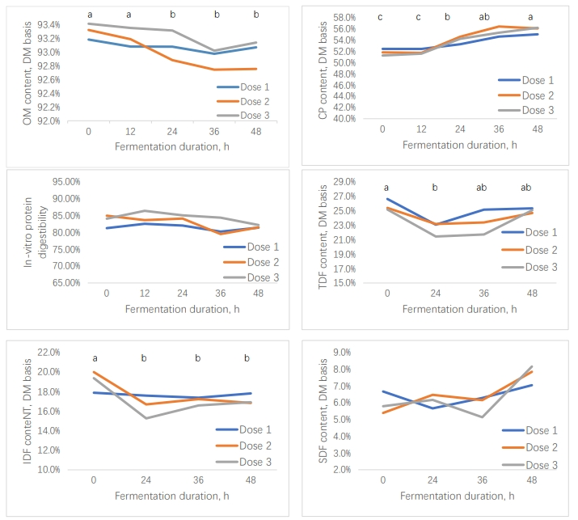
A B

C D

E F
Figure 3. Nutrient contents of soybean meal fermented with A. oryzae with different inoculation dosage and fermentation duration. (A) Organic matter, (B) Crude protein (CP) content, (C) in vitro protein digestibility and (D) total dietary fiber, (E) insoluble dietary fiber, (F) soluble dietary fiber. abc Mean fermentation durations without a common letter differ (P＜0.05).

Objective 2: Study the effect of fermentation on trypsin remove and soybean meal nutritional values

Materials and methods

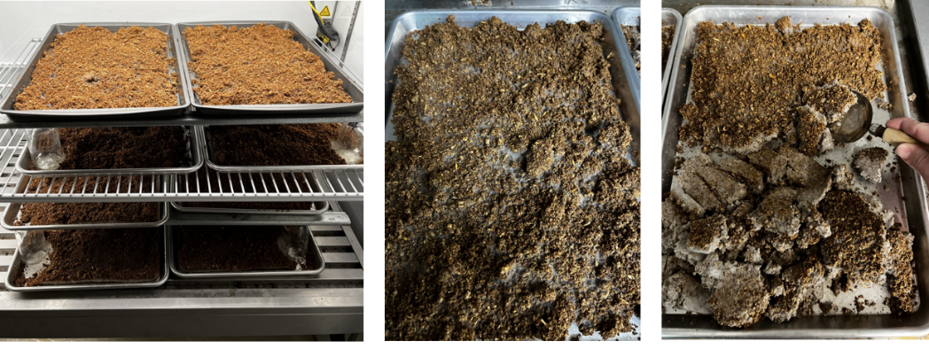
Fermentation: Commercial soybean meal (SBM) was purchased from local distributor (MKC, Manhattan, KS). An autoclave was used to sterilize the soybean meal at 121°C for 2 hours after adding distilled water to bring the moisture content to 50%. The A. oryzae spore suspension was prepared in the same way as stated in objective one. Solid-state fermentation was carried out in a large humidity chamber with temperature and humidity ratio controlled. Then soybean meal was inoculated at 1×10⁴ spore/g SBM (db, %) and fermented at 37 ºC for 36 hours. Fermentation substrate was sprayed with distilled water at the surface and flipped with clean spatula every 12 hours until the end of fermentation. Fermented soybean meal was immediately oven-dried at 60 ℃ for around 36 hours and then ground through a 1.0 mm sieve. Ground subsamples were taken from each batch and stored at room temperature for further analysis. Figure 4 shows the soybean meal during fermentation and after fermentation.
Figure 4. Soybean meal at the beginning (left) and the end of fermentation (middle, surface; right, bottom flipped over).

Composition analysis: The nutritional profiles of unfermented and fermented soybean meal were analyzed. Dry matter (DM), organic matter (OM), and ash were determined according to the methods. Moisture content was determined using air force oven at 105 ºC for 16 hrs. Protein content was measured using nitrogen combustion method via a Leco FP-2000 nitrogen determinator. Nitrogen content was converted to protein using a conversion factor of 6.25. Crude fat content was determined by using the acid hydrolysis and hexane extraction method. Soluble and insoluble dietary fiber were determined according to AOAC method. Aflatoxin (B1, B2, G1 and G2) analysis was conducted with test strips (Reveal Q+, Neogen Ltd., Lansing, MI) and quantified with an AccuScan Gold reader.
Sugars (sucrose, stachyose, raffinose and verbascose) and amino acids were determined at the University of Missouri Agricultural Experiment Station Chemical Laboratories; Columbia, MO). Sucrose, stachyose, raffinose and verbascose contents were determined by gas chromatography. All amino acids, except methionine, cysteine, and tryptophan, were digested with 6 N HCl for 24 h at 110°C. The amino acids were then separated by ion-exchange chromatography and the concentration was determined with a Beckman 6300 amino acid analyzer. Methionine and cysteine were first oxidized by performic acid to methionine sulfone and cysteic acid, respectively, prior to acid hydrolysis. Tryptophan was hydrolyzed in 3 M mercaptoethanesulfonic acid before analysis. Available lysine was determined (AOAC 975.44) and lysine availability (%) was calculated as the ratio of available lysine to total lysine.
The Kunitz trypsin inhibitors (KTI) and Bowman-Birk trypsin inhibitors (BBI) were determined in triplicate by a simplified spectrophotometer method and expressed a trypsin inhibitor unit (TIU)/g of sample. For KTI analysis, 20 mg ground sample and 1 mL of 10 mM NaOH were added into a 2 mL tube and vigorously agitated on a vortex mixer at room temperature for 10 minutes followed by a 10-minute centrifugation at 16,000 g. Protein concentration in the supernatant was measured by Bio-Rad protein assay. Add 50 μL of protein concentration and 150 assay buffer (50mM Tris-HCl, pH8.2 and 20 mM CaCl2) to a 1.5 mL tube followed by addition of 500 μL of BAPNA solution (0.4mg/mL) and 200 μL of trypsin (20 μg/mL) and vortex of the solution. Reaction was run for 10 minutes at 37 ℃ in a water bath and terminated by adding 100 μL of 30% (v/v) acetic acid. Absorbance was measured at 410 nm. The positive control, substrate blank and enzyme blank were used in parallel. For BBI analysis, the same procedure was used but BAPNA and trypsin were replaced with AAPF (N-Succinyl-Ala-Ala-Pro-Phe-p-nitroanilide) and α-chymotrypsin. In the analysis, one TIU was defined as a decrease in 0.1 absorbance units at 410 nm.

Results and Discussion
Over 200 lbs of soybean meal were fermented with A. oryzae across 19 batches using optimal fermentation condition identified from Objective 1. They were used to produce sufficient material for experimental diet production and subsequent animal feeding trials. Unfortunately, 11 batches of unfermented soybean meal samples molded due to accidental exposure to tap water. Unfermented soybean meal and the corresponding fermented soybean meal samples from the 8 clean batches were used for analysis of macronutrients. One composite sample of unfermented soybean meal and another composite sample of fermented soybean meal from these 8 batches were used for analysis of amino acid composition, sugars (sucrose, stachyose, raffinose and verbascose) and Aflatoxins. The trypsin inhibitors (Kunitz trypsin inhibitor and Bowman-Birk trypsin inhibitor) analysis data came from corresponding unfermented soybean meal, retorted but not fermented soybean meal and fermented soybean meal from 5 batches. Fermentation of soybean meal with A. oryzae decreased (P<0.05) OM, IDF and gross energy (GE) in soybean meal while it increased (P<0.05) CP and SDF content (Table 1). The crude fat and TDF content were not influenced by fermentation. For amino acid composition, methionine content numerically increased from 0.72% to 0.81% DM and cysteine content numerically increased from 0.76 to 0.82% DM (Table 2). Sucrose was completely eliminated while major oligosaccharides decreased in fermented soybean meal. Both KTI and BBI in unfermented soybean meal (3.17 and 2.29 TIU/g DM) were completely inactivated by retort processing prior to fermentation. The Aflatoxin content of fermented soybean meal was 2.6 ppm which, while not zero, is substantially lower than the U.S. Food and Drug Administration (FDA) guideline limit in pet food (20 ppm).

Table 1. Paired t-test analysis results of nutrient composition from 8 batches of unfermented soybean meal (U-SBM) and A. oryzae fermented soybean meal (F-SBM).
Nutrient, DM | U-SBM | F-SBM | Difference¹ | SEM of difference | P-value
Organic matter, % | 92.52 | 91.51 | -1.01 | 0.001 | <.001
Crude protein, % | 50.05 | 54.69 | 4.63 | 0.004 | <.001
Crude fat, % | 2.21 | 2.40 | 0.19 | 0.002 | 0.2874
TDF, % | 25.06 | 23.88 | -1.18 | 0.009 | 0.2104
IDF, % | 19.32 | 15.29 | -4.03 | 0.009 | 0.0026
SDF, % | 5.74 | 8.59 | 2.85 | 0.005 | <.001
GE, kcal/kg | 4720.2 | 4555.6 | -164.6 | 13.78 | <.001
¹Calculated by (F-SBM) - (U-SBM).
TDF-total dietary fiber; IDF-insoluble dietary fiber; SDF-soluble dietary fiber; GE-gross energy.

Table 2. Amino acid composition, common soybean sugar contents and trypsin inhibitor units (TIU) in unfermented soybean meal (U-SBM) and A. oryzae fermented soybean meal (F-SBM).
Chemicals | U-SBM |  | F-SBM
Amino acids, % DM
Arginine | 3.64 |  | 3.46
Histidine | 1.34 |  | 1.36
Isoleucine | 2.46 |  | 2.72
Leucine | 3.99 |  | 4.43
Lysine | 3.21 |  | 2.96
Methionine | 0.72 |  | 0.81
Phenylalanine | 2.64 |  | 2.92
Threonine | 1.96 |  | 2.17
Tryptophan | 0.63 |  | 0.63
Valine | 2.55 |  | 2.84
Alanine | 2.23 |  | 2.52
Aspartic acid | 5.69 |  | 6.21
Cysteine | 0.76 |  | 0.82
Glutamic acid | 9.34 |  | 10.11
Glycine | 2.14 |  | 2.35
Serine | 2.15 |  | 2.33
Proline | 2.56 |  | 2.85
Tyrosine | 1.90 |  | 2.11
Hydroxylysine | 0.02 |  | 0.01
Hydroxyproline | 0.07 |  | 0.08
Taurine | 0.09 |  | 0.06
Lanthionine | 0.00 |  | 0.07
Ornithine | 0.03 |  | 0.08
Sugars, % DM
Sucrose | 6.58 |  | 0.00
Raffinose | 0.95 |  | 0.12
Stachyose | 2.93 |  | 0.14
Verbascose | 0.55 |  | 0.32
Trypsin inhibitor, TIU/g DM | U-SBM | R-SBM |  | F-SBM
Kunitz TI | 3.17 | Not detected |  | Not detected
Bowman-Birk TI | 2.29 | Not detected |  | Not detected
DM-dry matter; R-SBM-retorted but not fermented soybean meal.

Objective 3: Study the potential of fermented soybean meal as a major ingredient for extruded dog food application

Materials and methods

Experimental diets: Fermented soybean meal produced during study of Objective 2 were used for dog food extrusion. Four diets were formulated to be nutritionally balanced for adult dogs (Table 4). The SBM diet consists of 30% soybean meal, while the AMF diet included the same amount of soybean meal but with an additional 1% of commercial A. oryzae biomass product. In contrast, the FSBM diet substituted regular soybean meal with 30% fermented soybean meal. The SPI diet deviated from the others by incorporating 18% soy protein isolate to contribute an equivalent quantity of protein to the soybean meal in the SBM diet. The experimental diets were formulated to be consistent with premium dog food with high-protein and moderate level of fat (>25% CP and >12% CF). Diets were formulated to have similar nutritional composition and included titanium dioxide (TiO₂; 0.4%) as an indigestible marker for determination of apparent total tract digestibility (ATTD) of dietary nutrients. As predicted by the formulation, the concentrations of minerals (calcium, phosphorous, potassium, magnesium, sodium, manganese, copper iron, and zinc) were similar among diets and met AAFCO nutrient profile recommendations for adult dogs as maintenance.

Extrusion processing: The dry expanded pet foods were produced using a single screw extruder (EX; model X20, Wenger Manufacturing, Sabetha, KS, USA). The extruder had a screw profile and barrel temperatures based on a typical commercial pet food configuration. At the end of the extruder barrel there were 2 inserts with a single hole (diameter was 7.07 mm) on each insert. Fixed input parameters were kept constant throughout each individual food production (Table 3).
During extrusion process, PC and EX parameters were all collected from sensor readouts every 30 min to estimate the effects of different soybean treatments on extrusion operating parameters. Output variables were those parameters resulting from the input variables, and included EX die temperature, EX motor load and specific mechanical energy (SME). Measurements were collected at uniform time increments (30 min term) during the production for a total of 3 samples per experimental diet and were considered treatment replicates.
After extrusion, extrudates were transported by a negative air pressure conveying system to a pilot scale dryer at 220°F for 8 minutes, 8 minutes, and 6.6 minutes in three zones of the cooler (Wenger Manufacturing, Sabetha, KS, USA) to reach a moisture content of less than 10%. After drying, the chicken fat and digest (dry dog flavor) were applied to the kibbles in a drum mixer (35 lb. capacity). Samples of kibbles before and after coating were collected for further analysis.
In-barrel moisture (IBM) was calculated using the following equation:
IBM, %=$\frac{m_{f}*X_{fw}+m_{ps}+m_{pw}+m_{es}+m_{ew}}{m_{f}+m_{ps}+m_{pw}+m_{es}+m_{ew}}$
Where m_{f} is dry feed rate, X_{fw} is moisture content of feed material, m_{ps} and m_{pw} are steam and water injection rate in preconditioner respectively. The m_{es} and m_{ew} are steam and water injection rate in extruder barrel respectively.
SME was calculated using the following equation:
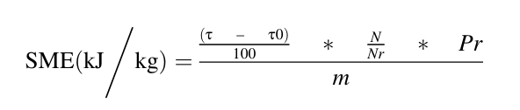
where, τ is the EX motor load, τ₀ is the EX no load % torque, N is the EX screw speed (rpm), Nr is the rated EX screw speed, Pr is the rated EX motor power, and m is dry feed rate (kg/s).
Sectional expansion index (SEI) was determined by comparing the squared diameter of the dried extruded kibbles by the squared die diameter of the extruder:
SEI =$\frac{D^{2}}{d^{2}}$
where D is the extrudate diameter and d is the extruder die diameter.
Specific length in cm/g was determined by equation:
Specific length = $\frac{l}{m}$
where l is the extrudate length and m is extrudate mass.
Piece volume (V, cm³) was determined by equation:
V=$\frac{πlD^{2}}{4}$
Piece density (g/cm³) was determined by equation:
Piece density =$\frac{m}{V}$
where m is the piece mass.
Wet bulk density was measured off the extruder in three replicates manually during each treatment processing using a 1 L cup and leveling the kibbles with a metal ruler and weighing on a digital scale with 0.1 g sensitivity. Dry bulk density was measured off the dryer in three replicates using the same method.

Particle size distribution: An Alpine jet sieve (Hosokawa Micron, E200 LS) was used to measure the particle sizedistributions (PSD) of the raw mixed material of four diets collected before extrusion. The ASTM standard sieve sizes used for understanding the granulation ranges from 125 μm to 1000 μm. The analysis was carried out in duplicate by taking 100 g of material for each run. The PSD was measured based on the amount of material (g) passing through the Sieves. Additionally, by measuring the weights of material retained over each sieve, the geometric mean diameter (dgw) was calculated using the following expression:

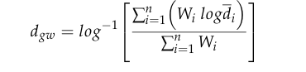
where W_{i i}s amount of flour retained on i’th sieve (g), n is the total number of sieves, and di is aperture size of the i’th sieve.

Rapid viscosity analysis (RVA): Rapid Visco Analysis (RVA) was used to measure the viscosity of materials under conditions of heat and shear. The analysis was conducted using an RVA 4500. For each sample, a portion of 3.5 grams were weighted and mixed with 25 mL deionized water in the test cup. The testing cycle kept the sample at 50 °C for 1 minute and then heated up to 95 °C at a rate of 12.2°C/minute; it was then held at 95°C for 2.5 minutes. The sample was then cooled to 50 °C at 11.8 °C per minute before being held for 2 minutes.

Feeding trial: Dogs were housed in USDA approved kennels (Large Animal Research Center at Kansas State University; Manhattan, KS, USA). Twelve healthy adult beagles (6 neutered male and 6 spayed female) of similar age and ideal body condition score were individually housed in metabolic pens (1.83m × 1.20m) equipped with an acrylic-mesh floor to allow for the separation of urine and feces. The dogs were randomly assigned and fed a specific diet. Initial dietary intake on day 0 was determined by weighing the dogs and calculating the dogs’ daily metabolizable energy (ME) requirements for an average for laboratory kennel dogs (130 × BW^{0.75}). The ME of the experimental diets was calculated using the prediction equations in dog foods ([8.5 × Crude fat] +[3.5 × Crude protein] + [3.5 × Nitrogen-free extract]). The daily food allowance was calculated using the dogs’ daily ME relative to the predicted ME for the diets. Dogs were fed twice daily (8:00 AM and 5:00 PM) in equal rations to meet daily food allowance. Orts were removed and weighed after the feeding. Throughout the study, dogs were weighed weekly, and their food allowance was adjusted by 5 or 10% for the subsequent week to maintain their BW. Water was provided for ad libitum consumption.
The study was conducted in a replicated 4 × 4 Latin square design consisting of four periods with 9 d of adaptation to the diet followed by 5 d of total fecal collection for a total duration of 56 d. After the 9 d of adaptation, fecal samples were collected and scored on a 5-point scale where 1 = liquid diarrhea, 2 = very soft consistency, unformed stool; 3 = soft stool that retains shape; 4 = well-formed firm stool that does not leave residue when picked up; and 5 = very hard, dry stool. Fecal samples were stored at -20℃ until the end of each period and then were thawed at room temperature, pooled by dog, weighed, and freeze dried until the moisture level was below 10%. The partially dried fecal samples were also weighed, and the values were used when calculating the DM (dry matter) of the fecal samples. Diet samples and partially dried fecal samples were ground using a laboratory fixed blade impact mill (1-mm screen) and stored in lidded glass jars at room temperature in preparation for chemical analysis.

Chemical analysis: All chemical analysis was performed in duplicate unless otherwise specified. The ground experimental diet samples (after coating) and fecal samples were analyzed for DM, organic matter (OM), and ash according to the methods of Association of Official Analytical Chemists. Crude protein (CP) content of the samples was analyzed using a nitrogen analyzer by the Dumas combustion method. The titanium dioxide content in the samples was analyzed according to a colorimetric method. The insoluble and soluble dietary fiber (IDF and SDF) content of diet samples was measured according to AOAC method.
Analysis for sugars (sucrose, stachyose, raffinose and verbascose) and amino acid composition in soybean products and A. oryzae biomass product (Amaferm®) was conducted at University of Missouri. Sucrose, stachyose, raffinose and verbascose contents were determined by gas chromatography. All amino acids, except methionine, cysteine, and tryptophan, were digested with 6 N HCl for 24 h at 110°C. The amino acids were then separated by ion-exchange chromatography and the concentration was determined with a Beckman 6300 amino acid analyzer (Beckman, Palo Alto, CA). Methionine and cysteine were first oxidized by performic acid to methionine sulfone and cysteic acid, respectively, prior to acid hydrolysis. Tryptophan was hydrolyzed in 3 M mercaptoethanesulfonic acid before analysis. Available lysine was determined and lysine availability (%) was calculated as the ratio of available lysine to total lysine.
Ammonia concentration in the fresh fecal samples was analyzed by colorimetric method described by Chaney and Marbach (1962) in duplicates. The fresh fecal samples were thawed and diluted with deionized water and 0.1N HCl and homogenized. The homogenized samples were centrifuged at 3,000 g for 20 min to separate the suspended solids. The 1 mL of the supernatant of the centrifuged samples was collected and kept frozen at −20 ℃ for at least 24 h to complete deproteinization. The acidified samples were thawed, centrifuged at 20,000 g for 15min, and plated.
Fecal SCFA including BCFA contents were analyzed on a gas chromatography. The fresh fecal samples were thawed and diluted with deionized water and homogenized, followed by centrifugation at 3,000 g for 20 min to separate the suspended solids. The 1mL of the supernatant of the centrifuged samples was collected acidified with 0.25mL of 25% m-phosphoric acid was before deproteinization at −20 ℃ for at least 24 h. The GC is equipped with flame ionization detector (FID) and a capillary column. Hydrogen was used as a carrier gas with a flow rate of 35 mL/min, and the split ratio was 100:1 with injection volume of 0.2 µL. Nitrogen was used as the makeup gas with a flow rate of 25 mL/min. The detector and injector temperatures were set at 300℃, and the initial oven temperature was set to 40℃ with a ramp rate of 20℃/min to 180℃ for a total run time of 8 min. The peak area of chromatograms was determined using integrative software. The concentrations of SCFA (acetate, propionate, and butyrate) and BCFA (isobutyrate, isovalerate, and valerate) in samples were quantified by comparing the sample peak area to three standards with known concentrations of each volatile free acid and corrected for the fecal dry matter content.

Digestibility calculation: Two methods were utilized to estimate apparent total tract nutrient digestibility. The total fecal collection (TFC) method requires the collection of all feces excreted by the experimental animals. The marker method uses TiO₂ as an indigestible dietary marker. In current study, apparent total tract digestibility (ATTD) of DM, OM, CP were calculated according to the TFC and marker methods by following equations:
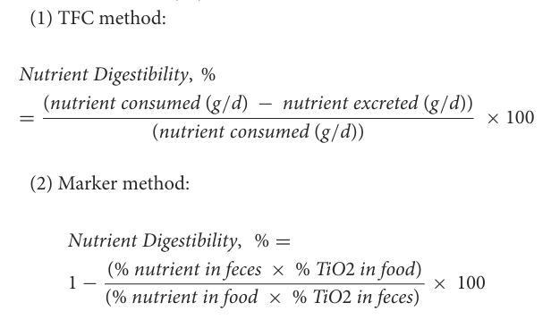

Palatability trial: Palatability testing was conducted at a commercial research kennel (Summit Ridge Farms; Susquehanna, PA) with a two-bowl test by beagle dogs (n = 20) for 2 days with each AMF, FSBM and SPI compared to the SBM. Two stainless steel bowls, each containing ∼400g of diet, were offered once daily for 2 days. Bowl placement was reversed daily and both bowls were presented for 30min. If one diet was completely consumed prior to the end of the 30min, both bowls were removed. The total quantity of the food consumption and first choice (FC) preference were recorded for each dog. Individual intake ratios (IR) were calculated by dividing the intake of each diet into the total intake for both test diets.

Results and discussion

Extrusion processing: The objective of the extrusion process was to evaluate the performance of fermented soybean meal compared to regular soybean meal and soybean protein isolate in terms of extrusion conditions and outcomes. During extrusion, some input variables were kept the same across diets, including feeder screw speed (13 rpm), PC screw speed (400 rpm), PC steam flow (13.1±0.09 kg/h), barrel set temperatures (50°C, 70°C, and 90°C for each head zone), and knife speed (1842 rpm). The extruder shaft speed was 636 rpm for SBM, AMF and FSBM but had to decrease to 342 rpm for SPI due to surging (Table 3).
The PC discharge temperature was consistent across treatments, but the PC water injection rate was greater (P<0.05) for SBM and AMF (18.50 and 19.30 kg/h, respectively) than for FSBM and SPI (11.27 and 13.07 kg/h, respectively). The motor power and die temperature were both greater (P<0.05) for FSBM and SPI (10.57 kW,117 ℃ and 10.03 kW, 117.33 ℃, respectively) than for SBM and AMF (5.90 kW, 100.33 ℃ and 7.57 kW, 104.67 ℃, respectively). The in-barrel moisture (IBM) content was the lowest (P<0.05) for FSBM (28.21%), while SPI (33.45%) had lower (P<0.05) IBM than SBM and AMF (34.46% and 34.69%, respectively). The SPI (305.3 kJ/kg) generated the greatest (P<0.05) SME with the SBM (83.7 kJ/kg) generating the least (P<0.05) SME.

Table 3. Experimental diet formulas (SBM, 30% soybean meal; AMF, 30% SBM and 1% Amaferm®; FSBM, 30% fermented soybean meal; SPI, 18% soybean protein isolate).
Ingredient, % | SBM | AMF | FSBM | SPI
Soybean meal | 30.00 | 30.00 | 0.00 | 0.00
Amaferm® | 0.00 | 1.00 | 0.00 | 0.00
Fermented soybean meal | 0.00 | 0.00 | 30.00 | 0.00
Soybean protein isolate | 0.00 | 0.00 | 0.00 | 18.00
Brewer’s rice | 0.00 | 0.00 | 0.00 | 10.68
Corn | 37.23 | 35.87 | 39.11 | 40.00
Beet pulp | 3.79 | 3.79 | 3.79 | 3.79
Poultry by-produce meal | 19.31 | 19.25 | 16.00 | 16.06
Chicken fat | 5.82 | 6.06 | 6.07 | 6.00
Dog dry digest | 1.00 | 1.00 | 1.00 | 1.00
Fish oil | 1.00 | 1.00 | 1.00 | 1.00
Calcium carbonate | 0.47 | 0.51 | 0.60 | 0.68
Dicalcium phosphate | 0.37 | 0.31 | 0.82 | 0.84
Potassium chloride | 0.00 | 0.20 | 0.60 | 0.95
Salt | 0.25 | 0.25 | 0.25 | 0.25
Choline chloride | 0.10 | 0.10 | 0.10 | 0.10
Titanium dioxide | 0.40 | 0.40 | 0.40 | 0.40
Vitamin Premix¹ | 0.15 | 0.15 | 0.15 | 0.15
Trace mineral premix² | 0.10 | 0.10 | 0.10 | 0.10
Analyzed nutrient composition
Dry matter, % | 93.6 | 93.9 | 96.00 | 93.9
Dry matter basis
Crude protein, % | 33.2 | 33.8 | 31.5 | 35.0
Crude fat, % | 12.4 | 12.3 | 11.5 | 11.0
Ash, % | 7.78 | 7.28 | 8.61 | 7.18
Total dietary fiber, % | 17.9 | 17.6 | 19.8 | 14.0
Insoluble dietary fiber, % | 13.3 | 13.7 | 14.7 | 9.4
Soluble dietary fiber, % | 4.6 | 3.9 | 5.1 | 4.6
Gross energy, kcal/kg | 4,956 | 4,976 | 4,830 | 4,938
Sugars, %
Sucrose | 2.97 | 3.01 | 0.97 | 1.05
Stachyose | 0.57 | 1.19 | 0.13 | 0.01
Raffinose | 0.40 | 0.47 | 0.10 | 0.09
Verbascose | 0.00 | 0.00 | 0.00 | 0.00
Total fermentable carbohydrate³, % | 5.57 | 5.56 | 5.33 | 4.60
Trypsin inhibitors⁴, TIU/g | ND | ND | ND | ND
¹Vitamin premix: 5.51% moisture, 4.02% crude protein, 34.5% ash, 13.4% calcium, 17,162,999 IU/kg Vitamin A, 920,000 IU/kg Vitamin D, 79,887 IU/kg Vitamin E, 14,252 mg/kgthiamine, 4,719 mg/kg riboflavin, 12,186 mg/kg pantothenic acid, 64,736 mg/kg Niacin, 5,537 mg/kg pyridoxine, 720 mg/kg Folic acid, 70 mg/kg biotin, 22 mg/kg vitamin B12.
²Trace mineral premix: 0.66% moisture, 21.5% calcium, 0.02% sodium, 0.57% magnesium, 38,910 mg/kg iron, 11,234 mg/kg copper, 5,842 mg/kg manganese, 88,000 mg/kg zinc, 1,584 mg/kg iodine, 310 mg/kg selenium, 19% carbohydrate, and 1% crude fat.
³The sum of soluble dietary fiber, stachyose and raffinose.
⁴Include Kunitz trypsin inhibitor and Bowman-Birk trypsin inhibitor.
ND, not detected.

The kibbles from SBM and AMF diets had poor expansion, leading to inefficient drying with a moisture content of about 15% after the initial drying session. To address this, these kibbles were manually re-fed into the dryer at a rate matching the extrusion throughput for a second drying session on the following day. All reported dry kibble data reflect samples that underwent two drying sessions. Both wet and dry kibbles followed a similar ranking in SEI, with the kibbles from SPI showing the greatest expansion (P<0.05), followed by kibbles from FSBM. Kibbles from the SBM and AMF diets had the least expansion (P<0.05) (Table 4). The differences in bulk density among diets were more distinguishable in dry kibbles than in wet kibbles. For the dry kibbles, bulk density decreased (P<0.05) in an order of SBM, AMF, FSBM and SPI (520.3, 481.0, 385.0 and 324.7 g/L, respectively).

Particle sizes distribution: Both the geometric particle size (D_{gw}) and geometric standard deviation of the particle diameter (S_{dw}) decreased in order of SBM, AMF, FSBM and SPI (Table 5). When using the selected series of 8 sieves (diameter from 125 to 1000 μm), the raw mixes of all four diets showed a unimodal particle size distribution (Figure 5). All diets had a mode in the center of the size class between 212 and 500 μm, but the peak height varied among them. The raw mix of SPI had the lowest peak, while FSBM had a lower peak than both SBM and AMF.
Table 4. Extrusion processing data and out-of-extruder kibble measurements of treatment diets (SBM, 30% soybean meal; AMF, 30% SBM and 1% Amaferm®; FSBM, 30% fermented soybean meal; SPI, 18% soybean protein isolate).
Parameter | SBM | AMF | FSBM | SPI | SEM | P-Value
Feed rate (as-is), kg/h | 113.05 | 117.00 | 124.20 | 98.85 | 4.583 | 0.0681
PC water injection, kg/h | 18.50ª | 19.30ª | 11.27^{b} | 13.07^{b} | 0.604 | <.001
PC discharge temperature, ℃ | 93.9 | 92.7 | 95.0 | 94.3 | 0.71 | 0.1723
EX Shaft speed, rpm | 636^{ab} | 637ª | 636^{b} | 342^{c} | 0.2 | <.001
EX Water injection, kg/h | 12.60 | 13.23 | 11.60 | 11.90 | 0.533 | 0.2109
Motor power, kW | 5.90^{b} | 7.57^{b} | 10.57ª | 10.03ª | 0.512 | <.001
Die temperature, ℃ | 100.33^{b} | 104.67^{b} | 117.00ª | 117.33ª | 1.581 | <.001
Die pressure, psig | 200^{b} | 250ª | 210^{b} | 250ª | 5.0 | <.001
In-barrel moisture, % | 34.46ª | 34.69ª | 28.21^{c} | 33.45^{b} | 0.002 | <.001
SME, kJ/kg | 83.7^{c} | 115.9^{bc} | 198.7^{b} | 305.3ª | 14.57 | 0.0015
Wet kibble characteristics
SEI, mm² /mm² | 1.44^{c} | 1.50^{c} | 1.87^{b} | 2.45ª | 0.030 | <.001
Piece density, g/cm³ | 0.788ª | 0.759ª | 0.575^{b} | 0.449^{c} | 0.0227 | <.001
Specific length, mm/g | 22.95^{b} | 22.69^{b} | 25.75ª | 23.68^{ab} | 0.651 | 0.0049
Bulk density, g/L | 520.7ª | 484.0^{ab} | 419.0^{bc} | 348.3^{c} | 17.31 | <.001
Dry kibble characteristics
SEI, mm² /mm² | 1.30^{c} | 1.31^{c} | 1.80^{b} | 2.55ª | 0.024 | <.001
Piece density, g/cm³ | 0.74ª | 0.68^{b} | 0.49^{c} | 0.41^{d} | 0.010 | <.001
Specific length, mm/g | 26.63^{b} | 28.60ª | 29.19ª | 24.26^{c} | 0.314 | <.001
Bulk density, g/L | 520.3ª | 481.0^{b} | 385.0^{c} | 324.7^{d} | 5.73 | <.001
^{abc} Means within a row lacking a common superscript letter are different (P < 0.05).
PC-preconditioner; EX-extruder; SEM-specific mechanical energy; SEI-sectional expansion index.

Table 5. Geometric mean diameter of raw mixes and standard deviation of the particle diameter of each raw mix.
 | SBM | AMF | FSBM | SPI
D_{gw} | 382.8 | 347.1 | 286.8 | 223.1
S_{gw} | 300.63 | 284.28 | 240.80 | 206.93

Figure 5. Particle size distribution of raw mixed material of four experimental diets.
Rapid viscosity analysis (RVA): The rapid viscosity analysis (RVA) revealed peak viscosity for each experimental treatment (Figure 6). The results showed clear differences among soybean products, with SPI exhibiting the highest viscosity (1200 cp), followed by SBM and AMF (277 and 272 cp, respectively), and FSBM showing the lowest viscosity (110 cp). The inclusion of 1% Amaferm® in AMF did not affect viscosity, as their viscosity curves overlapped. The SPI also took less time for hydration and swelling. In contrast, FSBM showed less changes in viscosity compared to the other three diets during the entire cycle. However, FSBM started to build up viscosity and reached the peak viscosity faster than SBM and AMF.

Figure 6. Rapid viscosity analysis results of raw mixed material of experimental diets.

Experimental ingredients and diets: The soybean meal and fermented soybean meal had comparable CP contents of 51.44% and 54.69% DM, respectively, with Amaferm® and soybean protein isolate representing the lower (15.00% DM) and higher extremes (92.14% DM) respectively (Table 6). Fermentation improved the methionine and cysteine contents of soybean meal from 0.75% to 0.81% DM and 0.75% to 0.82% DM (i.e., 14.7 and 14.81 mg/g CP), respectively, and they were greater than those in soybean protein isolate on a CP basis (13.02 and 12.37 mg/g CP, respectively). Despite its much lower CP, Amaferm® matched the soybean meal in taurine content (0.11% and 0.13% DM, respectively). Sugar contents decreased from soybean meal to fermented soybean meal, and then to soybean protein isolate, except for verbascose, with Amaferm® having the highest raffinose content (1.40% DM). No trypsin inhibitors were detected in the diets (Table 3) though they were present in the soybean meal ingredient. All diets had similar contents of DM, CP, ash and GE but the SPI had much lower IDF (9.4% DM) than the other three diets (averagely 13.9% DM). The inclusion of 1% Amaferm® in the AMF diet notably increased stachyose and raffinose levels (1.12% and 0.44% DM, respectively) compared to the SBM diet (0.53% and 0.37% DM, respectively). The content of galacto-oligosaccharide (GOS) in the FSBM (0.22% DM) was lower than that of the SBM (6.80% DM) but still greater than that of the SPI (0.09% DM).

Table 6. Analyzed nutrient composition of soybean products and Amaferm® (A. oryzae biomass) used in this study.
Nutrient | Soybean meal | Amaferm® | Fermented soybean meal | Soybean protein isolate
Dry matter, % | 89.67 | 92.57 | 94.40 | 96.24
Dry matter basis
Crude protein, % | 51.44 | 15.00 | 54.69 | 92.14
Crude fat, % | 2.44 | 5.22 | 2.47 | -
Sugars, %
Sucrose | 6.87 | 2.11 | 0.00 | 0.00
Stachyose | 5.30 | 0.03 | 0.14 | 0.00
Raffinose | 1.27 | 1.40 | 0.12 | 0.00
Verbascose | 0.23 | 0.00 | 0.32 | 0.00
Trypsin inhibitor, TIU/mg
Kunitz TI | 3.17 | - | ND | -
Bowman-Birk TI | 2.29 | - | ND | -
Amino acids, %
Arginine | 3.95 | 1.04 | 3.46 | 7.53
Histidine | 1.45 | 0.43 | 1.36 | 2.42
Isoleucine | 2.55 | 0.51 | 2.72 | 4.64
Leucine | 4.19 | 0.94 | 4.43 | 7.51
Lysine | 3.53 | 0.58 | 2.96 | 5.79
Methionine | 0.75 | 0.22 | 0.81 | 1.20
Phenylalanine | 2.82 | 0.62 | 2.92 | 5.28
Threonine | 2.15 | 0.49 | 2.17 | 3.35
Tryptophan | 0.68 | 0.21 | 0.63 | 1.16
Valine | 2.68 | 0.73 | 2.84 | 4.67
Alanine | 2.37 | 0.72 | 2.52 | 3.75
Aspartic acid | 6.14 | 1.04 | 6.21 | 11.26
Cysteine | 0.75 | 0.36 | 0.82 | 1.14
Glutamic acid | 10.08 | 2.92 | 10.11 | 19.83
Glycine | 2.31 | 0.84 | 2.35 | 3.91
Serine | 2.45 | 0.56 | 2.33 | 4.21
Proline | 2.71 | 0.93 | 2.85 | 5.10
Tyrosine | 2.03 | 0.40 | 2.11 | 3.54
Taurine | 0.13 | 0.11 | 0.06 | 0.00
TI, trypsin inhibitor.

Food intake and stool quality: Generally, the food was well tolerated and consumed by dogs in this study as food intake were not different among dogs regardless of diets (Table 7). However, one dog was removed from the panel due to stress-induced bloody stool confirmed by veterinary staff at the LARC at Kansas State University (Manhattan, KS, USA) from the second period and after. Dogs fed with the SPI had the lowest (P<0.001) wet fecal output, dry fecal output, fecal moisture content and defecation frequency (96.5 g, 157.5 g, 67.5% and 1.8 times/day, respectively) compared to dogs fed with the other three diets (averagely 171.6 g, 233.4g, 72.7% and 2.2 times/day, respectively). Fecal score tended (P=0.0558) to increase in dogs fed with SPI compared to that of dogs on other three diets. The average fecal score of 3.73±0.09 from all dogs was within the ideal range.

Table 7. Food intake and stool quality parameters of dogs fed diets with experiment diets (SBM, 30% soybean meal; AMF, 30% SBM and 1% Amaferm®; FSBM, 30% fermented soybean meal; SPI, 18% soybean protein isolate).
 | SBM (n=12) | AMF (n=11) | FSBM  (n=11) | SPI  (n=11) | MSE | P-value
Food intake (as-is), g/d | 212.6 | 212.0 | 202.6 | 204.1 | 26.94 | 0.0779
Wet fecal output, g/day | 171.4ª | 179.4ª | 164.1ª | 96.5^{b} | 38.21 | ＜0.001
Dry fecal output, g/day | 45.8ª | 47.3ª | 47.0ª | 31.5^{b} | 7.36 | ＜0.001
Fecal moisture, % | 72.85^{ab} | 73.80ª | 71.33^{b} | 67.50^{c} | 0.024 | ＜0.001
Defecations per day | 2.2ª | 2.3ª | 2.1ª | 1.8^{b} | 0.40 | ＜0.001
Fecal score¹ | 3.66 | 3.67 | 3.72 | 3.85 | 0.326 | 0.0558
¹ Scores were on a 1 to 5-point scale with 0.5 increments (1, liquid; 2, soft, unformed stool; 3 = soft and retains shape; 4 = well-formed and consistent stool; 5 = very hard, dry feces (ideal score 3.5 and 4.0).
^{abc} Means in a row with unlike superscripts differ P<0.05.

Apparent Total Tract Digestibility: The food amounts offered to each dog during the feeding trial were adjusted weekly to maintain body weight of dogs, which proved successful with an average bodyweight of 9.81±1.63 kg at day 0 and 9.75±1.80 kg at day 56.
Overall, the ATTD of macronutrients calculated by TFC method were greater than those calculated by marker method (Table 8). Regardless of methods, the ATTD of DM, OM, CP and GE were the greatest (P<0.05) in dogs fed the SPI. The ATTD of CF was similar among dogs fed with experimental diets. The rankings of ATTD of OM and GE in dogs fed with the SBM, AMF and FSBM calculated by both methods were similar. The ATTD of DM and CP were similar among dogs fed with SBM, AMF and FSBM if calculated by TFC method; but the ATTD of DM in dogs fed with FSBM (74.05%) was greater (P<0.05) than that in dogs fed with SBM (72.67%) when calculated by marker method.

Table 8. The nutrient apparent total tract digestibility in dogs fed with experimental diets (SBM, 30% soybean meal; AMF, 30% SBM and 1% Amaferm®; FSBM, 30% fermented soybean meal; SPI, 18% soybean protein isolate) estimated by total fecal collection method and marker (TiO₂) method.
Nutrients | SBM  (n=12) | AMF (n=11) | FSBM  (n=11) | SPI  (n=11) | MSE | P-value
Total fecal collection method
Dry matter, % | 77.02^{b} | 77.62^{b} | 76.57^{b} | 83.47ª | 0.050 | 0.001
Organic matter, % | 80.17^{b} | 79.54^{b} | 80.48^{b} | 86.96ª | 0.044 | ＜0.001
Crude protein, % | 78.69^{b} | 80.05^{b} | 78.21^{b} | 86.77ª | 0.055 | ＜0.001
Crude fat, % | 95.81 | 95.19 | 95.75 | 95.69 | 0.014 | 0.582
Gross energy, % | 81.15^{b} | 80.55^{b} | 81.10^{b} | 87.03ª | 0.042 | ＜0.001
Marker (TiO₂) method
Dry matter, % | 72.67^{c} | 73.78^{c} | 74.05^{b} | 81.65ª | 0.023 | ＜0.001
Organic matter, % | 77.22^{b} | 77.61^{b} | 77.55^{b} | 85.96ª | 0.019 | ＜0.001
Crude protein, % | 75.59^{c} | 78.15^{b} | 75.01^{c} | 85.77ª | 0.031 | ＜0.001
Crude fat, % | 95.21 | 94.58 | 95.24 | 95.39 | 0.012 | 0.597
Gross energy, % | 78.37^{b} | 78.71^{b} | 78.22^{b} | 86.05ª | 0.016 | ＜0.001
^{abc} Means in a row with unlike superscripts differ P<0.05.

Colonic Fermentation: The fecal pH was higher (P<0.05) in dogs fed with SPI (5.93) compared to that in dogs fed with SBM and AMF, with dogs on FSBM intermediate (5.60, 5.48 and 5.64, respectively (Table 9). The fecal ammonia content was similar among dogs fed with experimental diets. The content of total fatty acids, SCFA, acetate and propionate in fresh feces were greater (P<0.05) in dogs fed with AMF (583.9, 571.8, 305.9 and 201.8 μmol/g DM feces, respectively) than those in dogs fed with SPI (417.1, 403.2, 222.2 and 112.0 μmol/g DM feces, respectively), with dogs on SBM and FSBM intermediate. Though isovalerate was the only BCFA that showed greater (P<0.05) concentration in fresh feces from dogs fed with SPI compared to that of dogs fed with FSBM (5.13 and 2.27 μmol/g DM feces, respectively), the total BCFA content and isobutyrate content in fresh feces seemed to be numerically greater in dogs fed with SPI.
Regarding the proportion of individual short chain fatty acids relative to total SCFA, the proportion of acetate was similar among fresh feces from dogs fed with experimental diets (averagely 53.8%, Table 10). The relative proportion of propionate to total SCFA was less (P<0.05) in fresh feces from dogs on the SPI (27.2 and 96.72%, respectively) than those from dogs on the other three diets (averagely 33.7 and 97.74%, respectively). For butyrate, isovalerate and total BCFA, the proportions were greater (P<0.05) in fresh feces from dogs on the SPI (15.5, 1.182 and 3.28%, respectively) than those from dogs on the other three diets (averagely 10.32, 0.429 and 2.26%, respectively). Amaferm and FSBM did not move the SCFA proportions in a manner that would merit note.

Table 9. Concentrations of short-chain fatty acid (SCFA), branched-chain fatty acid (BCFA), and total fatty acids (SCFA + BCFA) production from fresh fecal samples collected from the dogs fed with experimental diets expressed as μmol/g of feces in dry matter (DM) basis.
Parameters, | SBM  (n=12) | AMF (n=11) | FSBM  (n=11) | SPI  (n=11) | MSE | P-value
Fecal pH | 5.60^{b} | 5.48^{b} | 5.64^{ab} | 5.93ª | 0.372 | 0.0058
Ammonia, μmol/g DM feces | 100.4 | 114.7 | 115.1 | 132.6 | 48.40 | 0.4435
SCFA, μmol/g DM feces | 463.5^{ab} | 571.8ª | 464.0^{ab} | 403.2^{b} | 162.37 | 0.0397
Acetate | 254.8^{ab} | 305.9ª | 256.5^{ab} | 222.2^{b} | 86.45 | 0.0420¹
Propionate | 155.3^{ab} | 201.8ª | 163.8^{ab} | 112.0^{b} | 56.65 | 0.0017
Butyrate | 52.73 | 63.69 | 42.56 | 69.03 | 34.509 | 0.1097
BCFA, μmol/g DM feces | 11.10 | 12.38 | 10.56 | 13.92 | 5.378 | 0.3880
Isobutyrate | 5.30 | 5.50 | 4.83 | 6.35 | 1.591 | 0.1315
Isovalerate | 2.71^{ab} | 2.70^{ab} | 2.27^{b} | 5.13 ª | 2.255 | 0.0171
Valerate | 3.08 | 4.18 | 3.46 | 2.44 | 2.065 | 0.1177
Total, μmol/g DM feces | 474.6^{ab} | 583.9ª | 474.4^{ab} | 417.1^{b} | 166.20 | 0.0486
¹P value of AMF and SPI from Tukey-Kramer post hoc analysis.
^{ab} Means in a row with unlike superscripts differ P<0.05.

Table 10. Least square means for short-chain fatty acid (SCFA) and branched-chain fatty acid (BCFA) production from fresh fecal sample collected from the dogs fed with experimental diets expressed as percentage of total fatty acids.
Parameter, % | SBM  (n=12) | AMF (n=11) | FSBM  (n=11) | SPI  (n=11) | MSE | P-value
Acetate | 54.67 | 52.31 | 54.25 | 54.05 | 0.045 | 0.6001
Propionate | 31.87ª | 35.14ª | 34.17ª | 27.20^{b} | 0.449 | ＜0.0001
Butyrate | 11.16^{b} | 10.44^{b} | 9.37^{b} | 15.50ª | 0.052 | 0.0034
Isobutyrate | 1.26^{ab} | 0.98^{b} | 1.06^{b} | 1.52ª | 0.004 | 0.0046
Isovalerate | 0.442^{b} | 0.415^{b} | 0.429^{b} | 1.182ª | 0.0037 | ＜0.0001
Valerate | 0.705 | 0.728 | 0.736 | 0.586 | 0.0032 | 0.5461
SCFA¹ | 97.58ª | 97.87ª | 97.77ª | 96.72^{b} | 0.007 | 0.0019
BCFA² | 2.42^{b} | 2.13^{b} | 2.23^{b} | 3.28ª | 0.007 | 0.0019
¹SCFA, short-chain fatty acids; sum of acetate, propionate, and butyrate.
²BCFA, branched-chain fatty acids; sum of isobutyrate, isovalerate, valerate.
^{ab} Means in a row with unlike superscripts differ P<0.05.
Palatability: Dogs did not show preference between SBM diet and AMF diet while FSBM diet was less palatable than SBM based on first choice and intake ratio (Table 11). Dog preferred SBM diet to SPI diet on the first day in regard to both first choice and intake ratio; but such preference disappeared on the second day.

Table 11. Palatability assessment of experimental diets by dogs.
Diet A vs. B | First choice, n¹ |  | Intake ratio of diet A²
Diet A vs. B | Day 1 | Day 2 | Day 1 | Day 2
SBM vs. AMF  SBM vs. FSBM  SBM vs. SPI | 9  11  5* | 9  18*  13 | 0.364  0.766*  0.372* | 0.417  0.803*  0.639
¹First choice number of first visits to bowl with diet B can be obtained by 20-n.
²Intake ratio of diet A = average of intake (g) of diet A/total intake (g) of diets A + B.
∗P-value is < 0.05.

V. Comprehensive Conclusions
- Soybean meal fermentation using A. oryzae with an inoculation dosage of 1×10⁴ spore/g SBM for 36 h was optimal to increase protein content while limiting soluble dietary fiber in the fermented product.
- Fermentation using A. oryzae with the ideal inoculation dosage and fermentation duration decreased soy oligosaccharides and increased contents of crude protein and sulfur-containing amino acid in soybean meal.
- Replacing regular soybean meal by A. oryzae fermented soybean meal at 30% of the diet did not bring extrusion challenges.
- The A. oryzae fermented soybean meal was less palatable than the regular soybean meal but had similar stool quality, nutrient digestibility and colonic fermentation pattern in dogs compared to regular soybean meal.

Other outcomes

Public communications
Presentation award | Presenter/student | Conference | Title
1st place | Youhan Chen | Pet Food Forum,  2024 | Performance of Aspergillus oryzae Fermented Soybean Meal in Processing and Expansion of Extruded Dog Foods
2nd place | Youhan Chen | KibbleCon, 2024 | Influence of Aspergillus oryzae Fermented Soybean Meal on Colonic Fermentation When Fed to Adult Dogs
2nd place | Youhan Chen | KibbleCon, 2023 | Effects of inoculation dosage and fermentation duration on crude protein content increase and  in vitro protein digestibility of soybean meal fermented by Aspergillus oryzae
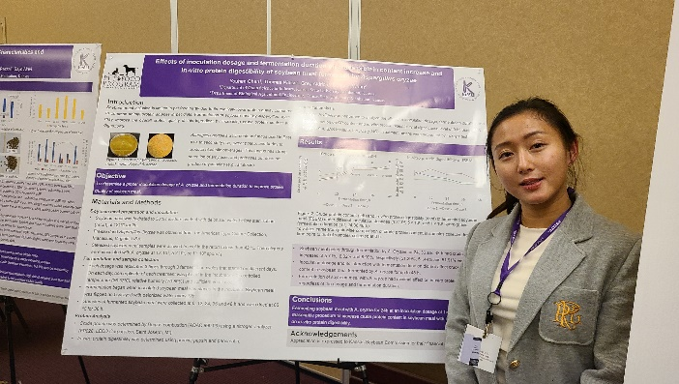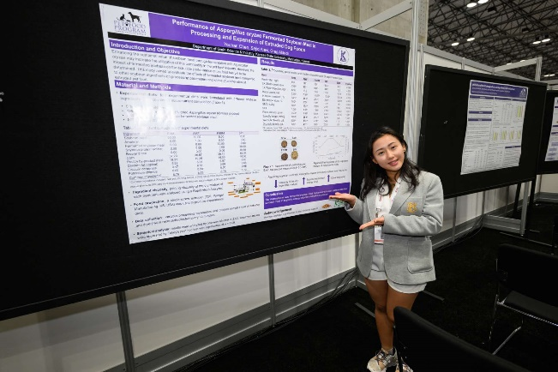
Figure 7. Awarded presentation photos. (left) KibbleCon 2023, (right) Pet Food Forum, 2024.

Peer-reviewed publications
- Chen, Y., Weiss, T., Wang, D., Alavi, S, & Aldrich, CG. Optimizing Aspergillus oryzae Inoculation and Fermentation Duration for Enhanced Protein Content in Soybean Meal and its Influence on Dog Food Extrusion. Fermentation. 2025 (in review process)
- Chen, Y., & Aldrich, CG. Digestibility and Palatability of Extruded Dog Food with Aspergillus oryzae Fermented Soybean Meal and its Influence on Colonic Fermentation. Journal of Animal Science. 2025 (in review process)

Aknowledgement: The PIs would like to thank Dr. Youhan Chen, Department of Grain Science and Industry, Kansas State University (youhan23@ksu.edu), for her valuable contributions to preparation of this report.

