Integrating Weed Management Strategies to Reduce seed Production and Viable Seed Dispersal in Kansas Soybean Production

Taylor Lambert and Jeremie Kouame

Abstract
The management of Palmer amaranth (Amaranthus palmeri) is a challenge in Kansas soybean production, particularly due to its high seed production, persistence in the soil seedbank and herbicide resistance concerns. Harvest Weed Seed Control (HWSD) strategies have shown promise in mitigating this issue by targeting weed seeds during harvest. A field trial assessed the effectiveness of herbicide programs and cover crops on Palmer amaranth biomass and seed production and the effectiveness of the HWSD in reducing Palmer amaranth seed viability in soybean fields. Results indicated that the herbicide programs were not different on their impact on biomass and seed production. In contrast, cover crops use reduced biomass and seed production ≥ 50%. Also, HWSD significantly reduced the viability of Palmer amaranth seeds exiting the back of the combine when the seed control unit was engaged (93% non-viable seed), contributing to a more effective seedbank management.

Introduction
Palmer amaranth is one of the most problematic weeds in U.S. agriculture, particularly in soybean production. Its ability to produce large numbers of seeds, coupled with its resistance to multiple herbicides (Heap, 2024) , has made it a persistent challenge for farmers. Previous research has demonstrated that a female Palmer amaranth plants can produce enormous quantities of seed, with some studies reporting up to 600,000 seeds per plant (Ward et al., 2013) . Seed retention at harvest has been identified as a critical factor in weed seedbank management (Soni et al., 2020). Harvest Weed Seed Control technologies, which manage or collect weed seeds during harvest, offer a promising solution (Walsh et al., 2017;Walsh et al., 2017;Walsh et al., 2018; Walsh et al., 2018; Walsh & Powles, 2014; Walsh et al., 2021). Previous research reported the effectiveness of the Harvest Weed Seed Destructor (HWSD) to render weed seeds non-viable (Schleich et al., 2023). However, its effectiveness could be compromised by several factors, including poor weed seed retention on the plant at harvest and losses from the combine header during harvest (Schleich et al., 2023). In particular, header losses, which occur when the combine header reel and sickle bar shake the plant, causing seeds to fall to the ground instead of being collected, can significantly reduce the number of weed seeds entering the combine (Schleich et al., 2023). As a result, understanding the performance of the HWSD requires more research conducted to quantify header losses as they occur in the field during harvest. Therefore, the objectives of this research were to evaluate (i) the impact of cover crop treatments and herbicide programs on Palmer amaranth biomass and seed production and (ii) the effectiveness of the HWSD to render Palmer amaranth seed non-viable (ii) and to quantify header loss.

Materials and Methods

Experimental Design
A field trial was conducted in a Kansas soybean field, west of Great Bend to evaluate i) the impact of cover crop treatments and herbicide programs on Palmer amaranth biomass and seed production and (ii) the effectiveness of the HWSD to render Palmer amaranth seed non-viable (ii) and to quantify header loss. The experiment had 8 treatments (two herbicide programs, two cover crop programs (with and without) and two HWSD levels (On and Off)) replicated 3 times. Each plot was 36ft wide by 150 ft long.

Sample Collection and Seed Categorization
Four major response variables were quantified: biomass production, seed production, header loss, and seed viability. To determine the impact of cover crop treatment and herbicide programs on Palmer amaranth biomass and seed production, a female palmer plant was harvested pre-harvest from each plot. To measure Palmer amaranth header loss during the harvest process, 2 pans were placed on either side of two female Palmer amaranth plants. The combine was operated at 4 mph and until the header had cut across the weed and passed over the pans which were automatically removed and bagged separately. To determine the impact of the seed control unit on Palmer amaranth seed viability, one pan was placed behind either side. (we have 2 impact mills on this machine) of the back of the combine while it was operating to collect Palmer amaranth seed exiting the HWSD (with the seed control on or off). The pans from both spots were bagged together. Following harvest, Palmer amaranth seed samples were cleaned of any foreign material. The seeds from the chaff trays where were categorized into four groups based on their level of damage (intact, slight, moderate, and fully destructed) after exiting the combine with an engaged seed control unit (Figure 1). A 0.0035 oz sub-sample was taken from the total seed sample to determine the proportion of seeds in each category. Previous studies have shown that only intact seeds retain viability after passing through the HWSD system (unpublished data); thus, only intact seeds were considered viable, while damaged seeds (slight, moderate, and destructed) were categorized as non-viable. Seed viability was calculated as the percentage of intact seeds in the total sample, both with and without the HWSD engaged.
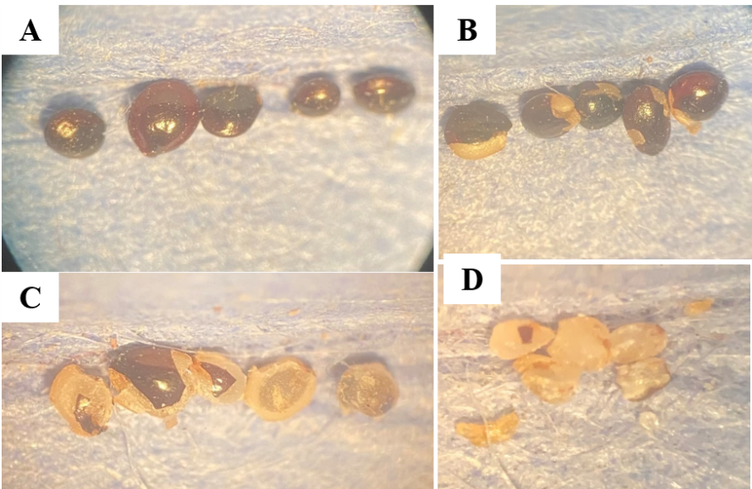
Figure 1. Categorization of damaged and non-damaged Palmer amaranth seeds collected from the seed control unit threshing loss (A) intact seed, (B) slightly damaged seeds, (C) moderately damaged, and (D) fully destructed

Data analysis
Weed biomass and seed data were subjected to ANOVA using the GLIMMIX procedure with SAS software (version 9.4; SAS Institute Inc, Cary, NC) and treatment means were separated using Tukey’s adjustment (α = 0.05). A two-sample t-test (within SAS) was used to evaluate the impact of the seed control unit (On/Off) on the viability of seed exiting the combine and the header loss.

Results and discussion

Biomass and seed production
No significant cover crop-by-herbicide interaction (p = 0.3360) was detected and the two herbicide programs did not differ in their impact on Palmer amaranth biomass (p = 0.8225). In contrast, cover crop use decreased Palmer amaranth biomass production (p = 0.0005). On average, Palmer amaranth biomass was 0.52 lb without cover crops but decreased by 54% with the implementation of cover crops (0.24 lb) (Figure 2).
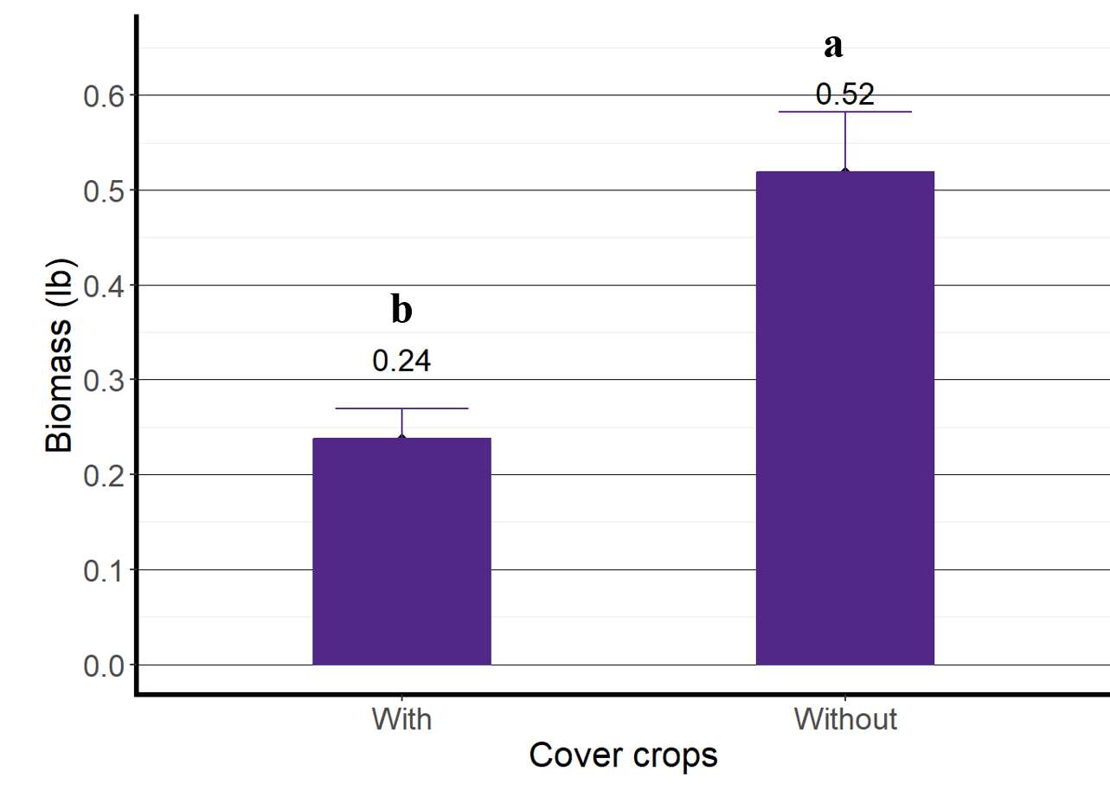
Figure 2. Impact of cover crops on Palmer amaranth biomass production

No significant cover crop-by-herbicide interaction (p = 0.0816) was detected and the two herbicide programs did not differ in their impact on Palmer amaranth seed production (p = 0.8374). In contrast, cover crop use decreased Palmer amaranth seed production (p = 0.0056). On average, Palmer amaranth produced 120,090 seeds per plant without cover crops but the seed number decreased by 50% with the implementation of cover crops (59,990 seeds) (Figure 3). These results are consistent with earlier research showing that a cereal rye cover crop reduced waterhemp seed production 90% compared to treatments without the cover crop, while herbicides had no significant impact on waterhemp seed production (Schleich et al., 2023). Additionally, the high seed production of Palmer amaranth in this study is similar previous findings of previous research (Ward et al., 2013).

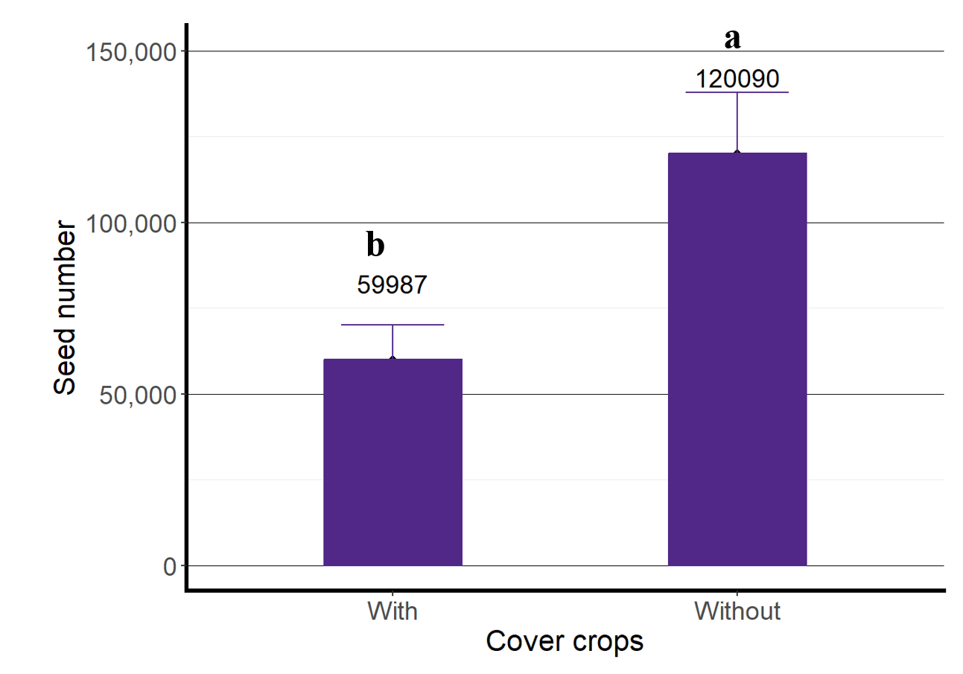Figure 3. Impact of cover crops on Palmer amaranth seed production

Header Loss
As expected, having the seed control engaged or disengaged did not impact the header loss (p = 0.6050). Palmer amaranth seeds collected in the pans, showed that an average of 2,650 seeds were lost at the header, which equated to a 3.3% loss of viable seed during harvest. Header loss results are variable in the scientific literature. For example, Schleigh et al. (2023) reported waterhemp header loss of 2.6% and was not affected by cover crop, herbicide program, or combine speed. Winans et al. (2023) reported that across 7 site-years, on average 31% of waterhemp seed that remained at harvest was lost at the combine header due to shatter, regardless of harvesting methods (either conventional or with the impact mill ). The same authors reported a header loss value of 89% for velvetleaf in a one-year data. Morningglory header loss was 48% and 58% in two different years, whereas a one year data showed header loss values of 52% and 34% for giant foxtail and common lambsquarters, respectively. The variability of values reported in the scientific literature and the ones obtained in the present study might be due to many factors that affect header loss including weed density at harvest at the specific site and the plant moisture content at the time of harvest.

Seed Viability
As expected, the percentage viability was affected by the status (On/Off) of the seed control unit (P <.0001). The viability of seeds that passed through the engaged seed control unit was significantly reduced, with only 7% of intact and viable seeds quantified in the present study (Figure 4). In contrast, when the HWSD was off, 83% of the seeds remained viable. This research needs to be repeated across years and locations to evaluate the impact of the seed control unit (On/Off) on seed viability.

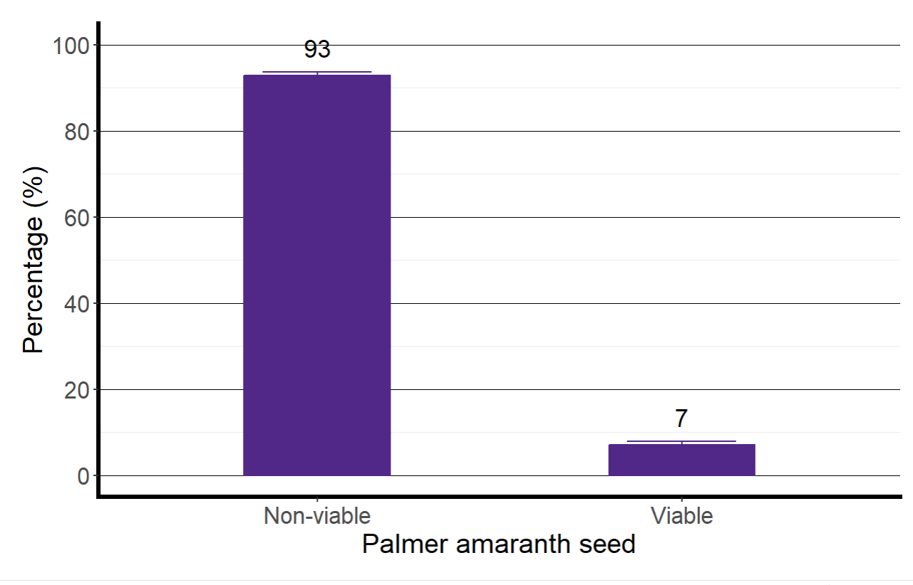
Figure 4. Impact of the engaged seed control unit on Palmer amaranth seed viability

The results of this study demonstrate that the HWSD system is highly effective in reducing the viability of Palmer amaranth seeds during harvest and can play a crucial role in reducing Palmer amaranth seedbank replenishment in soybean fields. The results about the viability of seed exiting the seed control unit are comparable to what was obtained by previous research. Ninety-six percent of waterhemp seeds that entered the combine at harvest were destroyed and seed destruction effectiveness was not affected by cereal rye cover crop, herbicide program, or combine speed (Schleich et al., 2023). Winans et al. (2023) reported 94% of waterhemp seed destructed across 7 site-years, with damage percentages ranging between 77% and 99%. Walsh et al. (2018) reported 100% Palmer amaranth seed destruction in North American soybean.

Conclusion and implications
The integration of HWSD technology into Kansas soybean production may have the potential to significantly reduce Palmer amaranth seed viability. However, this strategy is not a standalone system and should be integrated into an overall integrated weed management program to minimize Palmer amaranth seedbank replenishment and prevent further spread of this problematic weed. This study needs to be replicated in time and space to fully represent the variability across different soil types, climates, or farming practices.

Acknowledgements
This research was funded by the Kansas Soybean Commision. The authors would like to thank all the personnel at the Agricultural Research Center in Hays that helped with this study.

References
Heap, I. (2024). The international herbicide-resistant weed database online. Retrieved May 4, 2024 from www.weedscience.org
Jha, P., Norsworthy, J., Bridges, W., & Riley, M. (2008). Influence of glyphosate timing and row width on Palmer amaranth (<i>Amaranthus palmeri</i>) and pusley (<i>Richardia</i> spp.) demographics in glyphosate-resistant soybean. WEED SCIENCE, 56(3), 408-415. https://doi.org/10.1614/WS-07-174.1
Schleich, A., Licht, M., Owen, M., & Yadav, R. (2023). Managing herbicide-resistant waterhemp (Amaranthus tuberculatus [Moq.] JD Sauer) seedbanks by integrating several management tactics. AGROSYSTEMS GEOSCIENCES & ENVIRONMENT, 6(3), Article e20406. https://doi.org/10.1002/agg2.20406
Soni, N., Nissen, S. J., Westra, P., Norsworthy, J. K., Walsh, M., & Gaines, T. A. (2020). Seed retention of winter annual grass weeds at winter wheat harvest maturity shows potential for harvest weed seed control. Weed Technology, 34(2), 266-271. https://doi.org/10.1017/wet.2019.108
Walsh, M., Ouzman, J., Newman, P., Powles, S., & Llewellyn, R. (2017). High Levels of Adoption Indicate That Harvest Weed Seed Control Is Now an Established Weed Control Practice in Australian Cropping. Weed Technology, 31(3), 341-347. https://doi.org/10.1017/wet.2017.9
Walsh, M. J., Aves, C., & Powles, S. B. (2017). Harvest Weed Seed Control Systems are Similarly Effective on Rigid Ryegrass. Weed Technology, 31(2), 178-183. https://doi.org/10.1017/wet.2017.6
Walsh, M. J., Broster, J. C., & Powles, S. B. (2018). iHSD Mill Efficacy on the Seeds of Australian Cropping System Weeds. Weed Technology, 32(2), 103-108. https://doi.org/10.1017/wet.2017.95
Walsh, M. J., Broster, J. C., Schwartz‐Lazaro, L. M., Norsworthy, J. K., Davis, A. S., Tidemann, B. D.,…Bagavathiannan, M. V. (2018). Opportunities and challenges for harvest weed seed control in global cropping systems. Pest management science, 74(10), 2235-2245. https://doi.org/10.1002/ps.4802
Walsh, M. J., & Powles, S. B. (2014). High Seed Retention at Maturity of Annual Weeds Infesting Crop Fields Highlights the Potential for Harvest Weed Seed Control. Weed technology, 28(3), 486-493. https://doi.org/10.1614/WT-D-13-00183.1
Walsh, M. J., Rayner, A. E., Ruttledge, A., & Broster, J. C. (2021). Influence of chaff and chaff lines on weed seed survival and seedling emergence in Australian cropping systems. Weed Technology, 35(3), 515-521, Article Pii s0890037x20001426. https://doi.org/10.1017/wet.2020.142
Ward, S., Webster, T., & Steckel, L. (2013). Palmer amaranth (Amaranthus palmeri): A review [Review]. Weed Technology, 27(1), 12-27. https://doi.org/10.1614/WT-D-12-00113.1

