Final report – May 31, 2023 MSRPC Project: 10-15-44-22012
2022 Western Minnesota Soybean IPM Survey & Ag Student Training Program
INSTITUTION/ORGANIZATION: Regents of the University of Minnesota
PRINCIPLE INVESTIGATOR: Angie Peltier, apeltier@umn.edu, O: (218) 281-8692, C: (414) 704-1931
CO-INVESTIGATOR/S: Anthony Hanson
Project summary:
The western Minnesota soybean IPM survey expands our ability to obtain field reports on crop conditions and pest activity to tailor educational outreach to crop managers through radio, digital newsletters and through print in the ag press. The goal is to provide information regarding pest and disease pressure to producers to assist them in making economical pest management decisions.

Objective 1: 2022 Western Minnesota Soybean IPM Survey & Ag Student Training Program.
  - Conduct field surveys to report soybean crop stage and pest conditions in NW and WC MN.
    - Partner with the NDSU IPM program in conducting and reporting field and pest conditions across a region that includes NW and WC MN and eastern ND.
    - Deliver timely crop updates based on field observations with an emphasis on soybean aphid, two-spotted spider mite and other crop pest conditions as they develop.
--------------------------------------------------------------------------------------------------------------------
Leveraged funding: To provide a more diverse summer experience for this program’s interns and to share costs, we also sought and obtained funding from the Minnesota Wheat Research and Promotion Council for a similar small grains-version of the soybean survey.
Project Methodology. The MSRPC-sponsored IPM Survey was funded and conducted for the first time in 2015. UMN Extension continued this project in 2022 in coordination with similar efforts in North Dakota. As soon as MSRPC funding decisions were finalized, UMN Extension personnel began to advertise these positions to potential student interns to work out of regional Extension offices in Crookston, Moorhead and Morris, MN. Unfortunately, our efforts in this regard were not as successful as in past years. Not only had most students already lined up internships by the time we were permitted to advertise these positions, we were not permitted to pay interns the granted $15 hourly rate that would have allowed these positions to compete with the McDonald’s and Walmart’s of the region. Consequently, we only hired one intern working out of the Moorhead office, who had been recruited by one of the MSRPC 2021 scouts. This resulted in a significantly less robust survey than originally intended.
Project Deliverables:
The IPM scout began the season scouting small grains fields, switching over to soybeans mid-season. At each field, the scout collected data both inside and outside fields. Outside each field, grass areas that bordered fields were swept for grasshoppers (Figure 1) and their nymphs (Figure 2). Soybeans were inspected for soybean growth stages (Figure 3) soybean aphid incidence (Figure 4), soybean aphid severity (Figure 5), presence of aphids colonized by parasitic aphids (Figure 6), number of bean leaf beetles (Figure 7) and the severity of chewing injury they cause (Figure 8), spider mite presence on field edge (Figure 9) and inside field (Figure 10), and soybean gall midge presence (Figure 11). Please find Figures 1 through 11 below.
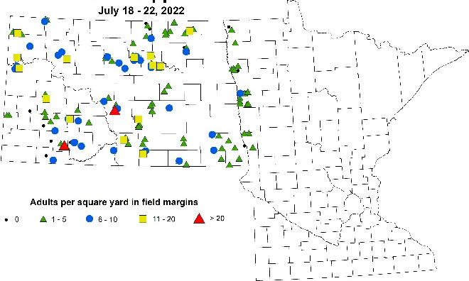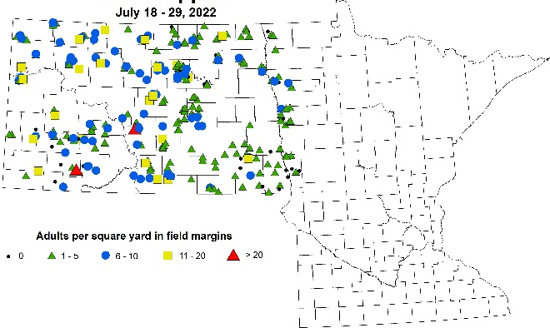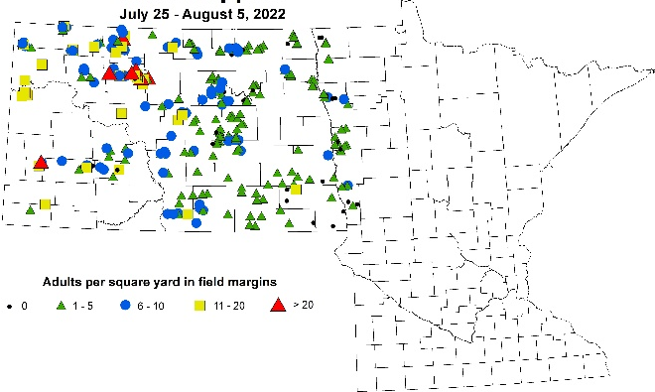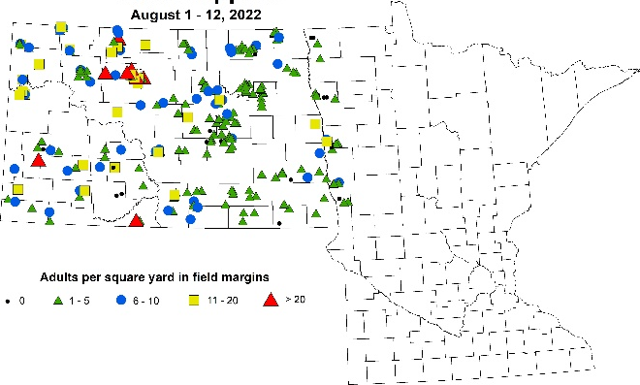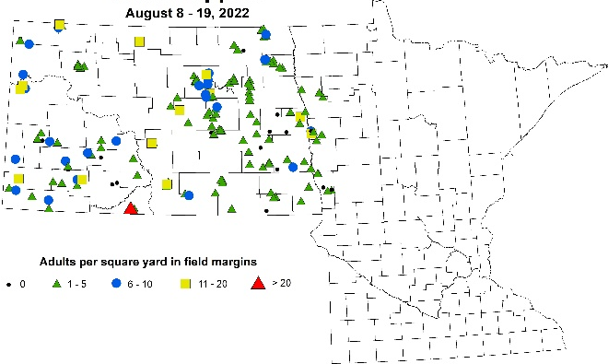
Figure 1. Grasshopper adults caught on the edge of scouted soybean fields over two-week periods from July 18 to August 19, 2022; Map: NDSU IPM.
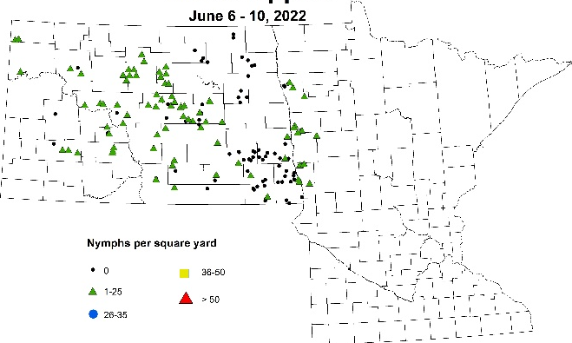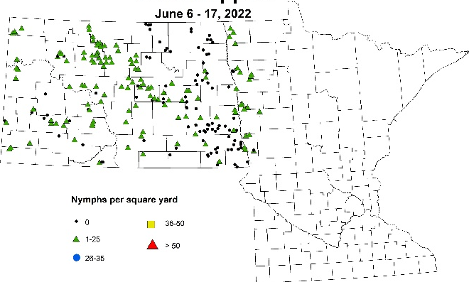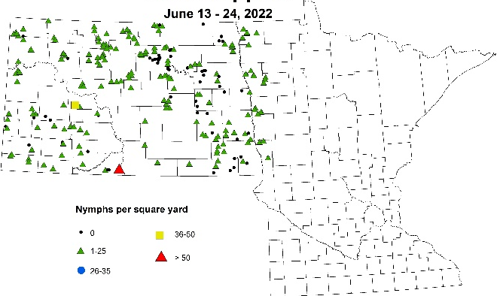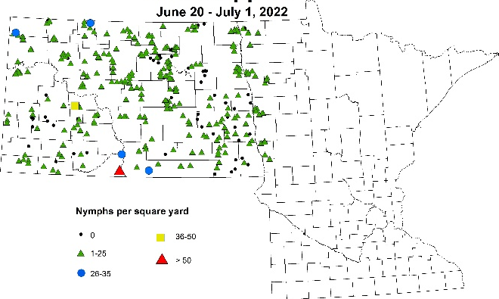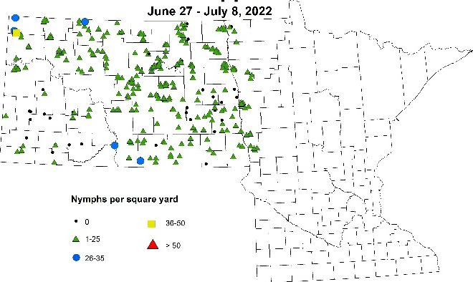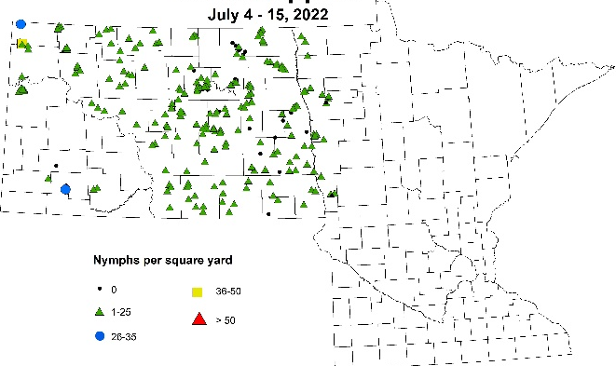
Figure 2. Grasshopper nymphs caught on the edge of scouted soybean fields over two-week periods from June 6 to July 15, 2022; Map: NDSU IPM.
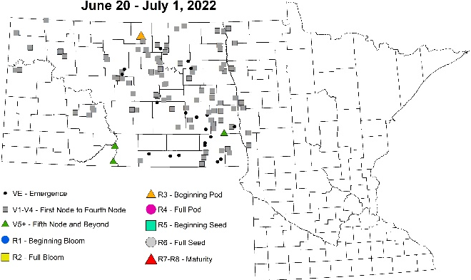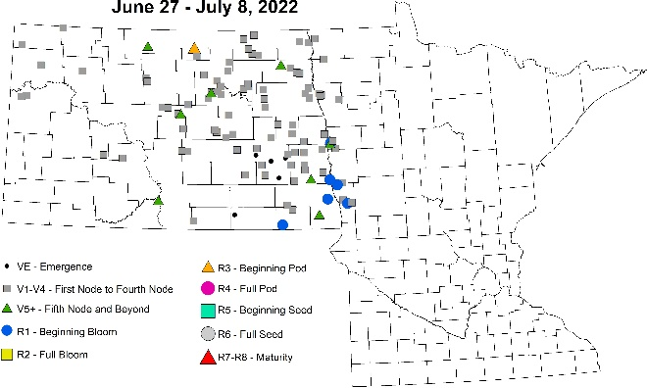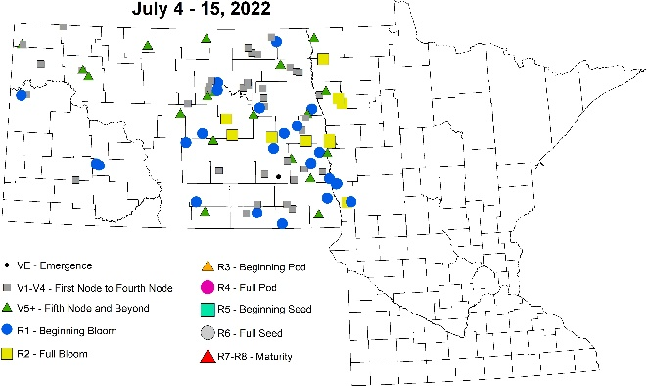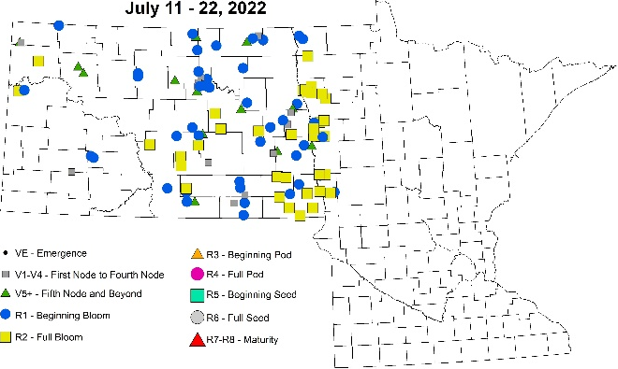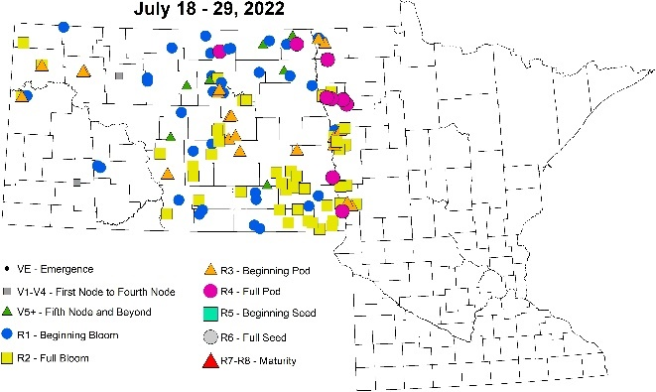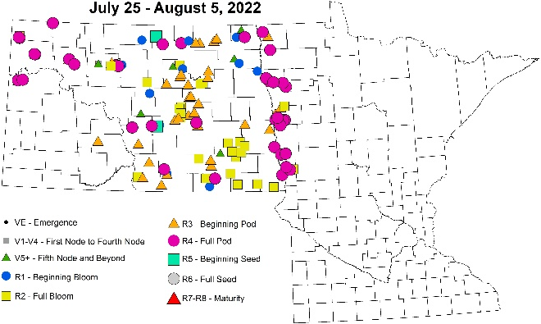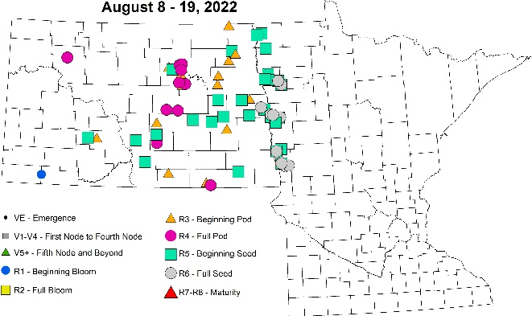
Figure 3. Soybean growth stages over two-week periods from June 20 to August 19, 2022; Map: NDSU IPM.
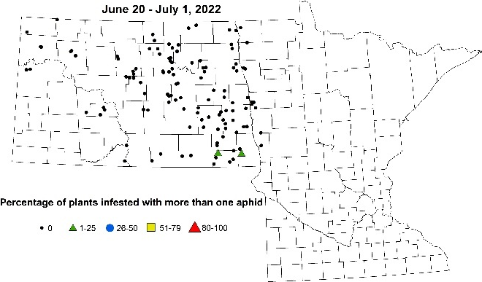 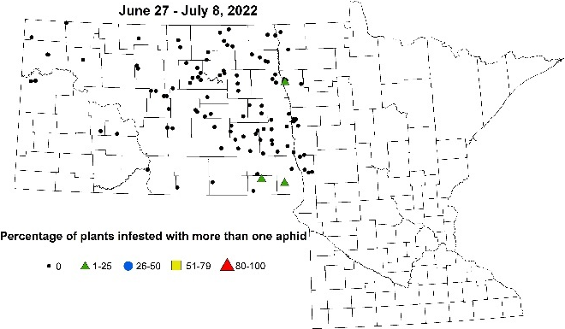 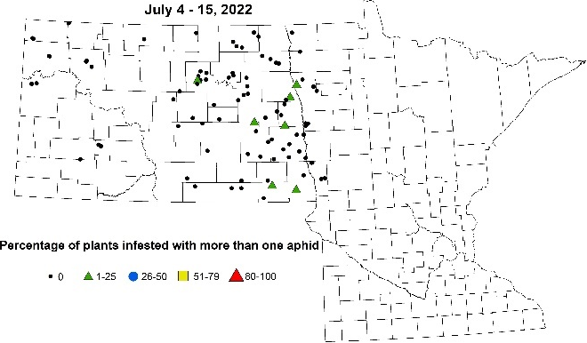 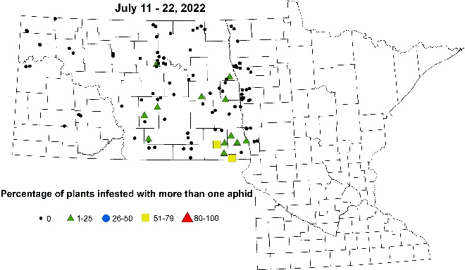 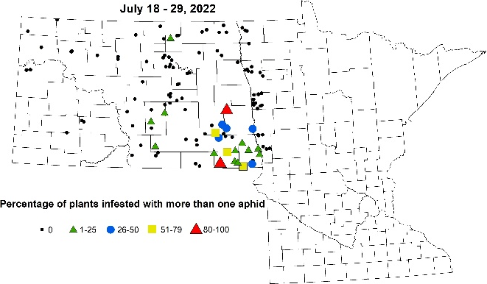 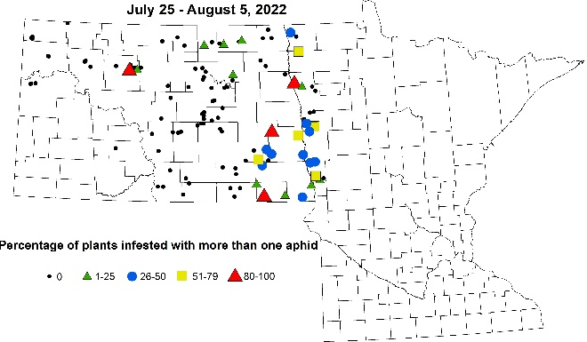 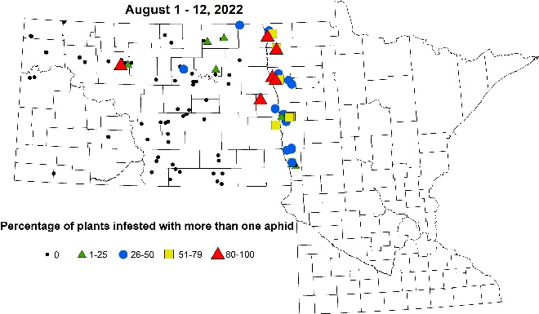 swept for 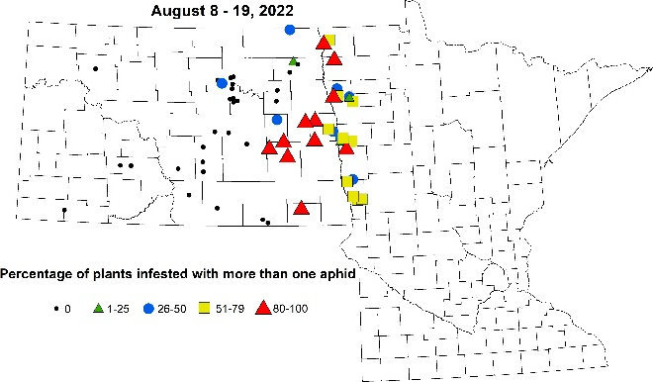
Figure 4. Soybean aphid incidence over two-week periods from June 20 to August 19, 2022; Map: NDSU IPM.
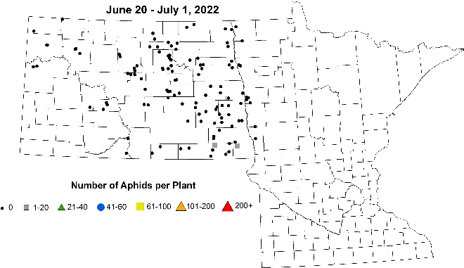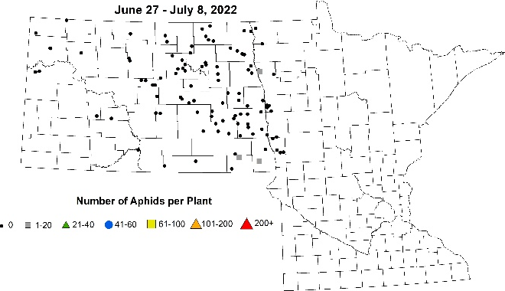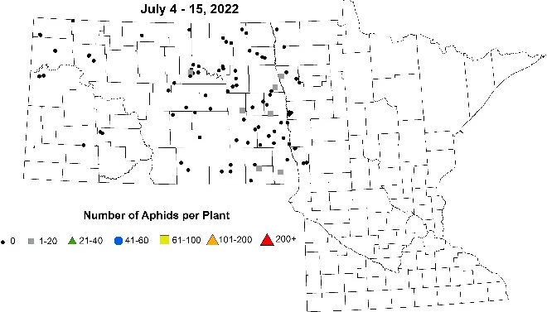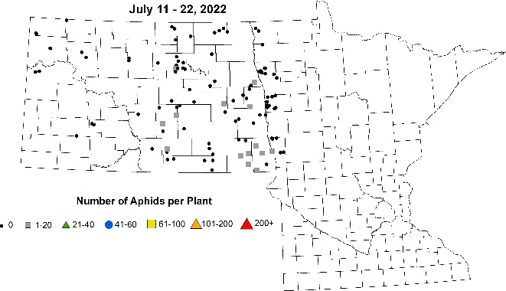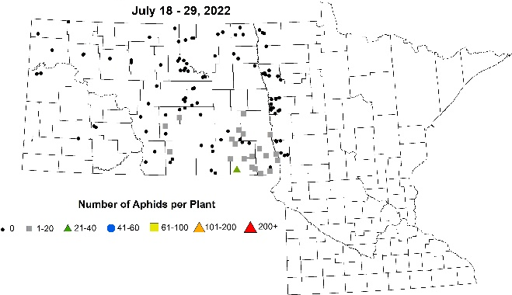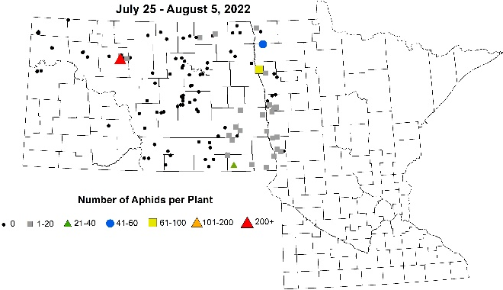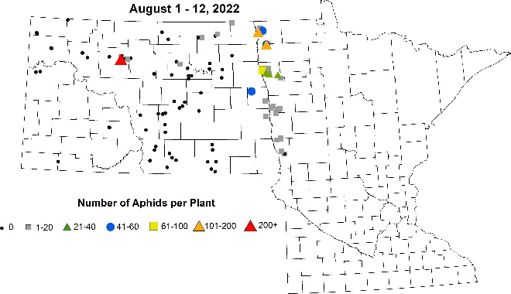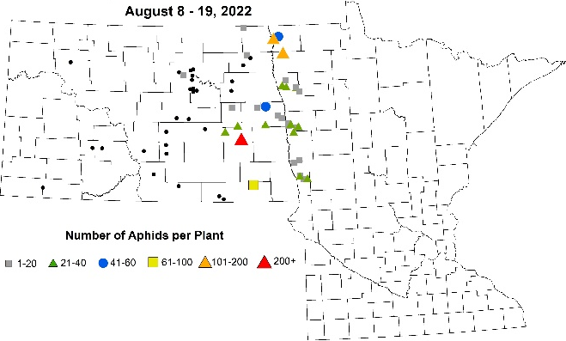
Figure 5. Soybean aphid severity (number of aphids per plant) over two-week periods from June 20 to August 19, 2022; Map: NDSU IPM.

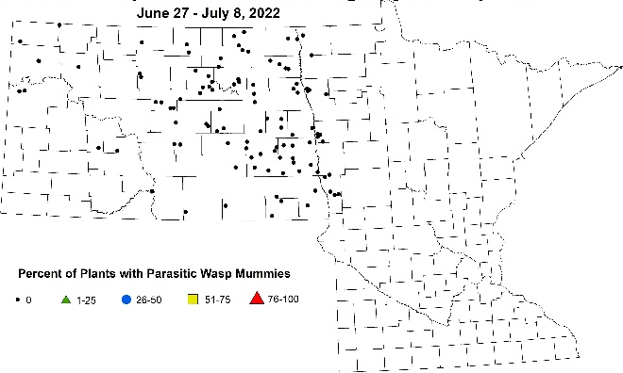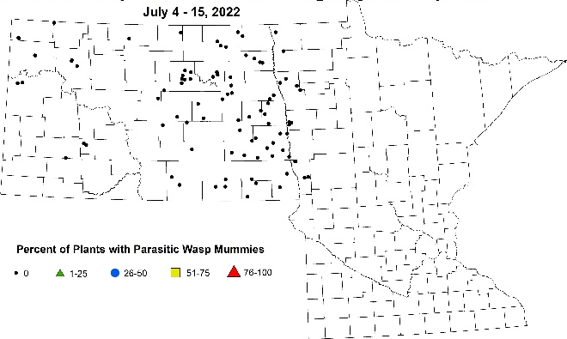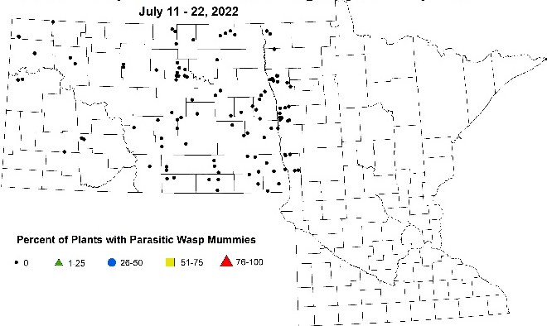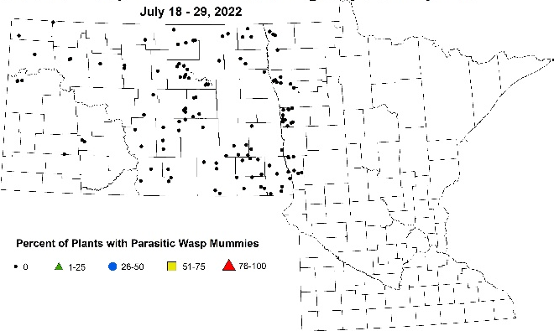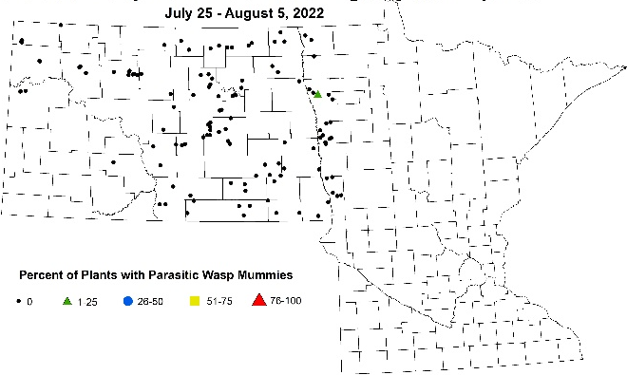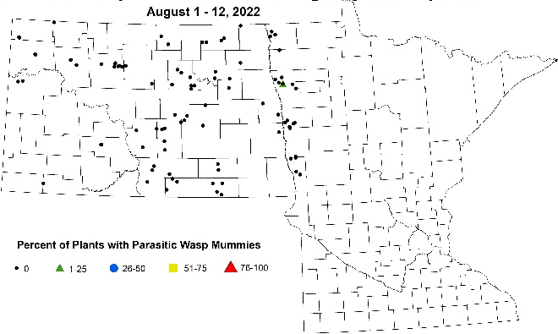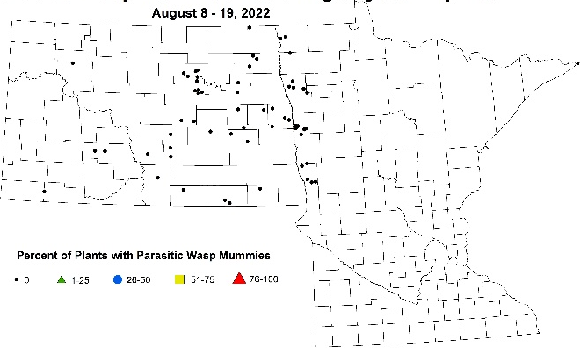
Figure 6. Percent of plants that had soybean aphids that were colonized by parasitic wasps over two-week periods from June 27 through August 19, 2022; Maps: NDSU IPM.

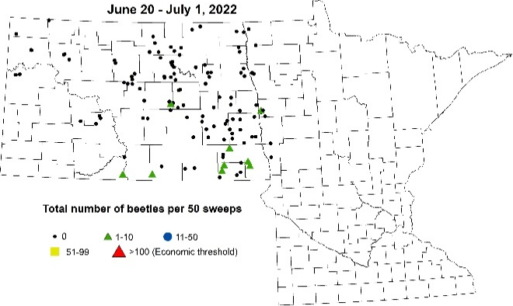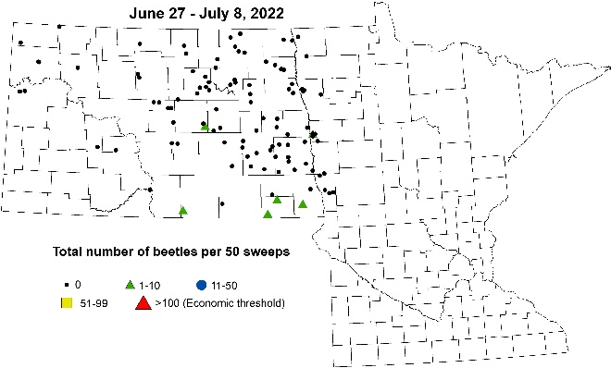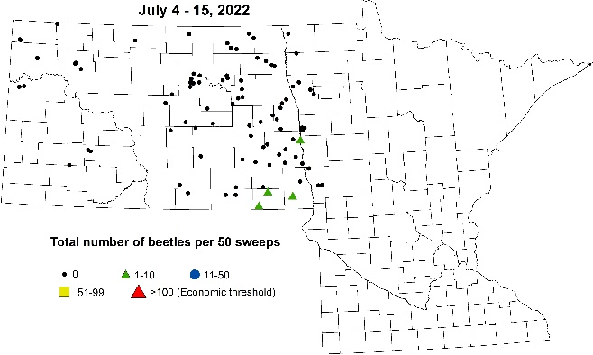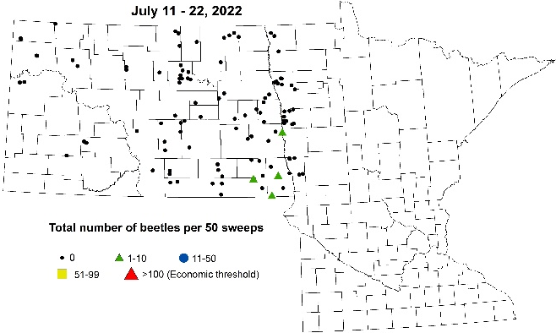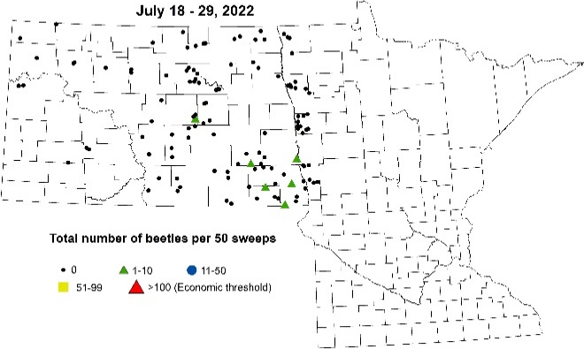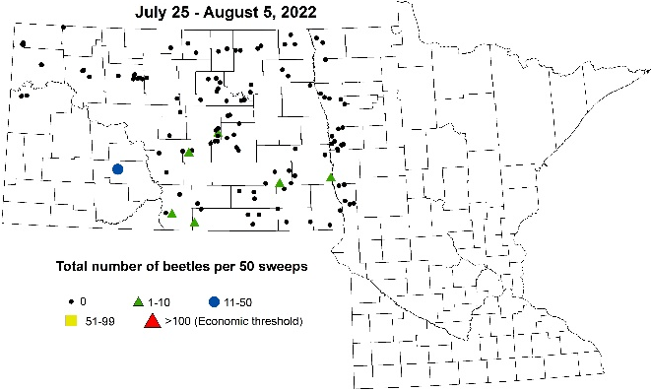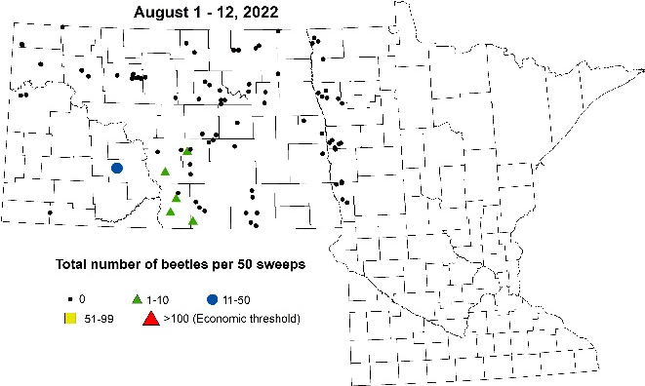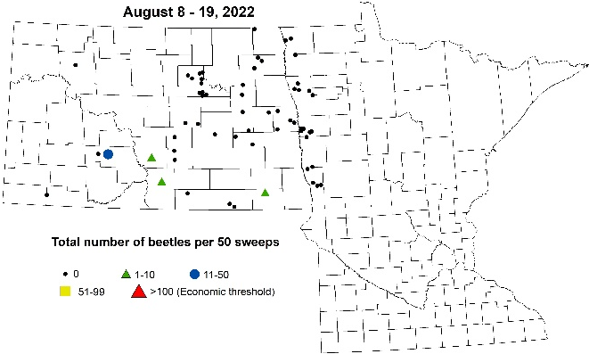
Figure 7. Number of bean leaf beetles per 50 sweeps over two-week periods from June 20 to August 19, 2022; Map: NDSU IPM.
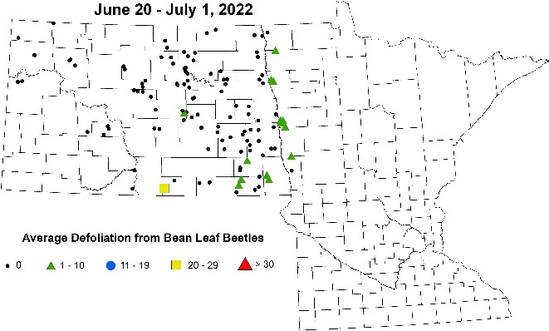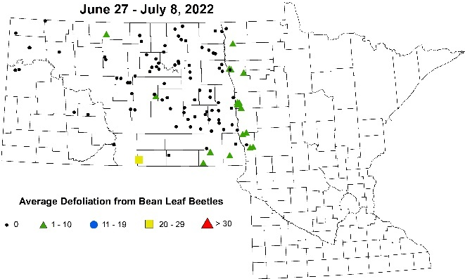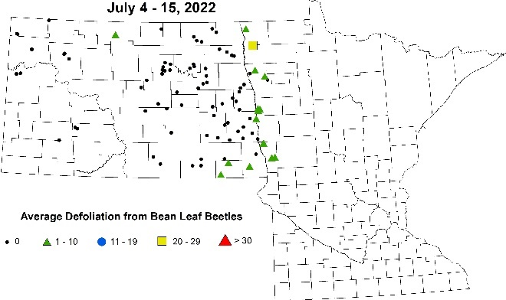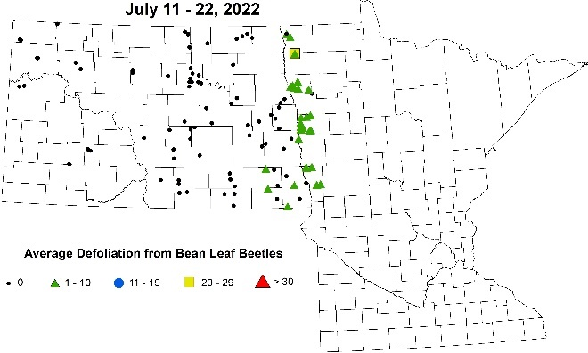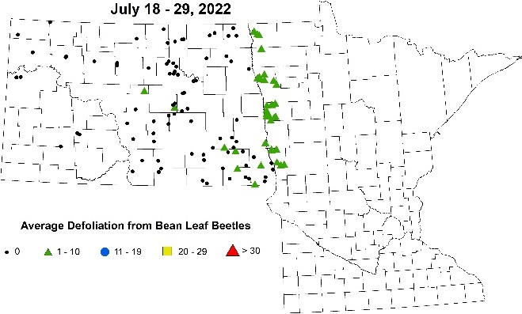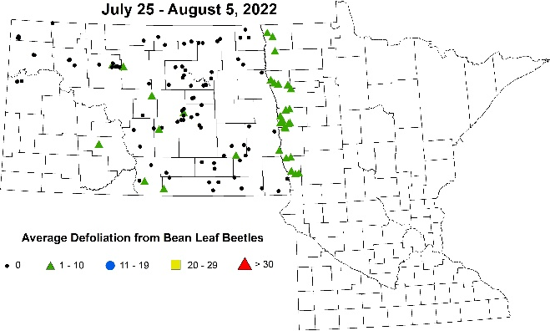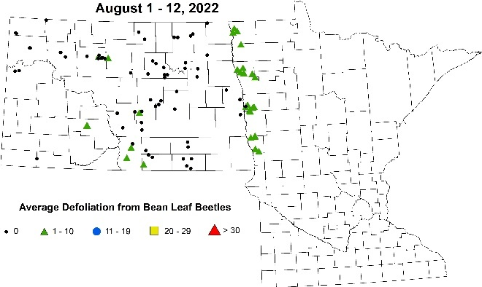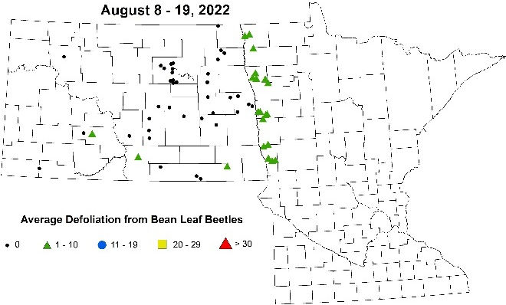
Figure 8. Average bean leaf beetle defoliation injury over two-week periods from June 20 to August 19, 2022; Map: NDSU IPM.
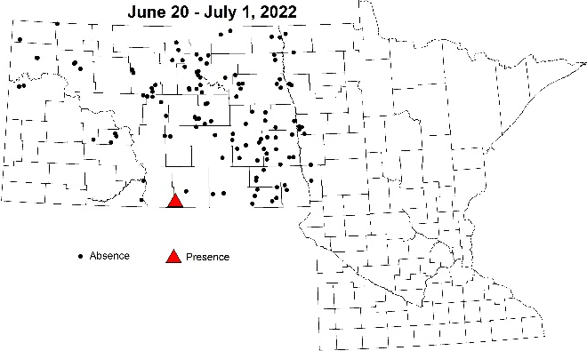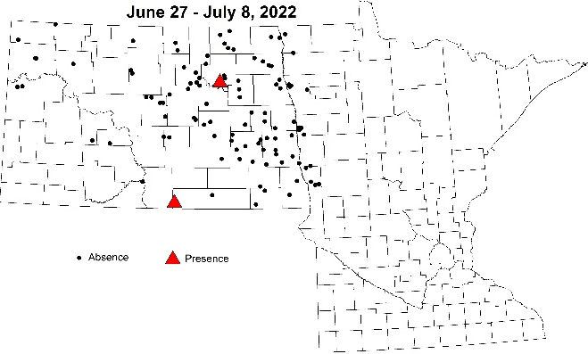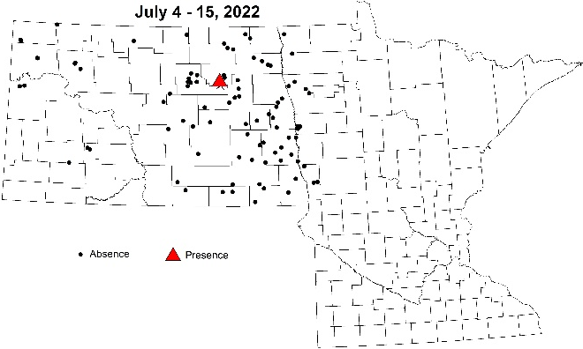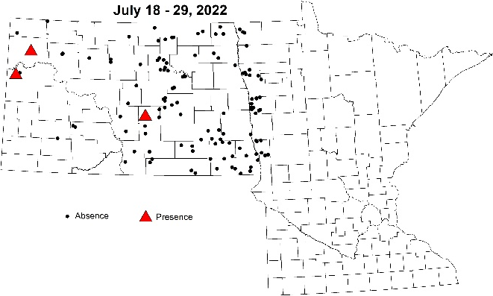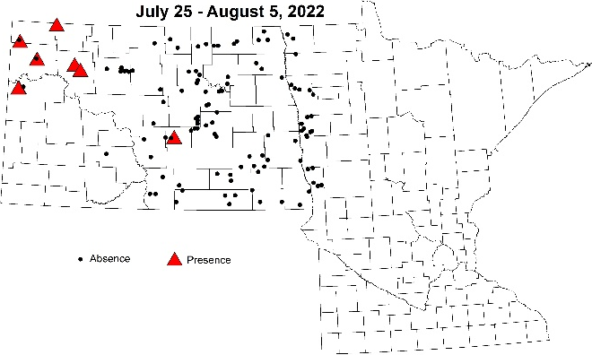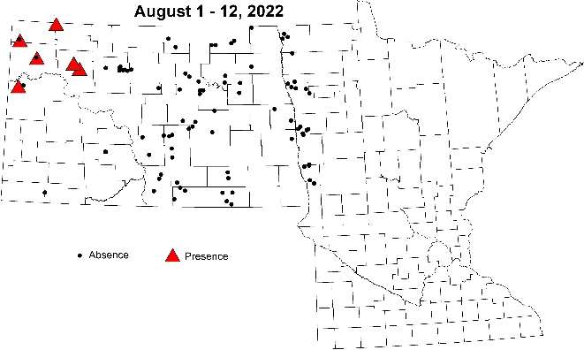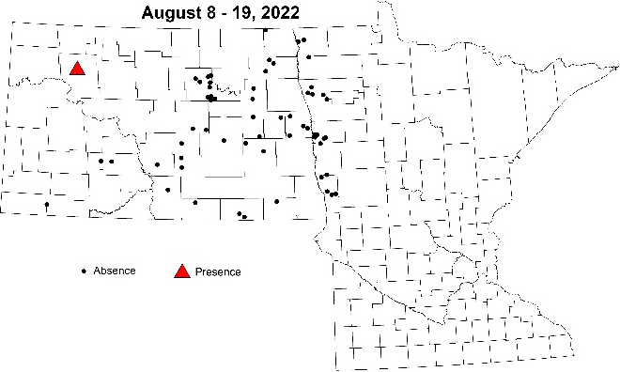
Figure 9. Presence of two-spotted spider mites on edge of field (red triangle) over two-week periods from June 20 to August 19, 2022; Map: NDSU IPM.
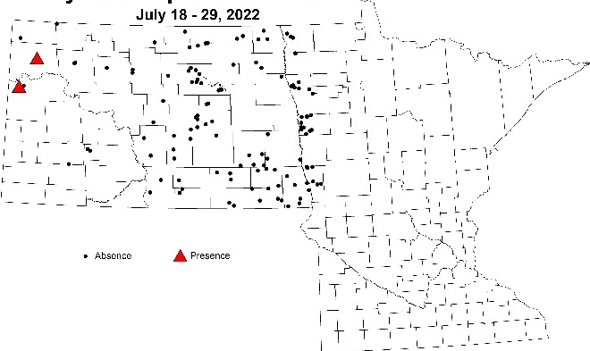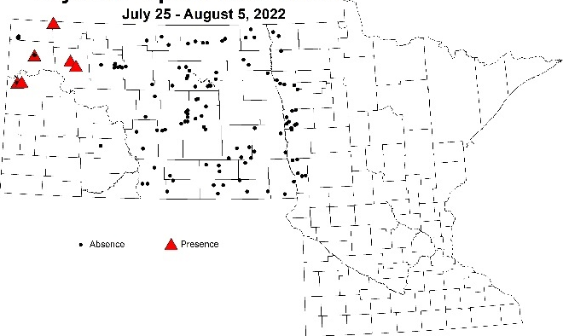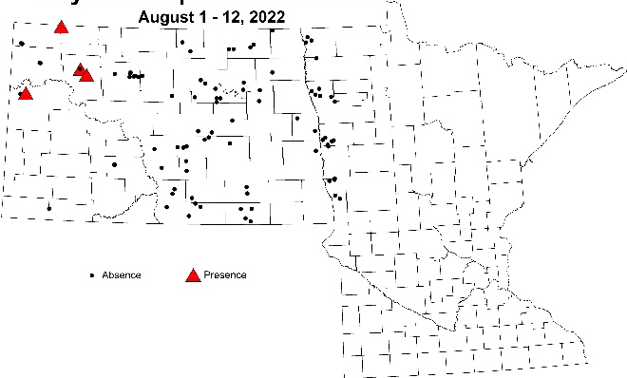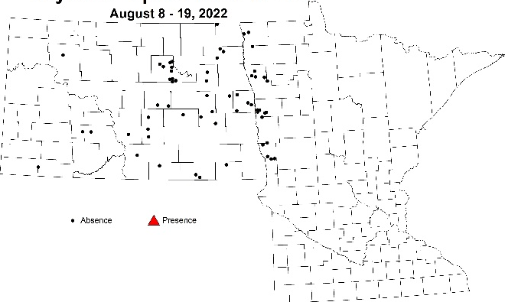
Figure 10. Presence of two-spotted spider mites (red triangle) inside field over two-week periods from July 18 to August 19, 2022; Map: NDSU IPM.
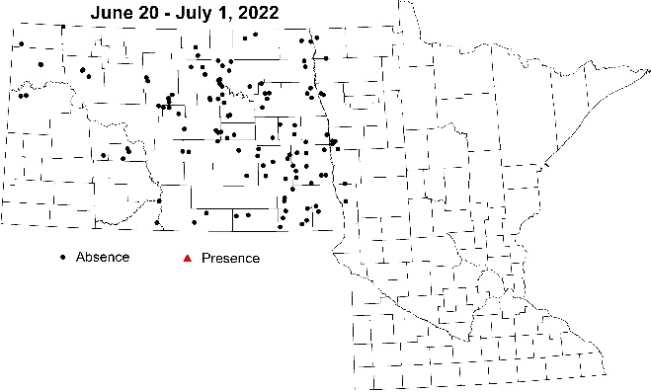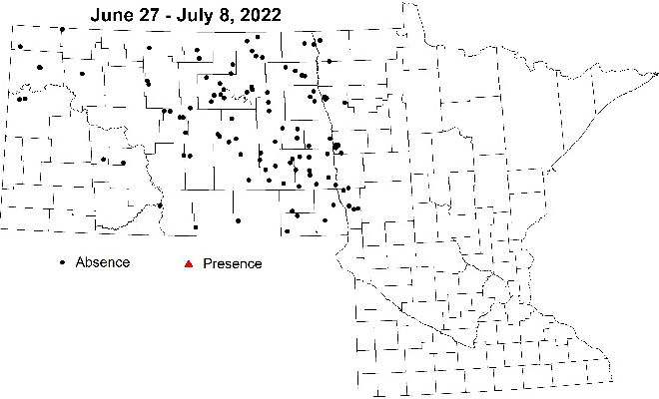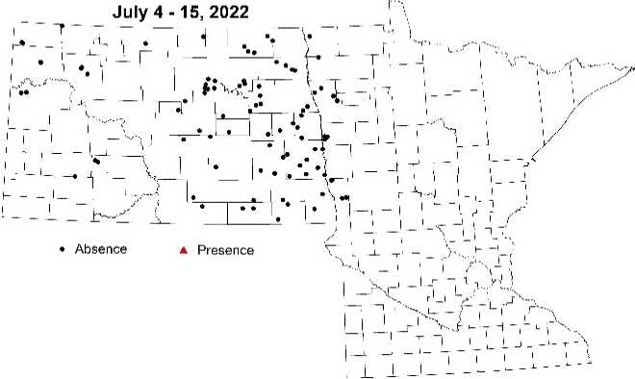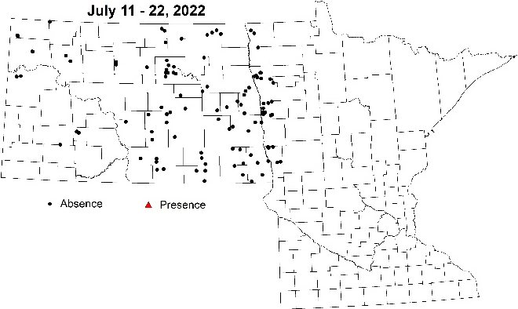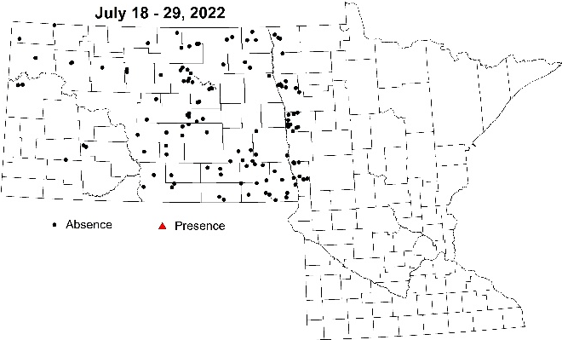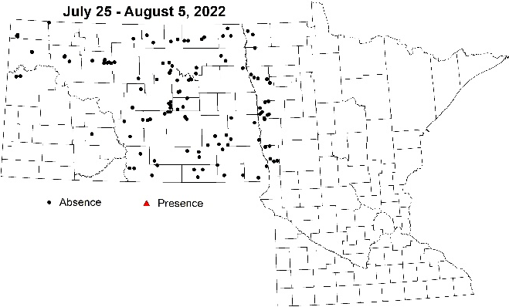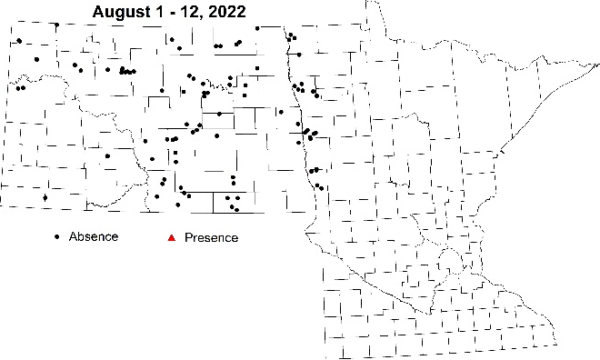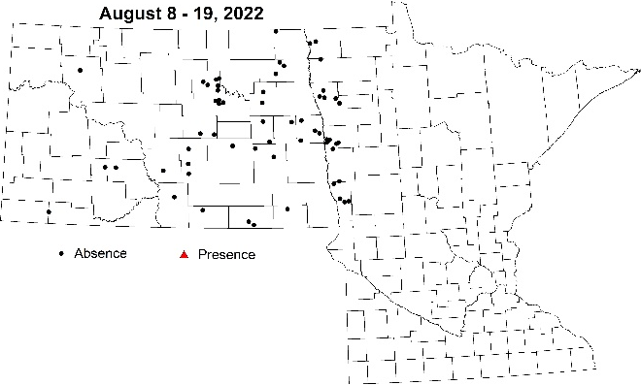
Figure 11. Presence of soybean gall midge larvae (red triangle) over two-week periods from June 20 to August 19, 2022; Map: NDSU IPM.
Outreach. Information about soybean pests and diseases was shared via blog articles, press releases, radio interviews and virtual and in-person programs. Find a listing of each below.
Blog articles (Note: Press releases based on these sessions were also compiled for statewide distribution.)
Minnesota Crop News.
- May 19, 2022. “Field Notes discussed cool, wet spring and forecast's impact on crop and pest development”. 440 page views.
- June 21, 2022. “Strategic Farming: Field Notes session discusses early-season pest and weed management challenges”. 285 page views
- July 5, 2022. “Strategic Farming: Field Notes session tackles corn rootworm and corn and soybean disease and fungicide recommendations”. 282 page views.
- August 16, 2022. “Strategic Farming: Field Notes resistance management episode - When pests bite back”. 396 page views.
Cropping Issues in NW MN.
- August 25, 2022. “NW MN IPM Survey Results”. 546 page views.
Virtual programs.
Strategic Farming: Field Notes sessions hosted by PI and/or Co-PI.
- July 6, 2022. The latest regarding risks for and management of iron deficiency chlorosis (IDC) in soybean. (55 attended live webinar, 59 downloaded audio via podcast)
- July 27, 2022: Getting Ready for late-season insects (61 attended live webinar, 53 downloaded audio via podcast)
Strategic Farming: Let’s Talk Crops!
- Mar 22, 2023. New and Emerging Pests of Corn and Soybean (109 attended live webinar, 92 watched YouTube video).
In-person programs.
UMN Field School, UMN campus-area research farm, St. Paul, MN
- July 20, 2022: Crop Pest Management sessions (2), Robert Koch and Anthony Hanson, ~30 participants
- July 21, 2022: Soybean Insect Scouting & Management sessions (2), Robert Koch & Anthony Hanson, ~ 30 participants.
Farmfest, Redwood Falls, MN
- August 3-4, 2022: UMN IPM Tools of the Trade booth, ~ 300 walk-by’s.
Prairie Grains Conference
- December 8, 2022: “An abundance of MN Soybean Research: Disease, Pest & Crop Management”, Soybean Research Reporting Session, ~ 65 participants.
Small grains update programs
- January 16, 2023: Morris, MN, 15 participants.
- January 30, 2023: McIntosh, MN, 25 participants.
- February 3, 2023: Roseau, MN, 21 participants.
Best of the Best in Wheat & Soybean Research Conferences
- February 8, 2023: Grand Forks, ND, 170 participants
- February 9, 2023: Moorhead, MN, 132 participants
Radio programs.
KTRF. 15 minutes. Farm & Home Show & KROX. 20 minutes. Valley Talk
- May 26, 2022. KTRF & KROX. Western MN IPM scouting program.
- June 16, 2022. KTRF & KROX. Western MN IPM scouting program.
- July 28, 2022. KTRF & KROX. Soybean disease and pest pressure.
- August 18, 2022. KTRF. Continue to scout to protect crops’ yield potential!
- August 26, 2022. KROX. Chlorpyrifos label revoked: here’s what to do with the Lorsban you kept handy to treat soybean aphid.
Print summary of IPM Survey results.
- Distributed to participants at the Dec. 8, 2022 Grand Forks, ND Prairie Grains Conference and at the joint MSRPC and MWRPC-sponsored Small Grains Update meetings a print summary of the survey results and interpretation. See pages 20-26 in the online version of this report here.

