FINAL Report – June 3, 2024 MSRPC Project: 10-15-44-22014
Minnesota SCN Squad: 2022 Minnesota Soybean Cyst Nematode Sampling and Education Program
Principal Investigator (PI): Angie Peltier, apeltier@umn.edu, O: (218) 281-8692
Co-PI(s): Anthony Hanson, UMN Extension and Seth Naeve, UMN Extension/Dept. of Agronomy and Plant Genetics
Cooperator: Phyllis Bongard, UMN Extension, bonga028@umn.edu,

Project Summary: Results of a prior Minnesota Soybean Research & Promotion Council-sponsored SCN sampling program administered by UMN Extension was disappointing. In 2018-2019, only 363 samples were returned for analysis after more than 5,000 sample bags were distributed to more than 1800 soybean producers, limiting the ability of UMN Extension and MSRPC members to get a ‘30,000 ft view’ of sample results that might drive both further sampling efforts and changes to soybean production practices to more actively manage SCN populations. The Team Soybean! project was designed to excite the next generation of soybean producers, agronomists and ag service providers and provide them with practical, hands-on experience in how best to detect and monitor SCN and end up getting a better ’30,000 ft view’.
Project Objectives:
- Minnesota SCN Squad: 2022 Minnesota Soybean Cyst Nematode Sampling and Education Program
  - Provide an educational curriculum to Minnesota ag teachers/FFA club advisors to increase students’ general knowledge about soybeans, their importance to the rural Minnesota economy and SCN, the most yield-limiting pathogen of Minnesota soybeans.
The first of three annotated PowerPoint presentations designed for FFA advisors to use in their classrooms has been completed and distributed (Figure 1). This presentation focuses on the contribution of soybean to Minnesota’s economy, the threat to Minnesota soybean yield posed by SCN, how the Team Soybean! program works and how to collect a soil sample for SCN in either fields that one knows is already infested or where SCN status is not known.
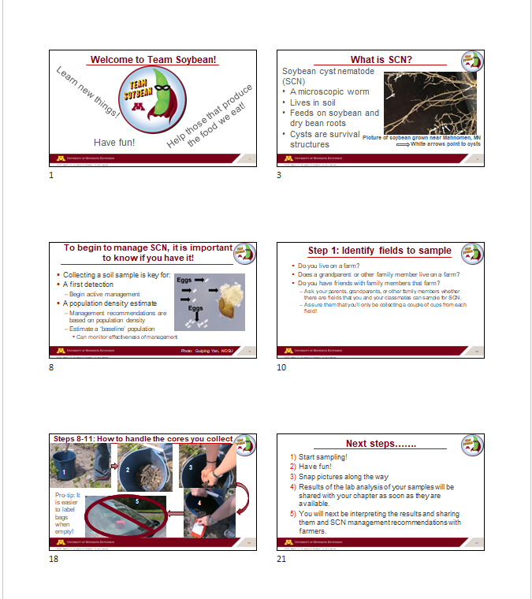
Figure 1. A sample of the slides designed for the Team Soybean! introductory PowerPoint presentation.
As SCN samples get shipped to and analyzed in the lab, another annotated PowerPoint presentation geared toward helping students interpret SCN egg count data, and how best to provide these data and egg count-based management recommendations to farmers that volunteered fields to sample is in progress. Lastly, another annotated PowerPoint presentation will be for those chapters and students that would like to “take it further” and will focus on graphically summarizing overall chapter results and providing farmers with information about regionally-adapted soybean varieties expressing a source of SCN resistance different from the most widely used PI88788.
  - Provide MSRPC-branded SCN sampling kits to FFA chapters so that they can collect soil samples for analysis from real-world farm fields, be they fields their own family or fields that local area producers farm. This sort of hands-on learning tends to create memorable ‘teachable moments’ for learners.
Items that make up the contents of an SCN sample kit were purchased and used to assemble individual sample kits for delivery to participating FFA chapters, including: bright, yellow 2 gallon buckets with lids, soil probes “branded” with a MSRPC sticker, chapter-specific sample bag labels, soil sample bags, fine and ultra-fine point Sharpies for labeling, work gloves, laminated sampling instructions (Figure 2), shipping box and pre-paid shipping label (Figure 3).
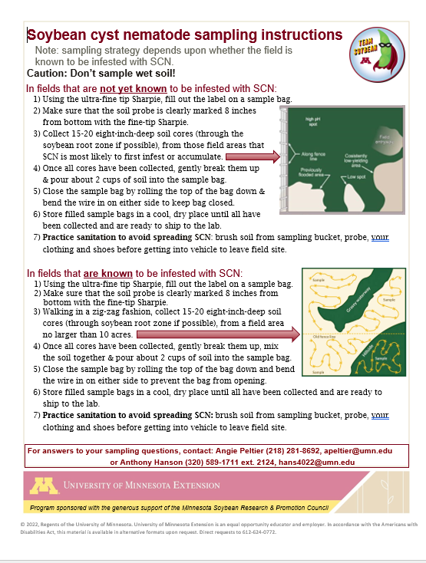
Figure 2. What the laminated soil sampling instructions look like. Note the credit to MSRPC included in the yellow banner across the bottom of the instructions.
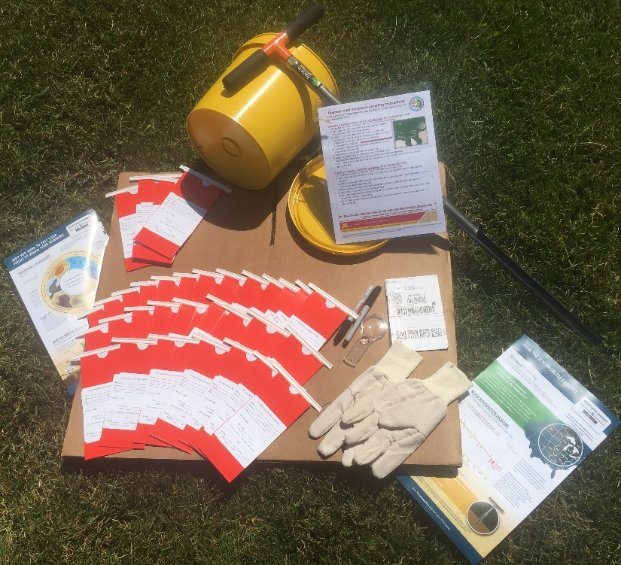
Figure 3. Contents of MSRPC-sponsored Team Soybean! sampling kit, including a soil probe with a MSRPC sticker affixed.
Participating chapters (and those that submitted samples for analysis in bold type) include: Climax-Shelly, Fosston, Frazee-Vergas, Hawley, Ulen-Hitterdal, Aitkin, Bertha-Hewitt, Pierz-Healy, Sebeka, Battle Lake, Brandon-Evansville, Herman-Norcross, Minnewaska-Glenwood Area, Osakis, Paynesville, West Central Area, Wheaton, Litchfield, Chatfield. Find the number of samples submitted by each chapter in Figure 4.
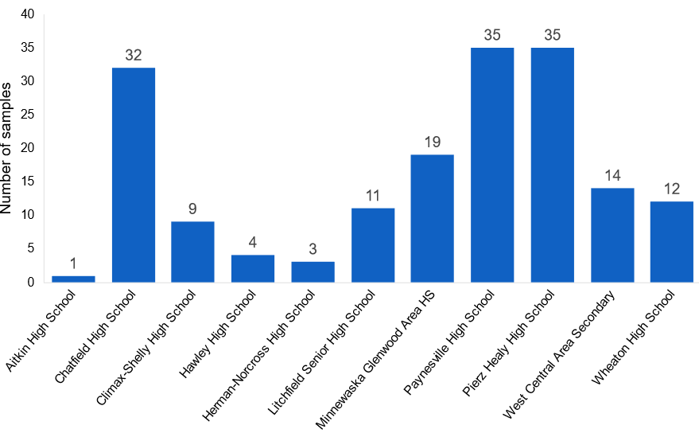
Figure 4. Number of samples submitted by 11 FFA chapters and analyzed SCN egg count as part of this program in 2022.
  - Provide results from SCN samples collected by FFA chapters so that students can discuss and map the results of their own survey, ‘learning by doing’ about the importance of gathering real-world data to assist soybean producers’ decision making.
An additional 41 slide PowerPoint presentation (Figure 5) was provided to chapter advisors that focused on what sample results mean (ex. What does eggs/100 cc mean?), what SCN management techniques are available, which management practices are recommended given a field’s sample results, how to communicate results to farmers and to others by learning how to produce charts and maps of sample results.
Chapter advisors were also provided with another fill-in-the-blank style press release to publicize the program to the community, and two spreadsheets, one that contained all of the information submitted along with samples to the lab and egg count-based management recommendations and one included most of the information included in the instructor’s spreadsheet minus management recommendations with the intention that the students learn how to contextualize and share sample results and management recommendations with participating farmers.
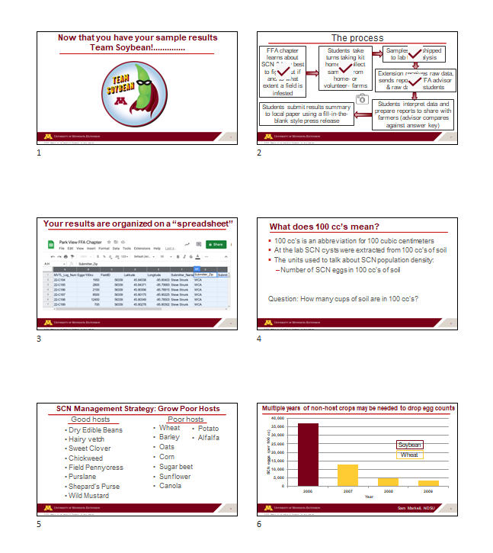
Figure 5. A 41 slide PowerPoint presentation providing information about SCN egg counts, what egg densities mean, population-based management recommendations and information about how to summarize (graph, map) and communicate a chapter’s SCN results was supplied to chapter advisors.

  - Provide data sheets and management recommendations that students will share with the farmers whose fields they sampled. This is a way to introduce students to one of the tasks of ag service providers and Extension agents.

A digital form was developed so that student email addresses could remain anonymous and sample results could be automatically emailed to the chapter advisor, who could subsequently doublecheck that the management recommendations and egg counts were without error, before forwarding the results to the participating farmer.

  - Get a ‘30,000 ft’ picture of the prevalence and severity of SCN infestations in areas of MN where SCN survey data has been sparse and underrepresented.
While the number of FFA chapters participating in this new program and the number of samples submitted by each chapter were disappointingly low, mapping of results we do have is currently underway. To get a better and more representative ‘30,000 ft view’ of SCN population densities, we submitted a no-cost extension for this project so that we could distribute sample bags to crop advisors and SWCD personnel that also have an interest in working with school-aged students or would like to offer this as a service to the farmers that they work with.

  - Survey participating FFA instructors, FFA students and farmers to evaluate program effectiveness for increasing knowledge about SCN and SCN management and increasing the desire to periodically monitor SCN population densities.
A survey of FFA advisors revealed that most used the modules developed through this program with their classes, were supportive of the program and were eager to be a part of it. In 2023 however, only one FFA chapter was interested in participating again (West Central Area) and two new classes participated (Marshall County Central Biology class and the New Richland FFA chapter) in the 2023 sampling program.

A recorded conversation regarding careers in agriculture was also shared with FFA instructors to share with their students. Staring in the video were Amy Brateng, a seed saleswoman and agronomist with South 89 Seed in Roseau, Michael Leiseth, the research plot manager at the UMN Northwest Research & Outreach Center in Crookston, Russel Delzer, the precision ag manager at Titam Machinery in Crookston and Andrew Steiner, Hancock SD FFA Advisor and owner/operator of a for-hire drone seed/pesticide application business. A student is less likely to end up in a field of study or employment if he/she is unable to “picture themselves” in a field of study or employment. These discussions (held via Zoom) were an effort to familiarize students with the sheer breadth of career options in agriculture.

