South Dakota Soybean Research and Promotion Council April 30, 2023 (Q 3)
Prepared by David Clay
Achieving 100 Bu/A soybean yields: on-farm research and sharing high yield protocols with South Dakota soybean producers
Principal investigators: David Clay, 688-5081, david.clay@sdstate.edu, Agronomy, Horticulture, and Plant Science Department, SDSU, Brookings SD; Sharon Clay, Sharon.clay@sdstate.edu, Connie Strunk, connie.strunk@sdstate.edu; and Anthony Bly, Anthony.bly@sdstate.edu;
Advisory board: David Iverson, David Wright, Craig Converse, Gordon Andersen, and Kyle Gustafson (Winfield Solutions)
On-farm studies provide information that producers use to reduce the economic risks associated with new products, test the efficiency of components within their current operation, and test innovative new ideas and concepts. In the project, a producer chooses his/her treatments based on their interest or desire prior to implementation. SDSU agronomists assist in experimental design, treatment application, scouting, and analysis. At the completion of the project, reports are distributed to the farmer collaborator, and they are posted SD Soybean Research and Promotion on-farm web site. Farmers use results from the study to identify treatments that might be success on their farm and reduce the economic risks associated with new products. To date, over 450 experiments have been conducted by SD farmers. SDSU undergraduate students are using the on-farm studies for their capstone class and planning for SOY100 2022 is completed. We just received word that additional support on soil health is being provided by NRCS. This project is centered around Madison, and it will provide funding for the adoption and quantification of BMP on soil health. We are in the process of identifying collaborators for this this on-farm study. This new project will help expand our on-farm research on soybeans and soil health.

- Continue the on-farm research program in 2021;
  - On farm studies
  - Create a remote sensing yield model
- Continue research designed to determine the importance of soil health in optimizing soybean
- Deliver information to producers through Soy100, AgOutlook, SD on-farm web-site, news releases, radio interviews, and SDSU websites.
- Use data collected in the on-farm SDSU classes (PS475 and PS428)

This year’s research work involves two activities that include continuing the on-farm studies and creating a remote sensing based yield model.
- Soybean On-farm Trials conducted in 2022:
Overall, we had over 79 total trials considering different yield zones throughout the state. This year trails were conducted at 18 different counties. Total enrollment was 30 growers including 15 new enrollments. On-farm research consist of varieties of experiment including seeding rate, varieties, Vitazyme, biologicals, fungicide et. This year’s experiments are mostly dominated with vitazyme, biological, seeding rate and soil health and UAV data was collected at different growth phase of the crop. More detail about the experiment is provided below in the table and figure.
Table. Total list of the trail in 2022. Yellow color highlighted are new farmers enrolled in 2022.
Farmer | County | Treatment | # of Trials | UAV
Minor, Lance | Aurora | Vitazyme in-furrow | 2 | √
Minor, Lance | Aurora | GoldStart in-furrow | 2 | √
Minor, Lance | Aurora | Seeding rate reduced by 30k | 2 | √
Minor, Lance | Aurora | Seeding rate increased by 30k | 2 | √
Hamilton, Jeff | Beatle | compost | 2
Ostrem, Tim | Beresford | Vitazyme in-furrow | 2 | √
Hanten, Todd | Codington | Vitazyme in-furrow | 2 | √
Holzwarth, Luke | Codington | Vitazyme in-furrow | 2 | √
Strom, Nick | Groton | foliar fungicide | 2 | √
Martinmaas, Tyson | Highmore | foliar fungicides | 2 | √
Jorgensen, Bryan | Kimbell | Biological seed treatment | 2 | √
Jorgensen, Bryan | Kimbell | SG Assist - Starter | 2 | √
Jorgensen, Bryan | Kimbell | foliar micronutrient | 2 | √
Strom, Corey | Kimbell | Sound Ag foliar | 2 | √
Carlson, Scott | Kingsburry | Starter | 2 | √
Converse, Craig | Kingsburry | Vitazyme in-furrow | 3 | √
Alverson, Keith | Lake | Populations | 3 | √
Alverson, Keith | Lake | Varieties | 3 | √
Renaas, Doyle | Lake | Vitazyme seed treatment | 2
Loewe, Matt | Lincoln | low seeding rate | 3 | √
Loewe, Matt | Lincoln | high seeding rate | 3 | √
Dave Claussen | Miner | salinity | 2 | √
Scott, Kevin | Minnihaha | Vitazyme in-furrow | 2 | √
Harnisch, Matt | Mitchel | winter rye cover crop | 2 | √
Paul Westhoff | Salem | Different landscape | 2 | √
Fischbach, Chris | Warner | Sound Ag foliar | 2
Fischbach, Chris | Warner | Vitazyme foliar | 2
Fechner, Darren | Yankton | Vitazyme in-furrow | 4 | √
Van Osdel, Brandon | Yankton | foliar fungicide | 2 | √
Frank Nedved | Yankton | Variety | 3 | √
Chad Malone | Kingsbury | Soil Health | 2
Ed Wilkinson | Kingsbury | Soil Health | 1
Chad Malone | Kingsbury | Soil Health | 1
Greg Albrecht | Kingsbury | Soil Health | 1
Paul Casper | Kingsbury | Soil Health | 1
Paul Casper | Kingsbury | Soil Health | 1
Scott Jensen | Kingsbury | Soil Health | 1
Jon Nelson | Kingsbury | Soil Health | 1
Lynn Jensen | Kingsbury | Soil Health | 1
Brett Anderson | Kingsbury | Soil Health | 1
 |  |  | 79
When compared to 2021-2022, the number of projects has increased from 63 to 71. Ten of these new on-farm projects are associated with soil health. The soil heath projects will be ongoing efforts over the next several years.
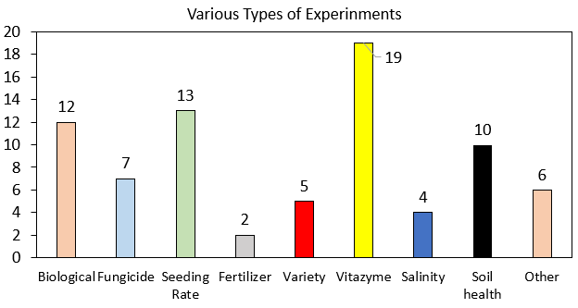
Total Farmers enrolled: 31
New farmers enrolled: 15
Total counties involved: 17

Figure 1. Various types of experinment conducted and their total numbers.
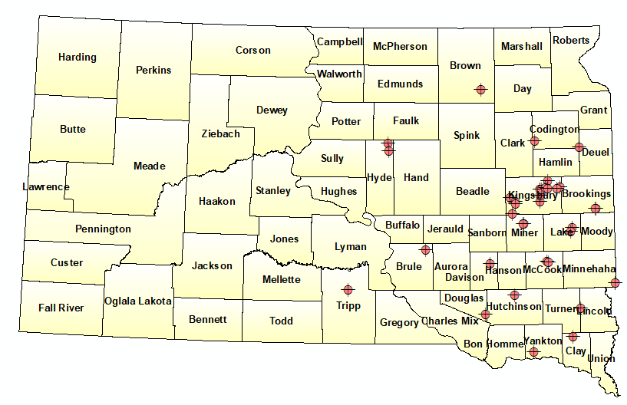
Figure 2. Distribution of different experinment at different counties of SD state.
Current progress
Abjective 1. Currently we have completed the project reports from 2022.
Objective 2: Develop PF algorithms that can be used by SD farmers to predict yields.
This has been completed and a summary of this work is below.
In modern precision agriculture, preharvest yield prediction plays a critical role in various decision-making process such grain policy making, crop marketing, price forecasting, insurance, and harvest plan. This paper presents deep neural network (DNN) as deep learning model and various machine learning based models such as random forest (RF), support vector machine (SVM), LASSO and ADABOOST in combination with high resolution satellite imagery to predict soybean yield in field scale level. Six high resolution satellite images (3.12 x 3.12m) at various growth stage of the soybean plants were used in 2019 and 2021 at three different locations of South Dakota. Ten different vegetative index (VI) were calculated from each derived images and yield data using yield monitoring system were used to predict soybean yield. Coefficient of determination (R2) and root mean squared error (RMSE) were utilized to evaluate the performance of models. Out of all tested models, DNN found to outperform to predict soybean yield across all locations and years. The reason behind its best accuracy was its multiple stacked nonlinear layers which resulted DNN as one of the most powerful nonlinear models. In our analysis we had 5 hidden layers and 50 neurons in each layer. Additionally, it applied cutting-edge deep learning methods like batch normalization and drop out, which improved overall prediction accuracy in comparison to other models. Moreover, accuracy of such model can be improved more by incorporating various environmental variables such as temperature, rainfall, soil type, elevation, and crop management in the models.
Objective 2: importance of cover crops
We conducted a detailed review article on the potential for cover crops to improve soil health. The abstract is below.
By influencing soil organic carbon (SOC), cover crops play a key role in shaping soil health and hence the system’s long-term sustainability. However, the magnitude by which cover crops impacts SOC depends on multiple factors, including soil type, climate, crop rotation, tillage type, cover crop growth, and years under management. To elucidate how these multiple factors influence the relative impact of cover crops on SOC, we conducted a meta-analysis on the impacts of cover crops within rotations that included corn (Zea mays L.) on SOC accumulation. Information on climatic conditions, soil characteristics, management, and cover crop performance was extracted, resulting in 198 paired comparisons from 61 peer-reviewed studies. Over the course of each study, cover crops on average increased SOC by 7.3% (95% CI, 4.9%–9.6%). Furthermore, the impact of cover crop–induced increases in percent change SOC was evaluated across soil textures, cover crop types, crop rotations, biomass amounts, cover crop durations, tillage practices, and climatic zones. Our results suggest that current cover crop–based corn production systems are sequestering 5.5 million Mg of SOC-C per year in the United States and have the potential to sequester 175 million Mg SOC per year globally. These findings can be used to improve carbon footprint calculations and develop science-based policy recommendations. Taken altogether, cover cropping is a promising strategy to sequester atmospheric C and hence make corn production systems more resilient to changing climates

Objective 3: Distribute information to farmers
2023 Soy100 2023 meeting. The planning committee consists of Adam Kask, Maria Kessler, Maggie VanderLaan, David Iverson, Kyle Gustafson, Anthony Bly, Connie Strunk, David Clay, and Shaina Westhoff.
This year we had a successful meeting and 139 people attended the meeting. The survey showed that the presentations were well received.
Cheryl Reese has also been involved in Soybean Shop Talks during 2023. The planning for soy100 for 2024 has been started.
New projects for 2023
New projects for 2023. Currently we have over 45 projects scheduled for 2023
Count | Name | Treatment | County
1 | Alverson, Keith | Lower population | Lake
2 | Alverson, Keith | Higher population | Lake
3 | Biskeborn, Scott | Xylem Plus | Brule
4 | Biskeborn, Scott | Vitazyme in-furrow | Brule
5 | Converse, Craig | BioCore | Kingsbury
6 | Converse, Craig | Biovante | Kingsbury
7 | Converse, Craig | Kunza | Kingsbury
8 | Converse, Craig | NanoPhos | Kingsbury
9 | Fechner, Darren | Vitazyme In-furrow | Douglas
10 | Fischbach, Chris | Source Foliar | Brown
11 | Holler, Morgan | Fungicide next week | Day
12 | Jorgensen, Bryan | Jun 30 foilar | Tripp
13 | Jorgensen, Bryan | Jul 5 foliar | Tripp
14 | Loewe, Matt | Higher population | Lincoln
15 | Loewe, Matt | Lower population | Lincoln
16 | Nelson, Jon | Nutricharge w/ 10-34-0 | Kingsbury
17 | Nelson, Jon | AgroLiquids Access S + Fulvic Ca | Kingsbury
18 | Scott, Kevin | Several trials - he'll get us | Minnehaha
19 | Strom, Corey | Vitazyme foliar @ R1 | Brule
20 | Strom, Corey | Vitazyme in-furrow | Brule
21 | Strom, Corey | Foliar fungicide | Brule
22 | Strom, Nick | BW Fusion Soyworks | Brown
23 | Strom, Nick | BW Fusion Soyworks | Brown

On-farm research projects in corn with biologicals and bio-stimulants.
Count | Name | Treatment | County
1 | Boesen, Todd | Pivot Bio | Brule
2 | Carlson, Scott | Holganix | Kingsbury
3 | Converse, Craig | BioArmor | Kingsbury
4 | Converse, Craig | BioCore | Kingsbury
5 | Converse, Craig | Biocore | Kingsbury
6 | Converse, Craig | BioniQ | Kingsbury
7 | Converse, Craig | Biovante | Kingsbury
8 | Converse, Craig | NanoCS | Kingsbury
9 | Converse, Craig | NanoCS | Kingsbury
10 | Converse, Craig | Nutriquire | Kingsbury
11 | Hanten, Todd | Holganix | Deuel
12 | Holler, Morgan | Evita Foliar | Day
13 | Jorgensen, Bryan | SG InFuze | Tripp
14 | McNeil, B.J. | Homemade biological | Hand
15 | Nedved, Frank | Biological or biostimulant | Yankton
16 | Nelson, Jon | Growcentia | Kingsbury
17 | Nelson, Jon | Holganix | Kingsbury
18 | Prouty, Martin | Pivot Bio | Hamlin
19 | Strom, Corey | Excelerate | Brule
20 | Strom, Nick | BW Fusion Cornworks | Brown
21 | Strom, Nick | BW Fusion Cornworks | Brown
22 | Strom, Nick | BW Fusion Cornworks | Brown

Research papers Accepted
- Joshi, D., H. Sieverding, H. Xu, H. Kwon, M. Wang, S. A. Clay, J. Johnson, S. Westhoff, and D. Clay. 2023. A global meta-analysis of cover crop response on soil carbon storage within a corn production system. Agronomy Journal, 2023, 1-15

In preparation
- Joshi, D.R., Clay., S.A., Sharma, P., Rekabdarkolaee, H.M., Kharel, T., Risso, D.M., Thapa, R., and Clay D.E., (2024) Artificial Intelligence and Satellite Based Remote Sensing can be used to Predict in-season Soybean (Glycine max) Yield, Agronomy Journal (in review)

Invited presentations
- Clay, D.E., Joshi, D., Miller, J., and S.A. Clay. 2023. Cover crop impact on corn yields, GHG emissions, and soil health. Precision Crop Cropping System Workshop. Brookings SD 7-20-23 (attendance 40).
- Westhoff, S., and D.E. Clay. 2023. Soil carbon, ASFMRA annual meeting, Brandon, SD, D June 9, 2023, attendance, 50.
- Clay, D.E. (2023) Presenter and mediator University Industry Council, Sioux Falls April 20, 2023, attendance 30
- Clay, D.E. 2023. Soil Carbon Markets, Nebraska Ethanol Board, Ethanol Forum, LaVista Nebraska, March 6-7, attendance, 150.
- Clay, D.E. 2023. Soil Carbon Markets, SD Chapter ASFMRA annual and educational meeting, Pierre, SD March 10, 2023, attendance, 50.
- Clay, D.E. 2022, Carbon neutrality, Kick off for endowed chair lectures at SDSU, September30, 2022. Brookings, SD attendance 30
- Clay, D.E. 2022. Kick off meeting for RCPP, Madison SD, September 13, 2022. Attendance 120.
- Clay, D.E. 2022. Everything counts, farm-to-biofuel carbon market opportunities. American coalition of Ethanol. Omaha, NE, August 23, 2022.
Volunteered paper
- Miller, J, S.A. Clay, D.E. Clay, G. Reicks, D.P. Horvath, and A.L. Daaigh. Corn-rye interactions by rye termination using RNA-Seq and analysis. ASA 2022 annual meeting, Baltimore, November 7-11.
- Kommineni, V., S. Xu., D.E. Clay, M.G. Nisrani. 2022, Soil health response to biochar and organic manure amendments in South Dakota Cover crop system. ASA 2022 annual meeting, Baltimore, November 7-11.
- Joshi, D.R., R. Ghimire, U. Mishra, S.A. Clay, and D.E. Clay. 2022, Conservation agriculture for food security and climate resilience. ASA 2022 annual meeting, Baltimore,
- Bhattarai, D., S.A. Clay, J. Clark, G. Hatfield, and D.E Clay. Predication of no-tillage corn N requirement using a machine learning algorithm, ASA 2022 annual meeting, Baltimore, November 7-11.
Student awards
- Joshi, D.R. (2023) SDSU 2023 Distinguished Dissertation Award.
- Bhattarai, D. (2022) First place, oral presentation, Prediction of no-till corn N requirement using machine learning algorithm, Precision Agriculture Systems, ASA, CSSA, and SSSA international annual meeting, 6-9 November 2022, Baltimore, MD.
- Bhattarai, D. (2022) First place, NUE Workshop Granular Hackathon Competition, Nitrogen Use Efficiency Workshop organized by The University of Nebraska-Lincoln, August 1-3, 2022. Bhattarai was the team leader of the "Jack's Hack" team.
- Bhattarai, D. (2022) Awardee, Gerald O. Mott Meritorious Graduate Student Award, Crop Science Society of America, 2022.
- Joshi, D.R, (2022).First place, Deep-learning and high-resolution satellite imagery to predict soybean yield. Airborne and Satellite Remote Sensing Student Oral Presentation Competition ASA, CSSA, and SSSA international annual meeting, 6-9 November 2022, Baltimore, MD.
- Joshi, D.R. (2022) U.S. Carbon Program Leadership Award by U.S. Carbon Cycle Science Program, Washington, D.C., U.S.

Additional funding
- Clay, D.E., Clay. S.A., Joshi, D., Westhoff, S., Reese, C.L., Reicks, G., Wang, T., and Nleya, T., Overcoming climate smart adoption barriers by demonstrating the value of linking no-tillage, cover crops, and enhanced N management into a single system, Classic USDA-NRCS-CIG program. Funding, 1,288,032. 2023-2026.
- Bloom, P., (2022) GEVO from corn to jet fuel, 30 million dollars. SDSU 1.9 million, SDSU lead D.E. Clay. 2023-2027,

Objective 4. Students enrolled in advanced classes are using on-farm studies in undergraduate research projects.
Addition information will be made available as these studies are completed.

