2020 Pennsylvania Soybean Board Research Project Final Report
Soybean Response to Nitrogen and Sulfur Rate and Timing of Fertilizer Application
Project period: 3/1/20 – 2/28/21
Project Leader:
Charles White, Assistant Professor and Extension Specialist, Soil Fertility and Nutrient Management, Department of Plant Sciences, Penn State
Project Overview:
The primary goal of this project was to determine whether soybean yield and quality were responsive to sulfur fertilization in the present or previous year in a soybean-corn rotation. We used plots which were fertilized with ammonium sulfate, gypsum, poultry litter, or elemental S as their sulfur source in 2019, the corn year of the rotation. We determined the depth distribution of the sulfur applied in 2019 from the different S sources prior to soybean planting in 2020, and monitored soybean rooting depth to identify when plants could access the S deep in the soil profile. We also wanted to determine if there is an interactive effect between nitrogen and sulfur fertilization on soybean yield and quality, since S is often applied as ammonium sulfate.
To achieve these goals, we used in-season plant tissue sampling, shallow soil sampling (8” depth), deep soil sampling (32” depth), and grain sampling to evaluate crop performance and soil nutrient storage. We compared the nutrient uptake of the plants in the different treatments and used the Penn State Ag Analytical Services Laboratory (AASL) interpretive nutrient levels for plant tissue samples to determine the nutritional status of the crop (low, normal, high, excessive). We compared the levels of S available throughout the growing season in the different treatments using the shallow soil samples. We also monitored soybean plant rooting depth and how it relates to the distribution of S throughout the soil profile. This research will allow Pennsylvania soybean growers to make more economical decisions about the timing of S fertilization in soybean-corn rotations.
Methods
In 2019 we conducted an experiment to demonstrate the effectiveness of different S containing fertilizers in corn at the Russell E Larson Agricultural Research Center. Sulfur was applied at a rate of 40 lbs per acre using gypsum, ammonium sulfate (AMS), elemental S, and poultry litter, while two unfertilized check plots were maintained. We chose this site for the experiment in 2020 since it would be rotated to soybeans and included unfertilized plots which we could treat with S in 2020 (Figure 1). The plots were 25’ x 15’. Three replications of this design were included in the experiment, along with a partial fourth replication which did not include the 2020 S and N treatments.
After corn harvest in 2019, deep soil samples (32” depth) were taken from each of the plots in November to evaluate the distribution of S throughout the soil profile. Prior to soybean planting in 2020, deep soil samples were taken again in April to assess the degree to which S had been retained in the soil profile against leaching. We have performed Mehlich III extractions on these samples and have had the extracts analyzed for S concentration.
Soybeans were planted on 26 May 2020 and S and N treatments were applied to their respective plots. Plots which received only S were treated with 40 lbs S per acre as gypsum, plots which received S and N were treated with 40 lbs S per acre and 35 lbs N per acre as AMS, and plots receiving only N were treated with 35 lbs N per acre as urea.
Figure 1. Example of plot layout in 2019 and 2020. Plots which received S in 2019 did not receive S in 2020. The No S plots were split in 2020 and gypsum, AMS, urea, and No S treatments were randomly assigned.
In June, whole soybean plant samples were taken from each of the plots when plants were at the V2 growth stage. Samples were dried, ground and sent to AASL for tissue nutrient analysis. Shallow soil samples (8” depth) were also collected from the plots to assess the available S. Finally, we collected deep soil samples from the borders of the plots to measure soybean rooting depth. The rooting depth samples were taken back to our laboratory and dissected to observe the plant roots.
Soybean trifoliates were sampled at the R1 growth stage in July. Samples were dried and ground and sent to AASL for tissue nutrient analysis, and the results have been received. Shallow soil samples were also collected from the plots. We then collected deep soil samples to measure soybean rooting depth. The rooting depth samples were dissected, and rooting depth measurements were made.
A third set of shallow soil samples and deep soil samples were taken in early September. The shallow soil samples were analyzed for available S and the deep soil samples were used to measure soybean rooting depth.
At the end of the growing season soybean grain yield was measured from each of the plots. Samples of grain from each plot were collected and sent to a commercial lab to be analyzed for total S, crude protein, cysteine, and methionine. This allowed us to determine the effect of the fertility treatments on grain quality as well as yield.
After soybean harvest, we collected deep soil samples from each of the plots to determine the depth distribution of S in the soil profile after two seasons of crop production. This allowed us to determine the effect of fertilizing with S in year one, year two, or neither year had on the S stored in the soil for the next crop.
Results
The deep soil samples collected after 2019 corn harvest, prior to 2020 soybean planting, and after 2020 soybean harvest were separated into 8” depth segments. We performed Mehlich III extractions on each depth segment and measured the S concentration in the extract using inductively coupled plasma atomic emission spectroscopy (ICP). The treatments were not significantly different at the 0-8” depth or at the 8-16” depth (Figure 2). However, at the 16-24” depth the 2019 elemental S and 2019 poultry litter treatments had greater S concentration than the control plots in Fall 2019 and in Spring 2020. The 2019 gypsum and 2019 AMS treatments were not significantly different from the untreated plots at the 16-24” depth in either Fall 2019 or Spring 2020. At the 24-32” depth in Fall 2019, all treatments which received S had greater S concentration than the untreated plots, but in Spring 2020 only the 2019 elemental S and 2019 poultry litter had greater S concentration than the untreated plots. At the 16-24” depth in Fall 2020, the 2019 elemental S and 2019 gypsum treatments had greater S concentration than the 2020 gypsum, control, 2020 AMS and 2020 urea treatments. The 2019 poultry litter, 2019 AMS, 2020 gypsum, 2020 AMS and control treatments were not significantly different from one another at the 16-24” depth in Fall 2020. At the 24-32” depth in Fall 2020, the 2019 elemental S, 2019 gypsum, 2019 poultry litter, and 2019 AMS had greater S concentration than the 2020 urea or 2020 AMS treatments. The absence of an increase in subsoil S concentration in the 2020 gypsum and 2020 AMS treatments compared to the control is interesting, especially in light of the Fall 2019 results when the same S rates were used on corn. One possible explanation is that the drought during the 2020 growing season prohibited leaching of SO₄⁻ ions into the subsoil. The excess S being held in the topsoil could then have been more easily taken up by the soybean plants, since the majority of their roots are within 12” of the soil surface.
Figure 2. Mehlich III extractable S distribution in the soil profile in Fall 2019 (A) after corn harvest, Spring 2020 (B) prior to soybean planting, and Fall 2020 (C) after soybean harvest. Depths with an “ns” indicate no significant differences between treatments and depths with “*” had significant differences between treatments at the p≤0.05 level. Treatments marked with “*” were significantly different from the control at that depth.
Deep soil samples collected in June, July, and September were taken to the laboratory after collection and dissected to measure rooting depth. One core was taken from the border of each replication, 4” from the soybean row, to a depth of 32”. Dissection began from the bottom of each soil core and proceeded towards the top until the first living root was identified and this was considered the maximum rooting depth. Based on the maximum observed rooting depths, at the V2 stage soybean roots were reaching a depth (13.75”) where Mehlich 3 S levels were equivalent between the plots receiving different S fertility treatments the previous year. However, at the R1 stage, roots had extended to a depth (28.25”) where soil layers contained significantly greater S in the poultry litter and elemental S treatments from 2019. By the time plants reached the R6 stage, roots had extended beyond our sampling depth (>32”).
Table 1. Observed maximum rooting depth at the V2, R1, and R6 soybean growth stage from deep soil samples collected from the borders of the experiment.
Growth stage | Maximum Rooting Depth (inches)
V2 | 13.75
R1 | 28.25
R6 | 32+

Whole soybean plants were collected from each plot when plants were at the V2 growth stage. Twenty-five plants were clipped at the soil surface, dried, ground and sent to AASL for plant tissue nutrient analysis. Only the 2020 urea treatment resulted in plants low in S content, defined as being below 0.21% S (Figure 3A). The plots which received gypsum and those which received AMS in 2020 had significantly higher S content than the untreated plots. Interestingly, the 2020 urea treatment had significantly lower S content than all other treatments, including the untreated plots. The 2019 elemental S was the only treatment of those which received S in 2019 that was greater than the untreated plots, likely due to the slow oxidation of elemental S fertilizer in soil, and no-till management resulting in high levels of S in the shallow soil. There was not a significant treatment effect for plant tissue N content at the V2 growth stage. The mean %N for all treatments was in the low range, below 3.10%. This result was unexpected, especially considering two of the treatments received N additions. This could be due to immature root nodules at this growth stage, or the relatively shallow root system of the plants.
Soybean trifoliates were sampled in July when plants were at the R1 growth stage. The uppermost fully expanded trifoliate was clipped from 25 plants in each plot, dried, ground and sent to AASL for plant tissue nutrient analysis. All of the treatments had plant tissue S content in the normal range, and there was not a significant treatment effect for S content (Figure 3B). This suggests that in plots which received S in 2019, the soybean roots had reached the S stored in the soil profile. When comparing treatments which had received S in either year to those which had not, there was significantly greater S content in treatments which had received S. When comparing treatments which had received S in 2019, treatments had received S in 2020, and treatments which did not receive S in either year, there was greater S content in treatments that had received S in 2020 than those which did not receive S in either year, while treatments which received S in 2019 were not significantly different from the 2020 S treatments or the no S treatments. There was not a significant treatment effect for plant tissue N content at the R1 stage, but plants had accumulated enough N to now be within the normal range for N content.

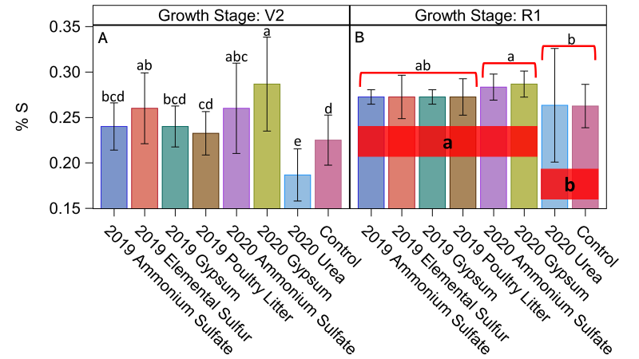
Figure 3. S content in soybean plants collected at the V2 (A) and R1 (B) stages of growth. Individual treatments were considered when analyzing data from the samples taken at V2. For the samples taken at R1, we grouped the treatments in two ways: 1) by those that received S and those that did not, and 2) those which received S in 2019, those which received S in 2020, and those which did not receive S in either year. The red boxes indicate the groups of treatments which received S and those which did not and the red brackets indicate treatments which received S in 2019, treatments which received S in 2020, and treatments which did not receive S in either year. Differing letters indicate significant differences at the p≤0.05 level.
Shallow soil samples (8” depth) collected in June, July, and early September were analyzed for Mehlich 3 extractable S concentration. The results indicated that there was not a significant effect of sampling date, so we averaged the measured S concentration across the three sampling dates for each treatment (Figure 4). The 2019 elemental S, 2019 poultry litter and 2020 gypsum treatments had greater S concentration in the top 8” of the soil than the 2020 urea or control. The 2020 AMS treatment had greater S concentration than the 2020 urea treatment, but was not significantly different from the control. The 2019 AMS and 2019 gypsum treatments were not significantly different from the control or the 2020 urea treatment. When we contrasted the group of treatments which had received S in either year to those which did not receive S, those which had received S had significantly greater S concentration in the top 8” of soil.
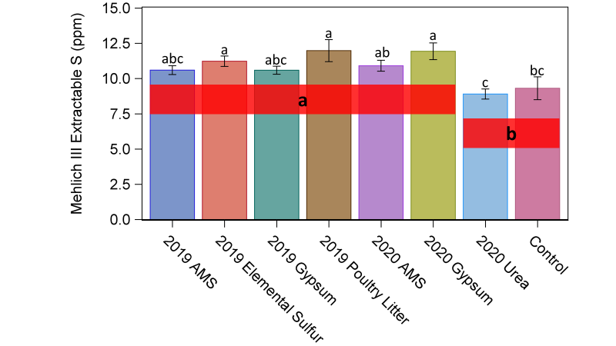Figure 4. Mehlich III extractable S concentration in 8” depth soil samples. In addition to analysis of individual treatment effects, we grouped treatments by those which had received S in either year and those which did not receive S in either year. Red boxes indicate the two groups of treatments. Differing letters indicate significant differences at the p≤0.05 level.
We harvested grain from the plots on 23 October 2020. We harvested the center two rows from each plot, weighed the grain, adjusted to 13% moisture and calculated yield. Mean yield from each treatment can be seen in figure 5. We found that there was no significant effect on grain yield of S source, whether the S had been applied in 2019 or 2020, or whether treatments had received S or not. Due to the severe drought which occurred at the experimental site during the summer and fall of 2020, it is difficult to draw definitive conclusions about yield based on these results.
During harvest, we collected grain samples from each of the plots which we had analyzed for S, methionine, cysteine, and crude protein concentration. We found that there was no treatment effect on crude protein concentration, but there were significant effects on S, methionine, and cysteine concentrations (Figure 6). The 2019 elemental S, 2019 poultry litter, 2020 gypsum, and 2020 AMS treatments resulted in greater grain S concentration that the control or 2020 urea treatments. The 2019 gypsum and 2019 AMS treatments were not significantly different from the control in terms of S concentration. For methionine concentration, we grouped the treatments by those which had received S in either year and those which did not. We found that the treatments which had received S had greater methionine concentration, regardless of year of S application (Figure 6B). We used the same two groups of treatments and found that the treatments which had received S had greater cysteine concentration than those which did not, regardless of year of S application (Figure 6C).
Conclusions
In this experiment we hypothesized that soybean yield and quality would respond positively to S fertilization. Our results indicated that there was not an effect on grain yield or crude protein concentration, however, grain S concentration increased as well as the concentration of the S-containing amino acids cysteine and methionine. This suggests that in cases where S doesn’t limit yield, there are still some effects of the addition of S, especially if producers are concerned about the amino acid concentration of their grain. We also sought to describe the depth distribution of S in the soil profile after S application, and did so at three time points: after corn harvest in 2019, prior to soybean planting in 2020, and after soybean harvest in 2020. We found that even after two seasons of crop production, subsoil S content was higher in treatments which had received S in 2019 than treatments which received no S in either year. This is an important finding because it illustrates the fact that the subsoil can act as a reservoir to hold S for use by multiple cropping cycles. In addition, our soybean plant rooting depth data and plant tissue testing data indicated that once roots reached the deeper soil layers containing S, plants readily took it up and assimilated it into their tissues. Finally, when considering the potential interaction between N and S, our plant tissue, soil testing, and grain analyses all indicated that gypsum and ammonium sulfate performed equally well. There was no difference in S content between the two treatments at either plant tissue sampling date, there were no differences in yield, and both treatments resulted in increased grain S, methionine, and cysteine concentrations when compared to the control. Therefore, if a producer’s intends to add S to their soybean crop, the cheaper of these two products should be selected, since the results so far indicate similar crop performance. It also appears that if S is added during the corn year of the rotation, producers should be able to rely on excess S stored in clayey subsoils.
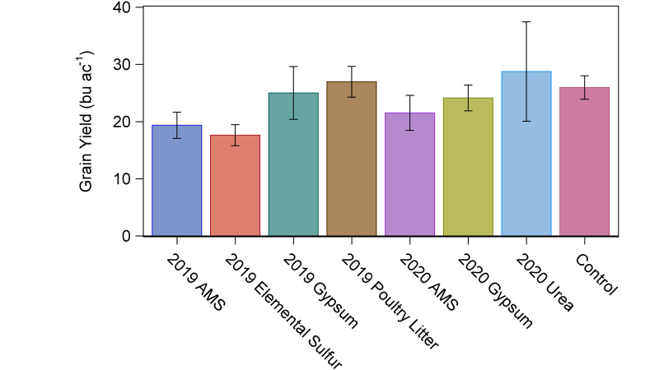
Figure 5. Mean soybean grain yield expressed in bushels per acre at the conclusion of the 2020 growing season. There was no significant effect of S fertilizer source, timing of S fertilizer application (2019 vs 2020), or whether or not S had been applied at the p≤0.05 level.

Figure 6. Mean soybean sulfur (A), methionine (B), and cysteine (C) concentration in harvested grain. For S concentration, differing letters indicate significantly different mean concentrations at the p≤0.05 level. For methionine and cysteine concentration, we contrasted two groups of treatments, those which had received S in 2019 or 2020, and those which had not received S in either year. Red boxes indicate the two groups of treatments, and differing letters indicate significant differences at the p≤0.05 level.

