Holey Voley: Vole Issues in Kentucky Soybeans
Matthew T. Springer, Assistant Extension Professor of Wildlife Management, Kentucky Wildlife Extension Specialist

There are many things that are on the minds of soybean growers as they work diligently to produce a quality soybean yield each year. Historically, voles issues were not even an afterthought. Unfortunately, it seems that in Kentucky, much of the upper-South, and probably even more so in Midwestern soybean fields, voles are now something that are on producers minds as a potential problem.
So what is driving the change? There is anecdotal evidence that this uptick in vole related issues is tied to no-till production practices. Potentially adding to that are the increasing presence of cover crops in fields. Voles are forage feeders that have a wide variety of diet. Unlike some small mammals, voles are active feeders year-round and have been known to store food in their burrows for winter. Due to the nature of the vole’s diet, they can be immensely destructive on agricultural plants (Figure 1) and can very much take advantage of cover crops as a food and cover source through winter. Mice are less likely to cause an issue with newly growing plants due to a different diet(Figure 2).
The number of producers having issues with voles was noticeable to me as I started my Wildlife Extension position in 2016. Our county ANR agents began asking more questions on voles in crop fields and when I talked with soybean producers the topic would come up in conversation in increasing frequency. After researching potential control methods, it was quickly evident that there were many folks across the country dealing with the issue but very little research developing methods to combat the problem at the scale our row crop producers’ work. Many suggested solutions included, snap trapping populations, mowing field borders, or encouraging natural predators. One of the few research projects on voles in no-till systems occurred in Southern Illinois in the early 90s by Ron Hines at the University of Illinois. He had tried a few different methods to control voles in no-till fields including alternatively feeding them cracked corn when beans sprouted, tilling, and application of pre-emergent herbicide 1 month prior to planting. His preliminary data suggested that the later technique may hold the most merit to limit vole damage over time, especially since the application of tilling causes the loss of all the soil health and erosion advantages of a no-till system, and alternative feeding is another input cost as well as holding the potential to increase vole populations over time.
In 2018, Kentucky Soybean Board (KSB) believed that dealing with voles was an important issue for producers and funded a proposal to test the impacts of different pre-planting herbicide application times to cover crops on vole populations from 2018-2020. In the winter of 2019, a University of Kentucky graduate student funded by the KSB, began research in Hardin County Kentucky to test Hine’s recommended herbicide treatment regime.
The student began by reaching out to ANR county agents, soybean producers, and crop scouts to locate fields that had historically dealt with large vole populations and vole caused damages in their fields. Several producers were kind enough to let us check out fields they knew they had issues with voles in the past and the student began walking those fields to identify the locations of all vole colonies. What became obvious very quickly was the variable nature of the vole colony locations. It was believed that these colonies would be closely tied to field edges, near existing grasslands, a potential source population that had individuals immigrate into the field. What you can see is that vole colonies, marked in yellow, were spread out all over the fields not just along the outside edges (Figure 3).
For the experiment, we identified and used 8 fields over two seasons, with each field having all three treatment plots, each 1 acre in size located in the areas with the highest numbers of vole colonies within the fields. These treatments included spraying cover crops 4 weeks, 2 weeks, and immediately before planting, The hypothesis was that the loss of vegetative cover and food prior to planting would make the voles leave the field or more likely to be predated. We monitored small mammals’ populations within these plots using Sherman traps during the entire study period.
We were able to catch thousands of rodents and hundreds of voles during our trapping seasons. The results from the herbicide treatment were not a clear as Hines had found. Weather limited our ability to apply treatments at the planned times, but we were able to collect data in all of our plots. Unfortunately, little support exists within our data that terminating cover crops early impacts vole population numbers. This may be due to the variable pace at which cover crops died across the treatment plots. But the more important aspect to this is that these are real world scenarios for producers so the advice of burning down cover crops as early as possible may need to be paired with other practices like raptor perches, or maybe spot tilling in areas with extreme vole densities to impact vole numbers.
With this being the first attempt at this problem we look to continue test alternative methods to help producers deal with this issue while maintaining all the benefits of cover crops. We believe that using the findings from KSB funded project, we will be able to obtain alternative funding from federal agencies to continue to identify a solution for our soybean producers.

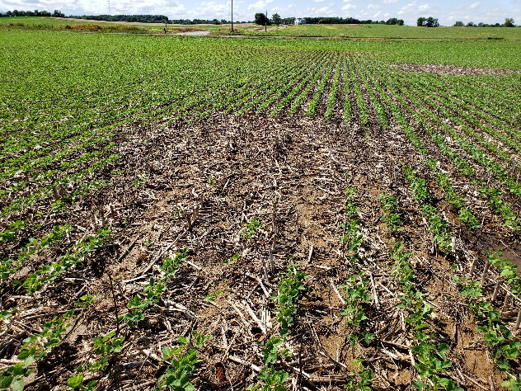
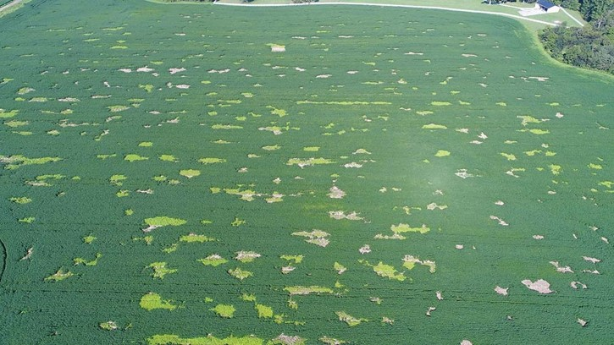
Figure 1. Examples of vole damage in soybean fields, one is a closeup of the damage the other is an aerial view.

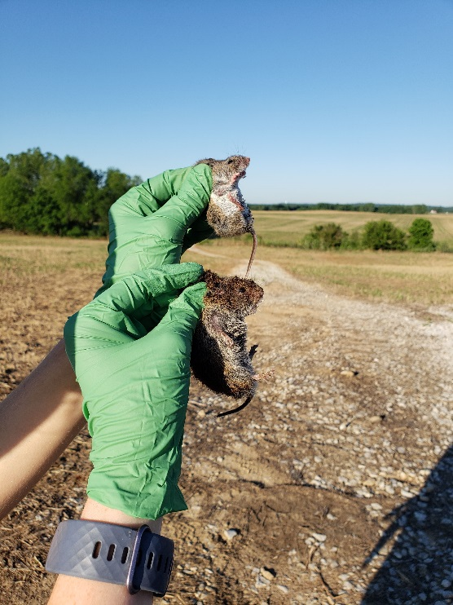
Figure 2. Example of mouse(top) verse a vole(bottom).

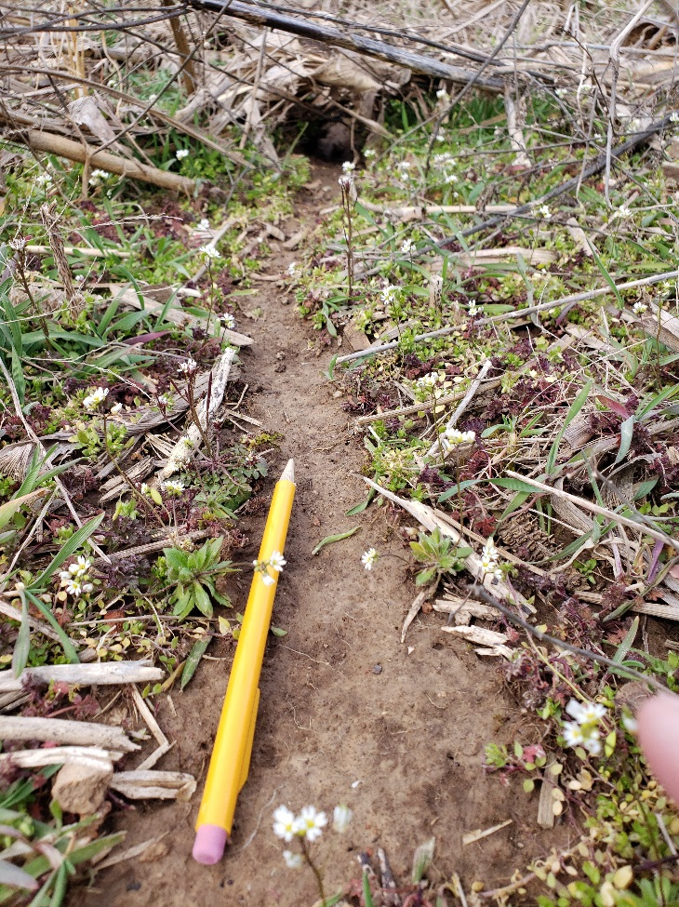
Figure 3. Example of an active vole den site with runway immediately in front of it.
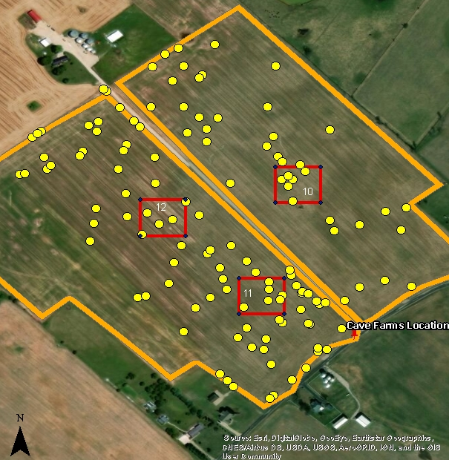
Figure 4. Number of active vole colonies in a field used in the study. Study plots are outlined in red, while yellow dots represent vole colonies.

