CONTROL OF SOYBEAN DISEASES

FY 2020 Technical Report for North Dakota Soybean Council
June 30, 2020

Principal Investigator: Dr. Berlin D. Nelson Jr., Plant Pathology, NDSU
Cooperators: Dr. Ted Helms, NDSU Soybean Breeder, Plant Sciences.
Dr. Sam Markell, NDSU Extension Pathologist

The objectives of this research program were to work with the NDSU soybean breeder to incorporate resistance to important diseases into public germplasm and cultivars and test material for resistance to fungal diseases, monitor soybean for new pathogens and new virulent strains of established pathogens and continue studying ways to manage important soybean diseases. An important emphasis in 2019, was to determine the extent of the area in Richland County with soybean fields showing symptoms of sudden death syndrome (SDS) and begin searching for sources of SDS resistance in maturity groups for this area.

In September of 2019 we published the first scientific report of sudden death syndrome of soybean (SDS) in North Dakota based on diseased plants observed in 2018. (Plant Disease. 2019, https://doi.org/10.1094/PDIS-08-19-1737-PDN). This disease was caused by Fusarium virguliforme, a soil borne fungus. The identification of this pathogen was verified using molecular methods of comparing North Dakota isolates with known isolates of the pathogen from other states and by pathogenicity tests in the greenhouse which produced disease on Barnes and Stutsman soybean varieties. In August of 2019, we surveyed a 225 square mile area in Richland, Country, around where SDS was first observed in fields in 2018. Although numerous soybean fields were examined, especially within patchy areas showing chlorosis or unusual leaf symptoms, no fields with classic symptoms of SDS were observed. Even one field with SDS in 2018 was planted to soybean in 2019, but there was no evidence of SDS. The other fields with SDS in 2018 were in corn in 2019. Environment is a very important factor in development of SDS foliar symptoms and apparently it may not have been conducive to development of foliar symptoms in 2019. In addition, there appeared to be more corn planted in that area in 2019, compared to soybean planted in 2018.

We consulted with pathologists from Iowa and Minnesota on methods to work with SDS under controlled conditions in the laboratory and greenhouse plus under field conditions because these states have had this disease for many years. In addition, seed of soybean genotypes reported as susceptible and resistant by other researchers were obtained which included maturity groups (0 to 00) for our area. Research on SDS has focused on developing a reliable screening technique that will allow us to consistently identify soybean genotypes with resistance to this pathogen under greenhouse and field conditions and to conduct other studies. Isolates of the pathogen from North Dakota were used and different inoculation techniques and different amounts of inoculum using the susceptible soybean varieties Barnes and Stutsman were examined. In addition, the most appropriate growth stage to rate the amount of disease was investigated. The inoculum used was grown on autoclaved wheat seeds for about 4 weeks then added directly to autoclaved soil. The quantity of inoculum in the range of 1:2 to 1:3 parts of inoculum: pasteurized soil in a layer, provided strong disease development in a susceptible variety. The following soybean varieties were tested in these greenhouse studies: Spencer, Merit, Evans, Barnes, McCall, MN0302, P19A14X and P15A63X. These varieties are reported to have susceptible to resistant reactions to SDS under field conditions. Results thus far have indicated that rating for foliar symptoms in the seedling stage (Figure 1) is best conducted within 3 to 4 weeks of planting under our greenhouse conditions. Foliar symptoms on seedlings tend to disappear or be less distinct as the plants grow older. Some varieties were less susceptible to pre and post-emergence damping-off by F. virguliforme (Figures 2 and 3). Other symptoms observed in the seedling stage include reduced plant size and delayed appearance of the trifoliate leaves. Barnes appears to be a good susceptible check with strong foliar symptoms and preemergence damping-off. McCall also had good foliar symptoms but not as much damping-off. MN0302 showed reduced foliar symptoms and damping-off. Experiments on the disease reaction of these and other varieties are still in progress. Resistant genotypes will be used as standard controls in future tests for resistance. Growers in Richland Co. may soon be requesting information on SDS resistant soybean varieties and such information for this area is currently not available. In spring 2020, an experiment was established on North Dakota State University Experiment Station land with those 8 varieties to test their reaction to SDS under field conditions.

In cooperation with Dr. Helms, the soybean breeder, we screened 100 advanced breeding lines for resistance to Phytophthora sojae races 3 and 4. Most of the screening was for Race 4 resistance since the source of resistance in the breeding lines is primarily from the Rps 6 gene. Over 60% of the lines were resistant to Race 4. One of the breeding lines resistant to race 3 was released in 2020 as ND Dickey by Dr. Helms and NDSU. Dickey is a non-GMO conventional soybean cultivar with a 00.07 maturity. We maintain a variety of races of P. sojae in storage and each year the races we use for screening are grown in the laboratory, inoculated onto a set of plants with known resistance and susceptibility, and then re-isolated from infected plants to make sure they have maintained their known virulence. In addition, we maintain other races which we use to determine which resistance genes are involved in the resistant reaction of plants. This past year most of the stored races were grown out in the laboratory and some were tested in the greenhouse for virulence. Cultures that are kept too long in storage can lose virulence. Some of the races had lost their virulence and were discarded. Only when we have verified the virulence of a particular race, is it used in the screening process. At present races 3 and 4 are the most common but other races exist in soybean fields. In 2019, we published a study on the adaptation of P. sojae to Rps resistance genes over the past two decades in North Dakota (Plant Health Progress 20:88-93; https://doi.org/10.1094/PHP-10-18-0062-RS). This publication compared the results of surveys of pathotypes conducted between 1991 to 2015. The results showed the increasing complexity of P. sojae pathotypes that occurred during two decades of soybean production in North Dakota.

We continued studies on Fusarium root rot of soybean caused by Fusarium solani and F. tricinctum. This is a major soybean root disease in the north central United States which is also a seedling disease. The objective was to investigated the effects of the macroconidia concentration and the additive effects of soybean cyst nematode, Heterodera glycines, on the severity of Fusarium root rot. To determine the effective spore concentrations of these two Fusarium spp., experiments were conducted in soil heated in a water bath at 27 ± 3°C in a greenhouse. Barnes soybean was planted in La Prairie silty loam soil infested with macroconidia at 10-fold increments of conidial suspensions ranging from 10¹ to 10⁶ macroconidia/ml soil. The percentage of root discoloration and the length of lesions on taproots increased as spore numbers increased, with significant effects of spore concentrations starting at 10⁴ and 10⁵ macroconidia/ml soil for F. solani and F. tricinctum, respectively. A non-linear sigmoid model was fitted to root discoloration against concentration, while a linear regression model was fitted to root lesion length against concentration. Although the shape of the fitted curves was similar for both Fusarium spp., F. solani caused more severe root rot than F. tricinctum. To further assess the additional effect of H. glycines on Fusarium root rot, the interaction between the nematode at different egg concentrations with the two Fusarium species at10⁵ macroconidia/ml soil was investigated in the greenhouse and under field conditions. Root rot severity caused by F. solani and F. tricinctum showed similar trends when H. glycines was added to the soil. In the greenhouse, root discoloration and lesion length were significantly greater in plants inoculated with Fusarium spp. and H. glycines at 10 eggs/ml soil or greater, compared to Fusarium spp. alone. In the field trials, co-inoculation of the two Fusarium spp. with H. glycines significantly increased root rot severity at a nematode population of 16.7 eggs/ml soil (Table 1). The results indicated that the presence of soybean cyst nematode can increase severity of root rot caused by F. solani and F. tricinctum and egg level in the soil is an important factor in the interaction of H. glycines with these Fusarium root rot pathogens.

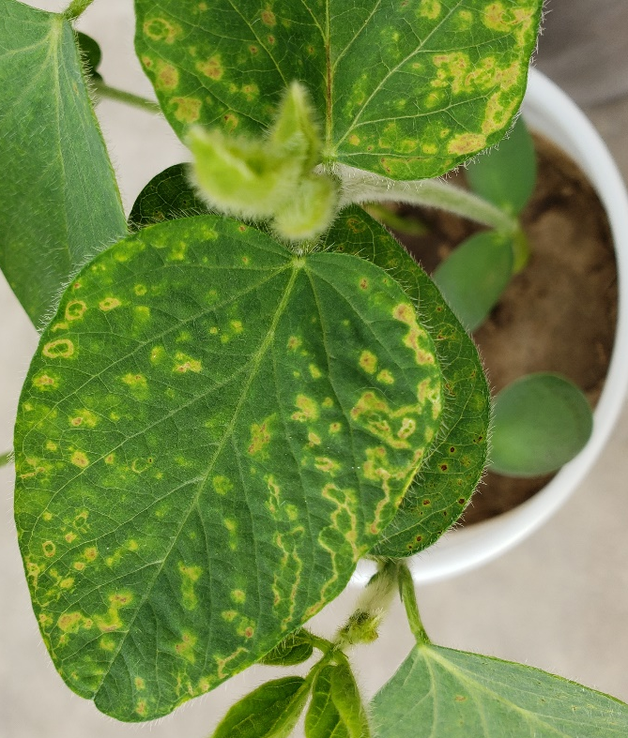
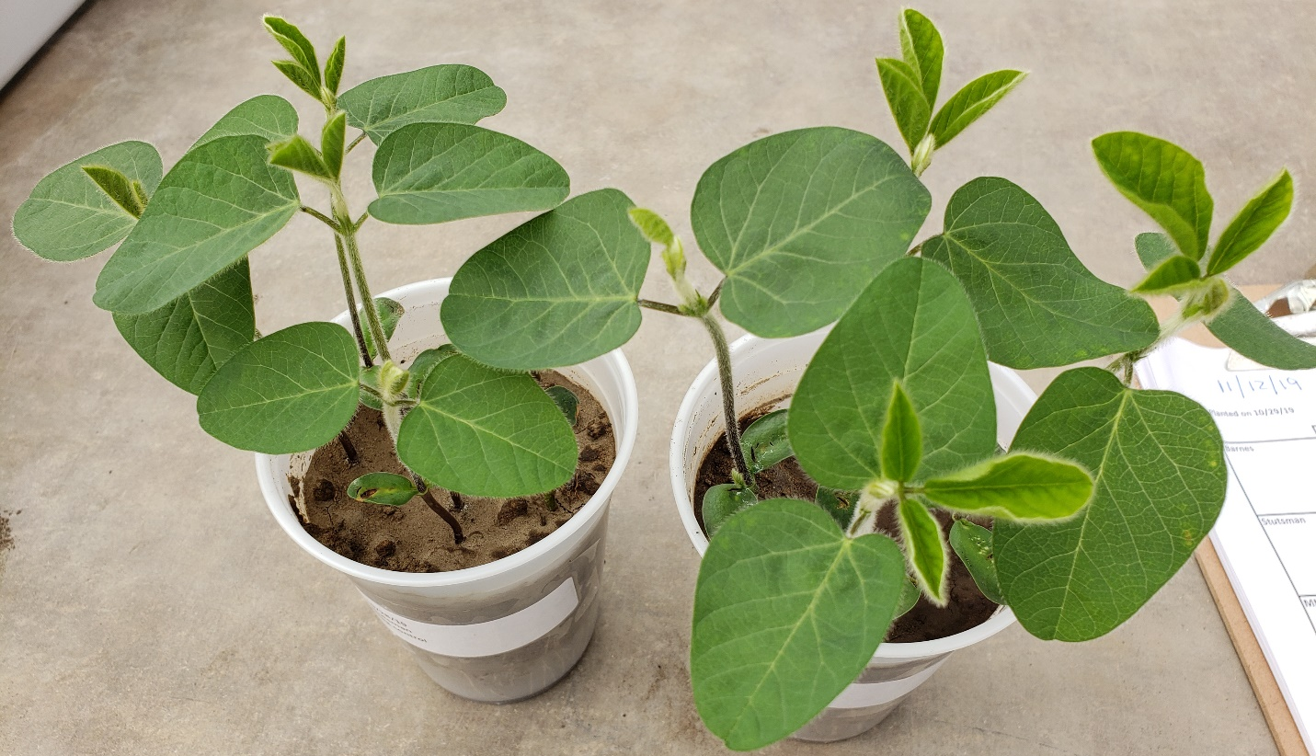
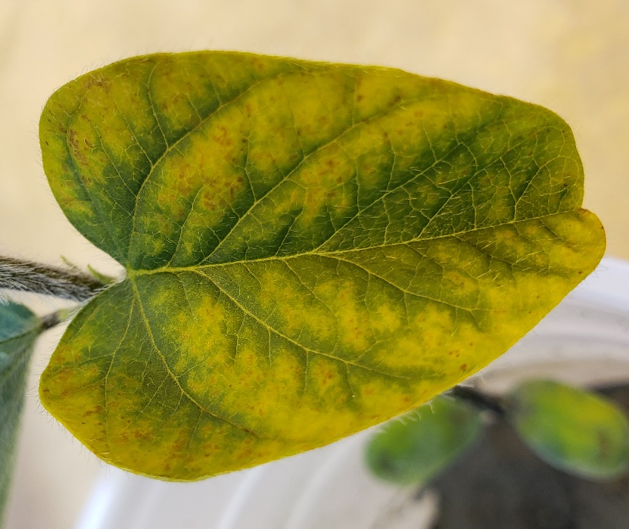
Figure 1. Barnes soybean. Top photo showing healthy plants and bottom photos showing foliar symptoms of sudden death syndrome in 3 to 4 week-old seedlings caused by Fusarium virguliforme.

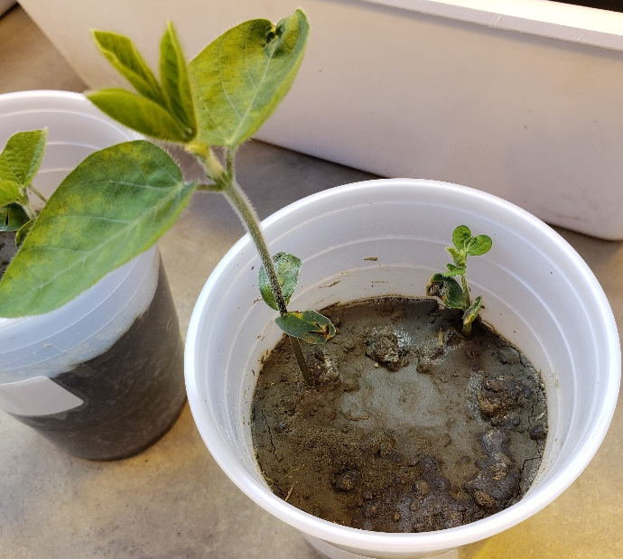
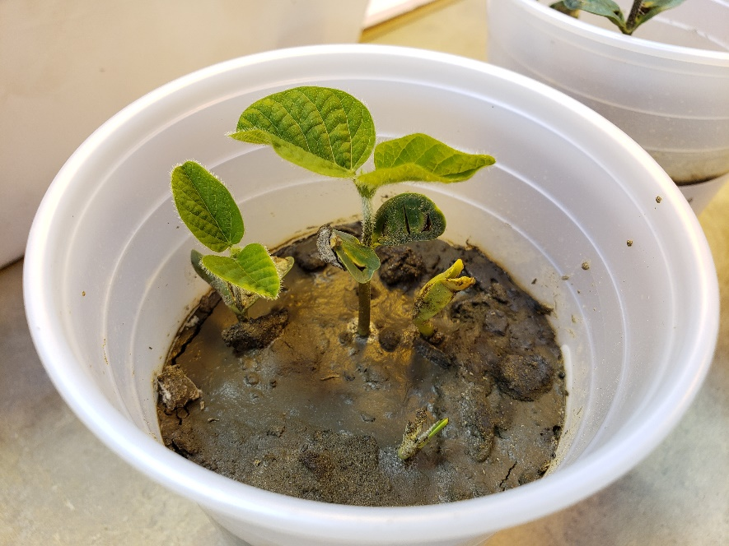

Figure 2. Barnes soybean. Pre- and post-emergence damping-off of seedlings in the greenhouse caused by Fusarium virguliforme, the cause of sudden death syndrome.

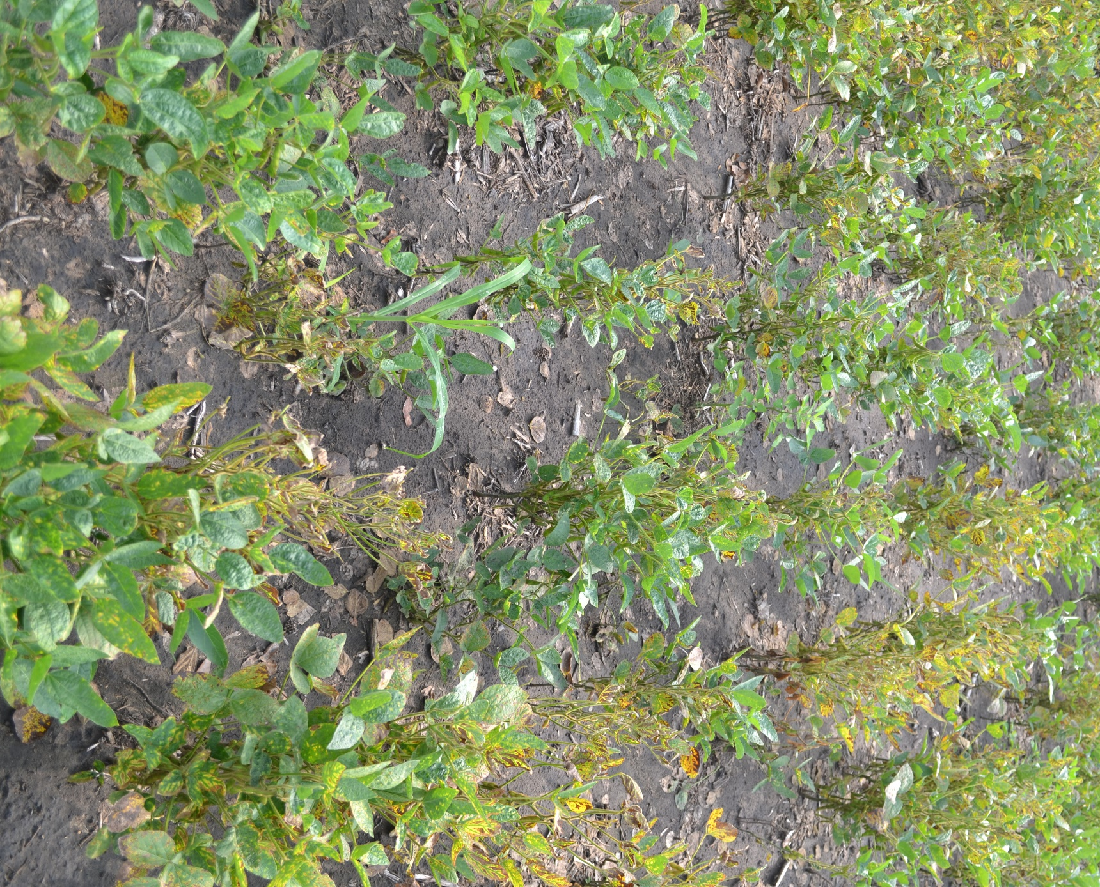

Figure 3. Example of a poor stand of soybean due to pre- and post-emergence damping-off caused by Fusarium virguliforme in a commercial soybean field with a high inoculum density. All live plants are showing SDS foliar symptoms.

Table 1. Additive effects of three levels of H. glycines on root rot severity caused by Fusarium solani and F. tricinctum under field conditions.ª
H.glycines  (eggs/ml soil) | Fusarium solani |  | Fusarium trinctum |  | Fusarium solani + Fusarium tricinctum
H.glycines  (eggs/ml soil) | Root discoloration (%) | Lesion length (cm) | Root discoloration (%) | Lesion length (cm) | Root discoloration (%) | Lesion length (cm)
 | 2 0 1 7
0 | 0 b | 0 b | 0 a | 0 b | 0 c | 0 b
1.7 | 6.67 ab | 0.03 b | 3.33 a | 0.7 ab | 6.67 bc | 0.16 b
8.5 | 6.67 ab | 0.16 ab | 4.17 a | 1.00 ab | 16.87 ab | 0.63 ab
16.7 | 13.34 a | 0.37 a | 4.5 a | 1.42 a | 31.67 a | 1.50 a
 | 2 0 1 8
0 | 0 b | 0 b | 0 b | 0 b | 0 b | 0 a
8.5 | 3.5 b | 0.01 b | 1.25 b | 0.08 b | 0.35 b | 0.04 a
16.7 | 6.83 a | 0.12 a | 2.5 a | 0.75 a | 7.50 a | 0.07 a
ª Field experiments were conducted in microplots on campus of North Dakota State University during 2017 to 2018 with Fusarium species at 10⁵ macroconidia/ml soil. There were 6 replications in 2017 and 10 in 2018. Disease severity of Fusarium root rot (root discoloration and lesion size) was evaluated at R8 growth stage. Values are the means of discoloration or lesion lengths from plants co-inoculated with F. solani or F. tricinctum, but minus the data from values obtained from plants inoculated with Fusarium alone. Means with the same letter are not significantly different at P<=0.05 based on Tukey’s studentized range test.

