CONTROL OF SOYBEAN DISEASES

FY 2019 Technical Report for ND Soybean Council
June 20, 2019

Principal Investigator: Dr. Berlin D. Nelson Jr., Plant Pathology, NDSU
Cooperators: Dr. Ted Helms, NDSU Soybean Breeder, Plant Sciences.
Dr. Sam Markell, NDSU Extension Pathologist

The objectives of this research program were primarily to screen NDSU breeding lines and cultivars for resistance to major diseases, monitor soybean for new pathogens, and continue research on Fusarium root rots. In cooperation with Dr. Helms, the soybean breeder, we screened 60 advanced breeding lines for resistance to Phytophthora sojae race 4 and several lines to race 3. Over 80% of the lines were resistant to this pathogen. One of the breeding lines resistant to race 4 was released in 2019 by NDSU and Dr. Helms as ND Rolette, a high yielding conventional soybean cultivar with a 00.09 maturity.

In August 2018, we surveyed 153 soybean fields in 10 counties (Barnes, Cass, Dicky, Griggs, LaMoure, Richland, Ransom, Sargent, Steele, and Traill) for evidence of sudden death syndrome (SDS), caused by Fusarium virguliforme. This disease had not previously been reported in North Dakota, but is a serious pathogen in other soybean production states including Minnesota and South Dakota. We were searching for specific foliar symptoms associated with SDS. Within 149 fields, no plants with typical symptoms of SDS were found and plant samples with symptoms that were somewhat similar to SDS foliar symptoms were only collected from 27 fields. All the root samples were washed, then dried and ground to eventually extract DNA to analyze for F. virguliforme. None of those fields were positive for the SDS pathogen.

On August 24 an extension agent in Richland County responded to a request we made to report any SDS-like symptoms to Drs. Markell and Nelson in NDSU Plant Pathology. We visited the area where the extension agent had observed unusual foliar symptoms and found in one field classic symptoms typical of SDS where there appeared to be about 20 to 30 acres showing foliar symptoms. In three other fields in the area we observed scattered plants showing SDS like symptoms. Plants were collected from these fields and isolations were made from the roots which showed typical root rot symptoms. We consistently isolated a fungus from the roots of symptomatic plants that matched the morphological description of F. virguliforme. We also prepared cultures of the various isolates of the fungus, dried the mycelium and extracted DNA so we could verify the identification using a molecular technique. The four isolates (P1-1, P4-1, P4-2, P10-2) and three known isolates of F. virguliforme as controls (13 FV 188 IL, NE 305 IA, and FV mol SS2 MN) were analyzed by PCR using primers to a specific region of the translation elongation factor 1, Fa+7/Ra+6, and the internal transcribed spacer (ITS) region. The amplicons from the unknown isolates and the known controls were then sequenced. BLAST analysis of both genes had 100% identical match with sequences of Fusarium virguliforme. (accession nos. MG470654.1, AY826772.1). Pathogenicity studies were also conducted in the greenhouse on the four isolates of F. virguliforme and all four isolates caused visible root rot of tap roots and lateral roots within two weeks from inoculation. This is the first report of this serious soil-borne pathogen and disease in North Dakota.

In August of 2018 we discovered a soybean field in Cass County with major damage from Charcoal rot, a soil borne disease caused by Macrophomina phaseolina. We visually estimated that more than 60% of a 210 acre field was infected and plants were either dead or dying and were showing major symptoms of Charcoal rot. We had never observed this amount of damage in a soybean field in North Dakota. There were other fields in the area that also had high levels of Charcoal rot. This area in Cass County had limited rain for several months. Drought conditions are a major factor associated with development of charcoal rot. Although this disease has been observed in numerous fields during past years, the level of incidence has been low with little evidence of any major damage. We took samples back to the laboratory and made isolations of the pathogen from the roots and identified the fungus as M. phaseolina. We made transects through the field and collected diseased plants and healthy plants to estimate the potential yield loss. In addition, with cooperation from John Nowatzki in Agricultural and Biosystems Engineering, we flew a drone over the field to photograph and map the entire field since this was the first soybean field observed in North Dakota with major damage from this pathogen. With the photographs we are currently using software to accurately calculate the percent of the field that was killed or was dying due to charcoal rot as of September 1, 2018. The information gained from the SDS and Charcoal rot fields will be used to prepare information for growers, crop scouts, and others in the soybean industry in ND, so these diseases can be identified and management options can be explained.

A field experiment was conducted in 2018 to test the effects of soil types on Fusarium root rot of soybean. Three soil types (La prairie silt loam, Fargo clay and Glyndon series) were used which represented soil types within the Red river valley. Soil was infested with Fusarium spp. at 15 barley grains per 100 ml soil. The experiment was a split plot design with soil types as main plot and Fusarium (F. solani and F. tricinctum) as subplots. Fusarium root rot was severe on soybean planted in Glyndon and La Prairie soils compared with Fargo clay. In the Glyndon and La Prairie soils, both F. solani and F. tricinctum reduced seedling emergence by 50% and caused post-emergence damping off on 60-100% of surviving plants. With F. solani only a few plants survived, while all plants died with F. tricinctum. In Fargo clay, F. solani and F. tricinctum did not cause a reduction in emergence, but caused post-emergence damping-off on about 20% of the plants. Both pathogens in Fargo clay resulted in reductions of plant height, weight and seed yield. F. solani caused more severe root rot than F. tricinctum. In May of 2019 this experiment was repeated using the same soil types.

We continued studies on two important root rot pathogens, Fusarium solani and F. tricinctum to determine how temperature affects disease development by these pathogens. This research on Fusarium root rots was partially funded by a multi-researcher grant from the United Soybean Board on seedling diseases of soybean. Growth of both species was measured in-vitro on potato dextrose agar at temperatures between 0 to 37º C and infection of the soybean cultivar Barnes was tested at temperatures of 15°C, 20°C, 25°C and 30°C using a rolled germination paper assay over one week and a soil infestation assay over 4 weeks. All experiments were conducted in a growth chamber. Various parameters of plant growth, disease incidence and disease severity were measured. The results showed that the optimum temperature for growth of F. solani was 29.9 C while for F. tricinctum it was 23.7 C. Temperature had a significant effect on the infection of cotyledons and roots after 1 week incubation. The most favorable temperature for infection of cotyledons by F. tricinctum was 25° C while for F. solani it was 30° C. For roots F. solani had the same optimal temperature as infection of cotyledons, but root infection by F. tricinctum was the highest at 15°C. When soybean was planted in infested soil, F. solani was highly aggressive to soybean and caused more severe infection on the roots and there was a higher infection frequency than with F. tricinctum. Root rot development by F. solani was greater at a higher temperature than with F. tricinctum, as the lesion lengths were longer and infection incidence was higher at 30 ℃ than that at the lower temperatures. For F. tricinctum, the optimal temperature for root rot development was 15°C.

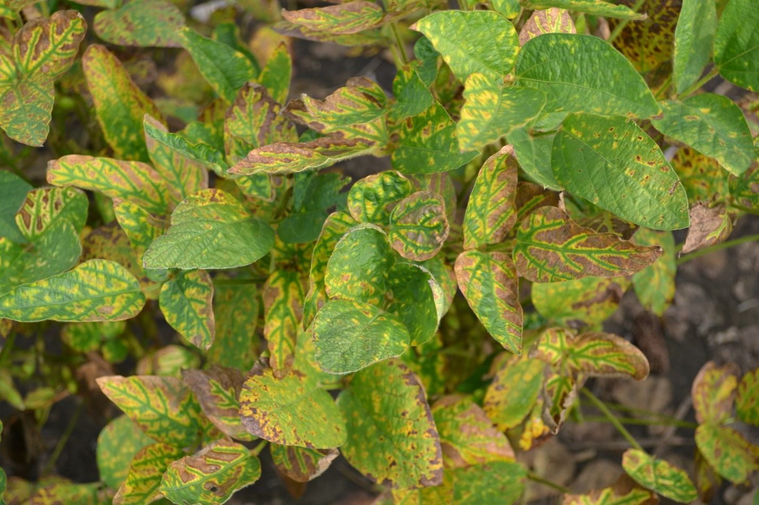

Foliar symptoms of sudden death syndrome on soybeans in North Dakota. August 2018.

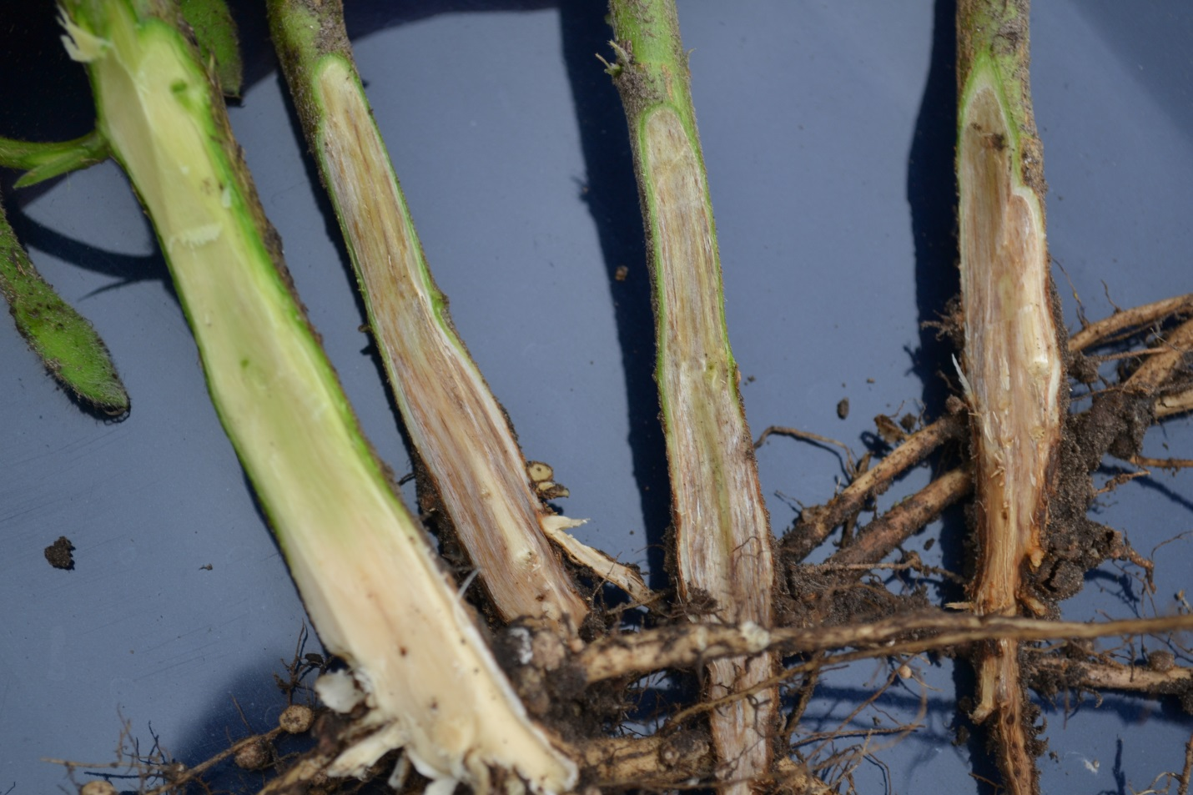

Symptoms of sudden death syndrome of soybean in infected plants. Notice the tissue discoloration in the base of the stems in the three infected plants on the right compared to the healthy plant on the left. Infected plants were stunted with root rot on tap roots and lateral roots.
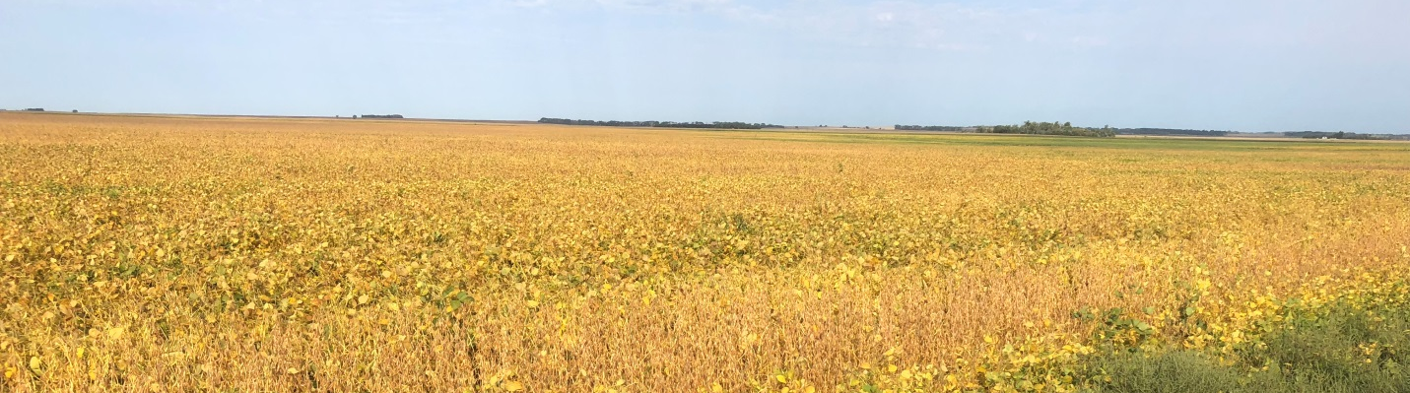

Field with charcoal rot, September 8, 2018: an area of the field with live plants. Compare with lower photo.

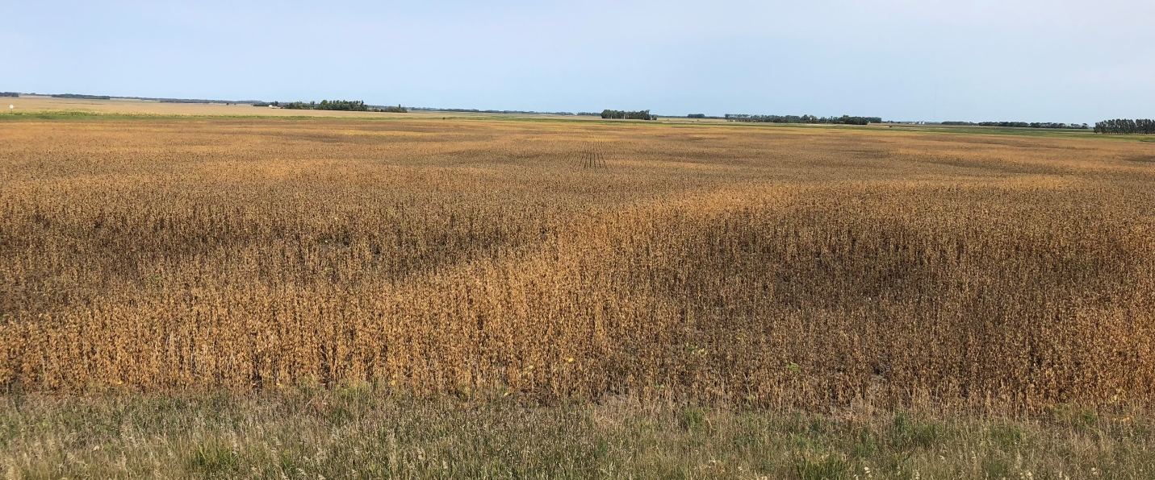

Field with charcoal rot: large areas of a 210 acre field with dead and dying plants on September 8, 2018. Many plants were already dead by August 15.

