MSMC Project Number: 16-391
- High-throughput phenotyping to accelerate soybean improvement through agronomy, breeding, and genetics

- Project Period: 04/01/2016 – 03/31/2019

- PI: Felix B. Fritschi; Co-PIs: Gary Stacey, Andrew Scaboo, Bill Wiebold, Guilherme DeSouza, Minviluz Stacey

- Layman’s Summary
Yield measurements at the end of the season are the ultimate measure of crop performance. However, while improved yield or efficiency is the ultimate goal of our research, these final measurements do not provide sufficient information on crop growth and development that drive yield in a particular environment. In-season measurements are critical to understand why yield may differ, and what we may change within the growing season to improve profitability. Therefore, researchers often manually assess plant growth, development and physiology, but these measurements typically are very time consuming. Many of today’s greatest challenges for soybean breeders and geneticists are related to this so-called “phenotyping bottleneck”. That is, while technological advances in genetics and molecular biology now provide powerful tools for breeding and biotechnology, the rate of genetic improvement is limited in part by the rate at which in-season soybean characteristics can be assessed. Consequently, platforms are needed that allow rapid, accurate and repeated assessment of key agronomic traits, or soybean phenotypes. Therefore, the objectives of this project were to 1) Assemble and deploy a highboy-based phenotyping platform for MO soybean researchers that will allow rapid and accurate assessment of a broad range of traits of field-grown soybean; and 2) Deploy the phenotyping platform to study soybean traits in response to different management practices, genetic/breeding populations, and soybean mutants to accelerate agronomic and genetic advances. We have designed and constructed a sensor platform that can be mounted on the front lift of a high-clearance tractor to characterize plants in four rows at a time. The platform “toolbar” consists of a T-slot aluminum frame that allows easy adjustment of sensors positions both horizontally as well as vertically. Sensors are mounted on the T-slot aluminum frame such that their position and orientation can be optimized as needed based on the developmental stage of the soybean plants. The sensors included on this platform are used to measure plant height (ultrasonic sensors), canopy temperature (infrared sensors), the light that is reflected by the canopy (spectrometers), and the shape of the plants (time-of-flight [ToF] sensors). The collection of these data is coupled with a high-precision GPS system so that the data points can be assigned to specific locations in the field (e.g. treatments, entries). While data from ultrasonic sensors, infrared sensors, and spectrometers can be analyzed using available tools, the extraction of 3-dimensional (3D) characteristics of soybeans from ToF sensors requires the development of appropriate software. The outcome of this project is a sensor platform for MO soybean researchers that can be deployed using a high-clearance tractor to rapidly assess plant height, canopy temperature, canopy light-use characteristics, and select 3D canopy characteristics. This platform now is available for MO soybean researchers and its use is expected to accelerate and improve data collection for a broad range of projects, including agronomic, physiological, and genetic research.
- Project Objectives and Results
This project was conducted to address the phenotyping needs of MO soybean researchers and address the following questions:
- What should a ground-based phenotyping platform that allows MO soybean researchers to rapidly and accurately assess important soybean characteristics under field conditions look like?
- What sensors should be included on the platform and how should they be mounted?
- How do we process the data from the sensors to facilitate extraction of information relevant for soybean researchers from these sensors?
- What is the best way to integrate the sensors and deploy the platform in the field?

The platform we developed (illustrated in Figure 1) is the final answer to these questions. Figure 1 shows the high-clearance tractor with the phenotyping platform with the different sensors and the datalogger and computer used to control and log the data from the different sensors. The platform shown and described below integrates the advances made as part of this project.
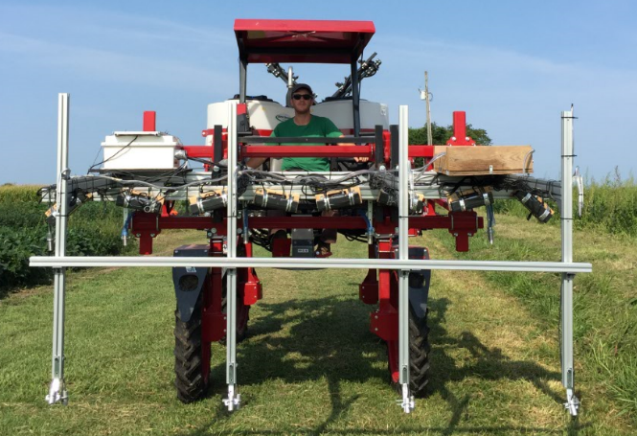
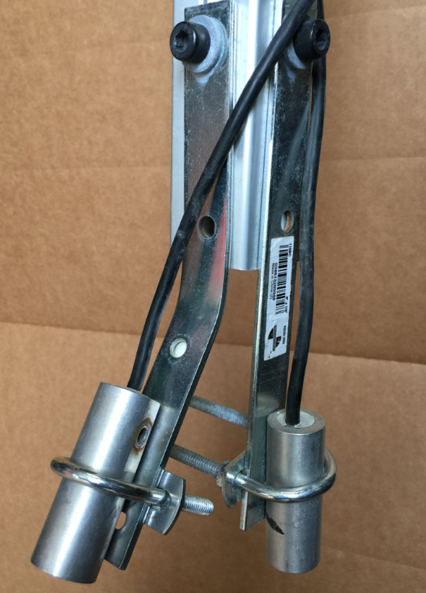
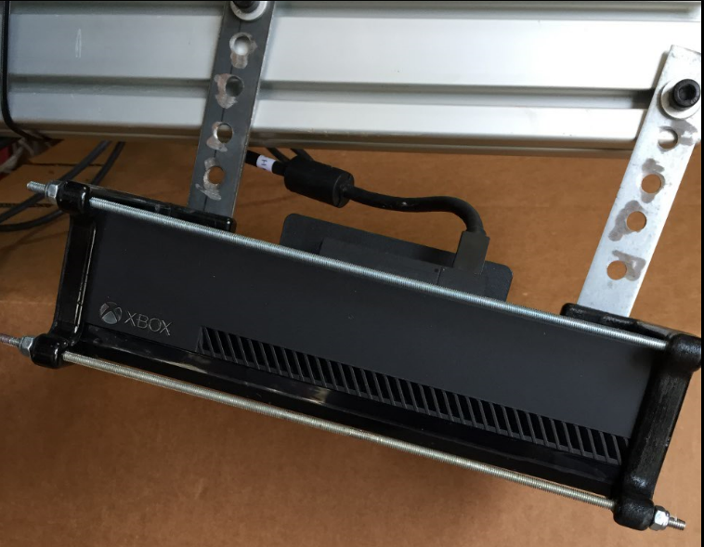
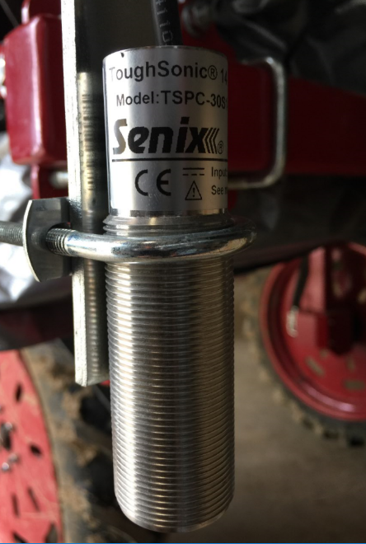
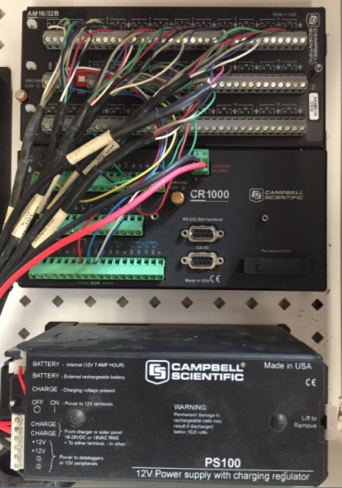
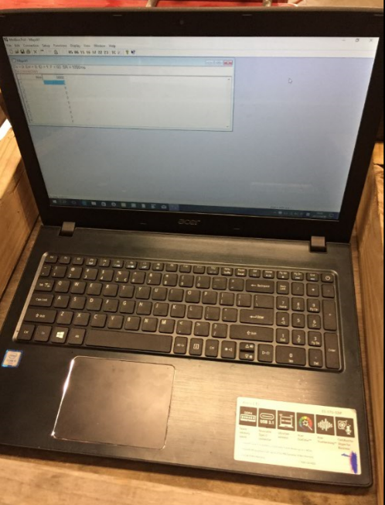
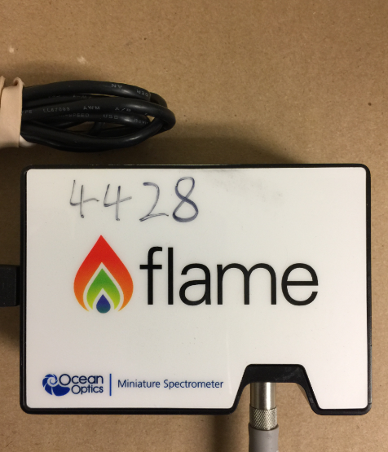




Developed by this project
1
2
3
4
5
6
7
8
9

TK One

Figure 1. Sensor platform (not including cover) mounted on a high-clearance tractor. 1) CR 1000 datalogger box with solar panel. The close-up shows CR 1000 wiring for infrared sensors; 2) Apogee thermal infrared sensors; 3) Senix ToughSonic 14 ultrasonic sensor; 4) Kinect Xbox One ToF sensor. The close-up image shows a single sensor mounted on the toolbar using custom 3D printed brackets; 5) Tray with laptop computer; 6) Ocean Optics spectrometer with fiber optics cables. Boxes 7 through 9 show the software needed for the different sensors. GPS not pictured.
Phenotyping platform description and elaboration on challenges and continuing efforts:
Each of four rows of soybean that can be phenotyped by the platform at one time is monitored by two infrared sensors (8 sensors), one ultrasonic sensor (4 sensors), two ToF sensors (8 sensors), and one spectrometer (4 sensors). Additionally, one ultrasonic sensor is installed to provide the distance to the ground for the sensor platform (needed as reference for plant height determination), and one spectrometer is mounted to measure the incoming radiation, important as reference for the other four spectrometers that measure the reflectance from the canopy. Further, the location of the platform in the field is registered by GPS.

With this sensor combination, researchers can characterize plant status and growth throughout the growing season. While ultrasonic and ToF sensors provide information about the plant stature and shape which are important for growth measurements and for light interception estimation, the infrared sensors and spectrometers provide insights about plant function. For instance, the temperature of the canopy is closely related to transpirational water loss by the soybean plants, which is a determined by both root and shoot traits and their interactions with the environment. Canopy reflectance, measured by the spectrometers, is a function of how and how efficiently the canopy uses incoming sunlight and caries information about the health of the soybean leaves and the photosynthetic machinery. As such, a single deployment of the phenotyping platform provides a wealth of information to researchers. This information is magnified by multiple deployments over the course of the season as this allows assessments such as growth rates and responses to management practices as well as disease pressure or drought stress. Importantly, the combination of the different sensors and the ability to monitor four rows at a time using a high-clearance tractor greatly enhances the number of genotypes or treatments that can be measured at one particular time. Optimally, the platform requires two individuals for deployment, the driver and one person to manage the sensors. In contrast, traditional manual phenotyping would require one person for one measurement, dramatically magnifying the time required for the collection of the same amount of information. Thus, this platform allows ground-based data collection of large populations or field experiments that would simply not be feasible for many MO soybean research programs.

The use of the Kinect Xbox One ToF sensors on this platform is a new application for these sensors which are used for home video-gaming and therefore very inexpensive and easy to operate. The goal of the non-traditional application of these sensors on the phenotyping platform was to acquire data to perform 3D modeling of plants for phenotyping. With a virtual 3D model in hand, plant characteristics can then be extracted from this model. This goal requires the development of software to analyze the data acquired by the two ToF sensors that acquire data from each row. The software developed by us relies on open-source libraries and allows operation of the multi-row scanner platform. Additionally, programs to pre and post process the data from the ToF sensors were created to combine multiple scans into a single 3D model, e.g. multiple rows of plants in the field. All algorithms were implemented using computer vision concepts and computer languages such as Python, C/C++, Java and Matlab.

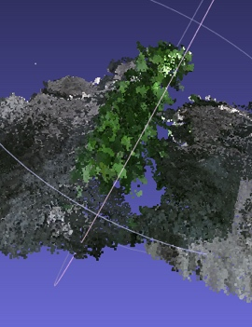
Scanning 3D objects under field conditions with the Kinect ToF sensors presented many challenges. For instance, challenges included vibrations resulting from the high-clearance tractor, high temperatures during deployment of sensors that were developed to function in conditioned environments, interference from sunlight, and motion of plants as a result of wind. To deal with these challenges, we modified the platform, switched from the Kinect 360 sensor used in the beginning to the Kinect Xbox One sensors, constructed a cover for the platform to reduce direct sunlight interference, and developed algorithms to deal with plant motion. As a result, we were able to generate 3D point clouds for plants in the field. These 3D point clouds are best viewed on a computer, but a still image is shown in Figure 2.

Figure 2. Single 3D point cloud showing one row of soybean in the field. To generate this 3D point cloud, images from multiple ToF sensors need to merged together into a single 3D model for a specific time stamp, and multiple time stamps need to be merged into a single 3D model to account for the length of the plot, and ultimately the entire field.

To improve the 3D models generated from the ToF sensors in the field, additional new algorithms are needed to account for object deformation caused by wind. Development of such algorithms is continuing.

- Answers to Key Questions
- How do results benefit Missouri soybean growers?
The platform generated as part of this project is available to MO soybean researchers which can deploy it for high-throughput phenotyping. That platform can benefit agronomic, physiological, and breeding and genetics research and thus has the potential to broadly impact soybean production research.

- Estimated financial return for the average Missouri soybean producer.
No direct financial return is resulting from this project. However, Missouri soybean producers benefit because this platform enhances the phenotyping ability of soybean researchers and alleviates important bottlenecks, particularly as related to genetic studies.

- Do results benefit the environment?
No direct benefit to the environment result from the development of this phenotyping platform. However, this novel tool has the potential to benefit the environment by supporting and enhancing agronomic research capabilities.

- What products or processes can be commercialized from this research?
It is possible that the ToF sensor use for phenotyping could be commercialized for application in plant science research, production agriculture, and possible applications outside agriculture (e.g. body scans for medical, fashion, online shopping). However, additional research is needed to move this ToF sensor application toward commercialization.
- How would you commercialize these products or processes?
Our prototype for ToF sensor deployment and 3D reconstruction is ready, tested and working in a research setting only. This serves as proof of concept. Further development of the system by experienced industrial partners would be require, especially when it comes to making the scanners more robust in a hazardous field environment.
- If no specific products or processes were produced, how do you plan to make your results available to producers or industry?
The outcome of this project is a phenotyping platform that is available to MO soybean researchers. The platform per se, will not be useful for producers, but the platform will indirectly benefit producers in that it can advance research on crop management and breeding. The sensors, particularly the advances we made with respect to ToF sensing of soybean canopies may be of interest to seed companies. We are raising awareness to attract interest for our advances through meetings, presentations, and publications. Also, we are preparing for publication of the algorithms developed under this research. Means to access the data collected will be explained in these papers so that other researchers have access to them and can build on the foundation developed here.
- Is additional time or research required before your results can be used by producers and industry?
The phenotyping platform is ready for deployment in its current configuration and different research groups can take advantage of it.
More time and investigation is required to enhance the 3D model generation and extract additional feature from the 3D models. This includes reconstruction of the entire field, further elimination of noise introduced in the final 3D model of a plant while stitching multiple point clouds from various view angles while still addressing multi-view registration issue, and development of an algorithm to compensate for distortion introduced due to the non-rigid nature of plants (plant movement due to wind).
- Where does this research go from here? What are the next steps?
We will deploy the platform as part of future soybean research projects and will continue with the development of the 3D modeling of plants in the field on the basis of ToF sensors. We will explore the addition of other sensors to the platform developed as part of this project. Additionally, we are exploring ideas for adaptation and deployment of these sensors for producers, such as on spraying equipment and combines.

- List of publications:
Abstract Publications:
Bai, H., A. Sanz-Saez, T. K. Das Nakini, G. DeSouza, and F.B. Fritschi. 2017. From gaming to high throughput phenotyping: use of an X-box camera to model soybean 3D structure and morphological traits. ASA, CSSA, and SSSA International Annual Meetings Oct. 22-25, 2017, Tampa, FL.
Bai, H., T.K.D. Nakini, F.B. Fritschi, and G. DeSouza. 2018. High-throughput phenotyping of soybean canopy characteristics with a multi-sensor system. ASA and CSSA International Annual Meetings Nov. 4-7, 2018, Baltimore, MD.

Presentation:
Fritschi, F.B. Show Me Soy School 2017, Bay Farm, “Soybean breeding and phenotyping”, July 14, 2017.

- Cost of original project and actual expenditures:

Budget Item | Budgeted | Spent
Salary | $181,851 | $180,063
Benefits | $43,837 | $38,985
Operating | $28,769 | $35,408
Total | $254,457 | $254,456

- List equipment purchased with MSMC funds, identifying inventory and serial number. (It is not considered equipment unless it costs $500 or more and has a life expectancy of at least 2 years.) Indicate current and future use of this equipment in support of soybean research.
No equipment was purchased with MSMC funds for this project. Matching funds were used to purchase the sensors and loggers, and the high-clearance tractor from Dr. Wiebold’s program was used to deploy the platform.

