REPORT YEAR 1

Evaluating the supplementation of soy lecithin for the production performance and physiological responses of channel catfish (Ictalurus punctatus)

Fernando Y. Yamamoto^{1,2}

¹Thad Cochran National Warmwater Aquaculture Center, Delta Research and Experiment Station, Mississippi State University, Stoneville, MS
²Department of Wildlife, Fisheries and Aquaculture, Mississippi State University, Starkville, MS

Summary
A ten-week feeding trial was conducted to evaluate graded levels of soy lecithin supplementation (0, 0.5, 1, 1.5, and 2% of feed) in plant-based diets for channel catfish (Ictalurus punctatus) juveniles. The catfish were stocked in 30-gallon aquaria (30 fish/tank) and fed to a fixed percentage of the tank biomass. At the end of the study, production performance parameters, as well as the whole-blood panel, whole-body proximate composition, and condition indices, were evaluated. The fish were also subjected to a stress challenge, where whole-blood parameters were analyzed at 0, 0.5, 1, 2, and 6 hours after subjecting them to a 2-min air exposure. Digesta samples from the posterior segment of the intestine were also sampled to assess the intestinal microbiota composition. The remaining fish were exposed to a bacterial pathogen Edwardsiella ictaluri, through immersion, and survival was monitored for 22 days. Feed efficiency and protein conversion efficiency were significantly affected by soy lecithin supplementation, where 1.5 and 0.5% presented the highest performance compared to the unsupplemented group. No differences were observed for weight gain, survival, condition indices, whole-body proximate composition, whole-blood parameters, and intestinal microbiota. The time after the air exposure significantly influenced the whole-blood parameters and plasma stress markers, but the dietary treatments only influenced plasma cortisol. Interestingly, the inclusion of 1.00 and 1.50% presented the highest cortisol levels when compared to the control group. After the bacterial challenge, a gradual and significant survival rate was observed as the inclusion levels of soy lecithin increased in the diet. Intestinal histology samples are currently being analyzed for the fold architecture and goblet cell counting. Two separate feeding trials are being conducted to further evaluate soy lecithin supplementation in a recirculating system and in experimental ponds. The inclusion of soy lecithin presented the potential to enhance the production performance of channel catfish juveniles and increase their resistance when exposed to a bacterial challenge.
Material and methods
Experimental diets and comparative feeding trial
Five experimental plant-based diets were formulated to be isolipidic and isonitrogenous and meet the nutritional requirements of catfish (Li & Robinson, 2021). The experimental diets were formulated to contain 36% crude protein, 5% lipid on a dry matter basis (Table 1). All ingredients used were sourced at the local feed mills in a similar fashion to the commercial diets available to the catfish farmers of the Mississippi Delta. Soy lecithin was included in graded levels 0.5, 1, 1.5 and 2% at the expense of soybean oil, and 0% treatment served as the control. The ingredients were individually weighted and mixed using a V-mixer machine (P-K Blend Master, Patterson-Kelley LLC, PA, USA) for 30 min with intermittent usage of the inner bar every 5 min for 5 min. The resulting mixture was poured into an orbital mixer and blended for further 15 min, where the mixture of soybean meal oil with soy lecithin was gradually included to the feed mash. Shortly after, deionized water was incorporated into the mixture, resulting in 30% of the volume of total feed weight. The resulting moistened mash was cold pelleted with 3-mm die plate (Hobart Machine, Hobart, OH, USA), and dried overnight using a forced air bench oven at room temperature. All experimental diets were analyzed for nutrient composition following the procedures established by AOAC (2005).
Each dietary treatment (Control, 0,5, 1, 1.5, and 2%) was randomly assigned to five tanks (30 gallons; n=5), stocked with 30 catfish juveniles (~4.4 g) each. Feed was adjusted according to body weight and provided twice daily for 70 days, and water quality parameters were measured three times a week. To monitor the water temperature and dissolved oxygen (DO), the optical DO meter (ProSolo ODO, YSI, Yellow Springs, OH, USA) was used, and the salinity and pH were monitored by handheld meters (Hach Company, Loveland, Co, USA). Total ammonia nitrogen (TAN) and total nitrite nitrogen (TNN) were measured using a spectrophotometer (Hach Company). The water quality parameters throughout the feeding trial were the following: Temperature: 27.0 ± 1.2°C, DO= 7.65 ± 0.39 mg/L, Salinity= 1.01 ± 0.38 mg/L, pH= 8.28 ± 0.14, TAN= 0.27 ± 0.19 mg/L, TNN= 0.03± 0.03 mg/L. The feeding trial was conducted following the procedures of Mississippi State University Institutional Animal care and Use Committee under the protocol IACUC-23-254.
At the end of the feeding trial, fish were netted out from each tank, counted, and group-weighed. The final biomass and the volume of feed offered were used to compute the following production performance parameters:
$$\text{Percentage of weight gain }\left(\text{\% of }\text{initial}\right)\text{=100 × }\left[{\left(\text{Average weight at the 70}\text{th}\text{ day (g) - average initial weight (g)}\right)}/{\text{average initial weight(g)}}\right]$$
$$\text{Feed efficiency }\left(\text{F}\text{E}\right)\text{=}{\text{weight gain (g) }}/{\text{dry feed intake (g)}}$$
$$\text{Survival }\left(\text{\%}\right)\text{=100 × (}{\text{number of surviving fish}}/{\text{initial}\text{ number of fish}}\text{)}$$

Whole-blood samples
After 70 days of feeding, the experimental fish were fastened for a day, and three randomly selected fish were anesthetized with MS-222 (150 mg/L) to collect blood samples using heparinized tuberculin syringes. Blood samples were collected from the caudal vasculature and immediately transferred to 1.5 mL centrifuge tubes. The red blood cell counts (RBC), samples were prepared with 798 µL NaCl buffer solution and 2 µL of the whole blood and homogenized with a pipette. The resulting mixture (20 µL) was aliquoted in a 0.6 mL tube and mixed in a 1:1 ratio with 0.4% Trypan blue solution. From this mixed tube, 10 µL of stained blood was added into each side of the slide and analyzed using an Invitrogen Thermo Fisher Countess II. In order to determine the hemoglobin concentration (HGB), 5 μL of the collected blood was homogenized with 1 mL of Drabkin's reagent. After 15 minutes, 800 μL was pipetted to a cuvette and read at 540 nm absorbance. Whole blood was centrifuged (3500 × g for 15 min) in microhematocrit capillary tubes and used to quantify hematocrit (HCT).

Condition indices and intestinal histology
Following the blood collection, the three fish were euthanized as previously described, individually weighed, and their liver and gastrointestinal tract were carefully dissected. The liver and intraperitoneal fat were weighed to compute the condition indices, and the liver and intestine were immediately preserved in 10% neutral-buffered formalin. Condition indices were computed as follows:
$$\text{Viscerosomatic indices} \left(\text{HSI or IPF ratio}\right)\left(\text{\%}\right)\text{=[}{\text{liver or IPF} \left(\text{g}\right)}/{\text{body weight} \left(\text{g}\right)\text{]×100}}$$

The organs were placed in plastic cassettes, embedded with paraffin, sectioned with a 5 µm thickness, and mounted on glass slides. Slides were stained using haematoxylin and eosin and images were taken using light microscopy.

Whole-body proximate composition
An initial pool of 300 g of catfish was sampled at the beginning of the feeding trial and stored frozen at -20°C prior to analyses. After 70 days of feeding, three fish per tank were sampled and euthanized with an overdose of MS-222 at 300 mg/L, and stored frozen at -20°C. Each tank sample was homogenized using a meat grinder, and ground fish samples were dried for 24 hours at 60°C. The samples were removed from the oven, placed in dissectors until ambient temperature was reached, and mechanically homogenized for further analyses. The whole-body samples were subjected to crude protein, crude fat, and ash following AOAC (2005). Protein conversion efficiency (PCE) was calculated according to the formula:
Protein conversion efficiency (PCE, %) = [(Final weight (g) × final protein (%) − (initial weight (g) × initial protein (%)] ÷ protein intake (g) × 100.

Air exposure challenge and analysis of stress markers in the plasma
Experimental fish continued to be fed their assigned experimental diet, and 5 days after the end of the feeding trial, the remaining fish were subjected to a stress challenge. Briefly, all fish from each tank were netted out and air-exposed for two minutes and immediately returned to their respective aquarium. Four fish per tank were randomly selected and bled at 0 (without air exposure) and at 0.5, 1, 2, 6 hours after the air exposure. Fish were bled following the same procedures previously described. After performing HCT, RBC and HGB, blood samples were kept undisturbed in the refrigerator (4°C) and centrifuged at a speed of 5000 rpm for 15 min at 4 °C to obtain plasma. The plasma samples were stored at -80°C until further analyzed.
Plasma cortisol levels were analyzed using an ELISA commercial kit (Cortisol EIA Kit; EA65 Enhanced Immunoassay Buffer, Oxford Biomedical Research, Oxford, USA). Plasma glucose (QuantiChrom TM Glucose Assay Kit, BioAssay Systems, CA, USA), lactate kit (L-Lactate Assay kit, Biomedical Research Service Center, NY, USA) were quantified following the manufacturer's instruction. Plasma osmolality was measured using a vapor pressure osmometer (Vapro 5.520; Wescor, Inc., Logan, UT).

Intestinal microbiota
The intestinal digesta was collected 9 days after the end of the feeding trial to assess the intestinal microbiota. One day before sampling, fish were fed to apparent satiation in three minutes intervals, to ensure that the intestinal transit time would be similar for all experimental units. Three catfish per tank were euthanized with an overdose of MS-222, and digesta samples were aseptically collected from the distal intestine and pooled per tank into 15 mL tubes. Subsequently, the pool of collected digesta was homogenized in PBS at a 1:1 (w/v) ratio, and 400 µL was aliquoted into a cryotube with beads. After that, the samples were kept at -80°C until they were further processed.
Further, the samples were thawed and vortexed, and 500 µL of each sample was centrifuged (15,000 g for 1 minute) in microcentrifuge tubes to extract the DNA. After removing the PBS supernatant, the pellet was utilized to extract DNA, according to the DNeasy Power Soil Pro Kit (QIAGEN, Hilden, Germany) steps. The extracted samples of DNA were shipped to the University of Minnesota Genomics Center, and they were subjected to short-read sequencing using an Illumina MiSeq platform, targeting the V3-V4 region of the 16S rRNA gene. The resulting data was analyzed as previously described by Yamamoto et al. (2024).

Bacterial challenge Edwardsiella ictaluri
The remaining fish from each tank were transferred to a flow-through system and they were offered their respective dietary treatment for an additional week prior to the bacterial challenge. Catfish were exposed to a virulent strain of Edwardsiella ictaluri (S97-773; GenBank ASM305480v2) on the eighth day through immersion. The isolate was obtained from the College of Veterinary Medicine repository and was originally isolated from an enteric septicemia outbreak in an industrial catfish operation. The immersion challenge was performed for one hour and fish cumulative mortality was monitored for 22 days.

Statistical analysis
Data collected from the feeding trial and body composition were subjected to a mixed model using one-way ANOVA and the distribution of the tanks as the main factors. If significant differences were observed (P<0.05), then a Tukey-HSD test was performed for comparison of means using the JMP Software (v.18.0, SAS Institute, CA, USA). The air exposure challenge was analyzed using a factorial model (5×5) with dietary treatments and sampling time as the main factors. If significant differences were observed for the main factors or their interaction, then a Tukey-HSD test was performed to compare the means. The cumulative survival of bacterial challenge was analyzed by the Kaplan–Meier survival test (1958).

RESULTS
Production performance, condition indices, whole blood parameters, and whole-body proximate composition
No significant differences (P>0.05) were observed for weight gain, survival, VSI, HSI, IPF, Ht, Hb, and RBC (Table 2). Significant differences were observed for feed efficiency, where the catfish fed 1.50% presented a higher feed efficiency when compared to the control group. No differences were observed among the dietary treatments for whole-body proximate composition (dry-matter, protein, lipid, and ash; Table 3). However, significant differences were observed for protein conversion efficiency, where fish fed diets supplemented with 0.5% had a better protein conversion than the control and the 2.0% groups. It is believed that the high variance presented in the treatment 2.00% precluded finding significant differences in weight gain and feed efficiency (Supplementary Figure 1A and 1C). If that treatment is excluded from the statistical model, a significant relationship can be observed if the weight gain and feed efficiency data are subjected to linear regression (Supplementary Figure 1B and 1D).

Intestinal histology and microbiota
Images for intestinal histology were taken (Figure 1), and are currently undergoing the measurements for intestinal folds and mucosa thickness. The composition of the intestinal microbiota of channel catfish fed the experimental diets mainly comprised of Cetobacterium sp. (~76%), followed by Plesiomonas sp. (~10%), and Turicbacter sp. (~7%) (Figure 2). No significant differences were observed for bacterial communities of catfish for alpha-, and beta-diversity and linear discriminant analysis (Table 4).

Air exposure stress challenge
The sampling time significantly affected most of the whole-blood parameters from the experimental fish, including RBC and plasma stress markers, but cortisol. However, dietary treatments did not affect most of the analyzed parameters, having only cortisol presenting significant differences, where fish treated with diets supplemented with 1.0 and 1.5% had higher cortisol levels when compared to unsupplemented diets (Control).

Bacterial challenge
After the 22 days of bacterial challenge, a significant treatment effect was observed in a dose-response manner, where the graded levels of dietary soy lecithin supplementation presented a numerical increase in survival (Figure 3). The control group presented a 35.8% survival rate, significantly different from the fish treated with soy supplemented diets (0.50%: 52.5% survival; 1.00%: 59.2%; 1.50%: 60.8%; and 2.00%: 70.8%).

Conclusion
The supplementation of soy lecithin in catfish diets increased their feed efficiency at 1.50% inclusion level and the protein conversion efficiency at 1.00%. Interestingly, higher cortisol levels were observed for catfish treated with 1.00 and 1.50% after an acute stress challenge. The dietary treatments did not influence the intestinal microbiota of catfish but significantly affected their disease resistance against Edwardsiella ictaluri. Two separate follow-up trials are being conducted this Summer evaluating the supplementation of soy lecithin. One study is testing the 1.00% inclusion against a positive control (catfish oil) and a negative control (Soybean oil) using channel catfish juveniles in a recirculating aquaculture system. The second study is evaluating the soy lecithin supplementation at a 0.50% inclusion for hybrid catfish in experimental ponds.

REFERENCES
AOAC. (2005). Official Methods of Analysis of AOAC International. In Association of Official Analysis Chemists International.
Kaplan, E. L., & Meier, P. (1958). Nonparametric estimation from incomplete observations. Journal of the American Statistical Association, 53(282), 457–481.
Li, M., & Robinson, E. (2021). A Practical Guide to Nutrition, Feeds, and Feeding of Catfish (Third Revision). NS Agricultural and Experimental Forestry Station, September 2021, 28.
Yamamoto, F. Y., Huang, J., Suarez-Barazeta, C. C., Craig, S. R., Older, C. E., Richardson, B. M., Santana, T. M., Griffin, M. J., Reifers, J. G., Goodman, P. M., & Gatlin, D. M. (2024). Exploring the nutritional value of corn fermented protein as a replacement for soybean meal in diets for juvenile channel catfish (Ictalurus punctatus): Impacts on production performance, intestinal health, and disease resistance. Aquaculture, 587(December 2023), 740824. https://doi.org/10.1016/j.aquaculture.2024.740824

Table 1: Feed formulation of experimental diets fed to channel catfish juveniles for 70 days. Values are expressed as g/100 g of feed on a dry-matter basis.
Ingredients | Control | 0.50% | 1% | 1.50% | 2%
Soybean meal¹ | 52.00 | 52.00 | 52.00 | 52.00 | 52.00
Corn meal¹ | 17.43 | 17.43 | 17.43 | 17.43 | 17.43
Corn germ¹ | 12.80 | 12.80 | 12.80 | 12.80 | 12.80
Cottonseed meal¹ | 10.00 | 10.00 | 10.00 | 10.00 | 10.00
Carboxymethyl cellulose² | 2.00 | 2.00 | 2.00 | 2.00 | 2.00
Wheat midds¹ | 2.00 | 2.00 | 2.00 | 2.00 | 2.00
Vitamin premix³ | 0.10 | 0.10 | 0.10 | 0.10 | 0.10
Mineral premix¹ | 0.10 | 0.10 | 0.10 | 0.10 | 0.10
DL-Methionine⁴ | 0.05 | 0.05 | 0.05 | 0.05 | 0.05
L-Lysine⁵ | 0.05 | 0.05 | 0.05 | 0.05 | 0.05
Soybean oil⁶ | 3.47 | 2.97 | 2.47 | 1.97 | 1.47
Soy lecithin⁷ | 0.00 | 0.50 | 1.00 | 1.50 | 2.00
Proximate composition
Dry Matter | 92.4 | 91.9 | 91.9 | 91.8 | 91.6
Protein | 35.4 | 35.1 | 34.9 | 35.1 | 35.2
Lipid | 5.88 | 5.69 | 5.91 | 5.95 | 5.48
Ash | 5.25 | 5.33 | 5.26 | 5.34 | 5.33
¹Ingredients donated by Delta Western Feed Ingredients and Fish Belt Feeds, MS, USA
²MP Biomedicals, Solon, OH, USA
³DSM Chemicals, Heerlen, Netherlands
⁴Thermo Scientific, Waltham, MA, USA
⁵Beantown Chemical, Hudson, NH, USA
⁶Food grade soybean oil, USA
⁷Bunge, St. Louis, MO, USA

Table 2: Production performance, condition indices and red blood cell panel of channel catfish (Ictalurus punctatus) juveniles, fed experimental diets supplemented with graded levels of soy lecithin for 70 days.
 | WG (%) | FE | Survival (%) | VSI (%) | HSI (%) | IPF (%) | Ht (%) | Hb | RBC
Control | 489.5 | 0.81^{B} | 98.7 | 8.92 | 1.80 | 3.63 | 29.0 | 3.95 | 4.95
0.50% | 520.6 | 0.86^{AB} | 98.7 | 8.96 | 1.66 | 4.12 | 28.2 | 4.47 | 5.00
1.00% | 514.9 | 0.84^{AB} | 98.7 | 8.65 | 1.65 | 3.56 | 28.4 | 4.41 | 4.89
1.50% | 545.5 | 0.89^{A} | 99.3 | 8.65 | 1.60 | 3.74 | 30.4 | 3.49 | 4.73
2.00% | 522.5 | 0.84^{AB} | 98.0 | 8.57 | 1.39 | 3.61 | 29.0 | 3.42 | 5.26
PSE | 12.2 | 0.02 | 0.7 | 0.25 | 0.09 | 0.27 | 0.7 | 0.48 | 0.31
P-value
Tank disposition | 0.001 | 0.3 | 0.1 | 0.05 | 0.42 | 0.06 | 0.0002 | 0.04 | 0.01
Treatment | 0.16 | 0.05 | 0.76 | 0.89 | 0.13 | 0.67 | 0.15 | 0.56 | 0.78
Abbreviations: FE: Feed efficiency; Hb: Hemoglobin; Ht: Hematocrit; HSI: Hepatosomatic index; IPF: Intraperitonal fat; PSE: Pooled standard error; RBC: Red blood cell count; VSI: Viscerosomatic index; WG: Weight gain.

Table 3: Whole-body proximate composition and protein conversion efficiency of channel catfish (Ictalurus punctatus) juveniles fed experimental diets supplemented with graded levels of soy lecithin for 70 days. Values are expressed as g/100 g of sample on a wet basis.
 | Dry matter | Protein | Lipid | Ash | PCE (%)
Control | 29.5 | 20.5 | 11.7 | 2.17 | 32.2^{B}
0.50% | 30.5 | 21.7 | 12.4 | 2.44 | 38.4^{A}
1.00% | 30.2 | 20.8 | 12.3 | 2.33 | 34.9^{AB}
1.50% | 29.8 | 20.9 | 11.5 | 2.21 | 36.5^{AB}
2.00% | 29.6 | 20.7 | 12.3 | 2.21 | 33.7^{B}
PSE | 0.5 | 0.42 | 0.6 | 0.07 | 1.1
P-value
Tank disposition | 0.45 | 0.11 | 0.29 | 0.93 | 0.04
Treatment | 0.69 | 0.27 | 0.85 | 0.13 | 0.0097
Abbreviations: PCE: Protein conversion efficiency; PSE: Pooled standard error.

Table 4: Alpha and beta diversity of intestinal microbiota from channel catfish (Ictalurus punctatus) digesta fed the experimental diets supplemented with graded doses of soy lecithin for 78 days. Alpha diversity was compared across treatments using Kruskal-Wallis test, and beta diversity was performed using the analysis of similarities test (ANOSIM).
Alpha diversity | Kruskal-Wallis  P-value
Faith phylogenetic diversity | 0.86
Observed features | 0.90
Pielou’s Evenness | 0.046
Shannon entropy | 0.08
Beta diversity | ANOSIM R | ANOSIM p-value
Bray Curtis | 0.024 | 0.30
Jaccard | 0.011 | 0.40
Unweighted UniFrac | 0.001 | 0.45
Weighted UniFrac | 0.022 | 0.31

Table 5: Whole blood parameters and plasma stress markers from channel catfish (Ictalurus punctatus) juveniles fed the experimental diets for 74 days and subjected to an air exposure stress challenge.
 | Ht | Hb | RBC | Cortisol | Glucose | Lactate | Osmolality
Time
0 h | 28.5^{AB} | 3.93^{AB} | 4.28 | 3.75^{B} | 43.6^{A} | 5.37^{B} | 256.5^{B}
0.5 h | 29.4^{A} | 4.23^{A} | 4.39 | 5.15^{B} | 57.1^{A} | 11.74^{A} | 268.9^{A}
1 h | 26.9^{BC} | 3.23^{C} | 3.90 | 4.80^{B} | 58.2^{A} | 13.50^{A} | 269.6^{A}
2 h | 26.4^{C} | 3.29^{C} | 4.37 | 3.86^{B} | 54.2^{A} | 6.90^{B} | 276.2^{AB}
6 h | 26.1^{C} | 3.58^{BC} | 4.21 | 7.65^{A} | 43.4^{A} | 4.57^{B} | 276.7^{AB}
Treatment
Control | 27.1 | 3.47 | 4.15 | 3.50^{B} | 49.5 | 7.76 | 268.8
0.50% | 27.6 | 3.76 | 4.29 | 4.63^{AB} | 54.2 | 7.98 | 270.5
1.00% | 27.5 | 3.59 | 4.13 | 5.82^{A} | 51.1 | 8.7 | 262.6
1.50% | 27.3 | 3.65 | 4.10 | 5.57^{A} | 50.3 | 8.47 | 273.8
2.00% | 27.9 | 3.80 | 4.48 | 5.06^{AB} | 51.3 | 9.48 | 273.0
P-values
Time | 0.79 | 0.31 | 0.38 | 0.0007 | 0.03 | <0.0001 | 0.002
Treatment | <.0001 | <.0001 | 0.16 | 0.12 | 0.94 | 0.44 | 0.21
Interaction | 0.08 | 0.31 | 0.01 | 0.03 | 0.49 | 0.28 | 0.31

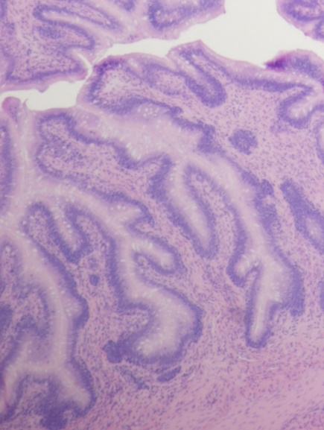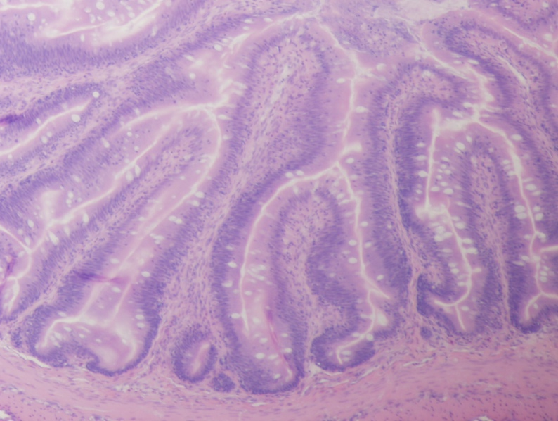
Figure 1: Posterior intestinal histology of channel catfish (Ictalurus punctatus) fed the experimental diets for 70 days

Figure 2: Bacterial relative abundance of channel catfish (Ictalurus punctatus) digesta offered the experimental diets for 70 days.

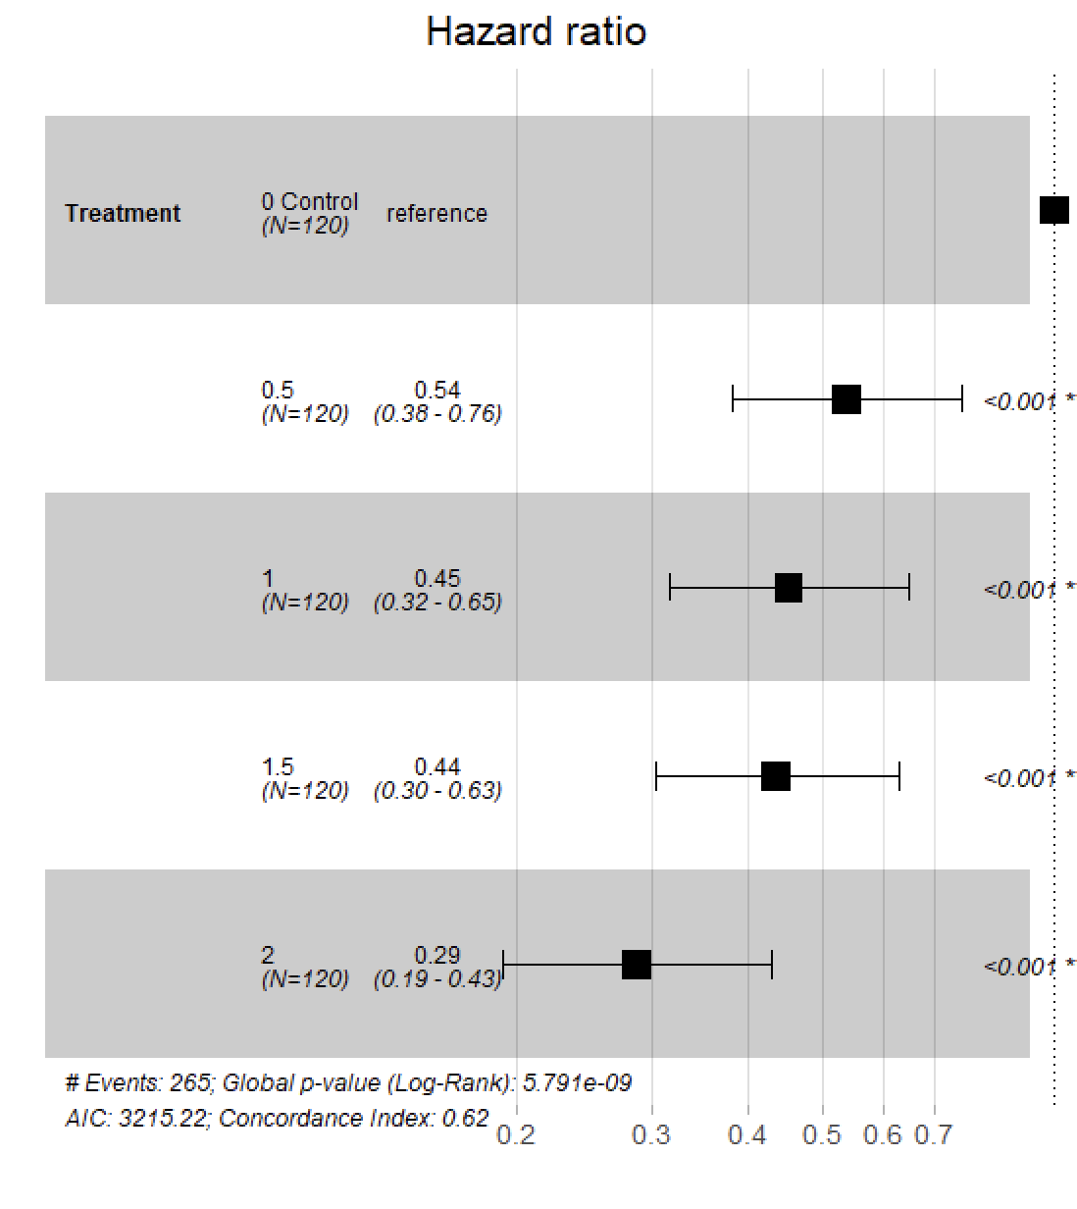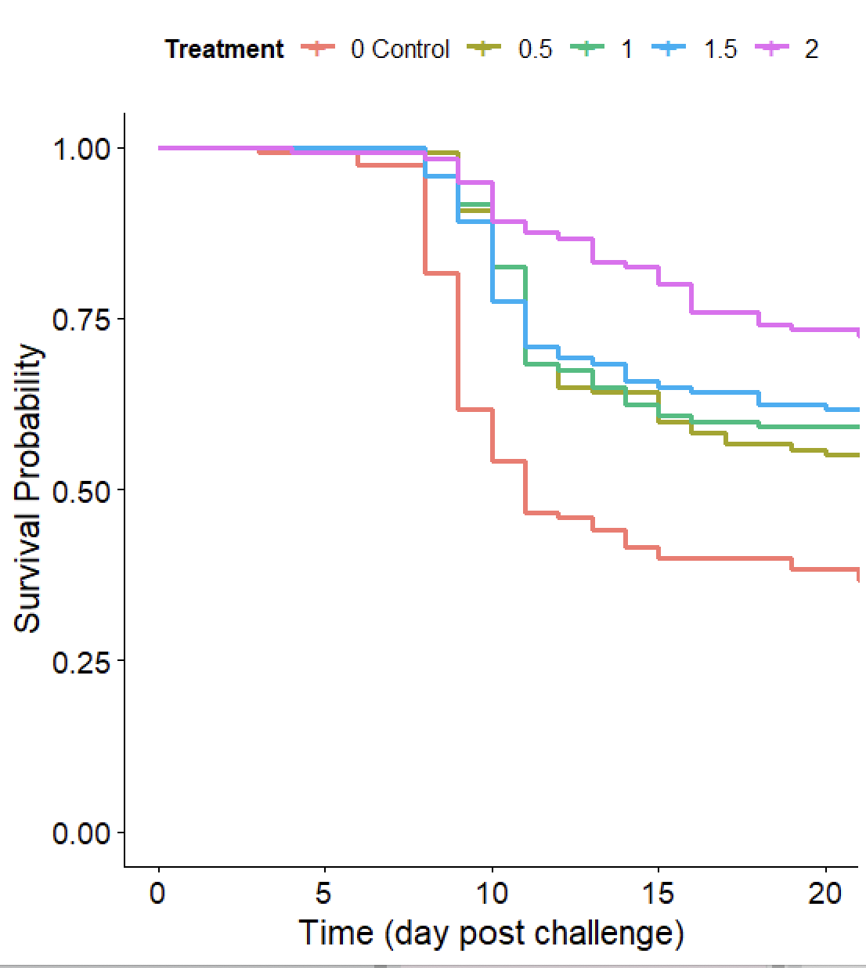
Figure 3: Cumulative survival rate of channel catfish (Ictalurus punctatus) juveniles exposed by bath immersion to Edwardsiella ictaluri (isolate S97-773), and a hazard ratio plot using the control diet as a reference.

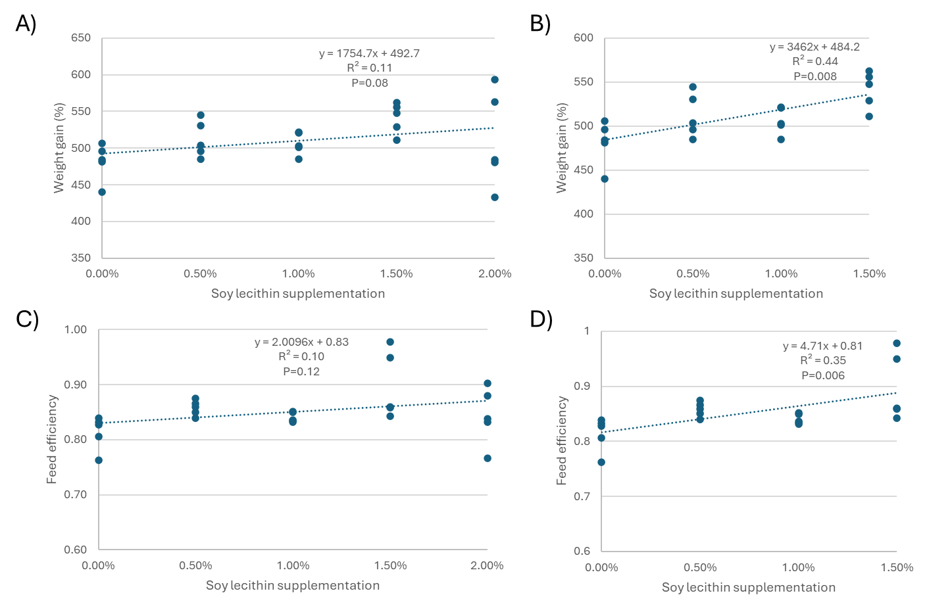
Supplementary Figure 1: Weight gain (A) and Feed efficiency (C) analyzed using a linear regression with the dataset as-is; and the same parameters being subjected to the same analysis but excluding the treatment 2.00% (B and D).

