Minnesota Soybean Research and Promotion Council

Annual Research Progress Report

Project Title: Team Soybean!: 2023 Minnesota Soybean Cyst Nematode (SCN) Sampling & Education Program

Principal Investigator(s): Angie Peltier & Anthony Hanson, UMN Extension & Seth Naeve, UMN Extension/Dept. of Agronomy and Plant Genetics

Project Period: Feb. 1 - April 30, 2024

Research Question/Objectives: This project is an effort to involve FFA students (with the assistance of their FFA advisors/ag teacher) in a statewide SCN sampling program. Obj. 1) Minnesota high school ag teachers were recruited to participate in the Team Soybean! program and were given a MSRPC-branded SCN sampling kit. Obj. 2) A curriculum was developed for teachers to use in the classroom, with one PowerPoint presentation designed to introduce students to soybeans, SCN biology and importance and how to collect a representative soil sample to estimate a field’s SCN population density. Another PowerPoint presentation covered how best to make sense of the results of the analysis of the samples they collected, the management recommendations that correspond with egg counts, how to visualize their chapter’s data through mapping and graphing and how to share the results and management recommendations with farmers. A link to a YouTube video of a panel discussion of folks in diverse ag careers was sent to teachers to play for their class so students could better ‘see themselves’ in one of these careers. Obj. 3) Get a ’30,000 ft view’ of SCN egg counts on Minnesota farm fields by compiling and mapping Fall 2022 and 2023 SCN egg counts.

Methods, Results & Discussion: The project reached out to the FFA chapter instructors that participated in the program in 2022 to determine how many would be willing to participate again in 2023. Only one ag teacher, Mr. Eric Sawatzke, MN’s 2023 Outstanding Ag Education Teacher of the Year from West Central Area Secondary School in Barrett, MN sought to participate again in 2023. No chapters that received the 2022 sampling kit but didn’t collect samples last fall collected and submitted samples in 2023, despite being urged to do so.

Additional instructors were solicited to join the team in letters and emails. Only one additional school with an ag teacher (New Richland, Hartland, Ellendale and Geneva High School - known as NRHEG High School) and one additional school with a willing biology teacher (Marshall County Central High School in Newfolden) signed up to participate.

Knowing that we were unlikely to get the ’30,000 foot view’ of SCN population densities throughout Minnesota as promised, we posted an article geared toward farmers and crop advisors on MN Crop News titled, “Know your SCN numbers: Free fall sampling program available”. This article provided a link to a Google form that folks could use to sign up to receive by mail sampling instructions and labels to stick on soil sample bags. The program sponsored by MSPRC would pay for the analysis of the first 1500 SCN samples submitted. A total of 1,511 bag labels were mailed to those that requested them. We mapped (Fig. 1) and graphed (Fig. 2) the results of the 393 samples analyzed.

Sixteen and a half percent of samples were below the limit of detection, and so had fewer than 50 eggs/100 cubic centimeter of soil (Fig. 2). This result does not mean that a field is not infested with SCN, just that the population density might be patchy or low enough so that we are unable to detected it when collecting 20 soil cores from a 10 acre area. Periodic sampling in this field is recommended as the risk of the field being infested has not decreased and once a field is infested as long as soybeans are produced in the field and soil continues to move, there will be a positive sample at a lab at some point.
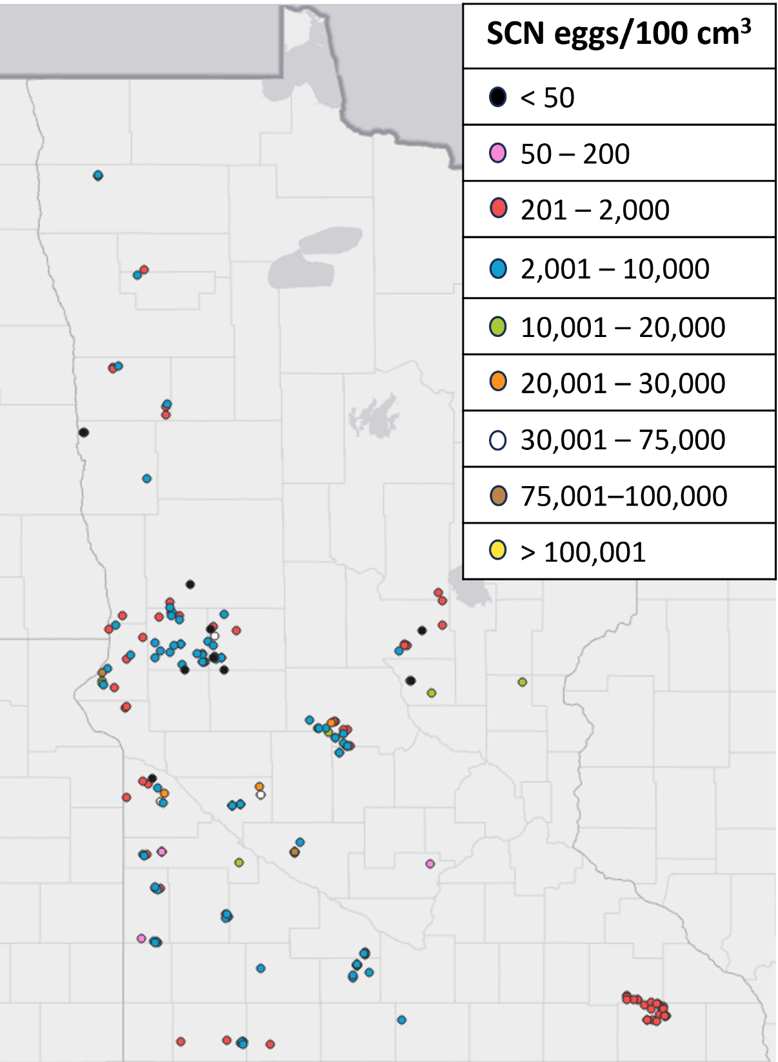
Figure 1. A map of the first 201 samples analyzed for SCN (collected fall 2022 & fall 2023). SCN egg densities ranged from below the limit of detection (black circles; 50 eggs/100 cc of soil) to 106,200 eggs/100 cc of soil near a town called Olivia in Renville County (yellow circle).

Nearly 10 percent of samples had fewer than 201 eggs/100 cc, a density low enough that one could grow a susceptible soybean variety without experiencing yield loss (Fig. 2). However, growing a susceptible soybean variety will make egg densities rise quickly. Twenty-nine percent of samples had between 201 and 2,000 eggs/100 cc, a density at which one could grow resistant soybean varieties without soybeans experiencing yield loss. A bit more than 33% of samples had 2,001-10,000 eggs/100 cc, a density at which one could plant a resistant soybean variety but should expect some SCN yield loss to occur. Soybean production is not recommended for fields that have densities greater than 10,000 eggs/100 cc because SCN-caused yield losses would be prohibitively high. More than 11% of samples were collected from fields in which soybean production would not be recommended.

Figure 2. The number (and percentage) of soil samples collected in 2022 & 2023 that fell into each SCN egg count category (n=393).

Application/Use: Management recommendations are based on egg count categories. Without knowing the density of SCN eggs in each field in which soybeans are grown, farmers would be unaware that SCN densities in certain fields and the potential for soybean yield loss might be so high that growing soybean would not be recommended until egg counts fall. This has profound implications for soybean yields and farm profitability.

Economic Benefit to a Typical 500 Acre Soybean Enterprise: This sampling program provides complimentary lab analysis to soybean producers in Minnesota worth $30 per sample. However, the knowledge about what is happening in a field’s soil can mean the difference between growing a crop with poor yield potential or a growing a crop that is not a host of SCN that can provide time for the SCN population to fall. SCN is capable of causing up to 30% yield loss without also causing above-ground symptoms. This means that for a farmer that hasn’t yet had to battle an SCN infestation and is used to growing 60 bushel per acre average soybeans, yield could trend down slowly to average 42 bu/A without clear attribution as SCN densities climb. If a bushel of soybeans is worth $13, losses could be as high as $234 per acre before the farmer may understand what is causing the downward slide in yields! This could be the difference between staying and going out of business. Yield losses due to brown stem rot and sudden death syndrome tend to be higher in fields also infested with SCN.

Recommended Future Research: The fact that 12% of samples yielded SCN egg counts so high that soybean production would no longer be recommended in the fields sampled was shocking, but not completely unexpected. As Minnesota soybean producers have had to primarily rely on the same source of genetic resistance (PI88788) in soybean varieties for many years, what we are seeing through soil sampling and lab analysis is the same phenomenon that was evident to the naked eye for years in waterhemp populations: repeatedly exposing a pest population to the same management tactic increases the probability that the population shifts to overcome that management tactic.

It would be worthwhile to Hg-type test Minnesota’s SCN populations to determine just how widespread PI88788-resistant SCN populations are throughout the state. A modified, less expensive Hg-type test could be run to test SCN populations against the sources of resistance that are (have been or will be) available in soybean varieties adapted to Minnesota.

In addition, a proposal for a pilot study in collaboration with a northwest MN soybean producer will be submitted to the Minnesota Soybean Research & Promotion Council for the 2024-25 funding cycle. Briefly, in a replicated on-farm strip trial in Norman County, in-furrow chelated iron to manage iron deficiency chlorosis (IDC) and a seed treatment to protect against SCN will be tested individually or in combination and compared to control plots that have received neither treatment. In addition to soybean yield components, spring and fall SCN egg counts and IDC ratings will also collected and treatments compared. Should this study prove illuminating, the team will submit a proposal to AFREC to fund additional similar on-farm research trials in northwest Minnesota.

Outreach: Egg count results and category distribution were shared at various winter meetings in northwest Minnesota, including:

Prairie Grains Conference – Soybean Research Reporting session. Grand Forks, ND, Dec. 14, 2023. (~60 attendees)

Summaries of this study were included in the On-farm Research Trials Booklet distributed at winter meetings including the On-farm Research Summit that precedes the Prairie Grains Conferences and all of the Small Grains Update Meetings held in January 2024. Typically, approximately 810 are printed and distributed.

Small Grains Update Meetings – (~300 attendees)
- Dilworth, MN, Jan. 9, 2024
- Ada, MN, Jan. 10, 2024
- Crookston, MN, Jan. 10, 2024
- Hallock, MN, Jan. 10, 2024
- Roseau, MN, Jan. 10, 2024
- St. Hilaire, MN, Jan. 11, 2024

