Research Report
May 31, 2023
Title: FY22 Management of Herbicide-Resistant Waterhemp in Minnesota Soybean
PI: Dr. Debalin Sarangi, UMN
Project Summary:
Waterhemp is the most difficult-to-manage weed in row crops in Minnesota. Recently, we received several complaints about waterhemp control failure in corn, soybean, and sugar beet in Minnesota. The first objective of this research was to evaluate the extent, profile, and patterns of herbicide resistance in waterhemp in Minnesota. Management of waterhemp in sugar beet is difficult if it follows corn or soybean as the previous crops as most of the corn and soybean herbicides show carryover injury to sugar beet. Moreover, there are limited postemergence herbicide options available in sugar beet. The second objective of this research was to evaluate a multi-tactic management approach for waterhemp in soybean-sugar beet rotation. As a part of the first objective, 90 putative herbicide-resistant waterhemp populations collected from 47 counties in Minnesota were screened against eight corn and soybean postemergence herbicides for resistance. All waterhemp populations were resistant to Raptor (herbicide site of action group 2) and 89% of all the populations were resistant Roundup PowerMAX (group 9). This research also found populations resistant to Enlist One (group 4), Xtendimax (group 4), Aatrex (group 5), Fomesafen (group 14), and Callisto (group 27) are present in Minnesota. Multiple herbicide-resistant waterhemp is a threat to the growers as they substantially reduce herbicide options to control this weed. Waterhemp populations resistant to two, three, four, five, and six different herbicide sites of action were also confirmed. As a part of the second objective, waterhemp management in soybean was evaluated in a soybean-sugar beet rotation. This field research was conducted in Rosemount, Franklin, and Moorhead, MN. The soybean was planted either in narrow (12 or 15 inches)- or wide-rows (22 inches) and herbicide treatments included low- and high-input programs. Although narrow-row soybean closed the canopy 7 to 14 days earlier than the wide-row, row spacing did not impact waterhemp management. High-input herbicide program worked best for waterhemp control across all the locations. Overall, this research showed that multiple herbicide-resistant waterhemp populations are on the rise in Minnesota. Herbicide options are available to manage waterhemp in soybean-sugar beet rotation.

Project Objectives:
1. Survey of herbicide-resistant waterhemp populations in Minnesota soybean
2. Evaluate multi-tactic waterhemp management options in soybean in a soybean-sugar beet rotation
This project is a continuation of the FY21 work. This report includes the overall accomplishment for the FY21 and FY22 projects.
Objective 1: Survey of herbicide-resistant waterhemp populations in Minnesota soybean
Waterhemp is a summer annual weed and the stakeholders in Minnesota reported that it is the most difficult-to-control weed in agronomic crops (e.g., corn, soybean, and sugar beet). In Minnesota, it emerges from the middle of May to early August depending on the weather condition and management practices.
The seeds of 90 putative herbicide-resistant waterhemp populations collected from corn, soybean, and sugar beet fields from 47 counties in MN were screened. The suspected herbicide-resistant waterhemp seeds were either submitted by the farmers and UMN’s Extension Educators, or collected by the UMN Weed Science Lab members. Waterhemp seeds were cleaned in a greenhouse at UMN’s St. Paul campus. Waterhemp populations were treated with 1x and 3x labeled doses of eight corn and soybean postemergence herbicides. The plants were 4 inches tall at herbicide application. The herbicide name and labeled rates are included in Table 1.
Table 1. Postemergence herbicide list and rates.
Herbicide trade name | Active ingredient | Site of action group# | Labeled rate (for corn or soybean)
Raptor | imazamox | 2 | 5 fl oz/A
Enlist One | 2,4-D choline | 4 | 2 pt/A
Xtendimax | dicamba (w/ VaporGrip) | 4 | 22 fl oz/A
Aatrex | atrazine | 5 | 2 lb ai/A
Roundup PowerMax | glyphosate | 9 | 32 fl oz/A
Liberty | glufosinate | 10 | 32 fl oz/A
Flexstar | fomesafen | 14 | 1 pt/A
Callisto | mesotrione | 27 | 3 fl oz/A

Individual plant injury data were recorded visually at 28 days after herbicide application on a scale of 0 to 100%, where 0% means no injury and 100% means complete death. Plant survival count and aboveground biomass data were also collected. Populations exhibiting ≥ 40% plant survival at 3x labeled rate were classified as ‘highly resistant’ and populations with < 40% plant survival at 3x rate but ≥ 40% plant survival at 1x rate were classified as ‘moderately resistant’. Populations with 20% to 39% survival rate at 1x rate were classified as ‘less sensitive’. If <20% of plants in a population survived the 1x labeled rate application of herbicide, the population is considered susceptible to that herbicide.
The results showed that the majority of the waterhemp populations screened in this study were resistant to Roundup PowerMAX (Group 9) and Raptor (Group 2). 31% of the populations were also resistant to Flexstar (Group 14). Previously, waterhemp populations resistant to these herbicide sites of action were reported in Minnesota, but this study showed that those resistant populations are spreading rapidly across the state. Moreover, we reported a few new cases of herbicide resistance in waterhemp in Minnesota. 47%, 22%, and 10% of all the populations were resistant to Aatrex (Group 5), Callisto (Group 27), and Enlist One (Group 4), respectively. Two waterhemp populations showed resistance to Xtendimax (Group 4). The screening results are summarized in Figure 1.
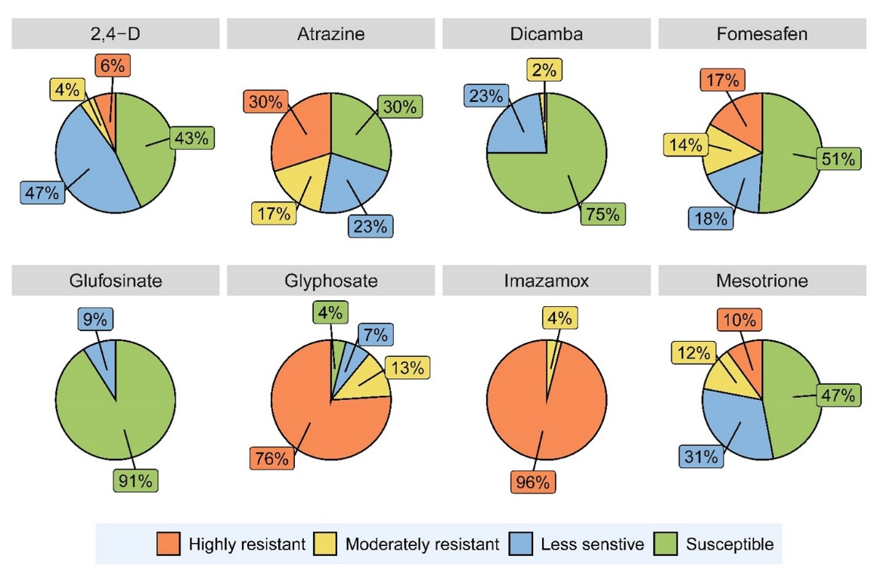
Figure 1. Percent waterhemp populations resistant to postemergence herbicides are listed out of 90 waterhemp population evaluated. The less sensitive populations have individual plants that showed higher tolerance to respective herbicides, and they have the potential to become herbicide-resistant in the future if not managed properly.
More concerning news is the spreading of the multiple herbicide-resistant waterhemp in Minnesota. If a waterhemp population showed resistance to two or more herbicide sites of action, they were listed as multiple herbicide-resistant. Twenty-eight populations were resistant to Raptor and Roundup. Thirty-four, 16, 7, and 4 populations showed three-, four-, five-, and six-way resistance, respectively. Two populations from Lincoln and Lyon Counties showed resistance to Raptor, Enlist One, Dicamba, Aatrex, Roundup, Flexstar, and Callisto. These six-way resistance cases (resistant to six herbicide sites of action) left no postemergence options but Liberty for corn and soybean farmers to control them.
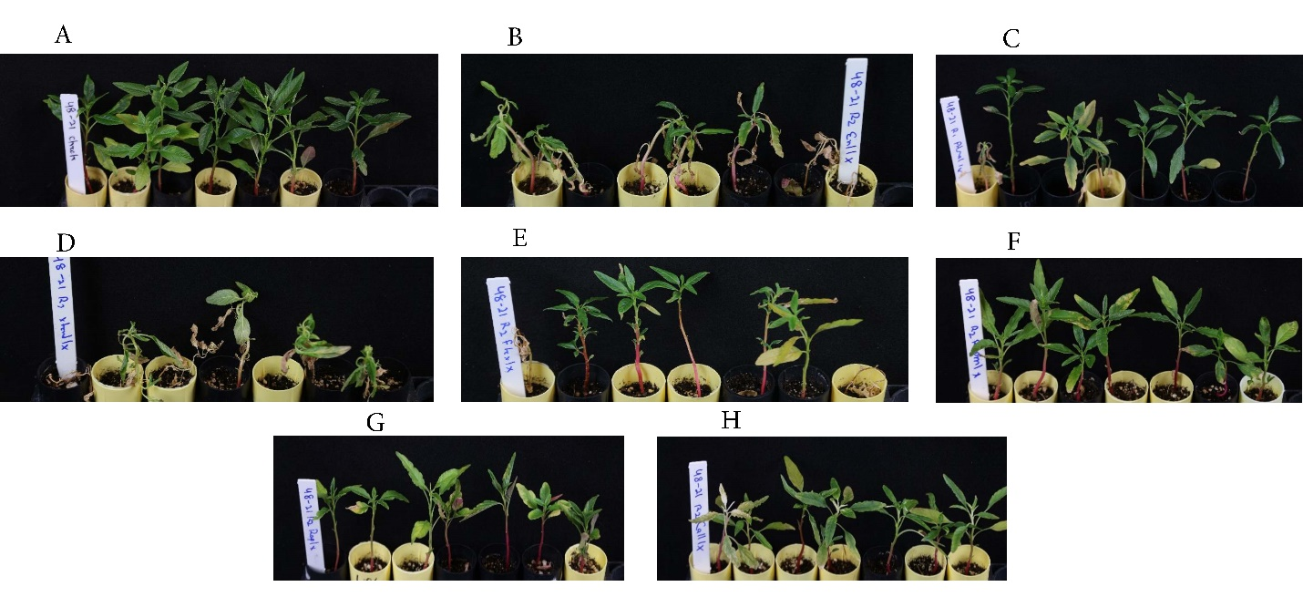
Figure 2. Waterhemp population from Lincoln County, MN, at 28 days after herbicide application at the labeled rates: (A) Nontreated control, (B) 2,4-D, (C) atrazine, (D) dicamba, (E) fomesafen, (F) glyphosate, (G) imazamox, and (H) mesotrione.
Conclusions: We confirmed that multiple herbicide-resistant waterhemp populations are on the rise in MN. Farmers need to be proactive in mitigating the evolution of herbicide resistance.

Objective 2: Evaluate multi-tactic waterhemp management options in soybean in a soybean-sugar beet rotation
The prevalence of multiple herbicide-resistant waterhemp reduces the herbicide options in agronomic crops, leading to increased production costs and lower profits. Waterhemp control is even more challenging in sugar beet if following soybean as a previous crop in the rotation. The preemergence herbicides used in soybean can carryover to subsequent sugar beet and cause substantial injury. Moreover, limited postemergence herbicide choices are available in sugar beet for waterhemp control compared to corn and soybean. Therefore, a multi-tactic approach that includes mechanical, cultural, and chemical control of waterhemp is needed in soybean-sugar beet rotation to reduce the weed seedbank.
The objective of this experiment was to evaluate waterhemp control, soybean yield, and waterhemp emergence in subsequent sugar beet crop in response to soybean row spacing, herbicide program, and harvest-time weed seed control (HWSC).
Materials and Methods
Field experiments were conducted in grower’s fields in Franklin, MN (2021-2022), Moorhead, MN (2021 -2023), and at the University of Minnesota’s Rosemount Research and Outreach Center near Rosemount, MN (2022-2023). The experiment was set up in a two-factor split-plot design with four replications. The main plot factor was soybean row spacings: narrow-row (15 inches in Moorhead and Rosemount and 12 inches in Franklin) and wide-row (22 inches). The herbicide programs included nontreated control, weed-free control, two low-input, two high-input herbicide programs, and a high-input herbicide program with HWSC simulation. Sugar beet was planted in the same field in the subsequent year.
Data Collection and Statistical Analysis
Soybean canopy cover was evaluated by estimating fractional green canopy cover (FGCC) using ground-based RGB images from weed-free control.
Waterhemp control in soybean was visually assessed in soybean at 21 d after PRE (DAPRE), and 28 d after MPOST (DAMP) on a scale of 0 to 100%, where 0% means no control and 100% means complete control. In addition, waterhemp seed production m⁻² and soybean yield were estimated. In subsequent sugar beet crop, waterhemp density was recorded at 28 d after planting (DAP). Waterhemp control, density, seed production, and soybean yield were subjected to ANOVA and further mean separation was conducted.
Results and Discussion
Due to inconsistent planting at the Moorhead site, the effect of row spacing was ignored in 2021 for that site. The 90% canopy closure in narrow-row was achieved by accumulating less GDD (158 to 400 cumulative GDD depending on the site and year) than the wide-row soybean. Thus, reducing soybean row spacing helped to achieve quicker soybean closure.
At 28 DAPRE in Rosemount (2022), flumioxazin provided > 72% waterhemp control compared with < 56% control achieved with dimethenamid-P or saflufenacil plus dimethenamid-P, whereas all the herbicide programs were similar at Franklin (2021). At Moorhead (2021 and 2022), waterhemp control at 28 DAPRE was not evaluated.
At 28 DAMP, row spacing did not impact waterhemp control. All the herbicide programs provided > 95% waterhemp control at Franklin. Dimethenamid-P (PRE) fb glyphosate (mid-POST) application provided 27% to 55% waterhemp control at Rosemount and Moorhead sites. Flumioxazin (PRE) fb lactofen plus acetochlor (early-POST) fb 2,4-D choline plus glyphosate (mid-POST) provided the highest waterhemp control (≥ 96%) across all the sites.
Waterhemp seed production was not evaluated at Moorhead 2022 site, whereas at other sites waterhemp seed production was comparable for narrow and wide row spacing. Nontreated control produced 130,000 to 525,000 waterhemp seeds m⁻², depending on the experiment site. Across all the sites, flumioxazin (PRE) fb lactofen plus acetochlor (early-POST) fb 2,4-D choline plus glyphosate (mid-POST) reduced waterhemp seed production to 0.
Row spacing did not impact soybean yield at Moorhead (2022), whereas narrow-row spacing outyielded wide-row spacing by 5 and 8.5 bu/A at Franklin and Rosemount, respectively. Over the experiment, nontreated control yielded 48 to 77% lower than the weed-free control.
At Franklin (2022), in subsequent sugar beet crop, nontreated control had the highest waterhemp density (188 plants m⁻²) at 28 DAP. At Moorhead in 2022, waterhemp density in sugar beet at 28 DAP, was similar in nontreated control (74 plants m⁻²) and dimethenamid-P (PRE) fb glyphosate (mid-POST) program (110 plants m⁻²).
2023 Experiments: Sugar beet is planted at Rosemount, MN and Moorhead, MN. Waterhemp emergence will be recorded at 28 DAP.

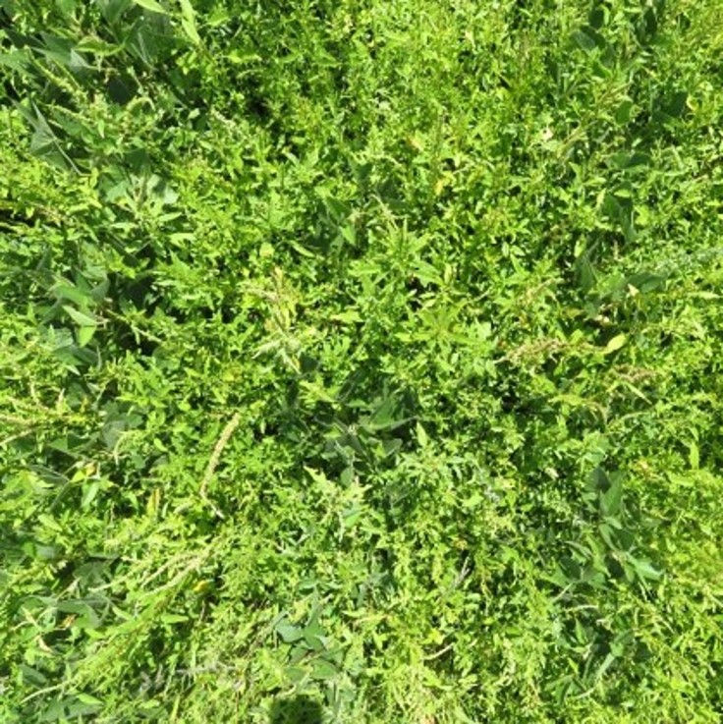
Nontreated control

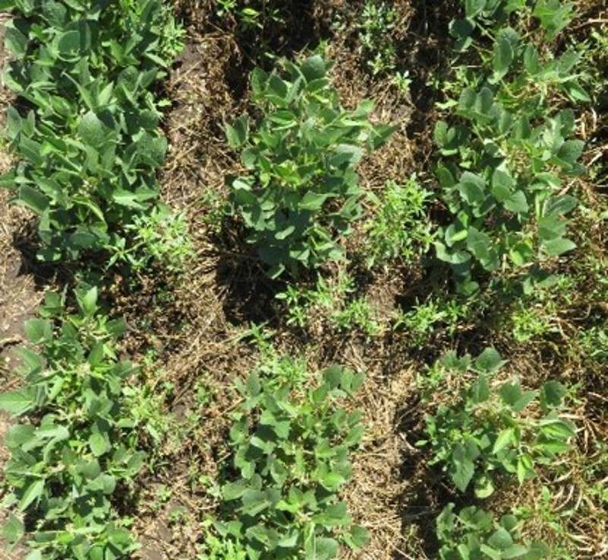
Dimethenamid-P (PRE) fb glyphosate (mid-POST)

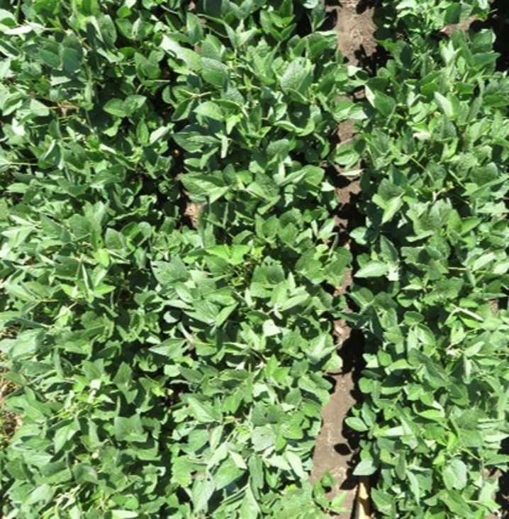
Flumioxazin (PRE) fb lactofen plus acetochlor (early-POST) fb 2,4-D choline plus glyphosate (mid-POST)

Figure 1: Waterhemp control at 28 DAMP at Rosemount, MN in 2022.
Deliverables:
Results obtained from this research were presented in six Field Days, and in fifteen Extension presentations. Two Minnesota Crop News articles were written. This research data were also presented at Minnesota Ag Expo in 2023. Some of the initial research data have been presented in the regional and national Weed Science meetings. The graduate student, Navjot Singh, will defend his thesis soon and his thesis will include all the data from these studies. Peer-reviewed journal articles will be submitted to journals in one month.

Performance Metrices:
1. Results obtained from this research improve the yield and quality of soybean grown in MN: Yes
2. Growers and other stakeholders are educated about the herbicide resistance in waterhemp, and integrated weed management: Yes
3. Results are presented in Extension events attended by the soybean growers.: Yes
4. One graduate student and one undergraduate student are mentored.: Yes
5. Peer-reviewed and Extension articles are published containing these results.: Two Extension articles were written and more peer-reviewed and Extension articles are upcoming.

