Progress report 4 – May 31, 2022 MSRPC Project: 10-15-44-22014
Minnesota SCN Squad: 2022 Minnesota Soybean Cyst Nematode Sampling and Education Program
Principal Investigator (PI): Angie Peltier, apeltier@umn.edu, O: (218) 281-8692, C: (414) 704-1931
Co-PI(s): Anthony Hanson, UMN Extension and Seth Naeve, UMN Extension/Dept. of Agronomy and Plant Genetics
Cooperator: Phyllis Bongard, UMN Extension, bonga028@umn.edu,

Project Summary: Results of a prior Minnesota Soybean Research & Promotion Council-sponsored SCN sampling program administered by UMN Extension was disappointing. In 2018-2019, only 363 samples were returned for analysis after more than 5,000 sample bags were distributed to more than 1800 soybean producers, limiting the ability of UMN Extension and MSRPC members to get a ‘30,000 ft view’ of sample results that might drive both further sampling efforts and changes to soybean production practices to more actively manage SCN populations. The Team Soybean! project was designed to excite the next generation of soybean producers, agronomists and ag service providers and provide them with practical, hands-on experience in how best to detect and monitor SCN and end up getting a better ’30,000 ft view’.
Project Objectives:
- Minnesota SCN Squad: 2022 Minnesota Soybean Cyst Nematode Sampling and Education Program
  - Provide an educational curriculum to Minnesota ag teachers/FFA club advisors to increase students’ general knowledge about soybeans, their importance to the rural Minnesota economy and SCN, the most yield-limiting pathogen of Minnesota soybeans.
The first of three annotated PowerPoint presentations designed for FFA advisors to use in their classrooms has been completed and distributed. This presentation focuses on the contribution of soybean to Minnesota’s economy, the threat to Minnesota soybean yield posed by SCN, how the Team Soybean! program works and how to collect a soil sample for SCN in either fields that one knows is already infested or where SCN status is not known.
As SCN samples get shipped to and analyzed in the lab, another annotated PowerPoint presentation geared toward helping students interpret SCN egg count data, and how best to provide these data and egg count-based management recommendations to farmers that volunteered fields to sample is in progress. Lastly, another annotated PowerPoint presentation will be for those chapters and students that would like to “take it further” and will focus on graphically summarizing overall chapter results and providing farmers with information about regionally-adapted soybean varieties expressing a source of SCN resistance different from the most widely used PI88788.
  - Provide MSRPC-branded SCN sampling kits to FFA chapters so that they can collect soil samples for analysis from real-world farm fields, be they fields their own family or fields that local area producers farm. This sort of hands-on learning tends to create memorable ‘teachable moments’ for learners.
Items that make up the contents of an SCN sample kit were purchased and used to assemble individual sample kits for delivery to participating FFA chapters, including: bright, yellow 2 gallon buckets with lids, soil probes “branded” with a MSRPC sticker, chapter-specific sample bag labels, soil sample bags, fine and ultra-fine point Sharpies for labeling, work gloves, laminated sampling instructions (Figure 1), shipping box and pre-paid shipping label (Figure 2).
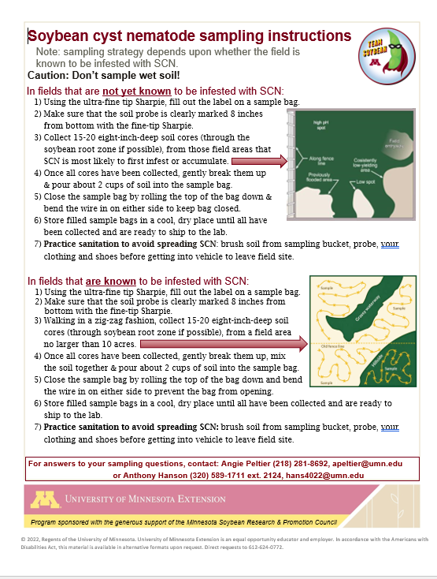
Figure 1. What the laminated soil sampling instructions look like. Note the credit to MSRPC included in the yellow banner across the bottom of the instructions.
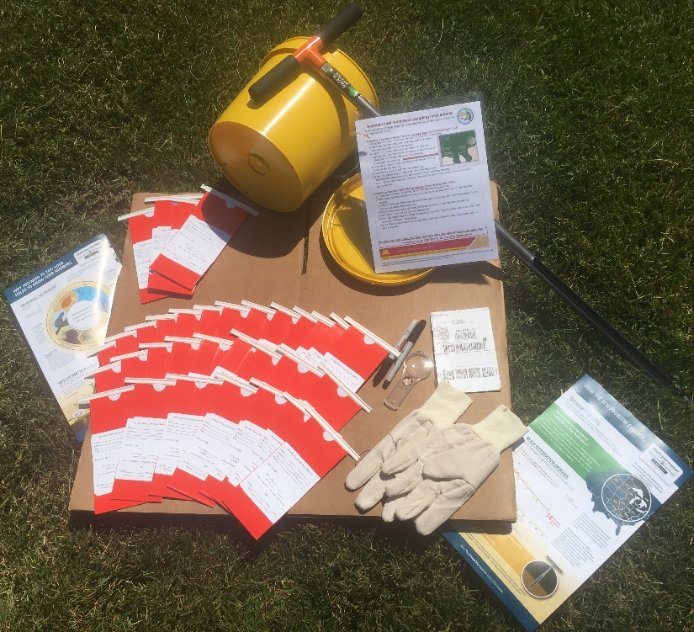
Figure 2. Contents of MSRPC-sponsored Team Soybean! sampling kit, including a soil probe with an MSRPC sticker affixed.
  - Provide results from SCN samples collected by FFA chapters so that students can discuss and map the results of their own survey, ‘learning by doing’ about the importance of gathering real-world data to assist soybean producers’ decision making.
  - Provide data sheets and management recommendations that students will share with the farmers whose fields they sampled. This is a way to introduce students to one of the tasks of ag service providers and Extension agents.
  - Get a ‘30,000 ft’ picture of the prevalence and severity of SCN infestations in areas of MN where SCN survey data has been sparse and underrepresented.
  - Survey participating FFA instructors, FFA students and farmers to evaluate program effectiveness for increasing knowledge about SCN and SCN management and increasing the desire to periodically monitor SCN population densities.
Multiple efforts have been made to recruit FFA chapters by sending email and U.S. mail communications targeted toward both key high school principals and FFA advisors/ag teachers. Initial outreach began with an email sent just prior to the state FFA convention this April. Additional communications through email, U.S. mail and through the ag press have continued. It is our expectation that many of these communications that took place over the summer will not yet have been received by FFA advisors if they did not check their physical or virtual mailboxes.
Five region 1 FFA chapters (northwest MN), agreed to be a part of Team Soybean! four from region 2 and seven from region 3 with another tentatively agreeing to join (Table 1).

Table 1. FFA chapters that agreed to be a part of Team Soybean! Note: only bolded chapters shipped samples to the lab for analysis
FFA Region | FFA Chapter | County
1 | Climax-Shelly | Polk-Norman
1 | Fosston | Polk
1 | Frazee-Vergas | Becker
1 | Hawley | Clay
1 | Ulen-Hitterdal | Clay
2 | Aitkin | Aitkin
2 | Bertha-Hewitt | Todd
2 | Pierz-Healy | Morrison
2 | Sebeka | Wadena
3 | Battle Lake | Otter Tail
3 | Brandon-Evansville | Douglas
3 | Herman-Norcross | Grant
3 | Minnewaska-Glenwood Area | Pope
3 | Osakis | Douglas-Todd
3 | Paynesville | Stearns
3 | West Central Area | Grant
3 | Wheaton | Traverse
8 | Chatfield | Fillmore/Olmstead
A flier advertising this project was distributed via email to members of county Soybean and Corn Growers Associations in at least 25 Minnesota counties with the thought that soybean producers’ support might spark additional chapters to join Team Soybean!. For the same reason, a press release was also distributed to these same 25 counties to be published by local newspapers. A nice feature article by Paula Mohr about this program was published in The Farmer by Paula Mohr. This article was distributed to their massive mailing list at least twice and was picked up for feature on the Minnesota Soybean Grower’s Minneline digital newsletter.
Lastly, several radio interviews have also highlighted this program:
- July 14. KQLX. Fargo.
- July 28. KTRF. Thief River Falls.
- July 28. KROX. Crookston.
A total of 174 samples were submitted by FFA chapters, with Climax-Shelly submitting 9, Herman-Norcross 3, Minnewaska-Glenwood Area 19, Paynesville 35, Pierz-Healy 35, West-Central Area 14, Wheaton 12, Chatfield 35, Litchfield 11 and Hawley 4 samples. Nine samples had SCN egg counts below the limit of detection (50 egg/100 cc) and 165 samples were positive for SCN, with densities ranging between 50 and 29,350 eggs/100 cc (Figure 3). Forty-seven samples had densities between 50 and 200 eggs/100 cc, a density at which one can still plant a susceptible soybean variety without current in-season yield penalty; however SCN population densities will continue to rise. Sixty-eight samples had densities between 201 and 2,000, under which one can still plant a susceptible variety with yield penalty or plant a resistant variety; 42 samples had densities between 2,001 and 10,000 eggs/ 100 cc, densities at which one can expect a yield loss with a resistant variety; and 9 samples had egg counts higher than 10,001 eggs/100 cc, a density at which soybean (and dry bean) production is no longer recommended as yield losses will be too great.

Figure 3. Number of samples submitted by Minnesota FFA chapters that fell into each egg count range.
A digital Qualtrics survey was used to assess FFA chapter experience with the educational products and sampling kit provided through this program; the survey was sent to 20 educators and seven educators responded, for a 35% response rate. The survey was sent to advisors of those FFA chapters that signed up to be a part of the program, whether or not they submitted samples.
Educator Impressions of Team Soybean Educational Materials. Educators were asked about which of the Team Soybean educational materials they used with their classes, 86% (6 of 7 respondents) used the “Welcome to Team Soybean” annotated PowerPoint presentation that covered both the importance of soybeans to MN and SCN to soybean and a 12-step protocol to collect a representative soil sample for either an initial SCN detection or to monitor known SCN infestations. Respondants indicated that 86% used the annotated “Now that you have your sample results” PowerPoint presentation, a resource that covered putting results into context, those SCN management strategies warranted based on SCN population densities and data visualization, and 43% (3 of 7 respondents) used the “Careers in Agriculture” video.
Of the seven educators that used the “Welcome to Team Soybean” PowerPoint, four answered additional questions about the presentation when asked to rate their response to statements (Table 2) on a scale of 0 to 10 where a score of “0” means disagree, a score of ‘5’ means neither disagree nor agree and a score of ’10’ means agree.
Table 2. Summary statistics for response ratings regarding the “Welcome to Team Soybean” PowerPoint; a score of “0” means disagree, a score of ‘5’ means neither disagree nor agree and a score of ’10’ means agree (n=4)
Statement | Minimum | Maximum | Mean | Std. Dev.
I used this PowerPoint in class | 5.0 | 10.0 | 7.5 | 2.5
I used this PowerPoint to prepare for a less formal discussion in class | 0.0 | 10.0 | 5.8 | 3.8
The notes in the PowerPoint were helpful | 4.0 | 10.0 | 7.5 | 2.2
The content was understandable to my students | 2.0 | 8.0 | 5.5 | 2.3
The PowerPoint stimulated good discussion in my class | 5.0 | 8.0 | 6.5 | 1.1
The PowerPoint provided content of value to my class | 4.0 | 10.0 | 6.8 | 2.4

Forty percent of the responding instructors used the “Now that you have your sampling results” PowerPoint in class (Table 3), 40% used it to prepare for class and 60% thought that the annotation was useful, understandable to students, stimulated good discussion and provided content of value.
Table 3. Number and (percentage) of responses to statements regarding the “Now that you have your sampling results” PowerPoint (n=5)
Statement | Disagree | Neither agree nor disagree | Agree
I used this PowerPoint in class | 2 (40%) | 1 (20%) | 2 (40%)
I used this PowerPoint to prepare for a less formal discussion in class | 0 (0%) | 2 (40%) | 2 (40%)
The notes in the PowerPoint were helpful | 0 (0%) | 2 (40%) | 3 (60%)
The content was understandable to my students | 0 (0%) | 2 (40%) | 3 (60%)
The PowerPoint stimulated good discussion in my class | 0 (0%) | 2 (40%) | 3 (60%)
The PowerPoint provided content of value to my class | 0 (0%) | 1 (20%) | 3 (60%)
Instructors were also asked to rate their impression of their students’ level of knowledge before and after engaging with Team Soybean educational materials (Table 4). Before engaging with the educational materials, 100% of the respondents (n=5) indicated that their students had either no knowledge or a low level of knowledge of the importance of SCN to soybean yield, how to collect a representative soil sample, how to interpret lab test results or map or graph data. After engaging with the educational materials, 100% of instructors indicated that their students had greater than no knowledge, 100% indicated that their students had a moderate or high level of knowledge regarding how to collect a representative soil sample, 80% that their students’ level of knowledge regarding the importance of SCN to soybean yield was moderate or high, 80% indicated that the students now have moderate or high levels of knowledge regarding how to map and graph data and 40% indicated that the students now have moderate or high knowledge regarding how to interpret lab test results.
Table 4. Instructor’s impression of their students’ level of knowledge BEFORE and AFTER engaging with Team Soybean provided educational materials regarding the following true statements and skills; the number and (percentage) of respondents’ impressions are reported here (n=5)
Statement | Level of knowledge BEFORE |  |  |  |  | Level of knowledge AFTER
 | None | Low | Moderate | High |  | None | Low | Moderate | High
Importance of SCN to soybean yield | 3 (60%) | 2 (40%) | 0 (0%) | 0 (0%) |  | 0 (0%) | 1 (20%) | 3 (60%) | 1 (20%)
How to collect a representative soil sample | 2 (40%) | 3 (60%) | 0 (0%) | 0 (0%) |  | 0 (0%) | 0 (0%) | 2 (40%) | 3 (60%)
How to interpret lab test results | 3 (60%) | 2 (40%) | 0 (0%) | 0 (0%) |  | 0 (0%) | 3 (60%) | 1 (20%) | 1 (20%)
How to graph data | 1 (20%) | 4 (80%) | 0 (0%) | 0 (0%) |  | 0 (0%) | 2 (40%) | 2 (40%) | 1 (20%)
How to map data | 1 (20%) | 4 (80%) | 0 (0%) | 0 (0%) |  | 0 (0%) | 2 (40%) | 2 (40%) | 1 (20%)
Respondents were asked to rate their level of agreement to the statements listed in Table 5 related to the “Careers in Agriculture” video on a scale of 0 to 10 where a score of “0” means disagree, a score of ‘5’ means neither disagree nor agree and a score of ’10’ means agree. One instructor (of the three that claimed to have used the video) agreed that they both used the video in class and that it provided information of value, but neither agreed, nor disagreed that it stimulated good discussion.
Table 5. Summary statistics for response ratings regarding the “Careers in Agriculture” video; a score of “0” means disagree, a score of ‘5’ means neither disagree nor agree and a score of ’10’ means agree (n=1)
Statement | Score
I used this video in class | 10
This video provided information of value to my class | 8
This video stimulated good discussion with my class | 6
Educator Impressions of Team Soybean Promotional Materials. When asked about the promotional materials developed for the program, which included a fill-in-the-blank-style press release (PR1) announcing their chapter’s participation in the sampling program and a fill-in-the-blank-style press release (PR2) announcing a chapter’s sample results, two instructors used PR1 and one used PR2. Respondents were asked to rate their responses to statements regarding PR1 on a scale of 0 to 10 where a score of “0” means disagree, a score of ‘5’ means neither disagree nor agree and a score of ’10’ means agree (Table 6). The one person that indicated they used PR2 agreed (score of 10) that it was both easy to fill in the blanks to complete the press release, and that they submitted PR2 to their local newspaper, although they failed to score their level of agreement to the statement, “The press release was printed in the local newspaper”.
Table 6. Summary statistics for response ratings regarding the press release “PR1”; a score of “0” means disagree, a score of ‘5’ means neither disagree nor agree and a score of ’10’ means agree (n=2)
Statement | Minimum | Maximum | Mean | Std. Dev.
It was easy to ‘fill in the blanks’ to complete the press release | 5.0 | 10.0 | 7.5 | 2.5
I submitted a press release to the local newspaper | 0.0 | 10.0 | 5.0 | 5.0
The press release was printed in the local newspaper | 10.0 | 10.0 | 10.0 | 0.0
Educator Impressions of Team Soybean Rewards. FFA instructors were asked to rate their impressions of the Team Soybean rewards presented to their students (Table 7) on a scale of 0 to 10 where a score of “0” means negative, a score of ‘5’ means neutral and a score of ’10’ means positive; with the average response indicating neutrality. Two instructors also provided additional comments regarding the rewards: “We loved the program, and the rewards were a sweet surprise” and “Appreciate the thought, but we didn’t need any rewards”.
Table 7. Summary statistics for response ratings regarding Team Soybean rewards provided to students on a score of “0” means negative, a score of ‘5’ means neutral and a score of ’10’ means positive (n=6)
Statement | Minimum | Maximum | Mean | Std. Dev.
Stickers | 0.0 | 10.0 | 5.5 | 3.3
Temporary tattoos | 0.0 | 10.0 | 5.7 | 3.3
Certificates of participation | 0.0 | 10.0 | 6.2 | 3.3
Instructors were asked about whether they’d like their chapter to participate in 2023. Instructors were notified that we received funding to continue the program in 2023 and were asked about their interest in participating in various aspects of the current program (sampling program, careers discussion) or an in-class soybean experiment during the 2023/2024 school year. Of the six instructors that responded to the survey, five (83%) indicated that they are interested in participating in the sampling program, three (50%) in the careers discussion and four (67%) in an in-class soybean experiment.
Instructors also offered general comments regarding the program, including: “I currently have sampling equipment for one student to sample at a time so having additional equipment would help students collect samples when they have time and not being able to miss those opportunities because of things like sports or other extra curriculars” and “Last year students did not have enough time to collect samples and send in by the deadline. This is a great program and I hope to better implement it next year”.
No-cost extension of project. A 1 year, no-cost extension of this project was granted by the MSRPC. Plans for these funds include contacting all of the school boards throughout the state to solicit additional schools to participate in the “Team Soybean” sampling program. This may require a bit of rebudgeting if participation by an FFA chapter requires us to ship sampling kits to schools. Additionally, in the target two regions (NW MN and the C/WC Lakes & Dairy regions) of the state, we plan to speak with the county Soybean & Corn Growers Associations about the program. Membership in these county-based associations are local and regional leaders with a keen interest in educating the next generation about agriculture and crop management. Engaging with these groups may lead to their advocating for county FFA (or science class) chapter Team Soybean participation.

