Objective:
To establish the optimal level of soy lecithin on catfish feeds based on production performance using a dose-response feeding trial. In the same study, to understand possible physiological changes to the channel catfish juveniles driven by the dietary lecithin supplementation.

Experimental diets and comparative feeding trial
Five experimental diets were formulated to be isolipidic and isonitrogenous, and ingredients were locally sourced from catfish feedmills. The experimental diets were prepared to contain 36% crude protein, 5% lipid on dry matter basis (Table 1). Soy lecithin was supplemented in graded levels 0.5, 1, 1.5 and 2% at the expense of soybean oil, and the 0% treatment served as a control group. To manufacture the experimental diets, the ingredients were individually weighted and mixed using a V-mixer machine (P-K Blend Master, Patterson-Kelley LLC, PA, USA) for 30 min with intermittent use of the inner mixing bar. The resulting mixture was poured into an orbital mixer and blended for further 15 min, where soybean oil was gradually incorporated into the feed. For the soy lecithin supplemented diets, crude lecithin was mixed with soybean oil while subjected to heat using a hot plate. Shortly after, deionized water was included at a 30% of the total volume of mash feed. The resulting moistened mixture was cold pelleted through a 3-mm die plate (Hobart Machine, Hobart, OH, USA), and left to dry overnight in a forced air oven at room temperature. All experimental diets were analyzed for nutrient composition following the procedures outlined by AOAC (2005).
Each dietary treatment (Control, 0,5, 1, 1.5 and 2%) was randomly assigned to five tanks (30 gallons; n=5), stocked with 30 catfish juveniles (~4.4g) each. The rearing system operated as a recirculating aquaculture system, and aeration was provided to each aquarium through air stones. Feed rations were adjusted according to body weight every two weeks, fish were fed twice a day, for 70 days. In order to ensure optimal growth, water quality parameters were measured three times a week and maintained within range for catfish culture. To monitor the water temperature, and dissolved oxygen (DO) the optical DO meter (ProSolo ODO, YSI, Yellow Springs, OH, USA) was used, and the salinity and pH were monitored by handheld devices (Hach Company, Loveland, Co, USA). Total ammonia nitrogen (TAN) and total nitrite nitrogen (TNN) were measured colorimetrically using spectrophotometer (Hach Company). The water quality parameteres from the feeding trial were the following (average ± SD): Temperature: 27.0 ± 1.2°C; DO= 7.65 ± 0.39 mg/L; Salinity= 1.01 ± 0.38 mg/L; pH= 8.28 ± 0.14; TAN= 0.27 ± 0.19; and TNN= 0.03± 0.03. This study was conducted following the procedures of Mississippi State University Institutional Animal care and Use Committee under the protocol IACUC-23-254.
At the end of the feeding trial, fish wer group weighed, and three fish per tank were anaesthetized with MS-222 (150 mg/L) to collect blood samples using heparinized tuberculin syringes. Blood samples were collected from the caudal peduncle vasculature, and immediately transferred to 1.5 ml centrifuge tubes.
For the red blood cell counts (RBC), samples were prepared using 798 µL NaCl buffer solution and 2 µL of the whole blood. Samples were further mixed in a 1:1 ratio with 0.4% Trypan Blue. From this mixture, 10 µL of stained blood was added into each slot of a hemacytometer. To determine the hemoglobin concentration (HGB), 5 μL of blood was added to 1 mL of Drabkin's reagent and mixed. After 15 minutes, 800 μL was aliquoted and subjected to a 540 nm absorbance. Another aliquot of whole blood was centrifuged (3,500 × g, for 15 min) in microhematocrit capillary tubes and used to quantify hematocrit (HCT). The remaining blood samples were centrifuged, and plasma was aliquoted and immediately store frozen at -20°C.

2.1- Whole-Body proximate composition analysis
The initial whole-body sample was taken from the same population used to stock the feeding trial by euthanizing the fish with MS-222 (300 mg/L), and later store frozen (-20°C). At the end of the feeding trial, three fish per tank were randomly selected and euthanized (MS-222 at 300 mg/L) frozen at -20°C. Whole-body samples were ground, which were subsequently dried for 24 hours at 100°C overnight. The samples were ground and subjected to proximate composition analyses. The body composition analysis from the samples were performed to measure the dry matter, crude protein, crude fat, and ash following the AOAC (2005) procedures.
The protein conversion efficiency (PCE,%). was calculated according to the formula:

Protein conversion efficiency (PCE, %) = [(Final weight (g) × final protein (%) − (initial weight (g) × initial protein (%)] ÷ protein intake (g) × 100.

2.2- Air exposure stress challenge
To perform the stress challenge, fish were air exposed by netting them out of the tank, and exposing them to air for two minutes, shortly after the fish were returned to their respective aquaria. Shortly after, four fish per tank were bled at 0 (without air exposure) and at 0.5, 1, 2, 6 h following air exposure. At each sampling time, the fish were bled following the aforementioned procedures. After performing HCT, RBC and HGB, blood samples were stored at 4°C for 3 h and centrifuged at 5,000 rpm for 15 min at 4°C to obtain plasma samples, which were immediately stored frozen -20°C.

2.3- Intestinal microbiota
The remaining fish were fed their respective dietary treaments for an additional eight days, and 18 hours prior sampling digesta, fish were fed to apparent satiation, and feeding was staggered for 3 min from tank to tank to ensure that transit time would be the same for all experimental units. Three fish were randomly selected from each tank and euthanized with MS-222 (~300 mg/L) and digesta samples were asseptically collected from the posterior segment of the intestine and pooled into 15 mL tubes. The pool of collected digesta was weighed, homogenized in PBS at a 1:1 (w/v) ratio, and 400 µL was aliquoted in cryotubes, and immediately stored at -80°C until they were further processed for DNA extraction.
For the DNA extraction procedure, the samples were thawed, centrifuged (15,000 × g for 1 minute) and the PBS supernatant was removed. The resulting pellet was subjected to DNA extraction following the manufacturer’s procedures (DNeasy Power Soil Pro Kit; QIAGEN, Hilden, Germany). The DNA samples were shipped to the University of Minnesota Genomics Center, and sequenced using Illumina MiSeq targeting the V3-V4 region of the 16S rRNA gene.

2.4- Bacterial challenge Edwardsiella ictaluri
The remaining experimental fish were transferred to a flow-through system, acclimated with their respective dietary diets for an additional week and and subjected to a bacterial challenge by immersion using a virulent strain of Edwardsiella ictaluri. The isolate (S97-773; GenBank ASM305480v2) was obtained from the College of Veterinary Medicine repository. The fish were exposed to E. ictalurid for one hour in their respective tanks, where the water flow was turned off, but with constant aeration through airstones. The fish were continuously fed their respective dietary diets and mortality was observed for 22 days. Dead fish were immediately removed and stored frozen prior incineration.

2.5- Statistical analysis
Data collected from the feeding trial and body composition were subjected to a mixed model using one-way ANOVA and the distribution of the tanks as main factors. If significant differences were observed (P<0.05), then a Student T-test was performed for comparison of means. The air exposure challenge was analyzed using a factorial model with dietary treatments and sampling time. The cumulative survival of bacterial challenge was analyzed by Kaplan–Meier conducted in GraphPad Prism 10.1.0.

3.0- Results
The treatment of 1.5%, was significantly higher than the other groups for weight gain and feed efficiency. The feed efficiency of 1.5% was statistically different from the treatments control, 1% and 2%. No significant differences were observed at the viscerosomatic (VSI), hepatosomatic (HSI) and visceral fat-somatic index (IPF). Hematocrit was significantly different between the 1% and 2% treatment.

3.1- Experimental diets and comparative feeding trial
Table 1- Growth performance of channel catfish after 70 days feeding trial.
 | Weight gain (%) | Feed efficiency | Survival (%) | VSI | HSI | IPF | Ht (%) | Hb | RBC
Control | 590.9^{B} | 0.56^{B} | 98.7 | 8.92 | 1.79 | 3.62 | 29.0^{AB} | 3.95 | 4.95
0.50% | 621.9^{AB} | 0.56^{AB} | 98.7 | 8.96 | 1.66 | 4.12 | 29.0^{AB} | 4.47 | 5.00
1.00% | 616.2^{AB} | 0.55^{B} | 98.7 | 8.65 | 1.65 | 3.55 | 28.2^{B} | 4.41 | 4.89
1.50% | 646.1^{A} | 0.59^{A} | 99.3 | 8.65 | 1.59 | 3.74 | 28.4^{AB} | 3.48 | 4.73
2.00% | 624.5^{AB} | 0.57^{B} | 98.0 | 8.56 | 1.39 | 3.61 | 30.4^{A} | 3.41 | 5.26
PSE | 15.9 | 0.01 | 0.8 | 0.27 | 0.09 | 0.29 | 0.9 | 0.53 | 0.35
P-value
Model | 0.003 | 0.03 | 0.43 | 0.32 | 0.13 | 0.28 | 0.003 | 0.17 | 0.19
Tank disposition | 0.0007 | 0.10 | 0.07 | 0.05 | 0.42 | 0.06 | 0.0002 | 0.56 | 0.01

3.2- Whole-body composition analysis
No statistical differences were observed in the whole-body composition analysis. However, the protein conversion efficiency (PCE%) was significantly affected (p=0.01) and differences could be observed between the 0.5% and the Control groups.

Table 2- Whole body composition analysis of channel catfish after 70 days trial.

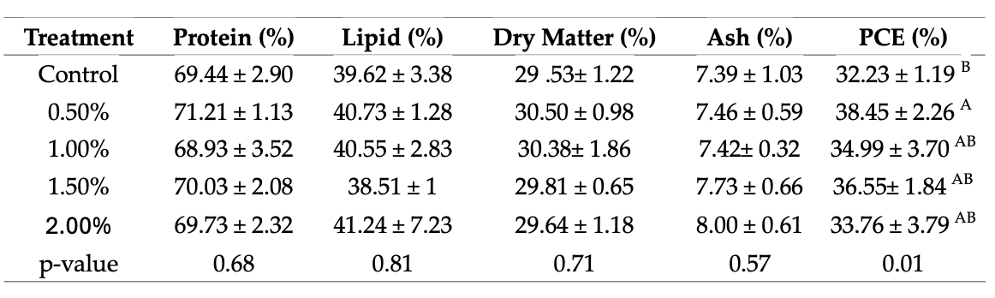
3.3- Air exposure challenge
Hemoglobin presented statistical differences for the collection points (p=<0.0001), but no differences were observed for the dietary treatments (Figure 1A). An interaction between dietary treatments and time (p=0.01) was observed for the number red blood cells (Figure 1B). Blood hematocrit only presented significant differences for the sampling time (p=<0.0001).

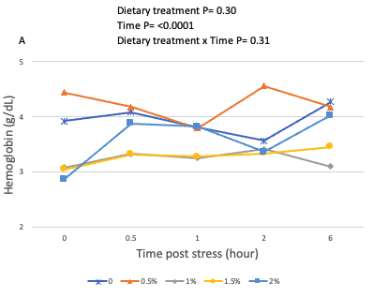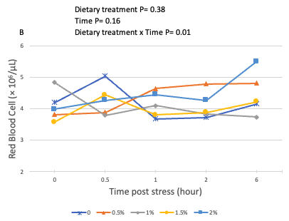

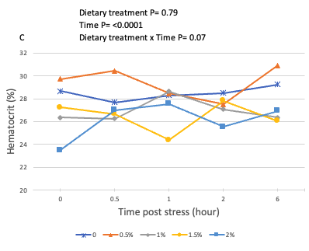

3.4- Bacterial challenge
The survival curve obtained from the bacterial challenge was significantly different (p=0.0007) between the dietary treatments, with the fish fed diets supplemented with 1% soy lecithin presenting the highest survival..
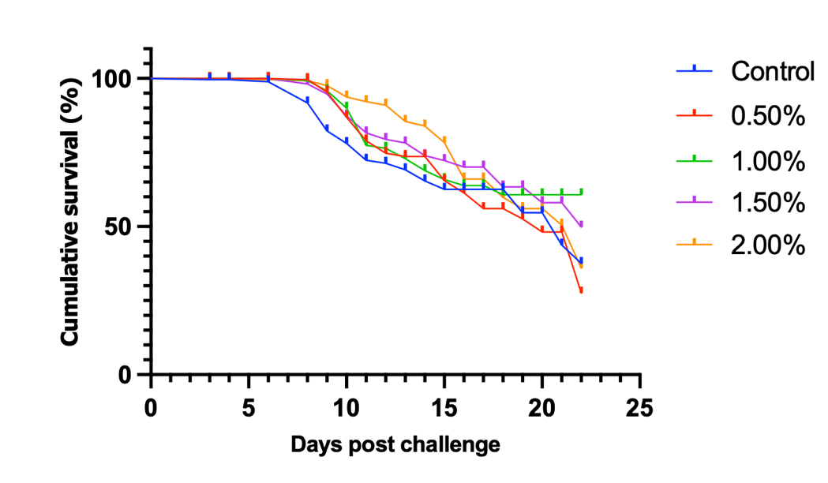

Summary
The feeding trial in aquaria was accomplished followed by a disease challenge. Samples for intestinal microbiome and plasma stress markers are currently being processed. The feeding trial and bacterial challenge will be repeated in the Summer using only a control treatment and 1% supplementation of soy lecithin to ensure that this data can be replicated. It is also foreseen that the field trial will be conducted this Summer in 0.1 acre ponds. Soy lecithin is being acquired from Bungee and experimental extruded diets will be prepared for this study.

