- Project title: Investigation of Herbicide Resistance in Tall Waterhemp and Palmer amaranth Populations and Management in New York (NY) Soybean Fields

- Investigator(s) name, contact information, and affiliation: Vipan Kumar, Associate Professor of Weed Science, Cornell University, Soil and Crop Sciences Section, 1115 Bradfield Hall, Ithaca, NY 14853. E-mail: vk364@cornell.edu; Phone: (607)-255-2212

- Specific research objectives:
- Investigate the distribution, frequency, and the level of evolved resistance to commonly used herbicides (glyphosate, 2,4-D, dicamba, glufosinate, lactofen, and ALS inhibitors) in tall waterhemp and Palmer amaranth populations from NY soybeans fields.
Seeds of tall waterhemp and other weed populations collected from NY soybeans fields were cleaned. Seeds of ten tall waterhemp populations were sown on the surface of commercial potting mix in flat trays placed in a greenhouse in Ithaca, NY. Due to poor and slow emergence of some populations, seedlings from only four waterhemp populations were transplanted and maintained with approximately 18 uniform seedlings per tray per population (Figure 1). Experiments were arranged in a randomized complete block design with 3 replications. Greenhouse conditions were maintained at 26/23 ± 3 C day/night temperatures and 16/8 h day/night photoperiod. At 3- to 4-inch-tall seedlings, each tall waterhemp population was separately sprayed with field-use rate of Roundup PowerMax @ 32 fl oz/a, Liberty @ 32 fl oz/a, Enlist One @ 32 fl oz/a, and Clarity @ 16 fl oz/a herbicides (Figure 1). Herbicide treatments were applied inside a spray chamber and appropriate adjuvants were used as defined by each herbicide label.
D
C
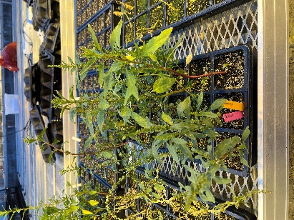
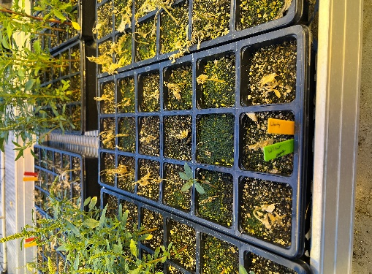
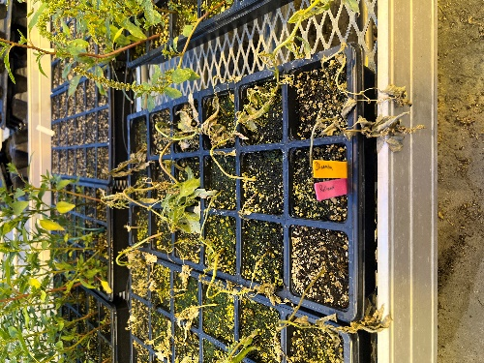
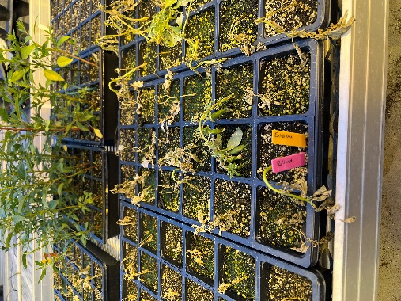
A
B
C
D

Figure 1. Response of tall waterhemp population from Seneca falls, NY to Durango (A), Liberty (B), Clarity (C), and Enlist One (D) o7 days after treatment).

Results: Based on percent survival (no. of plants survived out of 18 total treated) at 21 days after treatment, all four populations showed resistance to glyphosate (Durango) with survival frequency ranging from 85 to 100%. However, all other 3 herbicides, including Liberty, Clarity, and Enlist One provided complete control of all four populations with 0 survival frequency (Fig 1.). Further studies on additional waterhemp populations and horseweed populations will be initiated in Aug and hopefully results will be presented in next quarterly report.

Glyphosate Dose-Response Experiments. Seedlings of two suspected glyphosate-resistant (GR) waterhemp populations from NY (NY1 and NY2) and one known susceptible from Nebraska (NE) were transplanted to perform the full dose-response study to characterize the level of resistance in confirmed GR tall waterhemp populations compared to a known susceptible population. Plants from each selected population were grown in 10-cm diam plastic pots containing commercial potting mixture (Figure 2). Experiments were arranged in a randomized complete block design with 15 replications (one plant per pot for each herbicide dose per population). Each population was tested with various rates of Durango (glyphosate) herbicide: 0, 6.75, 13.5, 27, 54, 108, 216, 432 fl oz/a. Each rate of Durango included AMS at 2% v/v. All Durango treatments were applied using cabinet spray chamber at spray volume of 15 Gal/a. Data on percent visual control and shoot dry weights (on plant basis) were collected at 21 days after treatments (DAT). Non-linear log-logistic model was used to analyzed the data in R.
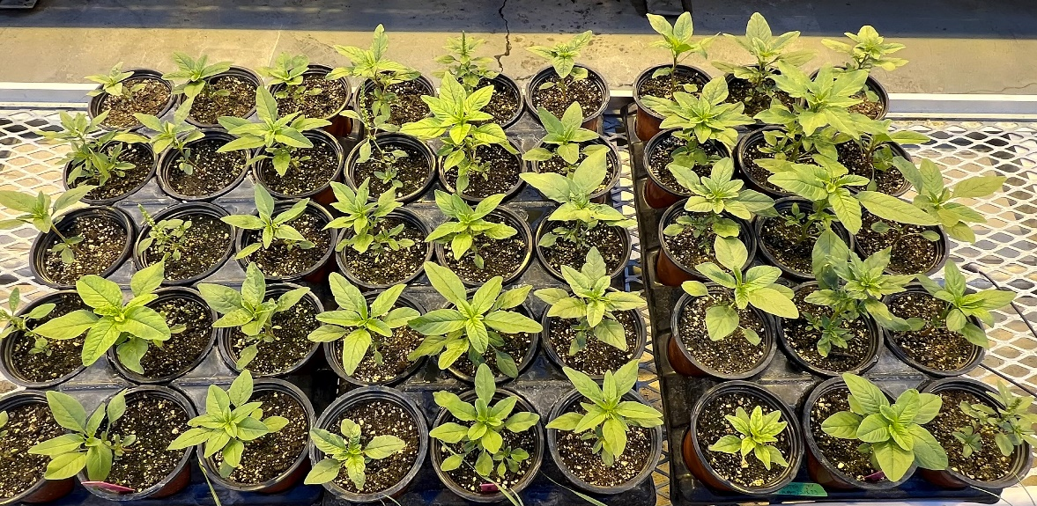

Figure 2. Seedlings of tall waterhemp populations from NY for glyphosate dose-response study.

Results. Results from glyphosate dose-response study indicated that both NY waterhemp populations needed 35.6 to 53.9 fl oz of Durango for 50% reduction in shoot dry weights (GR₅₀ values) as compared to 4.2 fl oz of Durango for NE population (Figure 3). By dividing the GR₅₀ values of both NY1 and NY2 populations with GR₅₀ value of NE population, it was found that both NY waterhemp populations have 8.4 to 12.5-fold resistance to glyphosate as compared to NE population (Figures 3 and 4). We are planning to characterize additional suspected GR waterhemp populations in Aug/Sep and results will be shared in third quarterly report.

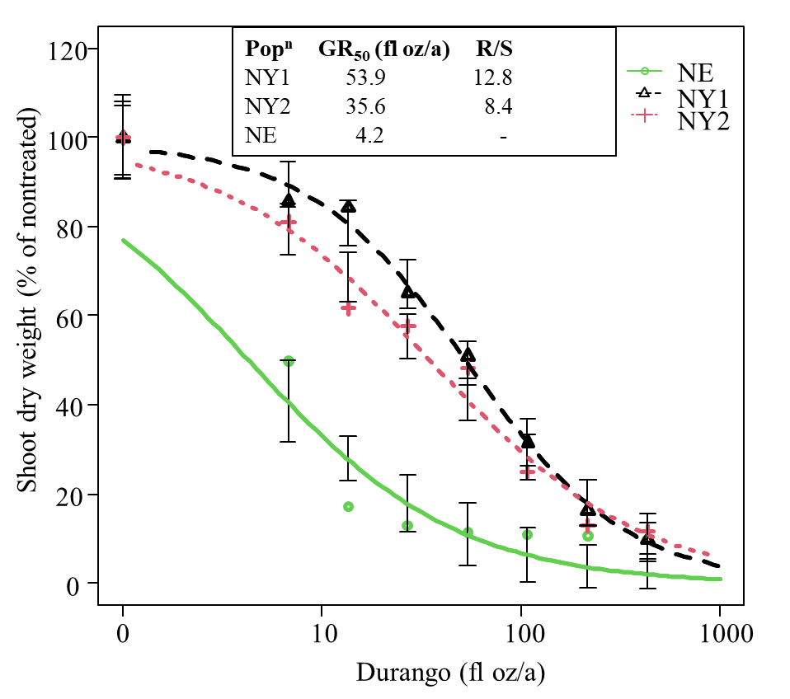

Figure 3. Shoot dry weight (% of nontreated) response of NY1, NY2, and NE waterhemp populations to various rates of Durango herbicide at 21 days after treatment.
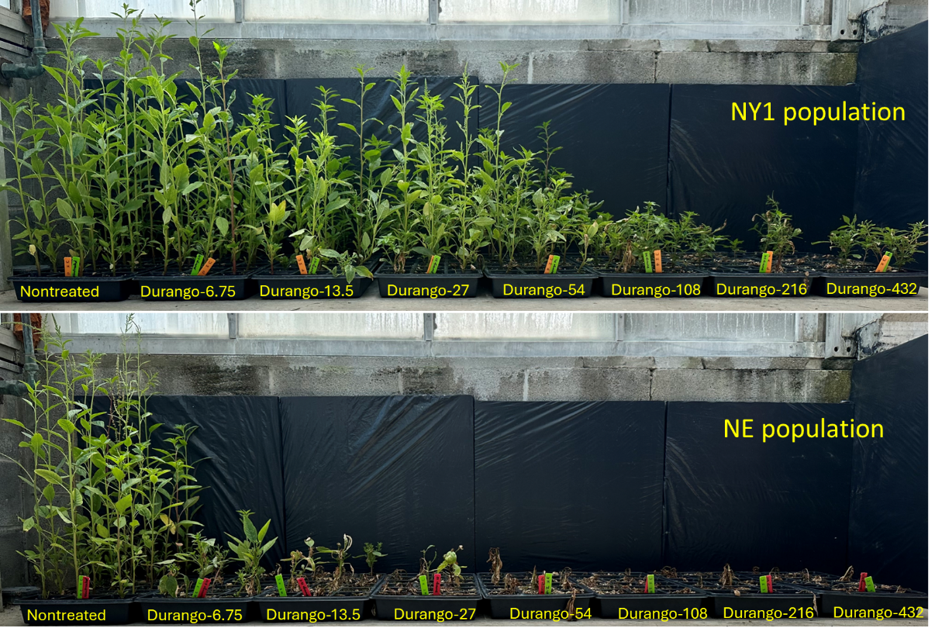

Figure 4. Visual response of NY1 and NE waterhemp populations to various rates of Durango herbicide at 21 DAT.
II. Evaluation of integrated herbicide programs for managing glyphosate-resistant tall waterhemp in Enlist® soybeans.

A field study was initiated to determine the performance of PRE and POST herbicide programs for crop safety and control of glyphosate-resistant tall waterhemp in Enlist soybeans. The study site historically had natural infestation of GR tall waterhemp. Experiment was established in randomized complete design with 3 replications. Enlist soybean variety was planted on May 25 using 30-inch row spacing. Selected PRE herbicides (Table 1) were applied immediately after soybean planting using handheld boom equipped with four AIXR nozzles using 15 Gal/a spray solution. POST and MPOST applications were made using same nozzles and spray volumes. Note: Due to poor infestation of horseweed, second study site in Jefferson County was abandoned.

Table 1. PRE and POST herbicides for managing glyphosate-resistant tall waterhemp in Enlist soybeans.
Herbicide (s) | Timing (s) | Rate(oz/a)
Nontreated | - | -
Classic + Valor + Metribuzin | PRE | 1.25 + 2 + 4.75
Panther Pro | PRE | 15
Warrant Ultra | PRE | 64
Boundary | PRE | 32
Classic + Valor + Metribuzin fb Enlist One + Liberty | PRE fb POST | 1.25 + 2 + 4.75 fb 32 + 32
Panther Pro fb Enlist One + Liberty | PRE fb POST | 15 fb 32 + 32
Warrant Ultra fb Enlist One + Liberty | PRE fb POST | 64 fb 32 + 32
Boundary fb Enlist One + Liberty | PRE fb POST | 32 fb 32 + 32
Enlist One + Liberty fb Enlist One + Liberty | EPOST fb MPOST | 32 + 32 fb 32 + 32
Roundup PM fb Roundup PM | EPOST fb MPOST | 32 fb 32

Results. All PRE alone treatments were highly effective and provided 90 to 95% control of GR tall waterhemp by mid-July, whereas all PRE followed by POST programs provided complete control of GR waterhemp (Figure 5 and 6). Control of GR waterhemp was less than 60% with two sequential treatments of Roundup PM (Figure 5 and 6)

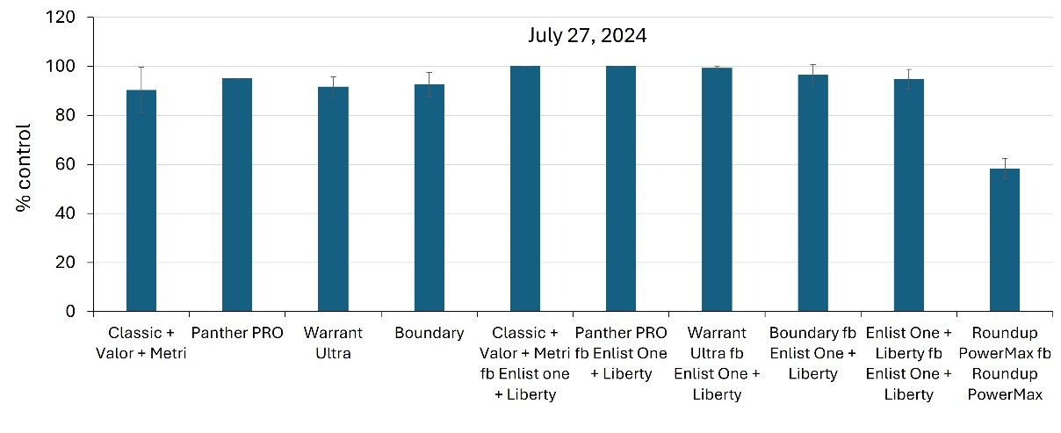
Figure 5. GR waterhemp control with various PRE and PRE followed by POST herbicide programs
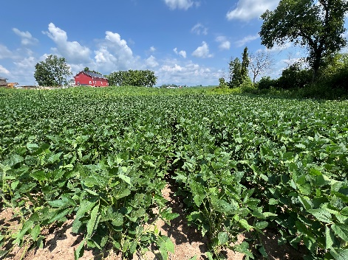
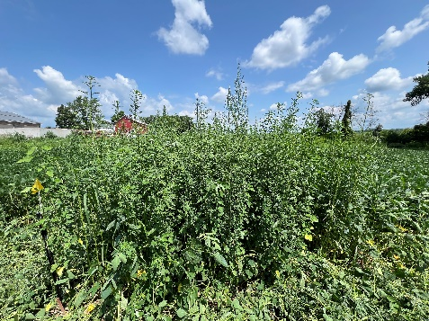
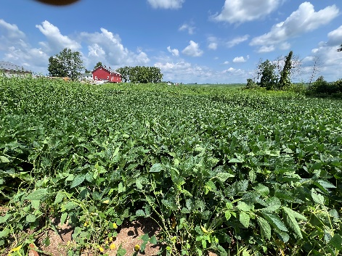

Panther PRO
Panther PRO fb Enlist One + Liberty
Nontreated

Figure 6. GR waterhemp control with Panther PRO (PRE) and Panther PRO followed by Enlist One + Liberty (PRE fb POST) on July 22, 20224.
Similarly, a separate field study was initiated to determine the performance of POST herbicide programs (one pass vs two pass programs) for crop safety and control of glyphosate-resistant tall waterhemp in Enlist soybeans. The study site historically had natural infestation of GR tall waterhemp. Experiment was established in randomized complete design with 3 replications. Enlist soybean variety was planted on May 25 using 30-inch row spacing. Selected POST and MPOST applications were made using same nozzles and spray volumes as for the PRE and POST study.
Table 2. POST herbicides for managing glyphosate-resistant tall waterhemp in Enlist soybeans.
 |  | Waterhemp control (%)
Herbicide (s) | Timing | 27-Jun | 17-Jul | 17-Aug
Roundup PowerMax + Warrant followed by (fb) Roundup PowerMax | POST fb MPOST | 87 | 82 | 76
Enlist One + Warrant + SelectMax | POST | 99 | 99 | 94
Liberty + Warrant | POST | 100 | 94 | 89
Enlist One + Liberty + Warrant | POST | 100 | 97 | 91
Enlist One + Warrant fb Liberty | POST fb MPOST | 100 | 99 | 94
Enlist One + Warrant + SelectMax fb Enlist One | POST fb MPOST | 95 | 92 | 86
Liberty + Warrant fb Enlist One | POST fb MPOST | 100 | 98 | 93
Liberty + Warrant fb Liberty | POST fb MPOST | 100 | 100 | 93
Enlist One + Liberty + Warrant fb Enlist One + Liberty | POST fb MPOST | 100 | 98 | 94

Results. Except sequential treatments of Roundup PowerMax, All POST programs (one pass and two pass) were highly effective and provided 86 to 100% control of GR tall waterhemp throughout the growing season (Table 2).

