FY23 Research Summary Feb 29, 2024
Title: Soybean Canopy for Herbicide-Resistant Weed Management: What Matters Most for Canopy Development?
Lead-PI: Dr. Debalin Sarangi

Project objectives:
1. Evaluate the impact of residual postemergence herbicides and Liberty application on soybean injury, canopy formation, and yield
2. Assess the impact of variety selection and planting date on canopy formation and late-season weed control
3. Canopy closure assessment for the statewide variety trials to measure differences in time to close the canopy

Research updates:
Field trials were conducted at UMN’s Rosemount Research and Outreach Center in 2023 for objectives 1&2. A graduate student (Ph.D.) was recruited and is working full-time on this project. In objective 1, the soybean was planted in 15- and 30-inches of row spacings. The row spacing impacted the canopy cover and yield but didn’t impact soybean injury (Figure 1). The results of objective 1 showed that the Warrant was most injurious to soybean and delayed canopy development compared to Dual II Magnum and Zidua (Figure 2). Also, there was a reduction in soybean yield when foliar-active herbicides were tank-mixed with Warrant or Dual II Magnum, but Zidua yielded similar to the no residual herbicide treatment (Figure 3). In objective 2, four commercial varieties of soybean (V1-XO1822 E, V2-1966 E, V3-CZ1660GTLL and V4-18A73 E) were planted at three different timings (early, mid and late planting). Among the four varieties two were known for having short-bushy growth habits, while the other two had tall-thin growth habits. As expected, tall variety CZ1660GTLL shown highest plant height and the short variety XO1822 E recorded highest width at the end of the season (Table 1). But results also showed that there was no difference in soybean canopy cover among the four varieties (Table 2). Early planted soybeans showed higher plant growth in terms of height, width, and volume (table 1). The results also showed that planting soybean early improved soybean yield compared to mid and late planting (Figure 4). Whereas as yield was similar among the four varieties (Figure 5). Data were collected from Objective 3, but the data analysis is pending. This research was demonstrated at the 2023 Corn and Soybean Weed Management Field Day, which was attended by 47 attendees including farmers, agronomists, industry representatives, and UMN Extension Educators. The results were presented at the North Central Weed Science Society meeting in Minneapolis in December 2023, the Weed Science Society of America’s Annual Meeting in San Antonio, TX, in January 2024, and the UMN Extension’s Research Update meetings and MN Ag Expo in January 2024.

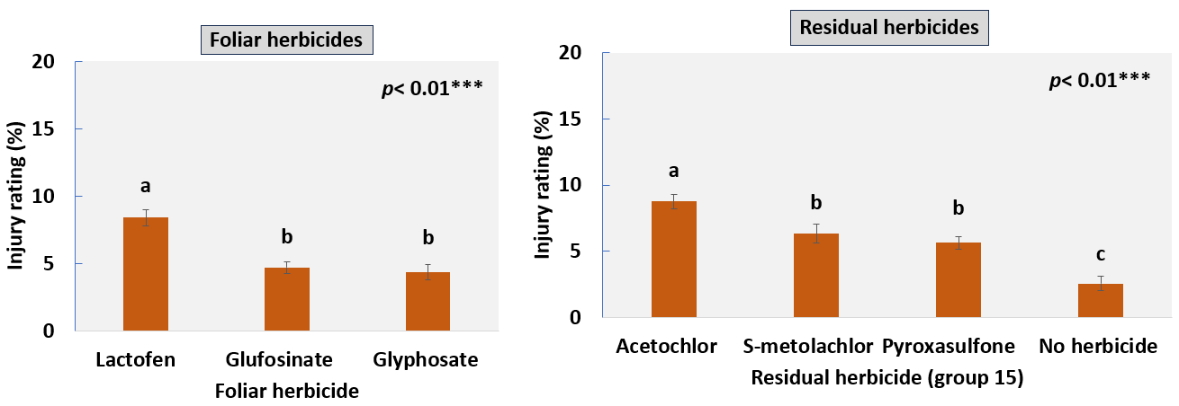

Figure 1: Soybean injury at 21 days after herbicide application as impacted by the foliar active herbicides and soil residual herbicides tank-mixed with them.

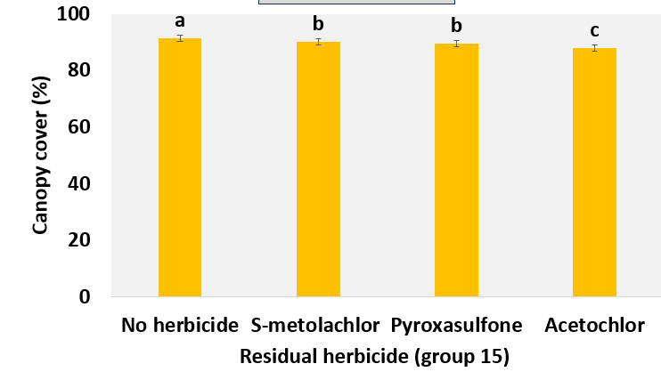
Figure 2: Soybean canopy cover at 42 days after herbicide application as impacted by the soil residual herbicides applied POST along with foliar-active herbicides.

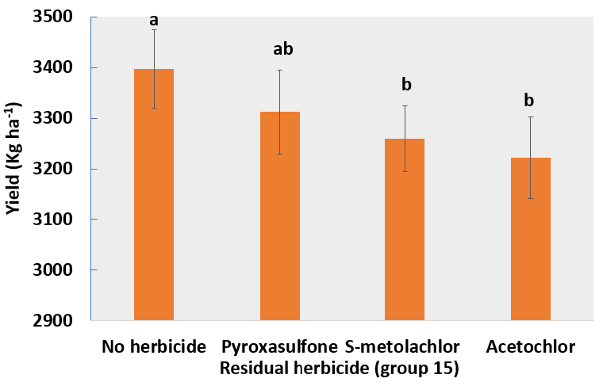
Figure 3: Soybean yield as impacted by the soil residual herbicides applied POST along with foliar-active herbicides.

Table 1. Plant height (cm), plant width (cm) and plant volume (cm3) influenced by variety selection and planting date in soybean at 7, 21 and 42 Days after treatment application (DAA)

 | Plant height (cm) |  |  | Plant width (cm) |  |  | Plant volume (cm³)
 | 7 DAA | 21 DAA | 42 DAA | 7 DAA | 21 DAA | 42 DAA | 7 DAA | 21 DAA | 42 DAA
Variety
V1 | 32.6 ab | 46 ab | 66.7 b | 43.3 a | 50.9 ab | 74.1 a | 36719 a | 101662 a | 292099 a
V2 | 30.6 b | 43.1 b | 67.9 b | 35.5 a | 52.6 a | 71.9 ab | 33032 a | 100740 a | 279208 a
V3 | 34.2 a | 49.1 a | 71.4 a | 19 ab | 50.4 bc | 70.9 b | 34087 a | 104936 a | 278463 a
V4 | 33 ab | 45.5 ab | 71.3 a | 43.3 b | 48.6 c | 70.2 b | 31549 a | 98716 a | 283423 a
Planting date
Early | 43.3 a | 55.9 a | 70.4 a | 41.5 a | 60.4 a | 72.1 ab | 59523 a | 159900 a | 288064 b
Mid | 35.5 b | 49.1 b | 74.7 b | 34.8 b | 53.1 b | 73.9 a | 35027 b | 109059 b | 322365 a
Late | 19 c | 32.8 c | 63 c | 19.9 c | 38.5 c | 69.3 b | 6990 c | 35580 c | 239466 c

Table 2. Canopy cover (%) influenced by variety selection and planting date in soybean at 7, 21 and 42 Days after treatment application (DAA)
 | Canopy cover (%)
 | 7 DAA | 21 DAA | 42 DAA
Variety
V1 | 39 a | 69 a | 92.5 a
V2 | 39.3 a | 67 ab | 89.8 a
V3 | 39.9 a | 65.7 ab | 86.7 a
V4 | 38 a | 63.1 b | 90.7 a
Planting date
Early | 53.8 a | 78.6 a | 89.8 a
Mid | 46.1 b | 72.4 b | 92.0 a
Late | 17.2 c | 47.7 c | 87.9 a

Figure 4: Soybean yield impacted by planting date.

Figure 5. Soybean yield impacted by varietal selection.

Performance Metrics:
1. Results of this research improve the weed control, yield, and quality of Minnesota soybean.
- Yes

2. A public database is initiated with the relative values of the time to close the canopy for commercially available varieties.
- Not yet. It will be done after analyzing the data from objective 3.

3. Future breeding efforts are initiated for the selection of varieties with early-season vigor and fast canopy closure.
- It will be done after analyzing data from objective 3 in 2024.

4. Stakeholders are educated about postemergence herbicide selection, variety selection, and integrated weed management.
- This research was demonstrated at the 2023 Corn and Soybean Weed Management Field Day, which was attended by 47 attendees including farmers, agronomists, industry representatives, and UMN Extension Educators. The results were presented at the North Central Weed Science Society meeting in Minneapolis in December 2023, the Weed Science Society of America’s Annual Meeting in San Antonio, TX, in January 2024, and the UMN Extension’s Research Update meetings and MN Ag Expo in January 2024.

5. Results are presented at Extension events attended by the soybean growers.
- This research was demonstrated at the 2023 Corn and Soybean Weed Management Field Day, which was attended by 47 attendees including farmers, agronomists, industry representatives, and UMN Extension Educators. The results were presented at the North Central Weed Science Society meeting in Minneapolis in December 2023, the Weed Science Society of America’s Annual Meeting in San Antonio, TX, in January 2024, and the UMN Extension’s Research Update meetings and MN Ag Expo in January 2024.

6. One graduate student is mentored.
- Yes

7. Peer-reviewed and Extension articles are published containing these results.
- Not yet, but they will be published after the second year of data collection in 2024.

