Research Report
November 30, 2024
Title: FY 23_Canopy Management for Herbicide-Resistant Weed Control, Growth and Yield in Soybean
Project Objectives:
1. Evaluate the impact of residual postemergence herbicides and Liberty application on soybean injury, canopy formation, and yield
2. Assess the impact of variety selection and planting date on canopy formation and late-season weed control
Progress of project 1: Impact of Row Spacing and POST herbicides on Soybean Canopy Formation and Growth
Field experiment was conducted in the summer of 2023 and 2024 using a split-plot design, with row spacing as the main plot treatment and herbicide treatment as the subplot at UMN’s Research and Outreach Center in Rosemount, MN. The soybean variety Enlist E3 [resistant to Liberty (glufosinate) and Roundup PowerMax (glyphosate)] which are widely grown in MN was selected for this study. Their maturity groups were the same. Row spacing treatments included wide row (30 inch) and narrow row (15 inch) with the same seed rate. Herbicide treatments included three very-long-chain fatty acid-inhibiting herbicides (herbicide site-of-action Group 15) applied postemergence with or without foliar active herbicides. Roundup-applied plots were treated as controls to estimate the impact of group 15 herbicides on soybean. A preemergence herbicide was applied across the study site on the day of soybean planting, and when needed, Roundup PowerMax was applied at 32 fl oz/A to keep this experimental area weed-free. The subplots were 10 ft wide and 30 ft long and the treatments were replicated four times.
Soybean injury was assessed visually for any visible phytotoxicity, necrosis, or stunting and compared to the Roundup PowerMax treatment at 3, 7, 14, 21, 28, 34, and 42 days after treatment (DAT). Soybean volume was calculated by measuring the height and width of five soybean plants within the center of two rows in the plot and using the formula below:

Soybean volume=𝚷*(half of width)2*height

Soybean volume was assessed weekly from Postemergence application to canopy closure for all plots. The photos of the canopy were captured using a digital camera, which was further processed using a mobile application called Canopeo. This application gave the accurate canopy cover (%) data. Soybean was harvested using a small plot combine and the yield was adjusted to 13% moisture.
Table 1. Herbicide treatments and doses for the postemergence application.
Treatment # | Herbicide | Dose (fl oz/A)
1 | Roundup PowerMax | 32
2 | Roundup PowerMax + Zidua SC | 32 + 5
3 | Roundup PowerMax + Warrant | 32 + 48
4 | Roundup PowerMax + Dual II Magnum | 32 + 27
5 | Liberty | 36
6 | Liberty + Zidua SC | 36 + 5
7 | Liberty + Warrant | 36 + 48
8 | Liberty + Dual II Magnum | 36 + 27
9 | Cobra | 12.5
10 | Cobra + Zidua SC | 12.5 + 5
11 | Cobra + Warrant | 12.5 + 48
12 | Cobra + Dual II Magnum | 12.5 + 27

The results from the two years of the experiment show that the incorporation of layered residual herbicide negatively impacted soybean canopy cover (Figure 1). The canopy cover percent decreased to 83% in warrant (acetochlor) applied treatments compared to treatments without residual herbicides (92%). This reduction in canopy cover could be due to the soybean injury caused by the residual herbicides. Dual II Magnum (87%) and Zidua (86%) also negatively impacted the soybean canopy cover at the end of the season (42 days after treatment). The higher plant volume (Figure 2) was estimated (3.1 x 10⁵) with wide row spacing compared to narrow (1.8 x 10⁵). At the end of the season Warrant negatively impacted soybean yield compared to no residual treatment (figure 4); however, it is noteworthy that the yield with all soil residual herbicides was comparable.

Figure 1. Effect of residual herbicide on soybean canopy cover (%) at 42 days after treatment application (averaged over two years).

Figure 2. Soybean plant volume as impacted by row spacing at 42 DAA

Figure 3. Soybean yield as impacted by soil residual herbicide
Conclusions: Depending on the selection of foliar-active and soil residual herbicides, some of the layered residual herbicide treatments can delay soybean canopy growth and reduce yield.
Progress of project 2: Assess the impact of variety selection and planting date on canopy formation and late-season weed control
Field experiments were conducted at UMN’s Research and Outreach Center in Rosemount, MN in the summer of 2023 and 2024. Experiment was laid out using a split-plot design, with planting date as the main plot treatment and variety as the subplot. Each subplots have a weedy and weed-free check. Soybean was planted on three different dates: late April (early planting), mid-May (mid-planting), and end of May (late planting). Four soybean varieties with two different canopy types (narrow and bushy, two varieties from each group) were selected for this experiment. The maturity groups are the same for the soybean varieties and recommended for southeast MN. Weed-free checks were maintained weed free by spraying Warrant and Glyphosate POST herbicides.
Soybean volume was assessed weekly from Roundup application to canopy closure for all plots. The canopy photos was taken with a digital camera and then processed using a mobile app called Canopeo, which provided precise canopy cover percentage data. Weed emergence were estimated from the weedy plots by placing a permanent quadrant (0.5 m2) in the field. The weed count were estimated every two weeks. Soybean was harvested using a small plot combine and the yield was adjusted to 13% moisture. Results two years showed that, early planting close canopy faster compared to mid and late planting. Difference in canopy cover at 21 days after POST application is shown in figure 4. The results from the first year also show that the tall-slender variety CZ1660GTLL showed the highest plant height (71.4 cm) and the short-bushy variety XO1822 E recorded the greatest width (74.1 cm) at the end of the season. However, there was no difference in soybean canopy cover among the four varieties. Early-planted soybeans showed higher plant growth in terms of height, width, and volume. The results also showed that planting soybeans early does not improve soybean canopy cover, but it improves soybean yield (4208 kg/ha) compared to mid (3923 kg/ha) and late (3745 kg/ha) planting (Figure 5).
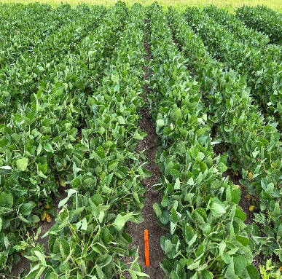
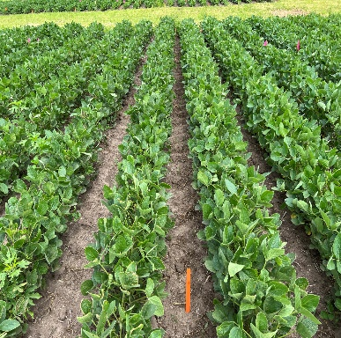
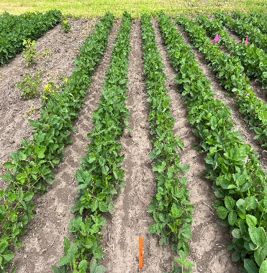
April-early planting
mid-May-mid planting
end of May-late planting

Figure 4. Soybean canopy cover at 21 days after POST application

Figure 5. Soybean yield (kg/ha) influenced by planting date (averaged over two years)

Conclusions: We observed that early planting can help in achieving canopy closer sooner and improves soybean yield. Narrow and bushy type varieties did not influence the canopy formation.

