Glufosinate-resistant waterhemp
Waterhemp (Amaranthus tuberculatus) is the most problematic weed in Minnesota soybean production, with season-long interference capable of reducing soybean yields by more than 70%. Waterhemp populations have evolved the resistance to herbicides from seven different sites of action at labeled doses. A recent study by University of Minnesota confirmed the presence of such populations in the state of Minnesota and identified glufosinate as the only herbicide effectively controlling all evaluated populations. At same time, crop producers throughout the midwestern United States are increasingly adopting glufosinate as an alternative to glyphosate in response to the widespread occurrence of glyphosate-resistant weeds. According to another survey conducted by University of Minnesota Extension survey approximately 75% soybean growers in the state were planning to plant soybean varieties that have been engineered for resistance to glufosinate along with some other herbicides.
Recently a farmer from Dodge County in MN reported an inability to control waterhemp in their field after multiple years of successful control with glufosinate. In response, the University of Minnesota conducted dose-response assays to quantify the extent of glufosinate resistance in waterhemp population collected from this field. We are also planning experiments to determine the genetic and physiological mechanism of glufosinate resistance in this population.
The information about the mechanism of glufosinate resistance in this population will help to devise better management tactics to slow the evolution and spread of such populations and to control it in the field.
Materials and Methods
Waterhemp seeds were collected from a suspected glufosinate-resistant population (putative-resistant) in Dodge County, Minnesota. Additionally, two known susceptible populations were obtained from Iowa State University to serve as negative controls. Dose-response assays were conducted in a greenhouse at the Plant Growth Facilities, University of Minnesota, Saint Paul, MN, using eight glufosinate doses ranging from 0 to 5,240 g ai ha⁻¹. Glufosinate was applied to plants at a uniform height of 10–12 cm, and assessments for percent injury, percent survival, and biomass reduction were performed 28 days after treatment.
To further evaluate the response of the putative-resistant population to other commonly used herbicides, whole-plant bioassays were conducted. These assays subjected both the putative-resistant and known susceptible populations to a one-time (1×) and three-times (3×) labeled rate for seven different post-emergence (POST) herbicides.
We also developed the list of the experiments to be conducted to evaluate the mechanism contributing to glufosinate resistance. These experiments will be conducted in the spring of 2025.
Results and Discussion.
The putative-resistant population exhibited a resistance index (RI) of 2.8 to 3.0, indicating that it requires approximately three times the glufosinate dose needed for 50% mortality in the susceptible control population. At the labeled glufosinate dose of 656 g ai ha⁻¹ (32 fl oz a⁻¹), this population demonstrated a 58% survival rate. Furthermore, we observed ≥ 80% survival irrespective of one time (1x) or three times recommended label rate (3x) of atrazine, imazamox, and glyphosate.

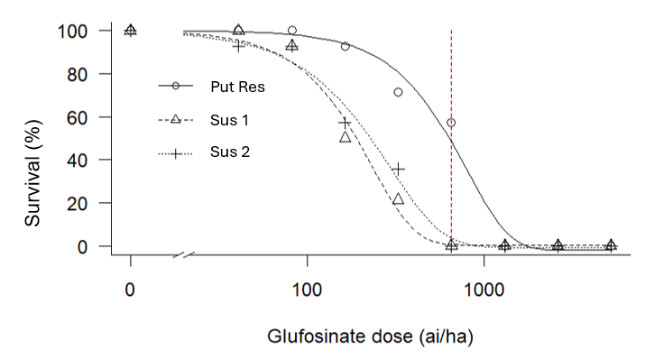
Figure 1. Percent survival for putative-resistant and known susceptible controls at various glufosinate doses used in the experiment.

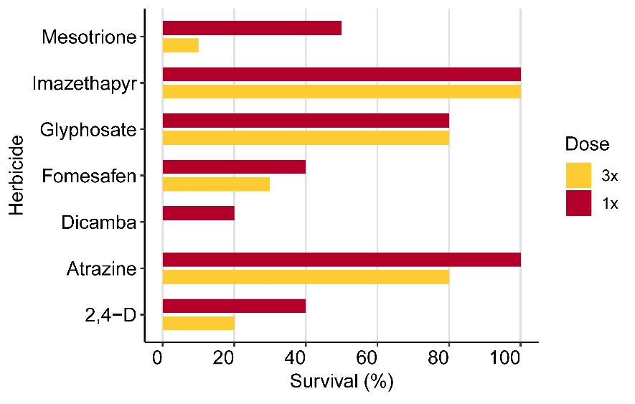
Figure 2. Percent survival of putative-glufosinate resistant waterhemp population at one time (1x) and three times recommended label rate (3x) for seven POST herbicides.

