Research Progress Report
November 2024
Title: Integrated Management of Giant Ragweed and Common Ragweed in Soybean.
Progress of project 1: Integrated Management of Giant Ragweed in Soybean-Corn Rotation
This report focuses exclusively on the data gathered in 2024 concerning the integrated management of giant ragweed in soybean.
A field study was conducted in 2022 at the Rosemount Research and Outreach Center near Rosemount, MN, using a split-plot design. The main plot treatments include cereal rye (Secale cereale L.) cover crop terminated at soybean planting, cover crop terminated at 7 d after planting (DAP), reduced tillage, conventional tillage, no-tillage plus burndown, and no-tillage. The subplot treatments include the application of POST-only, PRE followed by (fb) POST, and a nontreated check. At 21 d after PRE herbicide application (DAPRE), no-tillage plus burndown and cover crop terminated at planting and 7 DAP showed > 80% control of giant ragweed (Figure 1), and no-tillage plus burndown showed the lowest density of giant ragweed (Figure 1). Application of PRE provided 24% better control of giant ragweed compared with treatments without PRE herbicides. At 21 d after POST either of the pre-plant weed management tactics along with POST-only or PRE fb POST treatments of cover crop (terminated at planting or 7 DAP), and no-tillage showed more than 93% giant ragweed control and it was comparable with PRE fb POST treatments of reduced tillage and conventional tillage (Figure 2). At harvest, PRE fb POST with cover crop (terminated at planting or 7 DAP), and no-tillage burndown > 95% control of giant ragweed (Figure 3). Cover crop and no-tillage plus burndown along with Pre fb POST reduced the density of giant ragweed with < 5 plants m⁻². Integrated management approach that included cover crop and no-tillage burndown along with PRE fb POST herbicide program should be used for better control of giant ragweed.

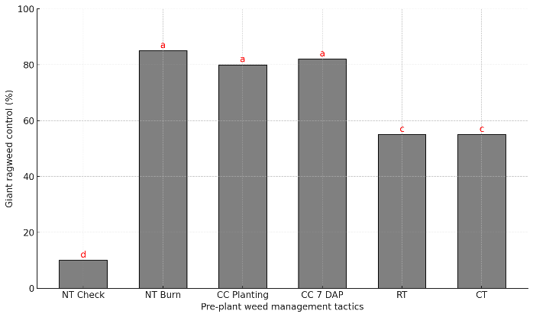
Figure 1. Giant Ragweed control at 21 DAPRE 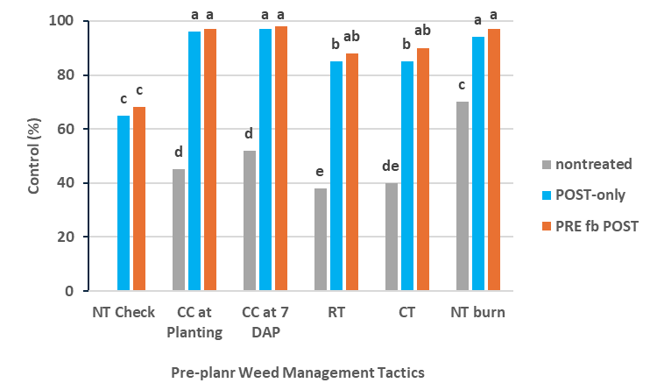
Figure 2. Giant Ragweed control at 21 Days after POST
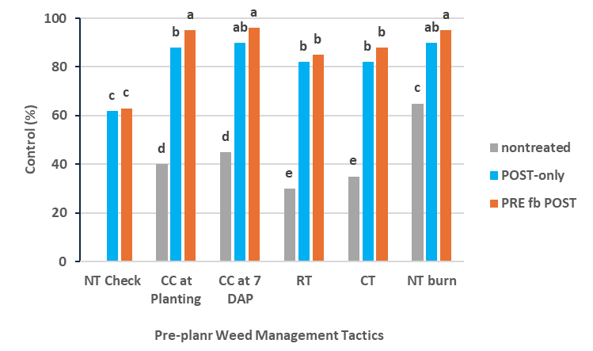

Figure 3. Giant ragweed control at 12 weeks after POST
Progress of project 2: Integrated Management of Common Ragweed in Soybean
This part of progress focuses exclusively on the data gathered in 2024 concerning the integrated management of common ragweed in soybean.
With the rapid evolution and spread of herbicide-resistant weeds, it is critical to consider
integrated weed management strategies, which combine both chemical and non-chemical tactics. A field research was conducted in 2024 at the University of Minnesota’s Northwest Research and Outreach Center near Crookston, MN, to compare cultural (cover crop) and mechanical (tillage) weed management practices combined with herbicide treatments for controlling common ragweed (Ambrosia artemisiifolia L.), and their effects on soybean [Glycine max (L.) Merr.] yield. The treatments were arranged in a split-plot design with four replications. The main plot factors included tillage and cover crop (cereal rye planted at 67 kg ha⁻¹ in the fall) treatments. The subplot factors included no herbicide treatment, a burndown
treatment, and pre-emergence (PRE) herbicide application. At 42 days after planting, the combination of no-tillage or light tillage (in the fall) with cover crop, conventional tillage (chisel plow in the fall and field cultivator in the spring), and strip tillage (in the fall) with PRE provided at least 95% control of common ragweed, reducing its density to ≤ 5 plants m⁻² (Figure 1 and 2). The highest soybean yield (3,750 kg ha⁻¹) was achieved when conventional tillage combined with the PRE treatment (Figure 3). Overall, treatments that included PRE herbicides showed a better control of common ragweed and higher soybean yield compared to burndown and no herbicide.

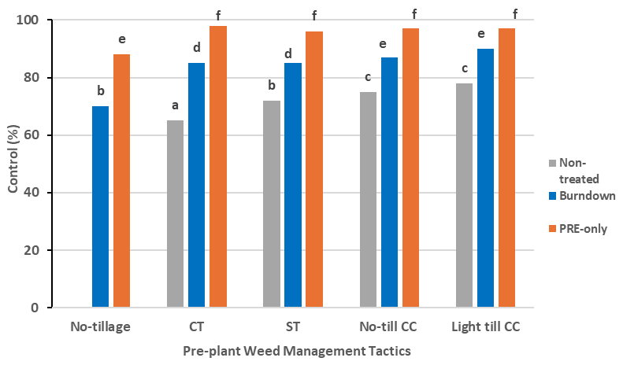
Figure 1. Common ragweed control at 42 days after planting

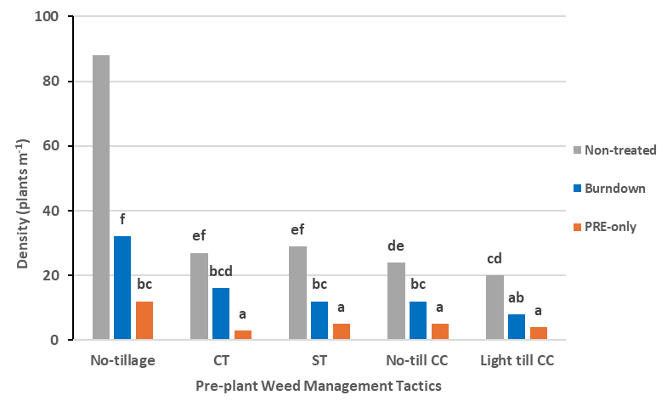
Figure 2. Common ragweed density at 42 days after planting
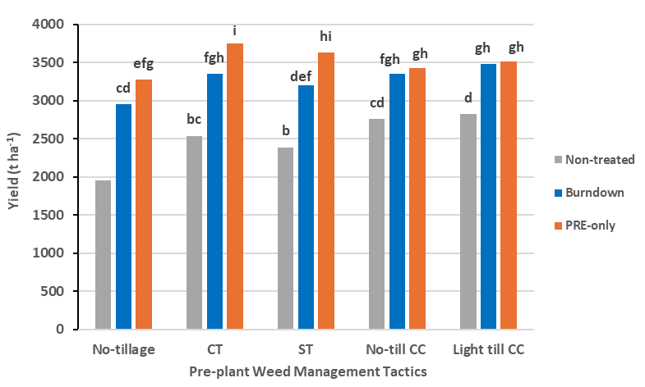
Figure 3. Soybean yield at harvest

