Objective 1. Continue to develop and enhance genomics-assisted breeding resources and tools to facilitate routine application in public breeding programs.
Objective 1 can be broken down into five sub-objectives for which we can report specific and significant progress during these past six months.
Sub-obj 1: Continue to genotype with genome-wide and trait-targeted markers all new breeding lines entered in the Northern Uniform Soybean Tests
Progress: This past summer we planted 511 new advanced breeding lines from the Northern Uniform Soybean Tests (NUST) and NUST SCN regional tests. Tissue was collected from each line and DNA was extracted. These are currently being prepared for shipment to our genotyping vendor. The 560 NUST breeding lines sampled last year were sent off for genotyping as described in the last quarterly report. Data was received and deposited into Soybeanbase as we anticipated in the last report.
As described in the last report, we processed and uploaded the 2023 Norther Uniform Trials data to the Soybase query portal (https://www.soybase.org/ncsrp/queryportal/). This database now hosts NUST trial data from 1993-2023. Data from the 2024 NUST trials was just collected this past fall. Once it is sent to Adam Brock, NUST coordinator, we will format it and upload it to the website.
A manuscript on this work we have pursued for the last several years has been submitted to the scientific journal Crop Science. It is currently under review. The manuscript described findings we’ve made from the data thus far, and publicly releases the data we have collected to the community who can analyze it to answer their own questions about the genetic control of phenotypes and optimization of genomics-assisted breeding.

Sub-obj 2: Enable individual public breeding programs to test and use genomic prediction
This project has instigated and enabled several public programs to start using genomic prediction routinely. Below are some highlights from reports from individuals programs that are part of the SOYGEN initiative.
UMN has refined its GS pipeline and tested it extensively on the UMN Preliminary Yield Trials (PYT) data. PYT 2023 progeny population lines were assayed using 1K low-density (LD) genotyping assay and parents of PYT23 lines from the crossing block were assayed using a low-pass sequencing platform to generate high density (HD) variant data. The 50K SoySNP Chip subset from the HD data set as the parental reference panel to impute 1K LD set to 50K HD set (~30K SNPs after QC). We used this imputed data to make genomic predictions using genomic prediction models that include GxE interaction effects. This last summer we planted a trial including lines selected using genomic prediction and phenotypic selection. The trial was successfully planted at six locations in Minnesota. Every location yielded good data recently collected during harvest. We are currently processing the data to assess whether our genomic predictions using the pipeline built in this project were successful or not.
The other highlight to describe is from the University of Missouri. Andrew Scaboo’s lab is diving into the data we collected as part of SOYGEN2 in the genomic selection experiment. This experiment tested genomic prediction versus phenotypic selection versus random selection at four universities: University of Minnesota, North Dakota State University, University of Illinois, and University of Missouri. The selection treatments we applied in the originally designed experiment were not as successful as we had hoped. Currently, we are thoroughly analyzing the data to figure out why the genomic selection treatment was not as successful as we had anticipated, and how we can better understand and utilize it in the future. Because this multi-institutional dataset is very large and complex, we are first starting to develop the analysis framework and treatments using the Missouri data only.
The first thing we did was analyze the molecular marker data to make sure no mistakes were made when sampling. The neighbor-joining tree displayed in Figure 1 shows that breeding families clustered together on the same branches of the tree, indicating the molecular marker relationships recapitulated the pedigree relationships. This suggests to us that the sampling was properly performed.
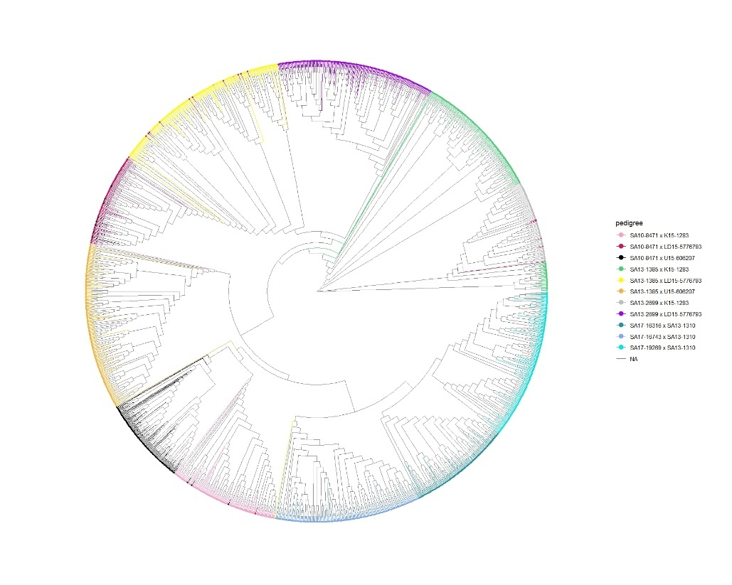
Figure 1. Neighbor-joining tree showing the relationships among breeding lines from the same family. Lines from the same family share a common color. It can be seen that lines from the same family largely cluster together.

The next thing we looked at was the quality of the phenotypic data by estimating the “broad-sense heritability” of the yield performance. Table 1 below displays the broad-sense heritability of the yield data from each family (indicated by experiment name). Broad-sense heritabilities were moderate to high for most families, but low for a couple of families such as EDGS(3)E and EDGS(3)G. Predictive ability within the families with low broad-sense heritability were also low as expected. It is not possible to achieve good correlations between genomic predictions and phenotypes if the contribution of the genetic component of the phenotype is low.

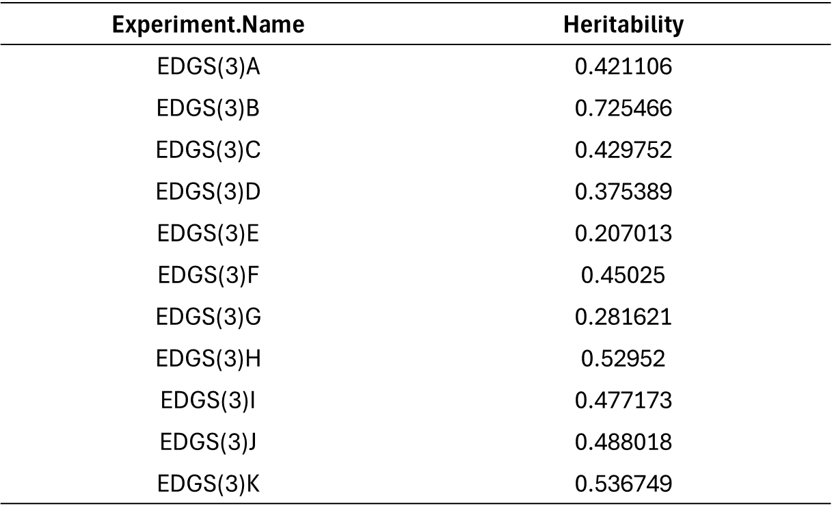
Table 1. Broad-sense heritability estimates of the yield data collected for each breeding family in the Missouri dataset. Data was collected using three reps grown in two years.

We went back through the data and re-applied our genomic prediction pipeline, modifying genotype imputation methods and estimating better genotype effects using the phenotype data. Figure 2 below shows the relationship between genomic predictions (y-axis) and observed yield (x-axis) for each family. Several families displayed good to moderate predictive ability (A=0.41, I=0.45, K=0.62), but several still displayed low predictive ability, but some of that is due to the low broad-sense heritability, such for family E (Broad-sense heritability=0.21, predictive ability= -0.24).

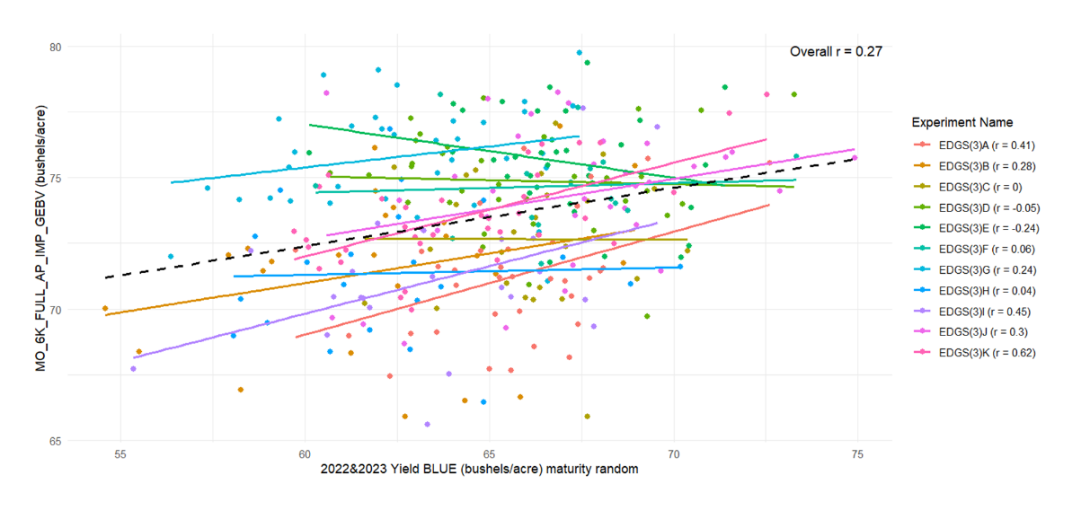
Figure 2. Relationship between genomic prediction (y-axis) and yield estimate (x-axis) for each breeding line of each family.

We are still exploring this dataset. Next steps include creating new models that model genotype-by-environment interaction effects. We will also test the effect of modeling historical data from the NUST dataset, and alternative ways of estimating genotype effects of breeding lines in the validation trials. New designs for creating training sets will also be explored. Results from these analyses will inform our breeding network on best practices for implementing genomic prediction.
Activities from the other universities were reported in the last report. There are no new activities to report for those universities.

Sub-obj 3: Development of a genomic prediction R-Shiny app for easy implementation of GS for breeders.
Progress on this application this past reporting period has largely been implementation of genotype-by-environment interact effect models for genomic prediction. This is now working, and will be an enormous contribution to the community of breeders who want to deploy these methods but lack the in-house technical skills to write their own software programs.
We’ve also streamlined the pipeline application for faster implementation and better user experience. We’ve redesigned the user interface and implemented effective deployment methods for easier distribution. We’ve also tested the application using several data sets from SOYGEN collaborators and others. The application has also been tested by groups implementing GS in other crops and there is growing interest in using the application among the community of researchers implementing GS. We’ve written the first draft of a manuscript describing the pipeline application and preparing it for publication. Finally, we are exploring means to make the application better with new features like one-click implementation and better modeling capabilities.

Sub-obj 4: Adopting and advancing BreedBase for storage of information for soybean genomic prediction.
There is little to report on this objective except for the fact that we continue to work with the USDA Breeding OnRamp team to optimize BreedBase for public soybean breeding (called “Soybeanbase”). We have met with this team periodically to make improvements to the database. At least four programs in SOYGEN are using this database for regular organization of genome-wide marker data.

Sub-obj 5: Connect target and training populations using imputation that leverages pedigree relationships and enhance this capacity by inclusion of this method in the software application.
This sub-obj has been completed this past reporting period. We have explored the use of AlphaPlantImpute and found that imputation accuracy is very high when projecting high-density SNPs onto low-density SNPs. This method has been incorporated into the genomic prediction R Shiny App as described above. A grad student presented two posters on this research this past reporting period and will prepare a publication. We have shown that the implementation of our imputation method increases genomic prediction accuracy (Figure 3).

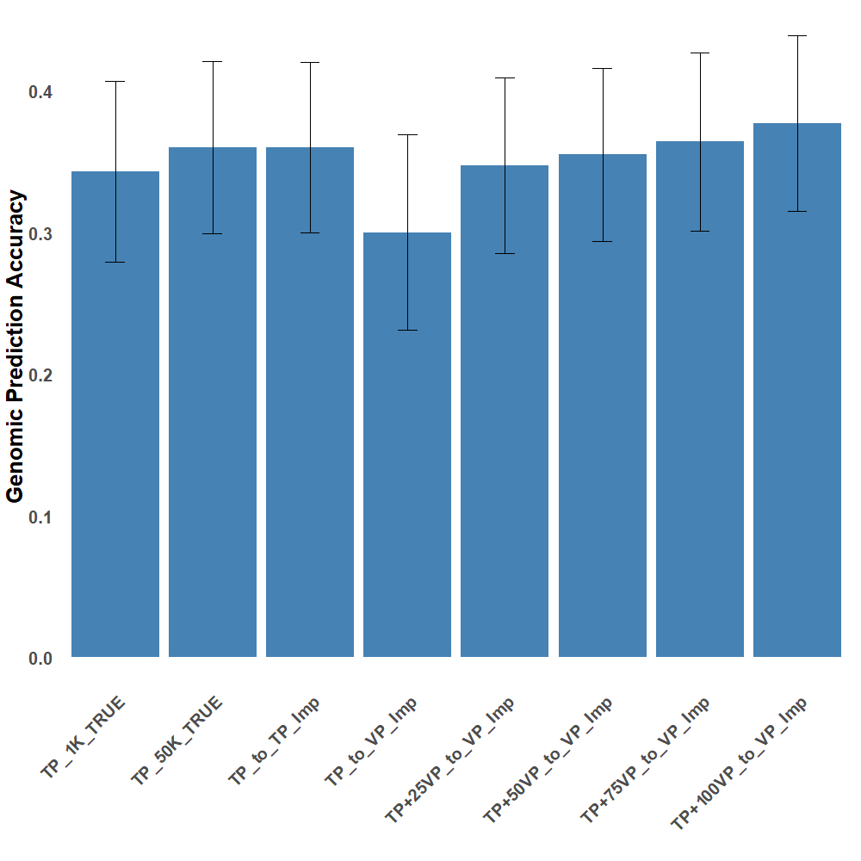
Figure 3. Genomic prediction accuracy when increasing marker density through genotype imputation. Comparing the first bar (TP_1K_TRUE) to the third bar (TP_to_TP_Imp) shows that imputation from low density to high density can achieve genomic prediction accuracies equivalent to if those high density marker genotypes were actually collected (costing extra money). Imputation is computationally intensive, but saves costs in actual genotyping.

Objective 2. Develop and test methods for predicting cultivar performance in future target environments through genomics-assisted breeding models, phenomics, and environmental characterization.
For this objective, we are conducting a multi-environment, multi-institutional coordinated performance trial of 1200 diverse breeding lines. Each breeding line will be phenotyped for several agronomic and phenological traits, and each will be genotyped using low pass re-sequencing technologies. Detailed environmental for each growing location in each year will be collected and analyzed. The ultimate goal is to better predict the interactions between the environment and genotype. If we are successful, we leverage genomic data, phenotype data, and environmental data to predict how new breeding lines may perform in future environments that a producer is most likely to encounter.
The last report focused on the design and packaging of these trials. Over 1200 packs of seed were distributed to the various universities for packaging and planting into yield trials. We are happy to report that all yield trials across the Midwest were successfully planted (except for one in Missouri because of excessive spring moisture). We, as a group, planted 20 locations of the SOYGEN GxE study, with each location including over 300 breeding lines replicated two times using an incomplete block design. The entire project includes over 12,400 plots. Date of emergence, R1 developmental stage, height, and yield were collected this past summer and fall. Samples of each plot were collected, and plans are being made to scan then with NIR to predict sample protein and oil. Yield data was collected. We are currently designing a process to efficiently collect yield data from each cooperator in an organized manner and deposit it in our database.

Progress is being made on genotyping all ~1200 breeding lines using skim sequencing as well. Seeds were delivered to the Hyten lab, who planted them in the greenhouse for tissue collection. DNA libraries have been prepared and shipping to DNA sequencing center is currently in progress.

Objective 3. Discover structural variants and test whether modelling structural variants improves genomic predictions for yield and seed composition.

We are building on recently-published work from the Hudson group which, using a novel genome variant-calling pipeline, identified >600k high-confidence structural variants (SVs) (Zhang et al., 2024) in the Sorghum Bioenergy Diversity Panel (Brenton et al., 2016). Using a modified version of this pipeline on SoyNAM (Song et al., 2017), we have identified SVs with the Wm82.a4.v1 reference and are in the process of running a further improved version of the pipeline with the recently-released Wm82.a6.v1 reference. Ongoing research suggests that incorporating SVs into downstream analyses can provide substantial improvements to results reliant on correcting for genotypic similarity in apportioning phenotypic variance.
While research is ongoing and conclusions are necessarily tentative, the net effect of unbalanced SVs (i.e. insertions, deletions, copy-number variation, etc.) modulate plant genome size, and this variation in the mass of nuclear material is a possible cause of phenotypic variation that has not been explored since the advent of sequencing-based analyses. We are developing methods to address this oversight.
One such method leverages k-mer-based genome size estimation (GSE), which has identified unexpectedly large variation among the SoyNAM founder population; an approximate 24% change between the smallest and largest genomes, which is consistent with optical-based GSEs reported in the literature (Leitch et al., 2019). Additionally, we’ve found that this variation in GSE among the SoyNAM founders is highly correlated with many agronomically-important phenotypic traits and the effects sizes for some of them, most notably oil and protein content, are quite large. Finally, we’ve found that including GSEs as an explicit correction in GWAS appears to improve both Type I and Type II error rates.
If borne out, this line of research will have a substantial impact on any branch of science interested in associating genomic variants with phenotypic outcomes, including plant breeding, evolutionary biology, quantitative genetics, ecology, conservation biology, bioinformatics, and human health particularly as it relates to cancer.

Peer-reviewed publications for this reporting period
- Wartha, C., and A.J. Lorenz. 2024. Genomic predictions of genetic variances and correlations among traits for breeding crosses in soybean. Nature Heredity 133: 173-185. https://doi.org/10.1038/s41437-024-00703-3
- Wartha, C.A., B. Campbell, V. Ramasubramanian, L. Nice, A. Brock, G. Cai, M.M. Eskandari, G. Graef, M.E. Hudson, D. Hyten, A.L. Mahan, N.F. Martin, L. McHale, C. Miranda, E. Monteverde- Dominguez, R. Nelson, K. Rainey, I. Rajcan, A. Scaboo, W. Schapaugh, A.K. Singh, J. Paolo Gomes, D. Wang, A.J. Lorenz. 2024. Genomic analysis and predictive modeling in the Northern Uniform Soybean Tests. Crop Science (submitted).

Volunteered presentations
- L. Singh, V. Ramasubramanian, B. Harms, M. Happ, G. Graef, D. Hyten, A. Lorenz. 2024 (Poster) Comparison of imputation methods for projection of markers from low density to high density for genomic selection in soybean (Glycine max). 7th International Conference of Quantitative Genetics held on 22-26 July, Vienna, Austria.

