A Novel Quantitative Trait Locus (QTL) Reduces Fusarium graminearum Infection in Soybean Seedlings
Christopher Detranaltes¹, Qijian Song², Jianxin Ma¹ ³, and Guohong Cai^{1 4 †}
¹ Department of Botany and Plant Pathology, Purdue University, West Lafayette, IN 47907
² Soybean Genomics and Improvement Laboratory, USDA-ARS, Beltsville, MD 20705
³ Department of Agronomy, Purdue University, West Lafayette, IN 47907
⁴ Crop Production and Pest Control Research Unit, USDA-ARS, West Lafayette, IN 47907 †Email: Guohong.cai@usda.gov

Key message: A QTL spanning 807.9 kb and accounting for 20.29% of the variation in post-emergent visual severity in soybean seedlings after inoculation with Fusarium graminearum was identified on chromosome 16.
Abstract
Seedling diseases are a leading cause of annual soybean (Glycine max (L.) Merr.) yield loss, with Fusarium graminearum (teleomorph Gibberella zeae (Schwein.) Petch) emerging as significant threat within the seedling disease complex. Its cross-pathogenicity on wheat and maize, along with increasing reports of fungicide resistance, highlights the need for improved genetic resistance in soybean. In a previous germplasm screening and genome-wide association study (GWAS) we identified a significantly resistant accession, PI 438500, from a panel of 208 diverse soybean accessions. This accession carried fewer marker-trait associations (MTAs) and lower predicted resistance than other significantly resistant accessions, yet displayed a highly resistant phenotype with low standard deviations. In this study, we developed an F_{2:3} mapping population from a bi-parental cross between PI 438500 and PI 548631 (highly susceptible to F. graminearum) and identified a quantitative trait locus (QTL) that explains 20.29% of the variation in post-emergent visual severity. This QTL region contains multiple candidate genes with predicted roles in plant defense mechanisms and helps elucidate PI 438500’s significant resistance to F. graminearum. Molecular markers linked and within this QTL region can help facilitate marker-assisted selection for F. graminearum resistance in soybean breeding.

Introduction
Each year, soybean growers are forced to contend with multiple biotic threats that significantly limit yield, including nematodes, plant pathogens, and insects. Protecting soybean from each of these biotic threats is critical for sustaining and enhancing yields across production regions and remains the top priority of soybean pathologists. Among these production constraints, seedling diseases, which are caused by a taxonomically diverse group of pathogens responsible for pre-emergent seed decay and post-emergent seedling death, have been especially damaging (Pimentel et al. 2022; Rojas et al. 2017). Seedling diseases disrupt stand establishment when genetically vulnerable plants are sown under favorable conditions for the pathogen. They have consistently ranked among the top five highest biotic yield limitations of soybean for at least two decades (Allen et al. 2017; Bradley et al. 2021; Wrather and Koenning 2006; Wrather et al. 2001).
In 2004, the pathogenicity of Fusarium graminearum on soybean seedlings was conclusively demonstrated for the first time (Pioli et al. 2004). Since then, the frequency of isolation from field samples and consistently high pathogenicity on soybean have become increasingly concerning (Broders et al. 2007; Chiotta et al. 2021; Díaz Arias et al. 2013; Ellis et al. 2011; Okello et al. 2020; Xue et al. 2007; Zhang et al. 2010). F. graminearum has long been recognized as a threat to soybean’s common crop rotation partners, wheat and maize. However, recent studies demonstrate that strains isolated from all three crops exhibit high cross-pathogenicity (Chiotta et al. 2021; Kuhnem et al. 2015; Okello and Mathew 2019). Worryingly, F. graminearum strains have also demonstrated fungicide insensitivity and resistance to multiple fungicidal modes of action (Becher et al. 2010; Broders et al. 2007; de Chaves et al. 2022; Talas and McDonald 2015). As the effectiveness of rotation and pesticide-based management strategies increasingly comes under threat, the need to identify and incorporate genetic resistance and tolerance in soybean is becoming, like-wise, increasingly critical.
Previous studies on the genetics of resistance to F. graminearum in soybean have thus far shown that genomic intervals and markers linked to phenotypic resistance are distributed across multiple soybean chromosomes and genetic backgrounds, with each conferring only partial tolerance to pathogenic infection. For example, six studies compared the length of F. graminearum induced lesions standardized to the total seedling length in a rolled-towel assay to map quantitative trait loci (QTL) for resistance, leading to the following conclusions: Ellis et al. detected five QTL from cultivars ‘Conrad’ and ‘Sloan’ underlying between 3.5 - 11.2% of lesion length variability on chromosomes 8, 13, 15, 16, and 19 (2012). Similarly, Stasko et al. detected an additional QTL from ‘Sloan’ on chromosome 14 explaining 4.8% of variability and generated additional supporting evidence for the QTL on chromosome 13 and 19 (2016). Zhang et al. detected three QTL from moderately resistant cultivar ‘Hefeng25’ on chromosomes 6 and 8 as well as four QTL from resistant cultivar ‘Conrad’ on chromosomes 2, 13, 16, and 19 (2020). Further, these QTL explained between 4.96 and 24.50% of lesion length variability. Acharya et al. mapped two QTL from accession PI 567301 B on chromosome 6 and 8 of which the interval on chromosome 8 was further fine-mapped and characterized to ten putative candidate genes by Million et al. (Acharya et al. 2015; Million et al. 2019). These QTL explained 6.3 and 23.9% of variance, respectively. Cheng et al. identified a single QTL associated with resistance on chromosome 6 from accession PI 567516 C which was roughly one megabase pair (Mbp) from the QTL identified by Acharya et al. (2017). Additionally, genome-wide association studies (GWAS) from panels of diverse germplasm have uncovered several marker-trait associations (MTAs) and supporting evidence for previous QTL linked with F. graminearum resistance distributed on chromosomes 2-7, 9, 13, 14, 17, 19-20 of the soybean genome (Detranaltes et al. 2023; Okello et al. 2023; Zhang et al. 2019).
No major gene conferring resistance to this pathogen in soybean has been identified to date. Quantitative resistance in crops offers certain advantages in breeding programs, notably its broad-spectrum efficacy which can confer resistance to multiple strains of the pathogen rather than being specific to single isolates or races (Poland et al. 2009). Furthermore, quantitative resistance typically has greater durability than major R gene resistance, allowing it to remain effective for much longer in management strategies. However, breeding for quantitative resistance also presents challenges, primarily when QTLs are of small effect, are linked to deleterious genes, or have significant polygenic interactions required for the phenotypic effect. One solution to the problem of breeding for small effect and complex QTL is to take advantage of DNA technologies in the implementation of marker-assisted selection (MAS) schemes, gene editing, and genomic prediction to breed many QTL into the next generation of elite varieties (Lin et al. 2022). Therefore, efforts to catalog sources of resistant germplasm and identify genome-wide QTL along with their associated markers remains essential to the mission of crop improvement.
In a previous study, we screened a panel of 208 diverse soybean accessions from the United States Department of Agriculture’s Germplasm Resources Information Network (GRIN) (Detranaltes et al. 2023). We observed significant natural variation in phenotypic response to F. graminearum among the tested accessions and through a GWAS uncovered five MTAs on chromosomes 2, 3, 6, 7, and 13 underlying the phenotypic responses observed from the panel. One soybean accession, PI 438500, displayed high levels of resistance with very low standard deviation in phenotype despite having only three of the five favorable alleles at the MTAs identified in that study. Our hypothesis is that this accession may carry a genetic insertion or low frequency allele responsible for the high levels of resistance not detectable by GWAS alone. In this study, we tested this hypothesis by performing a QTL mapping experiment using PI 438500 to isolate and detect any novel genetic explanations potentially responsible for the significant phenotypic performance of this accession.
Materials and Methods
Inoculum and Mapping Population used for Disease Evaluation
Isolate AC7T1-1 of F. graminearum was obtained and identified from a field scouting for soybean seedling disease samples and subsequently used to evaluate a diverse panel of germplasm accessions in 2021, as described in past publications (Detranaltes and Cai 2021; Detranaltes et al. 2023). The isolate was preserved immediately following isolation from a single spore culture in 20% glycerol in a liquid nitrogen cryogenic storage tank and revived on potato dextrose agar (PDA) prior to screening. Subcultures were grown on 100 × 15 mm PDA plates for 7 days at 21 ℃ ± 2° and then aseptically cut into approximately 1 cm² pieces. Parboiled brown rice was used to increase the inoculum from these plates using a previously described procedure adapted from Lin et al (2018). Briefly, twice autoclaved mixtures of 1:1 rice and distilled water in 12 L mycological spawn bags were infested by aseptically combining one fully colonized PDA plate per every 700g of rice. A mock-inoculated control treatment, used to assess germination in the absence of the pathogen under the disease evaluation conditions, was created by adding sterile PDA plates to a separate bag of rice medium. The media were incubated for 14 days at 21 ℃ ± 2° and shaken every other day to promote even colonization. At the end of the incubation period both media were visually observed for signs of contamination and for thorough colonization of the reddish-pink mycelium of F. graminearum in the inoculated treatment. Only a single spawn bag for each treatment was necessary to inoculate all plants tested.
From the germplasm screening results of our previous GWAS study, the resistant accession PI 438500 was selected for QTL mapping (Detranaltes et al. 2023). This study indicated that accession PI 438500 was highly resistant to F. graminearum compared to the population average despite having fewer favorable MTAs and predicted resistance, suggesting possible rare loci for resistance not detectable by the GWAS alone. An F_{2:3} population derived from a bi-parental cross of PI 438500 (cv. ‘Virginia’) by a highly susceptible accession PI 548631 (cv. ‘Williams’), also identified through the previous study, was generated from an initial three F₁ plants followed by single seed descent. PI 438500 was used as the male gamete donor due to its dominant purple flower color over PI 548631’s white flower color, and outcrossing was confirmed in the F₁ plants using flower color morphology. F₂ plants were field-grown and singly harvested in summer 2022 using an ALMACO BT-14 belt thresher with thorough cleaning between each threshing. F₃ seed collected from each F₂ plant was packeted separately and maintained in a cold room set to 4 ℃ until the start of the disease evaluation.
Disease Evaluation of the Mapping Population
A total of 286 F_{2:3} families were randomly selected from the mapping population and a single F₃ seed free from visual symptoms of disease or damage was chosen from each family. The disease evaluation was conducted in spring of 2023 in a greenhouse using the same modified procedure when previously screening the mapping population parents (Detranaltes et al. 2023). Briefly, perforated plastic greenhouse flats with 6 cm deep 48-cell inserts were filled with twice steam-sterilized, fine-grade vermiculite and placed on flood benches. The vermiculite was wetted and a 4 cm hole was dibbled into the vermiculite in each cell to which 1.5 mL of either inoculated or mock-inoculated rice medium was added to the bottom of the hole. In each hole, a single seed was placed in direct contact with the inoculum according to a randomized design and covered with sterile vermiculite. The benches were then flooded to 2 cm depth to ensure the inoculum was kept saturated. After 14 days, measurements of each plant including the total plant fresh weight, root fresh weight, and visual severity on a zero to five scale, described in Table 1, were taken. Visual severity scores of zero corresponded to a complete absence of visual symptoms of pathogen infection while five corresponded to damped-off seeds or seedlings. The temperature was maintained at 24–28 °C with a 16:8 photoperiod with overhead lighting. Water was added daily to maintain flooding at a depth of 2 cm. The resistant and susceptible parents were included in each tray of the inoculated treatments to ensure isolate pathogenicity for a total of six inoculated replicates per parental accession. Both parents and a subset of single seeds from 36 additional F_{2:3} families were included in the mock-inoculated treatments to ensure plants were able to germinate and grow in the absence of the pathogen.
Table 1: Scale for visual severity rating given to each F₃ plant
Rating | Symptoms on tap root | Symptoms on lateral roots
0 | No symptoms of pathogen infection | No symptoms of pathogen infection
1 | 1-25% visible discoloration | Discoloration progressing into less than 50%
2 | 26-50% visible discoloration | Discoloration progressing into 50% or more
3 | 51-75% visible discoloration | Stunting but average length more than 2.5 cm
4 | 76-100% visible discoloration | Stunting and average length less than 2.5 cm
5 | Damped-off seed or complete desiccation | Damped-off seed or complete desiccation

Genotyping, Linkage Mapping, and QTL Analysis
DNA was extracted using the DNeasy PowerSoil Pro Kit (QIAGEN) according to the manufacturer’s instructions. For each F₃ plant that germinated, immature unifoliate leaf tissue was collected after rating. For plants that damped-off or failed to germinate in the presence of the pathogen, tissue was removed from the vermiculite and DNA was extracted from the remains of the seed. Tissues were macerated using the sample tubes and reagents from the kit with an additional six 2.8 mm stainless steel beads (OPS diagnostics) added per tube in a homogenizer for one minute at 3000 rpm in a Mini BeadBeater 24 Disruptor (Research Products International). After extraction, the quality of the genomic DNA was examined by agarose gel electrophoresis and the concentration of successfully extracted samples were quantified using the Broad Range dsDNA Quantitation Kit on a Qubit 3 fluorometer. Low concentration samples were adjusted to a final concentration of at least 50 ng/μL using an overnight precipitation in ethanol followed by resuspension in the elution buffer provided in the kit to keep the background of all DNA samples standardized. A total of 273, inclusive of the two parental accessions, successfully extracted samples were then genotyped using the BARCSoySNP6K commercial microarray (Illumina) containing 6000 SNP markers.
Resulting SNP data for all samples were imported into R. Markers were ordered based on previously reported physical positions of the SNPs and linkage maps used in the development of the microarray (Song et al. 2020). A total of 48 SNPs were not assigned a confident physical position or marker order and were removed. Between the parental PI 438500 and PI 548631 accessions, 2663 SNPs were polymorphic. DNA samples genotyped at less than 90% of all polymorphic SNP marker sites were removed from further analysis to exclude poor quality samples. Additionally, SNP markers for which less than 90% of the DNA samples were successfully genotyped were also excluded to remove any low-affinity marker sites. A further 31 markers were dropped that showed anomalous segregation distortion (i.e. a higher genome-wide frequency of AB genotypes than AA and BB combined), to remove potential misreads. The final dataset for QTL mapping after quality control contained 218 individuals and 2600 SNP markers.
Genetic linkage between SNP markers was estimated from recombination frequencies observed across the F₃ samples using ‘est.map’ from the package ‘rqtl’ with the Kosambi mapping function (Broman et al. 2003). Multiple imputation was used to infer missing marker coverage using 64 unique simulations and a step size of 2 cM. QTL were detected using the visual severity phenotype as the response variable and emergence as a covariate. A genome-wide LOD score threshold at a 5% significance level for QTL association was generated using a total of 1000 randomized permutations of the dataset (Churchill and Doerge 1994). The position of the QTL was estimated using a 1.5 LOD score reduction upstream and downstream of the peak marker.

Results
Disease evaluation of the Parental Accessions and F2:3 Mapping Population
The two parents of the F_{2:3} mapping population, PI 438500 and PI 548631, also representing the resistant and susceptible checks for pathogenicity, displayed clear differences in their phenotypic performance across six replicates of both inoculated and mock inoculated treatments. None of the six seeds per parental accession failed to germinate when mock-inoculated and both had mean visual severity ratings of 0. Mock-inoculated PI 438500 had a mean fresh total weight of 2.42 g ± a standard deviation of 0.25 g and mean fresh root weight of 1.13 ± 0.18 g, while PI 548631 had a mean fresh total weight of 2.57 g ± 0.16 g and mean fresh root weight of 1.1 ± 0.06 g. In the inoculated replicates, PI 438500 germinated across every replicate and had a mean visual severity rating of two. PI 548631 germinated in half of the replicates and had a mean visual severity rating of 4.5. PI 438500 averaged a fresh total weight of 1.5 ± 0.27 g and fresh root weight of 0.4 ± 0.13 g, which was a reduction of 0.92 g and 0.73 g from the control replicate means, respectively. PI 548631 averaged a fresh total weight of 0.5 ± 0.52 g and fresh root weight of 0.1 ± 0.12 g, which was a reduction of 2.07 g and 1.00 g from the control replicate means, respectively. Based on these results, PI 548300 displayed partial resistance across all measures evident at 14 days-after-planting when compared to its mock-inoculated control while PI 548631 remained highly susceptible, confirming our previous germplasm screening findings.
Among the randomly selected subset of 36 F₃ individuals included in the mock-inoculated control, emergence was 100%, suggesting no underlying germination issues within the mapping population in the absence of the pathogen. The third filial generation of an intercross is not genetically stable, and each seed is potentially segregating at different loci from its siblings. Therefore, only a single replicate per F_{2:3} family was considered for disease evaluation and subsequent genotyping. Among the phenotypic performance of F₃ seeds for which DNA was successfully isolated for genotyping, 129 germinated while 142 failed to emerge from the surface of the vermiculite, leading to highly biased distributions of the fresh total and root weights towards zero (Figure 1). Fresh total weight and root weight ranged from 0 - 2.9 g and 0 - 1.1 g, respectively. Visual severity was also skewed with 158 F3’s having a severity of five and 113 having a severity rating between zero and four. Evidence for complete immunity to F. graminearum was not supported, with the phenotypic distributions of seedlings that didn’t damp-off skewing towards lower fresh weights and higher severity ratings than either control parent, indicating only partial quantitative resistance to the pathogen.
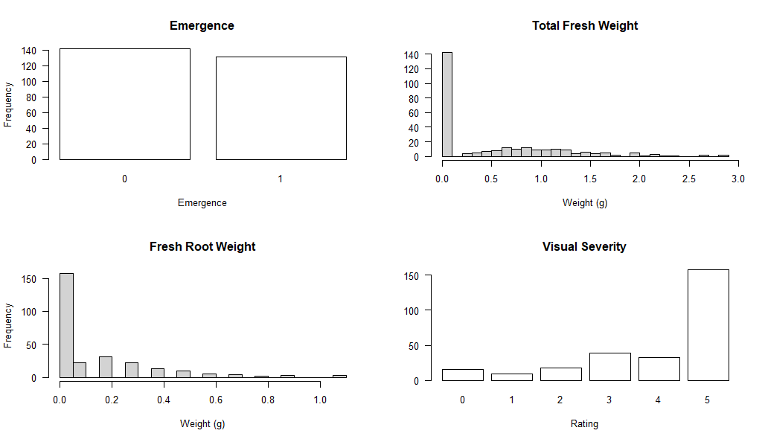
Figure 1: Phenotypic distributions of the four measures of disease evaluation of the two parental accessions and 271 F₃ progeny evaluated and sent for genotyping.

Linkage map
A total of 218 DNA samples were considered successfully genotyped after quality control, inclusive of the two parents. A total of 3179 SNPs were monomorphic between the resistant and susceptible parent while 2600 were polymorphic and passed quality control. No heterozygous loci were observed in the pure line parental accessions. The genotypes were dummy-coded in AB designation format such that PI 548631 (susceptible) represented the AA homozygous genotype while PI 438500 (resistant) was coded to represent the BB genotype at all remaining polymorphic loci. Among the 216 F₃ progeny, total genotypic frequencies of 37.8% AA, 25.0% AB, and 37.1% BB were observed across all SNPs (Figure 2). These genotypic frequencies matched the expected Mendelian frequencies of 1.5:1:1.5 of an F₃ intercross and further confirmed successful outcrossing.
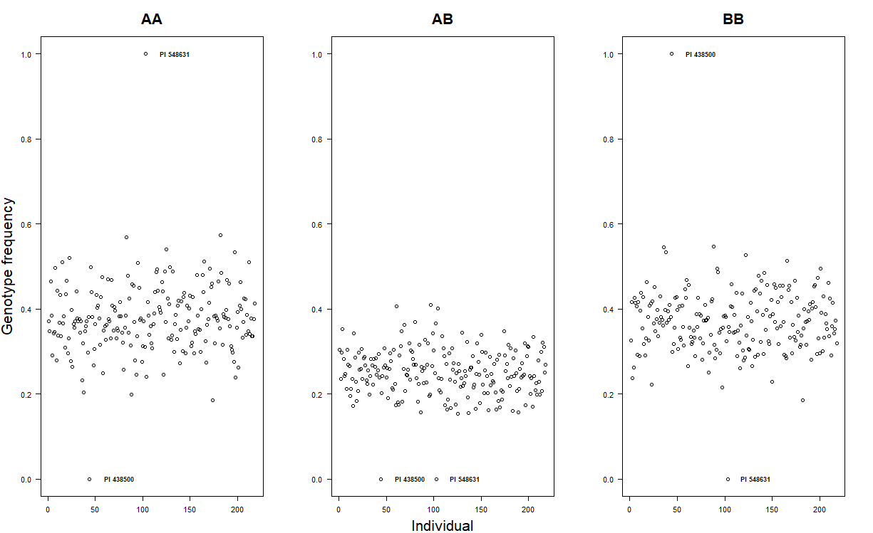
Figure 2: Genotypic frequencies of the 273 quality DNA samples at the 2600 high-quality polymorphic loci. The outlier frequencies representing the fixed genotypes of the parental accessions are labelled on each panel with their plant introduction accession number.
Marker order based on previously published physical positions and linkage mapping of the SNPs included in the microarray was supported by the observed data from the mapping population. All markers mapped to the chromosomes they were physically validated to during the development of the BARCSoySNP6K microarray (Song et al. 2020). A pairwise recombination heat map of the 2600 high-quality SNP markers showed an unbroken relationship between a given marker position and recombination rate relative to the ordering of upstream and downstream marker positions (Figure 3). Some segmentation of the heat map was observed on chromosomes 4, 8, 10-11, and 13-19 which corresponded with gaps in marker coverage observed on these chromosomes.

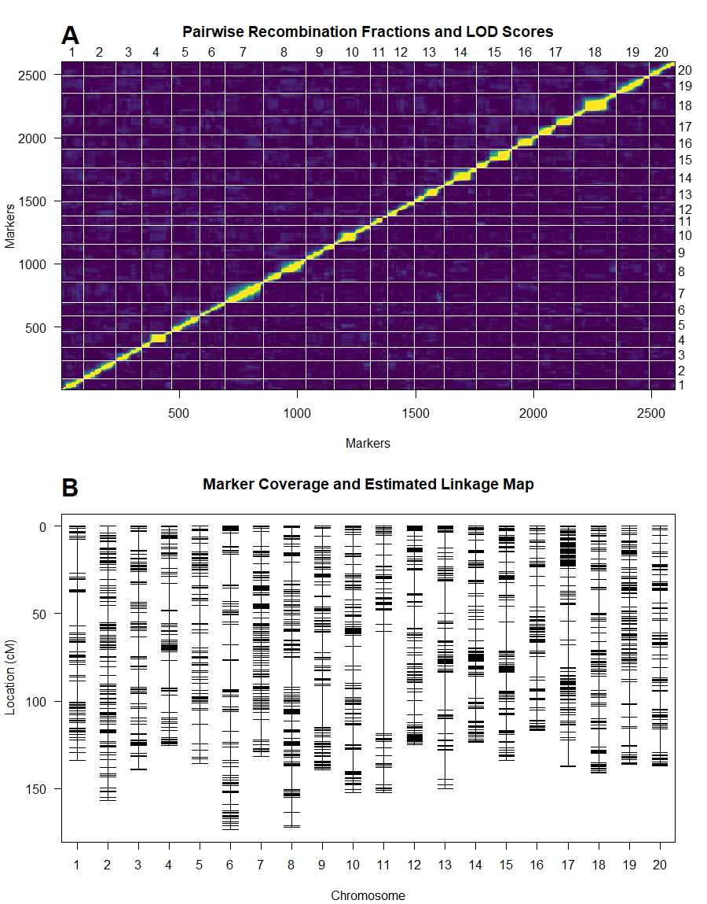
Figure 3: A.) Recombination frequency heat map of the ordered 2600 markers along the 20 soybean chromosomes. Yellow indicates recombination frequencies approaching zero, or near-complete linkage, while dark blue indicates recombination frequencies approaching 0.5, or complete independence. B.) Genome-wide linkage map showing total length of coverage from the first to the last marker on each chromosome and estimated intermarker distances in cM.
The final linkage map covered 2812.3 cM with an average marker spacing of 1.1 cM across the 20 soybean chromosomes (Table 2). In total, 17 of the 20 chromosomes had coverage with maximum estimated distances between markers of less than 20 cM. Chromosomes 9, 11, and 13 had the largest observed intermarker distances but did not correspond to the largest estimates of total chromosome length (Figure 3, Table 2).
Table 2: Numerical summary of the marker density, lengths, and marker spacing per chromosome and genome-wide in the estimated linkage map.
Chromosome | Number of Markers | Length (cM) | Average Marker Spacing (cM) | Max Spacing (cM)
1 | 92 | 133.9 | 1.5 | 19.1
2 | 138 | 156.9 | 1.1 | 10.2
3 | 110 | 139.1 | 1.3 | 11.5
4 | 124 | 125.3 | 1 | 15.9
5 | 122 | 135.6 | 1.1 | 11.1
6 | 106 | 173.5 | 1.7 | 17.4
7 | 162 | 131.7 | 0.8 | 11.2
8 | 181 | 172.2 | 1 | 17
9 | 118 | 139 | 1.2 | 23.9
10 | 154 | 152.5 | 1 | 12.2
11 | 73 | 152.2 | 2.1 | 58.1
12 | 113 | 125 | 1.1 | 13.6
13 | 128 | 150.1 | 1.2 | 21.7
14 | 137 | 123.5 | 0.9 | 12.6
15 | 149 | 133.8 | 0.9 | 16.6
16 | 114 | 116.7 | 1 | 11.9
17 | 148 | 137.6 | 0.9 | 14.6
18 | 181 | 140.8 | 0.8 | 13.4
19 | 138 | 136.1 | 1 | 12.7
20 | 112 | 136.8 | 1.2 | 13.8
Genome-Wide | 2600 | 2812.3 | 1.1 | 58.1
QTL analysis
Due to the large number of F₃ plants that did not emerge in the presence of F. graminearum, the QTL model was fitted both with emergence included as a covariate (COV) and without covariates (Non-COV). The genome-wide LOD threshold for QTL detection at α = 0.05 in the Non-COV model was 4.10, and 4.12 in the COV model, based on 1000 random permutations of the dataset. A single QTL associated with visual severity rating was identified on chromosome 16 using multiple imputation interval mapping with both models (Figure 4). The peak LOD score was 6.24 in the Non-COV model and 6.40 in the COV model and unanimously centered on SNP marker “Gm16_36328948_A_G” which is located towards the distal end of the long arm of chromosome 16. A 1.5-reduction in LOD score confidence interval placed the QTL between SNP markers “Gm16_36218124_A_G” and “Gm16_37026443_G_T” across both models. The estimated effect size of substituting a single B (resistant) allele for A (susceptible) at the peak marker of this QTL in the Non-COV model reduced the population mean visual severity rating of 3.76 by 0.52 ± 0.12, while the opposite substitution increased the severity rating by 0.38 ± 0.24 (Figure 5). The Non-COV single QTL model explained 8.69% of the variance in visual severity score and was significant compared to the null model of zero QTL (p-value 1.1 x 10⁻⁴). In the COV model, percentage of the variance explained by the QTL significantly improved to 20.29% (p-value 5.6 x 10⁻⁷) and the effect size of A to B allele substitution reduced visual severity scores by 0.77 ± 0.14 from an overall population mean of 2.84 (Figure 5). The opposite substitution increased visual severity score by 0.22 ± 0.29. Attempts to extend to multiple QTL models through composite interval mapping failed to detect significant evidence for additional interacting or additive QTL in this mapping population.

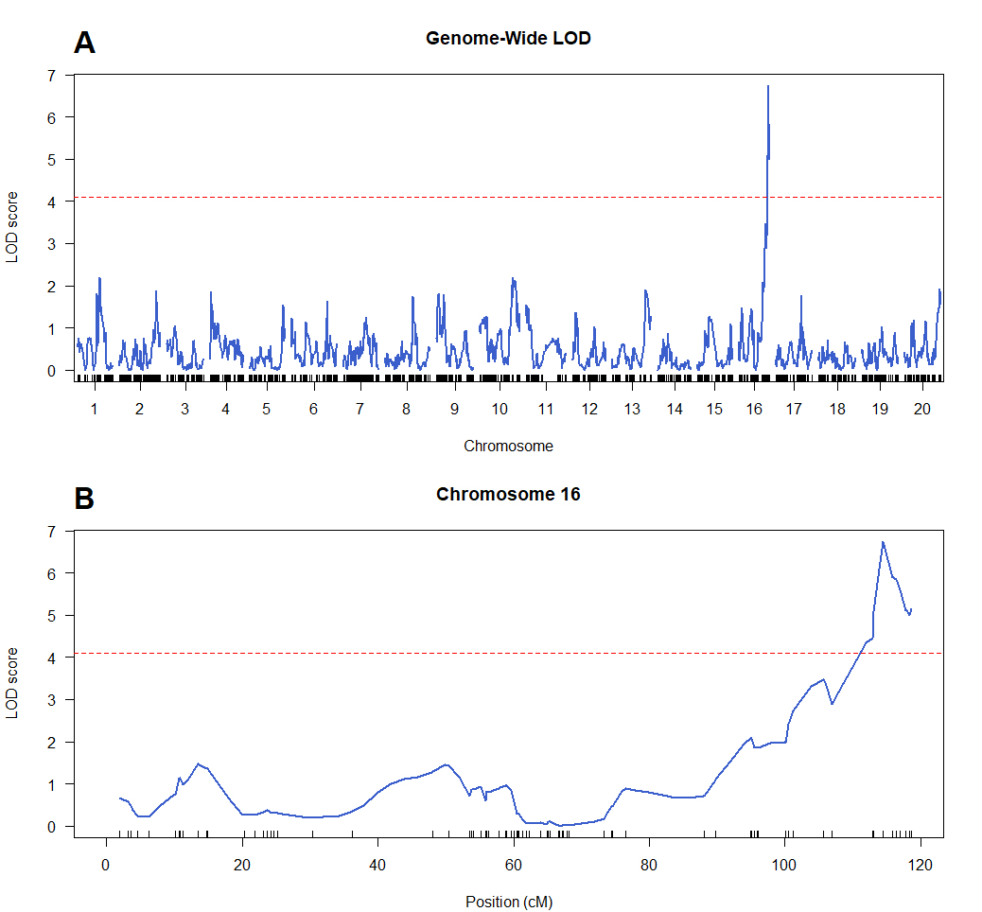
Figure 4: A.) Genome-wide LOD plot showing LOD scores of QTL detection signals at a walking speed of 2 cM across each of the 20 soybean chromosomes. The red dashed line indicates the genome-wide LOD threshold at significance level α = 0.05. B.) LOD plot of chromosome 16 alone where the QTL was detected. Red dashed line indicates genome-wide LOD threshold at significance level α = 0.05. In both plots, vertical black lines along the x-axis represent the positions of SNP markers.
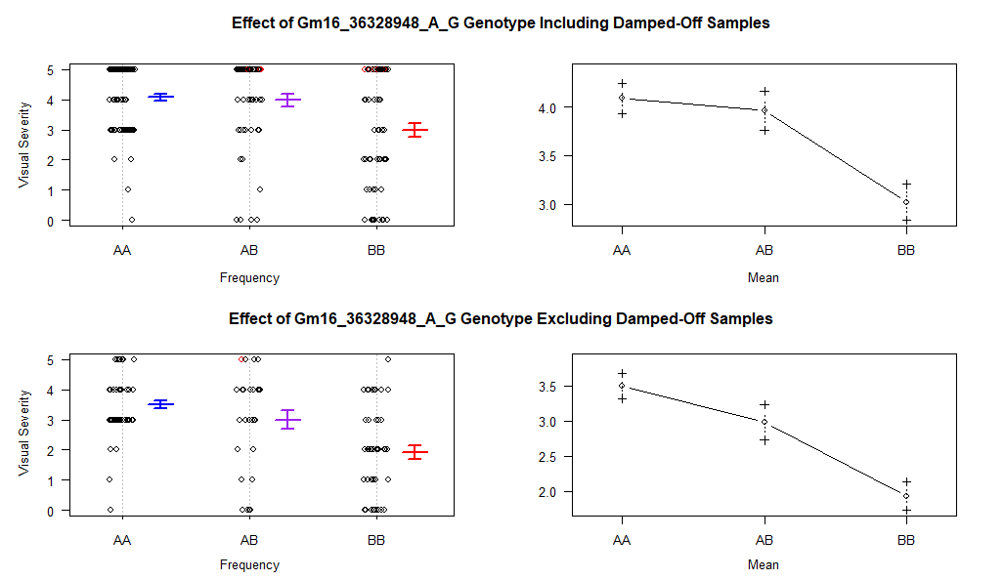
Figure 5: Plots of Gm16_36328948_A_G SNP genotype effect on the visual severity disease evaluation measure. The left two plots show the frequency of F₃ plants in each severity rating category while the right two show the genotypic mean ± standard error. The top row includes all genotyped samples, including those that damped-off. The bottom row shows the effect of Gm16_36328948_A_G SNP genotype only on seedlings that emerged.
Genes in the chromosome 16 QTL region
All available gene annotations in the Glycine max ‘Williams82’ genome assembly version 4 (glyma.Wm82.gnm4) corresponding to the 807.9 kbp interval were retrieved from SoyBase (https://www.soybase.org). The interval included a total of 105 predicted genes corresponding to 194 unique gene ontology (GO) terms and 19 uncharacterized proteins to which GO terms have not yet been assigned (Supplementary table 1). The most frequent biological functions ascribed to these GO terms were signal transduction, unspecified biological processes, wounding/defense responses, and negative regulation of peptidase activity (Supplementary table 2). Of the annotated genes within the interval, 10 are associated with defense responses or stress tolerance, 28 are associated with cell signaling or transport, and 4 are associated with cell wall development or modification. An additional 13 genes are predicted to encode proteins associated with unspecified biological processes (GO:0008150) not inclusive of the 19 uncharacterized genes not ascribed any GO terms, mentioned previously. The peak SNP associated with the QTL interval is located within the coding region of the 8,102 bp gene Glyma.16G208800 which is predicted to encode a zinc finger CCCH domain protein associated with biological process GO terms GO:0003677 (DNA binding) and GO:0005515 (protein binding).
Gene expression data was available for 96 of the 105 genes in the QTL interval across tissue types and development checkpoints observed in the ‘Williams 82’ haplotype through the CoNekT toolkit in the Legume Information Service database (https://conekt.legumeinfo.org/) (Figure 6). To investigate the observation that the QTL seems to impact visual severity of emerged seedlings more than it prevents pre-emergent damping off, the three- and four-day-old root hair expression dataset was compared to the 14-day-old mature root and root tips expression dataset to look for genes upregulated post-emergence (Table 3). The gene at the peak marker in the interval, Glyma.16G208800, appears to have low expression throughout early seed and late seedling development and across tissue types in ‘Williams 82’ plants unchallenged by pathogen infection. A total of 23 genes were upregulated at least two-fold in 14-day-old root tissues compared to 3- and 4-day-old root hairs from germinating seeds (Table 3). Of high interest among the 23 putative candidates was Glyma.16G211800, which has predicted functions in defense response, was 5.5-fold upregulated, and had the highest expression of any defense related genes in seedling roots from among the 23 upregulated genes. It encodes a predicted Kunitz trypsin inhibitor 1 (KTI1) protein which functions as a negative regulator of proteinase enzymes. Eight additional putative candidate genes have uncharacterized functions. Because the expression data was generated in the absence of F. graminearum, it cannot be ruled out that the gene or genes responsible for the phenotype are an inducible defense response.
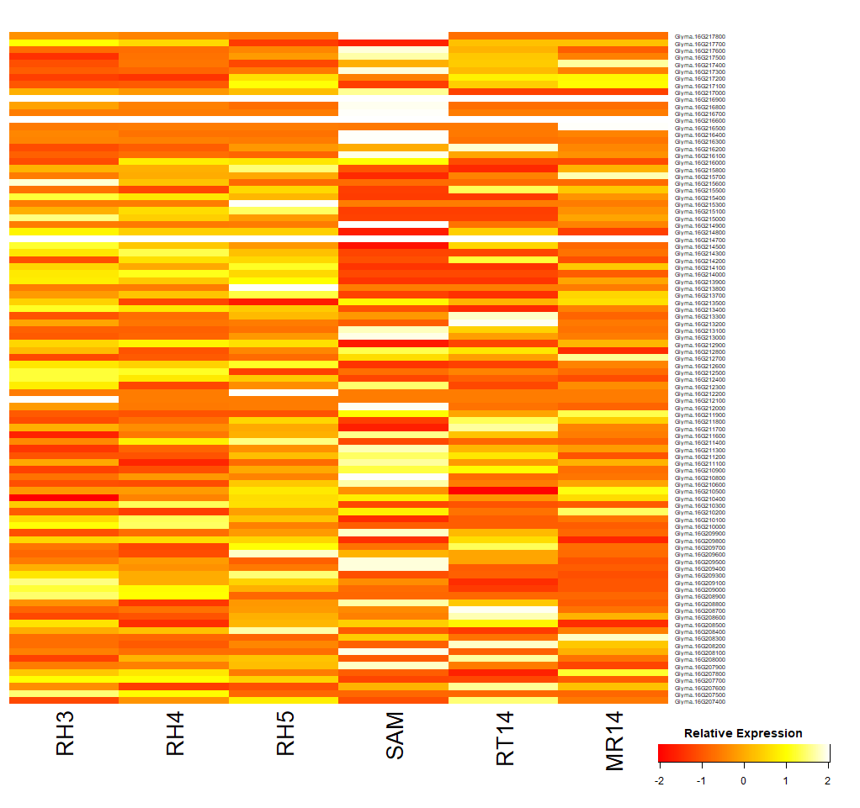
Figure 6: Expression heatmap of 96 predicted genes in the chromosome 16 QTL interval identified in this study. Expression data was in raw read counts and is standardized by each gene across six tissues and developmental time points. RH3 = Three-day-old root hairs, RH4 = Four-day-old root hairs, RH5 = Five-day-old root hairs, SAM = 14-day-old stem apical meristem, RT14 = 14-day-old root tip, MR14 = 14-day-old mature root. Data originally from Libault et al. (2010)

Table 3: Summary comparison of the 23 genes showing two-fold increased expression reads from 14-day old seedling root and root tip tissue relative to three- and four-day old root hairs from germinating seeds over the 807.9 kbp interval detected on chromosome 16.

 | Average Expression
 | Germinating Root Hairsª | Seedling Roots^{b} | Fold Change | GO Descriptions
Glyma.16G216500 | 0.1 | 14.8 | 197.5 | Leaf senescence, cadaverine transport
Glyma.16G208300 | 1.5 | 11.5 | 7.5 | Catabolic process, pollen tube growth
Glyma.16G211900 | 0.4 | 2.7 | 7.5 | RNA modification, chloroplast RNA processing
Glyma.16G211800 | 57.2 | 312.6 | 5.5 | Defense response, response to insect, negative regulation of peptidase activity
Glyma.16G209700 | 0.2 | 1.1 | 5.2 | RNA modification
Glyma.16G217300 | 7.5 | 37.4 | 5.0 | Regulation of translation, virus induced gene silencing, response to auxin, embryo development ending in seed dormancy, auxin metabolic process, adaxial/abaxial pattern specification, leaf morphogenesis, response to far red light, leaf vascular tissue pattern formation, leaf proximal/distal pattern formation, viral process, posttranscriptional gene silencing, cell differentiation, gene silencing by miRNA, innate immune response, adventitious root development, defense response to virus, viral gene silencing in virus induced gene silencing
Glyma.16G211300 | 0.1 | 0.3 | 4.9 | DNA replication checkpoint, mitotic cell cycle, DNA replication, chloroplast organization, regulation of DNA-dependent DNA replication initiation, gametophyte development, chromosome organization, DNA replication preinitiation complex assembly
Glyma.16G217400 | 0.3 | 1.5 | 4.3 | Regulation of transcription, DNA-templated
Glyma.16G217200 | 0.1 | 0.4 | 3.7 | Sucrose metabolic process, callose deposition in phloem sieve plate
Glyma.16G217100 | 0.6 | 2.0 | 3.7 | Biological process
Glyma.16G213100 | 0.6 | 2.1 | 3.6 | Chloroplast fission, plastid fission
Glyma.16G208700 | 16.1 | 52.8 | 3.3 | Protein folding
Glyma.16G216200 | 1.3 | 3.7 | 2.9 | Multicellular organism development, meristem maintenance
Glyma.16G213300 | 18.5 | 53.8 | 2.9 | Protein glycosylation
Glyma.16G208200 | 1.2 | 3.5 | 2.9 | Catabolic process, pollen tube growth
Glyma.16G213000 | 0.8 | 2.0 | 2.6 | DNA endoreduplication, root hair initiation
Glyma.16G208000 | 0.8 | 2.2 | 2.6 | NA
Glyma.16G212700 | 12.3 | 29.7 | 2.4 | NA
Glyma.16G211600 | 1.1 | 2.2 | 2.1 | NA
Glyma.16G217500 | 2.8 | 5.9 | 2.1 | Biological process
Glyma.16G210200 | 1.1 | 2.3 | 2.1 | Biological process
Glyma.16G210900 | 2.2 | 4.6 | 2.0 | Biological process
Glyma.16G209900 | 1.0 | 2.0 | 2.0 | NA
ª Averaged data of three- and four-day-old germinating root hairs deposited in CoNekT (Libault et al. 2010)
^{b} Averaged data of 14-day-old root tips and mature root tissue deposited in CoNekT (Libault et al. 2010)

Discussion
In this study, we conducted QTL mapping on F₃ progeny of a resistant-by-susceptible bi-parental cross between accessions PI 438500 × PI 548631 to identify genomic regions associated with a reduction in visual severity in response to Fusarium graminearum infection. We identified a novel QTL on chromosome 16 which accounts for approximately 20% of the phenotypic variation in post-emergence visual severity. This QTL spans the genomic interval between SNP markers “Gm16_36218124_A_G” and “Gm16_37026443_G_T” and represents a promising target for breeding efforts focused on improving resistance to F. graminearum in soybean.
Although two previous studies have mapped QTL associated with F. graminearum resistance on chromosome 16, translated physical positions from the published marker ranges as annotated in the ‘Williams 82’ reference genome indicate significant separation between those QTL and the QTL identified in this study. For instance, the QTL reported by Ellis et al. from ‘Conrad’ is located approximately 30.4 Mbp away from the interval reported in this study (Ellis et al. 2012). Similarly, Zhang et al., using the same phenotyping methods as Ellis et al., also reported a QTL from resistant cultivar ‘Conrad’ on chromosome 16 with the border of their interval range being 9.9 Mbp away from the closest flanking marker of our interval (Zhang et al. 2020). Further confirmation of the candidate genes underlying resistance in ‘Conrad’ and PI 438500 would help further confirm the distinction between these two QTL and reveal whether they may act additively or epistatically.
Our previous GWAS study identified five MTAs influencing F. graminearum resistance within the panel of 208 accessions (Detranaltes et al. 2023). Accession PI 438500 carried three of these MTAs on chromosomes 2, 3 and 13. Although these MTAs were not detected as significant QTL in the present study, LOD peaks below the genome-wide significance threshold were observed in the regions surrounding these markers (Supplementary Figure 1). Notably, this study employed a reduced subset of SNP markers for genotyping, preventing a direct comparison of SNP markers across studies. However, the furthest markers from the previously reported MTAs were only 214, 48, and 25 kbp away from the MTAs carried on chromosomes 2, 3, and 13 respectively. Our previous GWAS study also revealed that these MTAs contributed between 3.0 and 4.8% of the variation in phenotype, while the QTL effect reported here was 20.29% in the COV model, likely reducing the overall weighted impact of the three minor-effect MTAs present in PI 438500 when determining significance and model fit. Our findings support the hypothesis that PI 438500 harbors a novel QTL not detected in the previous GWAS analysis. Retrospective analysis of the GWAS data further indicates that the interval range between “Gm16_36218124_A_G” and “Gm16_37026443_G_T” did not contain any MTAs excluded due to low minor-allele frequency, suggesting that the chromosome 16 resistance QTL in PI 438500 may be due to a genetic insertion between SNP markers or to a unique expression pattern in the genetic background of PI 438500. Future fine-mapping efforts should account for this possibility and ideally include sequencing of the interval in PI 438500 to detect any insertions absent from the ‘Williams 82’ reference genome. The interval contains an additional 99 SNP markers identified in the development of SoySNP50K microarray, making this region marker-dense and suitable for fine mapping with commercially available genotyping resources.
Candidate genes within this interval include several with predicted defense functions. Of note is Glyma.16G211800 which is 5.5-fold upregulated in 14-day-old seedling roots relative to three- and four-day-old germinating root hairs, aligning with our finding that this QTL predominantly reduces post-emergent visual severity rather than preventing pre-emergent damping-off. Glyma.16G211800 encodes a predicted KTI1 protein, which functions as a negative regulator of proteinase enzymes. Given that F. graminearum undergoes a marked upregulation of the expression of proteinase genes during soybean infection, likely as a pathogenesis mechanism aimed at degrading proteins embedded in the cell wall, this gene may play a key role in resistance (Lowe et al. 2015; Naeem et al. 2021; Sun et al. 2013). Additionally, 41 genes within the interval have GO terms associated with defense response, signal transduction, and cell wall modification. Although these genes were not significantly upregulated in the comparison of root tissue expression data, they may be inducible and activated only in the presence of the pathogen. Future expression analyses should focus on candidate genes in this region, ideally using predicted genes identified within the QTL interval identified by sequencing the region from PI 438500, and sampling across both control and inoculated treatments and early seed and late seedling stages. Finally, the interval also contains several uncharacterized proteins and predicted proteins with unknown functions which may also contribute to as yet unknown resistance mechanisms.
Plant pathologists have been interested in identifying resistance to Fusarium graminearum in soybean since it was first demonstrated to be pathogenic on this crop in 2004. Twenty years have passed since this observation and significant progress towards the discovery and cataloging of resistant germplasm and genomic intervals have been made, though commercial varieties with resistance remain unavailable. Our work contributes a novel QTL with significant effect on post-emergent reduction in visual severity.

Funding: This work was supported by the Indiana Soybean Alliance and North Central Soybean Research Program of the United States of America.
Conflicts of Interest: The authors declare no conflicts of interest. Mention of trade names or commercial products in this publication is solely for the purpose of providing specific information and does not imply recommendation or endorsement by the United States Department of Agriculture.

References
Acharya B, Lee S, Rouf Mian MA, Jun T-H, McHale LK, Michel AP, Dorrance AE (2015) Identification and mapping of quantitative trait loci (QTL) conferring resistance to Fusarium graminearum from soybean PI 567301B. Theor Appl Genet 128:827-838. https://doi.org/10.1007/s00122-015-2473-5
Allen TW, Bradley CA, Sisson AJ, Byamukama E, Chilvers MI, Coker CM, Collins AA, Damicone JP, Dorrance AE, Dufault NS, Esker PD, Faske TR, Giesler LJ, Grybauskas AP, Hershman DE, Hollier CA, Isakeit T, Jardine DJ, Kelly HM, Kemerait RC, Kleczewski NM, Koenning SR, Kurle JE, Malvick DK, Markell SG, Mehl HL, Mueller DS, Mueller JD, Mulrooney RP, Nelson BD, Newman MA, Osborne L, Overstreet C, Padgett GB, Phipps PM, Price PP, Sikora EJ, Smith DL, Spurlock TN, Tande CA, Tenuta AU, Wise KA, Wrather JA (2017) Soybean yield loss estimates due to diseases in the United States and Ontario, Canada, from 2010 to 2014. Plant Health Prog 18:19-27. https://doi.org/10.1094/PHP-RS-16-0066
Becher R, Hettwer U, Karlovsky P, Deising HB, Wirsel SGR (2010) Adaptation of Fusarium graminearum to tebuconazole yielded descendants diverging for levels of fitness, fungicide resistance, virulence, and mycotoxin production. Phytopathology 100:444-453. https://doi.org/10.1094/PHYTO-100-5-0444
Bradley CA, Allen TW, Sisson AJ, Bergstrom GC, Bissonnette KM, Bond J, Byamukama E, Chilvers MI, Collins AA, Damicone JP, Dorrance AE, Dufault NS, Esker PD, Faske TR, Fiorellino NM, Giesler LJ, Hartman GL, Hollier CA, Isakeit T, Jackson-Ziems TA, Jardine DJ, Kelly HM, Kemerait RC, Kleczewski NM, Koehler AM, Kratochvil RJ, Kurle JE, Malvick DK, Markell SG, Mathew FM, Mehl HL, Mehl KM, Mueller DS, Mueller JD, Nelson BD, Overstreet C, Padgett GB, Price PP, Sikora EJ, Small I, Smith DL, Spurlock TN, Tande CA, Telenko DEP, Tenuta AU, Thiessen LD, Warner F, Wiebold WJ, Wise KA (2021) Soybean yield loss estimates due to diseases in the United States and Ontario, Canada, from 2015 to 2019. Plant Health Prog 22:483-495. https://doi.org/10.1094/PHP-01-21-0013-RS
Broders K, Lipps P, Paul P, Dorrance A (2007) Evaluation of Fusarium graminearum associated with corn and soybean seed and seedling disease in Ohio. Plant Dis 91:1155-1160. https://doi.org/10.1094/PDIS-91-9-1155
Broman K, Wu H, Sen Ś, Churchill G (2003) R/qtl: QTL mapping in experimental crosses. Bioinformatics 19:889-890. https://doi.org/10.1093/bioinformatics/btg112
Cheng P, Gedling CR, Patil G, Vuong TD, Shannon JG, Dorrance AE, Nguyen HT (2017) Genetic mapping and haplotype analysis of a locus for quantitative resistance to Fusarium graminearum in soybean accession PI 567516C. Theor Appl Genet 130:999-1010. https://doi.org/10.1007/s00122-017-2866-8
Chiotta M, Alaniz Zanon M, Palazzini J, Alberione E, Barros G, Chulze S (2021) Fusarium graminearum species complex occurrence on soybean and F. graminearum sensu stricto inoculum maintenance on residues in soybean‐wheat rotation under field conditions. J Appl Microbiol 130:208-216. https://doi.org/10.1111/jam.14765
Churchill G, Doerge R (1994) Empirical threshold values for quantitative trait mapping. Genetics 138:963-971. https://doi.org/10.1093/genetics/138.3.963
de Chaves MA, Reginatto P, da Costa BS, de Paschoal RI, Teixeira ML, Fuentefria AM (2022) Fungicide resistance in Fusarium graminearum species complex. Curr Microbiol 79:62-62. https://doi.org/10.1007/s00284-021-02759-4
Detranaltes C, Cai G (2021) First report of Mycoleptodiscus terrestris causing root rot of soybean in Indiana. Plant Dis 105:1194-1194. https://doi.org/10.1094/PDIS-09-20-2023-PDN
Detranaltes C, Ma J, Cai G (2023) Identification of soybean germplasm and associated molecular markers with resistance to Fusarium graminearum. Agronomy (Basel) 13:2376. https://doi.org/10.3390/agronomy13092376
Díaz Arias MM, Leandro LF, Munkvold GP (2013) Aggressiveness of Fusarium species and impact of root infection on growth and yield of soybeans. Phytopathology 103:822-832. https://doi.org/10.1094/PHYTO-08-12-0207-R
Ellis M, Broders K, Paul P, Dorrance A (2011) Infection of soybean seed by Fusarium graminearum and effect of seed treatments on disease under controlled conditions. Plant Dis 95:401-407. https://doi.org/10.1094/PDIS-05-10-0317
Ellis ML, Wang H, Paul PA, St. Martin SK, McHale LK (2012) Identification of soybean genotypes resistant to Fusarium graminearum and genetic mapping of resistance quantitative trait loci in the cultivar conrad. Crop Sci 52:2224-2233. https://doi.org/10.2135/cropsci2011.11.0624
Kuhnem PR, Del Ponte EM, Dong Y, Bergstrom GC (2015) Fusarium graminearum isolates from wheat and maize in New York show similar range of aggressiveness and toxigenicity in cross-species pathogenicity tests. Phytopathology 105:441-448. https://doi.org/10.1094/PHYTO-07-14-0208-R
Libault M, Farmer A, Joshi T, Takahashi K, Langley RJ, Franklin LD, He J, Xu D, May G, Stacey G (2010) Integrated transcriptome atlas of the crop model Glycine max, and its use in comparative analyses in plants. Plant J 63:86-99. https://doi.org/10.1111/j.1365-313X.2010.04222.x
Lin F, Chhapekar SS, Vieira CC, Da Silva MP, Rojas A, Lee D, Liu N, Pardo EM, Lee Y-C, Dong Z, Pinheiro JB, Ploper LD, Rupe J, Chen P, Wang D, Nguyen HT (2022) Breeding for disease resistance in soybean: a global perspective. Theor Appl Genet 135:3773-3872. https://doi.org/10.1007/s00122-022-04101-3
Lin F, Wani SH, Collins PJ, Wen Z, Gu C, Chilvers MI, Wang D (2018) Mapping quantitative trait loci for tolerance to Pythium irregulare in soybean (Glycine max L.). G3 (Bethesda) 8:3155-3161. https://doi.org/10.1534/g3.118.200368
Lowe RG, McCorkelle O, Bleackley M, Collins C, Faou P, Mathivanan S, Anderson M (2015) Extracellular peptidases of the cereal pathogen Fusarium graminearum. Front Plant Sci 6:962-962. https://doi.org/10.3389/fpls.2015.00962
Million CR, Wijeratne S, Cassone BJ, Lee S, Rouf Mian MA, McHale LK, Dorrance AE (2019) Hybrid genome assembly of a major quantitative disease resistance locus in soybean toward Fusarium graminearum. Plant Genome 12:1-17. https://doi.org/10.3835/plantgenome2018.12.0102
Naeem M, Munir M, Li H, Raza MA, Song C, Wu X, Irshad G, Khalid MHB, Yang W, Chang X (2021) Transcriptional Responses of Fusarium graminearum Interacted with Soybean to Cause Root Rot. J Fungi (Basel) 7:422. https://doi.org/10.3390/jof7060422
Okello PN, Mathew FM (2019) Cross pathogenicity studies show South Dakota isolates of Fusarium acuminatum , F. equiseti , F. graminearum , F. oxysporum , F. proliferatum , F. solani , and F. subglutinans from either soybean or corn are pathogenic to both crops. Plant Health Prog 20:44-49. https://doi.org/10.1094/PHP-10-18-0056-RS
Okello PN, Petrovic K, Singh AK, Kontz B, Mathew FM (2020) Characterization of species of Fusarium causing root rot of soybean (Glycine max L.) in South Dakota, USA. Can J Plant Pathol 42:560-571. https://doi.org/10.1080/07060661.2020.1746695
Okello PN, Solanki S, Rafi N, Mathew F (2023) Sources of resistance, effect of maturity groups and marker-trait associations associated with Fusarium graminearum causing root rot of soybean (Glycine max). Plant Health Prog. https://doi.org/10.1094/PHP-01-23-0011-RS
Pimentel MF, Srour AY, Warner AJ, Bond JP, Bradley CA, Rupe J, Chilvers MI, Rojas JA, Jacobs JL, Little CR, Robertson AE, Giesler LJ, Malvick D, Wise K, Tenuta A, Fakhoury AM (2022) Ecology and diversity of culturable fungal species associated with soybean seedling diseases in the midwestern United States. J Appl Microbiol 132:3797-3811. https://doi.org/10.1111/jam.15507
Pioli R, Mozzoni L, Morandi E (2004) First report of pathogenic association between Fusarium graminearum and soybean. Plant Dis 88:220-220. https://doi.org/10.1094/PDIS.2004.88.2.220A
Poland JA, Balint-Kurti PJ, Wisser RJ, Pratt RC, Nelson RJ (2009) Shades of gray: the world of quantitative disease resistance. Trends Plant Sci 14:21-29. https://doi.org/10.1016/j.tplants.2008.10.006
Rojas JA, Jacobs JL, Napieralski S, Karaj B, Bradley C, Chase T, Esker P, Giesler L, Jardine D, Malvick D, Markell S, Nelson B, Robertson A, Rupe J, Smith D, Sweets L, Tenuta A, Wise K, Chilvers M (2017) Oomycete species associated with soybean seedlings in North America - part I: identification and pathogenicity characterization. Phytopathology 107:280-292. https://doi.org/10.1094/PHYTO-04-16-0177-R
Song Q, Yan L, Quigley C, Fickus E, Wei H, Chen L, Dong F, Araya S, Liu J, Hyten D, Pantalone V, Nelson RL (2020) Soybean BARCSoySNP6K: An assay for soybean genetics and breeding research. Plant J 104:800-811. https://doi.org/10.1111/tpj.14960
Stasko AK, Wickramasinghe D, Nauth BJ, Acharya B, Ellis ML, Taylor CG, McHale LK, Dorrance AE (2016) High‐density mapping of resistance QTL toward Phytophthora sojae, Pythium irregulare, and Fusarium graminearum in the same soybean population. Crop Sci 56:2476-2492. https://doi.org/10.2135/cropsci2015.12.0749
Sun HH, Fukao Y, Ishida S, Yamamoto H, Maekawa S, Fujiwara M, Sato T, Yamaguchi J (2013) Proteomics analysis reveals a highly heterogeneous proteasome composition and the post-translational regulation of peptidase activity under pathogen signaling in plants. J Proteome Res 12:5084-5095. https://doi.org/10.1021/pr400630w
Talas F, McDonald B (2015) Significant variation in sensitivity to a DMI fungicide in field populations of Fusarium graminearum. Plant Pathol 64:664-670. https://doi.org/10.1111/ppa.12280
Wrather J, Koenning S (2006) Estimates of disease effects on soybean yields in the United States 2003 to 2005. J Nematol 38:173-180.
Wrather J, Stienstra W, Koenning S (2001) Soybean disease loss estimates for the United States from 1996 to 1998. Can J Plant Pathol 23:122-131. https://doi.org/10.1080/07060660109506919
Xue A, Cober E, Voldeng H, Babcock C, Clear R (2007) Evaluation of the pathogenicity of Fusarium graminearum and Fusarium pseudograminearum on soybean seedlings under controlled conditions. Can J Plant Pathol 29:35-40. https://doi.org/10.1080/07060660709507435
Zhang C, Han Y, Qu Y, Teng W, Zhao X, Morris B (2020) Identification of quantitative trait loci underlying resistance of soybean to Fusarium graminearum. Plant Breed 139:141-147. https://doi.org/10.1111/pbr.12760
Zhang C, Zhao X, Qu Y, Teng W, Qiu L, Zheng H, Wang Z, Han Y, Li W (2019) Loci and candidate genes in soybean that confer resistance to Fusarium graminearum. Theor Appl Genet 132:431-441. https://doi.org/10.1007/s00122-018-3230-3
Zhang J, Xue A, Zhang H, Nagasawa A, Tambong J (2010) Response of soybean cultivars to root rot caused by Fusarium species. Can J Plant Sci 90:767-776. https://doi.org/10.4141/CJPS09133

Supplementary Files
Supplementary table 1: Predicted genes within the glyma.Wm82.gnm4 reference genome physically mapped within the 807.9 kbp interval between bounding SNP markers “Gm16_36218124_A_G” and “Gm16_37026443_G_T” identified in this study. The associated GO terms with each genes predicted biological function(s) is presented next to the gene they were ascribed to.
Genes in the QTL Interval | Associated GO terms
Glyma.16g207400 | GO:0006281 GO:0006412
Glyma.16g207500 | GO:0006950 GO:0006979 GO:0042744 GO:0055114
Glyma.16g207600 | GO:0015031 GO:0016192
Glyma.16g207700 | GO:0006725 GO:0055114
Glyma.16g207800 | GO:0006725 GO:0055114
Glyma.16g207900 | GO:0009737 GO:0009845 GO:0009908 GO:0016575 GO:0080186 GO:1902074
Glyma.16g208000 | NA
Glyma.16g208100 | GO:0009056 GO:0009860
Glyma.16g208200 | GO:0009056 GO:0009860
Glyma.16g208300 | GO:0009056 GO:0009860
Glyma.16g208400 | GO:0034765
Glyma.16g208500 | GO:0000054 GO:0000460 GO:0000470 GO:0009793 GO:0071215 GO:1902626
Glyma.16g208600 | GO:0000054 GO:0000460 GO:0000470 GO:0009793 GO:0071215 GO:1902626
Glyma.16g208700 | GO:0006457
Glyma.16g208800 | GO:0003677, GO:0005515
Glyma.16g208900 | NA
Glyma.16g209000 | GO:0007165 GO:0009611 GO:0071456
Glyma.16g209100 | NA
Glyma.16g209300 | GO:0006574
Glyma.16g209400 | GO:0009611 GO:0009651 GO:0009737 GO:0010222 GO:0010588 GO:0015908 GO:0055085 GO:0080051
Glyma.16g209500 | GO:0071456
Glyma.16g209600 | GO:0006869 GO:0007165
Glyma.16g209700 | GO:0009451
Glyma.16g209800 | GO:0005975 GO:0009620 GO:0009911 GO:0009965 GO:0071555
Glyma.16g209900 | NA
Glyma.16g210000 | GO:0006914 GO:0055085
Glyma.16g210100 | GO:0006468 GO:0009834
Glyma.16g210200 | GO:0008150
Glyma.16g210300 | GO:0007275 GO:0010268 GO:0016125 GO:0016132 GO:0055114
Glyma.16g210400 | GO:0008150
Glyma.16g210500 | GO:0006468 GO:0009755
Glyma.16g210600 | GO:0007165
Glyma.16g210702 | GO:0032259
Glyma.16g210800 | GO:0007165
Glyma.16g210900 | GO:0008150
Glyma.16g210966 | GO:0007165
Glyma.16g211032 | NA
Glyma.16g211100 | NA
Glyma.16g211200 | GO:0009555 GO:0009567
Glyma.16g211300 | GO:0000076 GO:0000278 GO:0006260 GO:0009658 GO:0030174 GO:0048229 GO:0051276 GO:0071163
Glyma.16g211400 | GO:0007165
Glyma.16g211600 | NA
Glyma.16g211700 | GO:0006952 GO:0009625 GO:0010466
Glyma.16g211800 | GO:0006952 GO:0009625 GO:0010466
Glyma.16g211900 | GO:0009451 GO:0031425
Glyma.16g212000 | GO:0006970 GO:0009651 GO:0009737 GO:0046345
Glyma.16g212100 | GO:0006952 GO:0009625 GO:0010466
Glyma.16g212200 | GO:0006952 GO:0009625 GO:0010466
Glyma.16g212300 | GO:0007165
Glyma.16g212400 | GO:0006952 GO:0009625 GO:0010466
Glyma.16g212500 | GO:0006952 GO:0009625 GO:0010466
Glyma.16g212600 | GO:0008150
Glyma.16g212700 | NA
Glyma.16g212800 | GO:0008150
Glyma.16g212900 | GO:0055085
Glyma.16g213000 | GO:0042023 GO:0048766
Glyma.16g213100 | GO:0010020 GO:0043572
Glyma.16g213200 | GO:0006099 GO:0006104 GO:0006105 GO:0009142
Glyma.16g213300 | GO:0006486
Glyma.16g213400 | NA
Glyma.16g213500 | GO:0016567
Glyma.16g213700 | GO:0007165
Glyma.16g213800 | GO:0007165
Glyma.16g213900 | GO:0007165
Glyma.16g214000 | NA
Glyma.16g214100 | GO:0007165
Glyma.16g214200 | GO:0007165
Glyma.16g214300 | GO:0007165
Glyma.16g214500 | GO:0007165
Glyma.16g214529 | NA
Glyma.16g214557 | GO:0042742
Glyma.16g214585 | GO:0007165
Glyma.16g214613 | GO:0008150
Glyma.16g214641 | NA
Glyma.16g214669 | GO:0007165
Glyma.16g214700 | NA
Glyma.16g214800 | GO:0007165
Glyma.16g214900 | GO:0007165
Glyma.16g215000 | GO:0007165
Glyma.16g215100 | GO:0007165
Glyma.16g215300 | GO:0007165
Glyma.16g215400 | GO:0007165
Glyma.16g215500 | NA
Glyma.16g215600 | NA
Glyma.16g215700 | NA
Glyma.16g215800 | GO:0008150
Glyma.16g216000 | NA
Glyma.16g216100 | GO:0002184 GO:0006415 GO:0040008
Glyma.16g216200 | GO:0007275 GO:0010073
Glyma.16g216300 | NA
Glyma.16g216400 | NA
Glyma.16g216500 | GO:0010150 GO:0015839
Glyma.16g216600 | GO:0000902 GO:0008150 GO:0009846 GO:0009860 GO:0052543
Glyma.16g216700 | GO:0008150
Glyma.16g216800 | GO:0008150
Glyma.16g216900 | GO:0008150
Glyma.16g217000 | GO:0008150
Glyma.16g217100 | GO:0008150
Glyma.16g217200 | GO:0005985 GO:0080165
Glyma.16g217300 | GO:0006417 GO:0009616 GO:0009733 GO:0009793 GO:0009850 GO:0009955 GO:0009965 GO:0010218 GO:0010305 GO:0010589 GO:0016032 GO:0016441 GO:0030154 GO:0035195 GO:0045087 GO:0048830 GO:0051607 GO:0060145
Glyma.16g217400 | GO:0006355
Glyma.16g217500 | GO:0008150
Glyma.16g217600 | GO:0006397 GO:0016554 GO:0051252 GO:1900871
Glyma.16g217700 | GO:0006355 GO:0007623
Glyma.16g217800 | GO:0006355 GO:0009828 GO:0010091

Supplementary table 2: GO term enrichment analysis for the biological processes associated with the 105 predicted genes within the chromosome 16 QTL interval.

GO_Term | Genome_GO_count | GO_Frequency | Expected_Frequency | Status | Corrected_P | GO_desc
GO:0007165 | 811 | 22 | 4.181085871 | Overrepresented | 2.90E-08 | signal transduction
GO:0009625 | 104 | 6 | 0.536168842 | Overrepresented | 0.001920608 | response to insect
GO:0009056 | 63 | 3 | 0.324794587 | Overrepresented | 0.479801297 | catabolic process
GO:0000460 | 26 | 2 | 0.13404221 | Overrepresented | 0.89429636 | maturation of 5.8S rRNA
GO:0000470 | 43 | 2 | 0.221685194 | Overrepresented | 2.347400845 | maturation of LSU-rRNA
GO:0009860 | 273 | 4 | 1.407443209 | Overrepresented | 6.001335264 | pollen tube growth
GO:0080165 | 11 | 1 | 0.056710166 | Overrepresented | 6.270347178 | callose deposition in phloem sieve plate
GO:0006574 | 12 | 1 | 0.061865636 | Overrepresented | 6.823072669 | valine catabolic process
GO:0006415 | 17 | 1 | 0.087642984 | Overrepresented | 9.544668156 | translational termination
GO:0048830 | 22 | 1 | 0.113420332 | Overrepresented | 12.19750369 | adventitious root development
GO:0009955 | 25 | 1 | 0.128886741 | Overrepresented | 13.75692103 | adaxial/abaxial pattern specification
GO:0010222 | 27 | 1 | 0.13919768 | Overrepresented | 14.78330761 | stem vascular tissue pattern formation
GO:0080186 | 29 | 1 | 0.149508619 | Overrepresented | 15.79923921 | developmental vegetative growth
GO:0009850 | 33 | 1 | 0.170130498 | Overrepresented | 17.8001602 | auxin metabolic process
GO:0034765 | 34 | 1 | 0.175285967 | Overrepresented | 18.29402035 | regulation of monoatomic ion transmembrane transport
GO:0016575 | 39 | 1 | 0.201063316 | Overrepresented | 20.72574354 | histone deacetylation
GO:0016132 | 45 | 1 | 0.231996133 | Overrepresented | 23.56280478 | brassinosteroid biosynthetic process
GO:0010020 | 51 | 1 | 0.262928951 | Overrepresented | 26.31400882 | chloroplast fission
GO:0000902 | 58 | 1 | 0.299017239 | Overrepresented | 29.41867734 | cell morphogenesis
GO:0010588 | 60 | 1 | 0.309328178 | Overrepresented | 30.28546624 | cotyledon vascular tissue pattern formation
GO:0009567 | 74 | 1 | 0.381504753 | Overrepresented | 36.11050742 | double fertilization forming a zygote and endosperm
GO:0010091 | 81 | 1 | 0.41759304 | Overrepresented | 38.86998644 | trichome branching
GO:0006260 | 84 | 1 | 0.433059449 | Overrepresented | 40.02264146 | DNA replication
GO:0051252 | 85 | 1 | 0.438214919 | Overrepresented | 40.40293686 | regulation of RNA metabolic process
GO:0016032 | 103 | 1 | 0.531013372 | Overrepresented | 46.92508032 | viral process
GO:0051607 | 104 | 1 | 0.536168842 | Overrepresented | 47.27006785 | defense response to virus
GO:0006099 | 110 | 1 | 0.567101659 | Overrepresented | 49.30323703 | tricarboxylic acid cycle
GO:0006417 | 128 | 1 | 0.659900113 | Overrepresented | 55.04031447 | regulation of translation
GO:0006869 | 132 | 1 | 0.680521991 | Overrepresented | 56.24483003 | lipid transport
GO:0009911 | 135 | 1 | 0.6959884 | Overrepresented | 57.1321231 | positive regulation of flower development
GO:0009846 | 141 | 1 | 0.726921218 | Overrepresented | 58.86623072 | pollen germination
GO:0006486 | 170 | 1 | 0.876429837 | Overrepresented | 66.53407042 | protein glycosylation
GO:0009834 | 181 | 1 | 0.933140003 | Overrepresented | 69.15644814 | plant-type secondary cell wall biogenesis
GO:0043531 | 469 | 20 | 1.614974975 | Overrepresented | 2.52E-14 | ADP binding
GO:0030414 | 31 | 6 | 0.106746747 | Overrepresented | 8.01E-08 | peptidase inhibitor activity
GO:0010466 | 28 | 6 | 0.14435315 | Overrepresented | 6.59E-07 | negative regulation of peptidase activity
GO:0004867 | 52 | 6 | 0.179059059 | Overrepresented | 2.09E-06 | serine-type endopeptidase inhibitor activity
GO:0004869 | 61 | 6 | 0.21005005 | Overrepresented | 5.54E-06 | cysteine-type endopeptidase inhibitor activity
GO:0016701 | 6 | 2 | 0.020660661 | Overrepresented | 0.01357581 | oxidoreductase activity, acting on single donors with O₂
GO:0006725 | 6 | 2 | 0.030932818 | Overrepresented | 0.044154104 | cellular aromatic compound metabolic process
GO:0080030 | 74 | 3 | 0.254814815 | Overrepresented | 0.167943843 | methyl indole-3-acetate esterase activity
GO:0052689 | 76 | 3 | 0.261701702 | Overrepresented | 0.181221089 | carboxylic ester hydrolase activity
GO:0043023 | 22 | 2 | 0.075755756 | Overrepresented | 0.201652741 | ribosomal large subunit binding
GO:0000054 | 15 | 2 | 0.077332044 | Overrepresented | 0.299821328 | ribosomal subunit export from nucleus
GO:1902626 | 16 | 2 | 0.082487514 | Overrepresented | 0.341499503 | assembly of large subunit precursor of preribosome
GO:0015226 | 2 | 1 | 0.006886887 | Overrepresented | 0.534431219 | carnitine transmembrane transporter activity
GO:0008198 | 37 | 2 | 0.127407407 | Overrepresented | 0.562116344 | ferrous iron binding
GO:0009142 | 2 | 1 | 0.010310939 | Overrepresented | 1.166465808 | NA
GO:0015839 | 2 | 1 | 0.010310939 | Overrepresented | 1.166465808 | cadaverine transport
GO:0016740 | 386 | 5 | 1.329169169 | Overrepresented | 0.856622125 | transferase activity
GO:0004775 | 5 | 1 | 0.017217217 | Overrepresented | 1.329259618 | succinate-CoA ligase (ADP-forming) activity
GO:1900871 | 4 | 1 | 0.020621879 | Overrepresented | 2.321057687 | chloroplast mRNA modification
GO:0004557 | 6 | 1 | 0.020660661 | Overrepresented | 1.592396487 | alpha-galactosidase activity
GO:0004576 | 6 | 1 | 0.020660661 | Overrepresented | 1.592396487 | oligosaccharyl transferase activity
GO:0015108 | 6 | 1 | 0.020660661 | Overrepresented | 1.592396487 | chloride transmembrane transporter activity
GO:0071163 | 5 | 1 | 0.025777348 | Overrepresented | 2.893938526 | DNA replication preinitiation complex assembly
GO:0010294 | 8 | 1 | 0.027547548 | Overrepresented | 2.115979683 | abscisic acid glucosyltransferase activity
GO:0070182 | 8 | 1 | 0.027547548 | Overrepresented | 2.115979683 | DNA polymerase binding
GO:0043022 | 77 | 2 | 0.265145145 | Overrepresented | 2.258827638 | ribosome binding
GO:0006105 | 6 | 1 | 0.030932818 | Overrepresented | 3.463895879 | succinate metabolic process
GO:0003860 | 9 | 1 | 0.030990991 | Overrepresented | 2.37643209 | 3-hydroxyisobutyryl-CoA hydrolase activity
GO:0048037 | 10 | 1 | 0.034434434 | Overrepresented | 2.635995741 | NA
GO:0000076 | 7 | 1 | 0.036088287 | Overrepresented | 4.030944586 | DNA replication checkpoint signaling
GO:0004550 | 11 | 1 | 0.037877878 | Overrepresented | 2.894673651 | nucleoside diphosphate kinase activity
GO:0016149 | 11 | 1 | 0.037877878 | Overrepresented | 2.894673651 | translation release factor activity, codon specific
GO:0035197 | 11 | 1 | 0.037877878 | Overrepresented | 2.894673651 | siRNA binding
GO:0060145 | 8 | 1 | 0.041243757 | Overrepresented | 4.595099416 | NA
GO:1990825 | 12 | 1 | 0.041321321 | Overrepresented | 3.152468824 | sequence-specific mRNA binding
GO:0003747 | 13 | 1 | 0.044764765 | Overrepresented | 3.409384256 | translation release factor activity
GO:0010589 | 9 | 1 | 0.046399227 | Overrepresented | 5.156375058 | leaf proximal/distal pattern formation
GO:0030174 | 9 | 1 | 0.046399227 | Overrepresented | 5.156375058 | regulation of DNA-templated DNA replication initiation
GO:0005247 | 15 | 1 | 0.051651652 | Overrepresented | 3.920587823 | voltage-gated chloride channel activity
GO:0052692 | 16 | 1 | 0.055095095 | Overrepresented | 4.174881897 | raffinose alpha-galactosidase activity
GO:0071215 | 73 | 2 | 0.376349283 | Overrepresented | 6.185492118 | cellular response to abscisic acid stimulus
GO:0002184 | 11 | 1 | 0.056710166 | Overrepresented | 6.270347178 | cytoplasmic translational termination
GO:0006104 | 11 | 1 | 0.056710166 | Overrepresented | 6.270347178 | succinyl-CoA metabolic process
GO:0035195 | 11 | 1 | 0.056710166 | Overrepresented | 6.270347178 | miRNA-mediated gene silencing
GO:0043572 | 11 | 1 | 0.056710166 | Overrepresented | 6.270347178 | plastid fission
GO:0015245 | 18 | 1 | 0.061981982 | Overrepresented | 4.680869401 | fatty acid transmembrane transporter activity
GO:0016157 | 18 | 1 | 0.061981982 | Overrepresented | 4.680869401 | sucrose synthase activity
GO:0005253 | 20 | 1 | 0.068868869 | Overrepresented | 5.183408959 | monoatomic anion channel activity
GO:0003906 | 22 | 1 | 0.075755756 | Overrepresented | 5.682523931 | DNA-(apurinic or apyrimidinic site) endonuclease activity
GO:0080051 | 15 | 1 | 0.077332044 | Overrepresented | 8.464379419 | cutin transport
GO:0035198 | 25 | 1 | 0.086086086 | Overrepresented | 6.424825998 | miRNA binding
GO:0051276 | 17 | 1 | 0.087642984 | Overrepresented | 9.544668156 | chromosome organization
GO:0009616 | 18 | 1 | 0.092798453 | Overrepresented | 10.08068012 | RNAi-mediated antiviral immune response
GO:0046345 | 21 | 1 | 0.108264862 | Overrepresented | 11.67235379 | abscisic acid catabolic process
GO:0016441 | 23 | 1 | 0.118575802 | Overrepresented | 12.71997247 | post-transcriptional gene silencing
GO:0048766 | 25 | 1 | 0.128886741 | Overrepresented | 13.75692103 | root hair initiation
GO:0052543 | 26 | 1 | 0.13404221 | Overrepresented | 14.27142785 | callose deposition in cell wall
GO:0015908 | 29 | 1 | 0.149508619 | Overrepresented | 15.79923921 | fatty acid transport
GO:0004521 | 48 | 1 | 0.165285285 | Overrepresented | 11.86972764 | RNA endonuclease activity
GO:0010268 | 33 | 1 | 0.170130498 | Overrepresented | 17.8001602 | brassinosteroid homeostasis
GO:0008289 | 233 | 2 | 0.802322322 | Overrepresented | 14.87991683 | lipid binding
GO:0016554 | 43 | 1 | 0.221685194 | Overrepresented | 22.62678733 | cytidine to uridine editing
GO:0042023 | 43 | 1 | 0.221685194 | Overrepresented | 22.62678733 | DNA endoreduplication
GO:0009965 | 164 | 2 | 0.845497019 | Overrepresented | 23.46221731 | leaf morphogenesis
GO:0004693 | 74 | 1 | 0.254814815 | Overrepresented | 17.53039197 | cyclin-dependent protein serine/threonine kinase activity
GO:0048229 | 50 | 1 | 0.257773482 | Overrepresented | 25.86132644 | gametophyte development
GO:0051213 | 276 | 2 | 0.95039039 | Overrepresented | 19.08832885 | dioxygenase activity
GO:0031425 | 55 | 1 | 0.28355083 | Overrepresented | 28.10172619 | chloroplast RNA processing
GO:0003684 | 84 | 1 | 0.289249249 | Overrepresented | 19.57692662 | damaged DNA binding
GO:0006914 | 60 | 1 | 0.309328178 | Overrepresented | 30.28546624 | autophagy
GO:0015250 | 90 | 1 | 0.30990991 | Overrepresented | 20.7716387 | water channel activity
GO:0016758 | 90 | 1 | 0.30990991 | Overrepresented | 20.7716387 | hexosyltransferase activity
GO:1902074 | 63 | 1 | 0.324794587 | Overrepresented | 31.56910816 | response to salt
GO:0035091 | 97 | 1 | 0.334014014 | Overrepresented | 22.13480183 | phosphatidylinositol binding
GO:0051537 | 99 | 1 | 0.340900901 | Overrepresented | 22.51831337 | 2 iron, 2 sulfur cluster binding
GO:0005985 | 71 | 1 | 0.366038344 | Overrepresented | 34.89722491 | sucrose metabolic process
GO:0010073 | 75 | 1 | 0.386660222 | Overrepresented | 36.51080675 | meristem maintenance
GO:0015144 | 119 | 1 | 0.40976977 | Overrepresented | 26.21235322 | carbohydrate transmembrane transporter activity
GO:0016125 | 80 | 1 | 0.41243757 | Overrepresented | 38.48181167 | sterol metabolic process
GO:0010305 | 84 | 1 | 0.433059449 | Overrepresented | 40.02264146 | leaf vascular tissue pattern formation
GO:0000166 | 130 | 1 | 0.447647648 | Overrepresented | 28.13875096 | nucleotide binding
GO:0009828 | 89 | 1 | 0.458836797 | Overrepresented | 41.9047686 | plant-type cell wall loosening
GO:0010218 | 98 | 1 | 0.505236024 | Overrepresented | 45.17334719 | response to far red light
GO:0005096 | 152 | 1 | 0.523403403 | Overrepresented | 31.78039633 | GTPase activator activity
GO:0000278 | 103 | 1 | 0.531013372 | Overrepresented | 46.92508032 | mitotic cell cycle
GO:0051015 | 158 | 1 | 0.544064064 | Overrepresented | 32.72683098 | actin filament binding
GO:0019901 | 180 | 1 | 0.61981982 | Overrepresented | 36.03517033 | protein kinase binding
GO:0004497 | 194 | 1 | 0.668028028 | Overrepresented | 38.01415717 | monooxygenase activity
GO:0000976 | 201 | 1 | 0.692132132 | Overrepresented | 38.9685721 | transcription cis-regulatory region binding
GO:0016787 | 677 | 3 | 2.331211211 | Overrepresented | 39.53693055 | hydrolase activity
GO:0045087 | 142 | 1 | 0.732076688 | Overrepresented | 59.15009009 | innate immune response
GO:0009055 | 244 | 1 | 0.8402002 | Overrepresented | 44.35408302 | electron transfer activity
GO:0043621 | 244 | 1 | 0.8402002 | Overrepresented | 44.35408302 | protein self-association
GO:0042626 | 246 | 1 | 0.847087087 | Overrepresented | 44.58573998 | ATPase-coupled transmembrane transporter activity
GO:0009755 | 166 | 1 | 0.855807959 | Overrepresented | 65.54312003 | hormone-mediated signaling pathway
GO:0008194 | 256 | 1 | 0.881521522 | Overrepresented | 45.72045282 | UDP-glycosyltransferase activity
GO:0004601 | 272 | 1 | 0.936616617 | Overrepresented | 47.45683062 | peroxidase activity
GO:0008150 | 6445 | 14 | 33.22700177 | Underrepresented | 0.012190749 | biological_process
GO:0006355 | 3024 | 3 | 15.59014016 | Underrepresented | 0.018019566 | regulation of DNA-templated transcription
GO:0006468 | 1933 | 2 | 9.965522797 | Underrepresented | 0.544824585 | protein phosphorylation
GO:0055114 | 2490 | 4 | 12.83711938 | Underrepresented | 0.917244012 | NA
GO:0016567 | 1149 | 1 | 5.923634606 | Underrepresented | 3.824495754 | NA
GO:0042742 | 846 | 1 | 4.361527308 | Underrepresented | 15.75400244 | defense response to bacterium
GO:0009651 | 969 | 2 | 4.995650072 | Underrepresented | 28.52239358 | response to salt stress
GO:0006979 | 652 | 1 | 3.361366199 | Underrepresented | 30.81984718 | response to oxidative stress
GO:0009733 | 710 | 1 | 3.660383438 | Underrepresented | 31.6862315 | response to auxin
GO:0071555 | 603 | 1 | 3.108748188 | Underrepresented | 43.48554458 | cell wall organization
GO:0030154 | 609 | 1 | 3.139681005 | Underrepresented | 43.61091298 | cell differentiation
GO:0009737 | 1013 | 3 | 5.222490736 | Underrepresented | 56.87993882 | response to abscisic acid
GO:0006412 | 534 | 1 | 2.753020783 | Underrepresented | 60.71843675 | translation
GO:0005975 | 548 | 1 | 2.825197358 | Underrepresented | 61.13137801 | carbohydrate metabolic process
GO:0009793 | 885 | 3 | 4.562590623 | Underrepresented | 72.34532245 | embryo development ending in seed dormancy
GO:0009658 | 388 | 1 | 2.000322217 | Underrepresented | 82.90227836 | chloroplast organization
GO:0032259 | 421 | 1 | 2.170452715 | Underrepresented | 83.09773737 | methylation
GO:0015031 | 422 | 1 | 2.175608184 | Underrepresented | 83.10997499 | protein transport
GO:0009555 | 467 | 1 | 2.407604318 | Underrepresented | 83.98898381 | pollen development
GO:0009611 | 595 | 2 | 3.06750443 | Underrepresented | 88.2040717 | response to wounding
GO:0007275 | 648 | 2 | 3.340744321 | Underrepresented | 88.62416709 | multicellular organism development
GO:0006281 | 339 | 1 | 1.747704205 | Underrepresented | 114 | DNA repair
GO:0006397 | 360 | 1 | 1.855969067 | Underrepresented | 114 | mRNA processing
GO:0006457 | 247 | 1 | 1.273400999 | Underrepresented | 114 | protein folding
GO:0006950 | 200 | 1 | 1.031093926 | Underrepresented | 114 | response to stress
GO:0006952 | 1273 | 6 | 6.56291284 | Underrepresented | 114 | defense response
GO:0007623 | 241 | 1 | 1.242468181 | Underrepresented | 114 | circadian rhythm
GO:0009451 | 457 | 2 | 2.356049621 | Underrepresented | 114 | RNA modification
GO:0010150 | 353 | 1 | 1.81988078 | Underrepresented | 114 | leaf senescence
GO:0016192 | 272 | 1 | 1.40228774 | Underrepresented | 114 | vesicle-mediated transport
GO:0055085 | 710 | 3 | 3.660383438 | Underrepresented | 114 | transmembrane transport
GO:0071456 | 572 | 2 | 2.948928629 | Underrepresented | 114 | cellular response to hypoxia
GO:0005515 | 8902 | 12 | 30.65353353 | Underrepresented | 0.006210122 | protein binding
GO:0005524 | 4751 | 5 | 16.3597998 | Underrepresented | 0.118440602 | ATP binding
GO:0003700 | 3538 | 3 | 12.1829029 | Underrepresented | 0.205618432 | DNA-binding transcription factor activity
GO:0003674 | 6594 | 12 | 22.70606607 | Underrepresented | 0.99812631 | molecular_function
GO:0044212 | 1901 | 1 | 6.545985986 | Underrepresented | 1.903444444 | NA
GO:0004674 | 1632 | 1 | 5.6196997 | Underrepresented | 3.78320975 | protein serine/threonine kinase activity
GO:0046872 | 3857 | 7 | 13.28136136 | Underrepresented | 6.539068317 | metal ion binding
GO:0016757 | 983 | 1 | 3.384904905 | Underrepresented | 21.09607387 | glycosyltransferase activity
GO:0003723 | 1172 | 2 | 4.035715716 | Underrepresented | 34.8774141 | RNA binding
GO:0016301 | 1182 | 2 | 4.07015015 | Underrepresented | 34.91628399 | kinase activity
GO:0004672 | 712 | 1 | 2.451731732 | Underrepresented | 41.00745941 | protein kinase activity
GO:0009908 | 509 | 1 | 2.624134042 | Underrepresented | 60.18482158 | flower development
GO:0003729 | 810 | 1 | 2.789189189 | Underrepresented | 41.6978508 | mRNA binding
GO:0003677 | 2381 | 6 | 8.198838839 | Underrepresented | 45.88986122 | DNA binding
GO:0016491 | 595 | 1 | 2.048848849 | Underrepresented | 56.73753923 | oxidoreductase activity
GO:0016887 | 655 | 1 | 2.255455455 | Underrepresented | 57.03582417 | ATP hydrolysis activity
GO:0020037 | 670 | 1 | 2.307107107 | Underrepresented | 57.16805581 | heme binding
GO:0051082 | 297 | 1 | 1.022702703 | Underrepresented | 78 | unfolded protein binding
GO:0006970 | 333 | 1 | 1.716771387 | Underrepresented | 114 | response to osmotic stress
GO:0009620 | 217 | 1 | 1.11873691 | Underrepresented | 114 | response to fungus
GO:0009845 | 213 | 1 | 1.098115031 | Underrepresented | 114 | seed germination
GO:0040008 | 240 | 1 | 1.237312711 | Underrepresented | 114 | regulation of growth
GO:0042744 | 217 | 1 | 1.11873691 | Underrepresented | 114 | hydrogen peroxide catabolic process
GO:0003735 | 473 | 1 | 1.628748749 | Underrepresented | 78 | structural constituent of ribosome
GO:0005507 | 386 | 1 | 1.329169169 | Underrepresented | 78 | copper ion binding
GO:0008168 | 312 | 1 | 1.074354354 | Underrepresented | 78 | methyltransferase activity
GO:0008270 | 1220 | 4 | 4.201001001 | Underrepresented | 78 | zinc ion binding
GO:0022857 | 455 | 1 | 1.566766767 | Underrepresented | 78 | transmembrane transporter activity
GO:0042803 | 446 | 1 | 1.535775776 | Underrepresented | 78 | protein homodimerization activity
GO:0061630 | 319 | 1 | 1.098458458 | Underrepresented | 78 | ubiquitin protein ligase activity

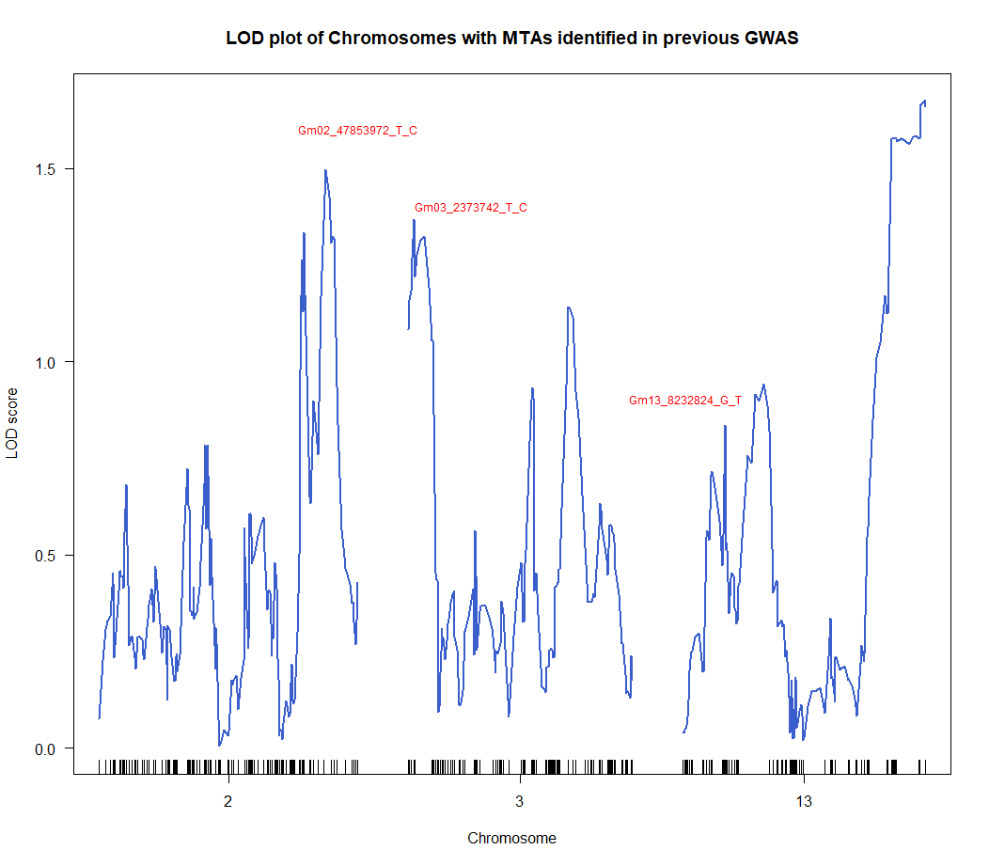
Supplementary Figure 1: LOD plots of the chromosomes on which PI 438500 was previously shown to carry resistance MTAs. The next closest markers to the MTAs that were included in the QTL analysis are highlighted above their corresponding LOD peaks.

