Background
This past year (2023) we replicated our study measuring timing, abundance, and economic impact of slugs, insects, and early-season pathogens across two planting dates (as early as possible and one month later) and two farms [CMREC (Beltsville, MD) and WyeREC (Queenstown, MD)]. We also assessed the impact of planting date on the control efficacy and economic benefits of adding a pyrethroid insecticide to the post-emergence herbicide application. The experimental design was replicated in two fields at each farm with three replicates of each treatment combination (date*pesticide) per field. In 2022, we found no significant differences in yield or seed quality between post-emergence herbicide alone and post-emergence herbicide mixed with Warrior II across both planting dates, but as weather and pest populations can vary greatly from year to year, we repeated this experiment in 2023 to make our conclusions about whether or not there is a pest control benefit more robust.

Experimental Design
Treatment Year Farm | Planted | Sprayed | Harvested
May 2022 BV, QT | May 2, Apr 29 | Jun 28, 30 | Oct 20, 19
June 2022 BV, QT | Jun 7, 1 | Jul 21, 22 | Oct 20, 19
May 2023 BV, QT | May 12, Apr 27 | Jul 4, 10 | Oct 19, 4
June 2023 BV, QT | Jun 12, May 31 | Jul 20, 25 | Oct 19, 4
Table 1. Dates of soybean planting, post-emergence treatment, and harvest at CMREC (Beltsville = BV) and WyeREC (Queenstown = QT).
For this experiment, we planted P38A54E full season, non irrigated soybeans at 15” row spacing for a population of 120-140,000 live seeds per acre using a planter or a drill, with 6-8 rows skipped to provide 30” rows to install traps (Figure 1). Plots were 45 ft wide by 60-79 ft long. We aimed to plant the earlier planting treatment (May) as soon as possible and the later planting treatment (June) 1 month later. We followed standard nutrient and chemical management practices for mid Atlantic no till, with burn down, pre-emergence, and post-emergence herbicide treatments. When we applied the post-emergence herbicide, we mixed in the highest labeled rate of Warrior II (1.92 fl oz/acre) for the insecticide+herbicide treated plots. This is the rate recommended for grasshoppers, stink bugs and spider mites, which were identified by MSB in 2021 as key pests of Maryland soybean. To evaluate the pest control benefits of the post-emergence Warrior II application, we focused our most intensive sampling efforts (sweep netting, defoliation assessments and visual counts of insects and damaged plants) on the dates immediately before spraying and about 2 weeks after spraying in both 2022 and 2023. This will allow us to compare the insecticide sprayed plots to the herbicide only plots to determine if there was an effect.

Sampling Methods
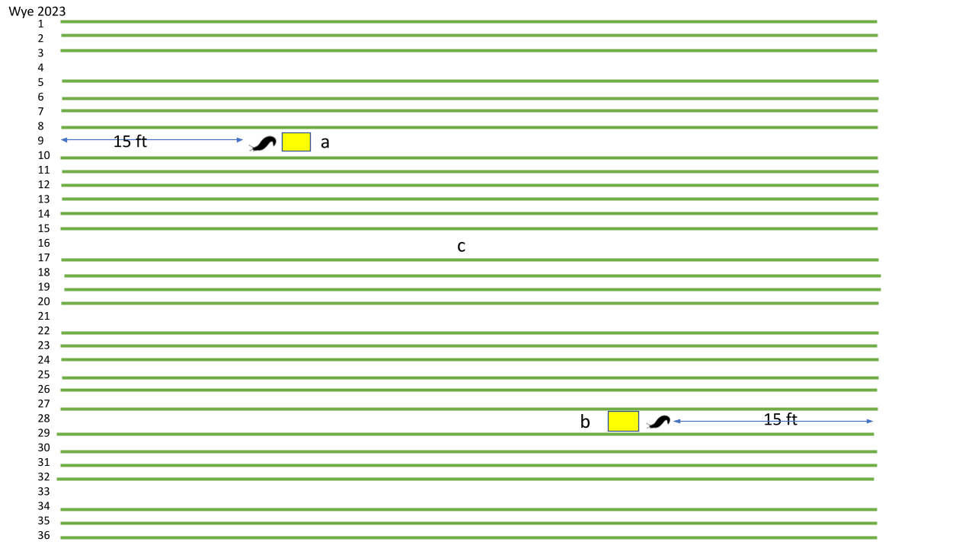
Figure 1. Sampling design showing within plot replication at Wye 2023. Slugs denote slug traps, yellow rectangle denotes sticky card traps, and locations a,c,b correspond to visual assessment, sweepnet, defoliation, and pod sampling.
As in 2022, we used multiple methods in 2023 to track pest presence and damage as well as measure the overall diversity and abundance of the invertebrate community. For the duration of the season, we checked moth traps for fall armyworm, western bean cutworm, and corn earworm weekly. For the first 11 weeks after planting, we monitored slug activity using 2 roof shingle traps (with a cup of soapy water underneath) per plot. From the early vegetative stages until canopy closure, we conducted 3 visual assessments of 6ft of row (both sides) and deployed 2 sticky cards in each plot to record insect activity/abundance. We also used sweep nets (10 sweeps of a single row in 3 locations) to sample (See Figure 1 for sampling locations.)
In addition to insect counts, in our visual assessments we also counted total stand, the number of plants with insect damage (damage incidence), and the number of plants with yellowing, wilting, necrosis, or any other obvious disease symptoms. Disease symptoms were photographed and leaf samples taken for analysis by a UMD plant pathologist. When plants were either located outside plot area or were not going to survive until harvest, they were dug up with the roots for better identification. We also quantified plant growth stage, height, and width (until canopy closure) as well as leaf defoliation. Leaf defoliation (in %) captures damage severity, and we sampled the unifoliate leaves when the plants are in VC-V2 and the top 2 trifoliates in later stages, using nondestructive estimation until V4. In 2022, we only estimated the area removed, but in 2023, we estimated both the area removed and the total area in order to be able to accurately calculate % defoliation in our early season nondestructive samples. After V4, we removed 5 representative damaged leaflets from different plants at each sampling site and analyzed leaf defoliation using the LeafByte app which measures total area and the amount removed. In late August, we destructively sampled 2 representative soybean plants per plot and counted the number of total and damaged pods. Prior to harvest we re-evaluated the stand and measured lodging. At harvest we repeated our 2022 measurements of Dectes stem borer (DSB) infestation (# of infested stems), seed damage (stink bug and pathogen), seed quality (% undamaged), and yield, to compare both planting dates and insecticide treatments in terms of economic benefit.

Data progress
Data analysis is ongoing. Sweepnets and sticky cards, after being collected in the field, were stored in plastic bags and frozen. All identification of 2022 and 2023 sweepnet samples was recently completed, and all data has been prepared for analysis. Preliminary 2022 results for defoliation, yield, and pod damage were presented at the 2023 Commodity Classic on 7/27/23, and a more summarized and final version of this data was presented at the 2023 Entomological Society of America National Meeting on 11/6/23. The 2023 yield measurements were completed the day of harvest, and the stems collected during harvest were analyzed for DSB in the days following. Seed quality and damage measurements were recently completed for 2023. We still have 912 sticky cards from 2022 and 792 sticky cards from 2023, corresponding to 11 weeks of measurement at CMREC and 12 weeks at WyeREC, and arthropod identifications for these have just begun.
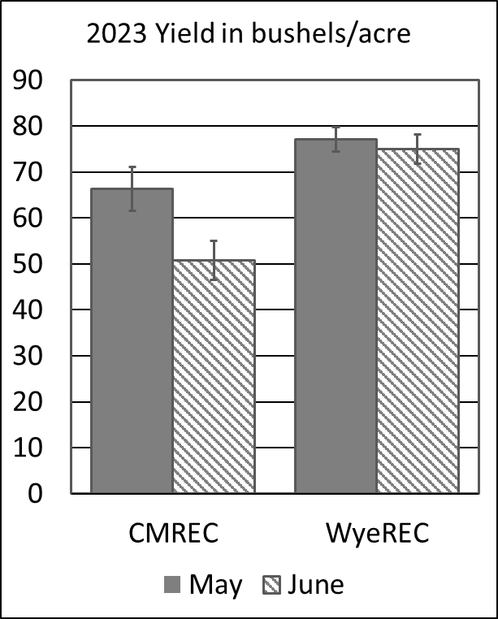
Figure 2. 2023 yield organized by farm and planting date with standard error bars.

Results/Summary
In 2022, we found no significant differences in yield as a result of planting date (F_{1,44} = 0.0737, p = 0.787) or treatment (F_{1,44} = 0.0142, p = 0.906), using a mixed linear effect model with farm included in the model as a random effect. In 2023, planting date had more of an impact on yield, particularly at one of the farms (CMREC, in Beltsville, MD), with the later plantings yielding lower. When analyzed with the mixed effect linear model, treating farm as a random effect, we did find a significant relationship between planting date and yield (F_{1,44} = 5.12, p = 0.0286), but no relationship with treatment (F_{1,44} = 0.245, p = 0.623).

In 2022, only planting date (F_{1,137} = 8.44, p = 0.00428) had an effect on mean leaf area defoliated over the measurement period. Insecticide treatment (F_{1,156} = 3.12, p = 0.0794) had no effect in a mixed linear model with farm as a random effect and date as a nested random effect. Mean leaf area defoliated was lower in the later planting, but defoliation treatment thresholds are around 15-20% for the reproductive stages and higher for the vegetative stages. The percent of leaf defoliation measured even during the reproductive stages did not exceed 12% and was usually lower, so there was not an economic level of defoliation.

In 2023, there was no difference between mean leaf area defoliated as a result of either planting date (F_{1,183} = 0.044, p = 0.947) or insecticide treatment (F_{1,178} = 0.0870, p = 0.768). A similar result was found for percent area defoliated when compared by planting date (F_{1,182} = 3.54, p = 0.0613) and insecticide treatment (F_{1,178} = 0.0365, p = 0.849). Mean percent of leaf defoliation measured (by date) did not exceed 15% once plants passed R1. Leaf defoliation greater than 15% was only found in June 12 plots at Beltsville in the VC-V1 stages.

Table 1. Mean ± SE end of season measurements by farm, planting, and treatment.
Farm | Date planted | Treatment | Leaf area defoliated (cm2) | % Leaf Defoliation | Yield (bu/ac) n=6
CMREC (BV) | May 12 | herbicide+Warrior II | 1.0±0.2(n=24) | 4.7±0.5(n=24) | 70.4±7.5
CMREC (BV) | May 12 | Herbicide only | 1.1±0.1(n=24) | 5.3±0.5(n=24) | 62.3±6.0
CMREC (BV) | Jun 12 | herbicide+Warrior II | 1.4±0.2(n=18) | 8.3±1.7(n=18) | 52.0±5.0
CMREC (BV) | Jun 12 | Herbicide only | 1.1±0.2(n=18) | 6.9±1.4(n=18) | 49.6±7.2
WyeREC (QT) | Apr 27 | herbicide+Warrior II | 1.1±0.1(n=30 | 6.0±0.6(n=30) | 78.4±4.4
WyeREC (QT) | Apr 27 | Herbicide only | 1.2±0.1(n=30) | 6.2±0.4(n=30) | 75.9±3.4
WyeREC (QT) | May 31 | herbicide+Warrior II | 1.2±0.1(n=24) | 4.3±0.3(n=24) | 72.3±4.4
WyeREC (QT) | May 31 | Herbicide only | 1.1±0.1(n=24) | 4.1±0.3(n=24) | 77.7±4.8

