Minnesota Soybean Research and Promotion Council

Annual Research Progress Report

Due November 1st

Audience: This information will be utilized to create a research reporting booklet that will be distributed to growers and crop consultants. This is a great opportunity to communi- cate your research directly to growers. Please keep your producer audience in mind when submitting your report. Reports will be printed in COLOR – please include color figures and photos to help explain your results to growers!

Project Title: Screening Soybean varieties to identify genetic resources of resistance against white mold

Principal Investigator(s):
Name - Ashish Ranjan
Institution -Department of Plant Pathology
University of Minnesota - Twin Cities
email address – aranjan@umn.edu
C0-PI(s):
Name - Aaron J. Lorenz
Institution - Department of Agronomy and Plant Genetics
University of Minnesota - Twin Cities
email address – lore0149@umn.edu

Name - Seth L. Naeve
Institution - Department of Agronomy and Plant Genetics
University of Minnesota - Twin Cities

Project Period: 2023-2024
Research Question/Objectives:
The primary objective of the proposal is to screen the soybean varieties for white mold disease resistance/susceptibility in the naturally infested field and controlled environment, greenhouse/growth chamber.
Objective 1. White mold disease screening on the soybean varieties produced through the UMN soybean breeding program and commercial varieties in the naturally infested field and controlled environment, greenhouse/growth chamber.

Objective 2. Evaluate the yield impact of white mold in treated and non-treated soybean varieties and quantify their yield potential under standard farm management practices.

Results:
1. Screening soybean varieties in growth chamber experiments.
S. sclerotiorum (a fungal pathogen that causes white mold on soybean) isolates from different regions can have a range of aggressiveness, causing a wide range of severity for different soybean genotypes. We initially performed an aggressiveness check for six isolates of S. sclerotiorum collected from different regions of Minnesota to represent different geographical distributions, including Johnson’s farm (used for field study) S. sclerotiorum isolate (Faribault). Therefore, we planned to check the aggressiveness of the isolate to already established three different check lines (William 82 and Bert, susceptible check line and Noir, highly tolerant check line) in our lab and compared them to highly virulent Ss Sibley, SsWT1980 (standard lab isolate) and Ss Faribault. We concluded that the Faribault strain is highly virulent (Figure 1).
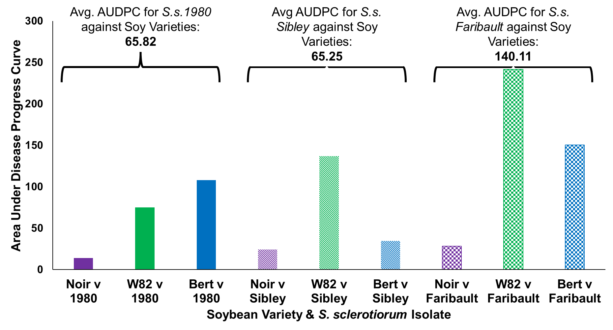
Figure 1. Area under disease progress curve in highly susceptible (William 82 and BERT), and highly resistant soybeans lines (Noir) following challenge with three different isolates of S. sclerotiorum (1980, Sibley and Faribault) 10 days post-inoculation (dpi).
Fifty soybean variety seeds were selected from the UMN breeding program and a few commercial varieties (provided by Dr. Lorenz and Dr. Seth) for screening for white mold under a controlled environment (plant growth chamber) condition. We have completed three biological replicates of screening more than 900 soybean plants. Data were analyzed using analysis of variance (ANOVA). ANOVA analysis indicated that the soybean varieties (genetic background) are significant predictors of sclerotinia stem rot (P = 4.32e⁻⁷). The study has led to the identification of a few highly resistant varieties (Figure 2).
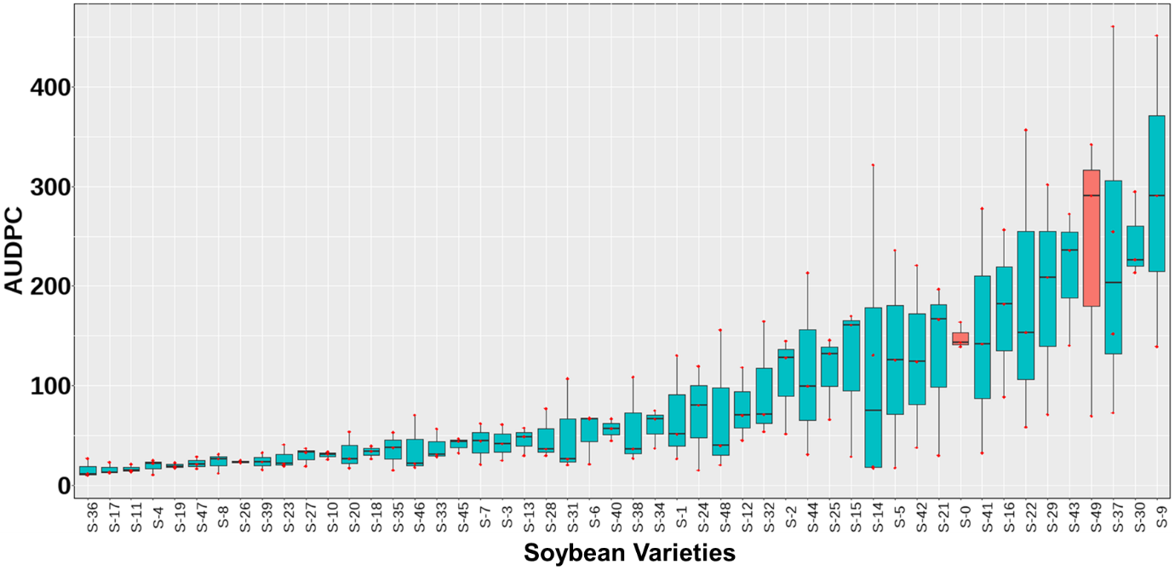 Figure 2. Area under disease progress curve (AUDPC) from growth chamber soybean screening result. The results are shown for 50 soybean varieties of the three biological replicates. Averages are calculated from 6 plants per variety per biological replicate, and error bars represent the Standard error (SE) n=18. Highly susceptible known soybean check lines "Bert (S0)" and "Sturdy (49)" are shown in red. ANOVA (P= 4.32e⁻⁷) indicated that the soybean varieties (genetic background) are significant predictors of sclerotinia stem rot.

2. Screening soybean varieties in naturally-infested white mold field.
For the field resistance study of 48 soybean varieties (also used in the controlled environment study), plots were designed in a randomized complete block design with four replications in Wlls, Faribault County, MN.
Soybeans were planted by Dr. Seth's group on May 23rd 2023 using a custom plot planter with four-row plots. We counted the germinated seeds and stalked the plots on June 15th. We also performed the first round of manual weeding. Soybean germination of some plots was affected due to poor rain, but later in the season, many of them recovered. We visited the farm for the second time on July 14th to stage the plant growth; they were in the R1-R2 stages of growth (Figure 3A). In our visits on August 8th and August 23rd, we scouted for S. Sclerotiorum apothecia (the fruiting body that produces ascospore) formation and disease incidences. We could see only a few apothecia (Figure 3B) but no significant disease incidences on the farm. 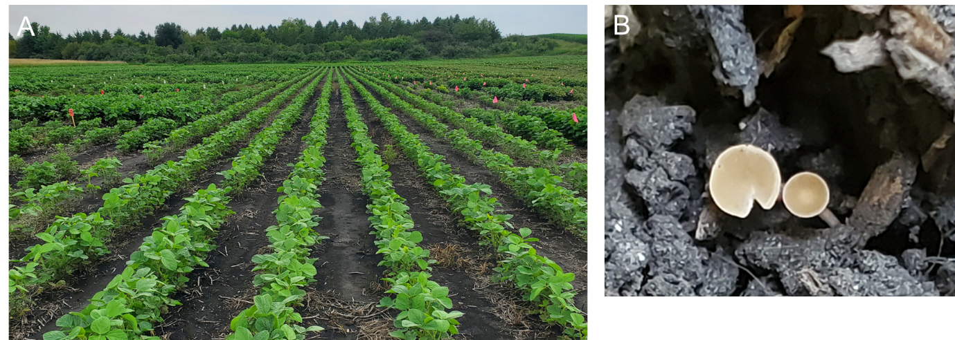

Figure 3. Soybean planting for sclerotinia stem rot disease screening (A, July 14th 2023) and visible S. Sclerotiorum apothecia in the field (B, August 23rd 2023).
This was followed by August 29th, 12th September scouting for disease incidence but did not see any significant disease incidence in soybean. It seems dry weather impacted disease development and progression. The soil was very dry and broken because of prolonged drought (Figure 4 A and B). Overall, disease pressure in the field was impacted due to long dry weather, and the field study did not replicate as we seen in the 2022 trial.
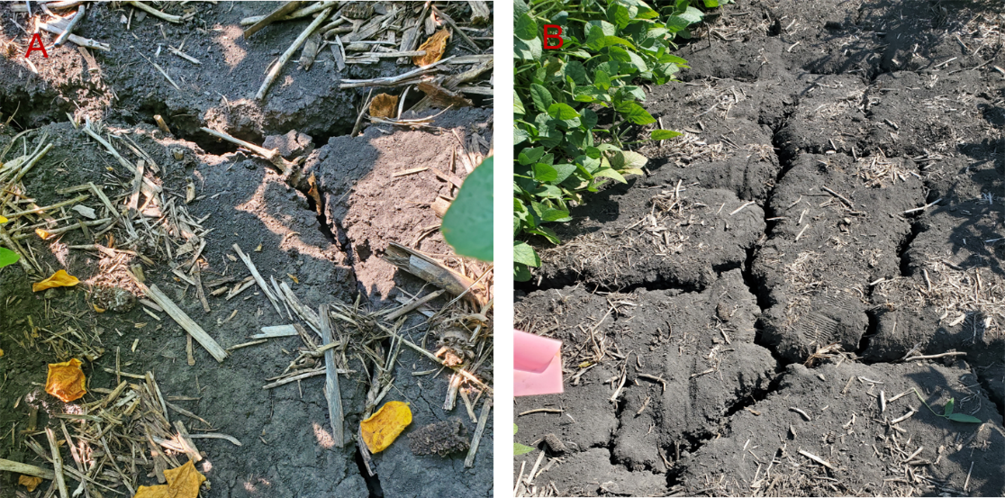
Figure 4 . Cracked ground. 29th August (A) and 12th September (B)

3. Soybean yield estimation in the naturally infested white mold field.
The plots for yield estimation were harvested on 20th October by Dr. Seth's group. Yield data from the field trial has been estimated. We know that yield is highly affected by the environment and its interaction with genotype. However, as we did not see disease pressure this year, this year’s data will not be very useful for understanding yield impact due to white mold.

Application/Use:
A simultaneous evaluation of soybean varieties in a controlled environment and a field study can give us a comprehensive understanding of their differential responses to white mold disease. Even though we lost our field screening data this year, we could use growth chamber study data to identify the resistant lines for further study. The identified white mold-resistant and higher-yield cultivars can become important genetic resources for future breeding program decisions and local growers' use.

Materials and Methods:
- White mold disease screening of the soybean varieties in growth chamber –
Plants were grown under a 16-h/8h day/night photoperiod with a temperature range of 21°C at night while 24°C during the daytime hours. The soybean genotypes were arranged in a randomized complete block design with three independent biological replicates of six plants each. Plants were grown in commercially available germination and growth mix Berger2, watered on alternate days, and fertilized once every two weeks. Sclerotia of S. sclerotiorum isolate were retrieved from storage and surface disinfested for 40 s in 95% ethanol, followed by 40 s in a 10% bleach solution (approximately 0.06% sodium hypochlorite solution) and dried on sterile filter paper. The sclerotia were plated onto a Petri dishes containing potato dextrose agar (PDA) culture media to initiate hyphal growth. The 5-mm plugs were subcultured from the actively growing edge of the culture and transferred to PDA (100 × 25 mm Petri plates). At the V5 growth stage, plants were challenged with S. sclerotiorum isolates using the cut petiole inoculation method (Ranjan et al., 2019). A total of 50 lines were screened against a highly aggressive S. sclerotiorum isolate isolated from Johnson's farm S. sclerotiorum isolate (Faribault). Disease progression following S. sclerotiorum inoculation was measured as lesion length using vernier caliper.

- Field resistance screening of soybean lines and yield estimation –
Plots were arranged in a randomized complete block design with four replications at a farmer cooperator's field at wells, Faribault county, MN, to determine field resistance to white mold and yield estimation. This field has a history of frequent white mold infections. In the first year of the study, we saw good white mold disease pressure. Plots were planted using a custom plot planter, with four-row plots 12 feet in length and rows spaced 30 inches apart. The white mold disease ratings were collected between the R4 and R6 growth stages. The disease incidence (DI) is assessed by taking three separate 1-yard (3 feet) sections within the inner two center rows of the plot by counting the cumulative number of diseased plants. The disease incidence is calculated by dividing the total number of infected plants by the number of plants. Disease severity (DS) rating measured by taking five separate one-foot-long sections of the inner rows of a plot and determining the highest severity within each length. Severity ratings will be scored in a scale of 0 to 3 (0 = no disease present, 1 = infection present on the lateral branch, 2 = infection present on the main stem but the lesion was not girdling, 3 = infection present on the main stem and the lesion was fully girdling) (as shown in figure 4). DS is calculated by taking the sum of all severity scores and dividing by the number of one-foot sections (=3) where the disease is present. The disease severity index (DIX) is calculated by dividing the DS by three and multiplying by the DI (DIX = DS/3 x DI) (Allen, T. W., et al. 2017, Webster, R.W et al., 2021). For yield estimation of soybean varieties under standard agricultural practice at the contractor plot, we planted another field nearby with 200 plots. Plots were harvested with an Almaco small-plot soybean combine for all the soybean varieties.

Economic Benefit to a Typical 500 Acre Soybean Enterprise:
White mold can lead to significant economic losses. Yield loss to the tune of 60% has been reported due to white mold. Yield losses are impacted by soybean variety, climate and pathogenic isolates. It has been reported that every 10% increase in disease can impact 2-5 bushel per acre. A recent study reported that for every 10 percent increase in DIX after 65 percent, there was a corresponding soybean yield loss of approximately 10 bushels per acre (Willbur, J. F. et al., 2019). Considering the recent report (Willbur, J. F. et al., 2019), the loss of 5,000 bushels in 500-acre soybean field is possible under a highly disease conducive environment. White mold also impacts the quality of seeds.

Recommended Future Research:
We have good data from our controlled environment study. We have completed our first year of the field screening study in 2022. This year, we could not get significant data from field studies due to non-conducive weather conditions. Continuation of our experiments for the following years (especially the field screening study) will increase our sample size and give a comprehensive understanding and conclusive results. These lines can be used as breeding lines to develop high-yielding white mold-resistant varieties. The panel of soybean varieties can also be used to identify genes and biological processes. These genes can be manipulated using gene editing tools like CRISPR/Cas9 for introgression in elite varieties.

References:

- Allen, T. W., et al. 2017. Soybean yield loss estimates due to diseases in the United States and Ontario, Canada from 2010 to 2014. Plant Health Progress 17:211-222.
- Ranjan, A., N. M. Westrick, S. Jain, J. S. Piotrowski, M. Ranjan, R. Kessens, L. Stiegman, C. R.Grau, S. P. Conley, D. L. Smith, and M. Kabbage. 2019. Resistance against S. sclerotiorum in soybean involves reprogramming of the phenylpropanoid pathway and up-regulation of antifungal activity targeting ergosterol biosynthesis. Plant Biotechnol. J. 17:1567-1581.1.
- Webster, R.W., Roth, M.G., Reed, H., Mueller, B., Groves, C.L., McCaghey, M., Chilvers, M.I.,Mueller, D.S., Kabbage, M., and Smith, D.L. 2021. Identification of soybean (Glycine max) check lines for evaluating genetic resistance to Sclerotinia stem rot. Plant Dis. 105, 2189-2195.
- McCaghey, M., Willbur, J., Ranjan, A., Grau, C.R., Chapman, S., Diers, B., Groves, C., Kabbage,M., & Smith, D.L. 2017. Development and evaluation of Glycine max germplasm lines with quantitative resistance to Sclerotinia sclerotiorum.
- Willbur, J. F., Mitchell, P. D., Fall, M. L., Byrne, A. M., Chapman, S. A., Floyd, C. M., Bradley, C. A., Ames, K. A., Chilvers, M. I., Kleczewski, N. M., Malvick, D. K., Mueller, B. D., Mueller, D. S., Kabbage, M., Conley, S. P., and Smith, D. L. 2019. Meta-analytic and economic approaches for evaluation of pesticide impact on Sclerotinia stem rot control and soybean yield in the North Central U.S. Phytopathology.

Publications:
- Nick Talmo, Kay Lerohl, Grace Petzold, Grace M. Anderson, Aaron Lorenz,
Seth Naeve, Ashish Ranjan, Screening soybean varieties for the genetic resource of resistance to white mold. 2023, AMER PHYTOPATHOLOGICAL SOC (APS) Plant Health 2023 (poster presentation), Denver, Colarado.

