Minnesota Soybean Research and Promotion Council

Annual Research Progress Report

Due November 1st

Audience: This information will be utilized to create a research reporting booklet that will be distributed to growers and crop consultants. This is a great opportunity to communi- cate your research directly to growers. Please keep your producer audience in mind when submitting your report. Reports will be printed in COLOR – please include color figures and photos to help explain your results to growers!

Project Title: Cold hardiness of soybean gall midge: Foundations for pest forecasting and cultural control

Principal Investigator(s): Robert Koch

Project Period: Aug. 1 to Oct. 31, 2023
Research Question/Objectives: Characterize the cold hardiness of soybean gall midge and incorporate this knowledge into management programs

Results: Last year, we found that soybean gall midge acclimated to winter conditions froze at -8 to -11 degrees F, and that mortality of soybean gall midge increased greatly as temperatures decreased to this freezing point and colder. This year, fields in southwest MN with adequate infestations were identified for the research goals proposed here. Methods were refined to produce cocoons throughout the growing season. Preliminary observations suggest that they develop to pupae in the cocoons early in the season, whereas later in the season they remain as third instars within the cocoons, which matches field observations for the overwintering stage of this insect. In addition, to measure the cold hardiness of soybean gall midge, methods were refined based on results from last year, collections were performed and insects are being acclimated in the laboratory.

Application/Use: This project will provide an understanding of the ability of this pest to survive cold temperatures (i.e., cold hardiness), which will enable us to provide research-based forecasting to inform farmers about their risk for this pest. More specifically, we will clarify which regions of Minnesota are at more or less risk for infestation by soybean gall midge. In addition, we will provide forecasts about the impact of winter on the coming year’s pest infestation.

Materials and Methods: Laboratory methods developed from the previous year’s project were used to obtain the overwintering stage of soybean gall midge (i.e., third instar larvae inside of cocoons). Briefly, at the end of the growing season, infested soybean stems were collected and carefully dissected. The larvae of soybean gall midge were transferred to small plastic vials containing finely sifted and lightly moistened sand (Figure 1). These vials were held in a growth chamber at a combination of temperature and day length that we identified to produce the overwintering stage. Upon development of the overwintering stage, the supercooling point (temperature at which they freeze) and lethal temperature (temperature at which they die after short-term exposure) was measured for a subset of this population (Figure 2). The remaining individuals were transferred to a chamber at 3 degrees C with a short day length and will be maintained at these conditions for 1 or 2 months. After those durations, the supercooling point and lethal temperature will be measured again (Figure 2). The above mentioned experiment is a replication of what was done last year. A new experiment is being added this year, in which we will measure how the duration of time at cold temperatures affects survival of the soybean gall midge. Freezers are also being established that will be use to hold the overwintering stage of soybean gall midge at different cold temperatures for up to several months. Subsets of individuals will be removed from the freezers at regular intervals to assess their survival. Overall, the results will be analyzed to compare if these measures of cold hardiness change after exposure to the simulated winter conditions and if measurements after exposure to the two different conditions differ from one another.

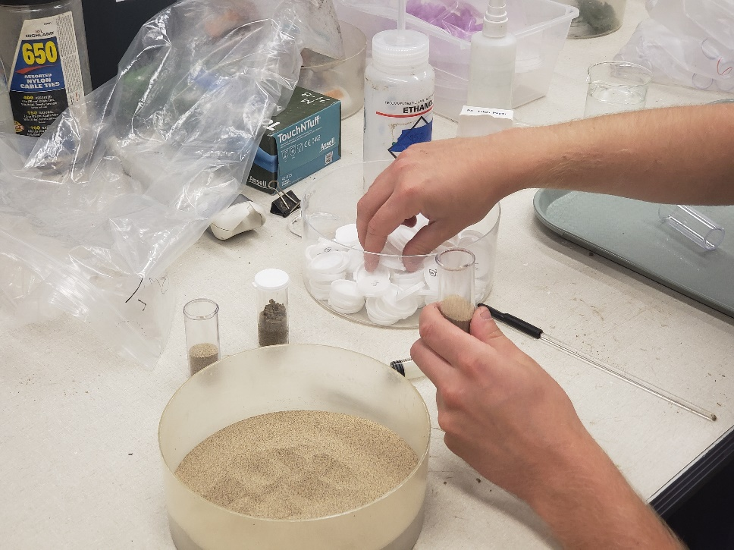
Fig. 1: Methods for getting field-collected larvae to form cocoons

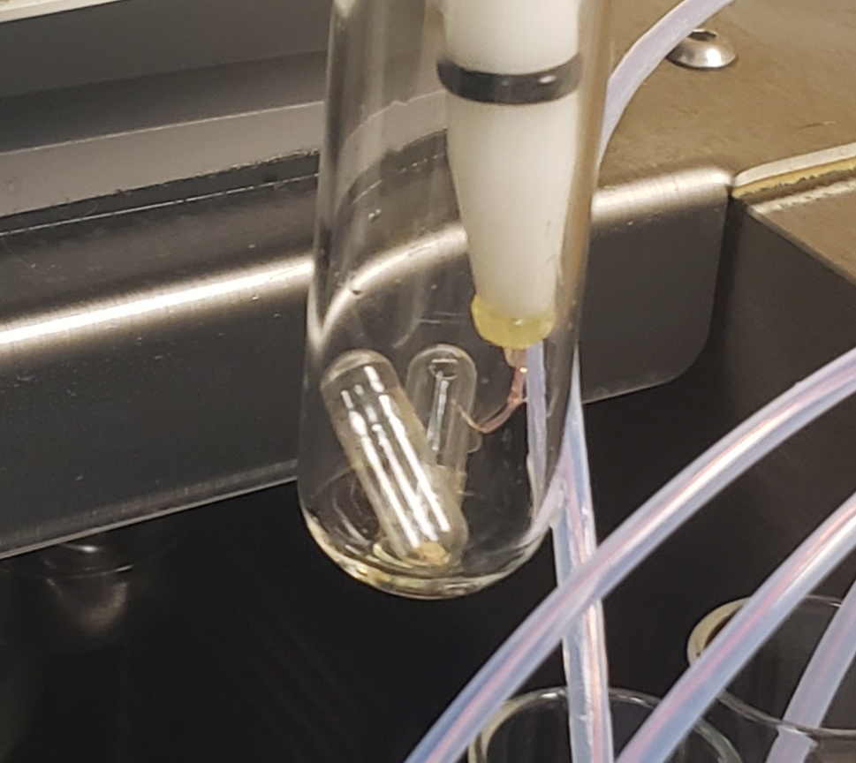
Fig. 2: Thermocouple wire recording temperature of two gel capsules containing SGM cocoons

Economic Benefit to a Typical 500 Acre Soybean Enterprise: This information will be important for helping farmers determine if and what actions to take against soybean gall midge. Furthermore, but understanding how cold affects the survival of this insect, recommendations for cultural control (e.g., tillage or residue management) could be developed to increase winter mortality of the pest.

Related Research: Additional research is underway to evaluate biological control for soybean gall midge.

Recommended Future Research: Future research could examine the survival of this insect exposed to cold temperature under field conditions.

References:

Publications:

