Project Title- Integrated agricultural systems to promote soil health and environmental resilience
This is the third year of research at the LAiYERS (Land mAnagement for improved Yield, Environmental Resilience, and Sustainability) plots, evaluating the impact of poultry manure and cover crop impacts on water quality, soil health, and crop yield. The plots were established in 2021(fig. 1), with subsurface tiles and drainage sampling wells installed in spring, and soybeans planted (date) after installation was complete. The first treatments were initiated in the fall of 2021 with cover crops planted to the designated plots (Systems 1, 3, 4, 6, 8) and the early winter and balanced poultry manure treatments applied (Systems 4, 5, 8, 9). The spring fertilizer and poultry manure treatments were applied in 2022 for the corn year of the rotation.
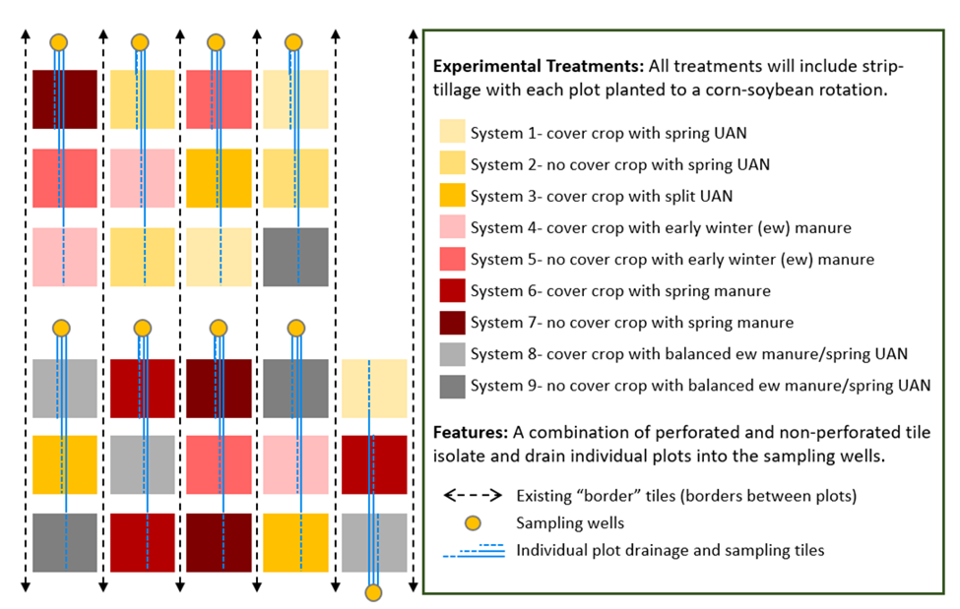
Figure 1. LAiYERS site experimental design. Each system- treatment is assigned to the 27 quarter-acre plots in triplicate. The N-management treatment is applied in the early winter or spring for the upcoming corn year.

An overview timeline (fig. 2) highlights field activities, including planting, harvest, and cover crop termination dates from 2021 through soybean harvest 2023. Additional field work in 2023 will include the early winter manure application for the 2024 corn year, scheduled to be applied on November 15th.

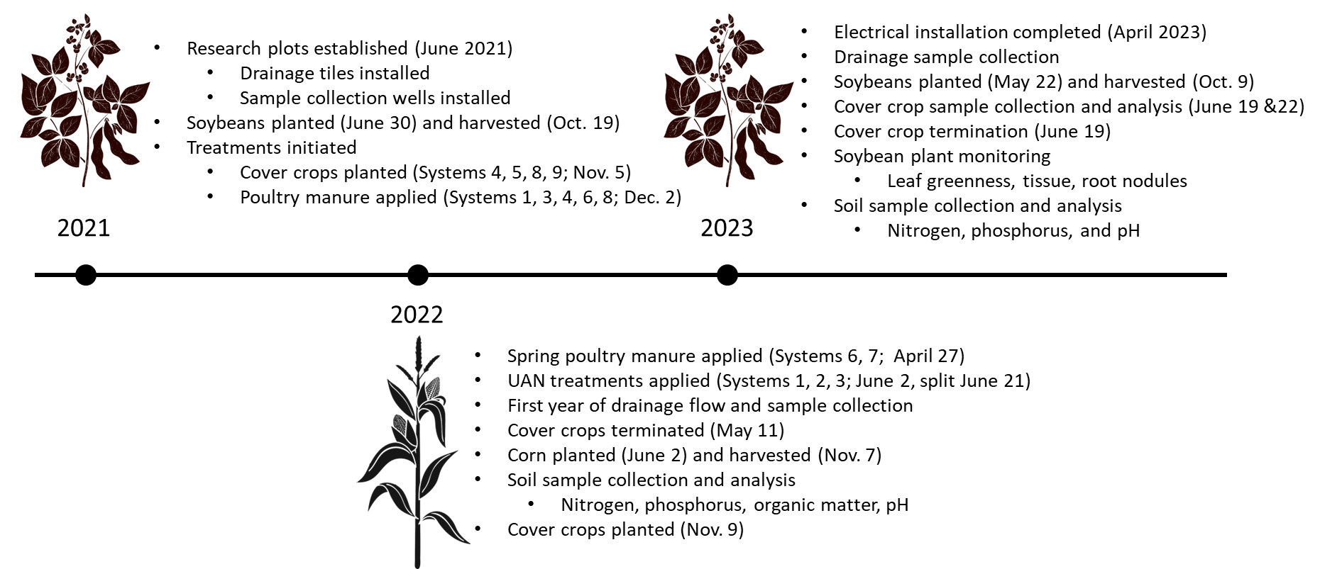

Figure 2. LAiYERS project timeline. The crop rotation includes soybeans in odd numbered years, corn in even numbered years, and cereal rye as a cover crop at designated plots in all years. Fall strip tillage will be used each year to increase spring field drying and accessibility and partially incorporate manure during application years.

Early analysis shows differences between treatments.
Differences in drainage water NOx-N concentrations were observed by treatment in 2023. The lowest measured concentrations were with the spring poultry manure treated plots, followed by the early winter and balanced manure plots. The highest concentrations were measured at the UAN plots, although these differences may not be statistically significant. All plots last received fertilizer treatment for the 2022 corn year (early winter 2021 or spring 2022). Data will be statistically analyzed and detailed in the final report.
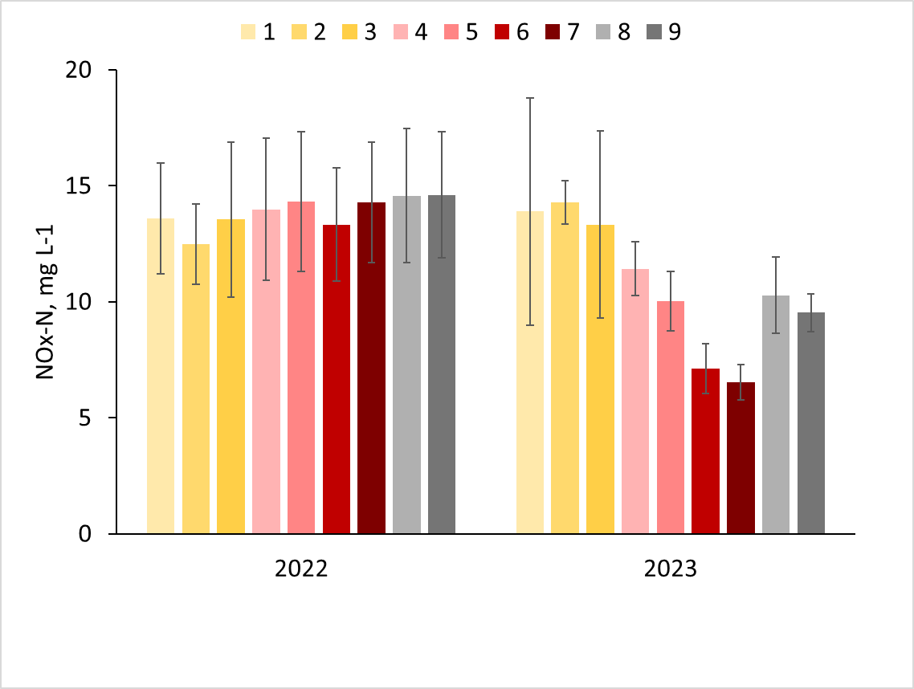
Soybean Year
no N-fertilizer applied
Corn Year
N-fertilizer applied
Figure 3. Average tile drainage water NOx-N concentrations by treatment with standard deviation error bars.
Soybeans were harvested on October 9th. Preliminary analysis (table 1) suggests a negative impact on crop yields with cover crops. The 2023 cover crop was terminated late (June 19) as part of an experimental design to evaluate the impact of cereal rye on weed suppression. While there was a measurable decrease in weed coverage with cover crops, a better balance in termination timing to achieve optimal yields is necessary.
Table 1. Preliminary 2023 soybean yields (median). Due to high variability within treatments, differences may not be significant.

Progress Toward Project Metrics
KPI #1: Data on yield, soil and water quality. Measured annually by collection of environmental datasets.
Environmental sample collection was completed throughout the 2023 season. Soybean plant samples, including leaf greenness and root nodules, were collected at various growth stages (V2, V5, R1) and cover crop samples were collected for biomass and tissue analysis at termination. Soil samples were collected with the soybean roots to a depth of 5-7” for nutrient analysis. Subsurface tile drainage water samples will be collected throughout the 2023 drainage season. The soybeans were planted on (date) and harvested on (date).
KPI #2: Improved understanding of manure integrated cropping systems and their impact on soybean yield and soil and water quality.
We have completed the third year of research and data collection at the LAiYERS plots. We continue to analyze the data to evaluate the treatment impacts on water quality, soil nutrient changes, and crop growth. The drainage data includes a year with fertilizer application (corn year; 2022) and no fertilizer application (soybean year; 2023), with distinct differences by treatment for each. Preliminary results suggest late termination of cover crops negatively impacted soybean yields.
This summer we were able to expand our outreach with the project to include a visiting elementary school teacher who was participating in the Research Experience for Teachers (RET) program at Iowa State University. With assistance, she evaluated and presented a poster highlighting the early results comparing the impact of cover crops on weed canopy, soybean plant greenness, and soybean root nodules. This data will be further evaluated to identify any system treatment effects on these characteristics.
Additional sample processing and data analysis will be completed over the next few months and included in the final report.

