Progress report 1 – November 30, 2022 MSRPC Project: 10-15-44-22014
Minnesota SCN Squad: 2022 Minnesota Soybean Cyst Nematode Sampling and Education Program
Principal Investigator (PI): Angie Peltier, apeltier@umn.edu, O: (218) 281-8692, C: (414) 704-1931
Co-PI(s): Anthony Hanson, UMN Extension and Seth Naeve, UMN Extension/Dept. of Agronomy and Plant Genetics
Cooperator: Phyllis Bongard, UMN Extension, bonga028@umn.edu,
UMN Extension Youth Development cooperators: Brian Mc Neill, Margo Bowerman, Alysa Tulabaski, Becca Turnquist

Project Summary: Results of a prior Minnesota Soybean Research & Promotion Council-sponsored SCN sampling program administered by UMN Extension was disappointing. In 2018-2019, only 363 samples were returned for analysis after more than 5,000 sample bags were distributed to more than 1800 soybean producers, limiting the ability of UMN Extension and MSRPC members to get a ‘30,000 ft view’ of sample results that might drive both further sampling efforts and changes to soybean production practices to more actively manage SCN populations. The Team Soybean! project was designed to excite the next generation of soybean producers, agronomists and ag service providers and provide them with practical, hands-on experience in how best to detect and monitor SCN and end up getting a better ’30,000 ft view’.
Project Objectives:
- Minnesota SCN Squad: 2022 Minnesota Soybean Cyst Nematode Sampling and Education Program
  - Provide an educational curriculum to Minnesota ag teachers/FFA club advisors to increase students’ general knowledge about soybeans, their importance to the rural Minnesota economy and SCN, the most yield-limiting pathogen of Minnesota soybeans.
The first of three annotated PowerPoint presentations designed for FFA advisors to use in their classrooms has been completed and distributed (Figure 1). This presentation focuses on the contribution of soybean to Minnesota’s economy, the threat to Minnesota soybean yield posed by SCN, how the Team Soybean! program works and how to collect a soil sample for SCN in either fields that one knows is already infested or where SCN status is not known.
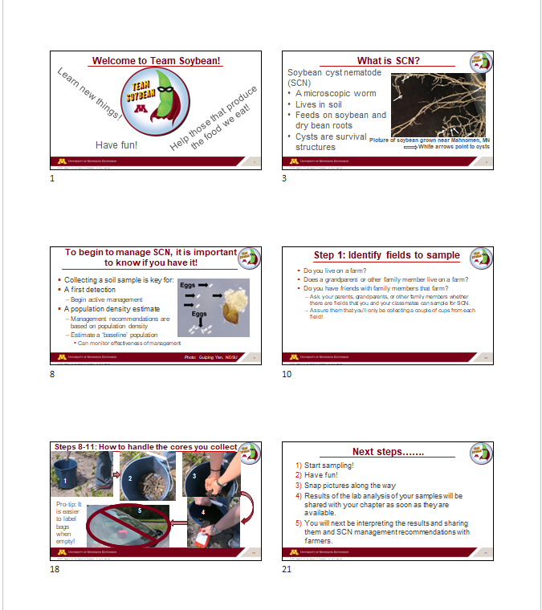
Figure 1. A sample of the slides designed for the Team Soybean! introductory PowerPoint presentation.
As SCN samples get shipped to and analyzed in the lab, another annotated PowerPoint presentation geared toward helping students interpret SCN egg count data, and how best to provide these data and egg count-based management recommendations to farmers that volunteered fields to sample is in progress. Lastly, another annotated PowerPoint presentation will be for those chapters and students that would like to “take it further” and will focus on graphically summarizing overall chapter results and providing farmers with information about regionally-adapted soybean varieties expressing a source of SCN resistance different from the most widely used PI88788.
  - Provide MSRPC-branded SCN sampling kits to FFA chapters so that they can collect soil samples for analysis from real-world farm fields, be they fields their own family or fields that local area producers farm. This sort of hands-on learning tends to create memorable ‘teachable moments’ for learners.
Items that make up the contents of an SCN sample kit were purchased and used to assemble individual sample kits for delivery to participating FFA chapters, including: bright, yellow 2 gallon buckets with lids, soil probes “branded” with a MSRPC sticker, chapter-specific sample bag labels, soil sample bags, fine and ultra-fine point Sharpies for labeling, work gloves, laminated sampling instructions (Figure 2), shipping box and pre-paid shipping label (Figure 3).
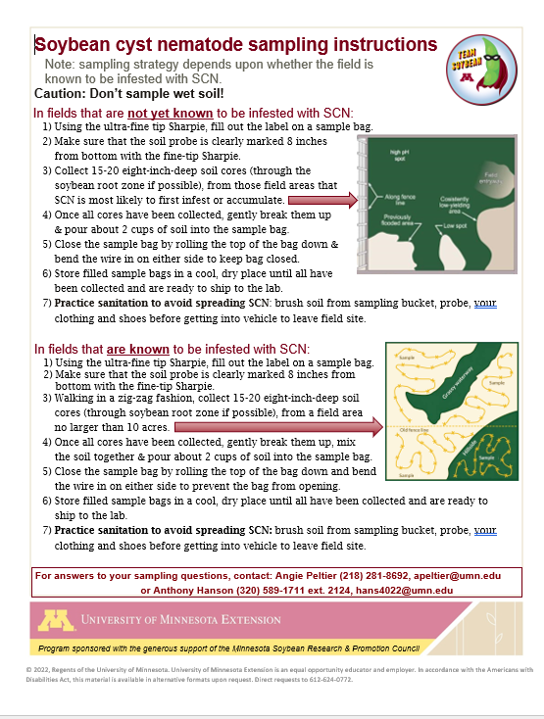
Figure 2. What the laminated soil sampling instructions look like. Note the credit to MSRPC included in the yellow banner across the bottom of the instructions.
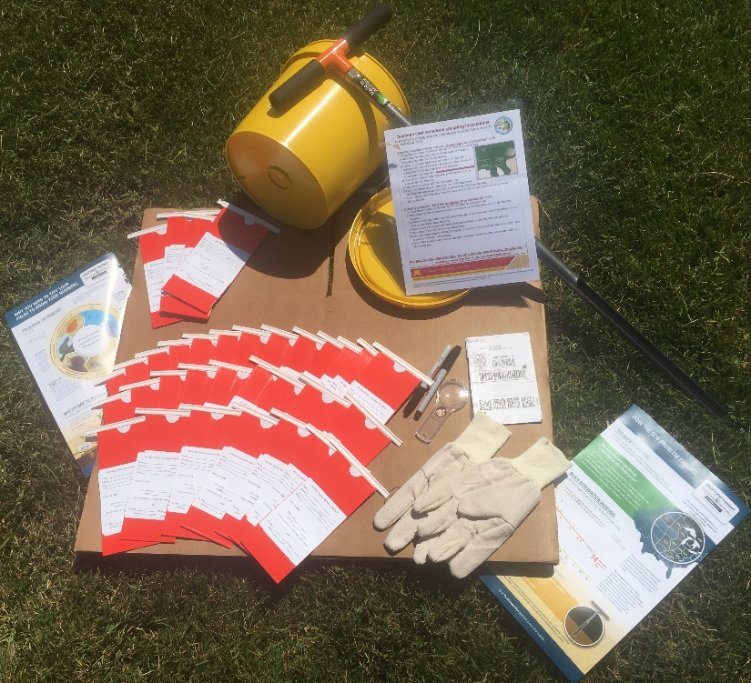
Figure 3. Contents of MSRPC-sponsored Team Soybean! sampling kit, including a soil probe with a MSRPC sticker affixed.
  - Provide results from SCN samples collected by FFA chapters so that students can discuss and map the results of their own survey, ‘learning by doing’ about the importance of gathering real-world data to assist soybean producers’ decision making.
  - Provide data sheets and management recommendations that students will share with the farmers whose fields they sampled. This is a way to introduce students to one of the tasks of ag service providers and Extension agents.
  - Get a ‘30,000 ft’ picture of the prevalence and severity of SCN infestations in areas of MN where SCN survey data has been sparse and underrepresented.
  - Survey participating FFA instructors, FFA students and farmers to evaluate program effectiveness for increasing knowledge about SCN and SCN management and increasing the desire to periodically monitor SCN population densities.
Multiple efforts have been made to recruit FFA chapters by sending email and U.S. mail communications targeted toward both key high school principals and FFA advisors/ag teachers. Initial outreach began with an email sent just prior to the state FFA convention this April. Additional communications through email, U.S. mail and through the ag press have continued. It is our expectation that many of these communications that took place over the summer will not yet have been received by FFA advisors if they did not check their physical or virtual mailboxes.
Four FFA chapters have agreed to be a part of Team Soybean! from Minnesota FFA region 1 (northwest MN), four from region 2 and seven from region 3 with another tentatively agreeing to join (Table 1).
Table 1. FFA chapters that have agreed to be a part of Team Soybean! Note: bolded chapters have shipped their samples to the lab as of November 30, 2023
FFA Region | FFA Chapter | County
1 | Climax-Shelly | Polk-Norman
1 | Fosston | Polk
1 | Frazee-Vergas | Becker
1 | Hawley | Clay
1 | Ulen-Hitterdal | Clay
2 | Aitkin | Aitkin
2 | Bertha-Hewitt | Todd
2 | Pierz-Healy | Morrison
2 | Sebeka | Wadena
3 | Battle Lake | Otter Tail
3 | Brandon-Evansville | Douglas
3 | Herman-Norcross | Grant
3 | Minnewaska-Glenwood Area | Pope
3 | Osakis | Douglas-Todd
3 | Paynesville | Stearns
3 | West Central Area | Grant
3 | Wheaton | Traverse
5 | Litchfield | Meeker
8 | Chatfield | Fillmore/Olmstead
A flier advertising this project was distributed via email to members of county Soybean and Corn Growers Associations in at least 25 Minnesota counties with the thought that soybean producers’ support might spark additional chapters to join Team Soybean!. For the same reason, a press release was also distributed to these same 25 counties to be published by local newspapers. A nice feature article by Paula Mohr about this program was published in The Farmer by Paula Mohr. This article was distributed to their massive mailing list at least twice and was picked up for feature on the Minnesota Soybean Grower’s Minneline digital newsletter.
Lastly, several radio interviews have also highlighted this program:
- July 14. KQLX. Fargo.
- July 28. KTRF. Thief River Falls.
- July 28. KROX. Crookston.

