South Dakota Soybean Research and Promotion Council October 28, 2022 (Q 2)
Prepared by David Clay
Achieving 100 Bu/A soybean yields: on-farm research and sharing high yield protocols with South Dakota soybean producers
Principal investigators: David Clay, 688-5081, david.clay@sdstate.edu, Agronomy, Horticulture, and Plant Science Department, SDSU, Brookings SD; Sharon Clay, Sharon.clay@sdstate.edu, Connie Strunk, connie.strunk@sdstate.edu; and Anthony Bly, Anthony.bly@sdstate.edu;
Advisory board: David Iverson, David Wright, Craig Converse, Gordon Andersen, and Kyle Gustafson (Winfield Solutions)
On-farm studies provide information that producers use to reduce the economic risks associated with new products, test the efficiency of components within their current operation, and test innovative new ideas and concepts. In the project, a producer chooses his/her treatments based on their interest or desire prior to implementation. SDSU agronomists assist in experimental design, treatment application, scouting, and analysis. At the completion of the project, reports are distributed to the farmer collaborator, and they are posted SD Soybean Research and Promotion on-farm web site. Farmers use results from the study to identify treatments that might be success on their farm and reduce the economic risks associated with new products. To date, over 450 experiments have been conducted by SD farmers. SDSU undergraduate students are using the on-farm studies for their capstone class and planning for SOY100 2022 is completed. We just received word that the American Ethanol Coalition and SDSU were funded in a UDSA-RCPP project focused on soil health. This project is centered around Madison, and it will provide funding for the adoption and quantification of BMP on soil health. We are in the process of identifying collaborators for this this on-farm study. This new project will help expand our on-farm research on soybeans and soil health.

- Continue the on-farm research program in 2021;
  - On farm studies
  - Create a remote sensing yield model
- Continue research designed to determine the importance of soil health in optimizing soybean
- Deliver information to producers through Soy100, AgOutlook, SD on-farm web-site, news releases, radio interviews, and SDSU websites.
- Use data collected in the on-farm SDSU classes (PS475 and PS428)

This year’s research work involves two activities that include continuing the on-farm studies and creating a remote sensing based yield model.
- Soybean On-farm Trials conducted in 2022:
Overall, we had over 79 total trials considering different yield zones throughout the state. This year trails were conducted at 18 different counties. Total enrollment was 30 growers including 15 new enrollments. On-farm research consist of varieties of experiment including seeding rate, varieties, Vitazyme, biologicals, fungicide et. This year’s experiments are mostly dominated with vitazyme, biological, seeding rate and soil health and UAV data was collected at different growth phase of the crop. More detail about the experiment is provided below in the table and figure.
Table. Total list of the trail in 2022. Yellow color highlighted are new farmers enrolled in 2022.
Farmer | County | Treatment | # of Trials | UAV
Minor, Lance | Aurora | Vitazyme in-furrow | 2 | √
Minor, Lance | Aurora | GoldStart in-furrow | 2 | √
Minor, Lance | Aurora | Seeding rate reduced by 30k | 2 | √
Minor, Lance | Aurora | Seeding rate increased by 30k | 2 | √
Hamilton, Jeff | Beatle | compost | 2
Ostrem, Tim | Beresford | Vitazyme in-furrow | 2 | √
Hanten, Todd | Codington | Vitazyme in-furrow | 2 | √
Holzwarth, Luke | Codington | Vitazyme in-furrow | 2 | √
Strom, Nick | Groton | foliar fungicide | 2 | √
Martinmaas, Tyson | Highmore | foliar fungicides | 2 | √
Jorgensen, Bryan | Kimbell | Biological seed treatment | 2 | √
Jorgensen, Bryan | Kimbell | SG Assist - Starter | 2 | √
Jorgensen, Bryan | Kimbell | foliar micronutrient | 2 | √
Strom, Corey | Kimbell | Sound Ag foliar | 2 | √
Carlson, Scott | Kingsburry | Starter | 2 | √
Converse, Craig | Kingsburry | Vitazyme in-furrow | 3 | √
Alverson, Keith | Lake | Populations | 3 | √
Alverson, Keith | Lake | Varieties | 3 | √
Renaas, Doyle | Lake | Vitazyme seed treatment | 2
Loewe, Matt | Lincoln | low seeding rate | 3 | √
Loewe, Matt | Lincoln | high seeding rate | 3 | √
Dave Claussen | Miner | salinity | 2 | √
Scott, Kevin | Minnihaha | Vitazyme in-furrow | 2 | √
Harnisch, Matt | Mitchel | winter rye cover crop | 2 | √
Paul Westhoff | Salem | Different landscape | 2 | √
Fischbach, Chris | Warner | Sound Ag foliar | 2
Fischbach, Chris | Warner | Vitazyme foliar | 2
Fechner, Darren | Yankton | Vitazyme in-furrow | 4 | √
Van Osdel, Brandon | Yankton | foliar fungicide | 2 | √
Frank Nedved | Yankton | Variety | 3 | √
Chad Malone | Kingsbury | Soil Health | 2
Ed Wilkinson | Kingsbury | Soil Health | 1
Chad Malone | Kingsbury | Soil Health | 1
Greg Albrecht | Kingsbury | Soil Health | 1
Paul Casper | Kingsbury | Soil Health | 1
Paul Casper | Kingsbury | Soil Health | 1
Scott Jensen | Kingsbury | Soil Health | 1
Jon Nelson | Kingsbury | Soil Health | 1
Lynn Jensen | Kingsbury | Soil Health | 1
Brett Anderson | Kingsbury | Soil Health | 1
 |  |  | 79
When compared to 2021-2022, the number of projects has increased from 63 to 71. Ten of these new on-farm projects are associated with soil health. The soil heath projects will be ongoing efforts over the next several years.
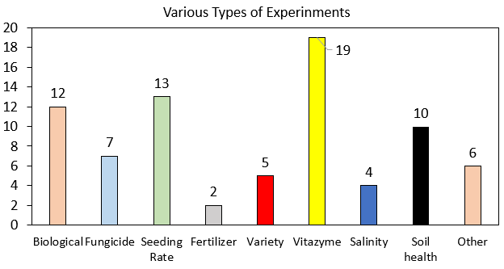
Total Farmers enrolled: 31
New farmers enrolled: 15
Total counties involved: 17

Figure 1. Various types of experinment conducted and their total numbers.
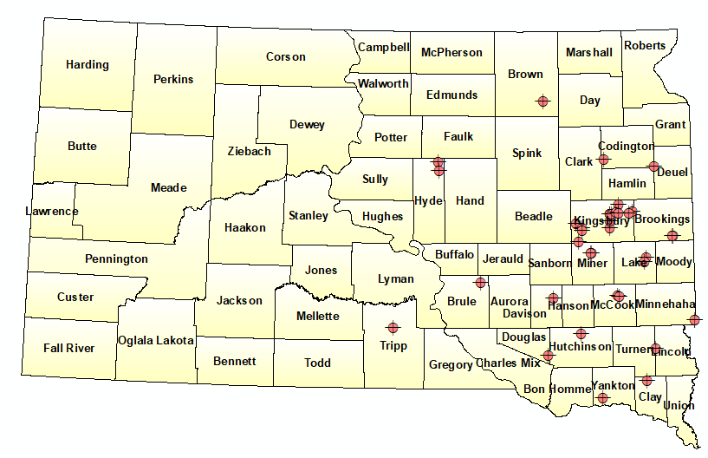
Figure 2. Distribution of different experinment at different counties of SD state.

Current progress
Abjective 1. Currently we have completed 15 reports and will process more as data is received.

Objective 2: Develop PF algorithms that can be used by SD farmers to predict yields.
We are developing an in-season algorithm that can be used to predict soybean yields prior to harvest. In this work we are testing different machine learning algorithms. A summary of this work is below.
In modern precision agriculture, preharvest yield prediction plays a critical role in various decision-making process such grain policy making, crop marketing, price forecasting, insurance, and harvest plan. This paper presents deep neural network (DNN) as deep learning model and various machine learning based models such as random forest (RF), support vector machine (SVM), LASSO and ADABOOST in combination with high resolution satellite imagery to predict soybean yield in field scale level. Six high resolution satellite images (3.12 x 3.12m) at various growth stage of the soybean plants were used in 2019 and 2021 at three different locations of South Dakota. Ten different vegetative index (VI) were calculated from each derived images and yield data using yield monitoring system were used to predict soybean yield. Coefficient of determination (R2) and root mean squared error (RMSE) were utilized to evaluate the performance of models. Out of all tested models, DNN found to outperform to predict soybean yield across all locations and years. The reason behind its best accuracy was its multiple stacked nonlinear layers which resulted DNN as one of the most powerful nonlinear models. In our analysis we had 5 hidden layers and 50 neurons in each layer. Additionally, it applied cutting-edge deep learning methods like batch normalization and drop out, which improved overall prediction accuracy in comparison to other models. Moreover, accuracy of such model can be improved more by incorporating various environmental variables such as temperature, rainfall, soil type, elevation, and crop management in the models.
Objective 2: importance of cover crops
We conducted a detailed review article on the potential for cover crops to improve soil health. The abstract is below.
By influencing soil organic carbon (SOC), cover crops play a key role in shaping soil health and hence, the long-term sustainability of our crop production systems. However, the magnitude by which cover crops impacts SOC depends on multiple factors, including soil, climate, management, cover crop growth, and years under management. To elucidate how these multiple factors influence the relative impact of cover crops on SOC, we conducted a global meta-analysis by searching published articles, which assessed changes in SOC with and without cover crops within corn (Zea mays L.) production systems. Information on climatic conditions, soil characteristics, management, and cover crop performance were extracted, resulting in 198 paired comparisons from 61 peer-reviewed studies. Overall, cover crops grown in corn rotations increased SOC from 4.9 to 9.6%(95% CI). The SOC increase was attributed to CO₂ fixation by the cover crop being greater than the amount of SOC lost through respiration. Furthermore, % SOC improvements under cover crops are more evident in soils with continuous corn systems, as well as in tropical and temperate climatic zones. Our results suggest that current cover crop-based corn production systems are sequestering 5.5 million Mg of SOC-C year⁻¹ in the United States and has the potential to sequester 175 million Mg SOC year⁻¹ globally. These findings can be used to improve carbon footprint calculations and develop science-based policy recommendations. Taken altogether, cover crops are a gold-standard practice to sequester atmospheric C and hence, make corn production systems more resilient to changing climates.

Objective 3: Distribute information to farmers
Planning activities for Soy100 2023 meeting. The planning committee consists of Adam Kask, Maria Kessler, Maggie VanderLaan, David Iverson, Kyle Gustafson, Anthony Bly, Connie Strunk, David Clay, and Shaina Westhoff.
The Advisory Committee began holding planning meetings in October 2022 to organize the 2023 Soy 100 meeting. This year’s meeting will take place at McCrory Gardens in Brookings, SD on Thursday, March 23rd. Speakers have all been confirmed, the agenda has been finalized, and Maggie & Mariah created the registration link on SD Soybean’s website. Based on last year’s participation with area soybean producers the Advisory Committee is planning for 200 to 250 attendees.
SDSU Extension is advertising for the meeting through their outlets and Dr. Clay’s lab group will begin dispensing meeting information to SDSU faculty, staff, and students. Speakers this year will include Mr. Tregg Cronin from Cronin Farms who will discuss marketing and economics, Mr. Karl Stenerson from WinField United who will discuss input availability on local and regional scales, and the remainder of the morning talks will focus on climate predictions and agronomic production from SDSU experts. The afternoon breakouts will consist of three options for attendees; Marketing and Economics, Soybean Diseases, and Agronomics. Attendees can choose which two options to attend.
The final piece that needs to be done is ordering morning refreshments and the noontime meal. Due to inflation and a change in campus catering providers, food prices have increased from last year. Dr. Clay’s lab group is working with the caterer, Sodexo, on finding an economical but satisfying option for meeting attendees. At the end of the meeting, attendees will be asked to complete a survey regarding the pertinence and quality of the speakers and the quality of the venue/food.
The Advisory Committee will have two more Zoom meetings before the implementation of Soy100 roughly around Feb 23rd and March 16th. All are welcome to attend these meetings to offer input or suggestions. Please contact Shaina Westhoff (Shaina.Westhoff@sdstate.edu) for meeting information.
The soy100 seminar focuses on the simple question, “What can farmers do to grow 100-bushel soybeans in South Dakota?” Attendees will hear from experts on soybean markets, weed resistance, soil health, water management and more.
9:30 a.m. Registration

Coffee and Rolls provided by SD Soybean Research and Promotion Council
10:00 a.m. Keynote: Marketing and Economics
Tregg Cronin; Cronin Farms

10:45 a.m. Coffee Break

11:00 a.m. 2023 Fertilizer Outlook & Discussion
Karl Stenerson; Senior Marketing Analyst, Crop Nutrients; WinField United
11:20 a.m. 100 Bushel Beans
Dr. Cheryl Reese; Senior Lecturer and Farmer; South Dakota State University
11:40 a.m. Climate Outlook and Update
Laura Edwards; State Climatologist; SDSU Extension

12:00 p.m. Lunch provided by SD Soybean Research and Promotion Council

1:00 p.m. Breakout
Session 1: Attend one 30min session
Marketing and Econ:
Tregg Cronin; Cronin Farms
Session 2: Soybean Diseases:
Connie Strunk; SDSU Extension
Dr. Madalyn Shires; Assistant Professor & Plant Pathology Specialist; SDSU Extension
Session 3: Agronomy:
Dr. Jon Kleinjan; SDSU Extension
1:30 p.m. Break
1:40 p.m. Breakout Session 2: Attend one 30min session
Same as above
2:10 p.m. Conclusion of Soy100

Presentations
- Miller, J, S.A. Clay, D.E. Clay, G. Reicks, D.P. Horvath, and A.L. Daaigh. Corn-rye interactions by rye termination using RNA-Seq and analysis. ASA 2022 annual meeting, Baltimore, November 7-11.
- Kommineni, V., S. Xu., D.E. Clay, M.G. Nisrani. 2022, Soil health response to biochar and organic manure amendments in South Dakota Cover crop system. ASA 2022 annual meeting, Baltimore, November 7-11.
- Joshi, D.R., R. Ghimire, U. Mishra, S.A. Clay, and D.E. Clay. 2022, Conservation agriculture for food security and climate resilience. ASA 2022 annual meeting, Baltimore,
- Bhattarai, D., S.A. Clay, J. Clark, G. Hatfield, and D.E Clay. Predication of no-tillage corn N requirement using a machine learning algorithm, ASA 2022 annual meeting, Baltimore, November 7-11.
- Reicks, G., S.A. Clay, D.E. Clay, J. Miller, and S. Westhoff. 2022. N fertilization and time can affect methane emissions. ASA 2022 annual meeting, Baltimore
- Clay, D.E. 2022, Carbon neutrality, Kick off for endowed chair lectures at SDSU, September30, 2022. Brookings, SD attendance 30
- Clay, D.E. 2022. Kick off meeting for RCPP, Madison SD, September 13, 2022. Attendance 120.
- Clay, D.E. 2022. Everything counts, farm-to-biofuel carbon market opportunities. American coalition of Ethanol. Omaha, NE, August 23, 2022.
- Brugler, S., and Clay. D.E. 2022. The influence of nitrogen stabilizers in no-till corn production on nitrogen losses to the atmosphere. NUE meeting, Lincoln NE, August 1-3, 2022
- Bhattarai, D., Clay, S.A., Clark, J.D., Clay D.E. 2022. Prediction of no-till corn N requirement that considers soil health. NUE meeting, Lincoln NE, August 1-3, 2022

Objective 4. Students enrolled in advanced classes are using on-farm studies in undergraduate research projects.
Addition information will be made available as these studies are completed.

Sample reports

Trial : Vitazyme Vs No Vitazyme comparision at high yield zone
Location: Kingsburry county
Methodology:
This experimental field was in Kingsbury County, South Dakota. Soybeans AG12XF1 variety was planted in 30-inch rows in strips on May 19, 2022. The purpose of this experiment is to compare the effects of Vitazyme treatment against a no vitazyme treatment. This experiment had 4 replications of each treatment. To determine the treatment effectiveness on different management zones, field was seperated into low (<35bu/ac), mid (35-55 bu/ac) and high (>55 bu/ac) yield zones.

Results
Overall vitazyme application different change the yield compared to no treatment areas (Figure 1 & Table 1). However effect of vitazyme on the soybean yield has been found in the trials that were conducted in the other counties. Therefore more research at multiple sites are needed to determine if the vitazyme application is consistent in different environmental conditions.

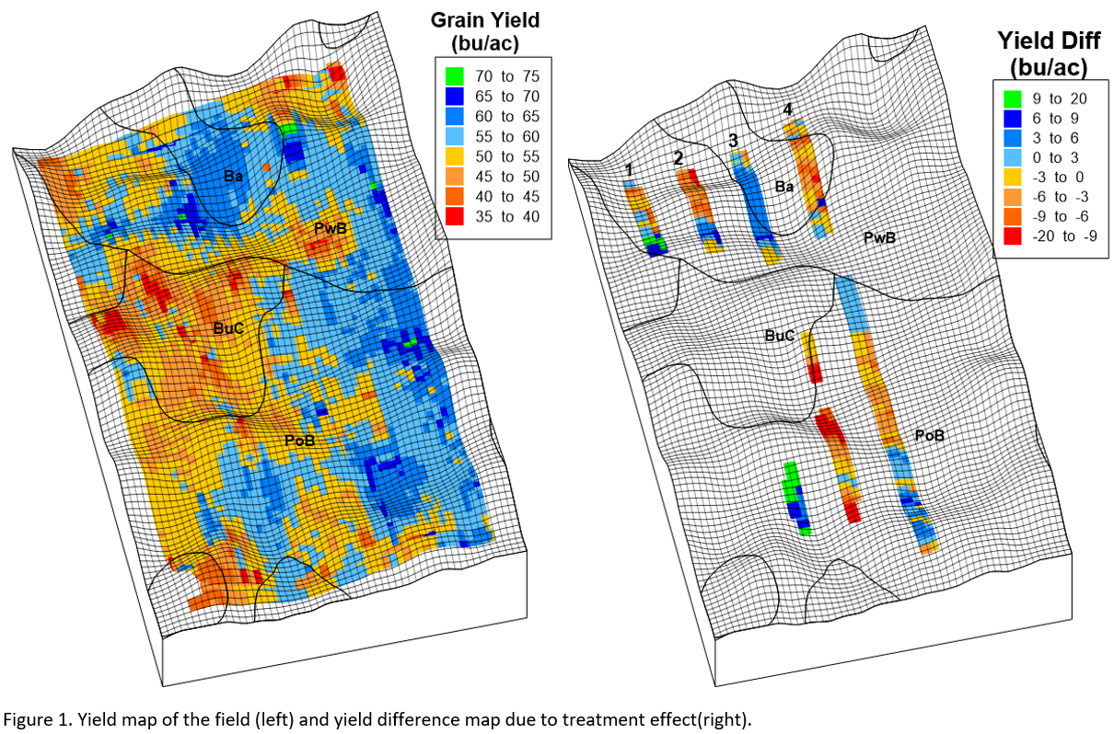

Table 1: Yield comparison between Vitazyme treated and untreated strips
Rep | Vitazyme | No Vitazyme | Difference
------------- bu ac⁻¹ -----------------
1 | 55.9 | 54.95 | 0.95
2 | 56.72 | 56.01 | 0.71
3 | 57.3 | 59.08 | -1.78
4 | 57.84 | 58.93 | -1.09
AVG |  |  | -0.30
90% CI |  |  | 1.58

Table 2. Different soil types in the field.
Soil Type | Description
Ba | Badger silty clay loam, 0 to 1 % slope
Buc | Buse-Barnes loams, 6 to 9% slopes
Pa | Parnell silty clay loam
PoB | Poinsett-Buse-Waubay complex, 1 to 6% slopes
PwB | Poinsett-Waubay silty clay loams, 1 to 6% slopes

