Managing Soybean Iron Deficiency Chlorosis with Agronomics and Economics
2022 Quarterly Report
Seth Naeve and Maykon da Silva

1. Overview
Soybean Iron Deficiency Chlorosis (IDC) is a major yield-limiting factor for soybean grown in the calcareous soils of the North Central United States. Among the most often used management strategies for IDC are variety selection, iron chelate application and increased seeding rates. However, because each of these management strategies can come at significant expense to soybean growers, the tradeoffs in cost and yield associated with their utilization may not maximize economic returns. Therefore, in order to overcome the problem and ensure profitability, effective and economical solutions are needed. The main objective of this study is to find the best management strategy combination for soybean IDC, both agronomically and economically. Coupled with an economic analysis, this study will provide farmers with more refined recommendations for managing IDC.

2. Specific objectives
Goal 1: Examine tradeoffs and interactive effects between varieties (AG13XF0 and AG12XF1), seeding densities (125,000 and 175,000 seeds acre⁻¹), and iron chelate rates (0, 2, and 4 lbs. Fe-EDDHA acre⁻¹) across a range of IDC stress levels.
Goal 2: Conduct profitability and risk efficient frontier analysis to provide soybean growers with a decision tool that will help determining what IDC management strategies to utilize given the severity of IDC, expected economic returns and risk.
Goal 3: Develop a model to predict grain yield based on timing and intensity of IDC using drone imagery.

3. Progress summary
In 2022, this study was conducted at four unique field sites on two farms in Western Minnesota, within the counties of Wilkin and Swift (Table 1). Locations were determined based on previous soybean IDC history provided by farmers’ cooperators’ knowledge. Planting the same trial within a farm field with varying IDC intensities was needed to determine whether management strategies should be changed based on the severity of IDC. A list of activities performed during the 2022 growing season is listed below (List 1).

Table 1. Location, county, site, and field coordinates for all four unique sites planted at two locations in Western Minnesota.
Location / County | Site | Field coordinates
Foxhome / Wilkin | Hotspot | 46°20'00.3"N 96°25'10.9"W
Foxhome / Wilkin | Non-Hotspot | 46°20'00.6"N 96°25'00.9"W
Danvers / Swift | Hotspot | 45°15'18.2"N 95°41'38.8"W
Danvers / Swift | Non-Hotspot | 45°15'28.0"N 95°41'39.1"W

List 1. List of activities performed during the 2022 growing season:
- Planting and treatment application: 05/28/22 at Foxhome and 06/03/22 at Danvers. The Iron Chelate (trade name Soygreen® AST) was applied in-furrow at the time of planting. Nitrogen (1 lb. urea plot⁻¹) was manually applied on-furrow at planting as well.
- Soil sampling: On 05/28/22 at Foxhome and 06/03/22 at Danvers. A total of 32 soil samples were collected for common soil chemical factors and nematode egg counts (SCN).
- Weather data collection: Weather stations were installed at each location at the time of planting. Weather stations were checked weekly and remained in the field until harvest.
- Field maintenance (weed control) and growth stages record keeping: On a weekly basis after planting. At Foxhome, herbicide was sprayed only where there was a high density of weeds. Escapes and other weeds spread throughout the study were manually removed.
- IDC severity assessment including greenness scores (1 to 5 visual rating), drone imagery (using a multispectral sensor), and Crop Circle (ground-based NDVI and NDRE): On a weekly basis after symptoms started to appear (V2). Thus, data was collected 10 times at Foxhome (6/22/22, 6/28/22, 7/5/22, 7/12/22, 7/21/22, 7/28/22, 8/3/22, 8/8/22, 8/16/22, 9/13/22) and 9 times at Danvers (6/22/22, 6/28/22, 7/05/22, 7/19/22, 7/28/22, 8/3/22, 8/8/22, 8/16/22, and 8/23/22).
- Ground Control Points (GCPs) installation: Six GCPs were installed at each of the four field sites. GPS coordinates from each GCP were collected with a centimeter-level GPS and will be used for geometric calibration of point clouds and orthomosaics. Done at both locations on 06/22/22.
- Stand counts: The number of plants in 1 linear meter (3.28 feet) was counted from the two central rows and was utilized to estimate plant population (plants/acre). On 6/28/22 at Foxhome, and on 7/19/22 at Danvers.
- Plant height: Before harvest, plant height was measured as the distance (cm) from the soil surface to the tip of the apical meristem and recorded for 5 randomly selected plants from each plot. Foxhome (09/21/22) and Danvers (10/04/22).
- Harvest: The two inner rows of each plot were harvested for grain yield estimation (bu acre⁻¹) when plants reached maturity (R8): On 09/29/22 at Foxhome and on 12/13/22 at Danvers.
- Data analysis and interpretation: October to November 2022.
- Prepare data summary and reports: As of 2021, the results of this study were presented at the ASA annual meeting in Baltimore/MD. The oral presentation from this study placed 1st in the Applied Soybean Research M.S. competition.
- Develop a model to estimate grain yield using drone imagery: yet to be done.

4. Preliminary results

- Planting a highly tolerant variety, applying Fe-EDDHA (Soygreen® AST) in-furrow at planting and increasing the plant population [from 309,000 seeds ha⁻¹ (125,000 seeds acre⁻¹) to 433,000 seeds ha⁻¹ (175,000 plants ha⁻¹)] were all effective at minimizing yield losses due to IDC.
- Larger yield responses were found for varieties and Fe-EDDHA rates as chlorosis symptoms increased, but their utilization tended to provide better results even at environments where IDC was low to moderate.
- When IDC was severe (Environmental Index of 4), the highly tolerant variety yielded 37% (0.85 Mg ha⁻¹) more than the moderately tolerant variety (Figure 1). Under the same IDC stress levels, yield improvements averaging 1.4 and 1.7 Mg ha⁻¹ were observed with soil applications of 2.24 and 4.48 kg Fe-EDDHA ha⁻¹ (2 and 4 lbs. Soygreen® AST acre⁻¹), respectively, compared to untreated plots (Figure 2).
- Although the effects of Fe-EDDHA application were greater for the moderately tolerant variety compared to the highly tolerant one, Fe-EDDHA application on the highly tolerant variety produced the highest yields (Figure 3).
- Consistent positive effects on yield were observed with increased seeding rates across environments and other management combinations [150 kg ha⁻¹ when moving from 309,000 to 433,000 seeds ha⁻¹ (125,000 to 175,000 seeds acre⁻¹, Figure 4)].
- Profitability and risk analysis showed that the best option for low-moderate IDC conditions (considering the amount of return per unit of risk) is the highly tolerant variety with 2.24 kg Fe-EDDHA ha⁻¹ at 309,000 seeds ha⁻¹ (2 lbs. Fe-EDDHA acre⁻¹ and 125,000 seeds acre⁻¹). This management combination is expected to provide a mean net return of $1723.61 ha⁻¹ to a risk of $579.99 ha⁻¹.
- Contrarily, the highly tolerant variety with 4.48 kg Fe-EDDHA ha⁻¹ planted at 433,000 seeds ha⁻¹ (4 lbs. Fe-EDDHA acre⁻¹ and 175,000 seeds acre⁻¹) is the best single alternative for areas where IDC is harsh. Under such IDC conditions, this management combination is predicted to yield $1755.54 ha⁻¹ in profits, with an associated risk of $536.33 ha⁻¹.

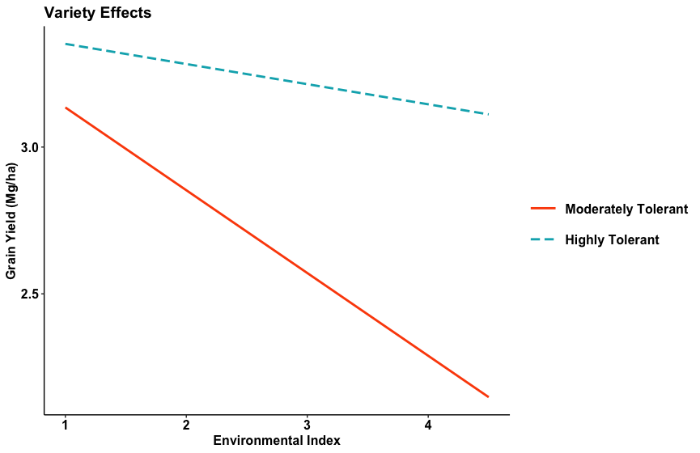
Figure 1. Decline in soybean grain yield (Mg ha⁻¹) in response to the interaction between varieties (MT and HT) and IDC severity measured by Environmental Index (EI).

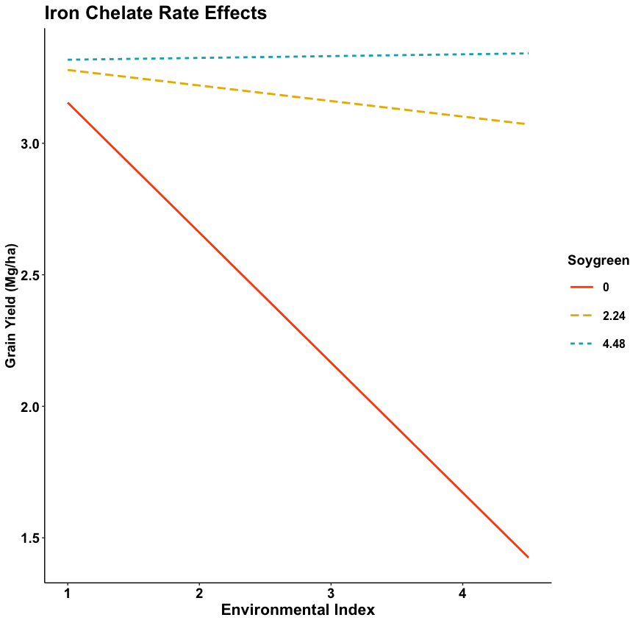
Figure 2. Soybean grain yield (Mg ha⁻¹) in response to the interaction between Fe-EDDHA rates (0, 2.24, and 4.48 kg Soygreen® ha⁻¹) and IDC severity measured by EI (Environmental Index).

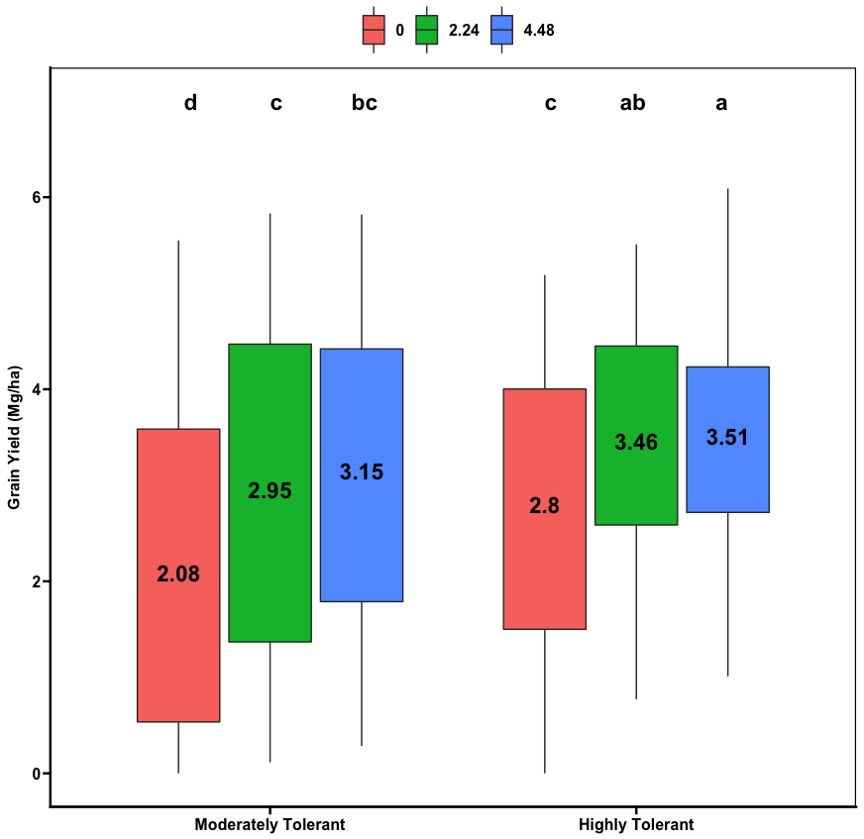
Figure 3. Distribution of grain yield (Mg ha⁻¹) as related to Fe-EDDHA rates for both varieties. Numbers inside the boxplots indicate the average grain yield. Black letters on top denote significant differences in grain yield (P < 0.05) across varieties and Fe-EDDHA rates.

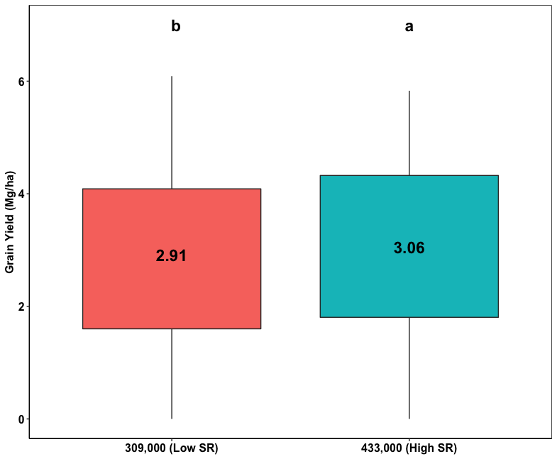
Figure 4. Distribution of grain yield as related to seeding rates. Numbers inside the boxplots indicate the average grain yield. Black letters on top denote significant differences in grain yield (P < 0.05) between seeding rates tested.

