Liming Impacts of Soybeans and Different Western North Dakota No-till Soils
Chris Augustin - NDSU Dickinson Research Extension Center

Project Summary

Many fields in western North Dakota are decreasing in yield due to acidic soils. Historically, North Dakota has not dealt with soil acidity issues. However, decades of nitrogen fertilizers paired with slightly acidic soil parent materials and poorly buffered soils has lowered soil pH below 5.5 on thousands of farmable acres. These areas of strong acidity are adversely impacted by reduced nutrient availability, soil microbial activity, and stunted roots from aluminum (Al) toxicity. These areas can be improved from surface liming. Lime recommendations are common in other states. However, there is little North Dakota data to guide soybean producers on acidic soil management. This data will be used to generate recommendations for liming acidic soils in North Dakota as well as provide opportunities to educate county-based Extension agriculture agents on soybean production and soil acidity. All crops are impacted by soil pH. This project was funded by the ND Wheat Commission, ND Corn Council, and ND Soybean Council for $26,780.00.

Project and Objectives

- Evaluate impact of lime rates on North Dakota soils and use data to build liming recommendations for North Dakota
- Evaluate soybean yield and quality differences among lime treatments
- Increase the knowledge base of acidic soil management in western North Dakota
  - Create a bulletin on acidic soil management
  - Host workshops to present data and answer production questions
  - Host in-service training to county extension agents
  - Use social media and other media outlets to distribute information to growers and the general public

Progress Deliverables

Ten locations (figure 1) were secured for the 2021 growing season. Experiments were located in Williams (wheat), Ward (soybean), Mercer (corn), Golden Valley (wheat), Dunn (corn), Stark (wheat and corn), Hettinger (soybean), Morton (wheat), and Kidder (soybean) counties. Soils were sampled then limed in April or May of 2021. Crops were hand harvested when mature. Then were cleaned and analyzed for quality and yield. Soil samples were collected in October or November. All soils were sent to the lab for analysis shortly after field collection. This data will be used (first of two-year project) to develop lime amendments for acid soil reclamation.

Project Results

Sugarbeet waste lime treatments increased the soil pH of the 0-3 and 0-6 in depths. Lime applications of 4, 8, and 16 tons/ac increased the 3-6 in soil depth (Table 1).
The regression analysis procedure produced statistically significant polynomial regressions from all, except the 6.3 and 7.1 buffer pH soil environments (Table 2). Even though all lime applications were statistically significant, it appears the greatest benefit was from the 2- and 4-tons lime per acre treatment as those are the steepest areas of the regression. The soil pH increase tapered off with the 8 and 16 tons per acre treatment.

Sugarbeet waste lime treatments impacted salinity, P, Ca, Mn, Al, and calcium-carbonate-equivalent (Table 3). However, SBWL treatments did not impact soil organic matter (p-value 0.955), nitrate (p-value 0.703), potassium (p-value 0.983), magnesium (p-value 0.799), zinc (p-value 0.888), sodium (p-value 0.698), and cation exchange capacity (p-value 0.995). The 4, 8, and 16 tons lime/ac treatments increased soil salinity (Table 3). Beet lime did not impact soil organic matter (p-value 0.9550), nitrates (p-value 0.703), potassium (p-value 0.9834), magnesium (p-value 0.799), sodium (p-value 0.655), zinc (p-value 0.888), and cation exchange capacity (p-value 0.996).

Beet lime may serve as a phosphorus fertilizer as lime increased Olsen phosphorus tests (table 2). Beet lime applications increased soil salinity, but all salinity tests were below yield reducing levels (table 2). There is calcium and magnesium in beet lime so the increase of soil tested calcium and magnesium (table 2) was not unexpected. Beet lime applications reduced soil extractable aluminum (table 2). However, the amount of aluminum in the untreated control was 5 ppm and below the 25 ppm threshold that many suggest as the amount of soil extractable aluminum needed to render the soil environment probable to aluminum toxicity. Clay content may play a role in this as aluminum is a large component of clay.

Calcium carbonate equivalent is a way to determine the amount of lime present in a soil. As lime applications increased so did the amount of calcium carbonate (table 2). It is interesting to note the 0 and 2 tons of lime per acre treatments both contained 0.6 percent calcium carbonate equivalent. This suggests that the approximately 2 tons of lime per acre fully reacted with the soil from the spring lime application to the October/November final soil collection.

Project Benefit to Soybean Farmers

Many Extension agents, producers, and crop consultants have been educated on soil acidity management at various workshops held at the Dickinson Research Extension Center. Six collaborating Extension agents and one specialist have had hands-on training in soil sampling, soil acidity management, and soybean production during the implementation of this project. This boots on the ground training will have direct impacts on the people served by NDSU Extension. This research will help all producers improve their crop yields as all crops are impacted by soil pH.
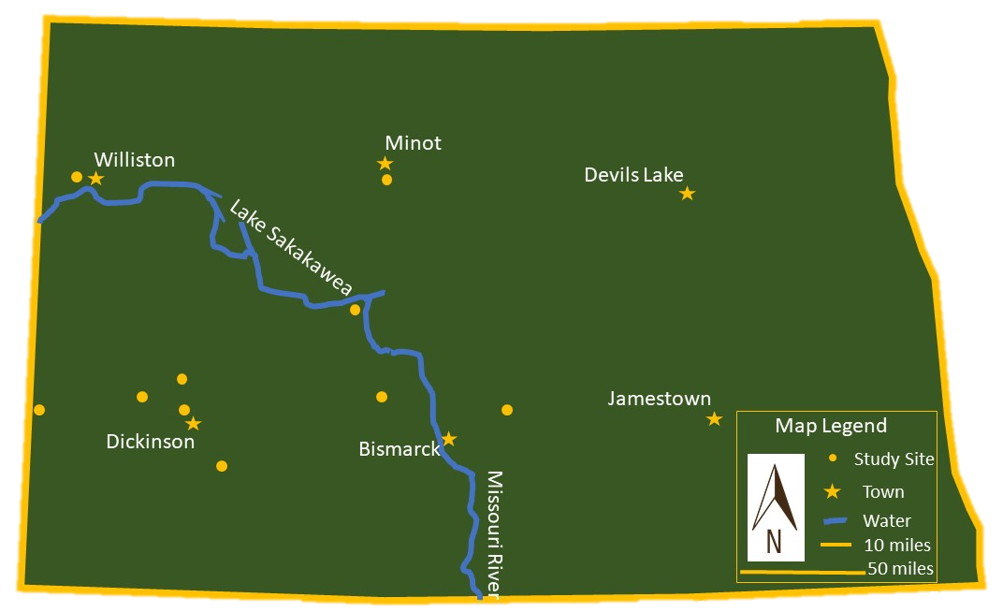
Figure 1. Location of experimental locations.

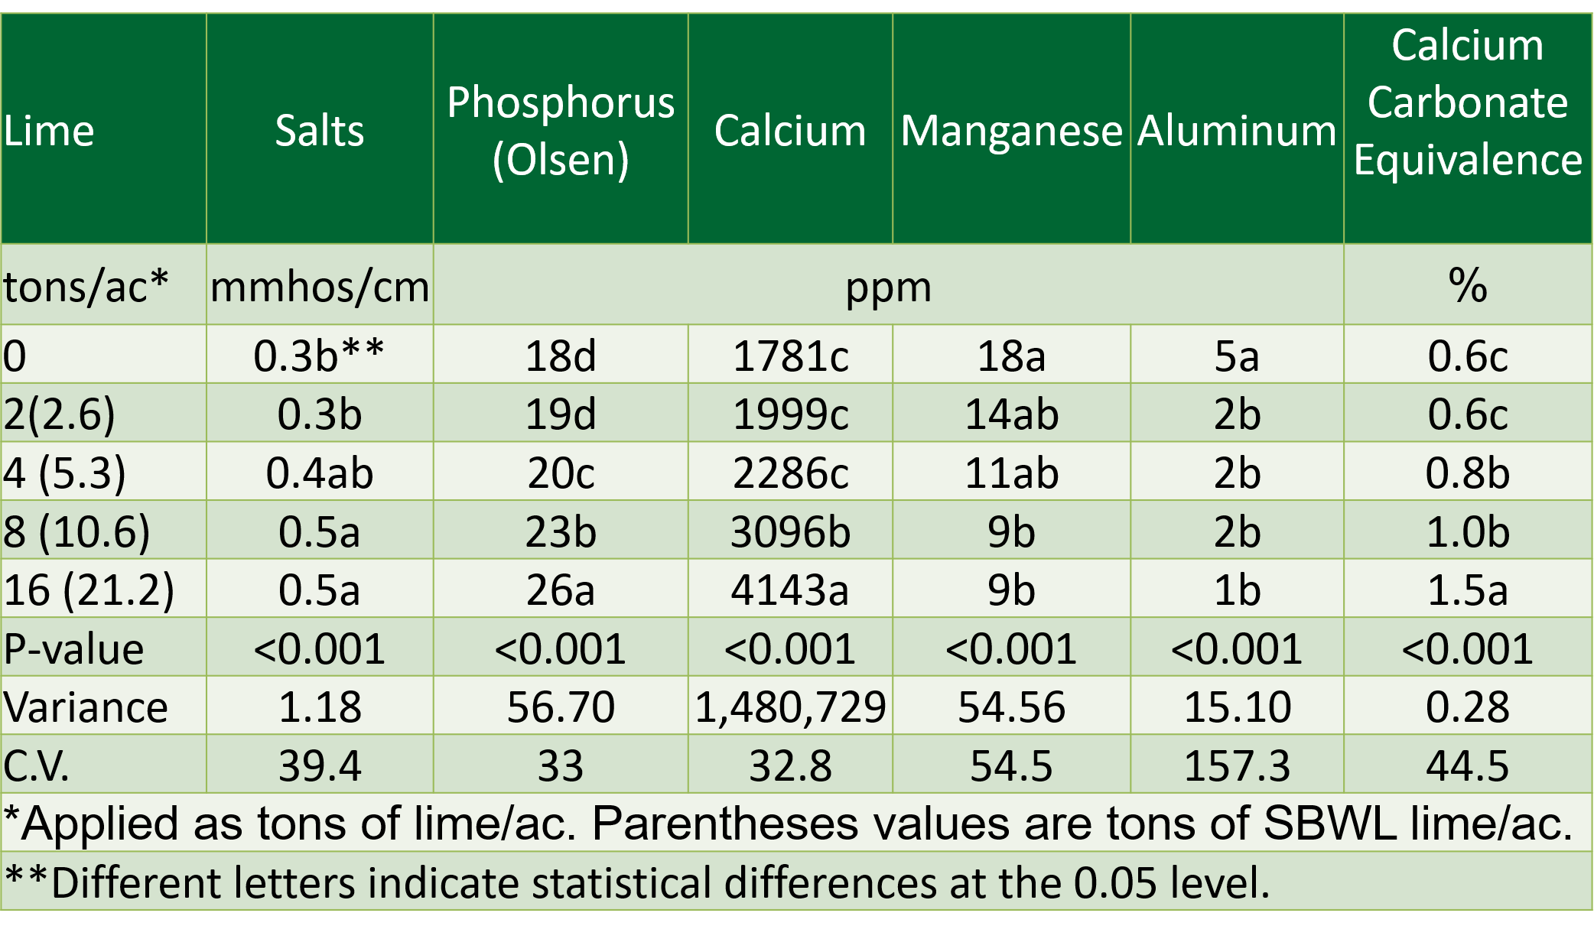
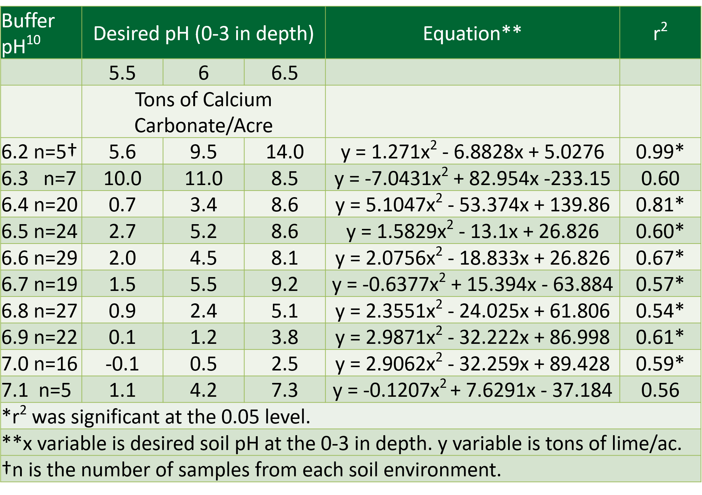
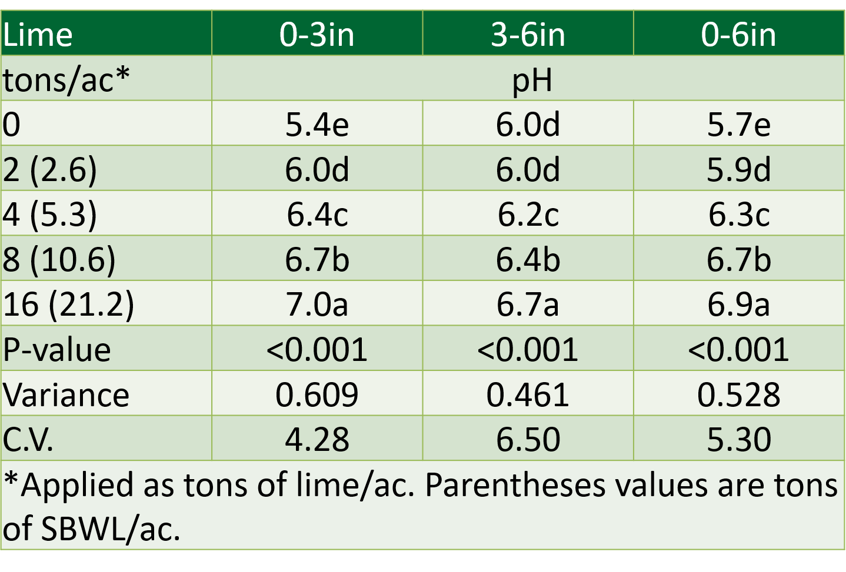
Table 1. Beet lime impacts on soil pH at various depths.
Beet Lime | 0-3in | 3-6in | 0-6in
tons CCE/ac | ----------pH----------
0 | 5.4e* | 6.0d | 5.7e
2 | 6.0d | 6.0d | 5.9d
4 | 6.4c | 6.2c | 6.3c
8 | 6.7b | 6.4b | 6.7b
16 | 7.0a | 6.7a | 6.9a
P-value | <0.001 | <0.001 | <0.001
C.V. | 4.28 | 6.50 | 5.30
*Different letters indicate statistical differences at the 0.05 level.

Table 2. Beet lime impacts on soil pH based off of buffer pH.
Buffer pH | Desired pH (0-3 inch depth) |  |  | Equation | r²
 | 5.50 | 6.00 | 6.50
6.2 | 5.6 | 9.5 | 14.0 | y** = 1.271x² - 6.8828x + 5.0276 | 0.99*
6.3 | 10.0† | 11.0 | 8.5 | y = -7.0431x² + 82.954x -233.15 | 0.60
6.4 | 0.7 | 3.4 | 8.6 | y = 5.1047x² - 53.374x + 139.86 | 0.81*
6.5 | 2.7 | 5.2 | 8.6 | y = 1.5829x² - 13.1x +26.826 | 0.60*
6.6 | 2.0 | 4.5 | 8.1 | y = 2.0756x² - 18.833x + 26.826 | 0.67*
6.7 | 1.5 | 5.5 | 9.2 | y = -0.6377x² + 15.394x - 63.884 | 0.57*
6.8 | 0.9 | 2.4 | 5.1 | y = 2.3551x² - 24.025x + 61.806 | 0.54*
6.9 | 0.1 | 1.2 | 3.8 | y = 2.9871x² - 32.222x + 86.998 | 0.61*
7.0 | -0.1 | 0.5 | 2.5 | y = 2.9062x² - 32.259x + 89.428 | 0.59*
7.1 | 1.1 | 4.2 | 7.3 | y = -0.1207x² + 7.6291x - 37.184 | 0.56
*Significant at the 0.05 level
**Y is tons of lime needed, X is desired pH
†Numbers shown in red do not make sense with the dataset. More data is needed to improve regressions.

Table 3. Beet lime impacts of soil nutrients at the 0-6 inch depth.
Beet Lime (applied as calcium carbonate equivalent) | Salts | OM | Phosphorus (Olsen) | Calcium | Manganese | Aluminum | Calcium Carbonate Equivalent
-t  Tons/ac- | -mmhos/cm- | -%- | --------------------ppm-------------------- |  |  |  | -%-
0 | 0.3b | 3.2 | 18d | 1781c | 18a | 5a | 0.6c
2 | 0.3b | 3.1 | 19d | 1999c | 14ab | 2b | 0.6c
4 | 0.4ab | 3.0 | 20c | 2286c | 11ab | 2b | 0.8b
8 | 0.5 | 3.0 | 23b | 3096b | 9b | 2b | 1.0b
16 | 0.5 | 3.0 | 26a | 4143a | 9b | 1b | 1.5a
P-value | <0.001 | 0.955 | <0.001 | <0.001 | <0.001 | <0.001 | <0.001
C.V. | 39.4 | 35.9 | 33.0 | 32.8 | 54.5 | 157.3 | 44.5
*Different letters indicate statistical differences at the 0.05 level.

