Project Title: SoyRenSeq: a Novel Approach for Disease Resistance Gene Discovery and Application for Soybean Improvement (Year 2)
Investigator: Madan K. Bhattacharyya,
Iowa State University
Progress Report:
Bhattacharyya lab proposed to conduct research accomplishing the following two objectives of this collaborative proposal.
Obj. 4. Evaluation of resistance to various pathogens and mapping of major R genes and QTL.
Obj. 5. Development of candidate R-gene-based molecular markers for precision breeding.

The progress made towards accomplishing the Objective 4 is summarized below.
We proposed to develop high density and high-resolution genetic maps of three genomic regions: Rps4/6/12/13 and two additional regions containing two novel Rps genes mapped to Chromosome 3 and 7. The progress made towards developing the high density and high-resolution genetic maps of the Rps4/6/13 region (Figure 1) is presented in Figure 2. We are also making progress towards mapping the other two novel Rps genes and will be reported in future reports.
The Rps4/6/12/13 region based on data of three of our publications (Sandhu et al. 2004; Sahoo et al. 2017 and Sahoo et al. 2021) is presented in Figure 1.
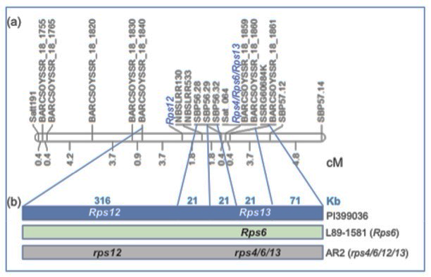
Figure 1. The genetic and physical maps of the Rps4/6/12/13 region (a) and three genotypes (b) for creating high-density and high-resolution maps of the three Rps genes (Sandhu et al. 2004; Sahoo et al. 2017 and Sahoo et al. 2021).
In the last summer, we grew two populations generated by hybridization of AR2 with L89-1581 for segregation of Rps6 and hybridization of L89-1581 with PI399036 for segregation of Rps6, 12 and 13. The F₁ and F₂ plants were grown in the Hinds Farm, located a mile north of Ames, IA in the Summer of 2023. A total of 60 F₂ plants from the cross between L89-1581 x PI399036 (Cross 1) were sown. Of these, 54 F₂ plant germinated. The F_{2:3} seeds were harvested from 48 plants.
From the AR2 X L89-1581 cross (Cross 2), 131 F₂ seeds were sown, of which 122 seeds germinated. The F_{2:3} seeds were harvested from all F₂ plants. The four seeds from each of the F_{2:3} families of both Cross 1 and Cross 2 were grown in each of the two greenhouses during the winter of 2023-24. Plant leaf tissues were collected from the plants for marker analysis to identify the recombinants. From molecular analysis of 46 of 122 families from the Cross 2, we identified six recombinants for fine mapping of Rps6.
We have recently developed a multiplexing PCR system for rapid evaluation of the segregants. We plan to evaluate thousands of segregating individuals from heterozygous F_{2:3} families for identifying many recombinants for developing high resolution map of this genomic region. The segregants of the AR2 X L89-1581 cross are being used to map the Rps6 gene, whereas that of the L89-1581 x PI399036 cross for mapping the Rps6, 12 and 13 genes. Study of this cross will also reveal if Rps6 and Rps13 are allelic; if not, then we expect to recover recombinants containing all three Rps genes.
Figure 2. Identification of SNPs mapped to the Rps4/6/12/13 region on Chromosome 18. The figure presents the region in chromosome 18 containing the Rps4, 6, 12 and 13 genes. The SNPs shown by horizontal lines on the chromosome are called between L89-1581 and PI 399036, parents of a cross being studied in this project. The distribution of 1,309 SNPs between SSR markers BARCSOYSSR_18_1820 and BARCSOYSSR_18_1870 is presented on left side of the chromosome. The Rps12 and Rps4/6/13 genes were mapped to two putative regions shown by green lines. The 1,309 SNPs were identified by comparing the short-read sequences of both L89-1581 and PI 399036. Each of the SNPs were supported by a minimum read depth of 20.

References
Sahoo, D. K., Abeysekara, N. S., Cianzio, S. R., Robertson, A. E. & Bhattacharyya, M. K. A novel Phytophthora sojae resistance Rps12 gene mapped to a genomic region that contains several Rps genes. PLoS One, 12, (2017). https://doi.org/10.1371/journal.pone.0169950
Sahoo, D.K., Das, A., Huang, X. et al. Tightly linked Rps12 and Rps13 genes provide broad-spectrum Phytophthora resistance in soybean. Sci Rep 11, 16907 (2021). https://doi.org/10.1038/s41598-021-96425-1
Sandhu, D., Gao, H., Cianzio, S. & Bhattacharyya, M. K. Deletion of a disease resistance nucleotide-binding-site leucine-rich-repeat-like sequence is associated with the loss of the Phytophthora resistance gene Rps4 in soybean. Genetics, 168, (2004). https://doi.org/10.1534/genetics.104.032037

