MSPRC Soybean Checkoff Report: 8/31/22

Enhancing Sclerotinia stem rot research capacity and exploring new avenues of disease management through soybean canopy architecture traits
Project year: May 1, 2022- April 30, 2023

PRINCIPLE INVESTIGATOR : Megan McCaghey, Assistant Professor
EMAIL ADDRESS: mmccaghe@umn.edu
PHONE : 501-352-1220
MAILING ADDRESS:
Office: 214 Stakman Hall
1991 Upper Buford Circle
495 Borlaug Hall
St. Paul, MN 55108

CO-PI: Aaron Lorenz, Associate Professor
EMAIL ADDRESS: lore0149@umn.edu
PHONE : 612-625-6754
MAILING ADDRESS:
Office: 307 Hayes Hall
411 Borlaug Hall
1991 Upper Buford Circle
St. Paul, MN 55108

CO-PI: Suma Sreekanta, Postdoctoral Researcher
EMAIL ADDRESS: sreek002@umn.edu
PHONE : 612-625-5274
MAILING ADDRESS:
Office: 596 Borlaug Hall
411 Borlaug Hall
1991 Upper Buford Circle
St. Paul, MN 55108

COLLABORATOR: Damon Smith, Associate Professor
EMAIL ADDRESS: damon.smith@wisc.edu
PHONE : 608-286-9706
MAILING ADDRESS:
495 Russell Labs
1630 Linden Dr
Madison, WI 53706

COLLABORATOR: Wade Webster, Graduate Student
EMAIL ADDRESS: rwwebster@wisc.edu
MAILING ADDRESS:
495 Russell Labs
1630 Linden Dr
Madison, WI 53706

SYNOPSIS OF PROJECT AIM:
To enhance disease resistance breeding in the in Minnesota, I propose foundational work to characterize Sclerotinia sclerotiorum isolates, collected throughout Minnesota, that can be used to comprehensively screen soybean lines and study fungal biology. I also propose developing and comparing field techniques for infesting research fields to conduct applied Sclerotinia stem rot (SSR) research. Lastly, this project aims to define relationships between canopy architecture and S. sclerotiorum development, to provide another, underexplored consideration for disease resistance breeding to SSR.
PROJECT OBJECTIVES:
- GOAL: Characterize the aggressiveness of S. sclerotiorum isolates for use in future pathogen biology and resistance screening assays

This study aims to characterize Minnesota isolates in soybean to establish a range of native, biologically relevant isolates for germplasm screening and fungal biology assays in Minnesota.

Obj. 1) Collect a panel of S. sclerotiorum isolates from Minnesota soybean fields and researchers
Towards this objective, we have developed an isolate collection of 28 isolates. These isolates have been collected mostly from the Northwestern part of Minnesota (near Crookston). Isolates were surface sterilized using 10% bleach and 70% ethanol solutions. The isolates were then stored with desiccant beads in the refrigerator (4 °C). Newly collected isolates were designated as “SSMM-“ followed by a number indicating the order in which the isolate was collected. I have also approved a draft permit from USDA APHIS to ship isolates from surrounding states. Seth Naeve, Aaron Lorenz, and their staff have also agreed to help me to collect isolates during field activities. I intend to use additional resources to collect isolates from seed at harvest including grower outreach with David Kee, Twitter, Dean Malvick, and Regional Extension Educators such as Ryan Miller. These networks should lead to a robust isolate collection.

Obj. 2) Characterize their growth and relative aggressiveness on soybean lines known to have differential resistance

We have started screenings to compare the aggressiveness between isolates and will continue trials into the fall and winter semester. In our preliminary screening, seven isolates of Sclerotinia sclerotiorum were evaluated for their aggressiveness as indicated by lesion size on soybean over time. An “empty plug” of agar with no fungus was used as a control to show that lesions were caused by the fungus, not cutting of the petiole. Three plants were inoculated in a single pot and five pots were inoculated per isolate (15 plants per isolate) at the V4 growth stage. The treatments were arranged in a randomized complete block design in the growth chamber. Lesions were measured at 24, 96, and 120 hours post inoculation (HPI). An additional replicate of screenings will begin on 9/12/22 and screenings will continue through the fall and winter.
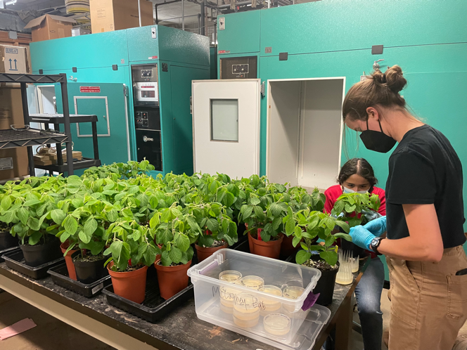
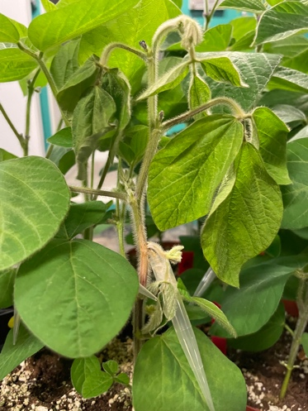
Sclerotinia inoculations with various isolates and an example lesion on a successfully inoculated plant
Consistent lesions formed on plants and allowed the isolates to be compared. Results of the initial screening indicated differing levels of aggressiveness per isolate (Figure 1). For example, MNSS4 P (light blue) appears to be less aggressive than MNSS4 V (bright pink).

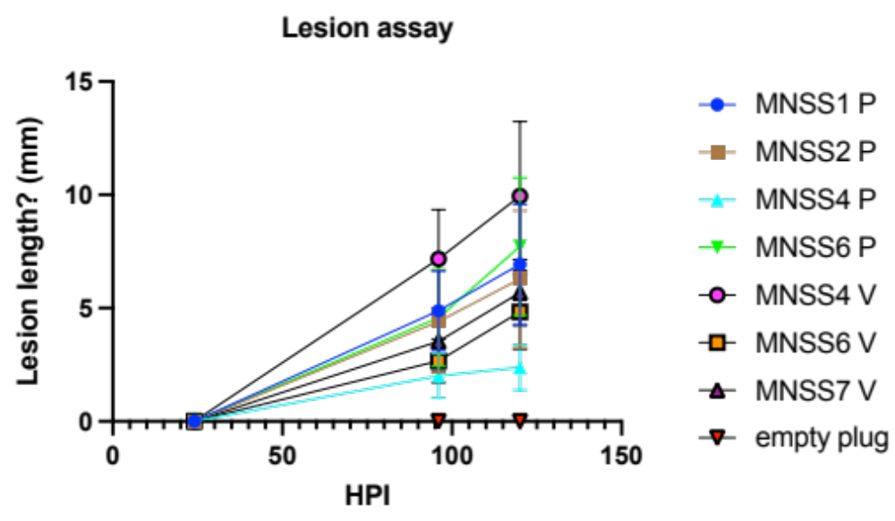

Figure 1. Lesion size on soybean at 24, 96, and 120 hrs after being inoculated (HPI) with seven isolates of Sclerotinia sclerotiorum. Graph provided by new graduate student, Hsuan-Fu Wang.
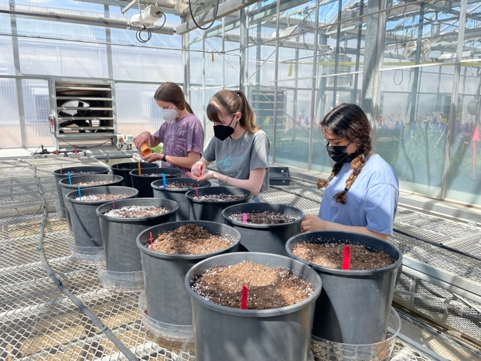
Once we identify a panel of isolates with different levels of aggressiveness, we can test whether isolates will distinguish the resistance ranking of cultivars. Using three representative isolates, we will inoculate soybean check lines developed by Dr. Damon Smith’s Lab at University of Wisconsin, Madison with known low, moderate, and high levels of resistance (compared to susceptible controls) to see if resistance rankings are similar when challenged with the new, UMN isolates.
Planting check lines from the Smith Lab

I have received the check lines from Damon, and we are currently bulking seed in the greenhouse for future screenings to determine whether our isolate panel can differentiate resistant from susceptible lines.

- GOAL : Define relationship between canopy architecture and SSR development

In addition to physiological resistance, plant architecture may be an important component of avoiding infection by S. sclerotiorum in the field. The development of SSR and the production of apothecia that cause disease in soybean are highly dependent on environmental conditions. Two of these particularly important conditions include moisture and light wavelength penetration to surface of the soil, where apothecia develop. Developing a better understanding of plant architecture in relation to disease development may lend to future possibilities of screening for architecture traits, combining genetic and architecture traits while breeding.

Obj. 1) Characterize the branching angle of lines in the field
The Lorenz Lab planted soybean panels (of diverse plant architectures) in Waseca on 5/16/22 and in St. Paul on 6/8/2022. They were also planted Rosemount but due to seed contamination during planting, we are unable to evaluate these. In total, we are evaluating three trials, in both Waseca and St. Paul. Suma Sreekanta, the postdoctoral researcher in the Lorenz Lab, is collecting data on various phenotypic traits that impact light penetration to the ground (where apothecia form). These data will be examined in the fall. Phenotypic traits are listed below:

Abbreviation | Trait | Definition
Branch traits
BA | Branch angle | Average branch angle between the main stem and primary branches
BD | Branch density/ distribution | Number of branches per cm of branching zone.
BN | Branch number | Number of branches on main stem
BO | Branch orientation | Angle between successive branches
BZ | Branching zone | Portion of the stem that bears branches measured as length from the bottom of the plant to the last branch initiated
BR | Branch ratio | Ratio of the branching zone to plant length/height. It give the proportion of the stem that has branches
Canopy traits
CC50 | Days to 50% canopy coverage | Calculated from the function fit to the canopy coverage data
CCR2 | Canopy coverage at R2 | Canopy coverage when lines reach R2 stage that is defined as
MCC_d | max growth rate (%/day) | Interpolated from the function fit to the canopy coverage data taken over the growing season
MCC_w | max growth rate (%/week) | Max growth rate is interpolated from a sliding window of a week based on the function fit to the canopy coverage data taken over the growing season
ACC | Average Canopy Coverage | mean of seasonally observed values of canopy coverage
Light interception traits
H50PAR | Height at 50% tPAR | Height of the plant where 50% of transmitted photosynthetically active radiation reaches within the canopy
PAR50H | tPAR at 50% height | Percent photosynthetically active radiation transmitted at 50% height of the canopy
PARG | tPAR at ground level | Percent transmitted photosynthetically active radiation reaching ground level
Leaf traits
LA | Leaf area | Area of a leaf harvested from mid canopy
LL | Leaf Length | Length of middle leaflet harvested from the leaf mid canopy
LW | Leaf Width | Width of middle leaflet harvested from the leaf mid canopy
Traits related to the top of the soybean plant
CH | Canopy height | Length of the main stem occupied by the top seven internodes.
IL4 | Internode length at node 4 | Internode length measured from the top of the plant where the top node is counted as node 1
IS4 | Internode slope | Slope calculated from internode lengths from the top 4 internodes of the plant canopy and used as a proxy for the gradient of node placement at the top of the canopy
PA4 | Petiole angle 4 | Angle of petiole formed with main stem at node 4 from the top
PL4 | Petiole length 4 | petiole length at node 4 counted from top of the plant
PS4 | Petiole slope | Slope calculated from petiole lengths from the top 4 nodes of the plant canopy and used as a proxy for the gradient of node placement at the top of the canopy
Whole plant traits
NO | Number of nodes | number of nodes on the main stem of the plant
PH | Plant Height | Calculated as the total length of the main stem
Plant shape traits
Sh_H | Plant shape parameter peak height | Calculated after fitting beta distribution to plant width obtained at various plant heights. Describes the maximum height at which maximum width is reached
Sh_A | Plant shape parameter area under the curve | Calculated after fitting beta distribution to plant width obtained at various plant heights describe the overall area of the distribution
Sh_W | Plant shape parameter width scaling factor | Calculated after fitting beta distribution to plant width obtained at various plant heights. Describes maximum width from the central line.

Obj. 2) Define the genetic, SSR resistance of architecturally diverse lines
Resistance screenings of plants inoculated with Sclerotinia in the greenhouse will begin in the winter, once we have complete phenotypic data from lines at the end of this growing season. Based on the data from Obj. 1 and Obj. 2, we will narrow down the number of lines to a panel with a range of the traits measured. We will compare their genetic resistance based on lesion progression over time.

Obj. 3) Measure canopy closure and light penetration along with apothecia and SSR development
Drone data for canopy coverage has been underway once or twice a week since planting. Currently the data is in the form of images, and they will need to be analyzed to be usable. This date will be analyzed at the end of the season when all the flights are complete.

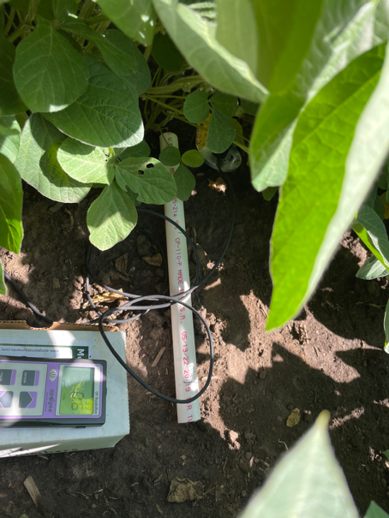
We scouted for apothecia in each row of soybeans using a t-shaped PVC push pole prior to flowering (in St. Paul and at early flowering stages (Waseca) through canopy closure, when apothecia begin to develop. The plots were checked in St. Paul on 7/13/2022, 7/22/2022, 7/27/2022, 8/4/2022, and 8/16/2022. We scouted for apothecia in Waseca on 8/2/2022, and 8/17/2022. No apothecia were observed. We are also conducting disease assessments at the R6, full pod growth stage. In Waseca, disease assessments were conducted on 8/17/2022 and we saw no SSR. We will conduct St. Paul evaluations on 9/1/22. The lack of apothecia and disease in Waseca is likely related to the drought experienced earlier in the summer, and we anticipate that our data collection will be improved with SSR nurseries in the future (Goal 3).
Light detection under the soybean canopy with a UVB meter

We collected light measurements using a UVB meter in St. Paul starting at beginning flowering, the time most important for Sclerotinia infection, and through canopy closure on 7/22/2022, 7/28/2022, and 8/4/2022. UVB captures that spectrum of wavelengths considered to be the most important for apothecia production. Measurements were conducted in the morning on days with no cloud cover that might block the UVB penetration to the ground. The samples were taken from the left row of each variety, while facing east. Measurements were captured in the center of each two rows at 0", 7.5", and 15" from the base of the plant. Comparisons of light conditions under the architecturally diverse lines will be made along with phenotypic comparisons that may contribute to SSR development this fall.

- GOAL: Develop reliable S. sclerotiorum nurseries for future SSR field trials

Currently, researchers do not have field sites with reliable and uniform inoculum where we can conduct SSR experiments (personal communication). High disease pressure, across plots is often required to observe the impact of experimental treatments (such as variety resistance differences or fungicide efficacy).

This summer, I am interested in trialing three methods to develop disease pressure for trials in 2023. These include 1) growing sunflowers, which are very susceptible to SSR, inoculating them the back of the head with a slurry of S. sclerotiorum, and then incorporating residue into the soil in the fall of 2022. I will also 2) sprinkle sclerotia inoculum generated in the lab on carrot seed into the field during the fall before 2023 trials. Cold conditioning over the winter should allow the inoculum to produce apothecia in the following field season. In the third method, 3) I will grow sclerotia in the lab, cold condition them in the fridge, and then spring apply the sclerotia to the field. 4) Untreated, naturally infested plots will be left as controls to compare with plots treated with the described infestation methods.

Towards this objective, plots were planted on June 3, 2022 at The Northwest Research and Outreach Center (NROC) in Crookston, MN. The variety used was an early, Phomopsis and SSR susceptible Nuseed variety, N4HM354. The trial is a randomized complete block design and each treatment is repeated six times. It was planted on 22” row spacing. Rows are 20 feet long and each treatment plot contained six rows. There is a four-foot buffer of untreated buffer between plots to prevent unintended inoculum spread. Five-foot alleys were left on the front and back of rows. These trials are misted during early flowering until beginning dry down to encourage disease development.
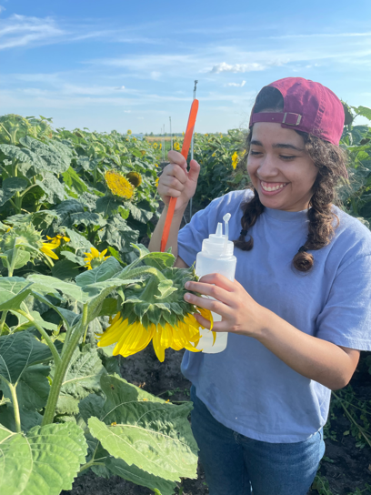
Sunflower Sclerotinia slurry inoculations in disease nurseries

We inoculated plots with a slurry of Sclerotinia at full flowering when some plants were at R5 and others were at R6 on August 22, 2022. Slurry was a prepared with a mixture of cultures from three isolates. We chose isolates with a range of aggressiveness, based on the results displayed in Table 1. We have also bulked sclerotia on autoclaved carrots and will apply sclerotia in field plots in the fall, to cold condition in the field and in the spring after cold conditioning a the lab refrigerator. We will apply 30 ml of sclerotia per plot.

In 2023, soybean will be evaluated in the plots and their incidence and severity of SSR infections will be compared. Apothecia debsity will also be monitored. It is expected that this work will allow for more uniform, consistent disease pressure in which to compare the performance of soybean lines and treatments for SSR.

IN SUMMARY:
The goals and objectives described in this proposal will set the stage for my soilborne fungi pathology lab to conduct biologically relevant SSR research in soybean and will open new, creative avenues to improve resistance to this challenging fungal disease.

Additional comments on students:
I recently hired two graduate students that will research soybean and SSR interactions.

Hsuan-Fu Wang is a PhD student who will be developing the isolate collection, characterizing these isolates, and developing a panel for soybean screenings. He brings experience in plant breeding, disease resistance screening, and molecular techniques in fungal biology from his MSc and work experience in agricultural industry.

Alisha Hershman is an MSc student will work to understand the relationship between soybean architecture and disease infection. She has extensive field and lab experience in soybean genetics and has worked for the USDA and Calyxt (a plant gene editing company).

We’ve had a great crew of three undergraduate students- Jane, Leslie, and Ella- this summer that have helped with culture maintenance, plant care, disease evaluations, and project implementation.

These are promising students, and I appreciate MSRPC support for their research efforts and learning.

PROJECT DELIVERABLES/OUTCOMES
  - Results will be presented at seminars and regional (Prairie Grains, Minnesota Ag Expo) and national meetings.
  - Peer-reviewed research publications will be developed.
  - A S. sclerotiorum isolate collection will be developed for future SSR work.
  - A research education and outreach opportunity will be available to students in my lab who are assisting with the project. The next generation of soybean researchers and will be trained in grower-driven research.
- New breeding opportunities will be explored through enhancing disease escape with plant architectural traits and candidate lines for breeding will be identified.
  - Improved SSR resistance screening methods (through the characterization of S. sclerotiorum isolates and improved nursery methods), can lead to improved SSR research across University of Minnesota and the Sclerotinia community.
  - Identification of lines with unique branching phenotypes can lead to candidates for quantitative trait loci (QTL) studies to identify genes related to branching phenotypes and disease resistance.
  - Collaborations between researchers of various departments and universities will build bridges of expertise in soybean research to enhance each other’s work in soybean improvement.

PERFORMANCE METRICS
- GOAL: Characterize the aggressiveness of S. sclerotiorum isolates for use in future pathogen biology and resistance screening assays
- This goal will be successful if new isolates are collected (more than 10) and a better understanding of their characteristics is developed (at least two repetitions of aggressiveness and growth assays should be completed in the project year).
- Isolates should be effectively used to differentiate resistance between check lines.

- GOAL : Define relationship between canopy architecture and SSR development
- Branching angles will be measured in the field, for all experimental lines.
- At least two experimental repetitions of greenhouse resistance screenings should be completed.
- Environmental data under canopies will be collected during the field season.
- These lines should be well characterized in their architectural and disease resistance traits by the end of the funding year.

- GOAL: Develop reliable S. sclerotiorum nurseries for future SSR field trials
- Experiments will be established and implemented in 2022.
- In 2023, data will be collected and analyzed to compare infestation methods.

