FY25 Midterm Report

Principal Investigator and Co-Investigators:
Principal Investigator: Katherine Kral-O’Brien; Natural Resource Ecology and Management, Iowa State University

Co-Investigator: Matt O’Neal; oneal@iastate.edu; Department of Plant Pathology, Entomology and Microbiology, Iowa State University.

Collaborator: Peter O’Brien; peter.obrien2@usda.gov; USDA-ARS National Laboratory for Agricultural and the Environment

Project Title: Identifying pollinators and resource use in corn-soybean based crop rotations

Brief Rationale: Soybean farmers and those interested in pollinator conservation need to know what pollinator species are found in soybean fields. Understanding how agricultural practices impact pollinators can help farmers make decisions and inform the Environmental Protection Agency (EPA) as they respond to the demands of the Endangered Species Act (ESA). Yet, little is known how soybeans and other crops are used by pollinators and how crop rotations interact with conservation practices. Without a better understanding of pollinator presence in soybean fields, the EPA will struggle to make science-based decisions that do not negatively impact production. Decisions that affect pesticide use require data from row crop systems, data like the occurrence of species of conservation concern in row crops (e.g., rusty patched bumble bees). The overarching goal of the project is to determine the diversity of pollinators found within row crop rotations in Iowa compared to alternative rotations. Our project falls under the key research area “soybean cropping system production practices, agronomics, and management to enhance productivity, profitability, and sustainability”.

Objectives:
- Conduct a literature review to identify pollinators found within corn and soybean fields to support field observations
- Determine diversity and visitation of pollinators in traditional corn and soybean rotations compared to alternative corn-soybean crop rotations

Table 1. Project metrics and milestones
 |  | Year 1 | Year 2 | Year 3
Objective 1: Literature review
Activities | Find relevant literature and data, compile review | X
Deliverables | Review manuscript | X
Objective 2: Pollinators in corn-soybean rotations
Activities | Data collection, analysis | X | X | X
Deliverables | Presentations (extension & conference) | X | X | X
Deliverables | Interim/final reports | X | X | X
Deliverables | Manuscript |  |  | X

Progress:
Objective 1. We have completed a search and hired a PhD student to help lead the literature review and carry out field research for Summer 2025. Additionally, we conducted preliminary searches in Web of Science and EBSCOhost to find peer-reviewed literature on pollinators visiting soybean and corn fields. Restricting articles to the USA, we are reviewing nearly 300 articles per crop per database (Table 2).

Table 2. Search results for our literature review on pollinators visiting corn and soybean fields.
Database | Crop | Results
EBSCOhost | Soybean | 224
EBSCOhost | Corn | 297
Web of Science | Soybean | 250
Web of Science | Corn | 268

We are extracting pollinator species data from historical field data from peer-reviewed publications. Currently, we have found Halictids (sweat bees) are the most abundantly found species in soybeans and corn fields in the Midwest (e.g., Gill and O’Neal 2015, St. Clair et al. 2022). The family of insects that include bumble bees and honey bees (Apidea) are the second most commonly found species. From these data, we currently found two species being considered for listing under the ESA in soybean fields. The American bumble bee (Bombus pensylvanicus) and the monarch butterfly (Danaus plexippus). The American bumble bee is petitioned for listing and has been found in soybean fields of Indiana and Nebraska, but not Iowa (St. Clair et al. In Preparation). The monarch butterfly is proposed for listing as threatened and has also been observed in soybean fields across the Midwest, including Iowa. However, we do not know how these two species use crop fields. They may be using soybean flowers for nectar or flying within fields to find other flowering plants. Monarchs are unlikely to use soybeans for nectar, but other bumble bee species have been observed foraging in soybeans (Levenson et al. 2022).

The next step will be reviewing articles to remove duplicates and irrelevant articles. Then, we will start extracting data from all papers and developing our review article. We will collect information on species richness, distance from field edge, location, surrounding land use, presence of conservation practices, and any toxicology information.

We are also leveraging Iowa Soybean Association (ISA) funds by partnering with a recently hired entomologist (Michael Killewald), who has trained with Dr. Jason Gibbs, associate professor of Entomology and curator of the R. E. Roughley Museum of Entomology at the University of Manitoba. Michael’s salary does not come from ISA, but his research interests overlap with those of this project. He has agreed to work with us to add more data to our review. Michael is working with our team to determine if bumble bees in the Iowa State University collection include the American bumble bee and if these preserved specimens contain pollen from soybeans. Michael will help train the graduate student in the area of pollen and bee identification and compile these data sets to help us determine if bumble bees are feeding on soybean and corn pollen.

Objective 2. We conducted preliminary pollinator surveys (not paid for by ISA) in summer 2024 to determine when alternative crop species flower and what pollinators are present. We originally planned to survey pea, sunflower, buckwheat, balansa clover, red clover, and sunn hemp with 1) active surveys where an observer walked through fields for 5 minutes, recording all pollinator species observed on flowers and 2) passive surveys where a video camera was placed by a flowerhead for 4 hours to observe all visiting pollinators. Based on these data we will survey pea, sunflower, buckwheat, and red clover in 2025 since they flowered during the corn and soybean growing season. The majority of pollinators were honey bees (Table 2), but we did observe monarchs using sunflowers for nectar (Figure 1).

Table 2. Preliminary data on different types of pollinators groups observed visiting flowers in sunflower fields in the USDA-ARS alternative corn-soybean based crop rotations.
 | Honey bees | Wild bees | Hoverflies | Butterflies | Moths | Total
Active surveys (15 min of human observer) | 18 | 14 | 12 | 37 | 5 | 86
Passive surveys (20 video hours) | 59 | 9 | 8 | 7 | 10 | 93
Total | 77 | 23 | 20 | 44 | 15 | 179
Percentage of total | 46% | 12% | 11% | 23% | 8%

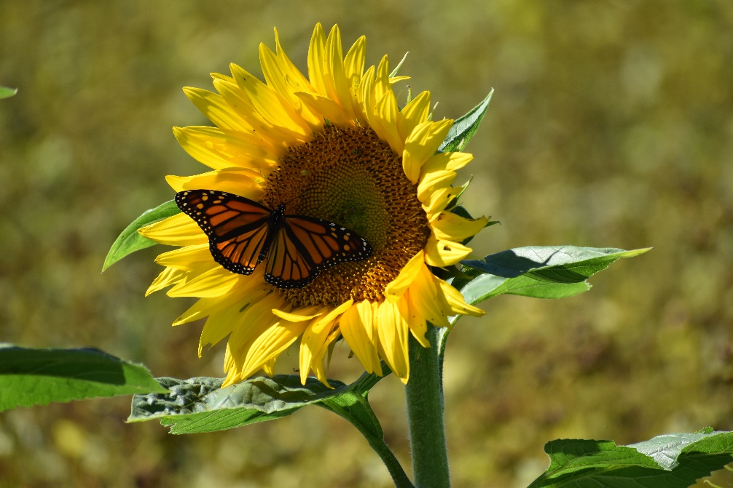
For the next steps, we will be meeting as a group to finalize plans for Summer 2025 pollinator surveys. The PhD student will be visiting representative fields across Iowa to survey pollinators.
Figure 1. Monarch butterfly nectaring on sunflower at USDA-ARS alternative corn-soybean based rotations plots in Summer 2024.

Benefits to Soybean Farmers Soybean farmers will provide this necessary information to help the EPA make science-based changes to their Insecticide Strategy.

Literature Cited:
Clair, A.L.S., Zhang, G., Dolezal, A.G., O’Neal, M.E. and Toth, A.L., 2022. Agroecosystem landscape diversity shapes wild bee communities independent of managed honey bee presence. Agriculture, Ecosystems & Environment, 327, p.107826.
Gill, K.A. and O’Neal, M.E., 2015. Survey of soybean insect pollinators: community identification and sampling method analysis. Environmental entomology, 44(3), pp.488-498.
Levenson, H.K., Sharp, A.E. and Tarpy, D.R., 2022. Evaluating the impact of increased pollinator habitat on bee visitation and yield metrics in soybean crops. Agriculture, Ecosystems & Environment, 331, p.107901.

