Please use this form to clearly and concisely report on project progress. The information included should reflect quantifiable results that can be used to evaluate and measure project success. Comments should be limited to the designated boxes. Technical reports, no longer than 4 pages, may be attached to this summary report.

Project Number:
Project Title: | Developing and releasing high-yielding soybean varieties /germplasm with climate-resilience and genetic diversity across maturity group 00 to VIII.
Organization: | Virginia Tech
Project Lead Name: | Bo Zhang
Report Date: | July 25, 2025
In the Progress Summary section below, please provide a brief summary of project progress in lay language that will be shared publicly in the National Soybean Checkoff Research Database. Do not include any confidential or proprietary information. If no lay language is provided, the contents of this entire report will be published in the National Soybean Checkoff Research Database.

Progress Summary (in non-proprietary lay language suitable to be shared publicly):
For Obj. 1 - Evaluate and release high-yielding soybean varieties with regional adaptation and climate resilience across MG 0 to VIII
Across multiple U.S. regions, our team released and advanced soybean varieties that combine high yield with climate resilience and disease resistance. Virginia Tech released V19-1409RR, a high-yielding, Roundup Ready®, mid V variety that consistently outperformed trial averages in USDA and Virginia state tests. University of Missouri released two conventional MG IV lines, S20-2227 and S20-7117, both resistant to stem canker and yielding over 60 bu/ac across 40+ environments. University of Georgia released G19-13438 and G18-8335LL, which combine strong yield with nematode and disease resistance. USDA-ARS entered 48 elite lines into national regional trials; many performed above 100% of the test mean. University of Arkansas’s line R19C-1035 showed high yield and flood tolerance in multiple trials.
For Obj. 2 - Develop soybean germplasm with diverse genetic backgrounds for climate resilience
To strengthen long-term resilience, we are expanding the genetic base of U.S. soybean breeding programs by incorporating exotic and wild soybean traits. Virginia Tech is testing 65 advanced lines with at least 6.25% exotic ancestry, including wild soybean and elite Chinese germplasm. University of Missouri made crosses using heat- and drought-tolerant donor parents, with progeny under development in Costa Rica. University of Georgia evaluated 38 nematode-resistant lines in national trials and over 1,500 early-generation lines with resistance to biotic stresses. USDA-ARS advanced drought-tolerant lines (N21-0559, N21-0580) with high yields and protein content. University of Arkansas planted more than 18,000 genetically diverse progeny rows and initiated 195 new crosses—including combinations of drought × flood tolerance—to develop multi-stress-resilient soybeans. North Dakota State University developed three new populations by crossing locally adapted lines with SSNF (sustained symbiotic nitrogen fixation) germplasm. From 181 F6 lines, 12 were identified as well-adapted to ND conditions. These will undergo trait confirmation and field testing, supporting reduced fertilizer needs and improved performance under climate stress.
For Obj. 3 - Discover novel genes associated with climate resilience using emerging technologies and methodologies to support breeding efforts.
We are using cutting-edge tools to identify traits and genes that help soybeans survive extreme conditions. Virginia Tech used drone-mounted thermal cameras to monitor 387 soybean accessions for canopy temperature across three growth stages. Machine learning models accurately predicted real temperatures (R² = 0.97), enabling selection for heat resilience. University of Missouri is mapping photosynthetic traits in 250 accessions under heat and drought, while also accounting for genetic population structure. University of Georgia genotyped 170 advanced lines using 6,000 genetic markers, integrating yield and marker data into powerful predictive models. USDA-ARS advanced a yield-enhancing line derived from an exotic parent and evaluated it across 16 environments. University of Arkansas developed genomic models for flood tolerance and screened 400 soybean accessions predicted to be tolerant. These lines are now in multi-environment trials. Together, these innovations allow us to identify key resilience genes and accelerate breeding of soybean cultivars that will thrive in a changing climate.

Detailed Project Status – Expand upon the above section. What key activities were undertaken and what were the key accomplishments during this reporting period? List each key deliverable from the proposal and describe progress made (or not made) toward achieving it, including metrics were appropriate.
Deliverables:
Obj. 1- Evaluate and release high-yielding soybean varieties with regional adaptation and climate resilience across MG 0 to VIII
Virginia Tech (Bo Zhang):
V19-1409RR, released in 2025, is a high-yield, mid-V Roundup Ready® Soybean. In the 16-location 2023 USDA Southern Soybean Uniform Trial, V19-1409RR ranked 6th out of 31 varieties for yield, producing 61.7 bu/ac. In 2024, while tested across 13 locations, V19-1409RR had the 9th best yield performance among 29 varieties, slightly lower than the check AG53XF2 (53.3 bu/ac). Protein content averages 33.5%, oil content is around 20% and meal protein content is 45.0%. In 2024, V19-1409RR entered the Virginia Soybean Performance Test and ranked 3rd out of 14 soybean elite lines with an average yield of 73.7 bu/ac. V19-1409RR outperformed the mean in three out of four locations, such as Eastern Shore, Suffolk, and Warsaw. 15lbs of Breeder seed are available for the 2025 season.
In the 2025 USDA Uniform Trials, a total of 33 lines were entered, distributed across seven different tests (PIV-S-Early, PIV-S-Late, PV-Early, PV-Late, UIV-S-Early, UIV-S-Late, and UV). These lines represent a set of diverse genetic backgrounds and trait profiles, including herbicide-tolerant lines carrying Roundup Ready (RR1 and RR2) and Liberty Link technologies. In addition, several lines were selected for their distinctive seed composition traits, such as high seed protein content, high oil levels, and modified fatty acid content.
University of Missouri (Feng Lin):
We have released 2 conventional soybean lines maturity group IV:
- S20-2227: An early maturity group IV line (MG 4.1) with resistance to stem canker. It has a high oil content (21.4%) and has shown strong yield performance across 41 environments (Table 1).
- S20-7117: A late maturity group IV line (MG 4.6), also resistant to stem canker. It demonstrated consistent yield performance across 40 environments (Table 2).
Table 1. Summary table of weighed seed yield average (bu/ac) with commercial checks within similar maturity groups across all testing environments (2021-2024)
Name | PYT-21 | AYT-22 | COOP-22 | COOP-23 | DU-23 | UP-23 | COOP-24 | DU-24 | UT-24 | Average*
S20-2227 | 65.6 | 56.4 | 68.7 | 60.5 | 51.0 | 58.7 | 64.0 | 58.2 | 60.1 | 61.4
NXT Check Average | 64.0 | 51.2 | 76.4 | 69.6 | 49.4 | 53.7 | 63.1 | 53.3 | 59.5 | 61.7
XT Check Average | 74.3 | 73.7 | 65.5 | 65.5 | 48.6 | 59.9 | 63.2 | 56.6 | 62.0 | 64.6
Test Average | 59.4 | 45.5 | 65.3 | 60.2 | 47.2 | 49.6 | 62.6 | 50.6 | 56.0 | 57.5
% NXT Check | 103 | 110 | 90 | 87 | 103 | 110 | 101 | 109 | 101 | 100
% XT Check | 88 | 77 | 97 | 92 | 105 | 98 | 101 | 103 | 102 | 95
Ranking | 3/48 | 7/40 | 12/40 | 10/26 | 6/17 | 6/15 | 4/16 | – | – | –
LSD (0.05) | 3.8 | 3.0 | 4.6 | 2.8 | 4.6 | 7.5 | 2.8 | 3.6 | 2.2 | –
Locations (n = 41) | 4 | 2 | 5 | 6 | 2 | 7 | 3 | 2 | 7 | –
*Weighted average across all locations.
NXT (Non-Xtend Check): AG 4632, LD15-3818, P41T07E, P42A84E, S13-10592, S13-3851
XT (Xtend Check): AG 35XF1, AG 38XF1, AG 40XF1, AG 41XF2, AG 43X7, AG 43XF2, AG 45X8, AG 46X6, P42A96X
Table 2. Summary table of weighed seed yield average (bu/ac) with commercial checks within similar maturity groups across all testing environments (2021-2024)
Name | PYT-21 | AYT-22 | COOP-22 | COOP-23 | DU-23 | UP-23 | COOP-24 | DU-24 | UT-24 | Average*
S20-7117 | 70.1 | 58.8 | 63.0 | 68.1 | 48.8 | 62.0 | 59.6 | 55.9 | 59.3 | 61.4
NXT Check Average | 61.7 | 41.6 | 66.1 | 71.5 | 53.2 | 62.3 | 50.5 | 55.3 | 62.1 | 59.9
XT Check Average | 75.1 | 60.5 | 74.1 | 72.9 | 66.0 | 69.7 | 62.3 | 61.5 | 65.1 | 68.5
Test Average | 60.5 | 39.8 | 65.8 | 62.5 | 50.4 | 52.9 | 54.2 | 51.0 | 57.3 | 56.5
% NXT Check | 114 | 141 | 95 | 95 | 92 | 100 | 118 | 101 | 96 | 104
% XT Check | 93 | 97 | 85 | 93 | 74 | 89 | 96 | 91 | 91 | 90
Ranking | 4/48 | 4/40 | 7/40 | 14/23 | 21/24 | 9/27 | 23/32 | 22/32 | 7/17 | –
LSD (0.05) | 3.3 | 3.7 | 4.1 | 4.2 | 3.2 | 7.4 | 2.9 | 4.4 | 7.2 | –
Locations (n = 40) | 4 | 2 | 6 | 3 | 2 | 7 | 6 | 2 | 8 | –
*Weighted average across all locations.
NXT (Non-Xtend Check): AG 4835, LD15-3818, P41T07E, P48A14E, P49T62E, S13-10592, S13-3851
XT (Xtend Check): AG 38XF1, AG 43XF2, AG 44XF2, AG 46X6, AG 48X9, P42A96X, P48A60X, AG 52XF0
USDA Uniform Test – MG VI Early
A total of 5 lines (Table 3) will be tested in the USDA Uniform test MCgi V Early this year. Results from Uniform Preliminary Maturity Group IV Early (UP4E) showed that that the top-performing varieties, S22PR-383E3 (54.3 bu/ac), exceeded both checks and the overall mean. S22PR-383E3 is an Enlist that will be entered in the 2025 Uniform Trials (UT4E) for further seed yield evaluation. It is worth noting that S20-25571, a drought tolerant soybean line, yielded 51.7 bu/ac outyielded both Xtend and Non Xtend Check (Table 4). For protein concentration, S21-20276 (35.3%) outperformed the mean (34.5%) and Xtend Check (33.9%), though the Non-Xtend Check (34.8%) showed higher protein performance. Oil concentration was 20.8% for S20-25571, exceeding the mean (19.8%) and Xtend Check (20.3%).
Table 3. Uniform Preliminary Maturity Group IV Early Yield (bu/ac), Protein (%), Oil (%), and Meal Protein (%) Averages Across 8 Environments
Name | Yield  (bu/ac) | Protein  (%) | Oil  (%) | Meal Protein  (%)
S20-25571 | 51.7 | 34.9 | 20.8 | 47.8
S21-11102 | 53.9 | 34.6 | 20.3 | 47.2
S21-20276 | 47.1 | 35.3 | 19.7 | 47.7
S21-22067 | 52.2 | 34.2 | 19.8 | 46.3
S22PR-383E3 | 54.3 | 34.4 | 18.9 | 46.2
Mean | 49.6 | 34.5 | 19.8 | 46.8
Xtend Check | 49.6 | 33.9 | 20.3 | 46.2
Non-Xtend Check | 48.7 | 34.8 | 20.9 | 47.8
Xtend Check = AG 43XF2 and AG 38XF1.
Non-Xtend Check = LD15-3818 and S13-3851C.
USDA Uniform Test – MG IV Late
The top performing lines from USDA Preliminary MG IV late will be tested in the USDA Uniform Test MG IV this year. S21-7836 had the highest seed yield (57.9 bu/ac), surpassing both the test average (50.1 bu/ac) and Xtend Check (54.1 bu/ac). For protein concentration, S21-11972 (35.8%) and S21-6008GT-HOLL (35.3%) exceeded the average (34.5%). Oil concentration was highest for S21-17588LL55 (21.5%), outperforming all checks and the mean (19.6%).
Table 4. Uniform Preliminary Maturity Group IV Late Yield (bu/ac), Protein (%), Oil (%), and Meal Protein (%) Averages Across 8 Environments
Variety/Check | Yield (bu/ac) | Protein (%) | Oil (%) | Meal Protein (%)
S21-11211 | 51.1 | 33.0 | 19.8 | 44.7
S21-15672 | 47.4 | 35.1 | 18.7 | 46.9
S21-20065 | 53.3 | 33.6 | 19.3 | 45.2
S21-7836 | 57.9 | 34.4 | 20.0 | 46.7
S22PR-329E3 | 52.8 | 32.8 | 19.8 | 44.5
Mean | 50.1 | 34.5 | 19.6 | 46.6
Xtend Check | 54.1 | 34.1 | 20.0 | 46.3
Non-Xtend Check | 56.0 | 33.5 | 20.1 | 45.6
Xtend Check = AG 46X6, AG 48X9, and AG 48XF2
Non-Xtend Check = S16-7922
USDA Preliminary Uniform Test
For the USDA Preliminary Test, we submitted a total of 25 soybean lines:
- 3 lines in Maturity Group (MG) III Late
- 10 lines in MG IV Early
- 12 lines in MG IV Late
These entries represent a diverse set of pedigrees, including both Enlist and conventional types, and carry a broad disease resistance package. Based on performance, the highest-yielding lines will be selected for advancement to the USDA Uniform Test.
Table 5. USDA Preliminary Uniform Test Entries by Test Name, Line, and Type (MG III–IV, 2025)
USDA TEST NAME | NAME | TYPE
PIII-S-L | S22PR-260E3 | E3
PIII-S-L | S22-9948 | C
PIII-S-L | S22-1701 | C
PIV-S-E | S22PR-205E3 | E3
PIV-S-E | S22-3121 | C
PIV-S-E | S22-6208 | C
PIV-S-E | S22-4327 | C
PIV-S-E | S22-7485 | C
PIV-S-E | S22-24366 | C
PIV-S-E | S22PR-336E3 | E3
PIV-S-E | S22-16004 | C
PIV-S-E | S22-24401 | C
PIV-S-E | S22-13815 | C
PIV-S-L | S22-13524 | C
PIV-S-L | S22-1294 | C
PIV-S-L | S22-7101 | C
PIV-S-L | S22-4648 | C
PIV-S-L | S22PR-347E3 | E3
PIV-S-L | S22-23421HS | C
PIV-S-L | S22-24339 | C
PIV-S-L | S22-3114 | C
PIV-S-L | S22-8401 | C
PIV-S-L | S22-15639 | C
PIV-S-L | S22-5521 | C
PIV-S-L | S22-8718 | C
PIII-S-L | S22PR-260E3 | E3
PIII-S-L | S22-9948 | C

University of Geogia (Zenglu Li):
Cultivar Release:
Applications for the release of two high-yielding, disease- and nematode-resistant cultivars, G19-13438 and G18-8335LL, have been approved by the University of Georgia Plant Germplasm and Cultivar Release Committee.
- G19-13438 (MG VII, conventional) showed excellent performance in multiple official tests:
  - 109.8% of check mean in the 2023–2024 USDA Uniform Tests
  - 99.1% in the 2022 USDA Preliminary Test
  - 103.2% of the test mean and 101.0% of Woodruff in the 2024 GA SVT test
- G18-8335LL (MG VII, glufosinate-tolerant) also demonstrated strong yield performance:
  - 103.7% of check mean in 2023–2024 USDA Uniform Tests
  - 122.7% in 2022 Uniform Tests
  - 107% in 2021 Preliminary Test
  - 108.3% in 2020 UGA AYT, and 119.2% in 2019 UGA PYT
Advanced Breeding Lines in Regional and UGA Trials:
- In 2025, 62 high-yielding lines—including conventional, RR2XFlex, and Enlist E3 types—were advanced to USDA Southern Uniform and Preliminary Uniform Tests across MG VI–VIII.
- Several top-performing lines were also entered into state variety trials in GA, NC, and SC.
- Based on 2024 data, 170 elite lines were selected for UGA Advanced Yield Trials (AYT) at three locations (GA, AL, LA), with three reps per location.
- In addition, 1500 high-yielding lines (conventional, XtendFlex, Enlist E3) are being evaluated in preliminary trials in Athens and Plains, GA.
Field Evaluation and Management:
Over 10,000 rows of soybean lines at various generations were planted and evaluated in 2025. Field planting and management for all trials and early generations were successfully completed.
USDA (Ben Fallen):
In 2025 a total of 48 entries were entered in the USDA Regional Trials MG 5 – MG 7/8. Twenty-three of the lines were new lines entered for the first year of evaluation. Twenty-five of the lines are being evaluated for either the 2nd or 3rd year. A large percentage of the advanced breeding lines yielded >100% of the test mean. In the 2024 USDA Regional MG V Trial the 5 entries yielded 100% - 106% of the test mean. The protein content of the lines ranged from 96% - 108% of the test mean protein and oil content. After the results from the 2025 trials ~5 lines will be evaluated for potential release.
Table 6. NC Entries in the 2025 USDA Regional Trials and 2024 USDA Regional (MGV) Trial Results.
NC Entries in the 2025 USDA Regional Trials |  |  |  | 2024 USDA Regional MG V Trial Results
Test |  | Test |  |  | % of Test Mean
Preliminary | Entries | Uniform | Entries | Cultivar | Yield | Protein | Oil
MG 5E | 4 | MG 5 | 5 | N19-0004 | 102% | 96% | 108%
MG 5L | 2 | MG 6 | 12 | N19-0042 | 103% | 105% | 99%
MG 6 | 8 | MG 7/8 | 8 | N19-0573 | 106% | 103% | 101%
MG 7/8 | 9 | Total: | 25 | N19-1095 | 102% | 105% | 107%
Total: | 23 |  |  | N19-1097 | 100% | 108% | 106%
University of Arkansas (Caio Vieira):
R19C-1035 (MG 4.7) is a potential release for 2025. It was recently tested in the 2023 and 2024 USDA Uniform Tests, Arkansas Variety Testing (ARVT), and Pre-Commercial (PCM) internal yield tests (Table 7). Similarly, in the ARVT flooding yield trials, R19C-1035 outperformed the test mean with a relative grain yield advantage of 143%. These results indicate that R19C-1035 has high yield potential in irrigated conditions while also providing lower grain yield loss during flooding. R19C-1035 is undergoing herbicide resistance introgression for both XtendFlex and Enlist-E3 technologies.
Table 7. Results from regional trials for R19C-1035
 |  | USDA Uniform |  | AR Variety Testing |  | PCM Tests
Line | Year | bu/ac | % Test | bu/ac | % Test | bu/ac | % Check
R19C-1035 | 2024 | 58.7 | 103.7 | 70.2 | 109.6 | 66.2 | 98.2
R19C-1035 | 2023 | 58.8 | 110.7 | 67.2 | 92.6 | 72.1 | 100.6

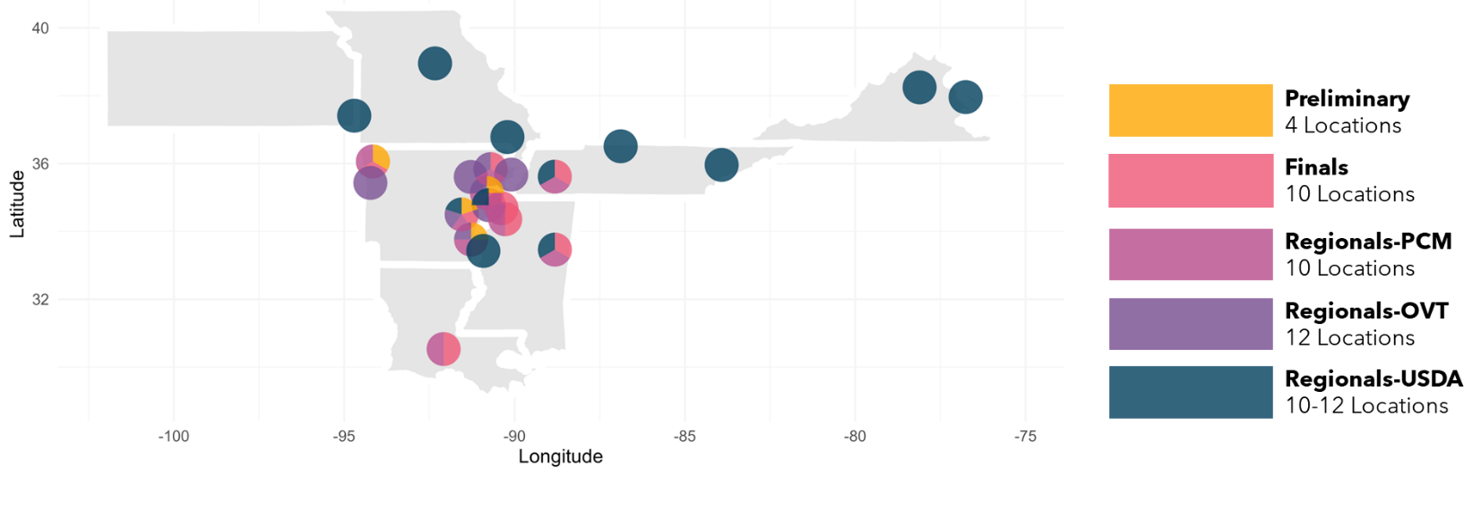
2025 Yield trials: Approximately 35,360 soybean plots were planted in 2025. Yield trials have been conducted across multiple environments in Arkansas and other mid-South states (Figure 1). In summary, 26 materials have been entered in the regional trials (USDA Uniform, OVT, and PCM), 170 in advanced trials, of which 60 are Enlist-E3, 1,720 in preliminary trials, of which 665 are Enlist-E3, and roughly 19,000 progeny rows.

Figure 1. 2025 Testing footprint at the UA Soybean Breeding program.
Obj. 2- Develop soybean germplasm with diverse genetic backgrounds for climate resilience
Virginia Tech (Bo Zhang):
To strengthen the genetic foundation of U.S. soybean germplasm for climate resilience, we are actively incorporating exotic and wild soybean accessions into our breeding pipeline. In the 2025 USDA Uniform Soybean Trials, five advanced breeding lines—spanning maturity groups Late III, Early and Late IV, and Late V—are under evaluation. These lines contain 6.25% to 12.5% exotic pedigree. For example, V21-2059DIR1, a Late Group V line, contains 12.5% pedigree from PI 574477 from China. This line also carries the Roundup Ready trait, demonstrating our efforts to combine agronomic performance with genetic diversity.
Complementing these national trials, the 2025 Virginia Tech yield trials include 65 experimental lines with exotic pedigrees representing at least 6.25% non-U.S. ancestry. Several lines have pedigrees with 50% exotic contributions. Notable examples include ‘Shennong027’ and ‘Shennong Black 7’, elite parents from Northeast China, and ‘Maroof-261’, a breeding line derived from wild soybean. These materials are being tested across multiple environments to identify resilient, high-performing genotypes.
University of Missouri (Feng Lin):
We made 8 different crosses last year to introduce traits related to climate resilience, such as drought and heat stress tolerance. The donor parents, which possess natural tolerance to high temperatures and low moisture conditions, were used in these crosses. The F1 seeds were sent to Costa Rica for population development, aiming to incorporate these valuable traits into our elite breeding lines. The progeny will be coming in 2026 as progeny rows.
Table 8. Crosses made for the summer of 2024
CROSS | PEDIGREE
1 | PI 471938/PI 684675
2 | S16-13165/PI 684675
3 | R18C-13665/S16-13165
4 | LD20-11622/R18C-13665
5 | S16-9090/R18C-13665
6 | LD20-6649/S16-9090
7 | LD20-6649/S16-13165
8 | S16-13165/R18-14502
This year, we plan to incorporate new lines from RILs and drought-tolerant sources by crossing them with high-yielding, flood-tolerant lines.
CROSS | PEDIGREE
1 | S20-4428/S19-10701
2 | S20-1492/S16-13165
3 | S20-25571/RIL035
4 | S16-13165/RIL227

University of Geogia (Zenglu Li):
Genetic Resistance and Trait Stacking:
- G19-13438 exhibits resistance to SCN races 2 and 5, southern and Javanese root-knot nematodes, frogeye leaf spot, and stem canker, with moderate resistance to SCN race 3 and peanut root-knot nematode.
- G18-8335LL carries stacked resistance to southern and Javanese root-knot nematodes, frogeye leaf spot, stem canker, and moderate resistance to SCN race 3 and peanut RKN.
Breeding Pipeline for Resistance:
- In 2025, 38 SCN- or RKN-resistant lines were advanced to the USDA Preliminary Yield Trials in MG VI–VIII.
- 170 additional lines with nematode resistance are being evaluated in UGA AYT across three locations.
- Over 1500 early-generation lines include resistance traits targeting key regional pests (e.g., SRKN and SCN race 3).
Molecular Breeding and Marker-Assisted Selection:
Continued genotyping and QTL confirmation for SCN resistance is ongoing, supporting the development of genetically diverse, climate-resilient germplasm.
USDA (Ben Fallen):
In a previous report a table was presented of new breeding lines that were developed with the goal of increasing genetic diversity, enhancing drought tolerance, and improving protein content while maintaining competitive yield performance. These lines incorporate PI 416937 and PI 407859, which are known sources of drought tolerance. N21-0559 and N21-0580 exhibited a wilting score of 2.0, indicating strong drought resistance comparable to N7006 (1.5), a recently released slow wilting cultivar. The commercial check (AG53X9) had the highest wilting score (3.5), reinforcing that the newly developed lines offer improved stress tolerance over existing commercial varieties. Several lines showed higher protein content than the commercial check (40.7%), with N21-0559 (44.5%) and N21-0580 (45.3%) exhibiting a ~5% increase. The protein levels across these lines indicate substantial improvements in seed composition, making them valuable for both agronomic and nutritional purposes. N21-0559 and N21-0580 out yielded the commercial check AG53X9 by 6 and 8 bu/ac, respectively. These newly developed soybean lines successfully integrate genetic diversity, drought resilience, and enhanced protein content. These two lines, N21-0559 and N21-0580, were entered into the Southern Uniform Preliminary MG 5 Late and MG 6 tests in 2025, respectively. In addition, both lines are being reevaluated for agronomic performance under irrigated and drought stress field conditions in 2025.
University of Arkansas (Caio Vieira):
2025 Progeny rows: A total of 18,849 F4:5 progeny rows derived from 181 bi-parental populations are being grown in Stuttgart, Arkansas. About 15,319 rows are derived from genetically and/or geographically diverse parental lines. Rows will be visually selected based on uniformity, pod load, and maturity. All selected lines will undergo genotyping with the Soy3KSNP to explore the potential of genomic prediction in identifying and selecting superior untested genotypes, as well as a proprietary molecular marker panel for multiple biotic and abiotic stressors.
2025 Crossing Block: A total of 56 conventional and 5 Enlist-E3® converted elite parental lines were entered in our crossing block. Over 87% of the parental lines in the crossing block have genetic and/or geographical diversity. Lines from other breeding programs and plant introductions from the germplasm bank are being used to introduce economically important traits such as resistance to biotic and abiotic stresses and improved seed composition, helping to diversify Arkansas germplasm. A total of 195 crossing combinations have been designed and will be conducted this summer. Combinations include wide crosses between northern and southern germplasm, Arkansas germplasm by PI-derived and PI materials, as well as Arkansas germplasm by high-yielding materials from other programs. It is worth mentioning that several drought-tolerant by flood-tolerant combinations were made, aiming to combine both water stress-related tolerance under a high-yielding background.
North Dakota State University (Carrie Dottey):

Sustained Symbiotic Nitrogen Fixation (SSNF) Trait Advancement Update: to develop North Dakota adapted soybean lines with the sustained symbiotic nitrogen fixation (SSNF) trait, three populations were created by crossing North Dakota breeding lines with SSNF-validated germplasm obtained from the University of Arkansas. The Arkansas lines, R01-581F and R01-416F, were acquired in October 2022 and had previously been validated for SSNF expression and yield retention compared to non-SSNF lines. Crosses were initiated in early 2023 in the North Dakota State University Dalrymple Greenhouse complex utilizing growth chambers set to daylengths characteristic of each parent’s maturity group.

The selected North Dakota parent, ND16-7175, was chosen due to its iron deficiency chlorosis (IDC) tolerance, with IDC scores ranging from 1.3 to 2.1 in two years of uniform trials (2019 and 2020). ND16-7175 is a maturity group (MG) 0.8 line and was the second highest yielding entry in the 2020 MG 0 Northern Uniform Trials, averaging 53.4 bu/ac across three locations. An additional North Dakota parent, ND17-26003(GT), was included to combine SSNF with glyphosate tolerance.

Table 9. Population Pedigrees and Development Timeline
Population | Pedigree | Parent Attributes | Purpose
1 | ND17-26003(GT) × R01-581F | ND17-26003: ND-adapted, glyphosate tolerant; R01-581F: SSNF, validated for yield retention | Introgress SSNF into glyphosate-tolerant ND background
2 | ND16-7175 × R01-581F | ND16-7175: High yield, IDC tolerance, MG 0.8; R01-581F: SSNF, yield-retaining | Incorporate SSNF into high-yield, IDC-tolerant ND background
3 | ND16-7175 × R01-416F | Same ND parent as above; R01-416F: SSNF, yield-retaining | Broaden SSNF genetic base in ND-adapted backgrounds

Early Generation Advancement: Four F₁ seeds were harvested in June 2023 and immediately replanted to produce F₂ seed. Four F₂ plants were single-plant threshed and placed in separate envelopes. The envelopes of F₂ seed from the three populations were shipped to the Costa Rica winter nursery in November 2023 for expedited advancement. Plants were progressed using a modified single pod descent method from F₂ to F₅. In February 2025, F₅ plants were single-plant threshed and increased as single rows. A total of 181 F₆ lines were received in May 2025.

Adaptation Screening: Single-marker analysis of the E maturity genes was conducted using simple probe markers as described by Tsubokura et al. (2017). Of the 181 F₆ lines tested, 12 were identified as adapted to North Dakota. The narrow selection was expected due to the broad cross of MG 0 × MG V parents.
Table 10. Summary of Screening Results for ND-Adapted F6 Lines with SSNF Trait (May–June 2025)
Screening Summary (May–June 2025) | Result
Total F6 lines screened | 181
Lines identified as ND-adapted | 12
Marker platform | Simple probe markers for E genes

Summary: In the Costa Rica winter nursery, early-generation advancement of three populations segregating for the sustained symbiotic nitrogen fixation (SSNF) trait; introgressed from University of Arkansas lines into North Dakota–adapted backgrounds; continued through February 2025. Plants were single-plant threshed and grown out as rows to increase seed.
In May 2025, we received 181 F₆ lines from these populations. Single-marker analysis of the E maturity genes was conducted to identify lines adapted to North Dakota growing conditions. Given the broad genetic cross between MG 0 and MG V parents, only 12 of the 181 lines were identified as adapted.
A postdoctoral researcher has been hired to oversee this project and will begin on July 16, 2025. The next phase involves greenhouse-based phenotyping to confirm the presence of the SSNF trait in these lines. Once confirmed, the project will proceed in two directions:
- Genetic characterization – Identify the underlying genetics controlling the SSNF trait.
- Field evaluation – Conduct yield trials under both dryland and irrigated conditions to determine the impact of SSNF on yield protection.
Obj. 3- Discover novel genes associated with climate resilience using emerging technologies and methodologies to support breeding efforts.
Virginia Tech (Bo Zhang):
The soybean diverse panel, containing 387 accessions, was scanned by DJI Mavic 3 Thermal drone throughout three growth stages, which are R3 (beginning pod), R4 (full pod), and R5 (beginning seed). The thermal images were then processed with orthomosaic, reflectance map generation, segmentation, feature extraction, and extracted plot-based data.
The canopy temperature estimated by UAS must be calibrated using thermal reference panels with known surface temperatures at the time of image acquisition. During the last season, 73 data points were collected, each accompanied by corresponding environmental conditions. Four machine learning models were trained to predict actual temperature from UAS-derived values, and among them, the multiple linear regression (MLR) model achieved the highest prediction accuracy (R² = 0.97) and the lowest mean squared error (MSE = 5.26) (Figure 2).
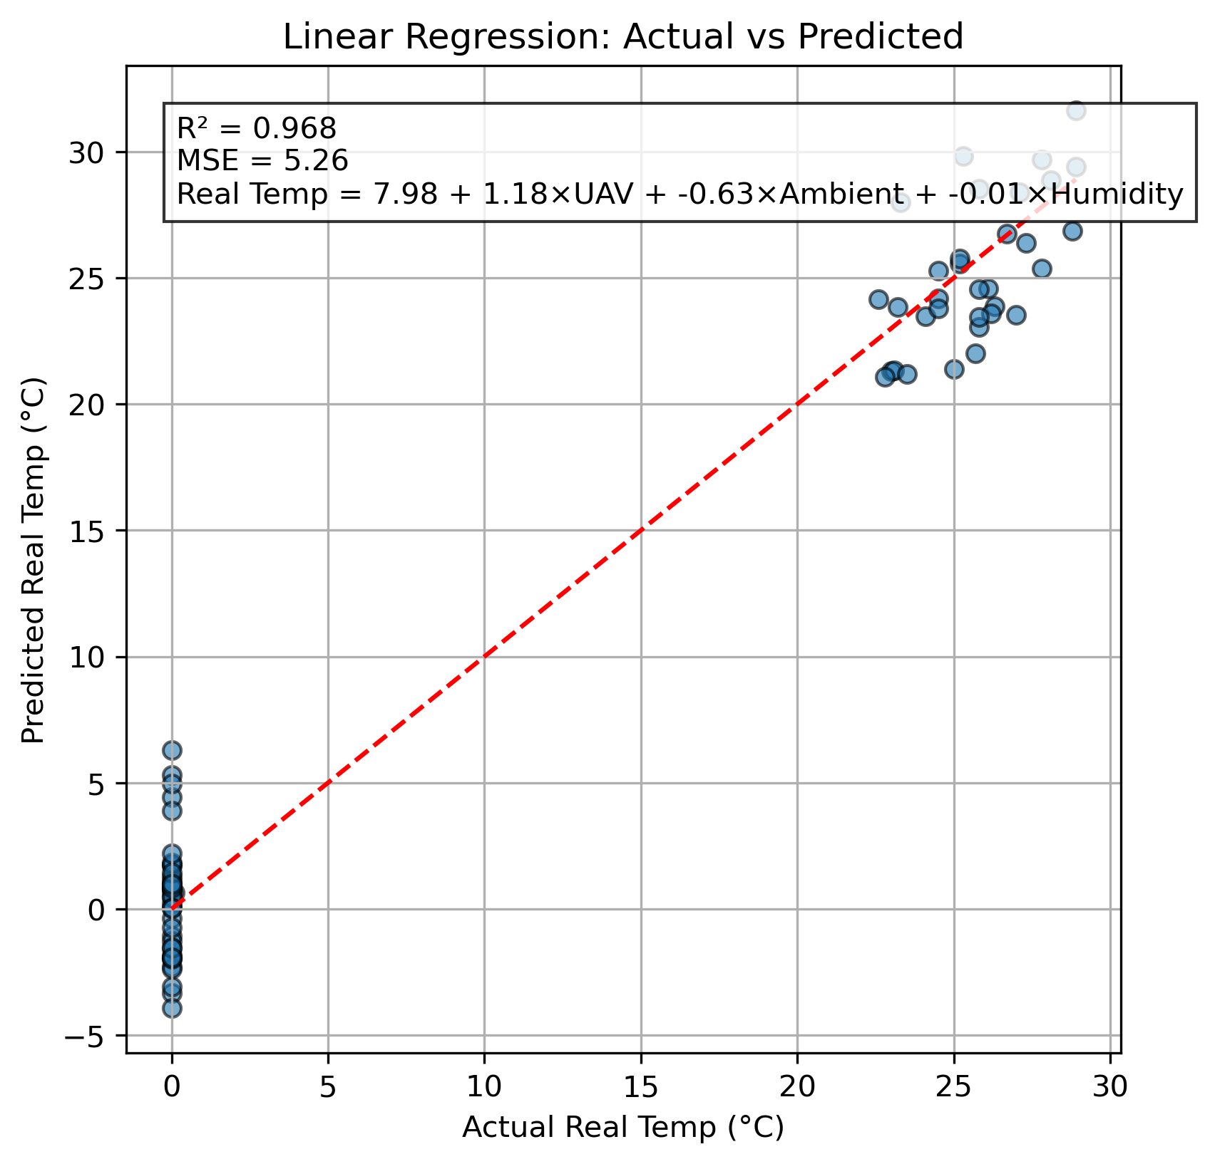
Figure 2. Actual V.S. predicted temperature of MLR model.
The distribution of canopy temperature follows a bell-shaped curve (Figure 3), reflecting the quantitative genetic nature of this trait and the broad genetic diversity present in our association panel. This is further supported by the ANOVA results, which show that the line effect contributes significantly to the observed phenotypic variance (Table 1). In addition, the effects of growth stage, location, and their interactions are also significant, likely due to differences in canopy structural development and the distinct microclimates of each site. These findings suggest that while canopy temperature is highly influenced by environmental conditions, it remains comparable across genotypes under similar environmental settings.

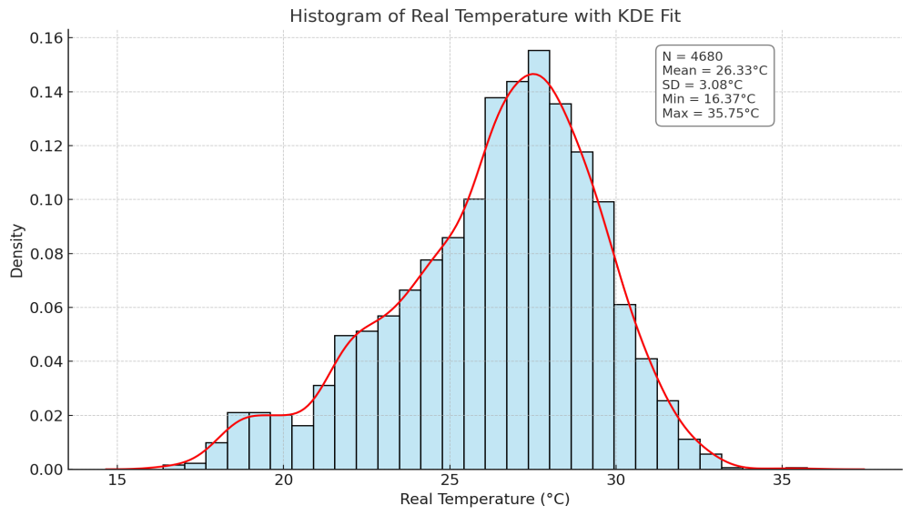
Figure 3. Distribution of canopy temperature.
Table 11. The ANOVA table of line, location, growth stage, and interaction effects.
SOV | DF | Sum Squares | Mean Squares | F Ratio | Prob > F
Line | 389 | 244.13 | 0.628 | 1.87 | <0.0001
Rep(Location) | 2 | 34.73 | 17.37 | 51.85 | <0.0001
Stage | 2 | 4405.48 | 2202.74 | 6577.58 | <0.0001
Location | 1 | 111.13 | 111.13 | 331.86 | <0.0001
Location*Stage | 2 | 2823.98 | 1411.99 | 4216.34 | <0.0001
Error | 4283 | 1434.32 | 0.3349
Correlation analysis revealed a moderately strong positive relationship between canopy temperatures at the R3 and R4 growth stages (r = 0.69) (Figure 4), indicating the presence of genotypes with consistently superior performance across both stages. This finding suggests that breeding efforts targeting elite lines with stable canopy temperature across developmental stages are feasible.
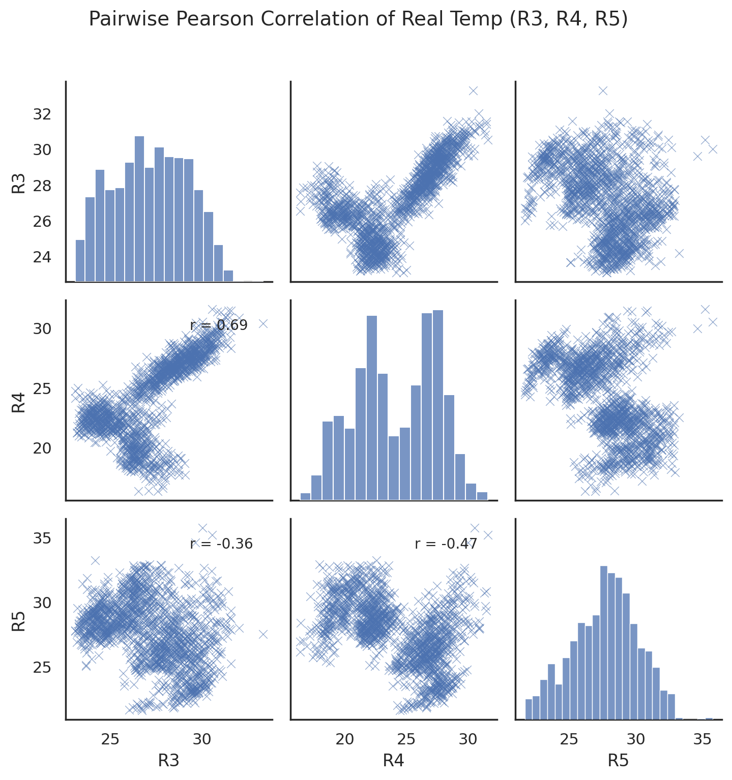
Figure 4. Correlation analysis of canopy temperature across multiple growth stages.
These results show the importance of considering stage-specific genetic control. These distinct results can reflect dynamic physiological and developmental processes, where genes can become relevant at different stages, switching locus and their influence. The 2025 soybean diverse panel results will be combined with the current data, and a multi-year trait association analysis will be conducted.
University of Missouri (Feng Lin):
Currently, we are conducting preliminary data analysis to assess the variability in photosynthetic traits across the diverse soybean panel of 250 PI accessions. Population structure analysis has been conducted to understand genetic diversity and relatedness among accessions, which will aid in refining the genome-wide association study (GWAS). Additionally, trait correlations under varying temperature conditions are being evaluated to identify trends in photosynthetic performance linked to heat stress resilience. Preliminary findings suggest traits related to light energy utilization and photosynthetic efficiency show promising association with stress response.
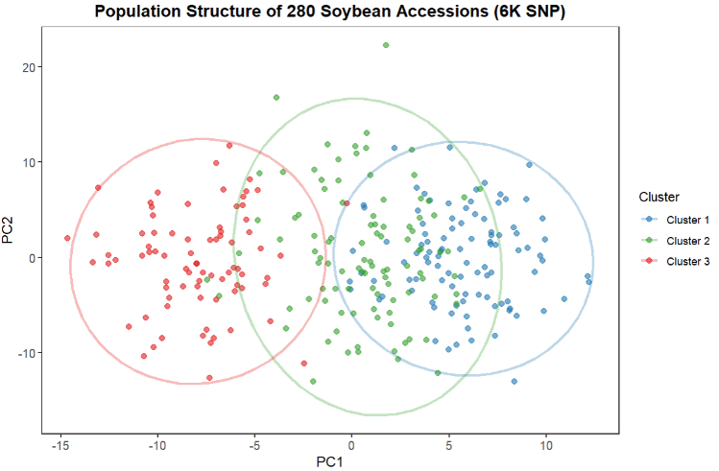
Figure 5. Population structure of 300 soybean accessions using subset 6K SNP from 50K SNP
The Principal Component Analysis of 28 soybean accessions (MG 3–5) genotyped with 6K SNPs reveals 3 overlapping clusters, indicating moderate population structure. While distinct ancestry groups are evident (possibly historical breeding pools or geographic origins), the partial overlap between clusters suggests shared genetic variation, possibly due to gene flow or convergent selection for thermotolerance. This structure aligns with the experimental design of phenotyping across temperature-variable field sites, where genetic divergence may underline observed trait variability in heat responses. The findings underscore the need to account for population stratification in GWAS to avoid spurious associations while leveraging admixed accessions to identify stable QTLs across environments.
This season, the 250 PI lines were planted at two locations: Fisk, MO and Ridgway, IL. Photosynthetic activity will be recorded once the plants reach the R2 to R3 growth stages. The Ridgway location is under rainfed conditions, while the Fisk location is irrigated using furrow irrigation. Each plot consists of a single row, 7 feet long. In addition, we will collect soil samples at both locations to include soil data as covariates in the analysis.
Publication:
- Harmeet Singh-Bakala, Francia Ravelombola, Cheryl Adeva, Maiara Oliveira, Ru Zhang, Jessica Argenta, Grover Shannon and Feng Lin. (2025). Harnessing Photosynthetic and Morpho-Physiological Traits for Drought-Resilient Soybean: Integrating Field Phenotyping and Predictive Approaches. Frontiers in Plant Physiology, section Photosynthesis and Metabolism. In Press
University of Geogia (Zenglu Li):
Over the past several years, we have developed genomic prediction models using genome-wide SNP markers and advanced materials, which have been successfully used to predict the superior cross combinations and select for the yield in early generations which were used for cross prediction and progeny selection in 2024. During 2025, we genotyped 170 advanced lines which were advanced to the 2025 advanced yield trials using 6,000 SNP markers. These lines are being yield-tested at 3 locations with 3 reps per location in 2025. The data sets, including both genotypic and phenotypic data, have been added to our existing large dataset to make a total of over 2000+ lines. The dataset will be used to optimize the training set for prediction of line performance. The updated models will be used to predict superior cross combinations and select plant rows in 2026 to develop high yielding and climate resilient soybean cultivars
USDA (Ben Fallen):
NDPJE-14-217 was developed from a cross between Clifford and N07-14221, a breeding line derived from N7002, a determinate MG VII cultivar released because of its excellent yield potential and traces 25% of its pedigree to PI 416937, which originated from Japan. N7002 was used as a source of exotic yield alleles to determine the potential impact for improving soybean yield in earlier maturing soybeans (MG V). Although NDPJE-14-217 was shown to only carry the PI 416937 allele at one of the two loci evaluated, the yield advantage was significant. NDPJE-14-217 was evaluated across 16 environments (Table 12). The yield of NDPJE-14-217 (57.6 bu/a) was statistically similar to the test mean (57.0 bu/a) and higher than Clifford (51.7 bu/a). No difference was observed with the checks Ellis (56.4 bu/a), Osage (60.1 bu/a) and UA 5814HP (56.7 bu/a). The maturity of NDPJE-14-217 was only one day later than Clifford (17 d), three days later than (15 d) and two days later than Osage (16 d). There was no statistical difference between the protein and oil content between NDPJE-14-217 (36.0%;19.3%) and Clifford (35.5%; 19.2%). The protein content of UA 5814HP (38.8%) was statistically higher, while the oil content (18.2%) was lower than NDPJE-14-217.
Table 12. Mean performance and seed composition of NDPJE-14-217, parental line Clifford and check cultivars evaluated across 3 years and 16 environments.
 | Yield | Height | Maturity | Seed Size | %Protein | %Oil | %Meal
Cultivar | (bu/a) | (in) | Oct.1=1 | (g/100sd) | (13% moisture basis) |  | Protein
NDPJE-14-217 | 57.6 | 27 | 18 | 15.6 | 36.0 | 19.3 | 48.5
Clifford | 51.7 | 26 | 17 | 14.3 | 35.5 | 19.2 | 47.8
Ellis | 56.4 | 25 | 15 | 12.1 | 35.3 | 18.9 | 47.3
Osage | 60.1 | 25 | 16 | 12.7 | 37.1 | 18.4 | 49.5
UA 5814HP | 56.7 | 32 | 24 | 15.2 | 38.8 | 18.2 | 51.6
Test mean | 57.0 | 27 | 19 | 14.1 | 36.5 | 18.8 | 48.8
LSD_{0.05} | 5.6 | 3 | 3 | 0.9 | 1.0 | 0.5 | 1.2
University of Arkansas (Caio Vieira):
Flooding tolerance: We currently have multiple ongoing studies, including bi-parental mapping populations, diverse panels, and breeding lines, to further understand the genetic architecture of flood tolerance in both early vegetative and reproductive growth stages. The study included in the previous report is about to be accepted at The Plant Genome. The model developed in the study was used to predict the entire USDA Germplasm Collection, identifying roughly 400 plant introductions that have an extreme response to flooding. We are growing this set of materials under both vegetative and reproductive flooding stress, and pending results may be used to develop breeding populations.

