A Soybean Crop Model Calibrated and Validated for Minnesota Field Conditions
The goal of this project is to generate a tool capable of predicting soybean yield under specific management (planting date, plant population, inter-row spacing) according to the soil, the tillage, the genotype, and the weather for fields all along Minnesota.
Objective: Calibrate and validate a crop simulation model using crop data generated across Minnesota.
We are currently calibrating and validating the CROPGRO model, that runs in the Decision Support System for Agrotechnology Transfer platform (DSSAT; https://dssat.net/), for Minnesota field conditions. We started to use local data generated by previous projects conducted in the Lab from which we have all the agronomic information. An example of the current state of the model is presented in the figure above where we are comparing observed and predicted yield for different planting dates and maturity ratings. The mean absolute error for this exercise was less than 6 bu per acre.

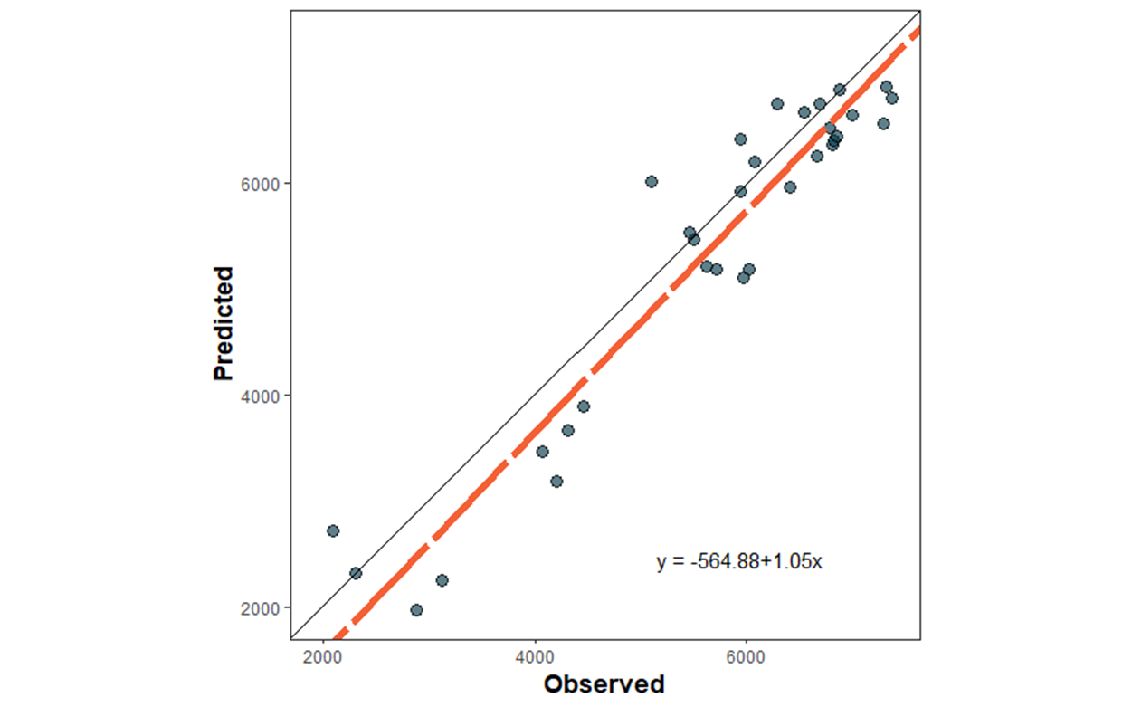

Currently we are collecting more data from different agronomic situations to continue with this process. Data is being generated in different experiments that we are conducting:
- Three soybean intensification experiments, two on-farm and one under controlled conditions.
- Four planting date by maturity experiments in different locations (Waseca, Grand Rapids, Crookston, and St. Paul)
- Ten commercial fields in different locations.
- Four controlled experiments on campus.
- Two dedication experiments in different locations.
In this way we are generating close to 100 different new crop situations that will help us to increase the model's predictive ability and also its precision.
Once calibrated and validated to local conditions, the model will be used to simulate some crop management exercises for different locations across Minnesota.

