Evaluation of seed treatments to manage combined infections if interveinal chlorosis
causing pathogens and soybean cyst nematodes

Principal Investigator: Venkat Chapara

Research Overview:
Interveinal chlorosis (yellowing between leaf veins) and leaf necrosis (tissue death) of soybean foliage, exacerbated by Soybean Cyst Nematode in the same field, has been reported to cause significant yield losses in soybeans globally. Similar infections, in conjunction with SCN, were identified on a soybean variety at Langdon Research Extension Center (LREC). Most of the samples were confirmed to be Brown Stem Rot (BSR) infections through molecular analysis. The symptoms of interveinal chlorosis and tissue death led to a decline in crop growth, and a significant reduction in yield was recorded at LREC over the past two seasons—an urgent need to address the research on the management of this disease in Soybeans in North Dakota.

Objective:
The current objectives were to evaluate various seed treatments to manage the interveinal chlorosis associated with Soybean Cyst Nematode and identify the pathogens responsible for the disease-causing interveinal chlorosis and tissue death besides BSR.

Progress of Work:
We have completed the year one field trial. Some seed treatments showed promising results in managing interveinal chlorosis with significant yields. The trial was conducted as follows.

Materials and Methods:
This research trial was conducted at the Langdon Research Extension Center with an objective to evaluate the performance of seed treatments to manage interveinal chlorosis in soybeans. The trial was planted on May 17, 2024 with treated seed of various treatments on the soybean cultivar ‘GT210086T20’ and compared with non-treated seed. The design was randomized complete block with four replications. The trial followed state recommended practices for land preparation, fertilization, seeding rate, weed and insect control. The plot size was 5 ft. wide x 16 ft. long. Interveinal Chlorosis was rated for foliar disease incidence (DI) and disease severity (DS) in the middle two rows of each plot at full seed to beginning maturity (R6 to R7) growth stages. DI refers to the percentage of plants with Interveinal Chlorosis foliar disease symptoms, and disease severity (DS) was rated using a 1–9 scale where 1 refers to low foliar disease pressure and 9 refers to the premature death of the plant. The foliar Interveinal Chlorosis disease index (FDX) was then calculated using the equation FDX = DI × DS/9 (Table 1). The plots were harvested with a Almco plot combine, and yields were calculated and adjusted to 13% moisture prior to analysis. Data was subjected to analysis of variance using complete block, balanced orthogonal designs of Genovix Generation II software.

Results to Date: Soybean seed treated with Trunemco®, Ilevo®, and Dynasty® had the lowest interveinal chlorosis FDX. These results are significantly statistically different from the other treatments tested. The seed treatments Trunemco® followed by Intego Solo®, Dynasty®, and Rancona Summit® showed significant difference in yield from the non-treated check (Table 1).

Table 1: Effect of fungicide seed treatments on mean plant stand, phytotoxicity, interveinal chlorosis (disease) incidence, severity, yield and test weights.

 | Rate
 | Fl oz/100lbs | Interveinal Chlorosis | Plant Stand | Plant Vigor | Yield | Test Weight
Treatment | (140,000) seed | FDX** | in 3ft length | (1 to 5 scale) | (bu/a) | (lbs/bu)
Ilevo | 3.62 | 5 | 5 | 3 | 42 | 58
Saltro | 3.04 | 8 | 4 | 3 | 37 | 58
Trunemco | 0.31 | 5 | 5 | 3 | 48 | 58
Dynasty | 0.459 | 5 | 4 | 3 | 44 | 58
Non-Treated | CHK | 21 | 5 | 3 | 37 | 58
Intego Solo | 0.148782 | 6 | 6 | 4 | 46 | 58
Rancona Summit | 4 | 6 | 5 | 3 | 44 | 58
Trilex | 1 | 16 | 4 | 3 | 39 | 58
 | Mean | 8.8 | 4.5 | 3 | 42 | 58
 | CV% | 57 | 34 | 10.5 | 12 | 0.46
 | LSD | 7.4 | 2.2 | 0.48 | 7 | NS
 | P-Value | 0.0289* | NS | 0.0151* | 0.0252* | NS
* Indicates the treatments have significant differences at P-Value 0.05
**FDX: Normalized Disease Index: 0-100 scale incidence*severity/9
NS: Indicates the treatments have non-significant differences at P-Value 0.05

Work to be Completed:
- Determination of SCN population in the treatments in mid-season after the treatment applications.
- Isolation and identification of the isolated fungal cultures from the infected roots and stems.

Other relevant information: Heavy rains caused poor germination if the soybean plants in the treatments. Interveinal chlorosis symptoms were conspicuous in the trial and was considerable to cause yield losses (Figure 1).
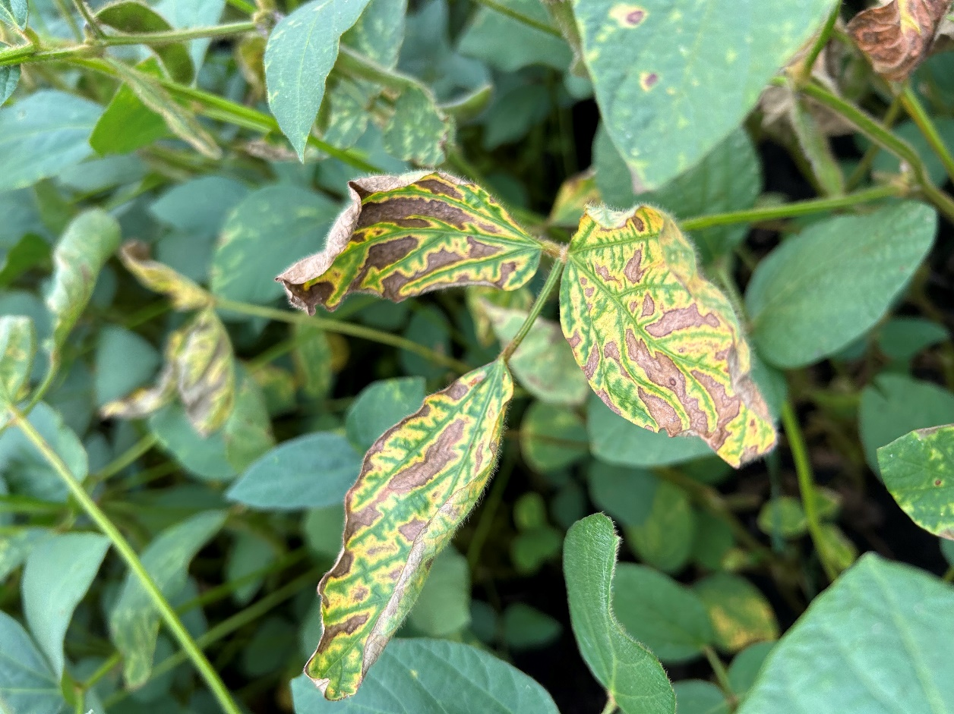
Figure 1: Interveinal chlorosis observed on soybean leaves in the seed treatment trial.

Summary:
Among the seed treatments tested this summer, the seed treatment Trunemco™ (Bacillus amyloliquefaciens + CIS-Jasmone) showed the lowest normalized disease index (NDI) and the highest yield compared to six other seed treatments and a non-treated check. The continuation of this research for two more years holds the promise of adding a management option to combat the interveinal chlorosis caused by the combination of BSR and SCN.
Acknowledgements: Special thanks to Brock Freer, Kartheek Chapara, Carter Mosher and Tucker Gellner

