Research project title: Evaluating soybean genotype differences to soil acidity
Principal and Co-Investigators: Qi Zhang (PI), Carrie Miranda (CO-PI), Larry Cihacek (CO-PI), Leandro Bortolon (CO-PI)
Research overview and objectives
Soil acidity is a growing problem in western North Dakota. High soil H⁺, alone or in combination of high Al³⁺ (a common problem in acid soil), inhibits plant growth and development, water/nutrient uptake, and interaction with soil microorganisms, resulting in reduced crop yield and increased sensitivity to other stresses (such as drought). Use of tolerant plants can help alleviate stress. Although there are soybean evaluation trials conducted in western ND that possibly encounter soil acidity, more detailed research is needed because of large variations of soil acidity (e.g. severity and spatial distribution) from site to site even in the same field. We are proposing this research to evaluate genetic differences of acidity tolerance in soybean. This project has two specific objectives: (1) quantify morphological and physiological responses of soybean genotypes to acidity in a hydroponic system and (2) validate the observations from the hydroponic system in a soil system with nodulation. Such information will help soybean growers who are challenged by soil acidity to address the problem directly. Our result will also assist soybean breeders identifying possible parental lines with high stress tolerance and providing reliable method/selecting index to facilitate the screening process.
Completed work
This is a 2-yr project (July 2024 – June 2026). We are reporting the work from July – Dec. 2024, which has been focusing on developing a screening protocol in order to quantify morphological and physiological responses of soybean genotypes in a hydroponic system (i.e. Objective 1).
Progress of work and results to date
An experiment was conducted to develop a hydroponic protocol to evaluate the effects of pH and aluminum (Al) on early growth of soybean plants. Briefly, soybean seeds were germinated in petri dishes and transplanted to a hydroponic system 4 – 5 days after germination. After one-week of acclimation, plants were exposed to a combination of 2 pH (4.0 vs. 6.5) and 2 levels of Al (0 vs. 200 µM). The concentrations of pH and Al were selected based on previous literature and visual observation from a preliminary study conducted in my lab. The hydroponic solutions were refreshed once weekly and pH was monitored daily and adjusted when needed. Plants were harvested three weeks after the stress exposure.
The results showed a significant pH x Al interaction in all five growth indices measured (P ≤ 0.05). At pH of 4.0, Al inhibited shoot and root growth (both length and biomass) in soybean seedlings (Table 1; Picture 1). However, as pH increased to 6.5, no differences were observed in tissue biomass between the plants treated with and without Al, although those treated with Al showed higher root and shoot length. The results indicate that acidity (i.e. low pH) and Al have limited negative effects on soybean growth when either of them occurred alone; however, severe damage may be observed when acidity and Al occur together.
Table 1. Soybean seedling growth as affected by pH and aluminum.
Treatment |  | Root length  (cm) | Shoot length  (cm) | Root dry weight  (g) | Shoot fresh weight  (g) | Shoot dry weight  (g)
pH | Aluminum
4.0 | 0 µM | 29.9 a^{z} | 36.1 a | 0.19 a | 7.75 a | 1.22 a
4.0 | 200 µM | 18.5 c | 27.8 bc | 0.14 b | 4.84 c | 0.81 c
6.5 | 0 µM | 21.9 b | 27.7 c | 0.13 b | 5.05 bc | 0.86 bc
6.5 | 200 µM | 28.1 a | 30.1 b | 0.16 ab | 5.88 b | 0.97 c
^{z}Means followed by the same letters in a column are not significantly different at P ≤ 0.05 level.
d
c
b
a
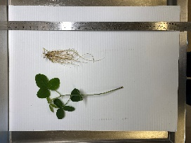 | 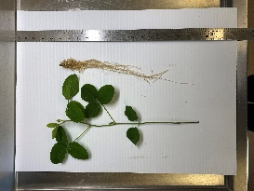 | 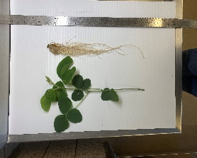 | 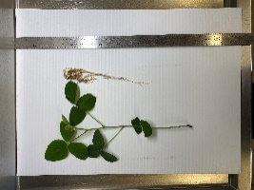
Picture 1. Soybean seedlings after three weeks of pH 4.0 with Al at 200 µM (a), pH 4.0 without Al (b), pH 6.5 with Al at µM (c), and pH 6.5 without Al (d).
Work to be completed
Another experiment is currently ongoing to fine toning the screening protocol, with modifications on pH (4.0 vs. 6.0) and Al (up to 500 µM), followed by genotype screening on acidity. Dr. Bortolon is contacting farmers and scouting fields to locate sites for soil collection in the spring, 2025 to validate the results observed from the hydroponic system.
Other relevant information
We don’t anticipate any barriers to achieving the objectives of this research.
Summary
Soil acidity, alone or in combination with Al, may interfere with plant growth and development. From our research, soybean was insensitive to acidity (pH = 4.0) or Al (200 µM) when either stress was applied alone in a hydroponic system. However, the combined acidity and Al condition reduced root and shoot elongation and biomass.

