- Project title: Investigation of Herbicide Resistance in Tall Waterhemp and Palmer amaranth Populations and Management in New York (NY) Soybean Fields

- Investigator(s) name, contact information, and affiliation: Vipan Kumar, Associate Professor of Weed Science, Cornell University, Soil and Crop Sciences Section, 1115 Bradfield Hall, Ithaca, NY 14853. E-mail: vk364@cornell.edu; Phone: (607)-255-2212

- Specific research objectives:
- Investigate the distribution, frequency, and the level of evolved resistance to commonly used herbicides (glyphosate, 2,4-D, dicamba, glufosinate, lactofen, and ALS inhibitors) in tall waterhemp and Palmer amaranth populations from NY soybeans fields.
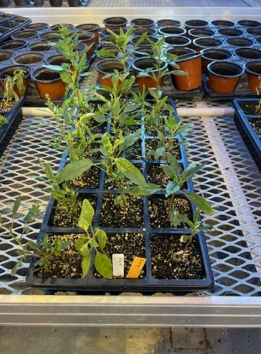
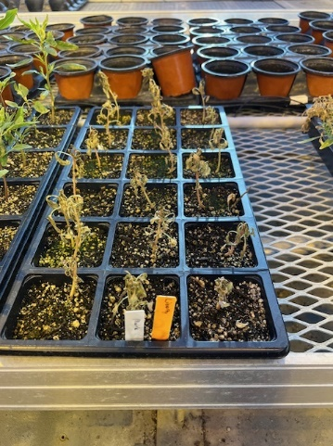
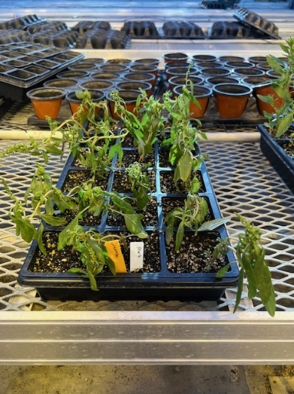
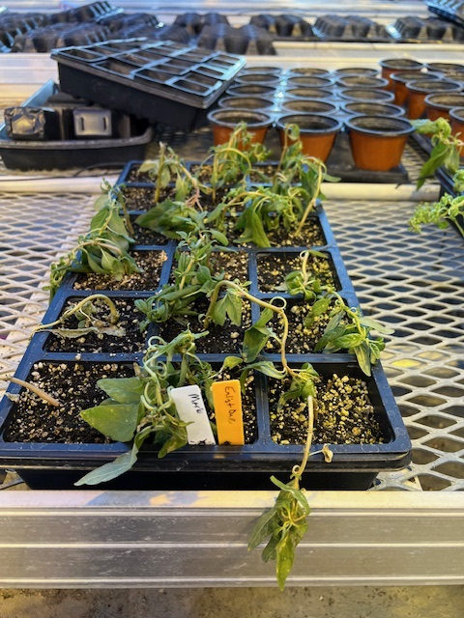
Seeds of tall waterhemp and other weed populations collected from NY soybeans fields were cleaned. Seeds of ten tall waterhemp populations were sown on the surface of commercial potting mix in flat trays placed in a greenhouse in Ithaca, NY. Due to poor and slow emergence of some populations, seedlings from only four waterhemp populations were transplanted and maintained with approximately 18 uniform seedlings per tray per population (Figure 1). Experiments were arranged in a randomized complete block design with 3 replications. Greenhouse conditions were maintained at 26/23 ± 3 C day/night temperatures and 16/8 h day/night photoperiod. At 3- to 4-inch-tall seedlings, each tall waterhemp population was separately sprayed with field-use rate of Roundup PowerMax @ 32 fl oz/a, Liberty @ 32 fl oz/a, Enlist One @ 32 fl oz/a, and Clarity @ 16 fl oz/a herbicides (Figure 1). Herbicide treatments were applied inside a spray chamber and appropriate adjuvants were used as defined by each herbicide label.
D
C
B
A
Figure 1. Response of tall waterhemp population from Seneca falls, NY to glyphosate (A), glufosinate (B), dicamba (C), and 2,4-D (D) on April 25 (7 days after treatment).

This is an ongoing experiment (about 10 days now) and percent control on a scale of 0 to 100, 0 being no injury/control and 100 being complete control/plant death will be visually assessed in coming days. The percentage of survived plants in each population to all tested herbicides will be calculated.

Glyphosate Dose-Response Experiments. Seedlings of two waterhemp populations from NY and one known susceptible from Nebraska are getting transplanted to perform the full dose-response study to characterize the level of resistance in confirmed glyphosate-resistant (GR) tall waterhemp populations compared to a known susceptible population. Plants from each selected population are grown in 10-cm diam plastic pots containing commercial potting mixture (Figure 2). Experiments will be arranged in a randomized complete block design with 15 replications (one plant per pot for each herbicide dose per population). Data will be collected and presented in next quarterly progress report.
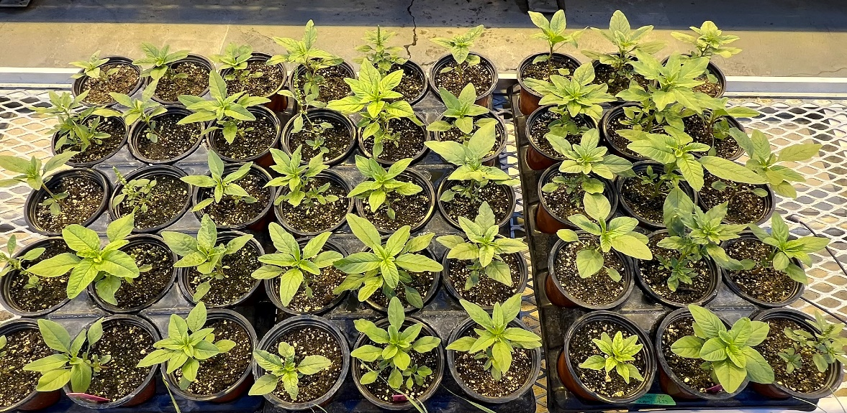

Figure 2. Seedlings of tall waterhemp populations from NY for glyphosate dose-response study.

II. Evaluation of integrated herbicide programs for managing glyphosate-resistant tall waterhemp in Enlist® soybeans.

Field studies will be conducted to determine the performance of PRE and POST herbicide programs for crop safety and control of glyphosate-resistant weeds (tall waterhemp, horseweed, etc.) in Enlist soybeans. Two growers’ fields (one field in Seneca falls county with confirmed glyphosate-resistant waterhemp and second field in Jefferson County with confirmed glyphosate-resistant marestails) have been identified to conduct the field experiments. Selected PRE and POST herbicides (Table 1) will be tested.

Table 1. PRE and POST herbicides for managing glyphosate-resistant tall waterhemp in Enlist soybeans.
Herbicide (s) | Timing (s) | Rate(oz/a)
Nontreated | - | -
Classic + Valor + Metribuzin | PRE | 1.25 + 2 + 4.75
Panther Pro | PRE | 15
Warrant Ultra | PRE | 64
Boundary | PRE | 32
Classic + Valor + Metribuzin fb Enlist One + Liberty | PRE fb POST | 1.25 + 2 + 4.75 fb 32 + 32
Panther Pro fb Enlist One + Liberty | PRE fb POST | 15 fb 32 + 32
Warrant Ultra fb Enlist One + Liberty | PRE fb POST | 64 fb 32 + 32
Boundary fb Enlist One + Liberty | PRE fb POST | 32 fb 32 + 32
Enlist One + Liberty fb Enlist One + Liberty | EPOST fb MPOST | 32 + 32 fb 32 + 32
Roundup PM fb Roundup PM | EPOST fb MPOST | 32 fb 32

Experiments will be set up in a randomized complete block design, with 4 replications. An Enlist soybean variety will be planted by following standard agronomic practices. We will provide more updates for the findings on the field experiments in next quarterly report.

