Project Title: SoyRenSeq: a Novel Approach for Disease Resistance Gene Discovery and Application for Soybean Improvement (Year 2)

Investigators: Dechun Wang, Feng Lin, Muhammad Salman
Michigan State University

Progress Report:
The Wang lab proposed to work on Objective 4, evaluation of resistance to various pathogens and mapping of major R genes and QTL.

Our progress made to date is summarized below:
Our previous study screened 470 germplasm lines and identified Colfax as a resistant genotype against P. sansomeana (Salman et al., submitted). We developed mapping populations by crossing Colfax with a susceptible genotype Senaki, and challenged 234 F2:3 families with P. sansomeana isolate MPS17-22 to study the inheritance pattern. The analysis revealed a 1:2:1 ratio of resistant:segregating resistant:susceptible indicating the involvement of a single major gene. Linkage analysis using extreme phenotypes anchored Rpsan1 to a 30 Mb region on chromosome 3. By selecting nine polymorphic SNP markers within the region, Rpsan1 was genetically delimited into a 21.3 cM region between Gm03_4487138_A_C and Gm03_5451606_A_C, which corresponds to a 1.06 Mb genomic region containing nine NBS-LRR genes based on Gmax2.0 assembly. The mapping results were then validated using two breeding populations derived from ‘E12076T-03’ × ‘Colfax’ and ‘E16099’ × ‘Colfax’ (Lin et al., 2024).

Table 1. Inheritance pattern of the F2:3 families (Colfax × Senaki) to P.sansomeana isolate MPS17-22 using goodness-of-fit test
F2:3 Populations | Population size | Observed  (Res:Seg:Sus) | Expected  (Res:Seg:Sus) | x²_{1:2:1} | P
CS3 | 96 | 16:51:29 | 24:48:24 | 3.896 | 0.143
CS5 | 107 | 31:56:20 | 26.75:53.5:26.75 | 2.495 | 0.287
CS6 | 31 | 11:14:6 | 7.75:15.5:7.75 | 1.903 | 0.386
Combined | 234 | 58:121:55 | 58.5:117:58.5 | 0.350 | 0.839
Res: homozygous resistant. Seg: segregation. Sus: susceptible.

Linkage analysis of Rpsan1 using extreme phenotypes:
Considering that it is more difficult to distinguish the homozygous resistant and heterozygous resistant phenotypes, we used the extremely susceptible phenotypes to start our linkage analysis. Of the 44 extremely susceptible lines, the percentage of ‘Senaki’ genotype (represented by ‘b’) was calculated for all the 1599 polymorphic SNP markers across 20 chromosomes (Fig. 1). Ideally, if a marker is cosegregating with Rpsan1, all the 44 extremely susceptible lines will be expected to be the ‘b’ genotype. Our results found that the highest percentage of genotype ‘b’ is the marker Gm03_5733321_A_G, with 84% of ‘b’ genotype on chromosome 3. Further investigation of this region uncovered a continuous genomic region of ~ 32 Mb with more than 60% ‘b’ genotypes (Fig. 1) between SNP markers Gm03_2224975_G_A and Gm03_35797299_A_G. Moreover, this region can be validated from the percentage of ‘a’ genotype in the 45 extremely resistant lines, with an average of 41%, compared to the average of 26% across the whole genome (Fig. 1). Therefore, Rpsan1 is very likely located within the 32 Mb genomic region on soybean chromosome 3 (Table 2).

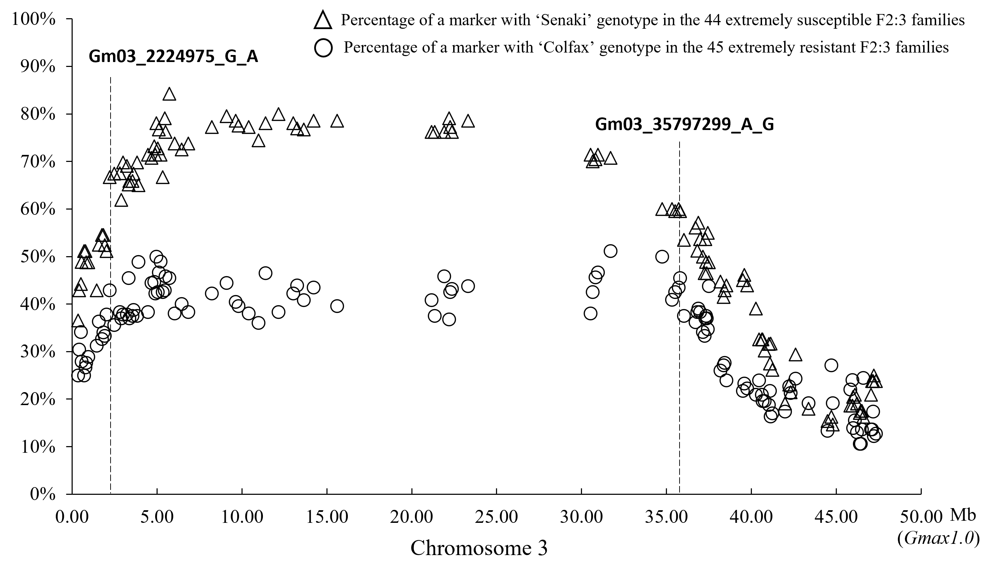 Figure 1. Linkage analysis of the resistance gene Rpsan1 on chromosome 3 using the 89 extreme phenotypes of the F2:3 families derived from ‘Colfax’ × ‘Senaki’. The dotted line indicates the position of left and right end of markers (Gm03_2224975_G_A and Gm03_35797299, respectively) with more than 60% of ‘Senaki’ genotype out of the 44 extremely susceptible F2:3 families.

Genetic mapping of Rpsan1 using 234 F2:3 families:
To further delimit the genetic position of Rpsan1, nine polymorphic SNP markers from the 6 k chip were selected spanning the 32 Mb genomic regions for genetic mapping using all the 234 F2:3 families. The nine markers covered a genetic region of 99.1 cM, and the order of the markers was in good agreement with the Williams82 reference genome on chromosome 3 (MLG N) (Schmutz et al. 2010; Song et al. 2013). Rpsan1 was mapped between Gm03_4487138_A_C and Gm03_5451606_A_C, with a genetic distance of 10.1 cM and 11.2 cM, respectively (Fig. 2). The mapped region of Rpsan1 corresponded to a physical distance of 1.06 Mb on chromosome 3 according to Gmax2.0 assembly, which contains nine NBS-LRR types of genes (www.soybase.org).
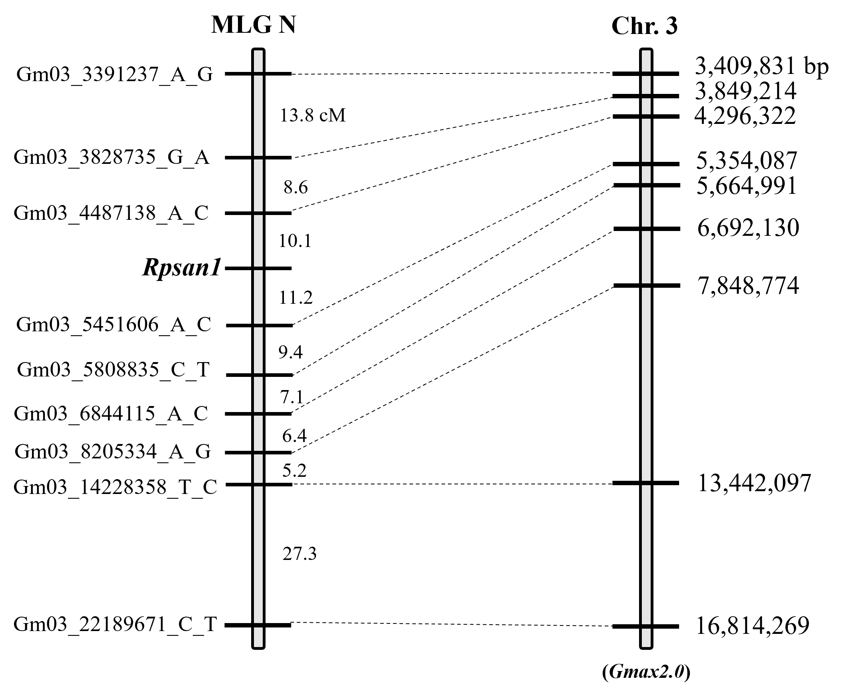
Figure 2. Genetic mapping of Rpsan1 using 9 SNP markers on chromosome 3. Left: genetic position of the 8 SNP markers and the Rpsan1 gene. Right: Physical position (Gmax2.0) of the mapped region of Rpsan1.

Validation of the Rpsan1 locus in two breeding populations
Two polymorphic markers, Gm03_5808835_C_T and Gm03_8205334_A_G, were identified and used for POP200032, from which 19 homozygous resistant (Rpsan1/Rpsan1) genotypes (R1 group) and 19 homozygous susceptible (rpsan1/rpsan1) genotypes (S1 group) were identified. Gm03_4487138_A_C and Gm03_5808835_C_T were found polymorphic between E16077 and Colfax and were therefore used for POP200040. Using the two markers, 16 F2:3 families were identified as ‘Rpsan1/Rpsan1’ genotypes (R2 group), and 21 F2:3 families were identified as ‘rpsan1/rpsan1 genotypes (S2 group) in POP200040. All the selected lines were inoculated with P. sansomeana isolate MPS17-22. As expected, the average ratio of resistant progenies in the R1 group is 0.685, which is close to that of Colfax (0.734), but significantly higher than that of the S1 group (0.132) and E12076T-03 (0.067) (Fig. 3a). For 200040, the average ratio of resistant progenies in the R2 group is 0.714, which is significantly higher than that of the S2 (0.193) and E16077 (0.000) (Fig. 3b). Therefore, the testing results from POP200032 and POP200040 confirmed that the markers are tightly linked with the Rpsan1 locus.
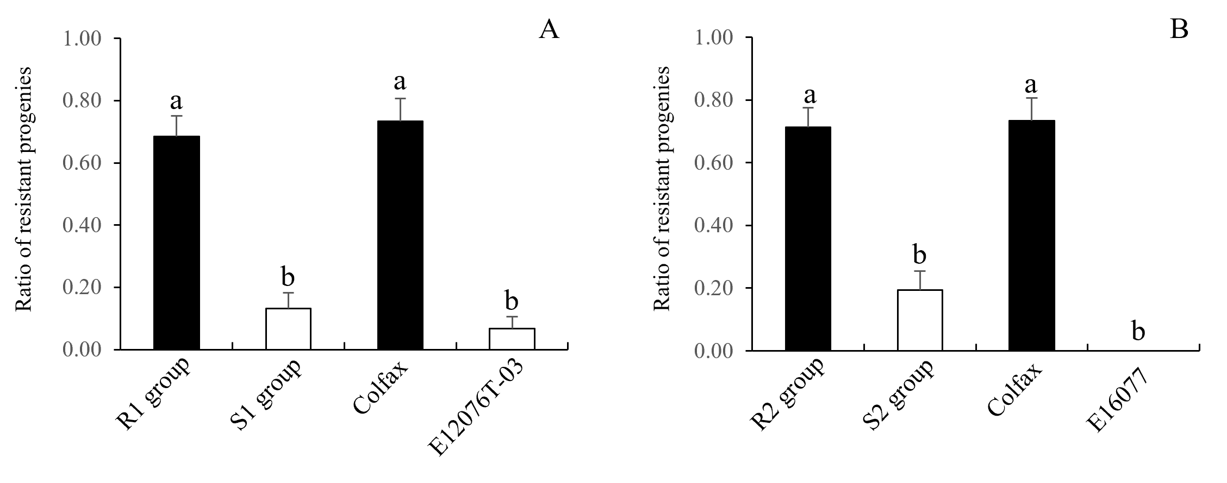Figure 3. Validation of the Rpsan1 locus using two breeding populations POP200032 (A), derived from E12076T-03 × Colfax, and POP200040 (B), derived from E16077 × Colfax. For POP200032, 19 F2:3 families were identified as ‘Rpsan1/Rpsan1’ genotypes (R group) and 19 F2:3 families were identified as ‘rpsan1/rpsan1 genotypes (S group) using Gm03_5808835_C_T and Gm03_8205334_A_G. For POP200040, 16 F2:3 families were identified as ‘Rpsan1/Rpsan1’ genotypes (R group) and 21 F2:3 families were identified as ‘rpsan1/rpsan1 genotypes (S group) using Gm03_4487138_A_C and Gm03_5808835_C_T. A: One-Way ANOVA test for the ratio of resistant progenies against P. sansomeana isolate MPS17-22 in POP200032, different letters indicate a significant difference between groups at 0.05 level. B: One-Way ANOVA test for the ratio of resistant progenies against P. sansomeana isolate MPS17-22 in POP200040, different letters indicate a significant difference between groups at 0.05 level.

References:
Dorrance AE (2018) Management of Phytophthora sojae of soybean: a review and future perspectives. Can J Plant Pathol 40:210–219
Dorrance AE, Jia H, Abney TS (2004) Evaluation of soybean differentials for their interaction with Phytophthora sojae. Plant Health Progr 5:9
Lin F, Salman M, Zhang Z, McCoy AG, Li W, Magar RT, Mitchell D, Zhao M, Gu C, Chilvers MI, Wang D (2024). Identification and molecular mapping of a major gene conferring resistance to Phytophthora sansomeana in soybean 'Colfax'. Theor Appl Genet. 22;137(3):55. doi: 10.1007/s00122-024-04556-6. PMID: 38386094.
Lin F, Zhao M, Ping J, Johnson A, Zhang B, Abney TS, Hughes TJ, Ma J (2013) Molecular mapping of two genes conferring resistance to Phytophthora sojae in a soybean landrace PI 567139B. Theor Appl Genet 126:2177–2185
Schmutz J, Cannon SB, Schlueter J, Ma J, Mitros T, Nelson W, Hyten DL, Song Q, Thelen JJ, Cheng J, Xu D (2010) Genome sequence of the palaeopolyploid soybean. Nature 463:178–183
Song Q, Hyten DL, Jia G, Quigley CV, Fickus EW, Nelson RL, Cregan PB (2013) Development and evaluation of SoySNP50K a high density genotyping array for soybean. PLoS ONE 8:54985

