Project Title- Integrated agricultural systems to promote soil health and environmental resilience
This report includes a brief overview of the end of year site activities and results from 2023, and the planned research activities and field work in the spring of 2024. The fourth year of research at the LAiYERS (Land mAnagement for improved Yield, Environmental Resilience, and Sustainability) plots begins in 2024. We will continue evaluating the impact of poultry manure and cover crop impacts on water quality, soil health, and crop yield. The plots were established in 2021(fig. 1), with soybeans planted in odd numbered years and corn planted in even numbered years. The treatments include chemical fertilizer or poultry manure applied at the agronomic recommended rate of 150 lbs N/acre, with or without cover crops.
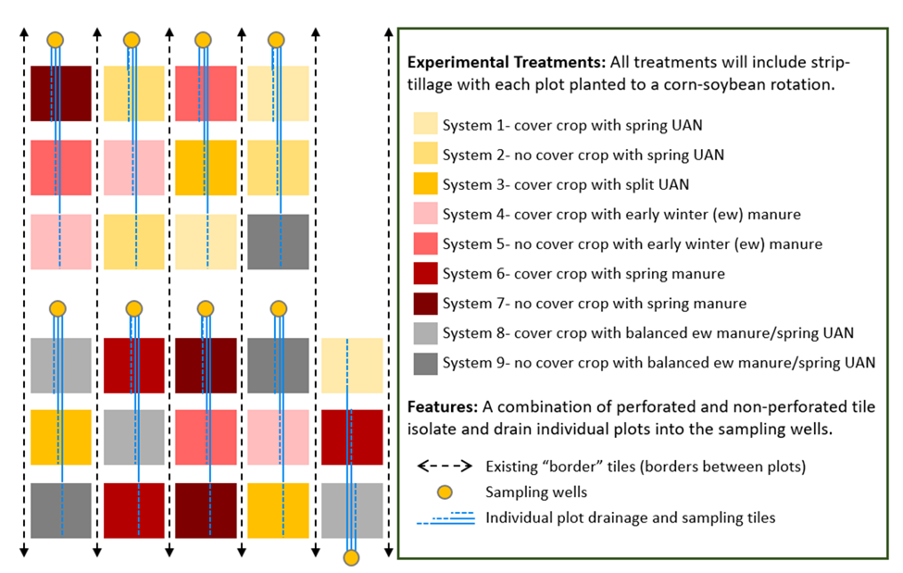
Figure 1. LAiYERS site experimental design. Each system- treatment is assigned to the 27 quarter-acre plots in triplicate. The N-management treatment is applied in the early winter or spring for the upcoming corn year.

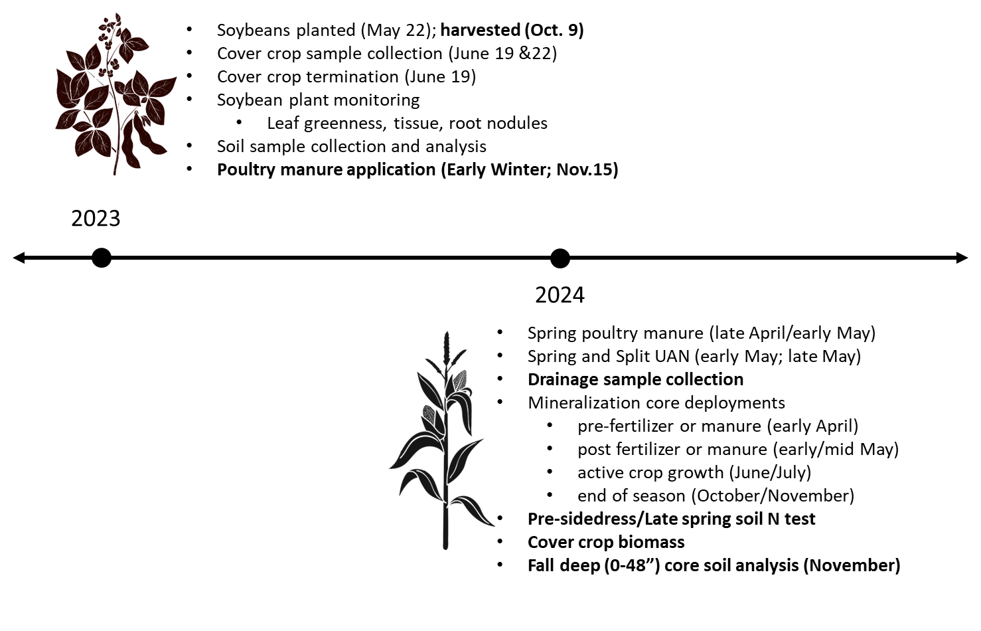

Figure 2. LAiYERS activities in 2023 and planned 2024 work. ISA project details are highlighted in bold. The crop rotation includes soybeans in odd numbered years, corn in even numbered years, and cereal rye as a cover crop at designated plots in all years. Fall strip tillage will be used each year to increase spring field drying and accessibility and partially incorporate manure during application years.

Soybean Yields
The soybean crop was harvested on October 9th. Four passes from each plot were harvested, and yields were corrected to 13% moisture. As previously reported, the soybean yields were lower in the cover crop plots for all treatments due to the late termination of the cover crop (June 19th) as part of an experimental design to evaluate weed suppression. While there was a measurable decrease in weed coverage with cover crops, a better balance in termination timing to achieve optimal yields is necessary.
Table 1. Median 2023 soybean yields by treatment. Due to high variability within treatments, differences may not be significant.
Poultry Manure and UAN Application
The early winter poultry manure was applied at an estimated 150 lbs available N/acre to the System 4 and 5 plots on November 15, 2023. This application rate includes an assumed 5% N loss at application and 60% N availability for the growing season. Manure samples were collected from the manure applicator at each plot and transported to AgSource laboratory in Ellsworth, Iowa the same day for nutrient analysis.
Poultry manure will be applied with the same loss and availability assumptions to the System 6 and 7 plots, and UAN will be applied at 150 lbs N/acre (100% availability assumed) to the System 1, 2, 8, and 9 plots in late April- early May. UAN will be applied to the System 3 plots at the same time at 75lbs N/acre, with another 75lbs N/acre UAN applied in June as sidedress.
Cover Crops
Cover crops were broadcast into the standing soybean plants on September 22, 2023. There is good early spring growth visible in all of the cover crop treated plots. Above ground biomass samples will be collected before the rye is terminated approximately 10 days before corn planting, and below ground cover crop biomass samples will be collected approximately 2 days after termination.
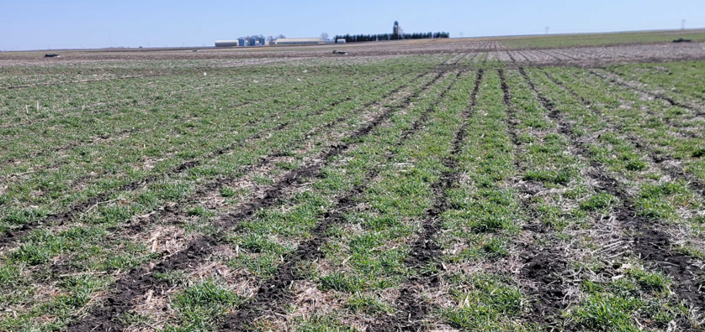
Progress Toward Project Metrics
KPI #1: Data on yield, soil and water quality. Measured annually by collection of environmental datasets.
Environmental sample collection has begun for the 2024 season with the first subsurface drainage water samples collected from the tiles at the flowing plots on March 27th this year. Drainage water sample will continue weekly while the tiles are flowing, with planned event/storm sampling also.
Additional sampling will include cover crop tissue and biomass, late spring soil N, and fall deep core sore soil analysis. Cover crop samples will be collected this spring before corn is planted for above ground and below ground biomass analysis.
KPI #2: Improved understanding of manure integrated cropping systems and their impact on soybean yield and soil and water quality.
This will be the fourth year of sample collection and data analysis at the LAiYERS site. Results will be presented at the Soil and Water Conservation Society Annual Conference this July.
We continue to analyze the data to evaluate the treatment impacts on water quality, soil nutrient changes, and crop growth. The drainage data will include two drainage seasons with fertilizer application (corn years; 2022 and 2024) and no fertilizer application (soybean year; 2023), with distinct differences by treatment for each. Preliminary results suggest late termination of cover crops negatively impacted soybean yields. The cover crop will be more conservatively managed going forward to avoid negative yield impacts.

