Images for progress report 1
1) Computation method for reconstructing current source distribution:
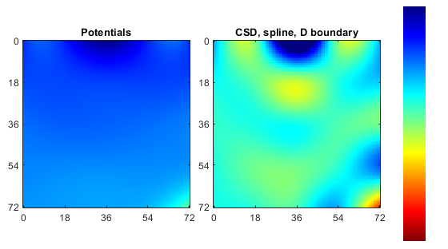
Potentials are measured in the rhizotron and current source distribution is reconstructed. Dark Blue indicates areas of high concentration of current sources.
2) Instrumented Rhizotron for measurements of local potentials
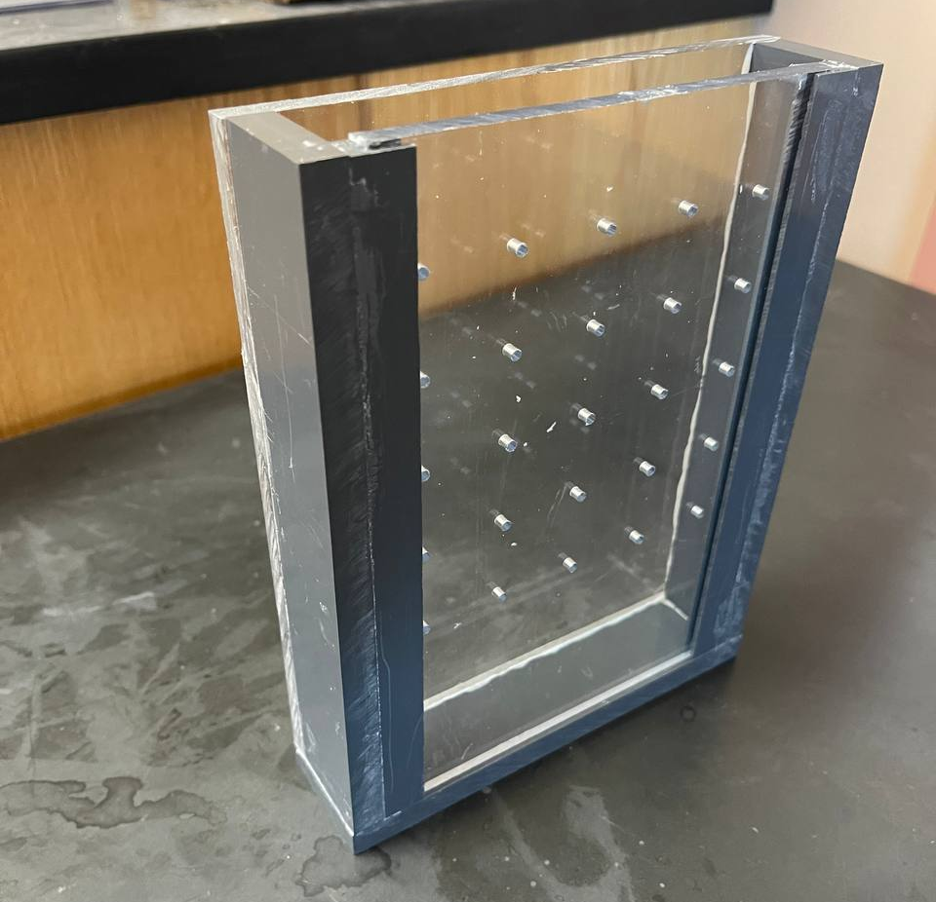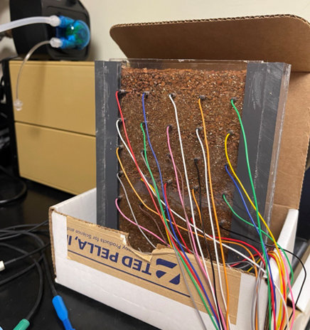
Empty Rhizotron and rhizotron with electrodes for potential measurements.
3) Soybean varieties growing in the instrumented rhizotron

