Please use this form to clearly and concisely report on project progress. The information included should reflect quantifiable results that can be used to evaluate and measure project success. Comments should be limited to the designated boxes. Technical reports, no longer than 4 pages, may be attached to this summary report.

Project Number:
Project Title: | Evaluation of soy ingredients in juvenile largemouth bass culture
Organization: | School of Fisheries, Aquaculture and Aquatic Sciences, Auburn University
Project Lead Name: | Timothy J. Bruce
Report Date: | July 1, 2023 –September 30, 2023
In the Project Summary section below, please provide a brief summary of project progress in lay language that will be shared publicly in the National Soybean Checkoff Research Database. Do not include any confidential or proprietary information. If no lay language is provided, the contents of this entire report will be published in the National Soybean Checkoff Research Database.

Project Summary (in non-proprietary lay language suitable to be shared publicly):
Using soy protein as a fishmeal replacement in domestic aquaculture allows fish producers to decrease operational costs while retaining or enhancing growth performance. There has been tremendous success in integrating soy protein into diets for major aquaculture species (i.e., channel catfish, tilapia, and rainbow trout). There is also an interest in expanding this work to other species using feeds with high levels of fishmeal, such as largemouth bass (LMB). As the demand for this species grows, there is an opportunity to magnify soy protein utilization in this market segment. There is limited information on the response to soybean process variants and optimized inclusion levels for bass. Type and level of inclusion are integral for optimizing inclusion rates that benefit industry-relevant growth performance and health. The proposed project will evaluate soy protein process variants [soybean meal (SBM); fermented soybean meal (FSBM), and soy protein concentrate (SPC)] to investigate LMB growth and development, as well as histological, microbial, and immunological aspects of intestinal health. Together, this allows for the selection of the most appropriate soy ingredient source. The proposed research results are expected to add to the body of knowledge promoting soy-optimized feed formulations and build on existing literature to encourage the use of US-based products in the aquaculture industry.

Primary Objectives: To evaluate the incorporation of soy protein ingredients in juvenile LMB diet formulations, we have initiated the following objectives:
- Objective 1: Determine growth performance in LMB fed soy protein
- Objective 2: Characterize gastrointestinal health following feeding with soy protein
- Objective 3: Discern changes to columnaris disease susceptibility following feeding with
soy process variants

This trial work will better define and compare soy protein sources as fishmeal replacements in LMB diets. This will, in turn, allow for more information to provide to feed formulators and increase the amount of soy in diets for a cultured species that is gaining momentum. In addition to the performance data, information on the intestinal integrity following feeding with these soy ingredients is also extremely valuable for extending insight into other fish species with commercial potential.

Detailed Project Status – Expand upon the above section. What key activities were undertaken and what were the key accomplishments during this reporting period? List each key deliverable from the proposal and describe progress made (or not made) toward achieving it, including metrics were appropriate.
Objective 1: Determine growth performance in LMB fed soy protein
We have completed the growth performance trial ahead of schedule during this quarter, and the team is currently working on data analysis. The experiment was conducted in 16 tanks (50 fish per tank with four replicates per diet; Table 1) within a RAS. The RAS environment had a maintained salinity level of 3.0 ppt. During much of this trial, the LMB were offered 4% of the tank biomass, spread out over eight feeds throughout the day. If the LMB reached satiation prior to the final feed, the remainder of the diet variants were scaled back for the day and recorded. Between Week 4 and Week 6 count and biomass data collection, the LMB were offered a 6% feed plan, but we reverted to 4% during Week 6 as observations showed this led to overfeeding and poorer water quality. Tank biomass and individual fish counts were obtained at each sampling to calculate growth indices. Preliminary data from the trial is provided in Figure 1 and Table 2, and the team will plan to analyze these data with a two-way repeated measures ANOVA following data validation. Overall, initial findings from the trial endpoint indicate that the soy diets all performed well and kept up with the basal control diet.

Table 1. Proximate analysis “as is” of each soy process variant diets and basal control fed to the LMB over the 14-week feeding trial. Basal (Control diet), soybean meal (SBM), fermented soybean meal diet (FSBM), and soy protein concentrate diet (SPC) .
Proximate | Basal | SBM | FSBM | SPC
Crude protein (%) | 43.7 | 41.9 | 41.2 | 42.5
Crude lipid (%) | 12.0 | 10.0 | 10.4 | 10.1
Ash (%) | 10.1 | 7.6 | 7.5 | 6.9
Fiber (%) | 2.4 | 4.7 | 3.4 | 3.4
Moisture (%) | 7.0 | 9.0 | 8.3 | 7.8

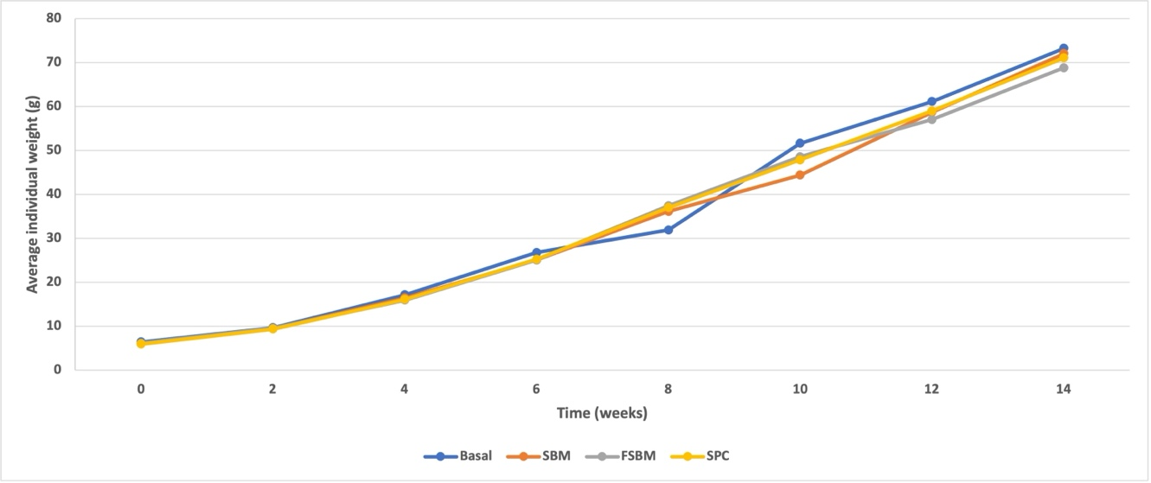
Figure 1. The average individual weight of LMB fed soy protein diets throughout the 14-week feeding trial.

Table 2. Calculated growth metrics at the end of the 14-week LMB soy feeding study. Data based on four replicate tanks and mean ± SEM is detailed. FCR=feed conversion ratio, TGC=thermal growth coefficient, PER=protein efficiency ratio, PG=percent gain.
Diet | FCR | TGC | PER | PG (%)
Basal | 1.10 ± 0.02 | 0.93 ± 0.05 | 2.09 ± 0.04 | 531± 188
SBM | 1.22 ± 0.06 | 0.91 ± 0.03 | 2.01 ± 0.09 | 517± 186
FSBM | 1.18 ± 0.05 | 0.92 ± 0.03 | 2.09 ± 0.10 | 512± 179
SPC | 1.15 ± 0.04 | 0.94 ± 0.03 | 2.08 ± 0.10 | 545± 193

Objective 2: Characterize gastrointestinal health following feeding with soy protein
From the growth performance trial sampling, we collected intestines and digesta for further analysis. Segments of the distal intestine were formalin-fixed and sent to the AU Veterinary School for slide processing. When returned, we will complete a histological examination to look for signs of enteritis. Additionally, gut microbiome samples have been sent to a commercial laboratory, and the sequencing is underway. We anticipate receiving the sequencing results in late October 2023 and will start the analysis. We have performed RNA extractions on all the intestinal samples for the gene expression component and are currently optimizing qPCR protocols to assess proinflammatory cytokines in the tissues.

Objective 3: Discern changes to columnaris disease susceptibility following feeding with
soy process variants

A follow-on pathogen challenge trial with F. columnare was conducted at the completion of the feeding trial. There were a few shortcomings with this component so far. High mortality was achieved in the challenge (Figure 2), which made it difficult to discern treatment differences. Also, protozoan parasites were found on some mock-control fish late challenge, which may correlate to transfer stress. The team will plan to conduct an additional study following short-term feeding with the same soy protein sources to obtain more data related to disease susceptibility.

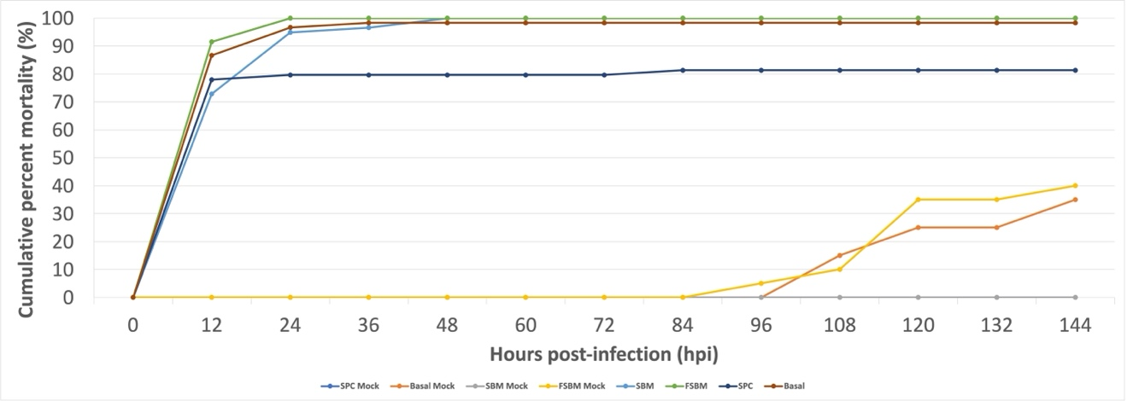
Figure 2. Mortality of soy-fed LMB following immersion challenge with F. columnare.

