Mid-Year Report for FY24 Research Projects
Funded by the North Dakota Soybean Council
Submitted by Iris Feng, 11/30/2023
- Research Project Title, Principal and Co-Investigators
Title: Anaerobic Digestion of Defatted Soybean Meal for Biogas and Biofertilizer Productions
PI: Iris (Xiaoyu) Feng and Co-PI: Ademola Ajayi-Banji
- Research Overview and Objectives
Overview:
Renewable energy drive will boost soybeans production to approximately 5.3 billion by 2030 with over 390,000 metric tons of defatted soybean meal (DSM) annually in North Dakota. DSM contains valuable protein and essential micronutrients, but an anti-nutritional reagent employed to optimize soybean oil significantly restricts its food applications. Additionally, due to the small livestock size in ND, only 23% of projected DSM would be consumed annually for animal feed. Thus, there is a pressing demand to explore and expand new applications for DSM. Anaerobic digestion (AD) is a well-established technology that decomposes biomass in the absence of oxygen, generating biogas and biofertilizer which can be locally utilized for heating and plant operations, and as a substitute for commercial fertilizer. This innovative use of DSM offers ND producers a sustainable and cost-efficient alternative for renewable energy production and nutrient recovery.
Objectives:
This proposal aims to assess the new use of DSM by 1) investigating the effect of physical properties and chemical pretreatments of DSM for increasing biogas yields in AD; 2) enhancing methane production and biofertilizer quality from DSM with co-digestion inclusion and additives of biochar and nanoparticles for energy sustainability and nutrient recovery.
Specific objectives include:
Objective 1: Evaluate the impact of particle sizes, total solids (liquid and solid states), and bioreactor temperatures on methane yield of DSM anaerobically digested in lab-scale reactors.
Objective 2: Investigate the effect of wet-state alkaline pretreatments of DSM on methane yield and nutrients in digestate.
Objective 3: Enhance methane yield and biofertilizer quality of anaerobically digested alkaline pretreated DSM with co-digestion inclusion and use of biochar and nanoparticles additives.
- Completed Work: Deliverables and/or Milestones
The following work has been completed:
- Collection and analysis of raw samples to understand the characteristics of DSM for biogas production.
- Inoculum preparation for the project.
- Two experiments for evaluating the impacts of three particle sizes, and two temperature at solid states on methane yield of DSM under anaerobic digestion has been completed. Data has been collected and analyzed.
- Experiments for evaluating the impacts of three particle sizes, and two temperature at liquid states on methane yield are ongoing.

- Progress of Work and Results to Date
- DSM samples were collected from the Northern Crops Institute, NDSU, Fargo, ND, and the raw samples was analyzed at NDSU Microcore Lab for Scanning Electron Microscopy (SEM) analysis and at NDSU Animal Science and Soil Testing labs for chemical properties and nutrient analysis. Samples were grated with a blender and sieved into three grades with respect to particle size of fine (< 0.48 mm), medium (0.48 – 0.70 mm), and large (0.72 – 1.00 mm). The results are presented in Figure 1 and Table 1.
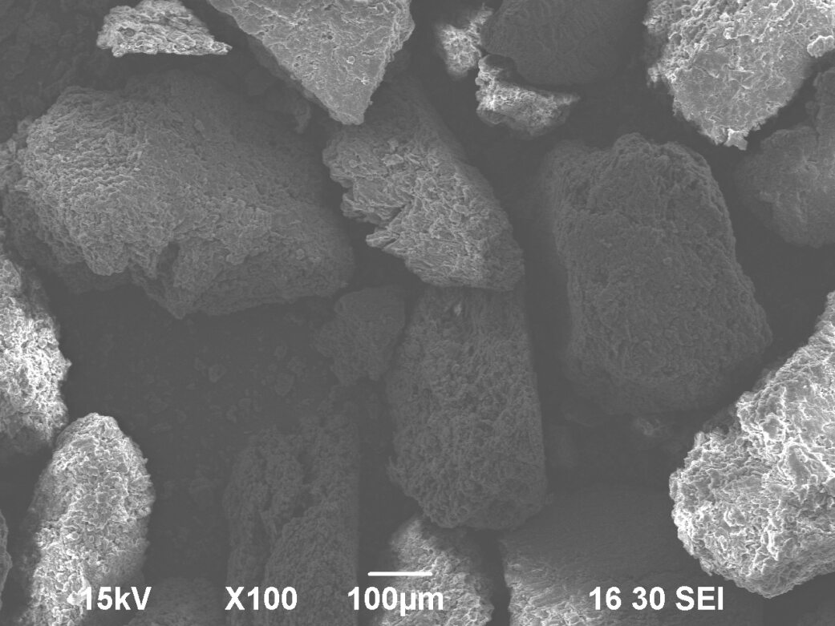
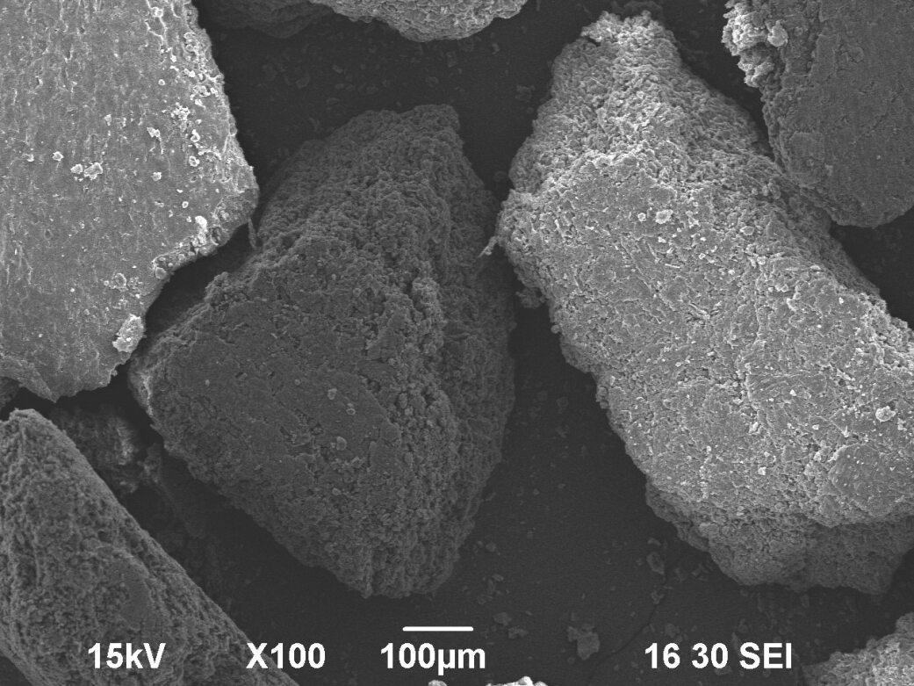
a). b).
Figure 1. Scanning Electron Microscopy (SEM) analysis for soybean meal raw samples: a). Fine particle size; b). Medium particle size

Table 1. Chemical properties and nutrient analysis of raw soybean meal samples.
Characteristics | Ammonia (mM) | Acetic (mM) | C (%) | N (%) | S (%) | DM (%)
Mean | 1.00 | 3.91 | 44.45 | 8.46 | 0.44 | 92.65
Characteristics | Hemicellulose (%) | Cellulose (%) | CP (%) | NDF (%) | ADF (%) | ADL (%)
Mean | 6.04 | 3.26 | 52.82 | 9.47 | 6.22 | 0.18

- The first experiment was designated for evaluating impact of three particle sizes and two bioreactor temperatures (mesophilic—35°C and thermophilic—55°C) at solid state (10% total solid) on methane yield of DSM anaerobically digested in lab-scale reactors. The experiment was conducted in two runs including a total of 18 treatments with triplites. Figures 2-4 show the measurements of pH, oxygen reduction potential (ORP) and electrical conductivity (EC) of control inoculum and treatments of three particle sizes in both mesophilic and thermophilic conditions. The first run lasted for four weeks between October 14th and November 14th to collect data of daily gas yield and total gas yield accumulation. AD was conducted in two water baths at setup temperatures of mesophilic—35°C and thermophilic—55°C, respectively. Due to the space limitation, triplicated controls and treatments were conducted in two runs separately. The second run is ongoing. Daily gas yield and total gas yield accumulation are shown in Figures 5 and 6 under mesophilic condition, and in Figures 7 and 8 under thermophilic condition, respectively. Methane concentrations (%) and hydrogen sulphide concentrations (ppm) were analyzed using GC and are shown in Table 2 and 3, respectively.
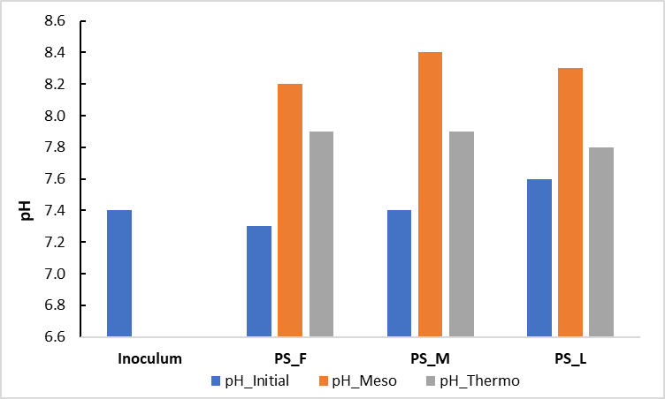
Figure 2. pH measurements of control inoculum and treatments for three particle sizes under mesophilic and thermophilic conditions.
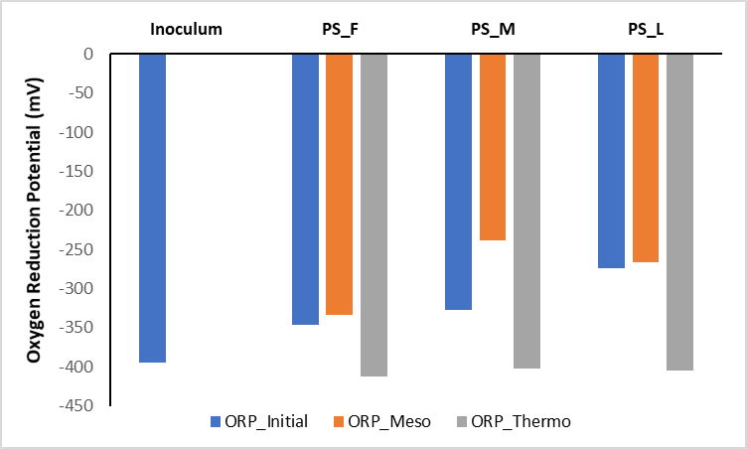
Figure 3. Oxygen reduction potential (ORP) measurements of control inoculum and treatments for three particle sizes under mesophilic and thermophilic conditions.

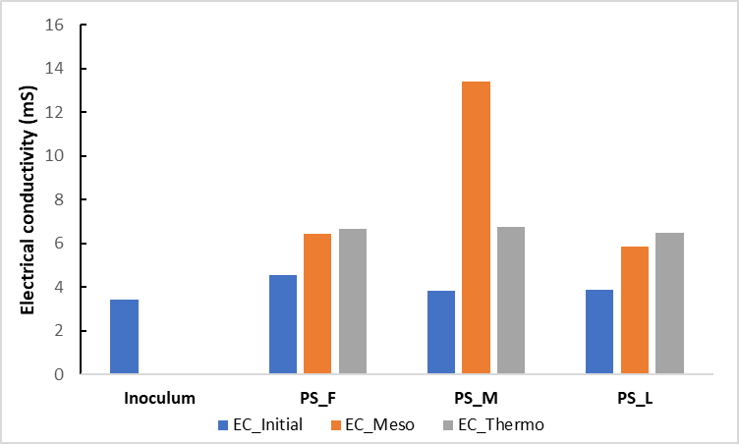
Figure 4. Electrical conductivity (EC) measurements of control inoculum and treatments for three particle sizes under mesophilic and thermophilic conditions.
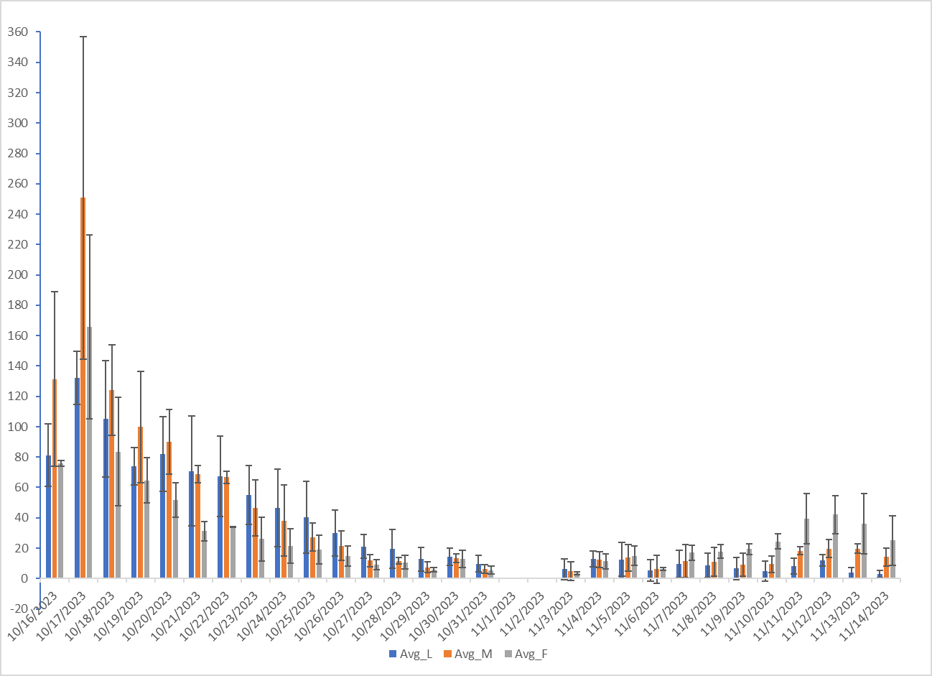
Figure 5. Daily gas yield of three particle sizes under Mesophilic condition.
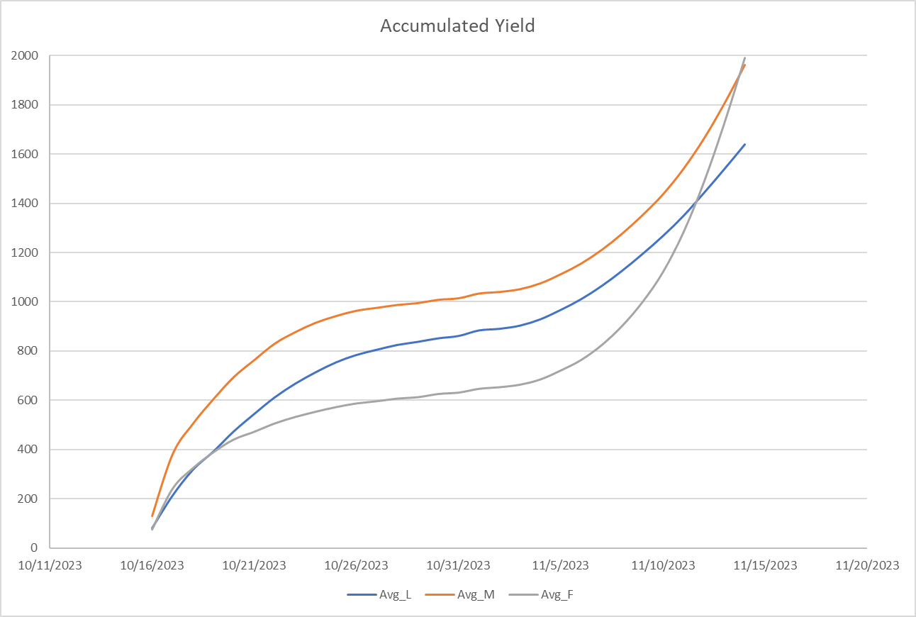
Figure 6. Accumulated gas production of three particle sizes under Mesophilic condition.
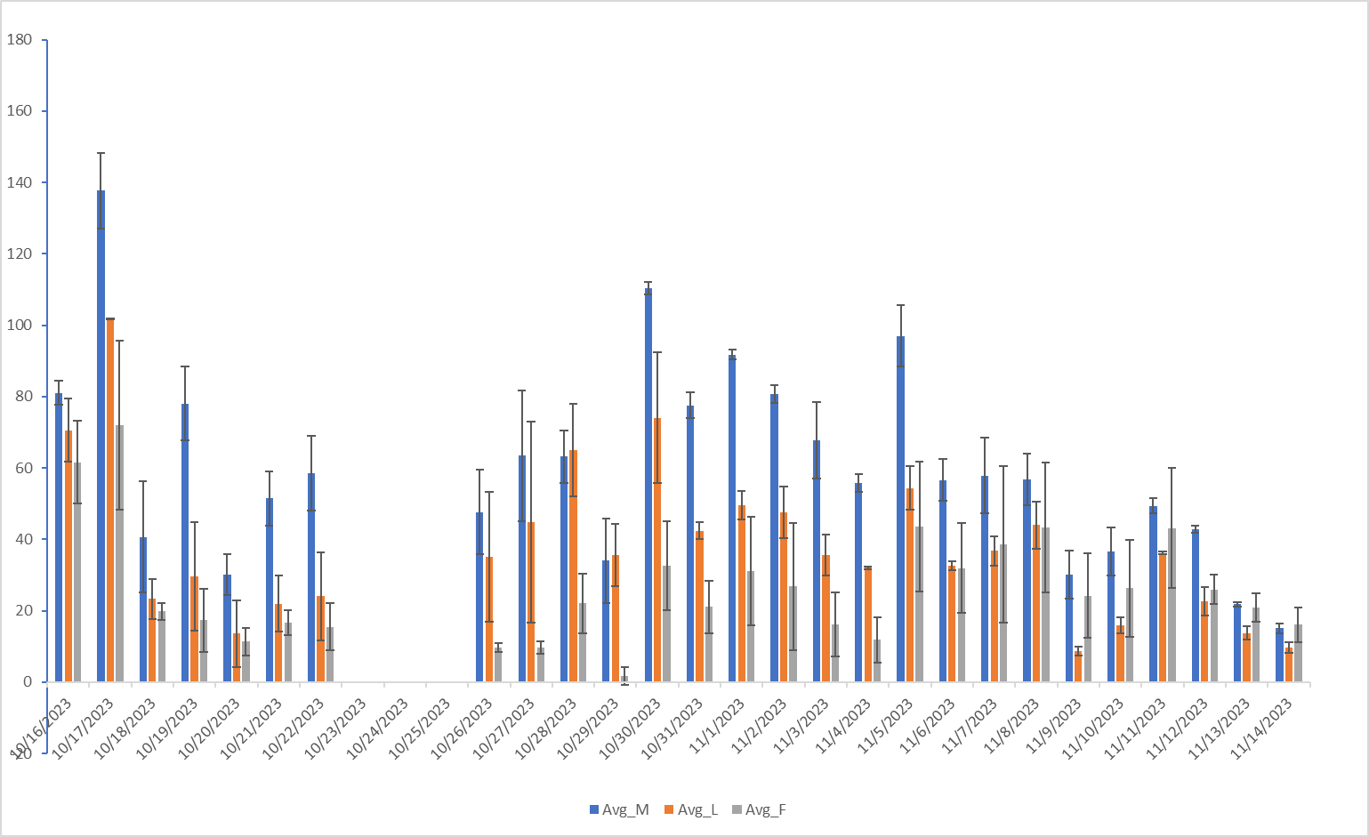
Figure 7. Daily gas yield of three particle sizes under Thermophilic condition.
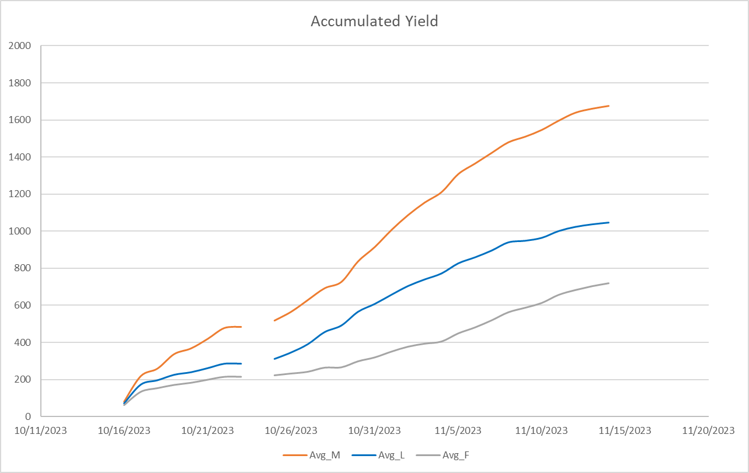
Figure 8. Accumulated gas production of three particle sizes under Thermophilic condition.
Table 2. Methane concentration.
Date | Mesophilic (%) |  |  | Thermophilic (%)
Date | PS_M | PS_L | PS_F | PS_M | PS_L | PS_F
10/17/2023 | 65.7 | 68.7 | 57.5 | 30.0 | 30.4 | 23.1
10/22/2023 | 52.1 | 54.8 | 55.1 | 21.7 | 25.6 | 24.3
10/23/2023 | 54.4 | 59.6 | 49.7 | 24.0 | 26.4 | 27.4
10/29/2023 | 41.9 | 57.3 | 53.3 | 38.8 | 47.2 | 16.9
11/1/2023 |  |  |  | 37.8 | 35.9 | 15.3
11/4/2023 | 45.9 | 53.6 | 54.2 | 51.9 | 59.4 | 23.4
Table 3. Hydrogen sulphide concentration.
Date | Mesophilic (ppm) |  |  | Thermophilic (ppm)
Date | PS_M | PS_L | PS_F | PS_M | PS_L | PS_F
10/17/2023 | 1645 | 1563 | 2582 | 8838 | 5226 | 10039
10/22/2023 | 973 | 808 | 1166 | 80 | 525 | 103
10/23/2023 | 1277 | 1415 | 1773 | 90 | 249 | 76
10/29/2023 | 957 | 737 | 1610 | 201 | 463 | 8
11/1/2023 |  |  |  | 159 | 235 | 8
11/4/2023 | 1524 | 1114 | 1552 | 151 | 287 | 7

- Work to be Completed
After completing the experiments of evaluating the particles sizes, temperatures, and total solids, the following experiments will need to be setup for further investigations:
- Investigate the effect of wet-state alkaline pretreatments of DSM on methane yield and nutrients in digestate.
- Enhance methane yield and biofertilizer quality of anaerobically digested alkaline pretreated
DSM with co-digestion inclusion and use of biochar and nanoparticles additives.
- Analyze data and publish the results on peer-reviewed journals and attend local and national conferences to present the findings.
- Prepare a dataset for LCA analysis in future (Multi-Year plan: 07/01/24~06/30/25).

- Other relevant information: potential barriers to achieving objectives, risk mitigation strategies, or breakthroughs
A pretest was conducted to investigate the pH stability during the AD. The experiment was interrupted and delayed due to the ABEN Department relocation during the summer and fall semesters 2023, we borrowed a second water bath from pilot plan to speed up the study by conducting mesophilic and thermophilic treatments simultaneously.
- Summary
In summary, based on the results of the current experiment, soybean meal is a promising feedstock for biogas production in AD. The total biogas yield, methane production, and gas production rate are affected by the different particle sizes and temperature of AD. The total gas production accumulated during four weeks of mesophilic was higher than that of thermophilic. The methane concentration of mesophilic was significantly greater than that of thermophilic especially in the early stage, however, the hydrogen sulphide concentration of thermophilic was significantly higher than that of mesophilic at start but dropped dramatically in the following weeks. The overall performance of biogas production in mesophilic condition was better than thermophilic condition, however, results of the current ongoing experiment should be included to draw the conclusion. After the temperature and particle size are selected, further investigation of alkaline pretreatments and co-digestion inclusion would be conducted to enhance the methane production. Nutrient analysis of slurry should be conducted to investigate the quality of biofertilizer.

