Composite Materials from Soy Meal and Soy Hulls both modified with Soy-Based Polymers
Andriy Voronov, Coatings and Polymeric Materials, North Dakota State University

Research Overview and Objectives
The main goal of this project is to investigate the feasibility of using soybean meal (SM) and soybean hulls (SH) in polymer composites/thermoplastics simultaneously. SM and SH contain two main constituents - soy proteins and carbohydrates (cellulose, hemicellulose). Both are sensitive to humidity and lack mechanical performance on their own. Additionally, soy proteins, hemicellulose, and cellulose are practically non-processable materials in film extrusion technology. Hemicellulose and cellulose are inherently rigid and, consequently, non-film-forming biopolymers. Abundant hydrogen bonding makes them incompatible with hydrophobic polymers and plasticizers, which complicates their homogeneous incorporation as reinforcing additives. On the other hand, soy proteins are flexible macromolecules that readily undergo conformational changes but are too hydrophilic to combine with other polymers. Hence, SM and SH constituents must be modified to convert them into processable thermoplastics while retaining their advantages, such as being able to be obtained from renewable feedstock and natural biodegradability.
A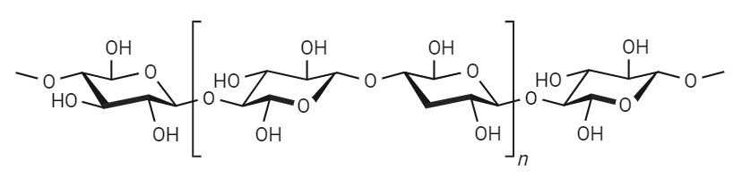
B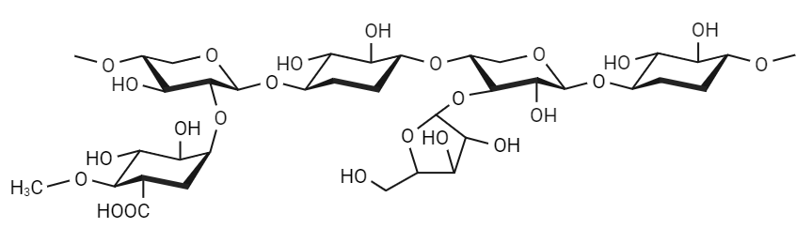
Figure 1. Chemical structure of cellulose (A), linear macromolecules with D-glucose monomeric units; chemical structure of hemicellulose monomer unit (B), branched macromolecules with xylopyranose backbone and glucuronic acid/arabinofuranoze side branches

The basic concept of this project is to engineer thermoplastics from SM and SH via covalent grafting (attachment) of soft and flexible hydrophobic soybean oil-based monomer (SBM) and/or high-oleic soybean oil-based monomer (HO-SBM) side chains. We hypothesize that modification of SM and SH constituents with soy-based (plasticizing/hydrophobizing) polymer side chains converts them into processable materials using a standard extrusion process. For this purpose, we need to develop a procedure for soy protein/hemicellulose/cellulose modification with soy-based polymers.
This work has three main goals. The first one is the synthesis of soybean oil-based (SBM) and high-oleic soybean oil-based (HO-SBM) monomers for modification of SM and SH. Second, is the development of a procedure for SM and SH modification with polymer side chains from SBM/HO-SBM. The third objective is the formulation/characterization of thermoplastics and composites from SM and SH modified with SBM/HO-SBM.
Completed Work: Deliverables and/or Milestones
This project has two milestones, modification of a complex mixture of hemicellulose, cellulose, and proteins from a renewable feedstock (SM and SH) and its application as composites and thermoplastics.
The outcome of this project will be the first attempt to modify natural resources without prior purification and separation of constituents. The thermo-mechanical properties are compared with the formulations of pure modified constituents to evaluate the effect of residual components, such as lipids, lignin, and pectin, which are in the minority in SM and SH. Testing of the prepared soy-based polymeric materials will determine their feasibility to be applied as thermoplastics or as additives into the polymer matrix to obtain composites.

Progress of Work and Results to Date
To date, Objective 1 has been completed. Scaled-up laboratory batches of SBM and HO-SBM for modification of SM and SH can be synthesized. The chemical structure and fatty acid composition of monomers are characterized by FTIR and ¹H NMR spectroscopies. Additionally, the reactivity of these monomers in free radical polymerization has been studied. Thermo-mechanical characterization shows that both SBM and HO-SBM homopolymers have low glass transition temperatures, which can be used for the plasticization of rigid counterparts such as hemicellulose and cellulose.
To date, Objective 2 is in progress. Both hemicellulose and cellulose contain hydroxy groups in the polymer backbone, and their modification includes two steps – substitution of hydroxy groups with the functional groups and grafting from these functional groups via free-radical polymerization of the monomer of interest. The principal difference is in different molecular weights or heterogeneity of aforementioned polysaccharides, therefore different reaction conditions are required. Hemicellulose modification with soy-based polymers (from SBM and HO-SBM) has been carried out. To modify hemicellulose, 2 strategies were implemented. The first includes the reaction of maleic anhydride (MA) with hemicellulose hydroxy groups and further reaction of MA vinyl double bond in free-radical polymerization with SBM/HO-SBM. In this case, the mixture of grafted hemicellulose and homopolymers of SBM/HO-SBM are obtained. The latter can be beneficial to the final material properties forming a matrix for grafted hemicellulose. The advantage of this method is its simple experimental procedure and lower sensitivity to the experimental conditions.
Scheme 1. Two-step grafting process of hemicellulose (D-glucose monomer units) via maleic anhydride modification and free-radical polymerization
In the second approach, hydroxy groups are reacted with α-bromoisobutyryl bromide to yield macroinitiator, which is further used in controlled free-radical polymerization. This method allows the precise control of the length of polymer side chains during the grafting process as well as increased purity of final material (homopolymer of SBM/HO-SBM is not formed during the reaction).
Scheme 2. Two-step grafting process of hemicellulose (D-glucose monomer units) via macroinitiator synthesis and controlled free-radical polymerization

To date, the first method, utilizing maleic anhydride to obtain grafted hemicellulose, is completed. Maleinization of hemicellulose was conducted in bulk at a 4:1 molar ratio of MA to monomer unit of hemicellulose (anhydroxylose). Then, maleinized hemicellulose was grafted in the presence of HOSBM and free radical initiator yielding grafted hemicellulose and homopolymer of HOSBM. The final material was purified and characterized using ¹H NMR spectroscopy and thermal analysis (DSC).
In the second method, hemicellulose was reacted with α-bromoisobutyryl bromide and obtained material characterized using ¹H NMR spectroscopy. In the following step, the synthesized macroinitiator will be reacted with the SBM/HO-SBM to obtain polymer side chains of chosen length using controlled free-radical polymerization. Based on the reaction mechanism, it is assumed that the final materials will not contain the homopolymer of SBM/HO-SBM.

Work to be Completed
Currently, the cellulose modification process is being carried out. To conduct successful modification of such a high molecular weight biopolymer as cellulose, it is crucial to achieve proper dispersion during the modification reaction. Therefore, we conduct experiments to define the solvent, which could maximize the solvation of cellulose hydroxy groups and thus increase the efficiency of hydroxy group substitution. The experimental conditions will suit both strategies – maleinization of cellulose and synthesis of macroinitiator. The obtained modified cellulose will be further used in conventional free-radical polymerization and controlled free-radical polymerization to yield grafted material.
Another constituent of SH and SM – soy protein is a complex mixture of proteins (for instance, glycinin and β-conglycinin); hence, we will conduct the identification of functional groups, which can undergo modification.
A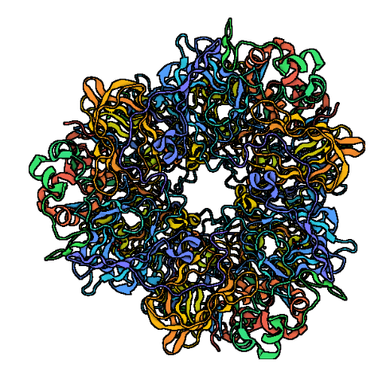B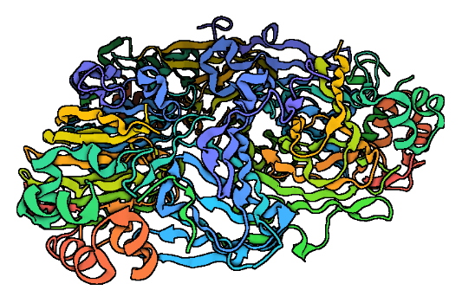
Figure 2. Structure of glycinin (A) and β-conglycinin (B). Created using BioRender.com

We will be continuing to develop a procedure for SBM- and HO-SBM-based polymer's covalent attachment to SM/SH constituents - cellulose, hemicellulose, soy protein – to investigate the feasibility of modified SM and SH in making thermoplastics and composites. Further, we aim to study the physical and chemical properties of the modified SM and SH constituents as well as thermoplastic films and biocomposites thereof. Upon finishing the modification of separate constituents of SM and SH, formulations that have a similar composition to the initial feedstock will be prepared, and their thermo-mechanical properties will be evaluated. The final objective will be to proceed with direct modification of SM and SH, its characterization, and comparison of the properties to previously prepared formulations.

Other relevant information: potential barriers to achieving objectives, risk mitigation strategies, or breakthroughs
The major potential risk is an inability to approach the target level of physical characteristics of the synthesized polymeric materials, which may be limited due to the quality and composition of feedstock materials, specifically SH and SM. The major direction of mitigating the potential problems is to search for and use different sources of cellulose, hemicellulose, and soy protein.

Summary
The synthesis of SBM/HO-SBM (Objective 1) has been performed, and both monomers are characterized and available for Objective 2. The team conducted a series of grafting experiments to verify the feasibility and the concept of grafting SBM- and HO-SBM-polymers to hemicellulose (part of Objective 2). In the second part of this project, modification of cellulose and soy protein will be conducted. After that, thermo-mechanical characterization of formulations with modified hemicellulose, cellulose, and soy proteins will be performed (Objective 3).

